It’s Not What You Do, it’s What I Expect: The Role of Perceivers’ Predictions in Shaping Social Perception.
Authors:
Carlos Ventura-Bort¹, Pilar Segarra², Pablo Ribes-Guardiola³ Anita Deak⁴, Mathias Weymar^{1,5}, & Rosario Poy²
¹Department of Biological Psychology and Affective Science, Faculty of Human Sciences, University of Potsdam, 14476 Potsdam, Germany
²Affective Neuroscience Lab, Department of Basic and Clinical Psychology, and Psychobiology, Universitat Jaume I, Castelló, Spain
³University of Valencia, Valencia, Spain
⁴Faculty of Humanities and Social Sciences, Institute of Psychology, University of Pecs, Hungary
⁵Faculty of Health Sciences Brandenburg, University of Potsdam, Potsdam, Germany

Supplementary material
- Prediction Strength varies as a function of emotion and facial expression in the replication sample.
- Predictability ratings and social judgments are modulated by emotional context and condition (matched vs nonmatched) in the replication sample.
- Predictability, trustworthiness, and likeability ratings are influenced by emotional context, facial expression, gender, and prediction strength in the replication sample.
- The representational structure of predictability ratings and social judgments are specially associated with the Prediction Model in the replication sample.

- Prediction Strength varies as a function of emotion and facial expression in the replication sample.
Substantial evidence was found for a modulation of the factor Emotion (happiness: standardized β =-1.93, t(333) = -30,13, p < .001; sadness: standardized β = -1.81, t(333) = -28.37, p < .001, BF₁₀ = 18.22). Bayesian model comparison also yielded decisive evidence for effects of Facial Expression (happiness: standardized β = -1.87, t(333) = -28.22, p < .001; sadness: standardized β = -1.88, t(333) = -29.45, p < .001, BF₁₀ > 100). Additionally, decisive evidence was found for Emotion x Facial Expression interaction effects (standardized βs > 1.80, ts (333) > 19.85, p< .001, BF₁₀ > 100; Figure S1), indicating higher differences across stereotypical expressions for happiness and sadness compared to fear.

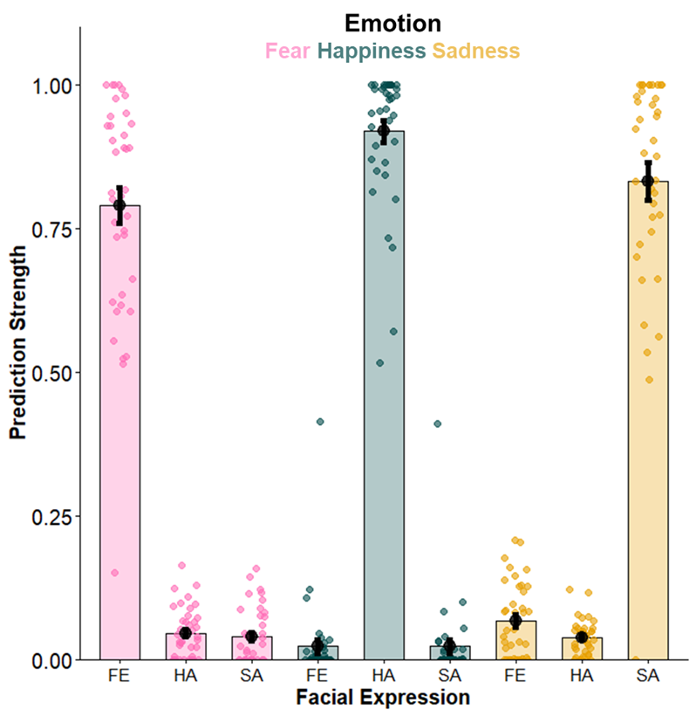
Figure S1. Prediction Strength derived from the Bayesian probability of P_{(Expression|Emotion)} across emotion and stereotypical expressions of fear, happiness, and sadness from the replication sample. Bar plots and dark dots represent the average scores across participants. Black lines represent standard errors. Dots represent single participants.

- Predictability ratings and social judgments are modulated by emotional context and condition (matched vs nonmatched) in the replication sample.
In the replication sample, evidence for a lack of main effect of Emotional Context was found (happiness: standardized β = 0.60, t(2199) = 14.21, p < .001; sadness: standardized β = 0.17, t(2199) = 3.99, p < .001, BF₁₀ = 0.03). However, decisive evidence for Condition (standardized β = -0.85, t(92) = -11.54, p < .001, BF₁₀ > 100) and Emotional Context x Condition interaction effects was observed (happiness: standardized β = -1.18, t(2199) = -15.37, p < .001; sadness: standardized β = -0.46, t(2199) = -5.96, p < .001, BF₁₀> 100); Figure S2A).
For trustworthiness ratings, strong evidence for Emotional Context was obtained (happiness: standardized β = 0.73, t(2200) = 15.90, p < .001; sadness: standardized β = 0.22, t(2220) = 4.87, p < .001, BF₁₀ = 23.62). Decisive evidence for Condition (standardized β = -0.58, t(62) = -5.81, p < .001, BF₁₀ > 100), and Emotional Context x Condition effects was also observed (happiness: standardized β = -1.09, t(2220) = -13.03, p < .001; sadness: standardized β = -0.48, t(2220) = -5.71, p < .001, BF₁₀> 100; Figure S2B).
For likeability ratings, anecdotal evidence was observed for a lack of Emotional Context effects (happiness: standardized β = 0.69, t(2220) = 14.76, p < .001; sadness: standardized β = 0.19, t(2220) = 4.12, p < .001, BF₁₀ = 0.77), but decisive evidence for Condition (standardized β = -0.47, t(60) = -4.14, p < .001, BF₁₀ > 100) and Emotional Context x Condition effects (happiness: standardized β = -1.14, t(2220) = -13.40, p < .001; sadness: standardized β = -0.42, t(2237) = -4.9, p < .001, BF₁₀ > 100; Figure S2C).

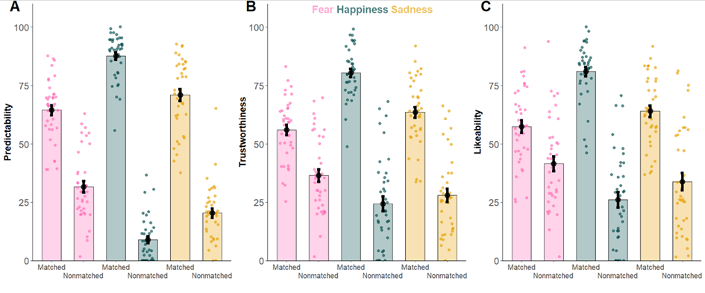
Figure S2. Predictability (A), trustworthiness (B), and likeability (C) ratings from the replication sample across emotional context and condition. Bar plots and dark dots represent the average scores across participants. Black lines represent standard errors. Dots represent single participants.

- Predictability, trustworthiness, and likeability ratings are influenced by emotional context, facial expression, gender, and prediction strength in the replication sample.
For predictability ratings, we found moderate evidence for Emotional Context effects (happiness: standardized β = 0.15, t(56.45) =0.45, p < .001; sadness: standardized β = 0.002, t(67.41) = -2.86, p = .005, BF₁₀ = 7.26), and decisive evidence for Facial Expression effects (happiness: standardized β =0.10, t(2164) = 3.26, p = .001; sadness: standardized β = 0.08, t(2162) = 5.03, p <.001, BF₁₀ = 0.56). We further found a lack of evidence for Gender effects (standardized β =-0.12, t(2186) = -0.53, p = .59, BF₁₀ = 0.06), and decisive evidence for Prediction Strength effects (standardized β = 0.40, t(42) = 28.89, p < .001, BF₁₀ > 100; Figure S3 A-D; Figure S4A). Wald tests revealed that Prediction Strength was the best predictor, χ²s(1) > 386, ps< .001. Emotional Context and Facial Expression did not differ from each other, χ²(1) = 1.79, p= .18, but were significantly different from the factor Gender: Emotional Context vs. Gender, χ²(1) = 4.03, p= .04, and Facial Expression vs. Gender χ²(1) = 9.17, p=0 .002.
For trustworthiness ratings, we observed decisive evidence for Emotional Context effects (happiness: standardized β =0.19 , t(2159) = 3.98, p < .001; sadness: standardized β =0.03 , t(2179) =- .08, p = .11, BF₁₀ > 100), and Facial Expression effects (happiness: standardized β =0.21 , t(2160) = 4.50, p < .001; sadness: standardized β = 0.22, t(2160) = 4.52, p < .001, BF₁₀ > 100). We found evidence for a lack of Gender effects (standardized β =-0.07, t(40) = -1.79, p = .079, BF₁₀= 0.31), but we observed decisive evidence for Prediction Strength effects(standardized β = 0.53, t(35) = 14.18, p <.001, BF₁₀ > 100; Figure S3 E-H; Figure S4B). Wald tests were conducted to compare coefficients across fixed levels. Results showed that Prediction Strength was the best predicting factor, χ²s(1) > 116, ps < .001. No differences were observed between Emotional Context and Facial Expression, χ²(1) = .08, p= .77. However, factors Emotional Context and Gender, χ²(1) = 16.84, p< .001, and Facial Expression and Gender, χ²(1) = 22.37, ps< .001, differed significantly from each other.
For likeability ratings, we found anecdotal evidence for Emotional Context effects (happiness: standardized β = 0.11, t(2113) = 2.34, p = .02; sadness: standardized β = -0.05, t(2126) = -1.10, p = .26, BF₁₀ = 1.14), and decisive evidence for Facial Expression effects (happiness: standardized β = 0.27, t(87.03) = 3.28, p = .001; sadness: standardized β = 0.17, t(87.03) = -2.34, p = .02, BF₁₀ > 100). We further found a lack of evidence for Gender effects (standardized β = -0.09, t(82) = -2.34, p = .024, BF₁₀ = 0.95), and decisive evidence for Prediction Strength effects (standardized β = 0.48, t(36) = 13.27, p < .001, BF₁₀ > 100; Figure S3 I-L; Figure S4). Wald tests comparing standardized coefficients across fixed levels indicated that Prediction Strength was a better predictor than any of the other fixed factors, χ²s(1) > 64.4, ps < .001. Whereas no differences were found between Emotional Context and Facial Expression, χ²(1) = 0.34, p = .559, significant differences emerged between Emotional Context and Gender, χ²(1) = 10.14, p = .001, and Facial Expression and Gender, χ²(1) = 17.66, p < .001 (Figure 6C).

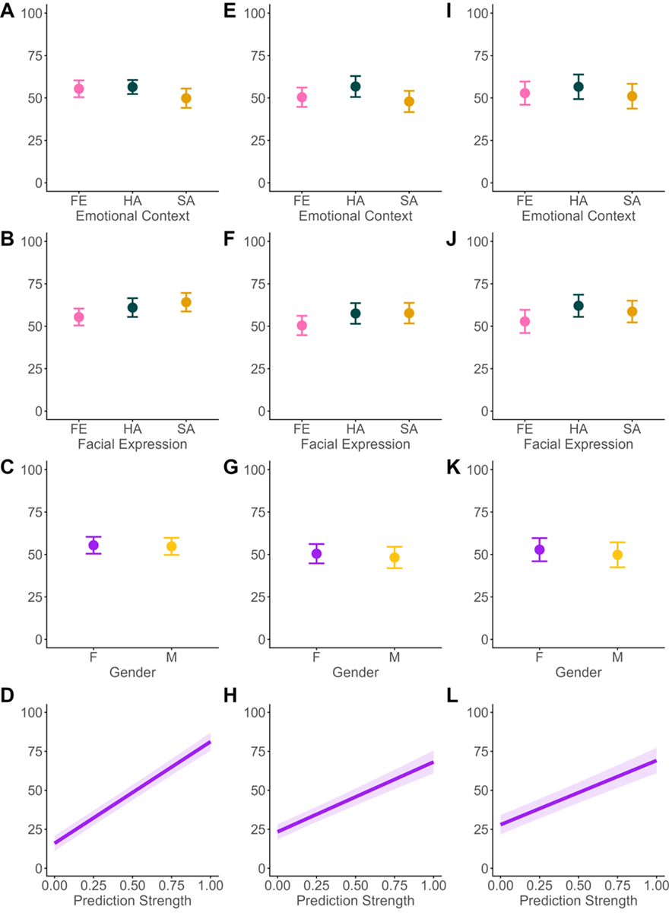
Figure S3. Model estimates of the effects of Emotional Context (fear, happiness, sadness), Facial Expression (stereotypical expression of fear, happiness, sadness), Gender, and Prediction Strength on predictability (A-D), trustworthiness (E-H), and likeability ratings (I-L) from the replication sample. Shaded areas and error bars depict the confidence intervals.

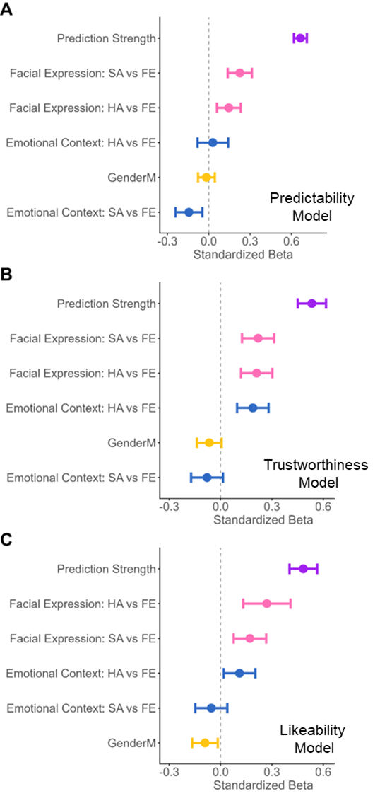
Figure S4. Standardized beta estimates of the effects of Prediction Strength, Emotional Context, Facial Expression, and Gender on predictability (A), trustworthiness (B), and likeability ratings (C) from the replication sample. Error bars depict confidence intervals.

- The representational structure of predictability ratings and social judgments are specially associated with the Prediction Model in the replication sample.
Results from the one-sample t-tests are described in Table S1.
As for the discovery sample, in the replication sample decisive evidence for a positive association between models and predictability ratings was observed, except for the gender-based models which showed a negative relationship (Table S1). Directly comparing the similarities across models revealed decisive evidence for a larger similarity between predictability ratings and the prediction strength model than with the other models (Gender Model: [0.38-0.48], p <.001, BF₁₀> 100; Emotional Context Model: [0.37-0.47], p <.001, BF₁₀= 36.37; Facial Expression Model: [0.36-0.47], p <.001, BF₁₀> 100; Gender vs Emotional Context: [-0.06-0.03], p = .85, BF₁₀ >100 ; Gender vs Facial Expression: [-0.07-0.03], p = .61, BF₁₀ >100 ; Emotional Context vs Facial Expression: [-0.04-0.06], p = .97, BF₁₀= 10.34; Figure S5A).
For trustworthiness ratings, evidence for a positive association with all models was observed (Table S1), with clearly stronger similarities with the prediction model (Gender Model: [0.22-0.34], p <.001, BF₁₀> 100; Emotional Context Model: [0.21-0.32], p <.001, BF₁₀> 100; Facial Expression Model: [0.20-0.31], p <.001, BF₁₀ >100; Gender vs Emotional Context: [-0.8-0.04], p = .82, BF₁₀ =0.49; Gender vs Expression: [-0.08-0.03], p = .70, BF₁₀ = 1.04; Emotional Context vs Facial Expression: [-0.05-0.06], p = .99, BF₁₀ = 0.24; Figure S5B).
A similar pattern of results was found for likeability ratings (Gender Model: [0.20-0.32], p <.001, BF₁₀> 100; Emotional Context Model: [0.17-0.29], p <.001, BF₁₀> 100; Facial Expression Model: [0.17-0.29], p <.001, BF₁₀ =0.13; Gender vs Emotional Context: [-0.09-0.03], p = .66, BF₁₀ = 0.63; Gender vs Facial Expression: [-0.09-0.03], p = .56, BF₁₀ = 1.0; Emotional Context vs Facial Expression: [-0.06-0.07], p = .99, BF₁₀ = 0.18; Figure S5C).
 | Sample | Gender | Emotional Context | Facial Expression | Prediction Strength
Predictability | Mean(SD) | -0.01 (0.01) | 0.01 (0.02) | 0.02 (0.02) | 0.43 (0.16)
Predictability | t-test | t₃₇ = -3.44, p=.001 | t₃₇ = 2.13, p=.04 | t₃₇ =4.02, p<.001 | t₃₇ = 16.32, p<.001
Predictability | BF₁₀ | 22 | 1.32 | 97.5 | >100
Trustworthiness | Mean(SD) | 0.01 (0.01) | 0.03 (0.05) | 0.03 (0.04) | 0.29 (0.17)
Trustworthiness | t-test | t₃₇ 1.0, p=.32 | t₃₇ = 3.81, p<.001 | t₃₇ = 4.79, p<.001 | t₃₇ = 10.41, p<.001
Trustworthiness | BF₁₀ | 0.27 | 57.82 | >100 | >100
Likeability | Mean(SD) | 0.01 (0.06) | 0.04 (0.07) | 0.04 (0.06) | 0.27 (0.17)
Likeability | t-test | t₃₇ =1.21, p=.23 | t₃₇ = 3.52, p=.001 | t₃₇ = 4.09, p<.001 | t₃₇ = 9.57, p<.001
Likeability | BF₁₀ | 0.34 | 27.17 | >100 | >100
Table S1. One-sample t-tests, and BF₁₀ indices of the similarity between the RSMs of models of gender, emotional context, facial expression, and prediction strength models and the RSMs of predictability, trustworthiness, and likeability ratings.

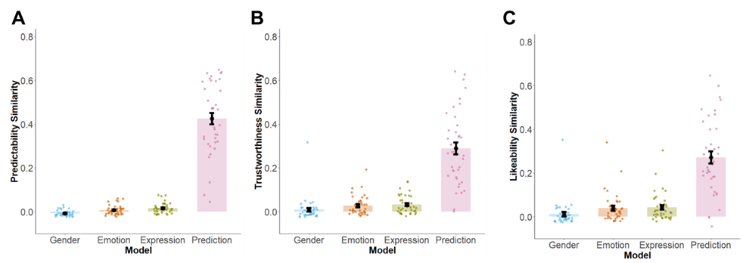
Figure S5. Averaged similarities between gender-, emotional context-, facial expression-, and prediction-based models and predictability (A), trustworthiness (B) and likeability (C) ratings. Bar plots and dark dots represent the average scores across participants. Black lines represent standard errors. Dots represent the similarities for single participants (Emotion: Emotional Context; Expression: Facial Expression).

