Figure1A
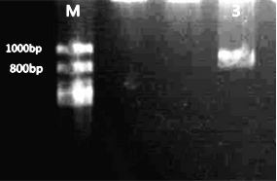
Figure1B
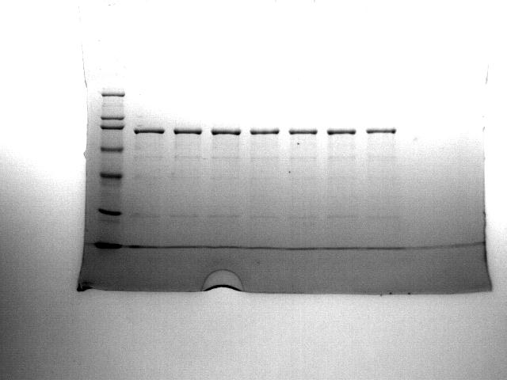 Figure 1. Expression, purification, and identification of α-HL. (A) Identification of amplified α-HL cDNA using PCR. M, DNA marker 1000 bp; lane 3, α-HL cDNA. (B and C) Identification of α-HL fusion protein using western blot analysis (B), and analysis of purified α-HL fusion protein using SDS-PAGE (C). M, Protein molecular weight marker; lanes 1–3, Expressed protein of α-HL fusion protein.

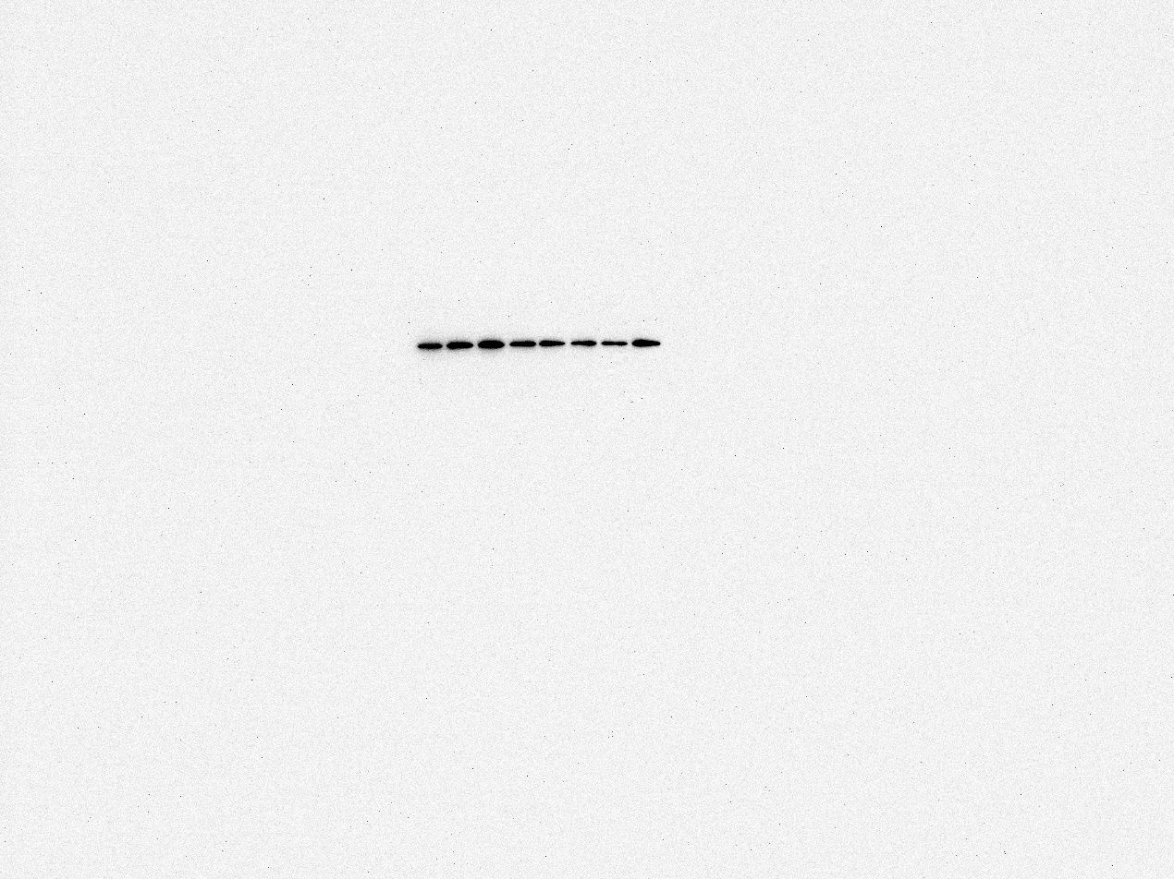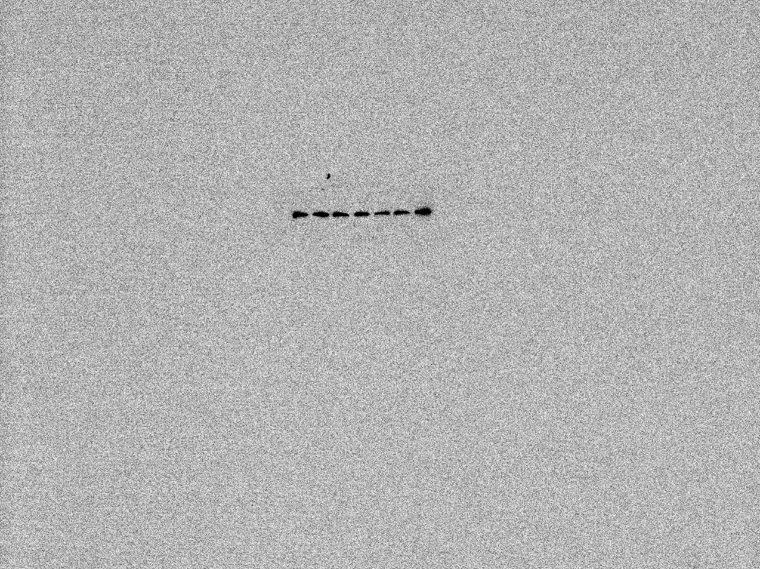
Figure 3. Expression and specificity detection of scFv against α-HL. (A) Identification of preliminarily screened scFvs against α-HL using ELISA. (B) Identification of scFvs by western blot analysis. The size of the protein was about 30 kDa. Note: lanes 1–15, expressed proteins of scFv2; scFv10; scFv46; scFv214; scFv511; scFv538; scFv555; scFv718; scFv722; scFv759; scFv777; scFv802; scFv845; scFv921; and scFv997.
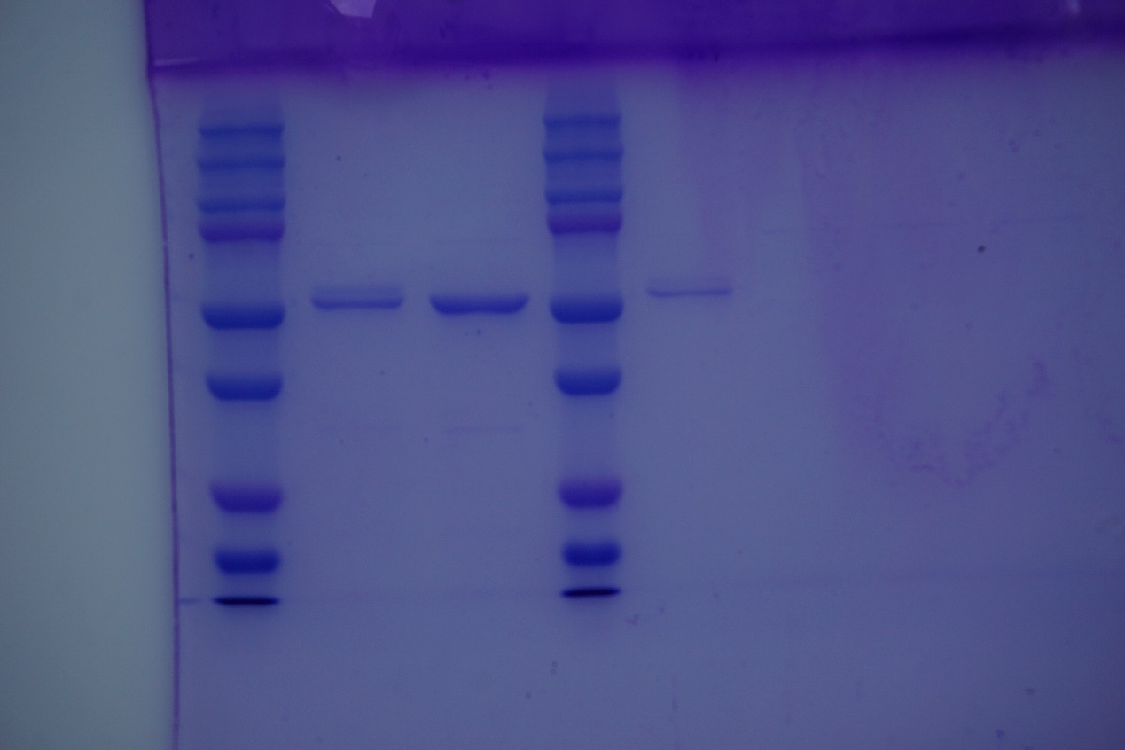
Figure 5. Expression and purification of scFv-Fc. (A) Identification of SP-scFv-Fc/pcDNA3.1 recombinant vector using western blot analysis. Lane 1, Expressed protein of scFv10-Fc/pcDNA3.1; lane 2, expressed protein of scFv555-Fc/pcDNA3.1; lane 3, expressed protein of scFv802-Fc/pcDNA3.1; Lane 4, Expressed protein of scFv10-Fc/pMH3; lane 2, expressed protein of scFv555-Fc/pMH3; lane 3, expressed protein of scFv802-Fc/pMH3. (B) Detection of expressed SP-scFv-Fc/pcDNA3.1 recombinant vector using ELISA. Control, pcDNA3.1 vector. (C) Detection of expressed SP-scFv-Fc/pMH3 recombinant vector using ELISA. Control, pMH3 vector. (D) Identification of the purified scFv555-Fc protein using SDS-PAGE. Note: M, Precision Plus Protein Standard.

