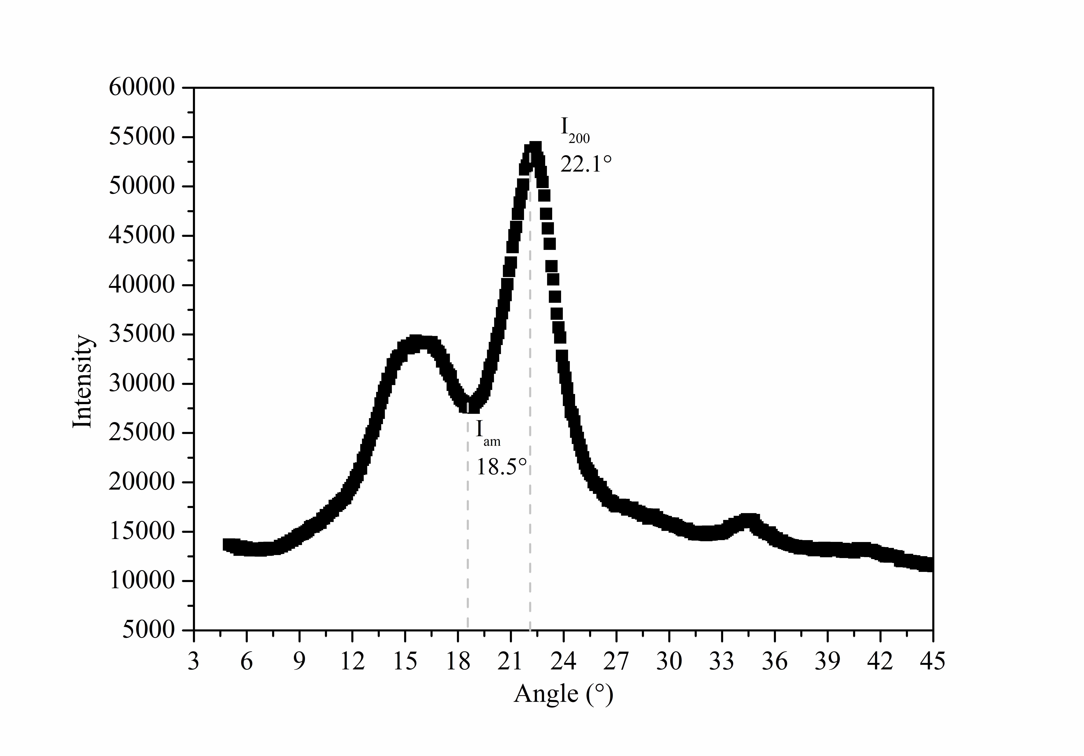
FigS. 1 the XRD diffraction pattern of crystallinity in wood

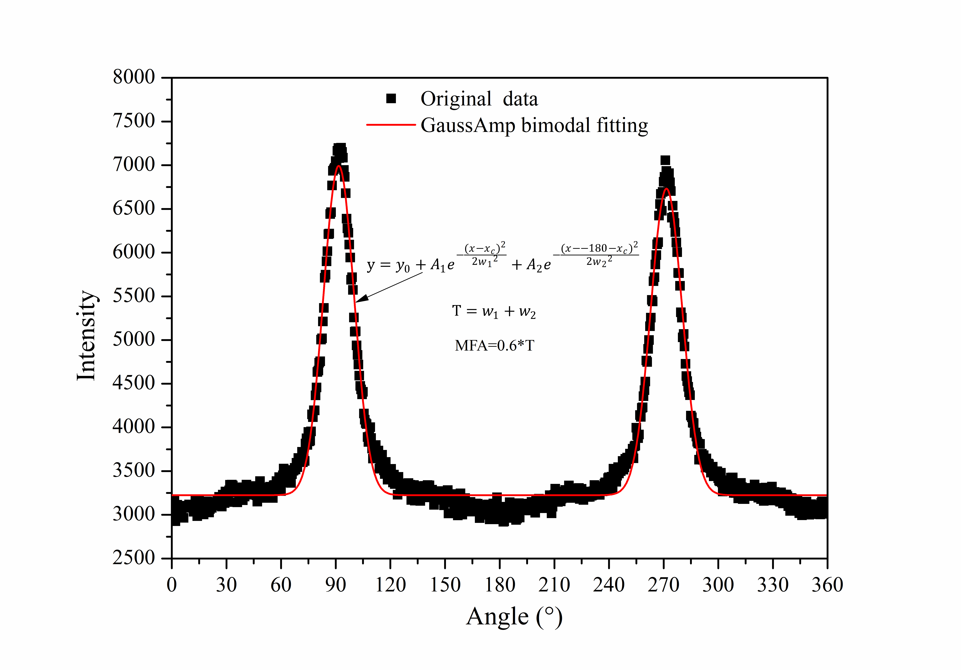
FigS. 2 the XRD diffraction pattern of wood in MFA testing

