SUPPLEMENTARY MATERIALS

Coral rubble facilitates feeding opportunities for invertivorous reef fishes on tropical coral reefs

Lisa S. Goberdhan^{1*}, Gareth J. Williams¹, Shaun K. Wilson^{2,3}, Rodney Melanie⁴, Nicholas A. J. Graham⁵

¹School of Ocean Sciences, Bangor University, Menai Bridge, Anglesey, LL59 5AB, UK
²Australian Institute of Marine Science, Crawley, Western Australia, Australia
³Ocean Institute, University of Western Australia, Crawley, Western Australia, Australia
⁴Seychelles Fisheries Authority, Victoria, Mahe, Seychelles
⁵Lancaster Environment Centre, Lancaster University, Lancaster, LA1 4YQ, UK

*l.goberdhan@bangor.ac.uk

Assignment of trophic guilds to invertivorous reef fish species
Table S1. List of invertivorous reef fish species recorded in this study and their corresponding trophic guild assignments (crustacivores, macroinvertivores, microinvertivores, sessile invertivores), based on global gut content synthesis by Parravicini et al. (2020).
Species | Trophic guild
Bodianus axillaris | Macroinvertivore
Epibulus insidiator | Crustacivore
Halichoeres hortulanus | Macroinvertivore
Halichoeres marginatus | Microinvertivore
Stethojulis albovittata | Microinvertivore
Lutjanus bohar | Crustacivore
Lutjanus gibbus | Crustacivore
Cephalopholis leopardus | Crustacivore
Oxycheilinus digramma | Crustacivore
Cheilinus trilobatus | Macroinvertivore
Gomphosus caeruleus | Microinvertivore
Hemigymnus fasciatus | Microinvertivore
Labroides bicolor | Microinvertivore
Labroides dimidiatus | Microinvertivore
Thalassoma hebraicum | Microinvertivore
Lethrinus harak | Crustacivore
Centropyge multispinis | Sessile invertivore
Chaetodon lunula | Microinvertivore
Plectorhinchus orientalis | Macroinvertivore
Anampses meleagrides | Microinvertivore
Hemigymnus melapterus | Microinvertivore
Cantherhines pardalis | Sessile invertivore
Macropharyngodon bipartitus | Microinvertivore
Monotaxis grandoculis | Macroinvertivore
Coris formosa | Macroinvertivore
Lethrinus obsoletus | Microinvertivore
Zanclus cornutus | Sessile invertivore
Pomacanthus semicirculatus | Sessile invertivore
Pomacanthus imperator | Sessile invertivore
Epinephelus spilotoceps | Crustacivore
Mulloidichthys flavolineatus | Macroinvertivore
Scolopsis frenatus | Microinvertivore
Halichoeres cosmetus | Microinvertivore
Parupeneus rubescens | Crustacivore
Sufflamen chrysopterum | Microinvertivore
Cheilinus fasciatus | Crustacivore
Parupeneus cyclostomus | Crustacivore
Parupeneus macronemus | Microinvertivore
Epinephelus fasciatus | Crustacivore
Novaculichthys taeniourus | Macroinvertivore
Parupeneus barberinus | Crustacivore
Parupeneus ciliatus | Crustacivore
Macolor niger | Crustacivore
Plectorhinchus schotaf | Macroinvertivore
Thalassoma lunare | Microinvertivore
Cephalopholis urodeta | Crustacivore
Thalassoma hardwicke | Microinvertivore
Apolemichthys trimaculatus | Sessile invertivore
Halichoeres scapularis | Microinvertivore
Epinephelus coeruleopunctatus | Crustacivore
Lutjanus rivulatus | Macroinvertivore
Epinephelus merra | Crustacivore
Lutjanus fulviflamma | Crustacivore
Lutjanus kasmira | Crustacivore
Lutjanus monostigma | Crustacivore
Parupeneus trifasciatus | Crustacivore
Lethrinus lentjan | Microinvertivore
Diagramma pictum | Macroinvertivore
Plectorhinchus gibbosus | Macroinvertivore

Categorising benthic regimes for surveyed reefs in inner Seychelles Islands 1994 - 2022

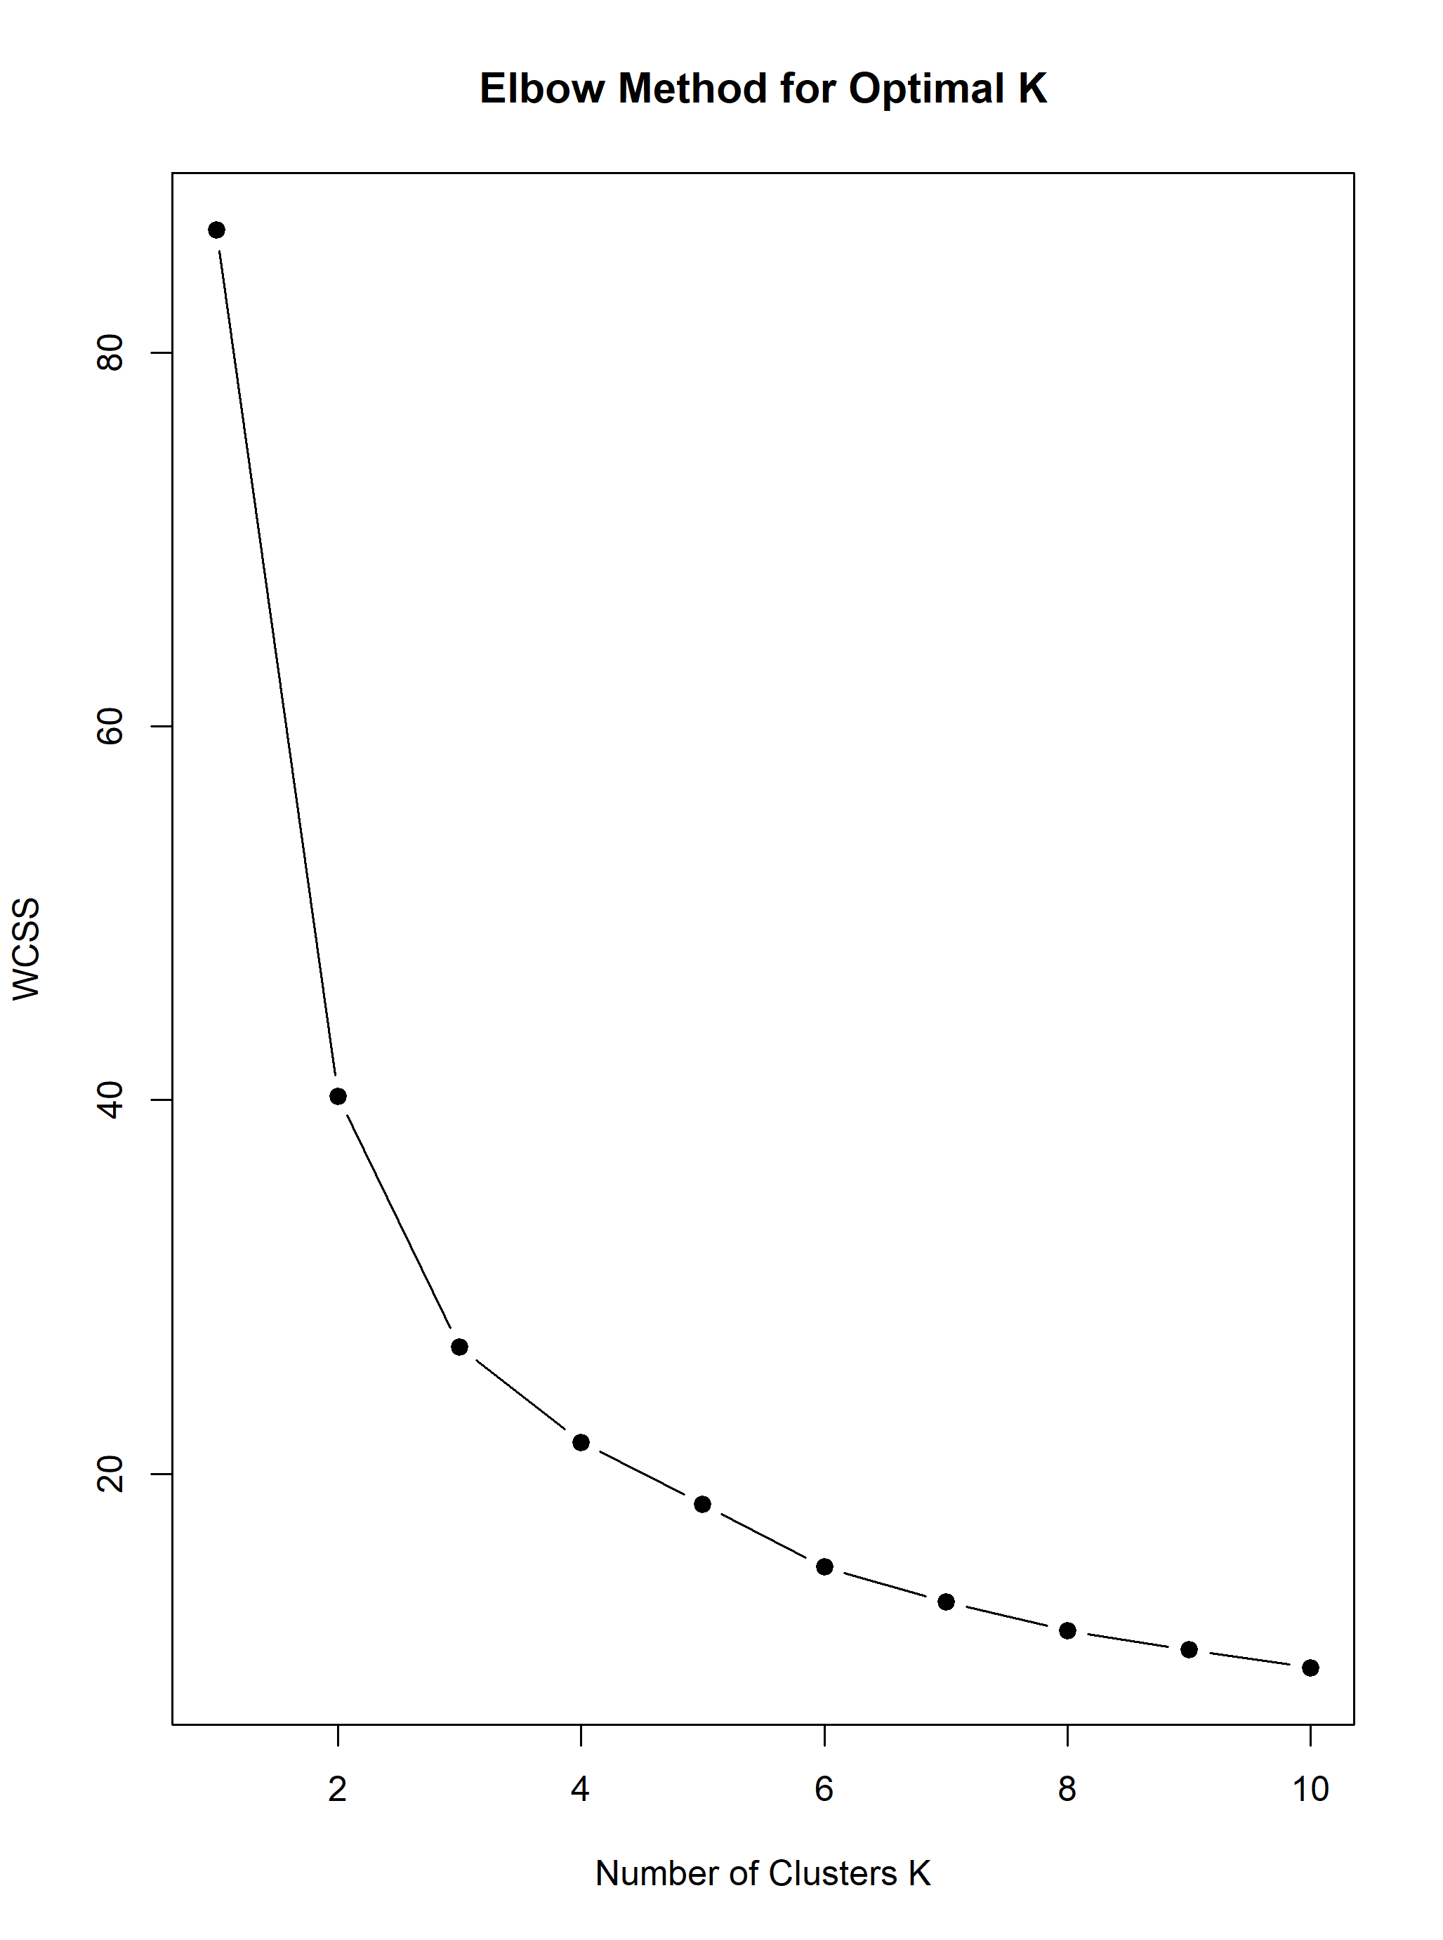

Supp. Fig. 1. Elbow method used to identify the optimal number of pre-defined clusters (k). Inflection point inferred at 3 clusters.

Differences in invertivorous fish community structure across benthic regimes (1994 – 2022) – CAP analysis results
Table S2. Cross validation results of classifying invertivorous reef fish communities to a prori defined benthic regimes.
 | Classified as
Original group | Hard substrate | Macroalgae | Rubble | Total | Correct Classification (%)
Hard substrate | 49 | 4 | 7 | 60 | 81.67
Macroalgae | 1 | 20 | 0 | 21 | 95.24
Rubble | 3 | 4 | 38 | 45 | 84.44
Total correct | 49 | 20 | 3 | 14 | 84.92

Differences in invertivorous fish community structure across benthic regimes (1994 – 2022) – PERMANOVA results

Table S3. Summary statistics of PERMANOVA on variation (a) body size, (b) crustacivore abundance, (c) macroinvertivore abundance (d) microinvertivore abundance (e) sessile invertivore abundance among benthic regimes. Significant values in bold.

 | Factor | df | SS | Pseudo-F | p
(a) Body size | Benthic regime | 2 | 77.64 | 8.65 | 0.0003
 | Residuals | 123 | 552.21
 | Total | 125
(b)Crustacivore | Benthic regime | 2 | 6772.2 | 5.90 | 0.0036
 | Residuals | 123 | 70657
 | Total | 125
(b)Macroinvertivore | Benthic regime | 2 | 1093.4 | 2.63 | 0.07
 | Residuals | 123 | 25592 | 2.63 | 2.63
 | Total | 125 | 61.996
(d) Microinvertivore | Benthic regime | 2 | 16069 | 6.00 | 0.0026
 | Residuals | 123 | 1.65E+05
 | Total | 125 | 8577.6
(d) Sessile invertivore | Benthic regime | 2 | 4957.1 | 13.69 | 0.0001
 | Residuals | 123 | 22262
 | Total | 125 | 27219

Relationship between invertivorous fish community structure and coral rubble habitats (2022): Kmeans clustering of benthic surveys in 2022

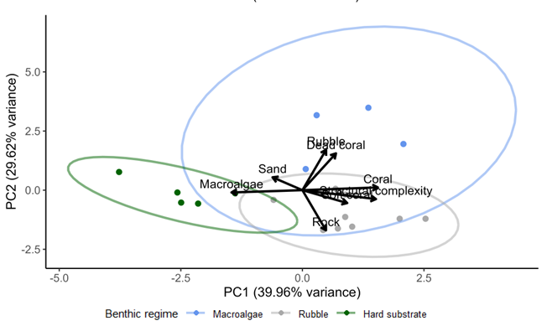
Supp. Fig. 2 PCA diagram with overlaying K-means clustering of the sites. Green dots (n = 4), blue dots (n = 5), and grey dots (n = 9) represent sites color-coded by its respective benthic regime.

Table S4. Mean benthic cover in each benthic regime expressed as a percentage
Benthic variable | Macroalgae regime  (n =4) | Rubble regime  (n = 5) | Hard substrate regime  (n = 9)
Coral (%) | 2.48 | 15.30 | 15.20
Sand (%) | 11.80 | 8.28 | 5.00
Rubble (%) | 11.30 | 53.90 | 14.50
Rock (%) | 33.50 | 15.70 | 59.60
Macroalgae (%) | 40.90 | 0.19 | 3.08
Soft coral (%) | 0.03 | 1.51 | 1.51
Dead coral (%) | 0.00 | 5.75 | 1.10

Relationship between invertivorous fish community structure and coral rubble habitats (2022): CAP analysis results

Table S5. CAP results showing cross validation results of classifying reef fish communities to benthic regimes
 | Classified as
Original group | Hard substrate | Macroalgae | Rubble | Total | Correct Classification (%)
Hard substrate | 7 | 0 | 2 | 9 | 77.78
Macroalgae | 0 | 4 | 1 | 5 | 80.00
Rubble | 1 | 0 | 3 | 4 | 75.00
Total correct | 7 | 4 | 3 | 14 | 77.78

Table S6. Species-specific associations of reef fish and benthic regime based on Spearman’s rank correlation coefficient and position along CAP axes for data in the year 2022.
Species | CAP1 | CAP2 | Benthic regime-association
Anampses meleagrides | 0.019654273 | 0.446158364 | Rubble
Bodianus axillaris | 0.335122099 | 0.550238852 | Rubble
Cantherhines pardalis | 0.242954878 | -0.156329566 | Hard substrate
Centropyge multispinis | 0.066333603 | 0.671980244 | Rubble
Chaetodon lunula | 0.2533742 | -0.308448442 | Hard substrate
Cheilinus trilobatus | -0.001323518 | -0.219681297 | Hard substrate
Coris formosa | 0.397762646 | 0.029496017 | Hard substrate
Epibulus insidiator | 0.669271157 | -0.001028668 | Hard substrate
Epinephelus merra | 0.163796464 | 0.27473292 | Hard substrate
Epinephelus spilotoceps | 0.426439361 | 0.059108075 | Hard substrate
Gomphosus caeruleus | 0.448713968 | 0.470361715 | Hard substrate
Halichoeres hortulanus | 0.359215304 | -0.321656325 | Hard substrate
Halichoeres marginatus | 0.004765591 | -0.21419097 | Hard substrate
Hemigymnus fasciatus | -0.036156546 | 0.124745306 | Macroalgae
Hemigymnus melapterus | 0.327667226 | 0.305925195 | Hard substrate
Labroides bicolor | 0.203126203 | 0.581383062 | Rubble
Labroides dimidiatus | 0.0395666 | 0.223002062 | Hard substrate
Lethrinus harak | 0.094646625 | 0.034495932 | Hard substrate
Lethrinus obsoletus | -0.126511758 | 0.216980911 | Macroalgae
Lutjanus bohar | 0.408380238 | 0.045753887 | Hard substrate
Macropharyngodon bipartitus | -0.32161731 | 0.038405375 | Macroalgae
Novaculichthys taeniourus | -0.185681616 | 0.21096026 | Macroalgae
Oxycheilinus digramma | 0.35725833 | 0.308505645 | Hard substrate
Parupeneus macronemus | -0.474675137 | 0.328938402 | Macroalgae
Pomacanthus imperator | 0.411364577 | -0.146912497 | Hard substrate
Pomacanthus semicirculatus | 0.189583285 | -0.441390349 | Hard substrate
Scolopsis frenatus | -0.105965133 | 0.203587203 | Macroalgae
Stethojulis albovittata | -0.443095569 | 0.323840795 | Macroalgae
Thalassoma hardwicke | 0 | 0 | NA
Thalassoma hebraicum | -0.123768591 | -0.441220605 | Macroalgae
Zanclus cornutus | 0.474676395 | 0.024703479 | Hard substrate
Epinephelus fasciatus | -0.197570116 | 0.301700142 | Rubble
Lethrinus lentjan | -0.191047393 | -0.16730989 | Macroalgae
Lutjanus gibbus | 0.375013378 | -0.281189743 | Hard substrate
Parupeneus barberinus | -0.254327352 | 0.08430446 | Macroalgae
Parupeneus trifasciatus | 0.125608225 | 0.092323296 | Hard substrate
Lutjanus fulviflamma | 0.578227571 | -0.416120829 | Hard substrate
Parupeneus ciliatus | 0.056197551 | 0.050769063 | Hard substrate
Plectorhinchus gibbosus | 0 | 0 | NA
Plectorhinchus orientalis | 0.133713202 | -0.490342848 | Hard substrate
Parupeneus cyclostomus | 0.114122549 | -0.064360634 | Hard substrate
Halichoeres cosmetus | -0.001328242 | 0.204267256 | Rubble
Lutjanus monostigma | 0 | 0 | NA
Macolor niger | 0.308689327 | -0.220566646 | Hard substrate
Plectorhinchus schotaf | 0.241013627 | -0.293532244 | Hard substrate
Sufflamen chrysopterum | 0.219639652 | -0.069221691 | Hard substrate
Monotaxis grandoculis | -0.040049454 | -0.14593678 | Macroalgae
Parupeneus rubescens | -0.360754452 | 0.04985229 | Macroalgae
Halichoeres scapularis | -0.09620582 | 0.619212248 | Rubble
Mulloidichthys flavolineatus | 0.418774133 | -0.253479634 | Hard substrate
Cephalopholis leopardus | -0.019690727 | 0.433002649 | Rubble
Thalassoma lunare | -0.107374742 | 0.332201887 | Rubble
Cheilinus fasciatus | -0.001328242 | 0.204267256 | Rubble
Apolemichthys trimaculatus | -0.092800733 | 0.282376327 | Rubble
Cephalopholis urodeta | 0.131028416 | 0.438865609 | Rubble
Epinephelus coeruleopunctatus | 0.0424913 | 0.105667631 | Hard substrate
Lutjanus rivulatus | 0 | 0 | NA
Lutjanus kasmira | 0.095407371 | -0.177881028 | Hard substrate
Diagramma pictum | -0.271910118 | -0.031226576 | Macroalgae

Table S7. Summary statistics of permutational analysis of variance (PERMANOVA) testing the effect of rubble disturbance on site-level response variables (n = 17) either present on coral rubble habitats or actively feeding in coral rubble habitats - (a) invertivorous fish community composition present (b) invertivorous fish community composition feeding (c) mean body size of invertivorous fish present (d) mean body size of invertivorous fish feeding (e) standard deviation of invertivorous fish present (f) standard deviation of invertivorous fish feeding (g) crustacivore abundance present (h) crustacivore abundance feeding (i) macroinvertivore abundance present (j) macroinvertivore abundance feeding (k) microinvertivore abundance present (l) microinvertivore abundance feeding (m) sessile invertivore abundance presence (n) sessile invertivore abundance feeding

 | Factor | df | SS | Pseudo-F | p
(a) Community composition present | Disturbance | 1 | 4210 | 6.75 | p < 0.01
 | Location | 16 | 44097 | 4.42 | p < 0.01
 | Residuals | 16 | 14379.00
(b) Community composition feeding | Disturbance | 1 | 7596.1 | 13.824 | p < 0.01
 | Location | 16 | 13345 | 1.5179 | p < 0.05
 | Residuals | 16 | 8792
(c) Mean body size present | Disturbance | 1 | 5704 | 0.82 | 0.39
 | Location | 16 | 191.38 | 2.7368 | p < 0.01
 | Residuals | 16 | 69.929
(d) Mean body size feeding | Disturbance | 1 | 4.9155 | 3.7388 | p = 0.11
 | Location | 16 | 158.98 | 7.5578 | p < 0.05
 | Residuals | 16 | 623.65
(e) SD body size present | Disturbance | 1 | 23.94 | 9.5581 | p < 0.01
 | Location | 16 | 65.101 | 1.6245 | 0.17
 | Residuals | 16 | 40.076
(f) SD body size feeding | Disturbance | 1 | 72.322 | 4.325 | p < 0.05
 | Location | 16 | 615.75 | 2.3014 | 0.17
 | Residuals | 16 | 83.61
(g) Crustacivore abundance present | Disturbance | 1 | 3.2426 | 13.93 | p < 0.01
 | Location | 16 | 32.88 | 10.974 | p < 0.05
 | Residuals | 16 | 21.12 | 5.2157
(h) Crustacivore abundance feeding | Disturbance | 1 | 0.11765 | 8.7273 | p < 0.01
 | Location | 16 | 0.34641 | 1.6061 | 0.1824
 | Residuals | 16 | 1.94
(i) Macroinvertivore abundance present | Disturbance | 1 | 2.844 | 19.948 | p < 0.01
 | Location | 16 | 0.86642 | 6.0774 | p < 0.01
 | Residuals | 16 | 2.281
(j) Macroinvertivore abundance feeding | Disturbance | 1 | 2.9412 | 13.873 | p < 0.01
 | Location | 16 | 4.7647 | 1.4046 | 0.2205
 | Residuals | 16 | 3.3922
(k) Microinvertivore abundance present | Disturbance | 1 | 15.559 | 21.706 | p < 0.01
 | Location | 16 | 29.083 | 2.5358 | p < 0.01
 | Residuals | 16 | 11.469
(l) Microinvertivore abundance feeding | Disturbance | 1 | 9.8856 | 18.36 | p < 0.01
 | Location | 16 | 9.8301 | 1.14 | 0.39
 | Residuals | 16 | 8.6144
(m) Sessile invertivore abundance present | Disturbance | 1 | 0.51062 | 8.1433 | p < 0.01
 | Location | 16 | 2.0817 | 2.0749 | 0.08
 | Residuals | 16 | 1.0033
(n) Sessile invertivore abundance feeding | Disturbance | 1 | 0.081699 | 4.2553 | 0.06
 | Location | 16 | 0.30719 | 1.00 | 0.43
 | Residuals | 16 | 0.30719

Table S8. Summary statistics of PERMANOVA testing the effect of benthic regime on pre-disturbance site-level response variables either present on coral rubble habitats or actively feeding in coral rubble habitats - (a) invertivorous fish community composition present (b) invertivorous fish community composition feeding (c) mean body size of invertivorous fish present (d) mean body size of invertivorous fish feeding (e) standard deviation of invertivorous fish present (f) standard deviation of invertivorous fish feeding (g) crustacivore abundance present (h) crustacivore abundance feeding (i) macroinvertivore abundance present (j) macroinvertivore abundance feeding (k) microinvertivore abundance present (l) microinvertivore abundance feeding (m) sessile invertivore abundance presence (n) sessile invertivore abundance feeding

 | Factor | df | SS | Pseudo-F | p
(a) Community composition present | Benthic regime | 2 | 2302.7 | 0.69154 | 0.7967
 | Residuals | 14 | 38986.00
(b) Community composition feeding | Benthic regime | 2 | 1503.5 | 2.2848 | p = 0.0498
 | Residuals | 14 | 4606.2
(c) Mean body size present | Benthic regime | 2 | 62.425 | 3.8079 | p < 0.05
 | Residuals | 14 | 114.76
(d) Mean body size feeding | Benthic regime | 2 | 16.252 | 2.7791 | 0.3
 | Residuals | 14 | 8.7719
(e) SD body size present | Benthic regime | 2 | 1.1018 | 0.12028 | 0.884
 | Residuals | 14 | 64.123
(f) SD body size feeding | Benthic regime | 2 | 0.95579 | 0.15355 | 1
 | Residuals | 14 | 9.3368
(g) Crustacivore abundance present | Benthic regime | 2 | 1.65 | 0.13835 | 0.8886
 | Residuals | 14 | 2.0958
(h) Crustacivore abundance feeding | Benthic regime | 2 | 0.0073529 | 0.52941 | 1.00
 | Residuals | 14
(i) Macroinvertivore abundance present | Benthic regime | 2 | 0.17059 | 0.25169 | 0.8173
 | Residuals | 14 | 4.7444
(j) Macroinvertivore abundance feeding | Benthic regime | 2 | 0.19118 | 16.059 | p < 0.01
 | Residuals | 14 | 0.083333
(k) Microinvertivore abundance present | Benthic regime | 2 | 2.7081 | 1.3719 | 0.2844
 | Residuals | 14 | 13.818
(l) Microinvertivore abundance feeding | Benthic regime | 2 | 0.035294 | 0.18843 | 0.88
 | Residuals | 14 | 1.3111
(m) Sessile invertivore abundance present | Benthic regime | 2 | 0.17549 | 2.799 | 0.0979
 | Residuals | 14
(n) Sessile invertivore abundance feeding | Benthic regime | 2 | 0.00 | Denominator is 0
 | Residuals | 14 | 0.00

Table S9. Summary statistics of PERMANOVA testing the effect of benthic on post-disturbance site-level response variables either present on coral rubble habitats or actively feeding in coral rubble habitats - (a) invertivorous fish community composition present (b) invertivorous fish community composition feeding (c) mean body size of invertivorous fish present (d) mean body size of invertivorous fish feeding (e) standard deviation of invertivorous fish present (f) standard deviation of invertivorous fish feeding (g) crustacivore abundance present (h) crustacivore abundance feeding (i) macroinvertivore abundance present (j) macroinvertivore abundance feeding (k) microinvertivore abundance present (l) microinvertivore abundance feeding (m) sessile invertivore abundance presence (n) sessile invertivore abundance feeding
 | Factor | df | SS | Pseudo-F | p
(a) Community composition present | Benthic regime | 2 | 3096.7 | 0.85465 | 0.6602
 | Residuals | 14 | 25364
(b) Community composition feeding | Benthic regime | 2 | 2004.2 | 0.82123 | 0.6151
 | Residuals | 14 | 17083
(c) Mean body size present | Benthic regime | 2 | 5.4893 | 0.48863 | 0.6163
 | Residuals | 14 | 78.638
(d) Mean body size feeding | Benthic regime | 2 | 13.752 | 0.75927 | 0.487
 | Residuals | 14 | 126.78
(e) SD body size present | Benthic regime | 2 | 2.9386 | 0.55574 | 0.5812
 | Residuals | 14 | 37.014
(f) SD body size feeding | Benthic regime | 2 | 1.8564 | 0.12523 | 0.8886
 | Residuals | 14 | 148.24
(g) Crustacivore abundance present | Benthic regime | 2 | 1.2967 | 0.71162 | 0.5641
 | Residuals | 14 | 12.756
(h) Crustacivore abundance feeding | Benthic regime | 2 | 0.074183 | 1.3546 | 0.3742
 | Residuals | 14 | 0.38333
(i) Macroinvertivore abundance present | Benthic regime | 2 | 0.73709 | 0.49178 | 0.6224
 | Residuals | 14 | 10.492
(j) Macroinvertivore abundance feeding | Benthic regime | 2 | 1.5824 | 1.76 | 0.21
 | Residuals | 14 | 6.3
(k) Microinvertivore abundance present | Benthic regime | 2 | 0.37892 | 0.11217 | 0.9003
 | Residuals | 14 | 23.647
(l) Microinvertivore abundance feeding | Benthic regime | 2 | 1.3397 | 0.59511 | 0.5897
 | Residuals | 14 | 15.758
(m) Sessile invertivore abundance present | Benthic regime | 2 | 0.16364 | 0.49655 | 0.6103
 | Residuals | 14
(n) Sessile invertivore abundance feeding | Benthic regime | 2 | 0.072712 | 0.93967 | 0.56
 | Residuals | 14 | 0.54167

