Supporting Information for
High Fire-Safety Ultrathin Porous Lithium Anode with Bulk Ion-Conductive Network
Ruyi Li¹, Shaowen Zhang¹, Yan Li¹, Hefeng Wang¹, Keer Chen¹, Yang Liu¹*, Bingkun Guo¹, Shigang Lu¹
Affiliations
¹ Materials Genome Institute, Shanghai University, Shanghai, 99 Shangda Road, Baoshan District, Shanghai, China.
*Corresponding author. Email: liuyang81@shu.edu.cn

Contents
- Supplementary Methods
- Supplementary Figures 1-32
- Supplementary Discussion 1-5
- Supplementary Table 1
- References and notes

- Supplementary Methods
1.1 Preparation of composite anode
The hydrogenated polymers used Polyvinylidene fluoride (PVDF, Aladdin Reagent Co., Ltd.). Li@PVDF composite material with a mass ratio of 1:5 (PVDF:Li, w:w) was prepared by overlaying and rolling a Li foil (from Zhongneng Lithium with a thickness of 100 µm) at a 1:1 area ratio in an argon-filled glove box. The composite anode was repeatedly folded and calendered until the additive was uniformly dispersed and the thickness reached <50 µm, then cut to circular pieces with a diameter of 15 mm. The other additives (Polyethylene (PE), Polytetrafluoroethylene (PTFE), Lithium fluoride (LiF) from Aladdin Reagent Co., Ltd.) were used at the same ratio. Then put composite anodes into vacuum annealing at 120°C for 24 hours to yield the final products.
1.2 Preparation of cathodes & cells
In the fabrication of lithium-ion batteries, LiCoO₂ (from Xiamen Tungsten Co., Ltd.) was chosen as the high-voltage cathode active material. Acetylene black (from TCI Shanghai) served as the conductive agent, and 5 wt% PVDF solution in N-methyl-2-pyrrolidone (NMP) was used as the binder, with a mass ratio of 8:1:1 for the active material, conductive agent, and binder. The LiFeO₄ (from Xiamen Tungsten Co., Ltd.) was chosen as the same ratio. The assembly was carried out in an Air with 25°C. All used is base electrolyte consisted of 1mol L⁻¹ Lithium hexafluorophosphate (LiPF₆) in a 1:1 vol ratio of Ethylene carbonate (EC) and Dimethyl carbonate (DMC). All cells in this work were 2032-type coin cells and the separator was Celgard 2400 at 25°C.
1.3 Material characterization
The Electrochemical Impedance Spectroscopy (EIS), Cyclic Voltammetry (CV) measurements were carried out on a Solartron electrochemical station with a scan rate of 0.1 mV s⁻¹, and 0.1-10⁵ Hz with the amplitude of 10 mV respectively. The cyclic performances of cells were tested on a Land CT2001C battery tester. All of the samples for X-ray Photoelectron Spectroscopy (XPS), Scanning Electron Microscope (SEM), and Energy Dispersive Spectroscopy (EDS), Raman Spectroscopy tests were dried in vacuum. X-ray Diffraction (XRD) (PANalytical Empyrean) were tested with a Cu Kα radiation source on a step size of 0.02°. XPS spectra was tested by AXIS ULTRA, Kratos, and the morphologies of surface were observed on a SEM (FESEM, Regulus-8230, Hitachi, Tokyo, Japan).
The hydrogen gas evolved was monitored using a custom gas-measurement chamber equipped with a palladium-alloy thin-film hydrogen sensor (model PDM300, Rilixin Co., China) with a measurement range of 200-10000 ppm. Before each experiment, the chamber was purged with high-purity Ar₂ (99.997%) for 30 min to remove residual air and moisture, which was then used as the carrier and protective gas.
1.4 Calculation method
The density functional theory (DFT) calculations were performed using the Gaussian 16W at the B3LYP /6-31g(d) level & CASTEP package implemented in Materials Studio 2020. The exchange-correlation interactions were treated within the framework of the Generalized Gradient Approximation (GGA) using the Perdew–Burke–Ernzerhof (PBE) functional¹⁻⁶.
The bulk ionic conductivity was derived from electrochemical impedance spectroscopy (EIS)^{7,8} based on the Warburg diffusion behavior. At low frequencies, the impedance spectra display a linear region with a slope of approximately 45°, which corresponds to the Warburg impedance associated with lithium-ion diffusion. The real part of the impedance () varies linearly with the reciprocal square root of the angular frequency (), following the relationship:
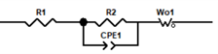
$Z^{'}=R_{e}+R_{ct}+σω^{-1/2}$ (S1)
where is the electrolyte resistance, $R_{ct}$is the charge-transfer resistance, and $σ$is the Warburg coefficient. The diffusion coefficient of Li⁺ ions ($D_{Li^{+}}$) can be obtained from $σ$according to the following equation:
$D_{Li^{+}}=\frac{R^{2}T^{2}}{2A^{2}n^{4}F^{4}C^{2}σ^{2}}$ (S2)
where $R$is the gas constant, $T$is the absolute temperature, $A$is the electrode area, $n$is the number of electrons transferred per reaction, $F$is the Faraday constant, and $C$is the Li⁺ concentration. The bulk ionic conductivity ($σ_{ion}$) was then calculated using the Nernst–Einstein relationship:
$σ_{ion}=\frac{n^{2}F^{2}CD_{Li^{+}}}{RT}$ (S3)
This approach enables quantitative evaluation of the ionic transport capability within the composite anodes bulk.
To evaluate the through-thickness ionic transport capability of bulk Li metal, a PEO|Li|PEO sandwich reference cell was assembled by placing two PEO membranes (cut to the same size) on both sides of a Li foil disc in an Ar-filled glovebox and sealing the stack between stainless-steel current collectors/spacers under constant pressure (followed by resting if needed to improve contact). Because PEO is Li⁺-conductive but electronically insulating, electronic short-circuiting is prevented; under a small AC perturbation, a small-amplitude interfacial exchange reaction at the PEO/Li interface (Li ⇄ Li⁺ + e⁻) couples external electron flow with Li⁺ transport, so the impedance response reflects the resistance of the PEO layers, interfacial polarization, and the effective ionic-transport contribution of the Li foil section. The series resistance (R_{s}) is taken from the high-frequency intercept (Z'' to 0) (with baseline subtraction if applicable), and the effective ionic conduction capability is estimated by , where (L) is the Li-foil thickness (50 μm) and (A) is the effective contact area (15 mm 1.766 cm⁻²).
The Tafel curve is obtained from the LSV of a Li@PVDF symmetric cell at 5 mA cm⁻², which the electrode potential is scanned at ±0.2 V vs. Li/Li⁺ and scanned rate is 1 mV s⁻¹. The relationship between the overpotential (η) and the current density (i) follows the Tafel equation:
$η=a+blog⁡i$ (S4)
where $a$is the intercept related to the exchange current density ($i_{0}$), and $b$is the Tafel slope, which reflects the charge-transfer kinetics at the electrode–electrolyte interface. The exchange current density can be derived from the intercept of the extrapolated linear region according to:
$i_{0}={10}^{-\frac{a}{b}}$ (S5)
The negative-to-positive capacity ratio (N/P ratio) calculated on an aerial-capacity basis: the cathode areal capacity is obtained from the designed cell capacity and electrode overlap area, while the anode areal capacity is determined by the Li inventory provided by two anode sheets; an effective N/P ratio can be further corrected by the Li utilization when applicable. In this work, the pouch cell exhibits an N/P ratio of 1.82.

- Supplementary Figures 1-32
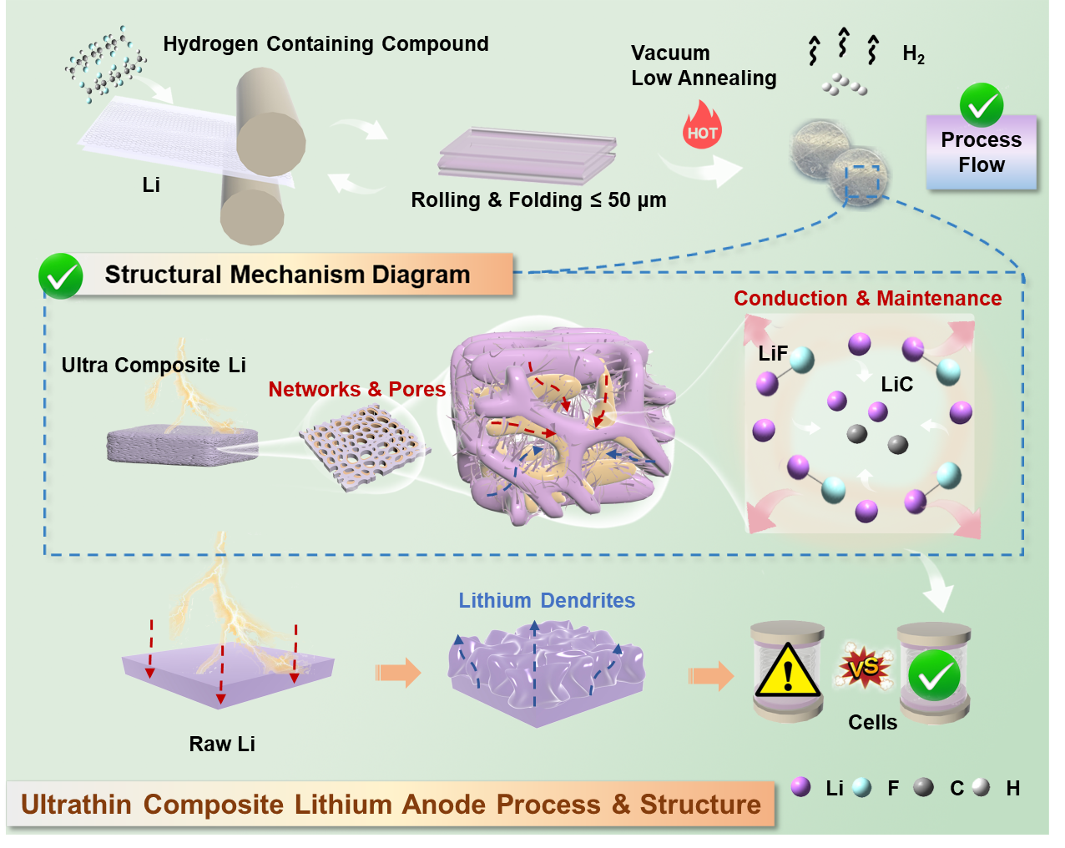
Supplementary Fig. 1. Schematic illustration of ultrathin Composite Lithium Anode Process & Structure.

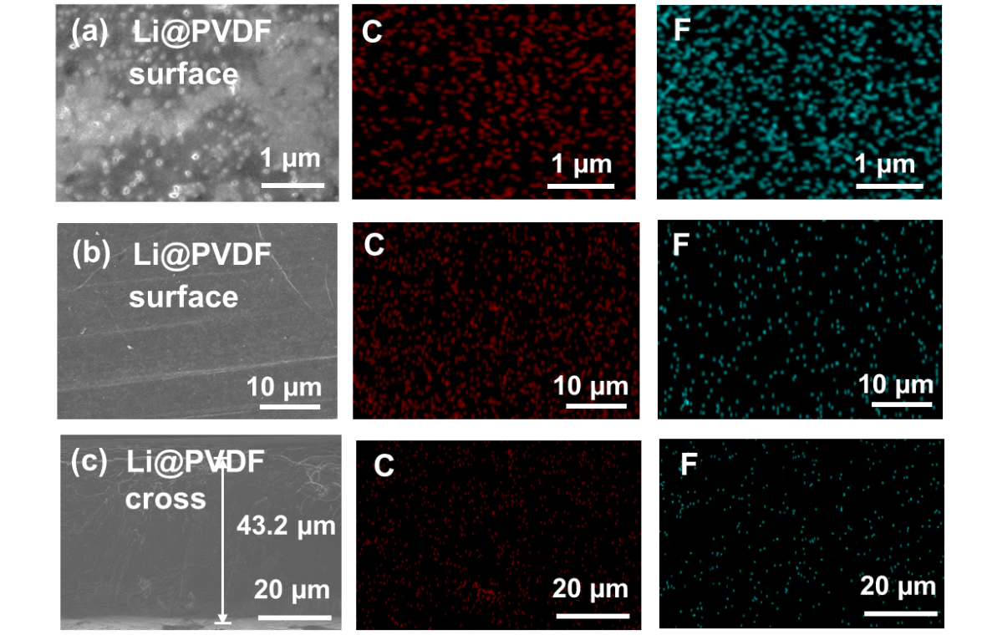
Supplementary Fig. 2. SEM images& EDS mapping of Li@PVDF (a, b) surface at 1 µm & 10 µm and (c) cross section at 20 µm.

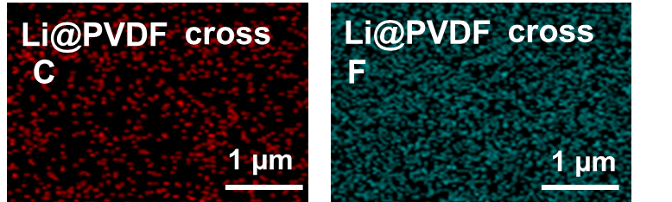
Supplementary Fig. 3. EDS mapping of Li@PVDF cross corresponding to Fig. 1a.

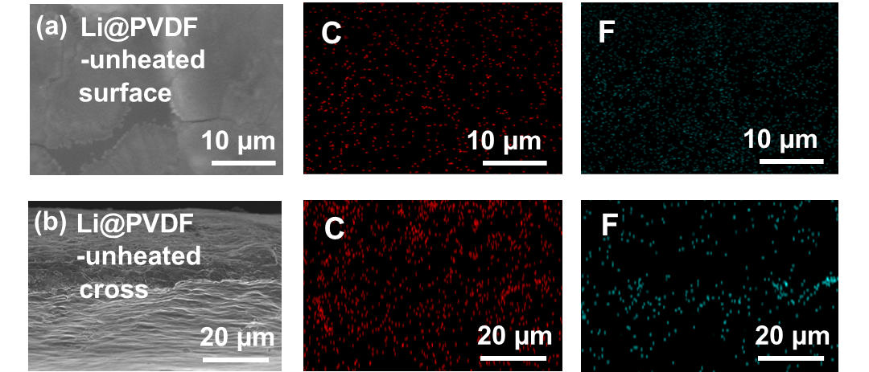
Supplementary Fig. 4. (a, b) SEM images& EDS mapping of Li@PVDF-unheated surface and cross section.

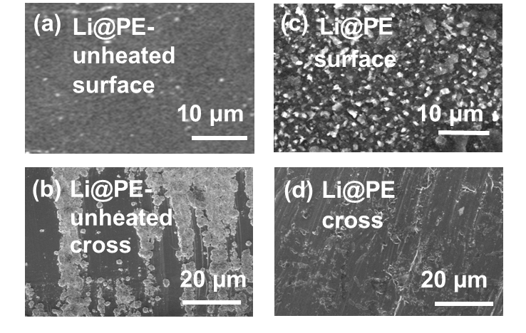
Supplementary Fig. 5. (a, b) SEM images of Li@PE-unheated / Li@PE surface and cross section.

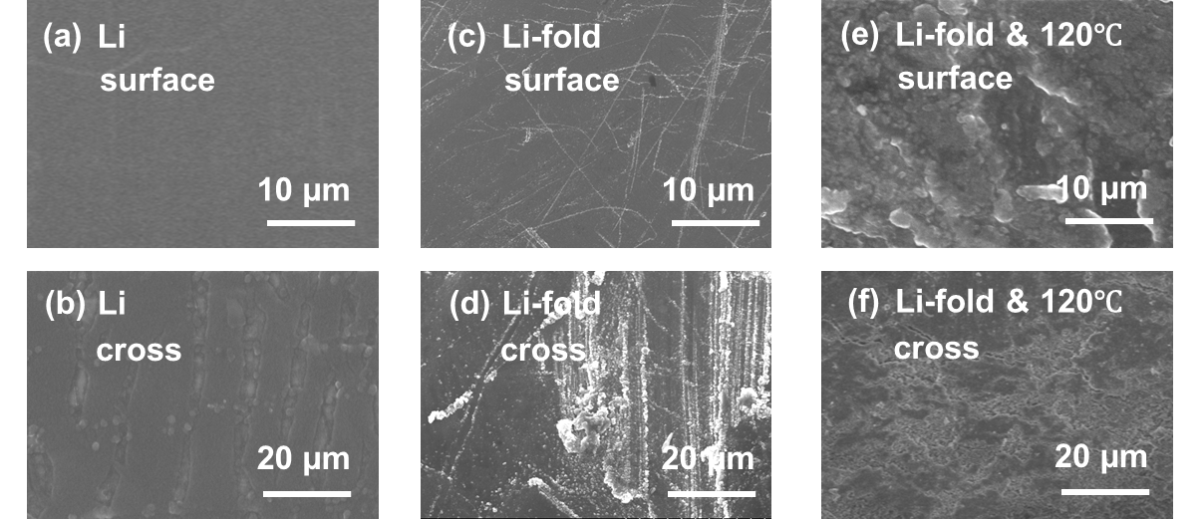
Supplementary Fig. 6. SEM images of (a, b) The raw Li. (c, d) Rolled & folded Li. (e, f) Rolled & folded 120℃ Li surface and cross section.

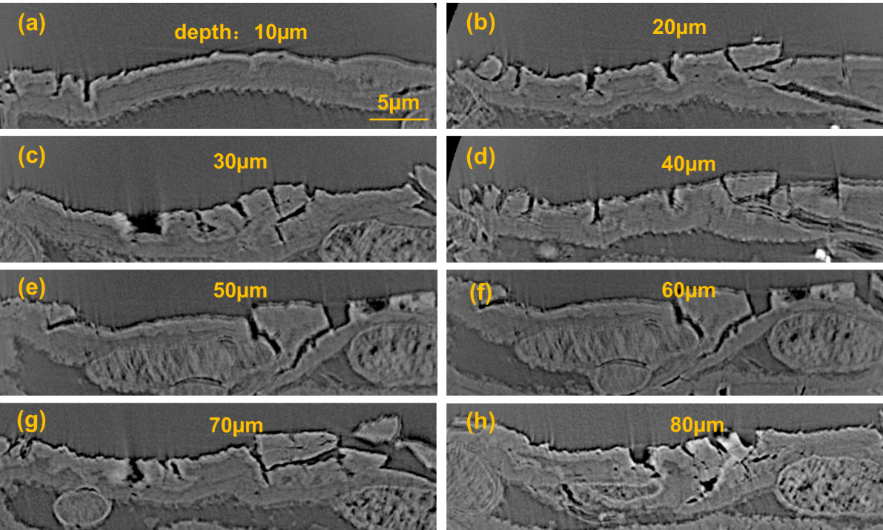
Supplementary Fig. 7. (a-h) Cross-sectional microstructure at different milling depths (10-80 μm).

Supplementary Discussion 1
Cross-sectional microstructure at different milling depths (10-80 μm).
Supplementary Fig. 7 presents a series of cross-sectional views at different milling depths (10-80 μm). Near the surface (10-20 μm), only sparse microcracks and localized defects are observed. With increasing depth (30-60 μm), the fissures become more frequent and progressively interconnected, forming a continuous void/channel network. Voids connected to these fissures remain visible at deeper regions (70-80 μm). This depth-dependent emergence and connectivity of voids suggest the presence of pressure-release pathways from the bulk to the surface, supporting the scenario that internally generated gas escaped through interconnected channels and left behind pore/void features in the bulk.

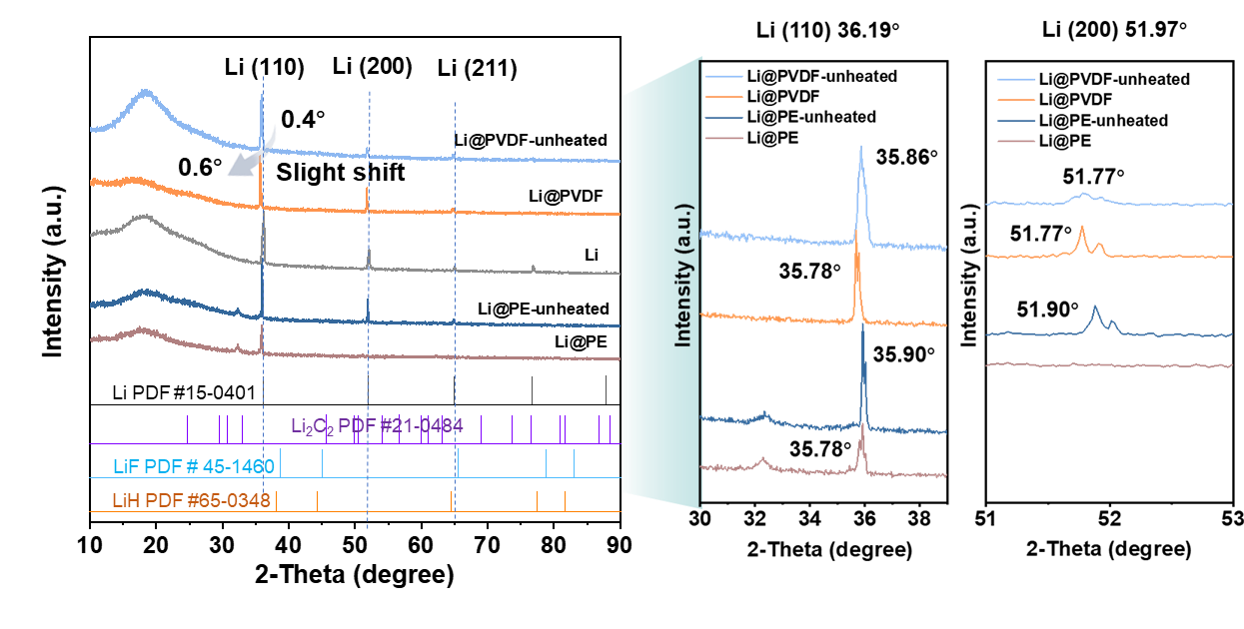
Supplementary Fig. 8. The full and magnified XRD profiles of the main Li (110) and (200) peaks.

Supplementary Discussion 2
The full and magnified XRD profiles
As shown in Supplementary Fig. 8, all samples are dominated by the metallic Li reflections (110), (200), and (211), and no pronounced new diffraction peaks attributable to Li-F, Li-H, or Li-C are detected, indicating that long-range crystallinity remains primarily metallic Li. Notably, Li@PVDF (especially after heating) exhibits a discernible, slight shift of the Li (110) and Li (200) peaks (~ 0.4-0.6°). The magnified views highlight systematic differences in peak positions (and line shapes) among different polymer systems and thermal histories, suggesting subtle lattice-spacing modulation and possible residual-stress/solid-solution-like distortion induced by the rolling-reaction-tempering process rather than the formation of dominant new phases.

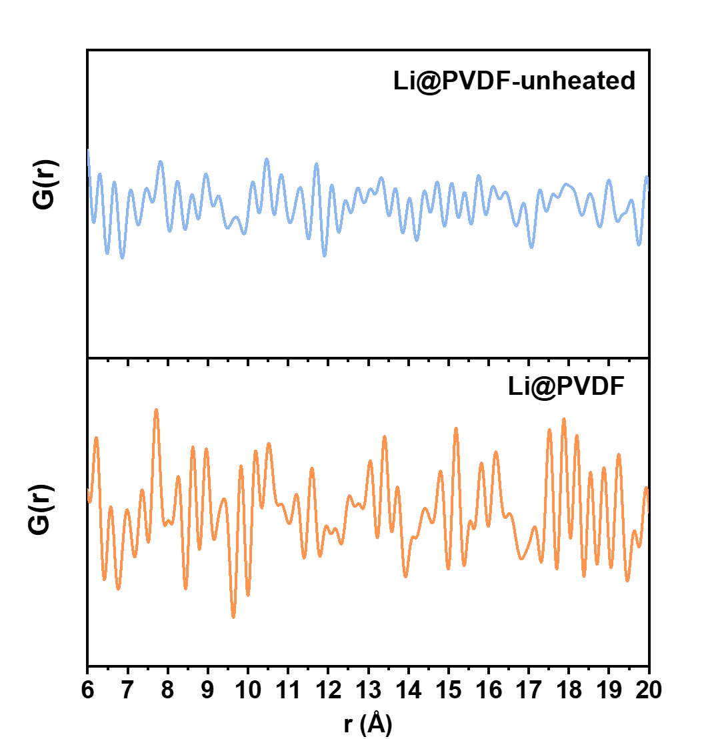
Supplementary Fig. 9. Total scattering PDF (6-20 Å) analysis of Li@PVDF before and after annealing.

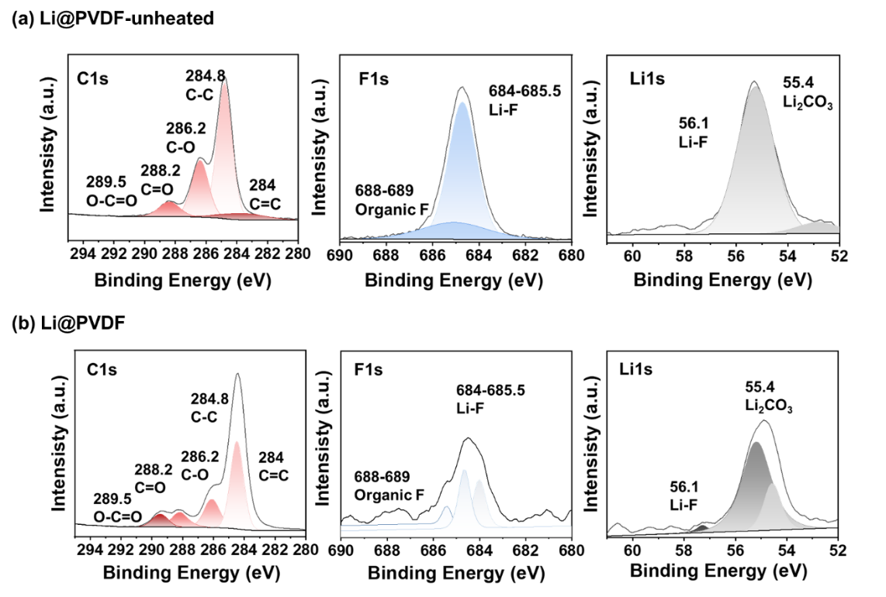
Supplementary Fig. 10. (a, b) High-resolution XPS spectra (C 1s, F 1s, and Li 1s) of Li@PVDF-unheated and annealed Li@PVDF.
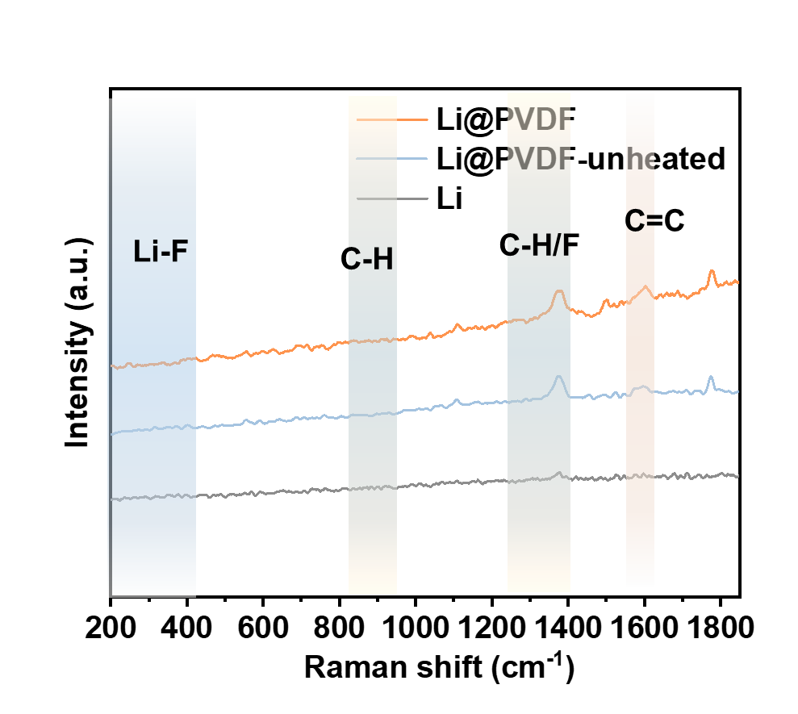
Supplementary Fig. 11. Raman spectra of Li@PVDF, Li@PVDF-unheated and raw Li.

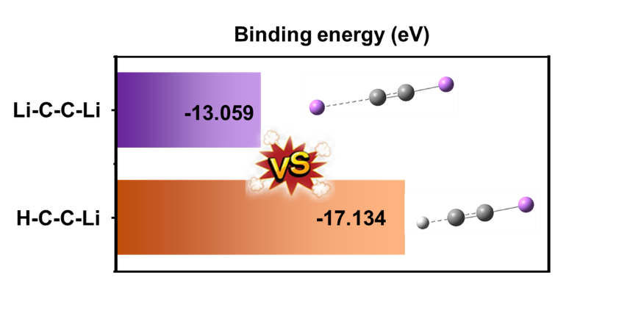
Supplementary Fig. 12. Competitive coordination in the Li-C-C-Li vs H-C-C-Li motifs revealed by calculated binding energies.

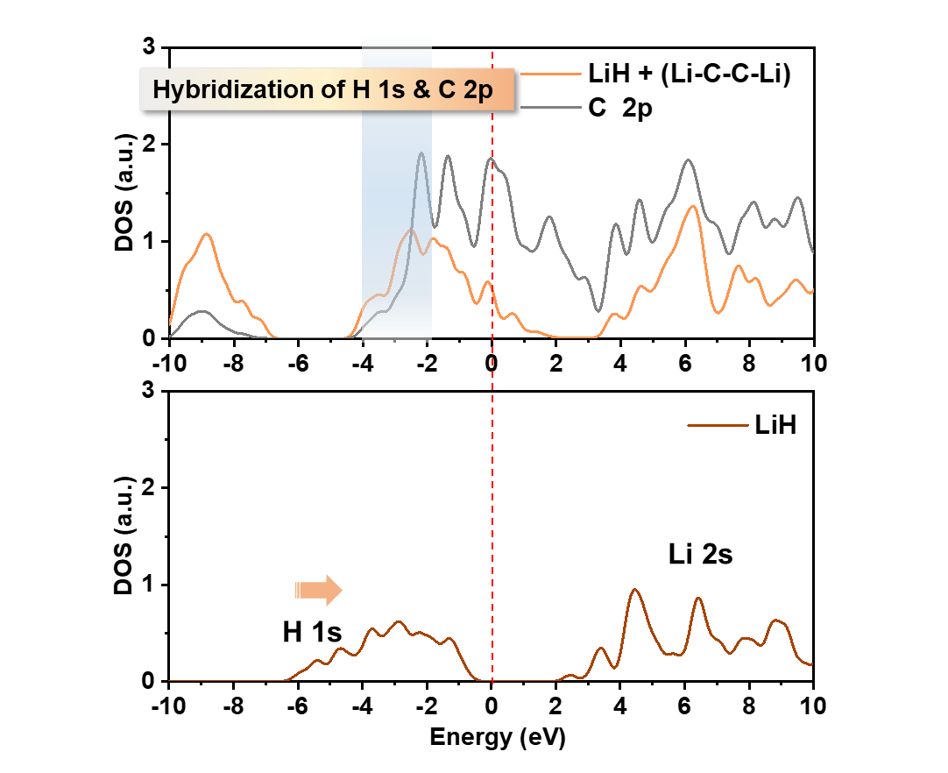
Supplementary Fig. 13. Comparison of the H 1s projected density of states (PDOS) between pure LiH and the Li-C containing system.

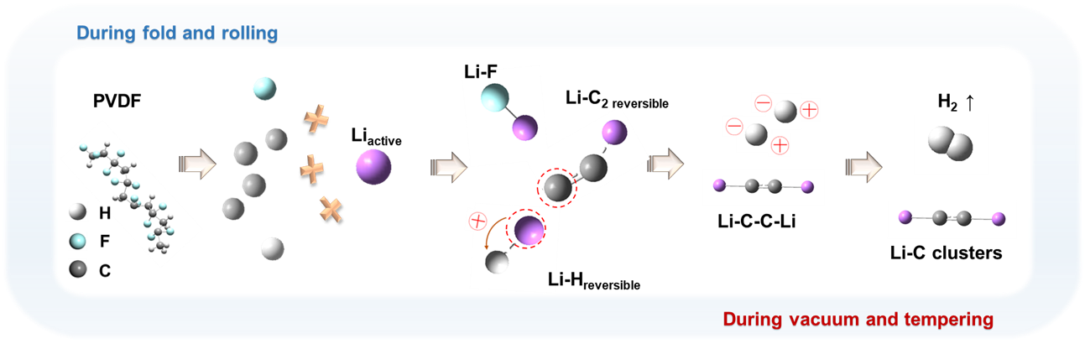
Supplementary Fig. 14. Gas evolution mechanism of PVDF lithiation and decomposition.

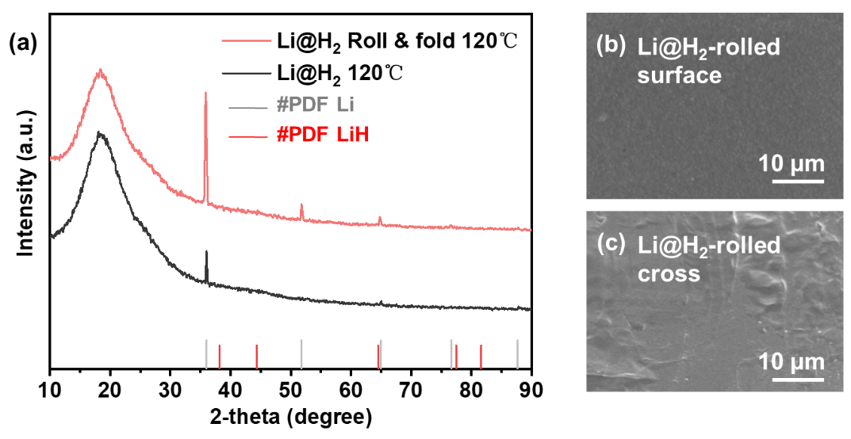
Supplementary Fig. 15. (a) XRD of Li@H₂ 120°C and Li@H₂ Roll & fold 120°C. (b, c) SEM image of Li@H₂ Roll & fold 120°C surface and cross.

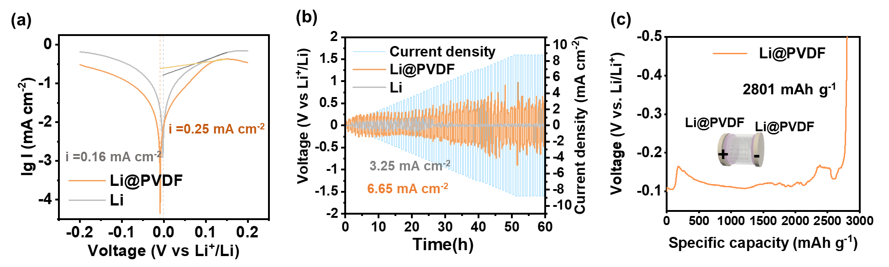
Supplementary Fig. 16. Kinetic and rate-capability characterization of Li@PVDF, including (a) exchange current density, (b) critical current density (CCD) and (c) accessible Li capacity, in comparison with raw Li.

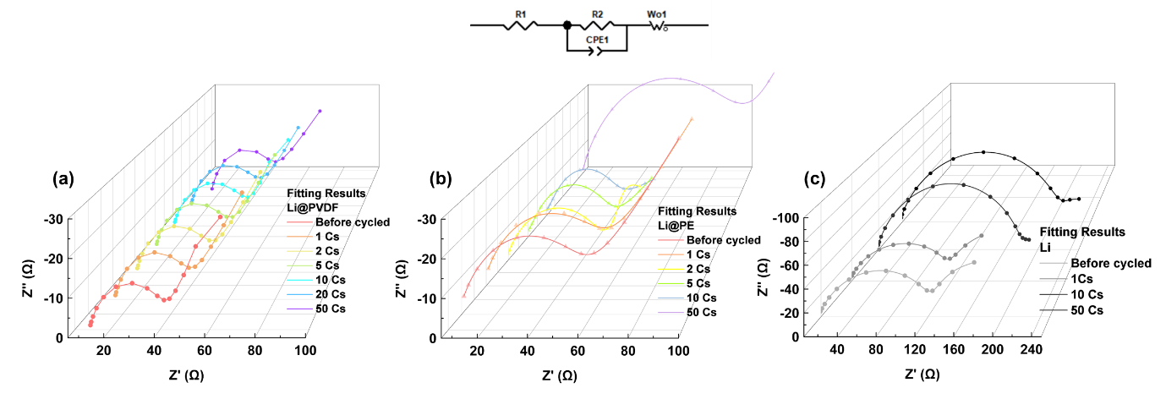
Supplementary Fig. 17. (a) In-EIS spectra and equivalent-circuit fitting of Li@PVDF, in comparison with (b) Li@PE and (c) raw Li before and after cycled.

Supplementary Discussion 3
Supplementary datas of In-EIS spectra
As shown in Figure Supplementary Fig. 17, the fitting impedance evolution of Li@PVDF symmetric cells (5 mA cm⁻²) was analyzed through in-situ EIS to evaluate the interfacial stability during cycling. Before cycling, Li@PVDF exhibited a smaller interfacial resistance of 11.9 (corresponding to the diameter of the high-frequency semicircle) compared with 20.2 for raw Li. The impedance evolution was further monitored at 1, 2, 5, 10, 20, and 50 cycles. The interfacial resistance of Li@PVDF increased only slightly from 11.9 to 13.4 , while that of raw Li rose to 37.6 . The initial impedance of Li@PE was ~20 Ω, which stabilized at ~10 Ω upon cycling. A sharp impedance increase was observed around the 50th cycle, attributable to structural degradation. The excellent interfacial stability can be attributed to the mechanically robust and chemically compatible Li@PVDF framework, which buffers the stress caused by repeated Li plating/stripping and suppresses the formation of resistive interphases.

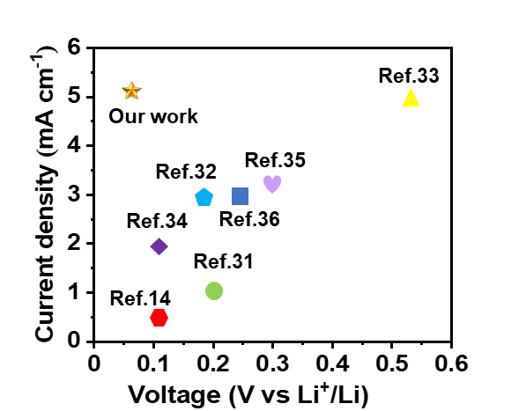
Supplementary Fig. 18. Comparison of symmetric-cell voltage-current density performance between this work and literature reports.

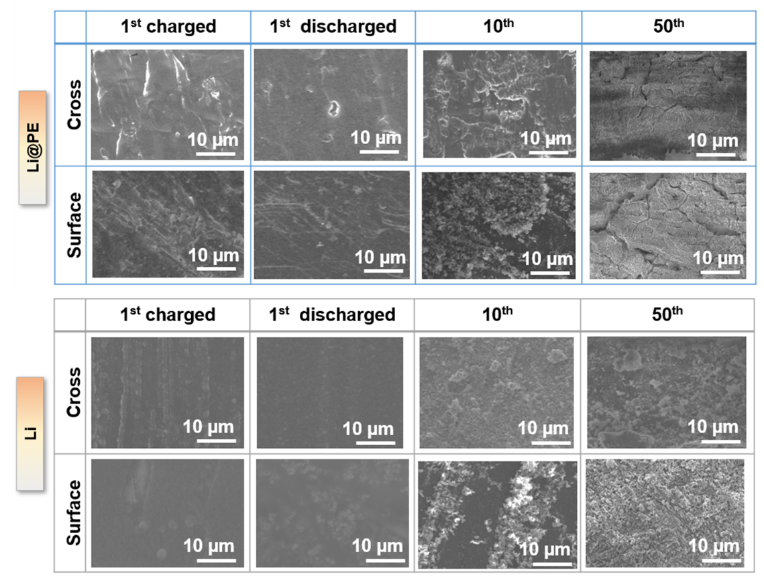
Supplementary Fig. 19. SEM images of Li@PE & raw Li after 1st charged & discharged, 10th charged and 50th charged surface and cross.

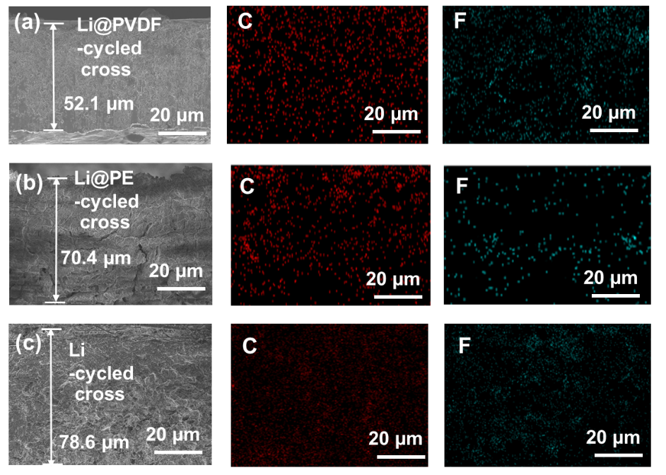
Supplementary Fig. 20. (a-c) Overall post-cycling cross-sectional SEM images and EDS C/F mapping of Li@PVDF, Li@PE, and raw Li, highlighting thickness expansion and structural integrity.

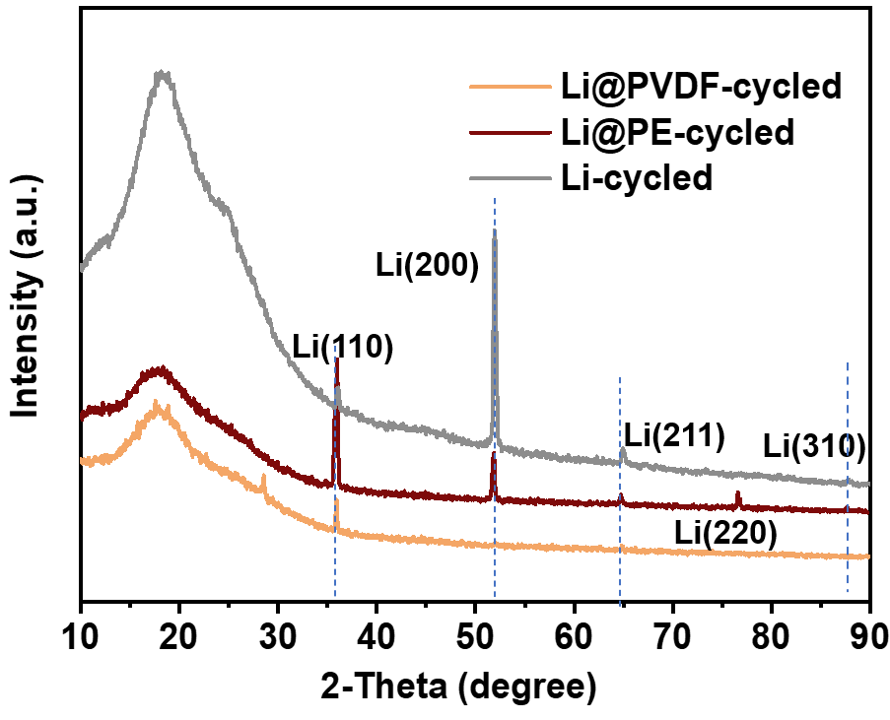
Supplementary Fig. 21. Post-cycling XRD patterns of Li@PVDF, Li@PE and raw Li.

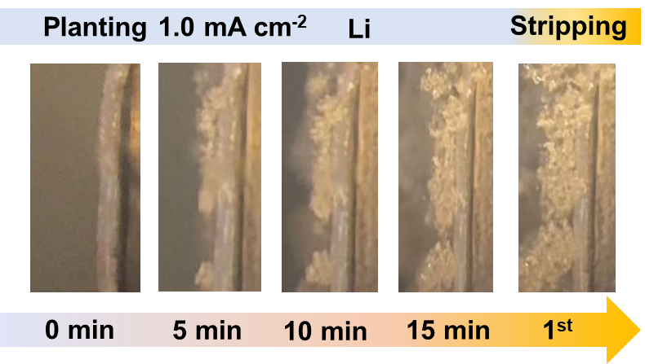
Supplementary Fig. 22. The in-suit optical microscopy of raw Li at 1 mA cm⁻² in two cycle periods.

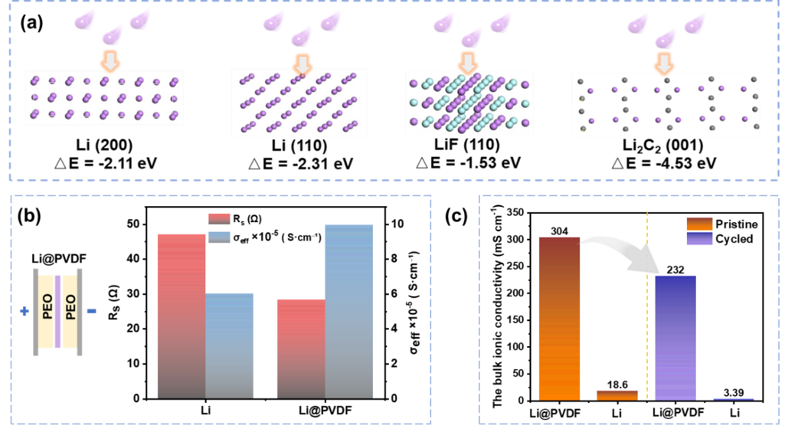
Supplementary Fig. 23. (a) The adsorption energies of lithium on Li (200), Li (110), LiF (110), and Li₂C₂ (001). (b) Comparison of $R_{s}$and $σ_{eff}$between raw Li and Li@PVDF in the PEO|Li|PEO reference cell. (c) Comparison of the Warburg bulk ionic conductivity of Li@PVDF and raw Li before and after 50th cycled.

Supplementary Discussion 4
Impedance and ionic conductivity of Li@PVDF
Consistent with this trend, impedance measurements in a PEO|Li|PEO reference configuration show that Li@PVDF exhibits a reduced high-frequency intercept () and an increased effective ionic conduction capability() relative to raw Li (;). Further analysis of the diffusion-controlled Warburg response indicates substantially higher bulk ionic conductivity for Li@PVDF than for Li, while cycling leads to a measurable decline (Li@PVDF: from 304 to 232 ; Li: from 18.6 to 3.39 ). Therefore, bulk conduction is primarily governed by Li⁺ migration, with an ion-transport network sustaining ionic conduction and thereby enabling plating/stripping within the electrode interior.

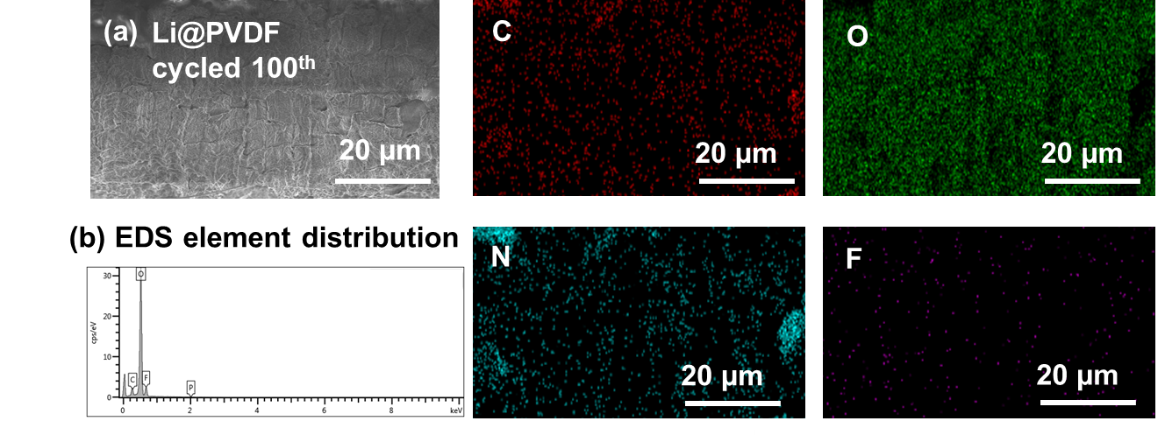
Supplementary Fig. 24. (a, b) SEM cross images and EDS elemental mapping of Li@PVDF (100 cycles).

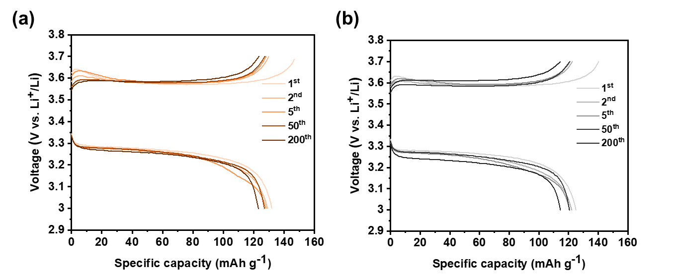
Supplementary Fig. 25. Representative charge-discharge voltage profiles corresponding to the cycling test in Fig. 3a (Li@PVDF (a) vs. raw Li (b)).

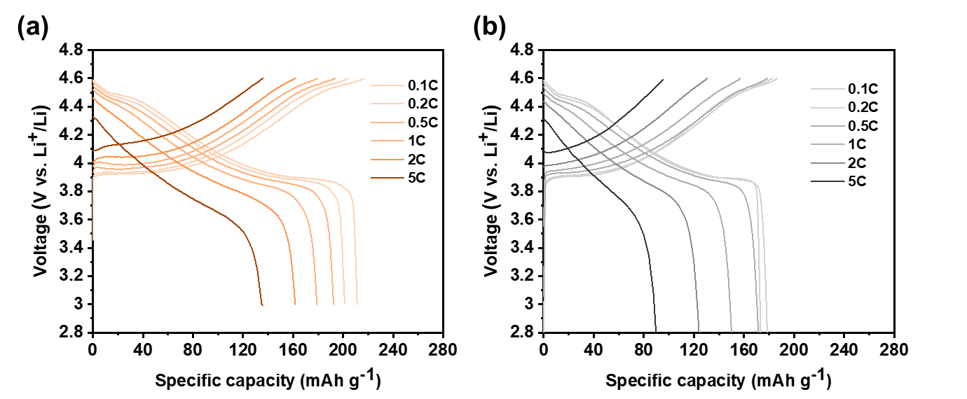
Supplementary Fig. 26. Representative charge-discharge voltage profiles corresponding to the rate cycling test in Fig. 3d (Li@PVDF (a) vs. raw Li (b)).

Supplementary Discussion 5
Li@PVDF cycling tests with cathodes
To evaluate the electrochemical performance of composite anodes paired with high-loading cathodes. As shown in Fig. 3a, the LiFePO₄ cell (mass loading ~ 7.2 mg cm⁻²) with Li@PVDF as anode delivers 131.9 mAh g⁻¹ in 50 cycles activation of at 1C and retains 120.3 mAh g⁻¹ in 300 cycles at 2C. And the raw Li cell shows faster capacity decay with less stable coulombic efficiency, indicating that Li@PVDF is better in supporting high-current long-term cycling. The charge-discharge profiles show that Li@PVDF cell maintains more stable plateaus with smaller voltage hysteresis across rates, consistent with the cycling performance (Supplementary Fig. 25). The cells were assembled using LiCoO₂ cathodes (mass loading ~ 9.6 mg cm⁻²) and tested under the cutoff voltage of 4.6 V at 1C. As shown in Fig. 3b, Li@PVDF cell delivers an initial discharge capacity of 211.8 mAh g⁻¹ and retained 183.0 mAh g⁻¹ in 100 cycles. In contrast, the raw Li cell exhibited a much faster capacity degradation, showing a rapid decline in only 40 cycles. At 4.6 V and 5C in Fig. 3c, the LiCoO₂ || Li@PVDF full cell delivers 170.8 mAh g⁻¹ and retains 138.2 mAh g⁻¹ in 300 cycles, indicating that Li@PVDF cell sustains a more stable interface with reduced polarization under high-rate operation, thereby enabling long-term cycling compared with raw Li.
The Li@PVDF cell delivers specific discharge capacities of 217.2 to 106.6 mAh g⁻¹ at 0.1 to 5C, respectively, and recovers to 201.6 mAh g⁻¹ when the rate returns to 0.5C (Fig. 3d). In comparison, the raw Li cell starts from 187.9 mAh g⁻¹ at 0.1C and suffers from a much sharper capacity decay at higher rates. The charge-discharge profiles show reduced voltage hysteresis and more stable plateaus of Li@PVDF cell, whereas raw Li cell exhibits more pronounced polarization, reflecting a more stable interface and reduced polarization under high-rate conditions (Supplementary Fig. 26). As shown in Fig. 3e, Li@PVDF cell was further evaluated in pouch cells with LiCoO₂ cathode. At 4.45 V and 0.5C, the LiCoO₂ cathode has an initial capacity of 100 mAh. In 100 cycles, Li@PVDF cell retained approximately 80% of its initial capacity, while the raw Li cell showed a significant capacity decay, retaining only ~50%.

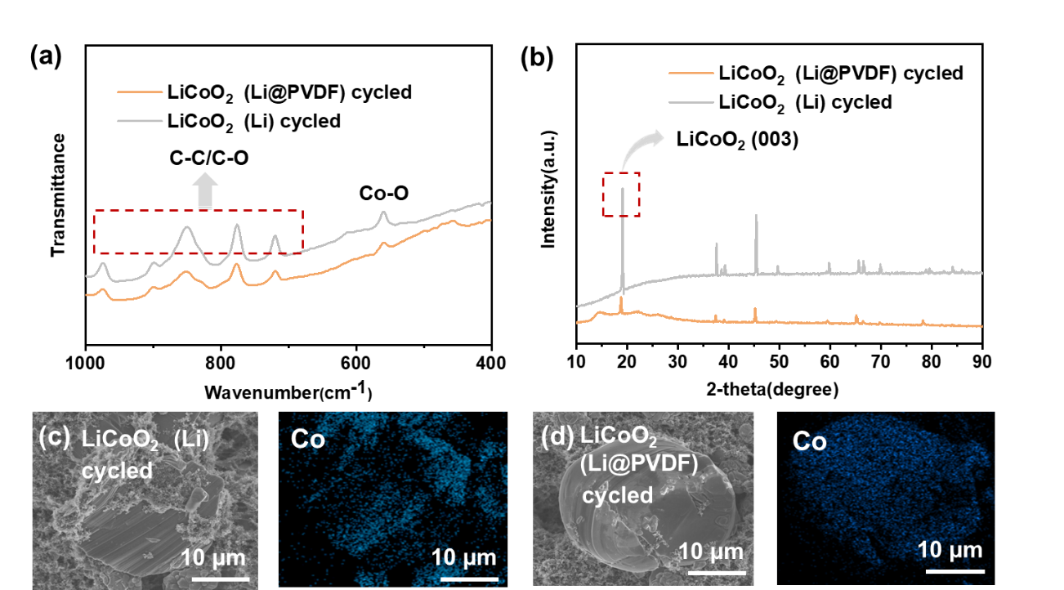
Supplementary Fig. 27. Characterization of cycled LiCoO₂ cathodes paired with raw Li and Li@PVDF, including (a) FTIR, (b)XRD patterns and (c)SEM/EDS Co mapping.

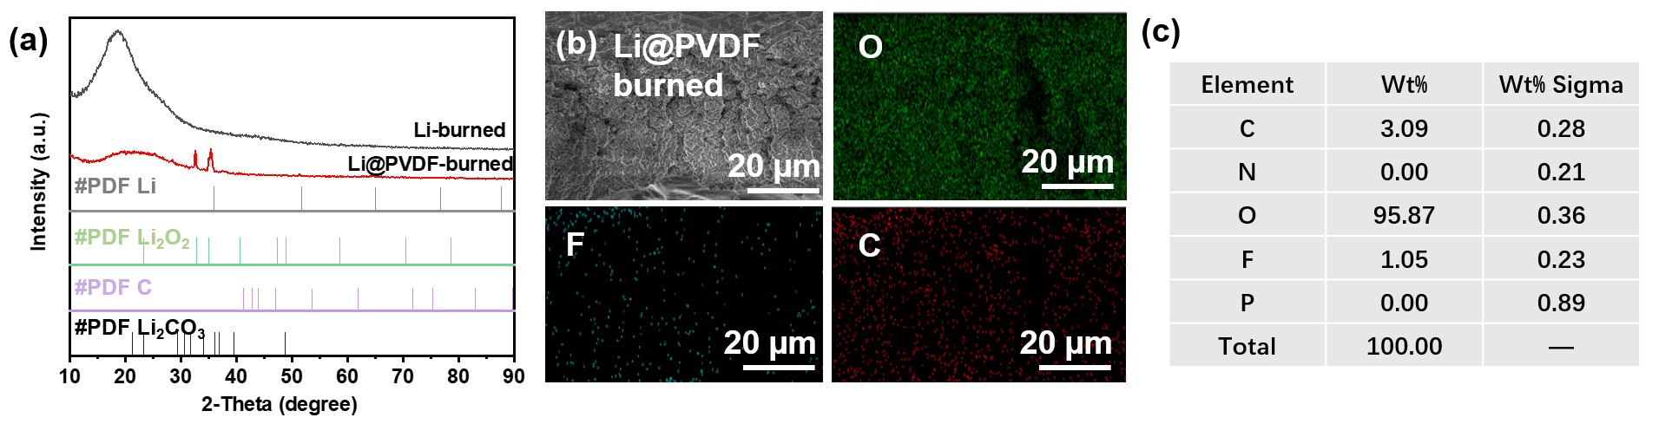
Supplementary Fig. 28. Post-combustions characterization (a) XRD pattern of Li@PVDF-burned and raw Li-burned, (b) SEM/EDS elemental mapping and corresponding quantitative (c) EDS summary of Li@PVDF-burned.

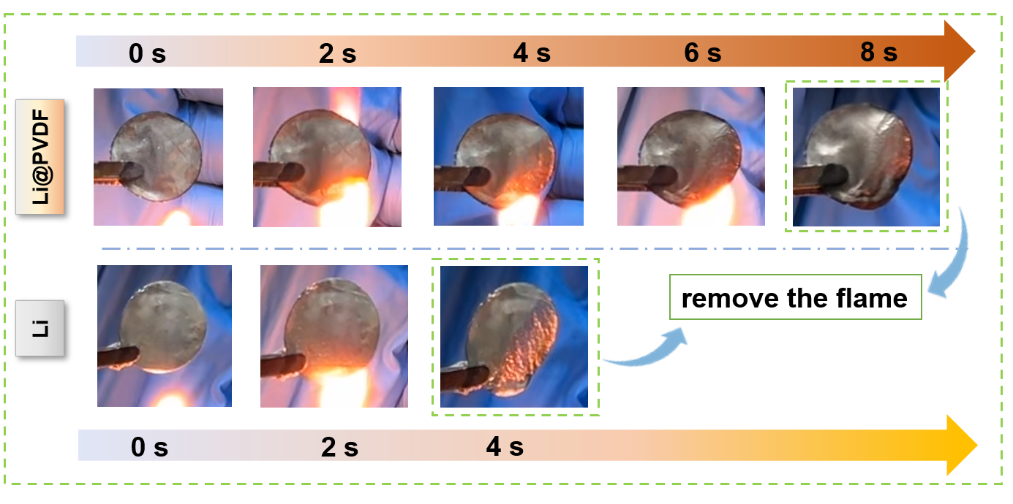
Supplementary Fig. 29. Supplementary combustion test with flame removal: morphology retention of Li@PVDF enabled by internal framework support compared with raw Li.

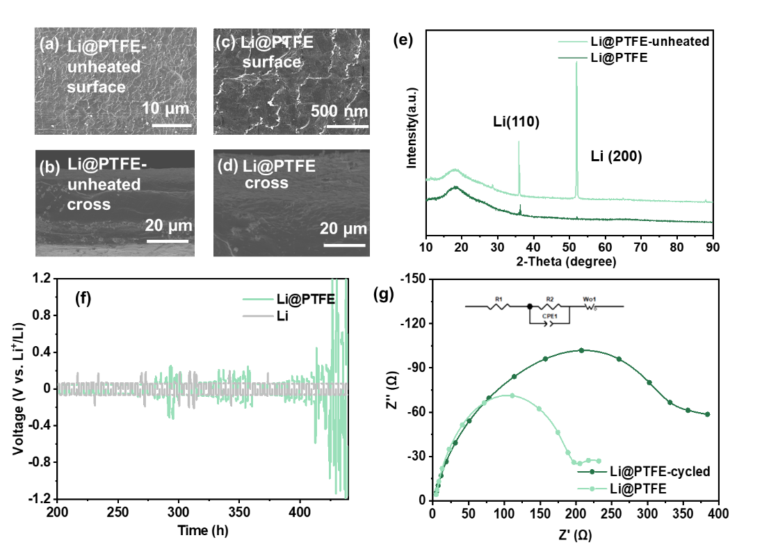
Supplementary Fig. 30. Li@PTFE (H-free) control anode: (a-d) morphology (surface/cross-section), (e) XRD patterns and (f) Symmetric-cell electrochemical performance at 1 mA cm⁻², including (g) EIS spectra with equivalent-circuit fitting.

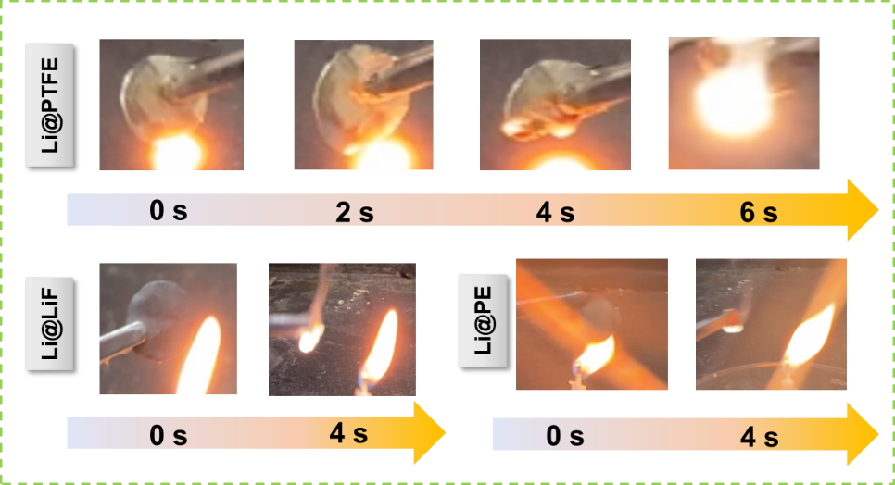
Supplementary Fig. 31. Supplementary combustion control experiments (Li@PTFE, Li@LiF, and Li@PE) highlighting the roles of pore-framework integrity and C/F effects in flame retardancy.
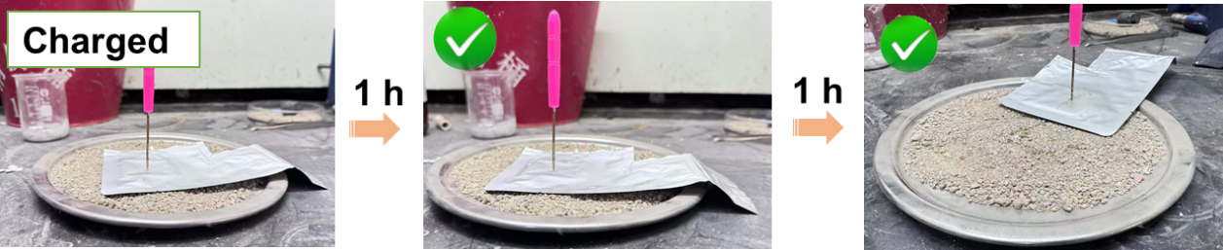
Supplementary Fig. 32. Nail-penetration safety test of the pouch cell charged to 4.45 V vs. Li⁺/Li.

- Supplementary Table 1
Supplementary Table 1. Comparisons of this work to the reported cells in literature.⁹⁻¹⁷

Published work | Anode | Cathode | Cathode mass loading | Voltage | Rate | Retain capacity | Reversible capacity | Electrolyte | DOI
Our work | Li@PVDF | LiCoO₂ | 9.6 mg cm⁻² | 4.6 V | 1C | 100th 86.4% | 211.8 mAh g⁻¹ | EC/DMC | Our work
 |  | LiFeO₄ | 7.2 mg cm⁻² | 3.7 V | 2C | 300th 91.7% | 131.9 mAh g⁻¹ | EC/DMC | Our work
Liang et al. Adv. Funct. Mater. 2023, 33, 2303077 | LMA | NCM622 | 3 mAh cm⁻² | — | 0.5C | 130th 92.0% | - | carbonate electrolyte | 10.1002/adfm.202303077
Li et al. Adv. Mater. 2023, 35, 2207310 | Li/Li₂₂Sn₅/LiF | LiCoO₂ | 21.17 mg cm⁻² | 4.5 V | 0.5C | 100th 91.1% | 187.1 mAh g⁻¹ | EC/DEC | 10.1002/adma.202207310
Xu et al. Adv. Mater. 2023, 35, 2302872 | ELMA@Li | LiCoO₂ | 25 mg cm⁻² | 4.3 V | 0.2C/0.5C | 180th >80% | — | — | 10.1002/adma.202302872
Zhu et al. Adv. Mater. 2024, 36, 2407128 | LiAl-p | NCM811 | 12.74 mg cm⁻² | 4.0 V | 1C | 1800th 83% | 199 mAh g⁻¹ | LPSC | 10.1002/adma.202407128
Liao et al. J. Power Sources 2025, 635, 236534 | Li@CNT | LiFeO₄ | 11.9 mg cm⁻² | — | 1C | 200th 94.7% | 142 mAh g⁻¹ | EC/EMC/FEC | 10.1016/j.jpowsour.2025.236534
Chen et al., Rare Met. 2025, 44(1):121–134 | LCA | LiFeO₄ | 17.2 mg·cm⁻² | 3.85 V | 0.5C | 110th 91.5% | 142.1 mAh·g⁻¹ | EC/DEC (1:1) + 5 wt% FEC | 10.1007/s12598-024-02922-3
Huang et al., Nano Lett. 2025, 25, 9337–9344 | Li@P3DDT | LiFeO₄ | — | — | 4C | 300th 85.0% | 119 mAh/cm² | LS009 electrolyte | 10.1021/acs.nanolett.5c01606
Wang et al., Energy Storage Mater. 2025, 78, 104259 | LSI-20 | NCM95 | ~18 mg·cm⁻² | — | 0.5C | 200th 89.2% | — | EC/DEC (1:1) + 10 wt% FEC + 1% VC | 10.1016/j.ensm.2025.104259
Qing et al., Sci. Bull. 2024, 69, 2842–2852 | LBN | LiFeO₄ | — | — | 2C | 400th 86.4% | — | — | 10.1016/j.scib.2024.07.021

- References and notes
1 Shirley, D. A. High-Resolution X-Ray Photoemission Spectrum of the Valence Bands of Gold. Physical Review B 5, 4709-4714 (1972). https://doi.org/10.1103/PhysRevB.5.4709
2 Lee, C., Yang, W. & Parr, R. G. Development of the Colle-Salvetti correlation-energy formula into a functional of the electron density. Physical Review B 37, 785-789 (1988). https://doi.org/10.1103/PhysRevB.37.785
3 Becke, A. D. Density-functional thermochemistry. III. The role of exact exchange. The Journal of Chemical Physics 98, 5648-5652 (1993). https://doi.org/10.1063/1.464913
4 Perdew, J. P., Burke, K. & Ernzerhof, M. Generalized Gradient Approximation Made Simple. Physical Review Letters 77, 3865-3868 (1996). https://doi.org/10.1103/PhysRevLett.77.3865
5 Segall, M. D. et al. First-principles simulation: ideas, illustrations and the CASTEP code. Journal of Physics: Condensed Matter 14, 2717 (2002). https://doi.org/10.1088/0953-8984/14/11/301
6 Billinge, S. J. L. & Kanatzidis, M. G. Beyond crystallography: the study of disorder, nanocrystallinity and crystallographically challenged materials with pair distribution functions. Chemical Communications 7, 749-760 (2004). https://doi.org/10.1039/B309577K
7 Macdonald, J. R. et al. Impedance Spectroscopy: Theory, Experiment, and Applications, Third Edition. (2018).
8 Mark E. Orazem, B. T. Experimental Methods. (2008). https://doi.org/https://doi.org/10.1002/9780470381588.ch7
9 Liang, H. et al. Manipulating Ion Transfer and Interface Stability by A Bulk Interphase Framework for Stable Lithium Metal Batteries. Advanced Functional Materials 33, 1616-3028 (2023). https://doi.org/10.1002/adfm.202303077
10 Li, G. et al. Locking Active Li Metal through Localized Redistribution of Fluoride Enabling Stable Li‐Metal Batteries. Advanced Materials 35, 1521-4095 (2022). https://doi.org/10.1002/adma.202207310
11 Xu, D. et al. Mechano‐Electrochemically Promoting Lithium Atom Diffusion and Relieving Accumulative Stress for Deep‐Cycling Lithium Metal Anodes. Advanced Materials 35, 0935-9648 (2023). https://doi.org/10.1002/adma.202302872
12 Zhu, J. et al. A Porous Li–Al Alloy Anode toward High‐Performance Sulfide‐Based All‐Solid‐State Lithium Batteries. Advanced Materials 36, 1521-4095 (2024). https://doi.org/10.1002/adma.202407128
13 Liao, J. et al. Dispersed-laminated structure enabled the practical ultrathin lithium anode. Journal of Power Sources 635 (2025). https://doi.org/10.1016/j.jpowsour.2025.236534
14 Chen, X. X. et al. Synergistic effect of infinite and finite solid solution enabling ultrathin Li–Cu–Ag alloy toward advanced Li metal anode. Rare Metals 44, 121-134 (2024). https://doi.org/10.1007/s12598-024-02922-3
15 Huang, S. et al. Stable Lithium Anodes Enabled by the Hardening and High Li(+) Flux Interlayer. Nano Lett 25, 9337-9344 (2025). https://doi.org/10.1021/acs.nanolett.5c01606
16 Wang, X. et al. Scalable production of ultrathin Li-Sn-In alloy foil with interpenetrated skeleton for high-energy-density lithium metal batteries. Energy Storage Materials 78, 24058297 (2025). https://doi.org/10.1016/j.ensm.2025.104259
17 Qing, P. et al. Interpenetrating LiB/Li(3)BN(2) phases enabling stable composite lithium metal anode. Sci Bull (Beijing) 69, 2842-2852 (2024). https://doi.org/10.1016/j.scib.2024.07.021

