Supplementary Information
Characterizing space-time patterns of nitrogen oxides (NO₂ and NO) pollution in Kigali, Rwanda

Pacifique Karekezi^{1,2}, Kate A Kyeremateng^{3,4}, Carissa L Lange³, Chantal Umutoni^{1,2}, Jean Remy Kubwimana^{1,2}, James Nimo^{5,6}, Jiayuan Wang³, Barbara E Mottey³, Paterne Gahungu^{2,7}, Silas S Mirau¹, Claudette Nyinawumuntu², Samson Niyizirugero², Pie-Celestin Hakizimana⁸, Isambi S Mbalawata², Majid Ezzati⁹⁻¹², Allison F Hughes⁵, Raphael E Arku^{3,*}

¹School of Computational and Communication Science and Engineering, The Nelson Mandela African Institution of Science and Technology, Arusha, Tanzania
²African Institute for Mathematical Sciences, Research and Innovation Centre, Kigali, Rwanda
³Department of Environmental Health Sciences, University of Massachusetts, Amherst, MA, USA
⁴Department of Biostatistics and Epidemiology, University of Massachusetts, Amherst, MA, USA
⁵Department of Physics, University of Ghana, Accra, Ghana
⁶Department of Environmental & Sustainable Engineering, State University of New York, Albany, USA
⁷Department of Mathematics, Faculty of Natural Sciences, Imperial College London, London, UK
⁸Rwanda Environment Management Authority, Kigali, Rwanda
⁹Department of Epidemiology and Biostatistics, School of Public Health, Imperial College London, London, UK
¹⁰Regional Institute for Population Studies, University of Ghana, Accra, Ghana
¹¹ MRC Centre for Environment and Health, School of Public Health, Imperial College London, London, UK
¹²Imperial Global Ghana, Accra, Ghana

* Correspondence to:
Raphael E Arku
School of Public Health and Health Sciences
University of Massachusetts Amherst, MA, USA
E-mail: rarku@umass.edu

Overview
The Kigali air quality monitoring campaign was conducted from November 2022 to December 2023 using Ogawa passive samplers to collect weekly NO_{X} measurements, following the measurement protocol previously applied in Accra, Ghana. The monitoring network comprised 10 fixed sites, operated continuously throughout the year to capture temporal variability, and 120 rotating sites, each sampled for one week to enhance spatial coverage. Descriptive analyses were performed to examine the space-time patterns of NO₂ and NO pollution in relation to land use and source features across the city of Kigali to inform future city planning and policy goals.
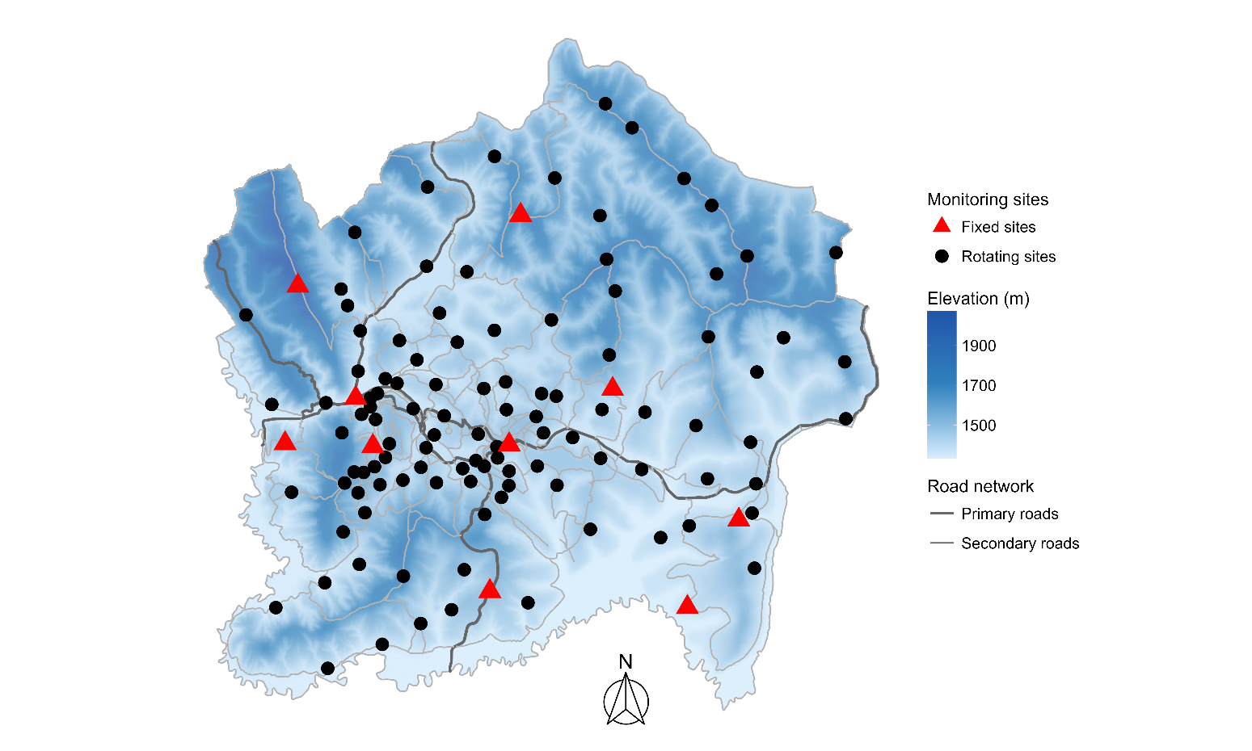

Figure S1. Spatial distribution of fixed (red) and rotating (black) air quality monitoring sites across Kigali, shown in relation to elevation, primary and secondary road network.

Descripive analysis
Spatial analysis
Pairwise comparisons among land-use categories revealed distinct patterns between fixed and rotating sites. At fixed sites, all pairwise comparisons were statistically significant for NO₂. In contrast, for NO, concentrations were statistically similar only between BKG and LDR. At rotating sites, significant differences in NO concentrations were observed only between BKG and CBI and between BKG and HDR. For NO₂ at rotating sites, significant differences were detected between BKG and CBI, BKG and HDR, and BKG and LDR (all p < 0.001), as well as between HDR and LDR (p = 0.006). No significant differences were found between CBI and HDR or between CBI and LDR (p = 0.340). Overall, fixed sites exhibited stronger and more consistent contrasts across land-use categories compared with rotating sites (Table S1)
Table S1. Pairwise comparisons of NO and NO₂ concentrations across land-use categories at fixed and rotating sites, p-values are shown.

Site Type | Pollutant | Comparison | n1 | n2 | p-value
Fixed | NO | BKG vs CBI | 133 | 140 | <0.001
 |  | BKG vs HDR | 133 | 44 | <0.001
 |  | CBI vs HDR | 140 | 44 | <0.001
 |  | BKG vs LDR | 133 | 147 | 0.241
 |  | CBI vs LDR | 140 | 147 | <0.001
 |  | HDR vs LDR | 44 | 147 | <0.001
Fixed | NO₂ | BKG vs CBI | 133 | 140 | <0.001
 |  | BKG vs HDR | 133 | 44 | <0.001
 |  | CBI vs HDR | 140 | 44 | <0.001
 |  | BKG vs LDR | 133 | 147 | <0.001
Site Type | Pollutant | Comparison | n1 | n2 | p-value
 |  | CBI vs LDR | 140 | 147 | <0.001
 |  | HDR vs LDR | 44 | 147 | <0.001
Rotating | NO | BKG vs CBI | 29 | 14 | <0.001
 |  | BKG vs HDR | 29 | 22 | <0.001
 |  | CBI vs HDR | 14 | 22 | 0.616
 |  | BKG vs LDR | 29 | 41 | 0.063
 |  | CBI vs LDR | 14 | 41 | 0.059
 |  | HDR vs LDR | 22 | 41 | 0.063
Rotating | NO₂ | BKG vs CBI | 29 | 14 | <0.001
 |  | BKG vs HDR | 29 | 22 | <0.001
 |  | CBI vs HDR | 14 | 22 | 0.340
 |  | BKG vs LDR | 29 | 41 | <0.001
 |  | CBI vs LDR | 14 | 41 | 0.340
 |  | HDR vs LDR | 22 | 41 | 0.006

n1 and n2 denote the number of observations included in each comparison.

The NO/NOₓ ratio remained relatively constant across land-use categories at rotating sites, but varied significantly at fixed sites. For fixed sites, the only non-significant pairwise difference was observed between HDR and BKG areas. In contrast, for rotating sites, no statistically significant differences were detected among land-use categories, despite differences in mean values (Table S2).

Table S2. Pairwise comparisons of the NO/NOₓ ratio between site types using one-way ANOVA with post-hoc tests.
Site type | Comparison | p-value
Fixed sites | Overall | <0.001
 | BKG vs CBI | <0.001
 | BKG vs HDR | 0.39
 | CBI vs HDR | <0.001
 | BKG vs LDR | 0.02
 | CBI vs LDR | <0.001
 | HDR vs LDR | 0.02
Rotating sites | Overall | 0.17
 | BKG vs CBI | 0.89
 | BKG vs HDR | 0.79
 | CBI vs HDR | 0.89
 | BKG vs LDR | 0.21
 | CBI vs LDR | 0.55
 | HDR vs LDR | 0.43

Generally, 48.5% of all fixed-site samples exceed the WHO annual guideline, while 53.8% of rotating-site samples are above this threshold. The highest percentages are observed in HDR and CBI areas, while the lowest are found in background areas (Table S3).

Table S3. Number and percentage of NO₂ samples exceeding the WHO guideline threshold across land-use categories for fixed and rotating monitoring sites.

Site Type | Category | Total Samples | Samples Exceeding WHO Threshold | % Exceeding WHO Threshold
Fixed | BKG | 133 | 6 | 4.5
 | LDR | 147 | 49 | 33.3
 | CBI | 140 | 126 | 90.0
 | HDR | 44 | 44 | 100.0
 | Overall | 464 | 225 | 48.5
Rotating | BKG | 29 | 0 | 0.0
 | CBI | 14 | 11 | 78.6
 | LDR | 41 | 25 | 61.0
 | HDR | 22 | 21 | 95.5
 | Overall | 106 | 57 | 53.8

Concentrations of both NO and NO₂ decreased with increasing distance from the primary road. Higher mean concentrations were observed at sites closer to the road, while lower concentrations were observed at more distant sites. For NO₂, differences were statistically significant across all distances (100 m to 1000 m; p < 0.05). In contrast, for NO, significant differences were observed only from 500 m onward, indicating that distinctions between near-road and more distant sites for NO concentrations become more pronounced at larger distances (Table S4).

Table S4. Table showing mean NO and NO₂ concentrations (µg/m³) at sites located 100–1000 m from the primary road, with standard deviations and pairwise comparison p-values.

Distance (m) | NO₂ (µg/m³) | NO (µg/m³) | N₁ | N₂ | p-value NO₂ | p-value NO
100 | 20.30 (9.48) | 7.79 (8.24) | 11 | 105 | 0.02 | 0.16
200 | 19.90 (8.52) | 7.53 (7.82) | 16 | 100 | <0.001 | 0.08
300 | 19.70 (7.88) | 7.01 (7.08) | 20 | 96 | <0.001 | 0.06
400 | 19.50 (8.01) | 6.24 (6.52) | 25 | 91 | <0.001 | 0.09
500 | 19.50 (7.58) | 6.48 (6.30) | 29 | 87 | <0.001 | 0.03
600 | 19.80 (7.65) | 6.34 (6.23) | 30 | 86 | <0.001 | 0.03
700 | 19.90 (7.43) | 6.56 (6.10) | 32 | 84 | <0.001 | 0.01
800 | 19.70 (7.42) | 6.46 (6.03) | 33 | 83 | <0.001 | 0.01
900 | 19.30 (7.28) | 6.58 (6.09) | 36 | 80 | <0.001 | 0.01
1000 | 19.30 (6.99) | 6.82 (6.02) | 39 | 77 | <0.001 | 0.00

N₁: number of measurements closer to the road
N₂: number of measurements farther from the road

.
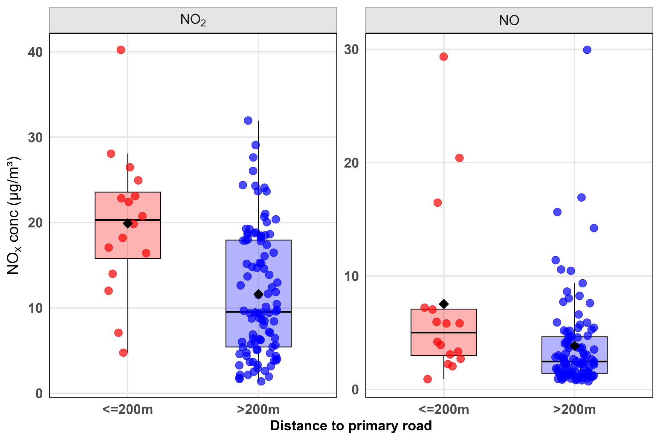

Figure S2. Scatter plots of NO₂ concentrations (μg/m³) by distance from primary roads (≤200 m and >200 m)

Temporal analysis

Overall seasonal difference were observed between the dry and rainy seasons. At the category level, significant differences in NO₂ were found in residential areas (HDR and LDR). Significant differences in NO were observed in BKG areas, CBI, and LDR (Table S5, Figure S2).

Table S5. Mean concentrations of NO₂ and NO (µg/m³) in dry and rainy seasons across different site categories. Includes standard deviations, sample size, mean differences (Dry − Rainy), and p-values for overall and category-specific comparisons.

Category | Dry Season (µg/m³) | Rainy Season (µg/m³) | n (Dry) | n (Rainy) | Difference (Dry − Rainy) | p-value
NO₂ (Overall) | 15.40 (13.10) | 12.90 (10.80) | 237 | 227 | 2.50 | 0.03
BKG | 4.31 (2.25) | 4.21 (2.40) | 67 | 66 | 0.10 | 0.80
CBI | 28.40 (14.30) | 24.90 (11.90) | 74 | 66 | 3.47 | 0.12
HDR | 23.30 (4.83) | 18.00 (2.77) | 22 | 22 | 5.37 | <0.001
LDR | 10.20 (2.80) | 8.45 (1.97) | 74 | 73 | 1.74 | <0.001
NO (Overall) | 5.18 (7.08) | 8.22 (11.20) | 237 | 227 | −3.04 | <0.001
BKG | 0.90 (0.58) | 1.81 (1.29) | 67 | 66 | −0.91 | <0.001
CBI | 12.20 (9.02) | 20.90 (13.90) | 74 | 66 | −8.76 | <0.001
HDR | 6.07 (2.14) | 7.15 (1.53) | 22 | 22 | −1.08 | 0.06
LDR | 1.79 (1.02) | 2.85 (1.73) | 74 | 73 | −1.06 | <0.001

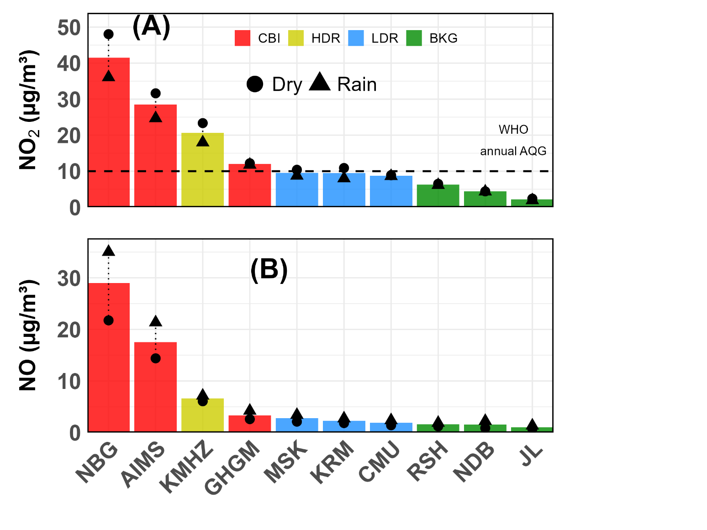

NBG: Nyabugogo
AIMS: African Institute for Mathematical Science (former location)
KMHZ: Kamuhoza
MSK: Masaka
KRM: Karama
CMU: Carnegy Melon University
RSH: Rusheshe
NDB: Nduba
JL: Jali

Figure S3. Annual, dry season, and rainy season mean NO₂ (A) and NO (B) at all fixed sites across the four land-use categories.

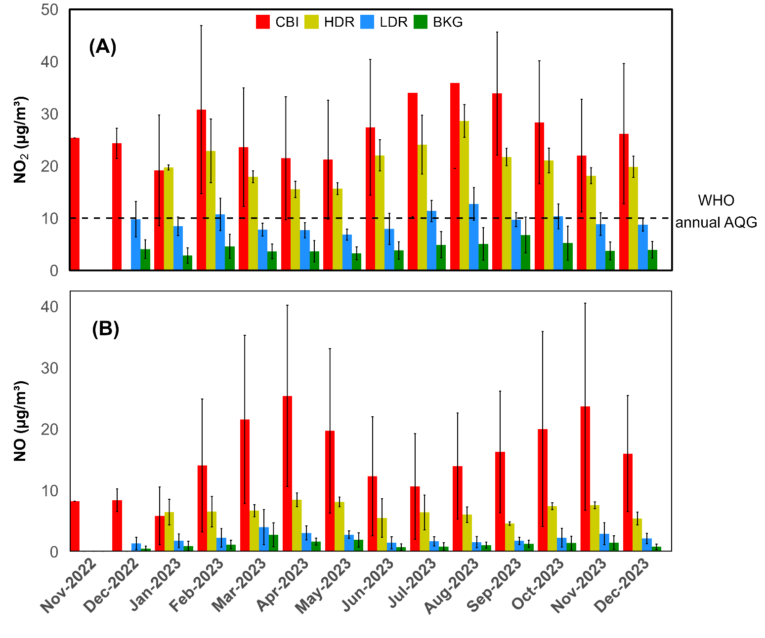
Figure S4. Monthly mean NO₂(A) and NO(B) concentrations at fixed sites across the four land-use categories and the WHO annual guideline for NO₂.

The NO/NOₓ ratio varied over time, with higher values during the rainy season and lower values during the dry season. The highest NO/NOₓ ratios were consistently observed in CBI areas, while the lowest values were found in LDR areas (Figure S4)

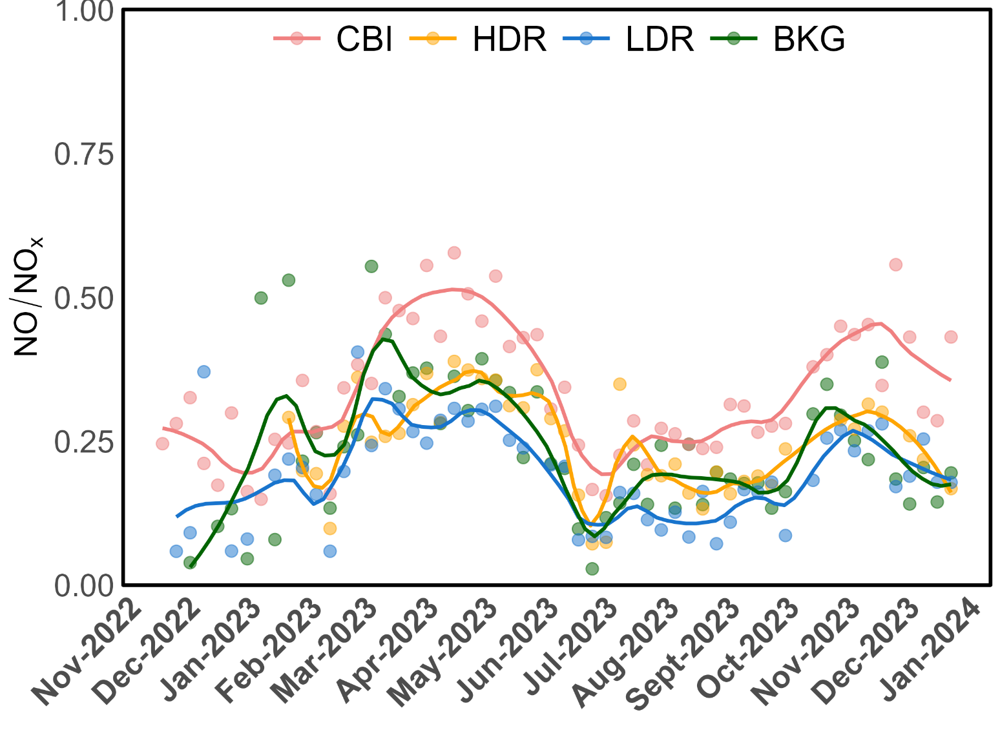
Figure S5. Temporal trends of the NO/NOₓ ratio across four land-use categories.

