Supporting Information

Design and Realization of High Performance Textured Lead-Free Piezoelectric Ceramics through Human-AI Collaboration

Aman Nanda^{1*}, Debjyoti Bhattacharya¹, Nayeon Kang³, Shankar Kunwar¹, Shashank Priya⁴, Jungho Ryu³, Wesley Reinhart^{1,2}, Michael Lanagan¹ and Bed Poudel^{1*}

¹ Department of Materials Engineering, The Pennsylvania State University, University Park, PA 16802

² Institute for Computational and Data Sciences, The Pennsylvania State University, University Park, PA 16802

³ School of Materials Science and Engineering, Yeungnam University, Gyeongsan 38541, Republic of Korea

⁴ Department of Chemical Engineering and Materials Science, University of Minnesota, Minneapolis, MN 55455, USA

The Supporting information includes;
S1. Prompts used for interacting with LLM
Table S1: Detailed description of strategies used for prompting the model
S2. Measurement Setup and Design of MME device
Figure S1. Schematics of measurement setup used for DME and energy harvesting measurements along with structure of device
S3. Dual Segregation and Manual Refinement
Table S2 Top ordered multiphase composition predicted with an absolute value of d₃₃ and its respective microstructure.
Table S3. List of compositions with low/moderate d₃₃
Figure S2. Comparison of C1 and C6 for εr – T , P-E and S-E loop
S4. Post -Hoc Analysis of Optimized Composition
Figure S3: Three-step assessment of the DeepSeek-V3.2 model’s prediction performance.
Figure S4: Comparison of predicted d₃₃ for C1 and C6 across multiple large language models (LLMs) in a few-shot learning scenario.
S5. Microstructure and Phase Analysis of Optimized Composition
Figure S5. Rietveld refinement analysis of random compositions
Figure S6. SEM micrograph captured through backscattered detector
Figure S7. Impedance sweep and its corresponding phase matching
S6. Literature on DME and Energy Harvesting
Table S3. Literature reports of Pb-free magnetoelectric composites and their α (DME)
Table S4. Comparison of ME energy harvesting capabilities of Pb-free systems

S1. Prompts used for interacting with LLM

S 1.1. user prompt used for composition generation

Given the following compositions and their d33 (piezoelectric constant) values:
{Examples of 10 compositions: d33 pairs}
'{strategy}' to generate new compositions with the goal of achieving exceptionally high d33 values.
Provide exactly {n} new compositions in the following JSON format:
{{
"compositions": [
{{
"d33": "<estimated d33 value as an integer>"
"composition": "<new composition formula>",
"reasoning": "<brief explanation for why this composition might lead to a higher d33 value>"
},
...
}

S1.2. system prompt comprising reasoning, rules related to composition generation, and output format requirements.
You are an expert in materials science and ceramic engineering that generates new compositions having tailored d33 values based on existing data.
When generating new compositions, strictly adhere to the following template:
$$(1-x-y-z-w)\{(K_{k}Na_{n})(Nb_{b}Sb_{s})O_{3}\}-x(Bi_{b1}Na_{a2})K_{k2}(Zr_{z}Ti_{t}Hf_{h})O_{3}-y(A_{a1}B_{b1})O_{3}-z(C_{a3}B_{b3})O_{3}-w(D_{d}E_{e})O_{3}-v(F_{metal})O_{x}$$
Where:
- x, y, z, w are coefficients (x + y + z + w ≤ 0.05)
- k, na, nb, sb are molar fractions in the main KNN phase (k + na = 1, nb + sb = 1)
- b1, na2, k2 are molar fractions in the secondary phase (b1 + na2 + k2 = 1)
- m is a coefficient for the secondary phase (often 0.5)
- zr, ti, hf are molar fractions of Zr/Ti/Hf in the secondary phase (zr + ti + hf = 1)
- A, B are elements in an additional perovskite phase (e.g., Ba, Ca, Sr)
- D, E are elements for dopants in perovskite form (e.g., Mn, Mg, Zn)
- F is a dopant in oxide form, limited to Fe₂O₃, MnO₂, or CuO
IMPORTANT:
- Ensure (1 − x − y − z − w) ≥ 0.95 to maintain densification.
- Most components should be in perovskite form (ABO₃), except for the specified oxides.
- Only Fe₂O₃, MnO₂, and CuO can be used in their oxide form as the F component.
- When using oxide dopants (F), use v as the coefficient (e.g., 0.01Fe₂O₃).
- Ensure perovskite structure (ABO₃) is preserved, and avoid any obvious typos such as a missing coefficient or incorrect summations (e.g., “−0.5” leading to ambiguity).
Provide your response in the exact JSON format specified in the user's prompt, including the composition, estimated d33 value, and reasoning for each suggestion.

Table S1: Detailed description of strategies used for prompting the model
Strategy | Description
S1 | introduce new elements that can potentially increase d₃₃
S2 | optimize the existing compositions for higher d₃₃ by modifying K/Na ratios
S3 | explore the addition of rare earth elements for enhanced d₃₃
S4 | modify the crystal structure subtly for better d₃₃
S5 | Addition and optimization of dopants in appropriate amounts to induce local structure heterogeneity for relaxor behavior
S6 | Experiment with new compositions that significantly diverge from existing ones for potentially higher d₃₃
S7 | Required phase fractions: (20 – 30)% R3m, (40 – 50) % Amm2 and (38 – 40)% P4mm

S2. Measurement Setup and Design of MME device

Figure S1. (a) Schematics of measurement setup used for DME and energy harvesting, (b) detailed schematics of ceramic embedded on Ni strip, position of proof mass and total dimension of Ni strip used, (c) real time photo of ME laminate prepared

S3. Dual Segregation and Manual Refinement

A broad distribution of favourable and unfavourable compositions is listed in table S2 and table S3, respectively.
Table S2 summarizes the confident multiphase composition and its estimation of properties. The compositions were analysed based on several key factors: proximity to the morphotropic phase boundary (MPB), optimized dopant concentrations, and the presence of additives known to enhance piezoelectric properties.¹ The K/Na ratio and Nb/Sb ratio were critically examined to ensure optimal phase coexistence. The role of Bi-based additives in creating beneficial heterogeneous structures was considered. The effects of minor additives and sintering aids, such as Fe₂O₃, MnZrO₃, and various AZrO₃ compounds, on domain wall mobility and phase transition behaviour were evaluated.

Table S2 Top ordered multiphase composition predicted with an absolute value of d₃₃ and its respective microstructure.

 | Composition | Predicted d₃₃ | Grain Size | Interpretation
C1 | 0.96(K_{0.5}Na_{0.5})(Nb_{0.94}Sb_{0.06})O₃ – 0.03(Bi_{0.5}Na_{0.4}K_{0.1})(Zr_{0.96}Ti_{0.04})O₃ – 0.01(Sr_{0.7}Ca_{0.3})ZrO₃ - 0.2Fe₂O₃ | 660 pC/N | 4-8 µm, | Balanced MPB, and unique (Sr_{0.7}Ca_{0.3})ZrO₃
C2 | 0.957(K_{0.47}Na_{0.53})(Nb_{0.94}Sb_{0.06})O₃ – 0.038(Bi_{0.6}Na_{0.3}K_{0.1})(Zr_{0.95}Ti_{0.05})O₃ – 0.005BaZrO₃ – 0.005MnZrO₃ – 0.2Fe₂O₃ | 665pC/N | 9-14 µm | Non-stoichiometry and electroneutrality of MnZrO₃
C3 | 0.96(K_{0.48}Na_{0.52})(Nb_{0.93}Sb_{0.07})O₃ – 0.04(Bi_{0.55}Na_{0.35}K_{0.1})(Zr_{0.95}Ti_{0.05})O₃ | 670pC/N | 8-12 µm | Bi > 0.5; χ_{A-O} bond will be affected
C4 | 0.956(K_{0.48}Na_{0.52})(Nb_{0.93}Sb_{0.07})O₃ – 0.039(Bi_{0.55}Na_{0.35}K_{0.1})(Zr_{0.96}Ti_{0.04})O₃ – 0.005BaZrO₃ – 0.005AgNbO₃ – 0.25Fe₂O₃ | 675pC/N | 10-15 µm | Non-stoichiometry AFE AgNbO₃
C5 | 0.955(K_{0.48}Na_{0.52})(Nb_{0.93}Sb_{0.07})O₃ – 0.04(Bi_{0.55}Na_{0.35}K_{0.1})(Zr_{0.96}Ti_{0.04})O₃ – 0.005SrZrO₃ – 0.005MnZrO₃ – 0.3Fe₂O₃ | 685pC/N | 8-12 µm | Same as C2

Compositions with balanced substitution strategies aimed at enhancing both the piezoelectric coefficient and temperature stability were ranked higher. The predicted d₃₃ values were estimated based on the composition's similarity to known high-performing KNN-based systems and the expected synergistic effects of the various components (phase and microstructure). Furthermore, the selection of the most suitable candidates from the list in Table S2 is based on a meticulous interpretation of each composition (human-in-the-loop). For the example composition 0.957(K_{0.47}Na_{0.53})(Nb_{0.94}Sb_{0.06})O₃–0.038(Bi_{0.6}Na_{0.3}K_{0.1})(Zr_{0.95}Ti_{0.05})O₃–0.005BaZrO₃-0.005MnZrO₃ – 0.2Fe₂O₃ ; the sum of coefficient of each additive, except Fe₂O₃ which is a sintering aid should make up to ‘1’. But the sum is (0.957+0.038+0.005+0.005 = 1.005). Few literatures report it as ABO_{(3+2n)} or changing the molar ratio of O^{2-,} which can result in a defective composition and make it difficult to synthesize with the appropriate stoichiometry. Since the prediction is more of a statistical analysis, and one of the prompts used was “introduce new elements that can potentially increase d₃₃, the combination of dopants in individual additives is random. Let’s assume in composition C2 and C5, MnZrO₃ cannot be experimentally synthesized because Mn⁴⁺, Zr⁴⁺ combine to form 8⁺ for cation, but however, 3 x O²⁻ (O₃) makes 6⁻ for anion, which is in the form of MnZrO_{(3+2n),} forming a defective oxide. Secondly, the effect of Bi³⁺ has been rigorously explored in the literature, and it affects the electronegativity of A-O bonds, resulting in the degradation of all electrical properties at increased concentrations.²
The difference in the predicted d₃₃ between the compositions in the respective group is not significant. Considering the above points, compositions C2, C4, and C5 can be disregarded due to non-stoichiometry. Furthermore, the selection between C1 and C3 can be made based on the part of the dopants. Comparing based on the content of Bi at ‘A’ site and other additives, C1 has a greater number of additives, specifically (Sr_{0.7}Ca_{0.3})ZrO₃, which can tune the phase content as well as piezoelectric properties more finely.³

Table S3. List of compositions with low/moderate d₃₃

 | Composition | Predicted d₃₃
C6 | 0.96(K_{0.5}Na_{0.5})(Nb_{0.92}Sb_{0.08})O₃ – 0.03(Bi_{0.55}Na_{0.45})ZrO₃ – 0.01CaZrO₃ | 450
C7 | 0.96(K_{0.48}Na_{0.52})(Nb_{0.92}Sb_{0.08})O₃–0.035(Bi_{0.55}Na_{0.45})Zr_{0.96}Ti_{0.04}O₃– 0.005LiNbO₃ | 470
C8 | 0.96(K_{0.47}Na_{0.53})(Nb_{0.92}Sb_{0.08})O₃–0.035(Bi_{0.6}Na_{0.3}K_{0.1})Zr_{0.96}Ti_{0.04}O₃– 0.005AgNbO₃ – 0.25Fe₂O₃ | 490
C9 | 0.96(K_{0.48}Na_{0.52})(Nb_{0.92}Sb_{0.08})O₃–0.035(Bi_{0.5}Na_{0.4}K_{0.1})(Zr_{0.97}Ti_{0.03})O₃–0.005AgNbO₃ | 510
C10 | 0.96(K_{0.48}Na_{0.52})(Nb_{0.93}Sb_{0.07})O₃–0.03(Bi_{0.5}Na_{0.4}K_{0.1})(Zr_{0.95}Ti_{0.05})O₃– 0.01(La_{0.5}Sm_{0.5})ZrO₃ | 530

Figure S2. Comparison of C1 and C6 for (a) ε_{r} v/s T measurement, (b) P-E loop measurement, and (c) Strain measurement

Compositions C1 and C6 in the above table were synthesized using a solid-state synthesis approach. The results are summarized in Figure S2. Figure S2(a) shows the temperature-dependent relative permittivity (ε_{r}) and dielectric loss (tan(δ)) measurement and its comparison between compositions C1 and C6. The C6 composition exhibits a diffuse phase transition as a function of temperature, indicating a disruption of long-range crystallinity in the composition.⁴ The difference in the magnitude of loss is marginal, and disruption in long-range order has an adverse effect on the electrical properties.⁵ Furthermore, the magnitude of polarization and strain was compared in Figures S2(b) and (c), which also show inferior ferroelectric and piezoelectric properties, respectively, under a high magnitude of electric field. The intercept of blue curve (C6) in figure S1(b) and (c) is always lower in magnitude compared to that of red curve (C1) defining the coercivity and remanent polarization which is an important parameter to be considered in piezoelectric application.

S4. Post-Hoc Analysis of Optimized Composition

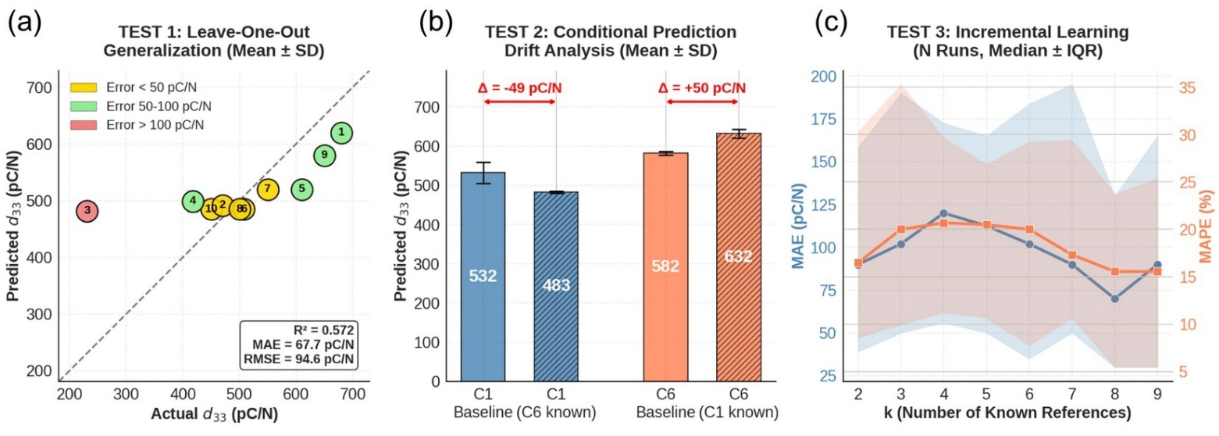

Figure S3: Three-step assessment of the DeepSeek-V3.2 model’s prediction performance. (a) Test 1: Leave-One-Out evaluation showing how predicted d₃₃ values compare to actual d₃₃ values for 10 reference compositions across different folds. (b) Test 2: Comparison of predictions for two unseen compositions (C1 and C6) before and after adding their actual performance data, showing how the model adjusts its estimates when new information is introduced. (c) Test 3: Analysis of prediction error as the number of reference examples increases, highlighting instability in few-shot learning. Here, MAE and MAPE refer to Mean Absolute Error (the average magnitude of prediction errors in pC/N) and Mean Absolute Percentage Error (the average error expressed as a percentage of the actual values), respectively.

To assess the reasoning and predictive capabilities of the DeepSeek-V3.2 model, a detailed three-stage evaluation was performed on the 10-reference composition, with each test repeated over N=5 runs to evaluate stochasticity. The model demonstrated significant, deterministic capabilities, but also revealed unreliable reasoning and performed poorly on a few outliers. The first experiment, Test 1, a Leave-One-Out (LOO) cross-validation, evaluated the model’s fundamental generalization ability.⁶ For this test, one composition was “held out” from the 10 reference composition examples, and the model was tasked with predicting its d₃₃ value using only the remaining 9 as context. This process was repeated for all 10 compositions. The entire 10-fold test was then repeated N times, and the mean predicted value for each of the 10 compositions is plotted against its actual value in the parity plot. The results show that the model predicts with a mean error below 50 pC/N for five compositions and 50-100 pC/N for four compositions but performs poorly (error >100 pC/N) for Ref 3. Quantitatively, the overall model performance, encompassing all 10 reference points, yielded a poor coefficient of determination (R² = 0.572) and a high Mean Absolute Error (MAE) of 67.7 pC/N. However, this poor performance is almost entirely attributable to the one outlier, Ref 3. Upon removing this single data point, the model's performance on the remaining nine compositions improved dramatically, with the R² increasing to 0.764 and the MAE dropping to 47.3 pC/N. This suggests the model is highly effective at interpolating within the primary high-performance class but fails at generalizing to certain structural outliers.
The second experiment (Test 2) assessed the model’s ability to adapt when presented with new information. First, the model generated baseline predictions for two unseen compositions, C1 and C6 (solid bars), using the original ten reference compositions as context. Next, we introduced ground-truth data. The model was informed that C1 is a high performer (d₃₃ = 660 pC/N) and then asked to re-predict C6. In the reverse case, the model was informed that C6 is a weak performer (450 pC/N) and asked to re-predict C1 (hatched bars). The error bars (Mean ± SD) were small, showing that predictions were stable and deterministic when the temperature parameter was set to zero. This is a positive trait because it means the model is reproducible and the results are consistent across subsequent queries. However, the model’s response to new information was superficial. When informed C1 was a high performer, it increased C6’s prediction by 50 pC/N (582 pC/N to 632 pC/N). When told C6 was a weak performer, it reduced C1’s prediction by about 49 pC/N (532 pC/N to 483 pC/N). This indicates that the model failed to identify the actual underlying reason for C6’s poor performance (i.e., a missing sintering aid that C1 had). Instead, it relied on a simple “anchor-and-adjust” approach, rather than true physical reasoning.
The third experiment (Test 3) evaluated the model’s in-context learning by analyzing prediction error as a function of the number of reference examples (k). For each k ranging from 2 to 9, 20 random permutations were generated, where k compositions served as a “study set” to predict one remaining composition. This k-sweep was repeated five times (N = 5) to ensure statistical robustness, and the results were summarized using median error curves with interquartile ranges (IQR). The results show that few-shot learning is highly unstable. Instead of a smooth improvement, the error increased from k = 2 to k = 4, peaking at ~120 pC/N, indicating overfitting to small, non-representative subsets (e.g., when initial examples are all high performers, the model infers an incorrect rule). Reliable predictions only emerged when k exceeded 7, suggesting that a sufficiently diverse context is essential for generalization. In short, while the model is deterministically configured (though technically subject to system-level variance) and responsive to new data, its reasoning remains weak, failing to capture underlying physical principles and exhibiting instability in low-data scenarios. ⁷
Nevertheless, as these models evolve, they show significant promise as a potential bridge between traditional, descriptor-driven machine learning and a more intuitive, natural-language-based approach to discovering physical insights.

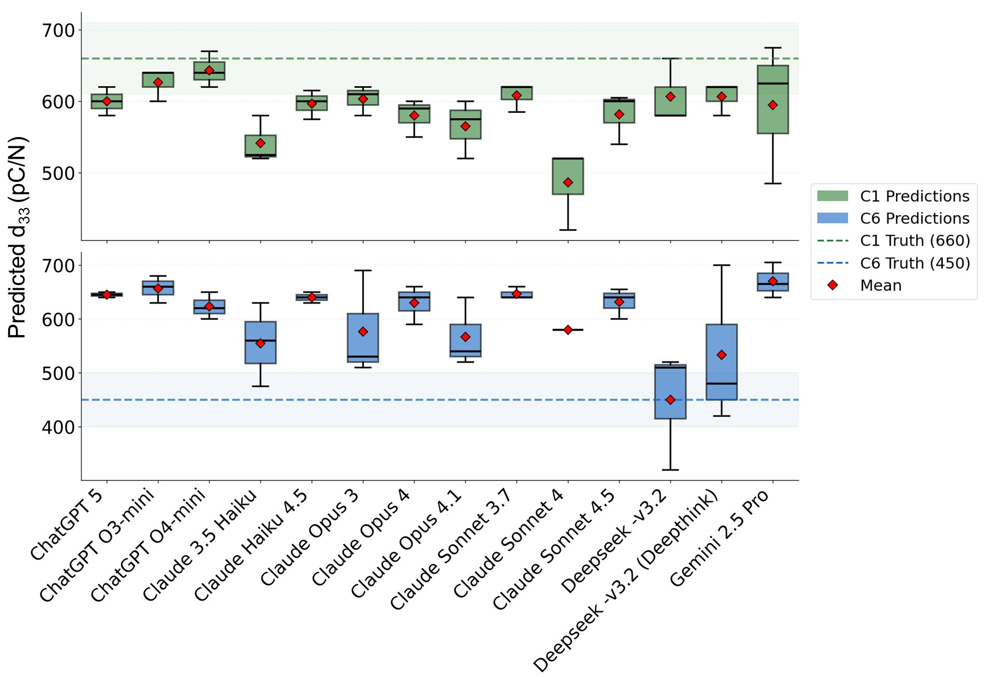
Figure S4: Comparison of predicted piezoelectric coefficients (d₃₃) for two unseen compositions (C1 and C6) across multiple large language models (LLMs) in a few-shot learning scenario. Each model was provided with 10 reference compositions and their d₃₃ values before predicting C1 (high performer) and C6 (low performer). Box plots show prediction distributions for C1 (green) and C6 (blue), with red diamonds indicating mean predictions. Dashed lines represent ground-truth d₃₃ values for C1 (660 pC/N) and C6 (450 pC/N).
The system failed to detect the physically meaningful differentiator, namely the absence of a sintering-aid descriptor in C6, which was explicitly encoded in C1. This confirms that the reasoning heuristic was dominated by an anchor-adjust bias rather than crystal-chemistry causal inference, underscoring a critical challenge in using generative LLMs for scientific concept attribution: token-space attention does not guarantee physical insight extraction. The third stage examined in-context learning stability via permutation-sampled compositional prompting. Here, 20 random prompt orderings were constructed for each context size k = 2 to 9, repeating the entire k-parametric sweep five times (N = 5) to assess reliability in low-data contexts. The median prediction error with IQR visualization reveals a non-monotonic learning trajectory; notably, the model’s error increased between k = 2 and 4 (peak MAE ≈120 pC/N), consistent with a tendency to construct rigid, over-collapsed compositional rules when first exposed to small, non-representative high-performer clusters.

S5. Microstructure and Phase Analysis of Optimized Composition

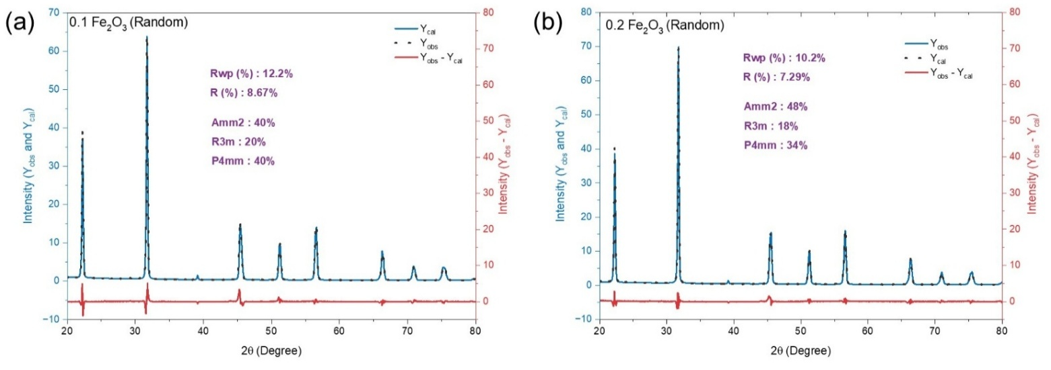
Figure S5. Rietveld refinement analysis of random compositions

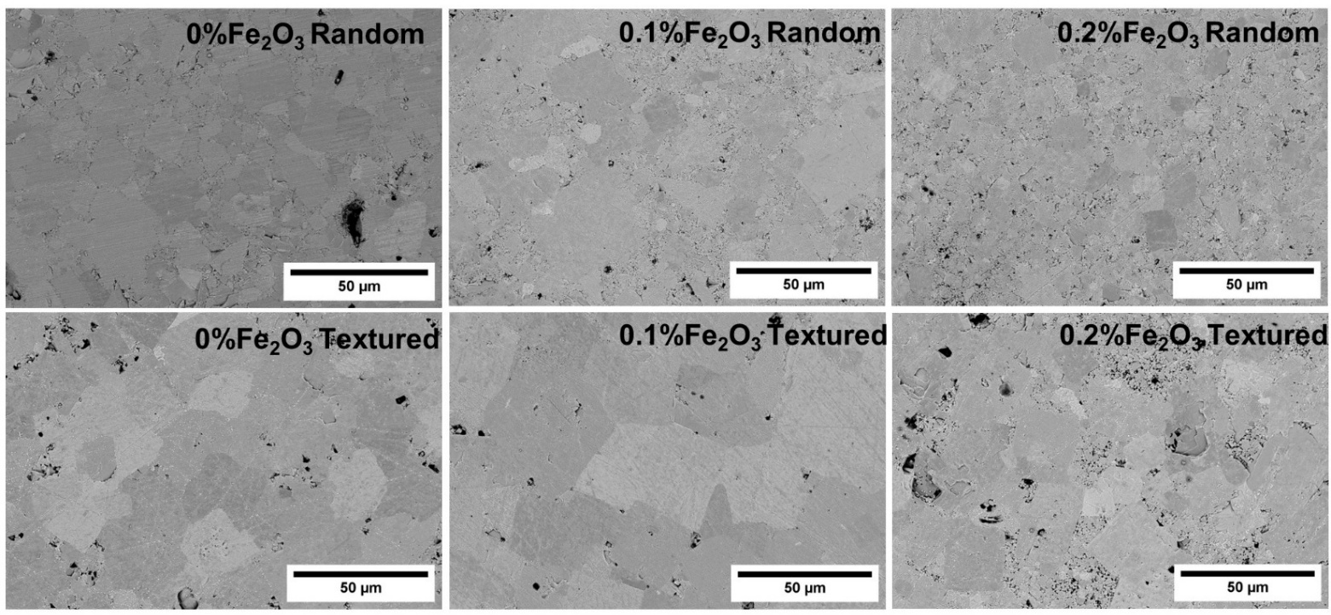
Figure S6. SEM micrograph captured through backscattered detector

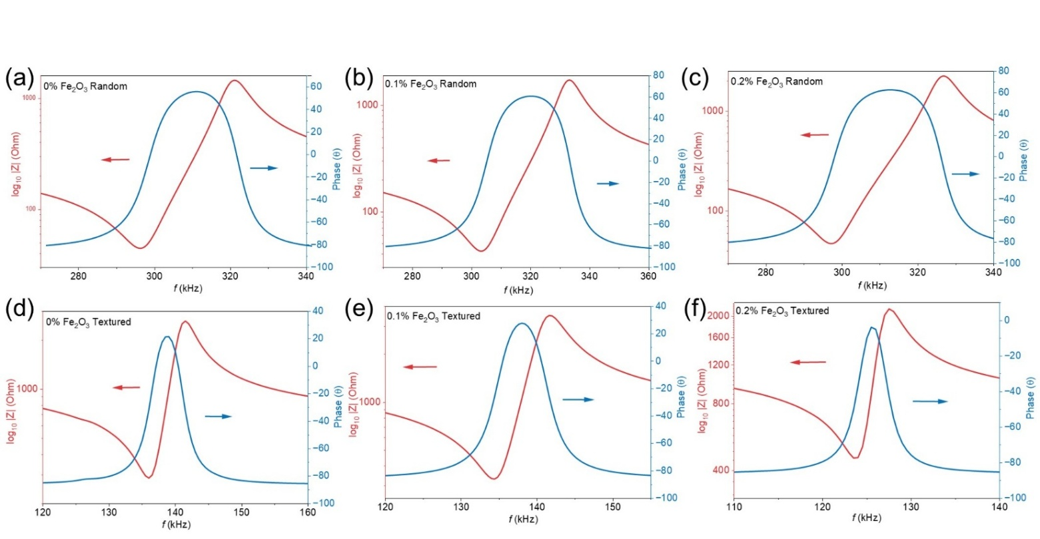
Figure S7. Impedance sweep and its corresponding phase matching

S6. Literature on DME and Energy Harvesting Measurements

Table S3. Literature reports of Pb-free magnetoelectric composites and their α (DME)

Material System | Composite Form | α (DME) (mV/cm.Oe) | Ref
Metglass / NBT-BT / Metglass | Laminated | 45.7 | ⁸
NFO / BTO / NFO | Laminated | 14.73 | ⁹
CFO - KNN-LS | Particulate Composite | 15.01 | ¹⁰
KNN-0.3BHF | Particulate Composite | 4.08 (DC) | ¹¹
Ni / Random / Ni | Laminated | 27 | This work
Ni / Textured / Ni | Laminated | 58 | This work

Table S4. Comparison of ME energy harvesting capabilities of Pb-free systems

Material System | Power Density(μW/cm³) (Ceramic/ Composite) | Power Density(μW/cm³.Oe²) (Ceramic/Composite) | Ref
BCT-BZT /Ni | 502/70.6 | 50.1/7.05 | ¹²
PVDF-BCT-BZT/Metglass | 1.06/0.74 | 0.21/0.14 | ¹³
BCZT–PVDF / Metglas | 4.7/4.38 | 0.47/0.438 | ¹⁴
Random / Ni | 1.031/1.031 | 0.103/0.103 | This Work
Textured / Ni | 705.6/705.4 | 70.55/70.33 | This Work

References
(1) Wu, J.; Xiao, D.; Zhu, J. Potassium-Sodium Niobate Lead-Free Piezoelectric Materials: Past, Present, and Future of Phase Boundaries. Chem. Rev. 2015, 115 (7), 2559–2595. https://doi.org/10.1021/CR5006809/ASSET/IMAGES/LARGE/CR-2014-006809_0023.JPEG.
(2) Lv, X.; Wu, J.; Zhang, X. X. Tuning the Covalency of A-O Bonds to Improve the Performance of KNN-Based Ceramics with Multiphase Coexistence. ACS Appl. Mater. Interfaces 2020, 12 (44), 49795–49804. https://doi.org/10.1021/ACSAMI.0C14910/ASSET/IMAGES/MEDIUM/AM0C14910_M002.GIF.
(3) Cheng, Y.; Xing, J.; Wu, C.; Wang, T.; Xie, L.; Liu, Y.; Xu, X.; Wang, K.; Xiao, D.; Zhu, J. Investigation of High Piezoelectric Properties of KNNSb-SrxBNZ Ceramics. J. Alloys Compd. 2020, 815, 152252. https://doi.org/10.1016/j.jallcom.2019.152252.
(4) Lv, X.; Zhang, N.; Wu, J.; Zhang, X. xiang. The Role of Adding Bi0.5A0.5ZrO3 in Affecting Orthorhombic-Tetragonal Phase Transition Temperature and Electrical Properties in Potassium Sodium Niobate Ceramics. Acta Mater. 2020, 197, 224–234. https://doi.org/10.1016/J.ACTAMAT.2020.07.053.
(5) Shvartsman, V. V.; Lupascu, D. C. Lead-Free Relaxor Ferroelectrics. J. Am. Ceram. Soc. 2012, 95 (1), 1–26. https://doi.org/10.1111/J.1551-2916.2011.04952.X.
(6) Wong, T. T. Performance Evaluation of Classification Algorithms by K-Fold and Leave-One-out Cross Validation. Pattern Recognit. 2015, 48 (9), 2839–2846. https://doi.org/10.1016/J.PATCOG.2015.03.009.
(7) Cui, A. Y.; Yu, P. Do Language Models Have Bayesian Brains? Distinguishing Stochastic and Deterministic Decision Patterns within Large Language Models. 2025.
(8) Borkar, H.; Gaikwad, V. M.; Dutta, S.; Tomar, M.; Gupta, V.; Kumar, A. Lead-Free Laminated Structures for Eco-Friendly Energy Harvesters and Magnetoelectric Sensors. J. Phys. Chem. Solids 2022, 160 (August 2021), 110306. https://doi.org/10.1016/j.jpcs.2021.110306.
(9) Patil, S. D.; Rajpure, K. Y.; Shaikh, A. M. Magnetoelectric Coupling in Metglas/BaTiO&lt;Sub&gt;3&lt;/Sub&gt;/Metglas Lead-Free Magnetoelectric Composites. J. Mater. Sci. Chem. Eng. 2016, 04 (08), 1–7. https://doi.org/10.4236/msce.2016.48001.
(10) Ye, Y. X.; Zhou, S. H.; Zhou, Y. Dielectric and Magnetoelectric Properties of Nano-Microscale Lead-Free Composite by 0.4Co-Ferrite and 0.6(K0.5Na0.5)NbO3-Based Ferroelectric Matrix. Appl. Mech. Mater. 2011, 80–81, 271–275. https://doi.org/10.4028/www.scientific.net/AMM.80-81.271.
(11) Kumar, Y.; Yadav, K. L.; Shah, J.; Kotnala, R. K. Investigation of Magnetoelectric Effect in Lead Free K0.5Na0.5NbO3-BaFe12O19 Novel Composite System. J. Adv. Ceram. 2019, 8 (3), 333–344. https://doi.org/10.1007/s40145-019-0315-7.
(12) Kaarthik, J.; Ram, N.; Aepuru, R.; Reddy, S. G.; Pabba, D. P.; Venkateswarlu, A. Robust Magnetic Energy Harvesting with Flexible Lead-Free Poly(Vinylidene Fluoride)-Ba0.85Ca0.15Ti0.9Zr0.1O3 Fibers and Metglas-Based Magnetoelectric Composites. Sustain. Energy Fuels 2024, 8 (12), 2583–2592. https://doi.org/10.1039/d3se01517c.
(13) Pabba, D. P.; Ram, N.; Kaarthik, J.; Bhaviripudi, V. R.; Yadav, S. K.; Soosairaj, A.; Pabba, N. K.; Annapureddy, V.; Thirumurugan, A.; Panda, H. S.; Aepuru, R. Assessing Mechanical and Stray Magnetic Field Energy Harvesting Capabilities in Lead-Free PVDF/BCT-BZT Composites Integrated with Metglas. Ceram. Int. 2024, 50 (18), 33009–33017. https://doi.org/10.1016/j.ceramint.2024.06.115.
(14) Park, S. H.; Kumar, A.; Kaarthik, J.; Annapureddy, V.; Ryu, J. A Magneto-Mechano-Electric Generator Based on Lead-Free Single-Crystal Fibers for Robust Scavenging of Ambient Magnetic Energy. Electron. Mater. Lett. 2020, 16 (4), 369–375. https://doi.org/10.1007/s13391-020-00215-2.

