Supplementary information
Table S1 Number of final replicates of each crop and domestication status due to removal for aphid and mite infestation during the growing season
Crop | Domestication status | Final replicates
Barley | CWR | 6
Barley | Dom | 7
Beet | CWR | 5
Beet | Dom | 6
Broad bean | CWR | 9
Broad bean | Dom | 4
Cucumber | CWR | 6
Cucumber | Dom | 4
Lentil | CWR | 2
Lentil | Dom | 5
Lettuce | CWR | 2
Lettuce | Dom | 3
Sunflower | CWR | 6
Sunflower | Dom | 4
Tomato | CWR | 5
Tomato | Dom | 5

Table S2 List of all included compounds from the original dataset obtained from the GC-MS analyses, classified by their chemical class.
Chemical family |  |  |  | Compounds
Aliphatic hydrocarbons
 | 2,2,4,6,6-pentamethyl-Heptane
 | 7-methyl-tetracyclo[4.1.0.0(2,4).0(3,5)]heptane
 | Dodecane
 | Hexadecane
 | Hexane
 | Pentane
 | Tridecane
Aromatic compounds
 | 2,6-bis(1,1-dimethylethyl)-4-(1-methylpropyl)-Phenol
 | 7-Amino-1,2,3,4-tetrahydro-1,1,4,4,6-pentamethyl-5-nitronaphthalene
 | m-Xylene
 | o-tert-butyl-Phenol
 | o-xylene
 | p-Benzoquinone
 | Phenol
 | TBHQ
 | Toluene
Fatty acid derivatives
 | 2-ethyl-1-Hexanol
 | [2-[(4-methylphenyl)sulfonyl]ethylidene]-dimethyl ester Propanedioic acid
 | 1-methyl-6-(1-oxoethyl)-3-oxo-4-prop-2-ylidenecyclononene
 | 3-(2,2-dimethylpropylidene)bicyclo[3.3.1]nonane-2,4-dione
 | Cyclohexanone
 | Isopropyl Myristate
 | N-Decanal
 | Nonanal
 | Salicylaldehyde
Halogenated compounds
 | 1,1,2-Trifluoro-2,5-bis(trifluoromethyl)hexane
 | 5,5'-Dicarboxy-3'-(2-chloroethyl)-4-(2-acetoxyethyl)-3,4'-dimethylpyrromethane
 | Bromoform
 | 1-Acetyl-6-(acetylamino)-5-methyl-1H-indazole
 | 2-methoxy[1]benzothieno[2,3-c]quinolin-6(5H)-one
 | 2-methyl-6-β-d-ribofuranosylimidazo[1,2-c]pyrimidin-5(6H)-one
 | 4-(benzoyloxy)-2H-pyran-3-one
 | 5,5'-Dicarboxy-3'-(2-chloroethyl)-4-(2-acetoxyethyl)-3,4'-dImethylpyrromethane
 | 5,7-dimethoxy-2,2-dimethyl-2H-chromene
 | 6-Acetyl-5,8-dimethoxy-2,2-dimethyl-2H-chromene
 | 7,8-Dimethoxy-1,2,4,5,10a,10b-hexahydrobenzo(de)-pyrrolo(3,2,1-ij)quinoline
 | Benzothiazole
 | N-methyl-N,N-di[2-(4-pyridyl)ethyl]-(2-pyridyl)ethylamine
Terpenoids
 | 15-methyltricyclo[6.5.2(13,14).0(7,15)]pentadecα-1,3,5,7,9,11,13-heptene
 | 1R-α-Pinene
 | Aristolen
 | CIS-α-Bisabolene
 | l-α-Pinene
 | Trans-α-Bisabolene
 | Unknown from lime oil
 | α-curcumene
 | β-Bisabolene
 | β-Cadinene
 | β-Gurjunene
 | β-Ionone epoxide
 | β-Maaliene
 | β-Sesquiphellandrene
 | δ-Cadinene
 | 2,2,4,6,6-pentamethyl-Heptane
 | 7-methyl-tetracyclo[4.1.0.0(2,4).0(3,5)]heptane

Table S3. Species predicted emission values per root gram and soil litre for crop wild relatives (CWR) and domesticates obtained from the GLM following a gamma distribution. As the interaction term was found non significant, it is just noted for the general domestication effect.
Crop | CWR |  | Domesticated
 | Predicted emission (μg g⁻¹ root L⁻¹ soil) | SE | Predicted emission  (μg g⁻¹ root L⁻¹ soil) | SE | P value
Barley | 0.0181 | 0.0083 | 0.0061 | 0.0035
Beet | 0.1432 | 0.0756 | 0.0481 | 0.0261
Broad bean | 0.1051 | 0.0505 | 0.0353 | 0.0184
Cucumber | 0.1578 | 0.0846 | 0.0530 | 0.0309
Lentil | 0.0870 | 0.0642 | 0.0292 | 0.0180
Lettuce | 0.1248 | 0.0956 | 0.0419 | 0.0316
Sunflower | 0.0866 | 0.0543 | 0.0291 | 0.0151
Tomato | 0.0264 | 0.0144 | 0.0089 | 0.0051
Average | 0.0756 | 0.0220 | 0.0254 | 0.0071 | 0.0093

Table S4. Species predicted uptake values per root gram and soil litre for crop wild relatives (CWR) and domesticates obtained from the GLM following a gamma Distribution.
CROP | CWR |  | Domesticated
 | Predicted uptake  (μg g⁻¹ root L⁻¹ soil) | SE |  | Predicted uptake  (μg g⁻¹ root L⁻¹ soil) | SE | P value
Barley | 0.0487 | 0.0249 |  | 0.0034 | 0.0016 | 0.0001
Beet | 0.0781 | 0.0439 |  | 0.0141 | 0.0072 | 0.0245
Broad bean | 0.0884 | 0.0370 |  | 0.0211 | 0.0132 | 0.0572
Cucumber | 0.1438 | 0.0737 |  | 0.0554 | 0.0348 | 0.2390
Lentil | 0.0129 | 0.0115 |  | 0.0495 | 0.0278 | 0.2011
Lettuce | 0.0749 | 0.0665 |  | 0.0582 | 0.0422 | 0.8261
Sunflower | 0.0530 | 0.0271 |  | 0.0205 | 0.0128 | 0.2407
Tomato | 0.0261 | 0.0147 |  | 0.0009 | 0.0005 | <0.0001
Average | 0.0533 | 0.0119 |  | 0.0153 | 0.0032 | <0.0001

Table S5. Species predicted Shannon diversity (H) of emitted VOCs for crop wild relatives (CWR) and domesticates obtained from the linear model. As the interaction term was found non-significant, it is just noted for the general domestication effect.
Crop | CWR |  | Domesticated
 | H | SE | H | SE | P value
Barley | 0.696 | 0.177 | 0.344 | 0.173
Beet | 1.298 | 0.190 | 0.946 | 0.186
Broad bean | 1.058 | 0.167 | 0.705 | 0.187
Cucumber | 1.082 | 0.192 | 0.729 | 0.201
Lentil | 0.669 | 0.240 | 0.316 | 0.224
Lettuce | 1.343 | 0.273 | 0.991 | 0.266
Sunflower | 1.322 | 0.192 | 0.969 | 0.201
Tomato | 2.220 | 0.196 | 1.868 | 0.196
Average | 1.211 | 0.096 | 0.858 | 0.096 | 0.0109
Table S6. Species predicted Shannon diversity (H) of absorbed VOCs for crop wild relatives (CWR) and domesticates obtained from the linear model.
Crop | CWR |  | Domesticated
 | H | SE | H | SE | P value
Barley | 1.992 | 0.177 | 0.902 | 0.164 | <0.0001
Beet | 1.512 | 0.194 | 2.033 | 0.177 | 0.0511
Broad bean | 0.839 | 0.144 | 0.634 | 0.217 | 0.4340
Cucumber | 1.802 | 0.177 | 1.982 | 0.217 | 0.5233
Lentil | 0.518 | 0.306 | 1.103 | 0.194 | 0.1116
Lettuce | 1.478 | 0.306 | 1.831 | 0.250 | 0.3755
Sunflower | 1.955 | 0.177 | 2.068 | 0.217 | 0.6868
Tomato | 1.778 | 0.194 | 1.656 | 0.194 | 0.6580
Average | 1.480 | 0.077 | 1.530 | 0.073 | 0.0109

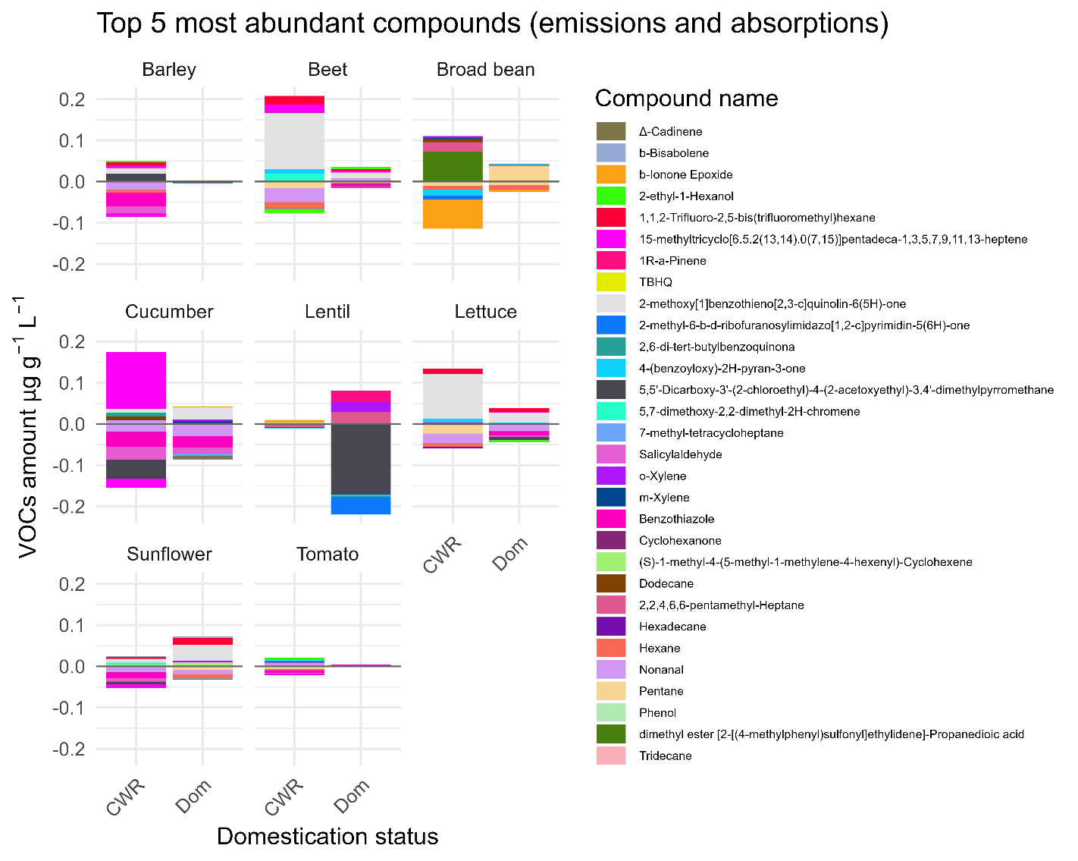
Figure S1. Mean of the five most abundant emitted and taken up compounds per root gram and soil litre for each species and domestication status. Each compound is represented by a coloured bar as listed in the legend on the right side.

Figure S2. Temperature effect on VOC emissions (a) and uptakes (b) for root gram and soil litre (natural log scale) in a humidity gradient. Each point represents a plant plot. Residuals did not match the requirement in both cases, thus this relation was not considered. Humidity was highly correlated to temperature (pearson’s correlation -0.94; p < 0.001).

Figure S3. Alpha diversity of VOCs in Shannon index in relation to microbial alpha diversity. Each point represents a plant pot. Correlation from the linear model is represented with a line and a shade for the 95% IC. Plots represent emitted VOC diversity contrasted with bacterial diversity (a) and fungal diversity (b), and taken up VOC diversity contrasted with bacterial (c) and fungal (d) diversity.
a)
b)
c)
d)

