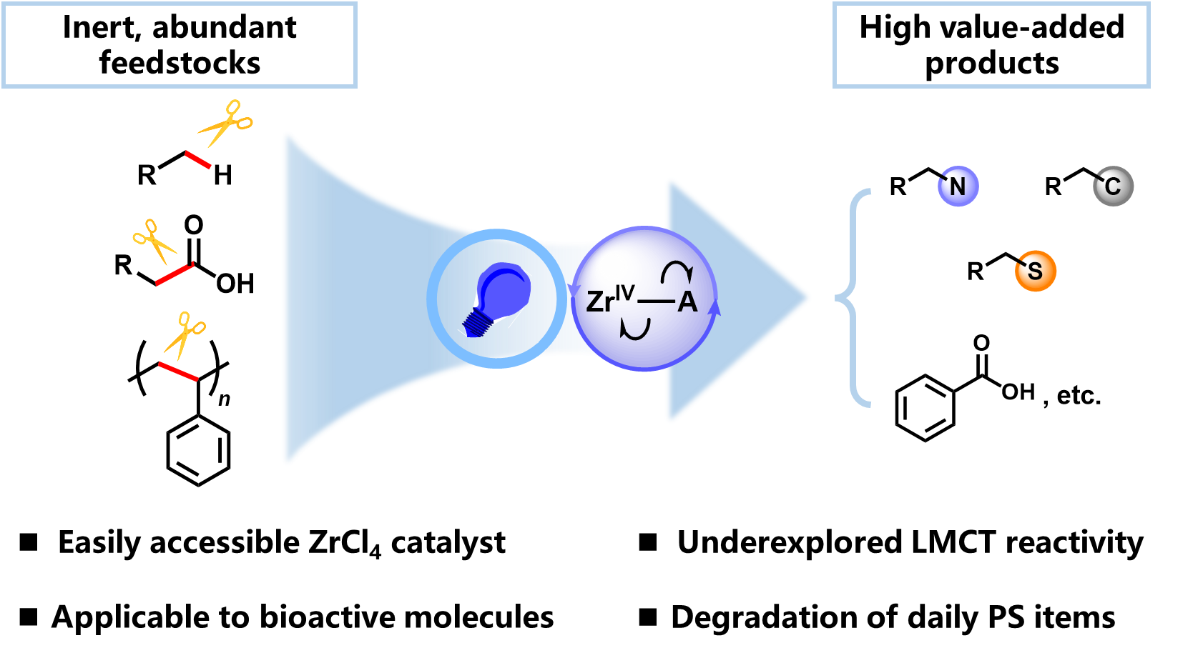

Leveraging zirconium for inert bond activation has long been a formidable challenge. Now it has been shown that under light irradiation, the easily accessible ZrCl₄ can furnish the direct functionalization of three types of abundant yet highly inert substrates via the underexplored LMCT reactivity.

