Supplementary Information for ‘Flat band carrier confinement in magic-angle twisted bilayer graphene’

  - Nikhil Tilak¹, Xinyuan Lai¹, Shuang Wu¹, Zenyuan Zhang¹,
  - Raquel de Almeida Ribeiro², Paul C Canfield^{2,3},
  - and Eva Y. Andrei^{1*}

1 Department of Physics and Astronomy, Rutgers, The State University of New Jersey, 136
Frelinghuysen Rd, Piscataway, NJ 08854
2 Ames Laboratory, U.S. Department of Energy, Ames, Iowa 50011, USA
3 Department of Physics and Astronomy, Iowa State University, Ames, Iowa 50011, USA.
E-mail: eandrei@physics.rutgers.edu
Device images 2
STM device 2
Planar Tunneling Device 2
Supplementary note 1: Individual dI/dV curves from Main Fig. 2 2
Supplementary note 2: High resolution STS mapping of QD states 3
Supplementary note 3: Set point dependence of the QD states 5
Supplementary note 4: Confinement in the hole-side band and Zero Bias Conductance 6
Supplementary note 5: Other origins of resonant states in STS 6
References 7

Device images

STM device

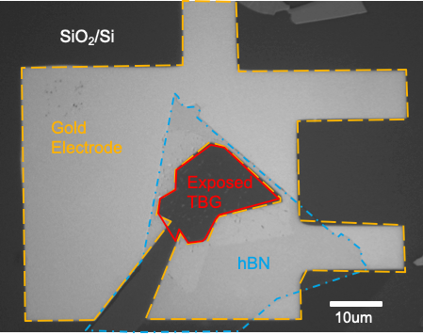
Supplementary Figure 1: Optical micrograph (grayscale) of the STM device. The Gold electrode (yellow dashed lines), TBG region (red solid line) and hBN (cyan dashed line) are marked.

Planar Tunneling Device

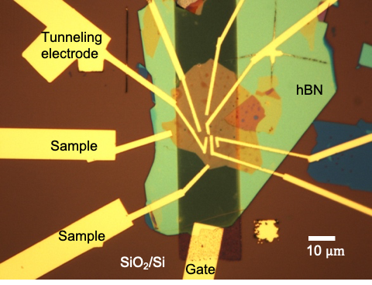
Supplementary Figure 2: Optical micrograph of the planar tunneling device.

Supplementary note 1: Individual dI/dV curves from Main Fig. 2

Supplementary Figure 3 shows the individual dI/dV spectra for the gate dependence map shown in main Fig 2.
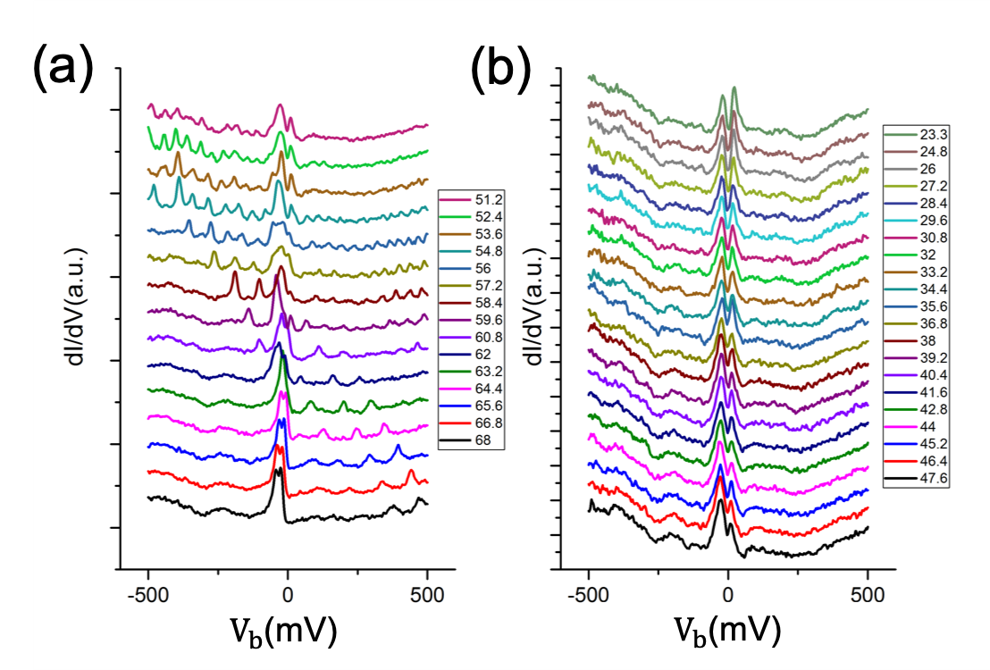
Supplementary Figure 3: dI/dV spectra on AA site (a) gate voltage 68 V to 51.2 V and (b) gate voltage 47.6 to 23.3 V respectively.

Supplementary note 2: High resolution STS mapping of QD states

To further study the Quantum dot at a smaller scale we performed dI/dV mapping in the region marked by the magenta square in Main Fig. 3a at a gate voltage of 57 V. Supplementary Fig. 4b shows the dI/dV spectrum measured at the position labelled by the green star in Figure Supplementary Fig. 4a. In addition to the flat bands on either side of 0 mV bias, several peaks corresponding to the charging of QD states are visible in the spectrum. In Supplementary Fig. 4(c-g) the dI/dV maps at these energies are shown. In the maps the charging states are seen as bright wavefronts. At higher energies all the wave-fronts with lower energies are also visible. As the energy is increased from negative values towards 0, the wave-fronts appear to move outward
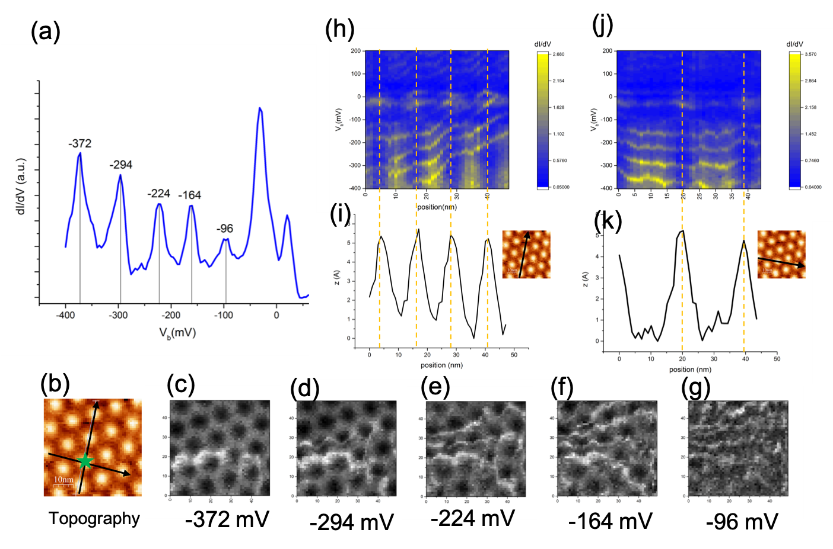
Supplementary Figure 4: dI/dV spatial maps. (a) shows an STS spectrum measured at position marked by the green star in topography (b). Charging peaks corresponding to the Quantum dot states are seen at -372 mV, -294 mV, -224 mV, -164 mV and -96 mV respectively. The dI/dV maps corresponding to these energies are shown in figures (c)-(g). Bright wave fronts corresponding to each QD state are seen in these maps. Figure (h) maps the position dependence of dI/dV at various points along the direction labelled by the arrow in the inset of (i). Figure (i) shows the corresponding topographic height variation along the same direction. The Quantum dot peaks in (h) show a general trend of shifting higher in energy (less negative) as the tip moves outwards towards the edge of the Quantum dot. This is an indication that the tip-dot capacitance reduced as the tip moves towards the edge of the Quantum dot. This reduces the tip-gating efficiency and thus the same QD state appears at higher bias voltages near the edge of the dot. The change in energy briefly slows down when the tip is scanning an AA site as marked by the dotted lines. This can be attributed again to the decrease in the gating efficiency of the tip as the tip-dot distance increases in the z direction while scanning the AA site. Figures (j) and (k) are similar to (h) and (i) except the direction is as indicated by the inset in (k) which is perpendicular to the direction for (h) and (i). Along this direction the Quantum dot peaks appear to have nearly constant energy. This is to be expected since this direction is along the QD wave fronts as seen in the dI/dV maps.
toward the edge of the QD. This can be explained by considering the decrease in the tip-dot capacitance as the tip moves from the center of the dot towards the edge. As the tip-dot capacitance decreases, the tip gating efficiency goes down. This means that we need a larger (less negative) bias in order to reach the same QD energy level.
This effect can be seen more directly by mapping the position dependence of the QD energy levels along a direction which points towards the edge of the QD (Supplementary Fig. 4h) and a direction orthogonal to it (Supplementary Fig. 4j). In Supplementary Fig. 4h, the QD states can be seen moving up in energy as the tip moves outward towards the edge of the dot. Interestingly the increase in the QD peak energies seems to slow down when the tip is close to the AA regions. This again can be explained by considering the reduction in the tip-gating efficiency as the tip-sample height is greater by about 0.5 nm (see Supplementary Fig 4i), when the tip is near the top of the AA sites owing to the larger LDOS there.
In contrast, in Supplementary Fig 4j, the energy of the QD states doesn’t seem to change much. This makes sense because the tip-dot capacitance doesn’t change a whole lot when the tip moves along this direction. Notice that this direction is roughly tangential to the wave-fronts.

Supplementary note 3: Set point dependence of the QD states

Another way of changing the tip-dot capacitance is by changing the initial set point at which the dI/dV spectrum is measured. To this end, we positioned the tip on top of an AA site and measured the dI/dV spectra at initial current set points of 20 pA to 90 pA in increments of 10 pA keeping the initial bias set point constant at -300 mV. In Supplementary Fig. S5a we plot the spectra as a map. The bright lines, most clearly seen at positive bias, are QD states. They have been labelled 1-7. Observe that as the set point is increased, the states move to higher energies. This increase in energy is plotted in Supplementary Fig. 5b. Almost all the states increase in energy by about 20 meV. Interestingly state 5 doesn’t seem to move much. We have been unable to explain this result.
As a sanity check we simulated the system as a spherical tip with radius 10 nm and the Quantum dot as a circular disc of radius 100 nm and calculated the capacitance between them for different tip-sample distances. The results are shown in Supplementary Fig. 5c. Each data point represents a simulation performed with a different tip-sample distance. The capacitance increases non-linearly as the tip-sample distance is reduced.
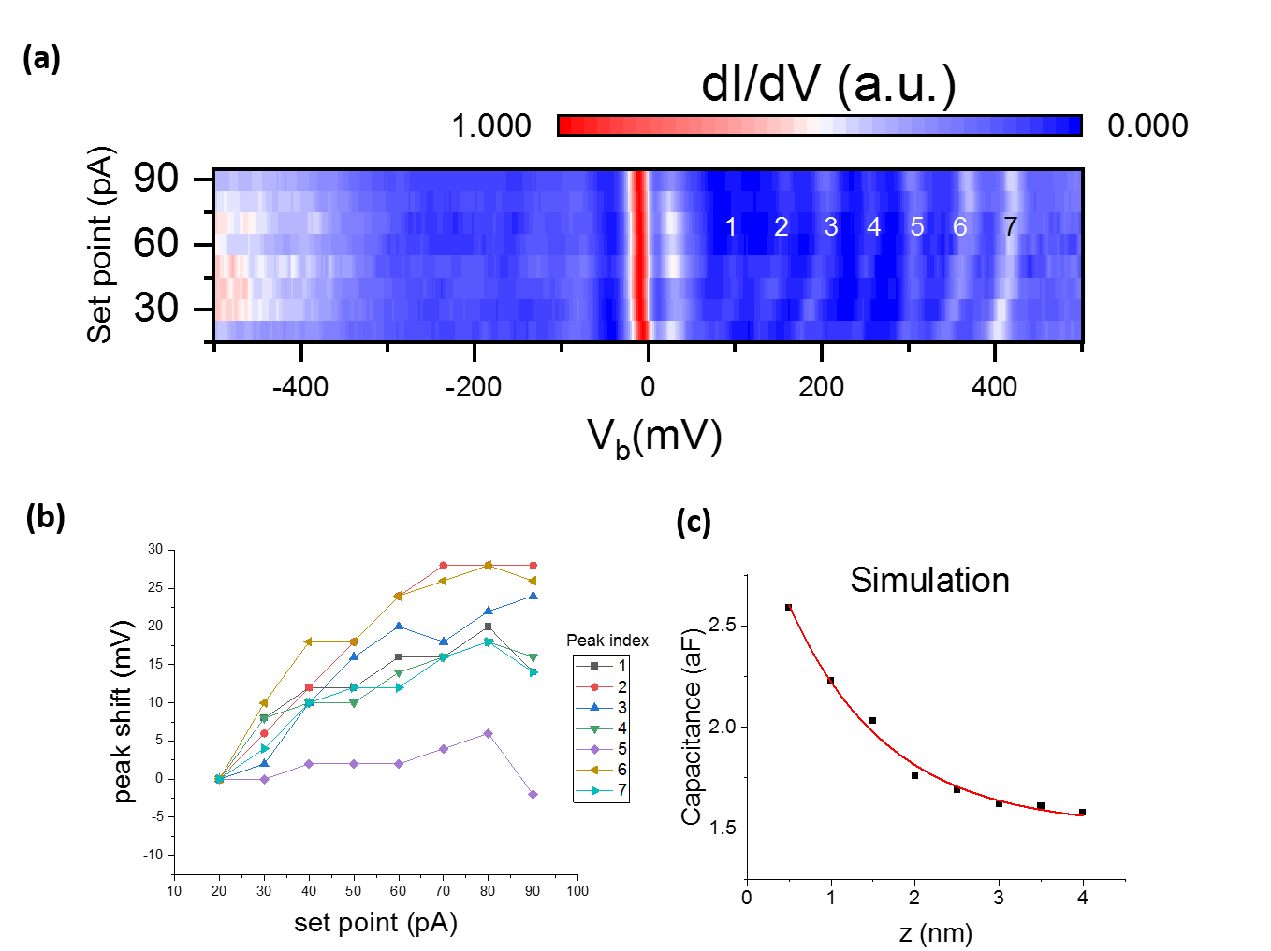
Supplementary Figure 5: Set point dependence of the confinement states. (a) is a set point dependence dI/dV map. current set points were varied between 20 pA and 90 pA while maintaining an initial bias set-point of -300 mV. The bright lines at positive biases represent confined states labelled by numbers 1 -7. As the set point in increased the energies of the states systematically increase. (b) plots the shift in the energy of each of the 7 states as the set point is increased from 20 to 90 pA. The states shift upwards in energy by about 20 meV. Interestingly state 5 doesn’t change significantly in energy. The capacitance between the tip and the sample should increase as the tip is brought closer to the sample. We simulated our tip as a sphere and the sample as a circular disc. The calculated Capacitance between the tip and the sample is plotted in (c) as a function of tip-sample distance. The capacitance indeed increases non-linearly as the tip-sample distance is reduced.

Supplementary note 4: Confinement in the hole-side band and Zero Bias Conductance curve
Although the results in the main figures demonstrate confinement near the electron-side band-edge, there is nothing special about the electron-side band. Confinement can also exist in the hole side band edge. We measured confinement states near the hole side band edge at a different position in the sample. results are shown in Supplementary Fig. S6.
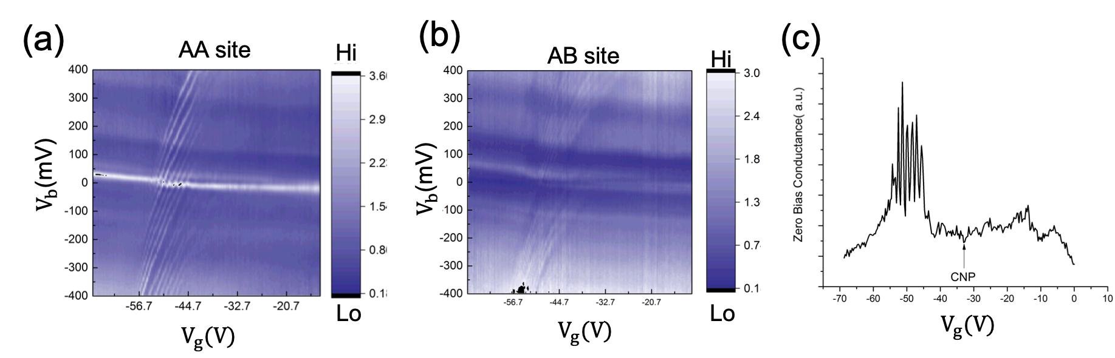
Supplementary Figure 6: Confinement in the hole-side flat band (a) is a gate dependence map at an AA site which shows confinement near the edge of the hole side flat band (b) shows the gate dependence at an AB site next to the AA site where (a) was measured.(c) Shows the zero bias conductance (ZBC) from (a). The charging states can be seen as sharp peaks in ZBC. They should not be confused with the dips that one expects in TBG due to correlated insulating states.

Supplementary note 5: Other origins of resonant states in STS

There are various scenarios where resonant states can appear in STS. One trivial possibility is that a weakly conducting impurity can be attached to the STM tip near the tunneling junction. This impurity can act like a Quantum dot and produce sharp peaks in STS whenever the sample or tip Fermi level aligns with its confinement states. Since such a Quantum dot is always surrounded by a tunneling barrier which is independent of the gate voltage, these peaks show up at all gate voltages. Main Figure 2c shows dI/dV spectra gathered at three different gate voltages. It can be seen that the resonant states exist only for a small range of gate voltage. Furthermore, we reformed the tip apex by applying bias pulses (3-6 VDC for 200 ms) while scanning the gold electrode. This procedure re-sculpts the very apex of the tip near the tunneling junction and is almost equivalent to changing tips. This procedure was repeated until sharp topographic scans were obtained. Then dI/dV spectra were measured on the Gold electrode to ensure that the spectrum was flat in the energy range of interest ($± 500 mV$). The resonant peaks in the TBG region were found to be reproducible before and after such tip cleaning. Therefore, we can safely rule out the possibility of a nanoparticle loosely stuck to the tip as a source of these peaks.
Another possibility is that the tip is invasive and creates local p-n junctions¹ or causes band bending locally^{2,3} in order to produce confinement. We can safely eliminate this possibility because the Quantum dot states occur in specific locations in our sample unlike tip-induced states which should not be position dependent.

References
References

1 Jiang, Y. et al. Tuning a circular p–n junction in graphene from quantum confinement to optical guiding. Nature Nanotechnology 12, 1045-1049, doi:10.1038/nnano.2017.181 (2017).
2 Dombrowski, R., Steinebach, C., Wittneven, C., Morgenstern, M. & Wiesendanger, R. Tip-induced band bending by scanning tunneling spectroscopy of the states of the tip-induced quantum dot on InAs(110). Physical Review B 59, 8043-8048, doi:10.1103/PhysRevB.59.8043 (1999).
3 Li, S.-Y. et al. Nanoscale detection of valley-dependent spin splitting around atomic defects of graphene. 2D Materials 6, 031005, doi:10.1088/2053-1583/ab2074 (2019).

