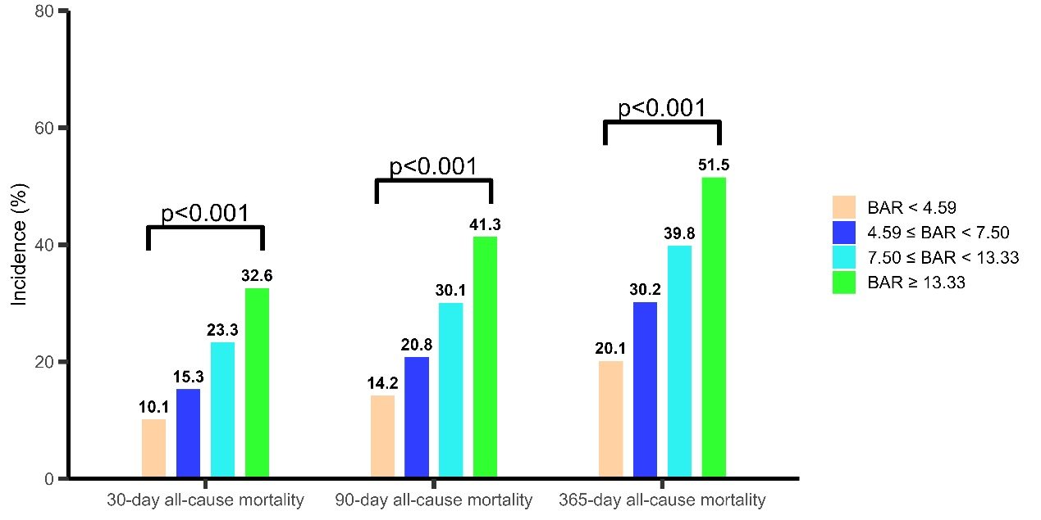
Figure S1. The 30-day, 90-day, and 360-day all-cause mortality in different groups in MIMIC IV database.
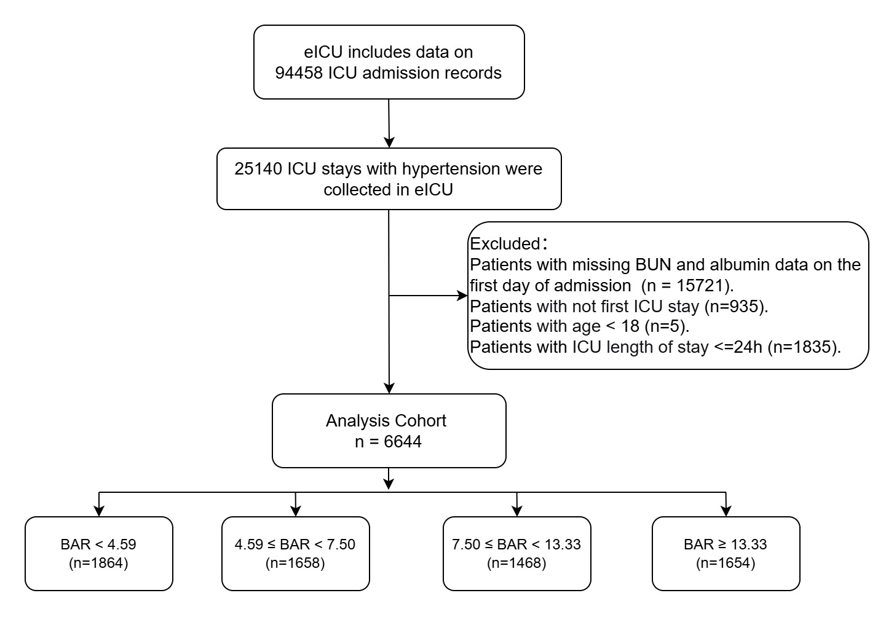
Figure S2. Flowchart of study participants in eICU 2.0 database.
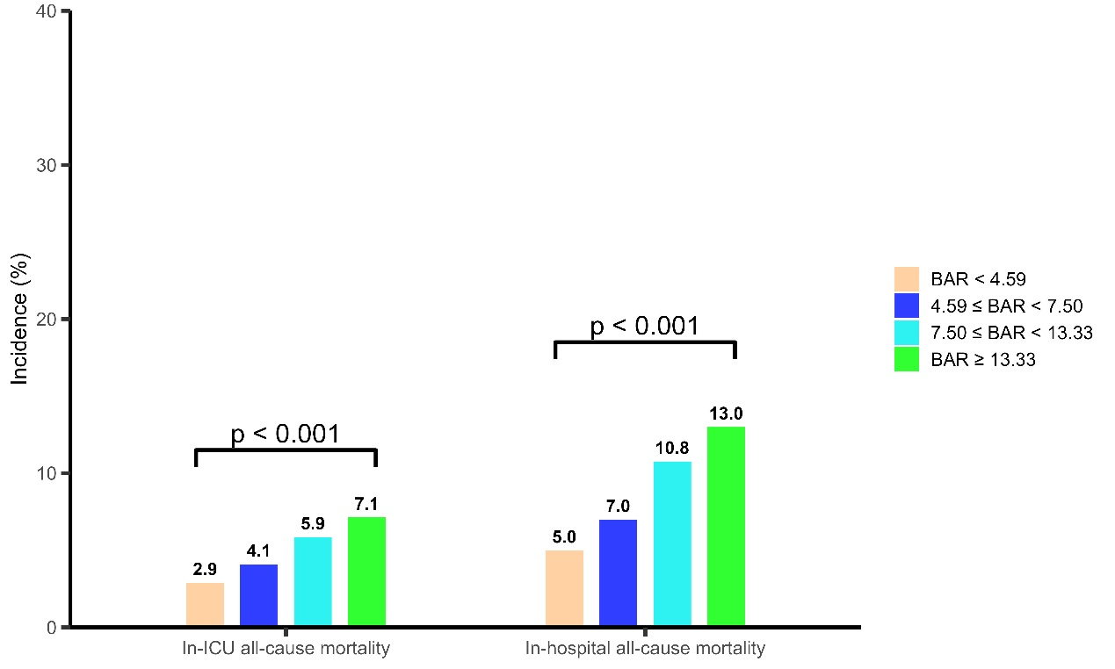
Figure S3. The 30-day, 90-day, and 360-day all-cause mortality in different groups in eICU 2.0 database.

