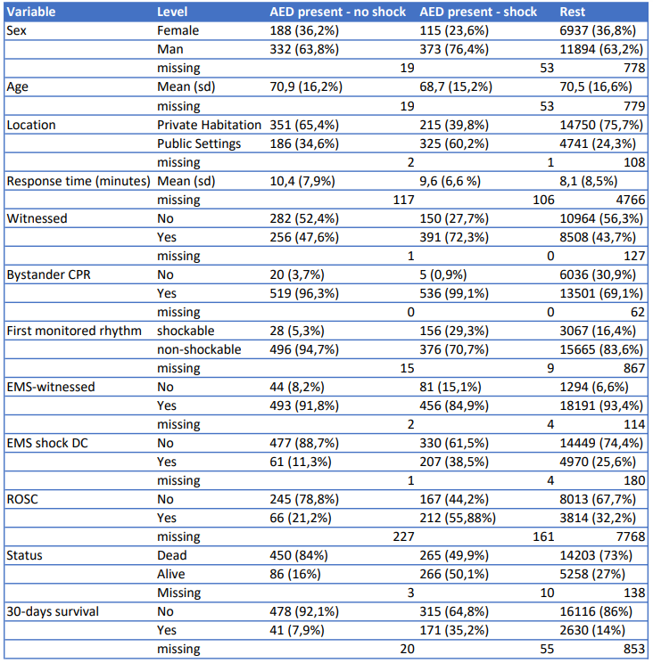
Table 1 – Danish Cardiac Arrest Registry year 2016 to 2019

