Biomass-Derived Carbon Electrodes with Optimized Defects and Porosity via Regulated Carbonization Temperature for Supercapacitors

Tserenlkham Byambadorj ^{a,b}, Jiawei Zhang ^{a,*}, Xuzhen Lu ª, Yuehui Wang ª, Fan Wang ª, Qian Liu ª, Yu Li ^{a,*}, Minghua Chen ª,

ª Key Laboratory of Engineering Dielectric and Applications (Ministry of Education), School of Electrical and Electronic Engineering, Harbin University of Science and Technology, Harbin 150080, P. R. China
^{b} School of Power Engineering, Mongolian University of Science and Technology, Ulaanbaatar 14191, Mongolia

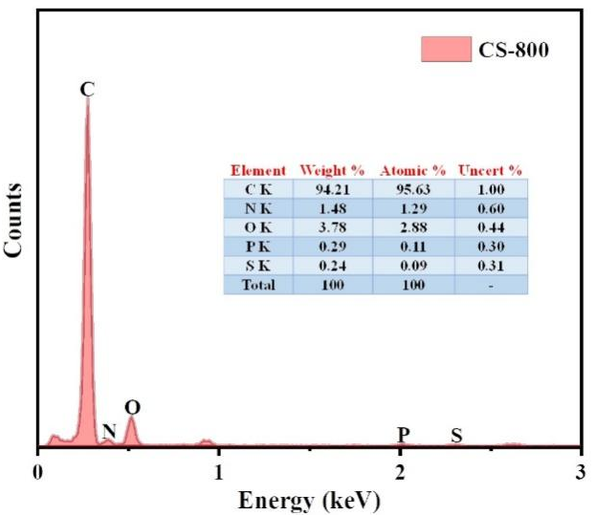
Figure S1. Elements distribution image of the CS-800 sample.

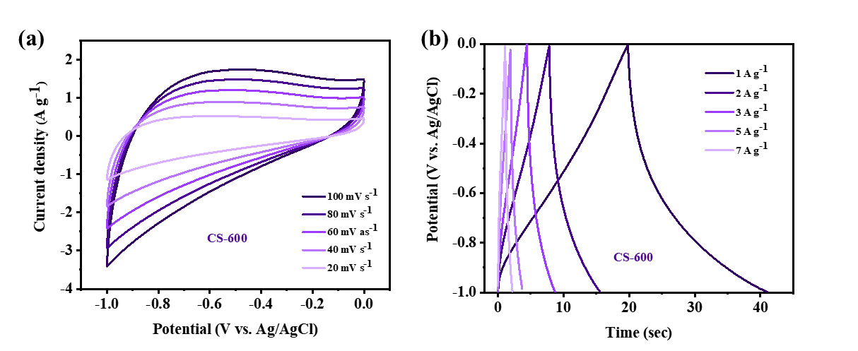
Figure S2. Electrochemical performance of the CS-600 electrode in a three-electrode configuration: (a) CV curves at various scan rates and (b) GCD curves at different current densities.

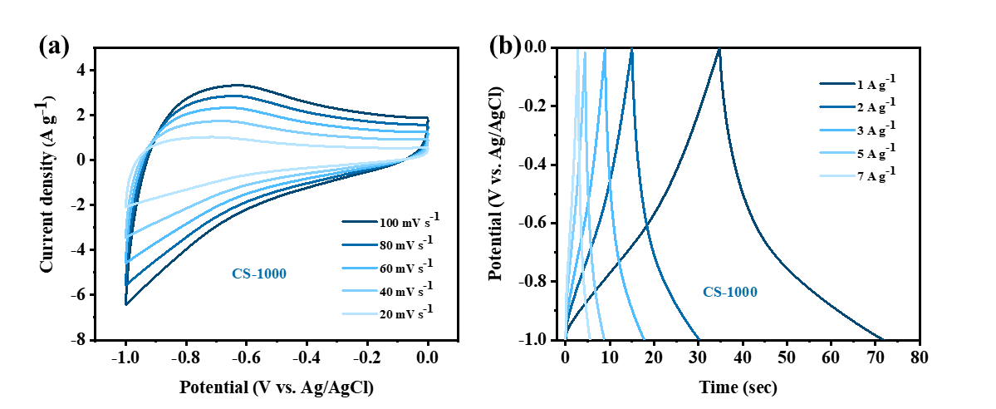
Figure S3. Electrochemical performance of the CS-1000 electrode in the three-electrode configuration: (a) CV curves at various scan rates and (b) GCD curves at different current densities.

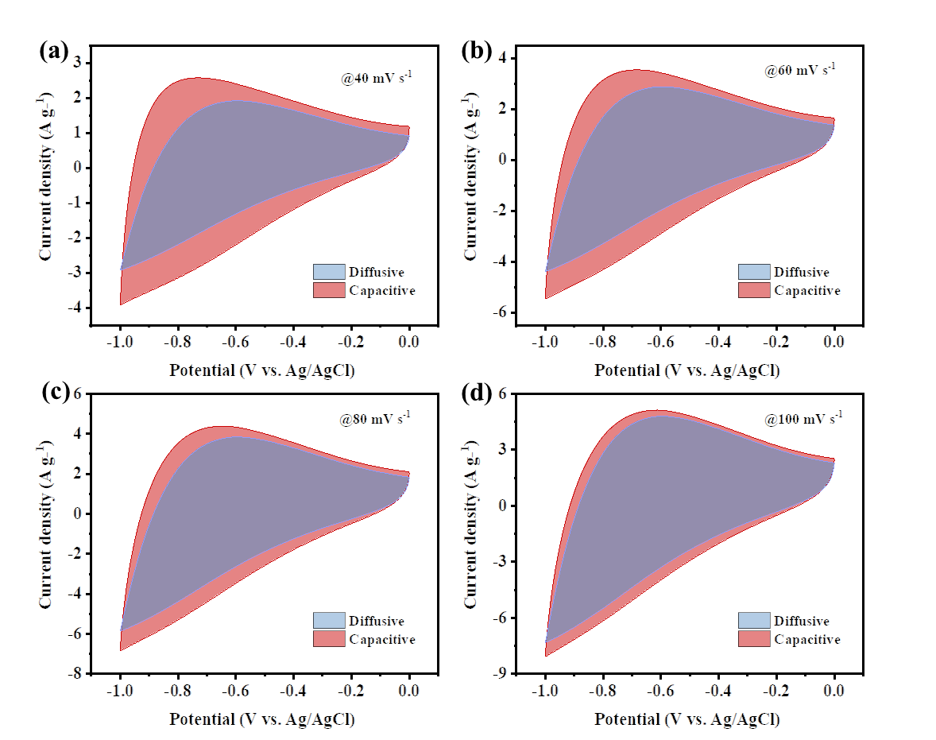
Figure S4. Deconvoluted voltammograms illustrating capacitive and diffusive regions scanned at 40 (a), 60 (b), 80 (c), and 100 mV s⁻¹ (d).

