Supplementary materials

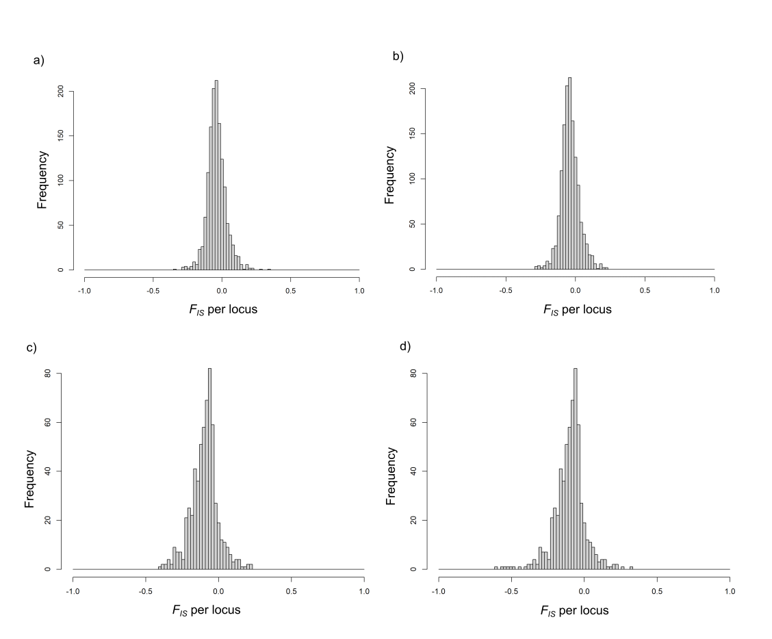

Fig. S1. Distribution of F_{IS} per locus before (left) and after (right) F_{IS} filtering.
a) and b) full dataset, c) and d) Haida Gwaii dataset

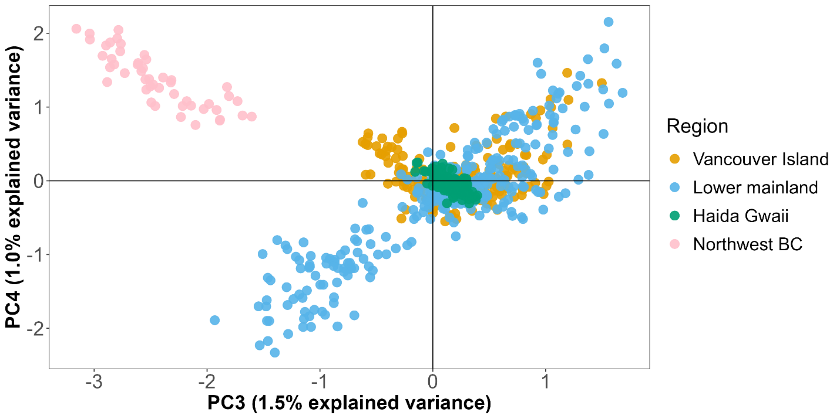
Fig. S2. Full dataset PCA with PC3 and PC4 axes.

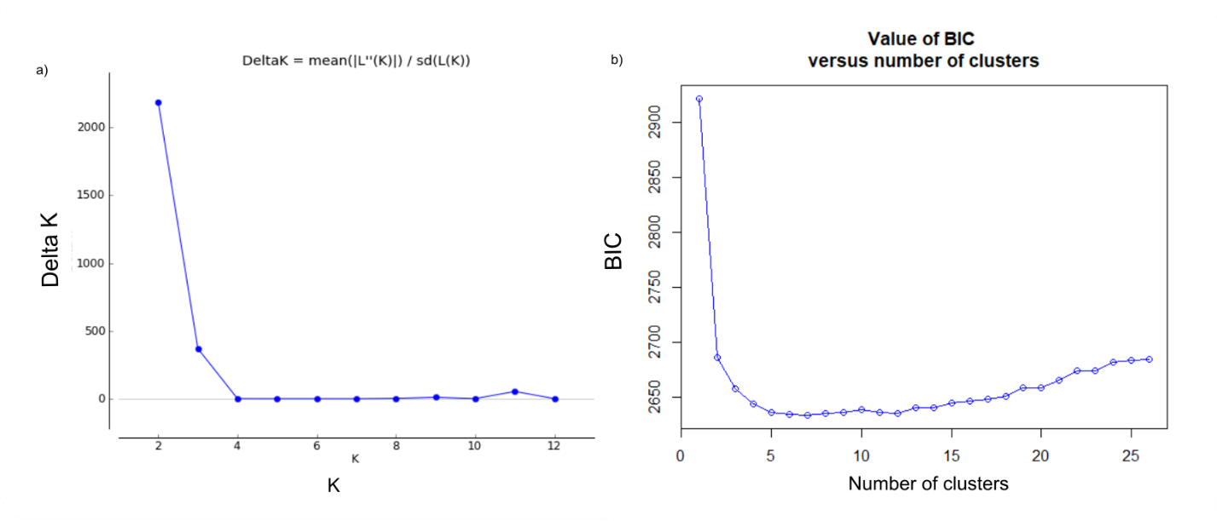
Fig. S3. Full dataset a) Delta K from STRUCTURE, b) BIC plot from DAPC.

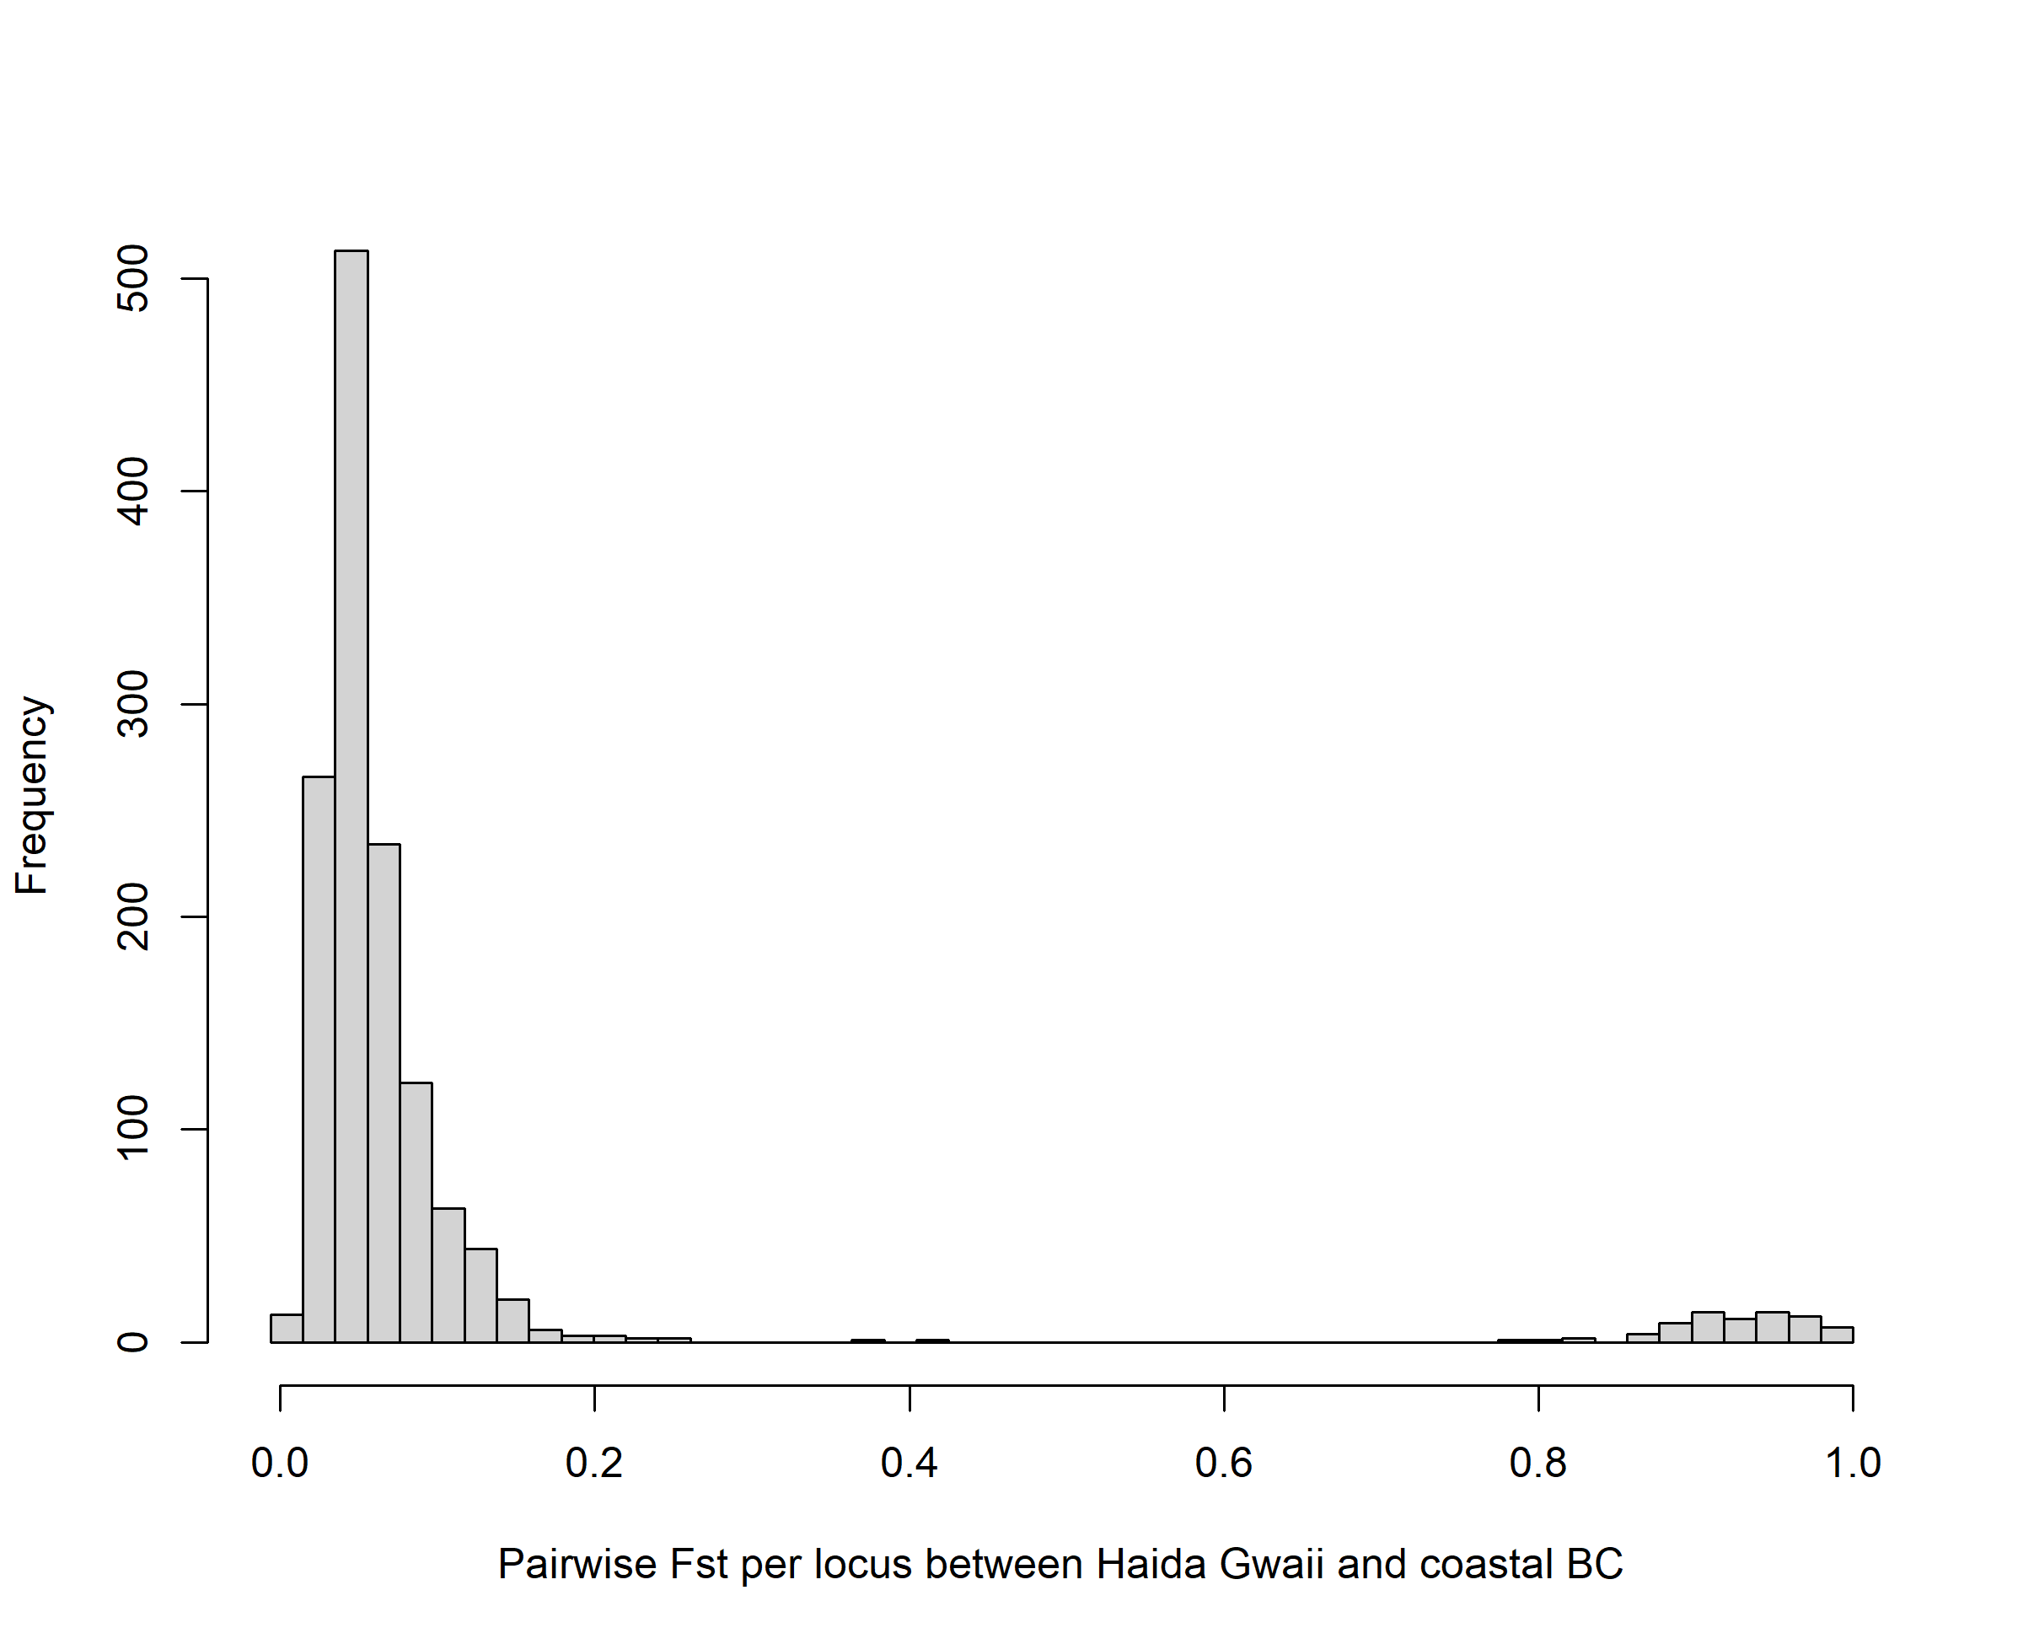
Fig. S4. Distribution of (non-weighted) pairwise F_{ST} per locus for Haida Gwaii versus elsewhere in coastal BC.

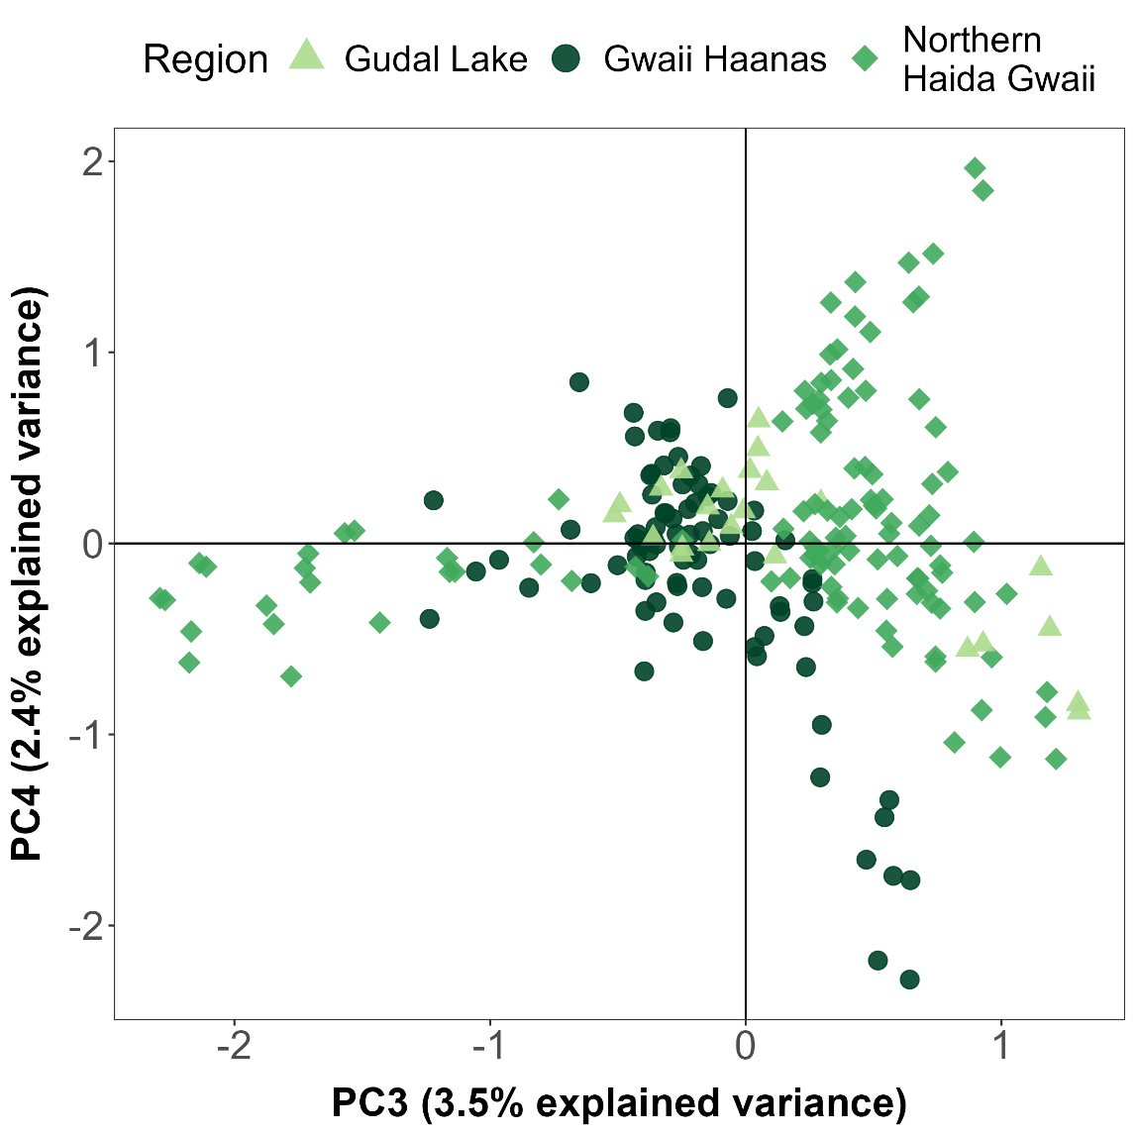
Fig. S5. PCA of Haida Gwaii SNPs with PC3 and PC4 axes.

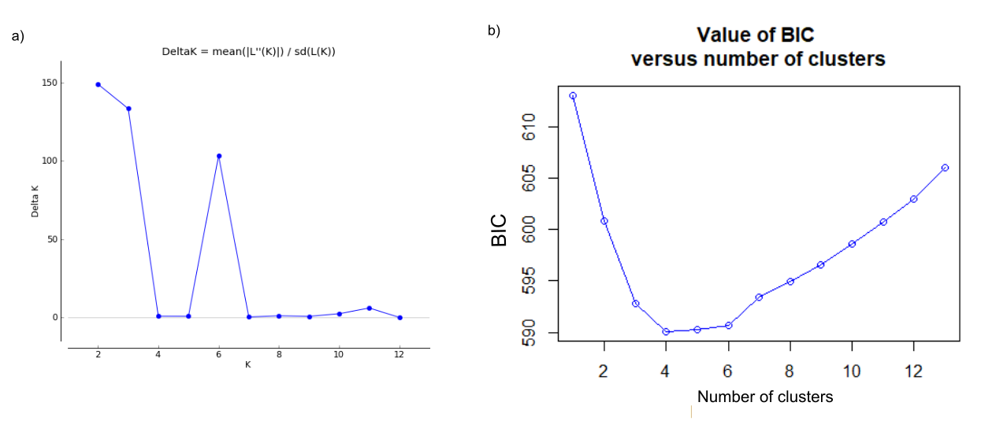
Fig. S6. Haida Gwaii a) Delta K from STRUCTURE, b) BIC plot from DAPC.

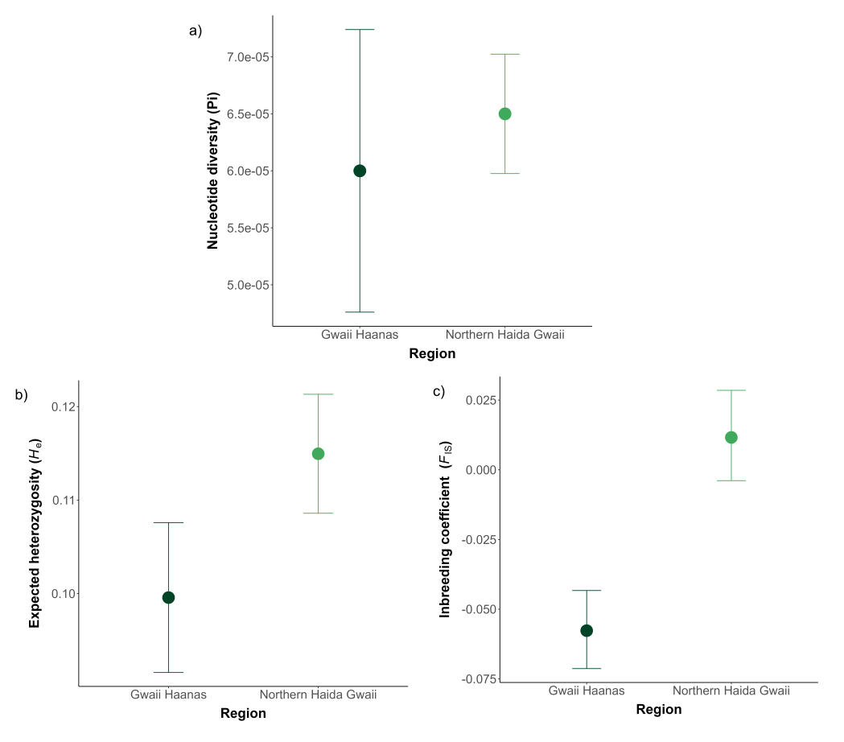
Fig. S7. Genetic diversity of Haida Gwaii toad populations – for Gwaii Haanas versus northern Haida Gwaii.
a) Nucleotide diversity (π), b) expected heterozygosity (H_{e}), and c) inbreeding coefficient (F_{IS}) – all with mean and 95% confidence intervals.

Table S1. Table of pairwise F_{ST} estimates per breeding site for the full dataset.
Breeding site codes (first three characters of every name) are as follows: Haida Gwaii and Northwest BC = R06, Vancouver Island = R01, lower mainland = R02.

Table S2. Evanno table from Structure Harvester for the full dataset.

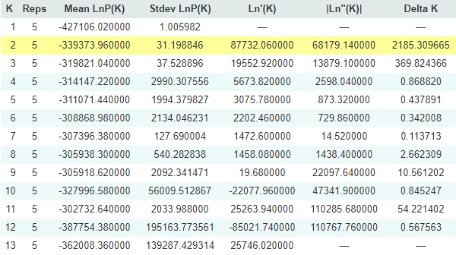

Table S3. Evanno table from Structure Harvester for the Haida Gwaii dataset.

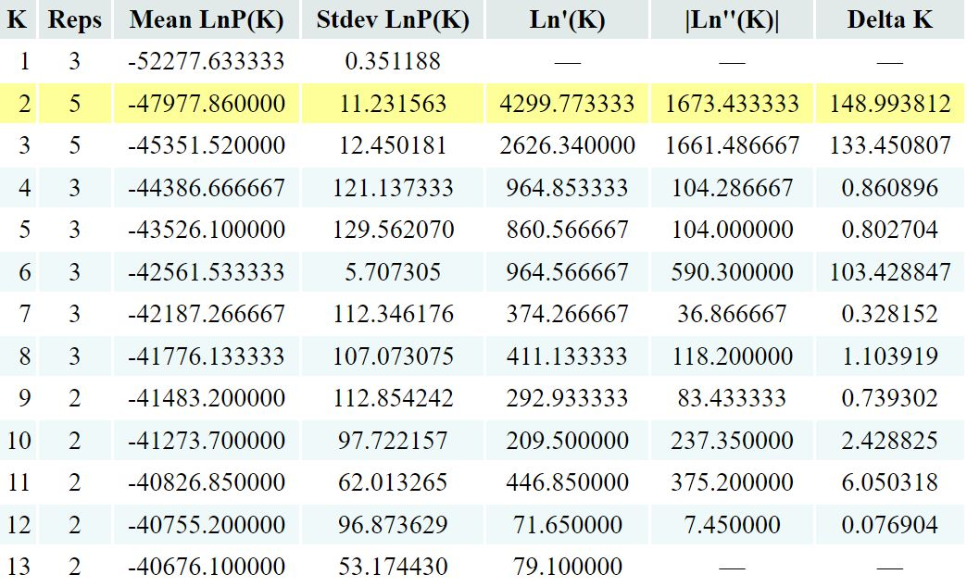

Table S4. Table of F_{IS} estimates and confidence intervals for the four regions. Fis_ll = lower confidence interval, Fis_hl = higher confidence interval.

Table S5. Table of pairwise F_{ST} values per breeding site for Haida Gwaii analysis.

