Supplementary Fig. S1. Species-level and isolate-level heterogeneity of 5-FU resistance.
(A) Alluvial plot linking species, anatomical site, (oral cavity and tumour) and resistance group (sensitive and resistant).
(B) Viability of isolates at 64 µg/mL 5-FU. Boxplots depict median and interquartile ranges; points represent individual isolates coloured by site (oral cavity and tumour).

Supplementary Fig. S2. Site- and species-resolved ordination and PERMANOVA summaries
(A) PCoA of accessory gene content faceted by anatomical site (oral cavity and tumour), coloured by resistance status.
(B) Heatmap showing PERMANOVA R² values for resistance status and anatomical location within individual Streptococcus species.

Supplementary Fig. S3: Homogeneity of multivariate dispersion across key metadata factors
PERMDISP (betadisper) analyses assessing homogeneity of multivariate dispersion for accessory gene content across (A) Anatomical location, (B) Resistance status, and (C) Species identity.
Supplementary Fig. S4. Species-specific accessory genome ordinations reveal heterogeneous resistance-associated structure
PCoA of accessory gene presence–absence profiles for individual Streptococcus species, based on Jaccard distances. Only species represented by ≥6 isolates and both resistance phenotypes were included (n = 7 species). Each panel corresponds to one species, with the percentage of variance explained by PCoA1 and PCoA2 indicated. Points represent individual isolates, coloured by resistance status (sensitive or resistant) and shaped by anatomical site (oral cavity or tumour). Ellipses indicate group dispersion for resistance categories where sufficient isolates were available. These ordinations illustrate partial and species-dependent resistance-associated structure but do not imply discrete clustering.

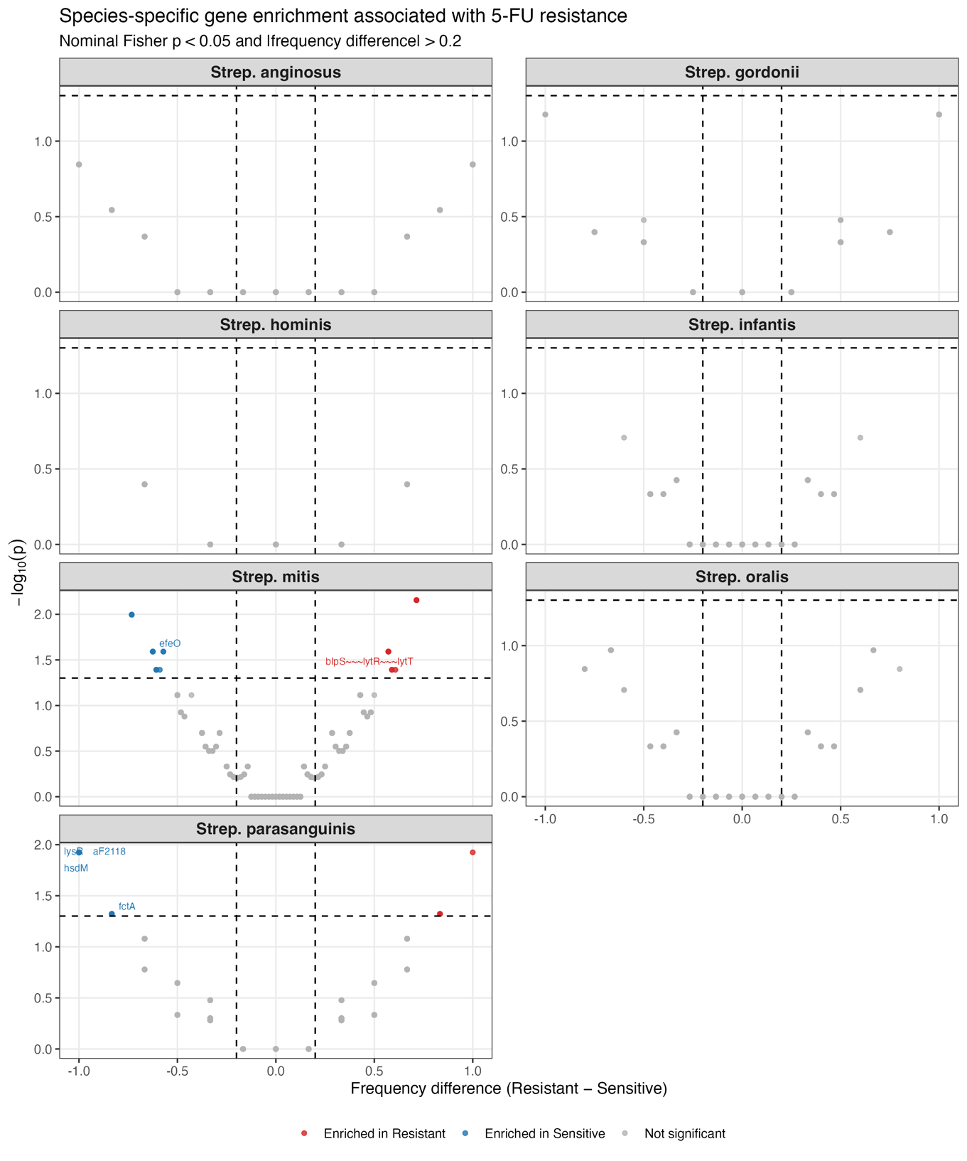
Supplementary Figure S5. Species-specific accessory gene associations with 5-FU resistance.
Faceted volcano plots show within-species Fisher’s exact tests comparing accessory gene presence/absence between resistant and sensitive isolates. The x-axis indicates the frequency difference (Resistant − Sensitive) and the y-axis shows −log10(p-value). Vertical dashed lines mark |Δfrequency| = 0.2 and the horizontal dashed line marks nominal p = 0.05. Points are coloured as enriched in resistant (red) or enriched in sensitive (blue) when both thresholds are met; otherwise, points are shown in grey. Selected loci are labelled (excluding genes with the prefix group_). (A) Strep. anginosus, (B) Strep. gordonii, (C) Strep. hominis, (D) Strep. infantis, (E) Strep. mitis, (F) Strep. oralis, (G) Strep. parasanguinis.
Supplementary Figure S6. Species-specific accessory gene associations with 5-FU resistance
Volcano plots show gene-level associations between resistant and sensitive Streptococcus isolates across three functional annotation frameworks: (A) CARD antibiotic resistance genes, (B) MFS and related transporter genes, and (C) VFDB virulence-associated genes. The x-axis represents the frequency difference between resistant and sensitive isolates (Resistant − Sensitive), and the y-axis shows −log₁₀(p-value) from Fisher’s exact tests. Vertical dashed lines indicate the minimum effect-size threshold (|frequency difference| > 0.2), and horizontal dashed lines indicate nominal statistical significance (p < 0.05). Genes enriched in resistant isolates are shown in red, genes enriched in sensitive isolates in blue, and non-significant genes in grey. These plots provide a complementary, gene-level visualisation of the patterns summarised in the corresponding heat maps (Fig. 4).

Supplementary Fig. S7. Functional and pathway enrichments in resistant versus sensitive isolates
(A) Functional category gene counts for resistance-associated genes, shown separately for resistant and sensitive groups.
(B) KEGG pathway enrichment analysis comparing resistant versus sensitive isolates; bars indicate the magnitude of enrichment (−log10 FDR) and direction of enrichment.
(C) Enriched COG functional categories comparing resistant versus sensitive isolates, displayed as log2 fold change.
(D) Enriched GO terms comparing resistant versus sensitive isolates, displayed as log2 fold change.

