Journal of Pharmaceutical Health Care and Sciences
Comparison of an HPLC-UV system (LM1010) and UPLC-MS/MS for plasma voriconazole measurement in routine clinical practice

Junichi Nakagawa¹, Kayo Ueno¹, Katsuyoshi Osanai², Masahiro Ishiyama³, Miyuki Matsushita⁴, Satoru Morikawa⁴, Hirofumi Tomita^{3, 5}, Takenori Niioka^{1, 6}

¹Department of Pharmacy, Hirosaki University Hospital, Aomori, Japan
²Department of Pharmacy, Aomori Prefectural Central Hospital, Aomori, Japan
³Department of Clinical Laboratory, Hirosaki University Hospital, Aomori, Japan and ⁴ Department of Chromatography Sales, Hitachi High-Tech Analysis Corporation, Tokyo, Japan
⁵Department of Cardiology and Nephrology, Hirosaki University Graduate School of Medicine
⁶Department of Pharmaceutical Science, Hirosaki University Graduate School of Medicine, Aomori, Japan

Correspondence
Takenori Niioka, PhD, Department of Pharmacy, Hirosaki University Hospital, 53 Hon-cho, Hirosaki, Aomori 036-8563, Japan
E-mail: t-niioka@hirosaki-u.ac.jp
ORCID: 0000-0002-4560-6423

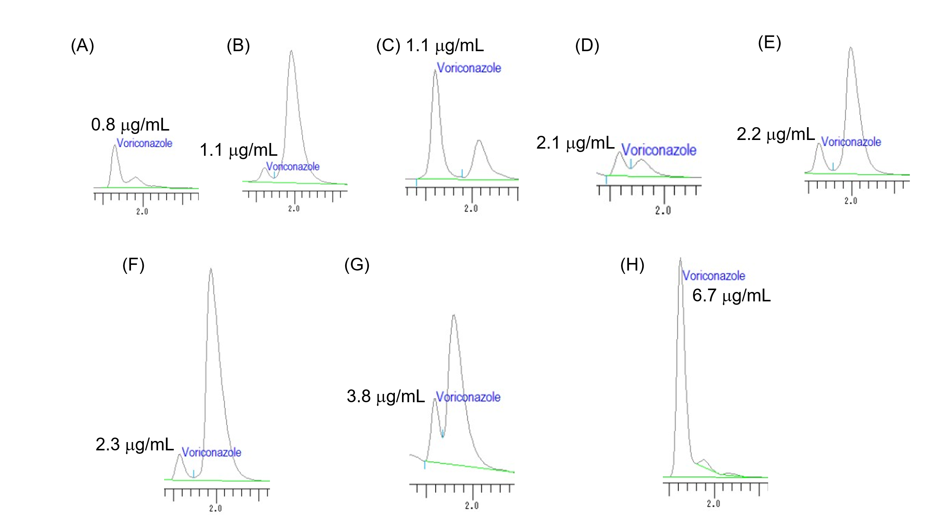
Supplementary Fig. 1 Chromatograms obtained by LM1010 showing interfering peaks partially overlapping with the voriconazole peak in eight patient samples from group B.
The numbers in each panel indicate the voriconazole plasma concentrations measured by LM1010.
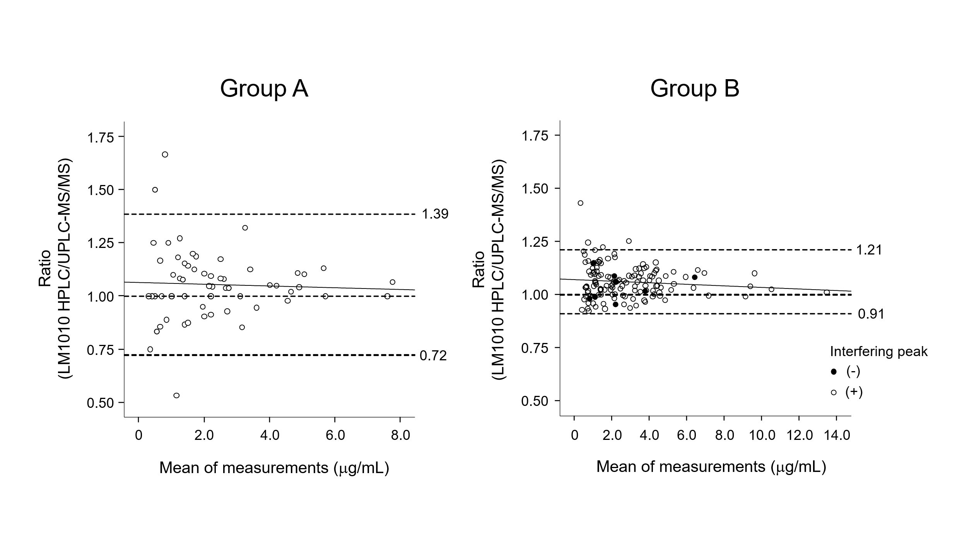
Supplementary Fig. 2 Bland-Altman plots of ratios between LM1010 and UPLC-MS/MS measurements of VRCZ.
Mean of measurements represents the mean voriconazole concentration measured by LM1010 and UPLC-MS/MS. The dashed lines indicate the mean difference ± 1.96 × standard deviation and 1, and the solid line represents the regression line.

Supplementary Table 1 List of concomitant drugs in group B.

Supplementary Table 2 Characteristics of patient samples in group B in which the interfering peak was detected by LM1010.

Supplementary Table 3 List of samples with discordant concentration categories between LM1010 and UPLC-MS/MS.

