Dose–response associations between C-reactive protein-triglyceride glucose index and asthma risk among Chinese adults aged ≥45 years: A prospective cohort
Contents
Fig. S1. Directed acyclic graph of the relationship between the CTI and asthma.
Fig. S2. Association of CTI and asthma incidence using restricted cubic spline model based on the different definition.
Fig. S3. Association of CTI and asthma incidence using restricted cubic spline model in cross-sectional analysis.
Table S1 Comparison of characteristics between included and excluded participants in the CHARLS cohort.
Table S2. Association of the CTI with asthma incidence using Cox proportional hazards models
Table S3. Association between the CTI and asthma prevalence using logistic regression models

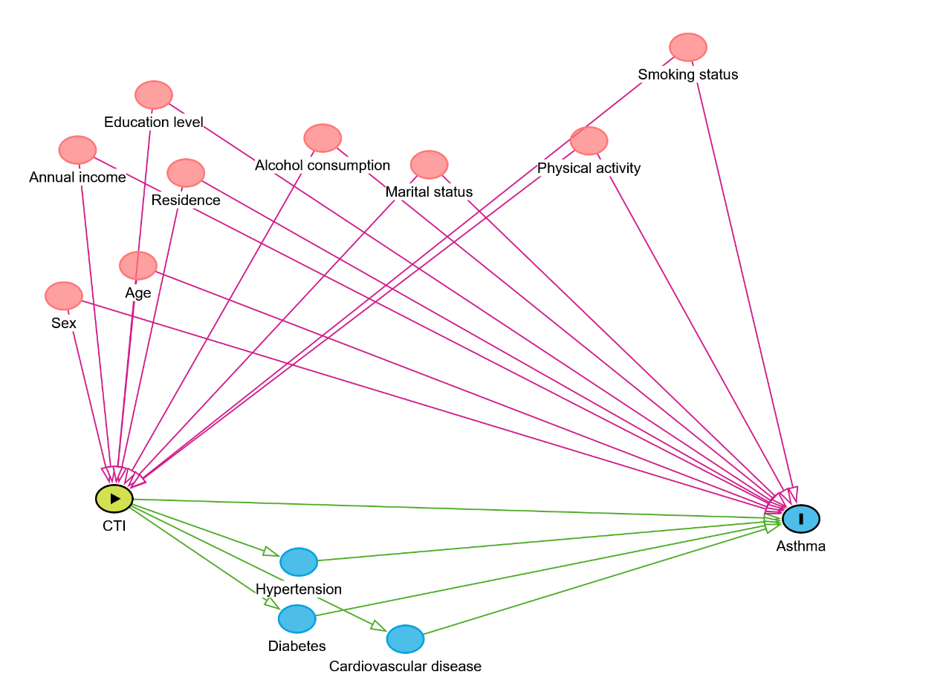
Fig. S1. Directed acyclic graph of the relationship between the CTI and asthma.

Fig. S2. Association of CTI and asthma incidence using restricted cubic spline model based on the different definition. Note: Knots were set at the 5th, 50th, and 95th percentiles of the CTI distribution. The median value is used as the reference. Adjusted for sex, age (continuous), residence, education level, annual income, and marital status, smoking status, alcohol consumption, and physical activity.

Fig. S3. Association of CTI and asthma incidence using restricted cubic spline model in cross-sectional analysis. Note: Knots were set at the 5th, 50th, and 95th percentiles of the CTI distribution. The median value is used as the reference. Adjusted for sex, age (continuous), residence, education level, annual income, and marital status, smoking status, alcohol consumption, and physical activity.

Table S1 Comparison of characteristics between included and excluded participants in the CHARLS cohort
Characteristics |  | Excluded participants | Included participants | P value
 |  | (n = 6,582) ª | (n = 11,126) | P value
Sex | Male | 3219 (48.9) | 5259 (47.3) | 0.035
 | Female | 3361 (51.1) | 5867 (52.7)
Age (years, continuous) |  | 57.39 (11.24) | 59.13 (9.45) | <0.001
Age (years, categorical) | 45–49 | 1904 (29.7) | 2163 (19.4) | <0.001
 | 50–59 | 2086 (32.6) | 4090 (36.8)
 | ≥ 60 | 2417 (37.7) | 4873 (43.8)
Residence | Urban | 3098 (47.1) | 4073 (36.6) | <0.001
 | Rural | 3484 (52.9) | 7053 (63.4)
Education level | No formal education | 1614 (24.6) | 3237 (29.1) | <0.001
 | Primary school | 2465 (37.5) | 4455 (40.0)
 | Middle school | 1448 (22.1) | 2229 (20.0)
 | High school and above | 1039 (15.8) | 1205 (10.8)
Annual income ^{b} | T1 | 1069 (16.2) | 2374 (21.3) | <0.001
 | T2 | 1182 (18.0) | 2301 (20.7)
 | T3 | 1265 (19.2) | 2350 (21.1)
 | Missing | 3066 (46.6) | 4101 (36.9)
Marital status | Married | 5655 (85.9) | 9762 (87.7) | 0.001
 | Unmarried | 71 (1.1) | 88 (0.8)
 | Other | 856 (13.0) | 1276 (11.5)
Alcohol consumption | Never drinker | 3982 (60.5) | 6516 (58.6) | 0.028
 | Former drinker | 506 (7.7) | 937 (8.4)
 | Current drinker | 2094 (31.8) | 3673 (33.0)
Smoking status | Never smoker | 4475 (68.0) | 6945 (62.4) | <0.001
 | Former smoker | 464 (7.0) | 953 (8.6)
 | Current smoker | 1643 (25.0) | 3228 (29.0)
Physical activity | None/Light | 877 (13.3) | 1607 (14.4) | <0.001
 | Moderate | 697 (10.6) | 1370 (12.3)
 | Heavy | 733 (11.1) | 1628 (14.6)
 | Missing | 4275 (64.9) | 6521 (58.6)
Hypertension | No | 4315 (65.6) | 6628 (59.6) | <0.001
 | Yes | 2267 (34.4) | 4498 (40.4)
Diabetes | No | 6155 (93.5) | 9256 (83.2) | <0.001
 | Yes | 427 (6.5) | 1870 (16.8)
Cardiovascular disease | No | 5709 (86.7) | 9497 (85.4) | 0.012
 | Yes | 873 (13.3) | 1629 (14.6)
ª: Numbers may not add up to 6,310 due to missing data.
^{b}: Annual income tertiles were categorized as follows: T1 (lowest tertile), T2 (middle tertile), and T3 (highest tertile).

Table S2. Association of the CTI with asthma incidence using Cox proportional hazards models
Characteristics |  | HR (95% CI) | P value
CTI (per 1 unit) |  | 1.22 (1.03, 1.44) | 0.021
CTI quartile
Q1 |  | Reference
Q2 |  | 1.07 (0.81, 1.41) | 0.630
Q3 |  | 1.12 (0.85, 1.48) | 0.416
Q4 |  | 1.29 (0.97, 1.71) | 0.082
P for trend |  |  | 0.080
CTI: C-reactive protein-triglyceride-glucose index; HR: hazard ratio; CI: confidence interval.
This model was adjusted for sex, age (continuous), residence, education level, annual income, and marital status, smoking status, alcohol consumption, physical activity, hypertension, diabetes, and cardiovascular disease.
Table S3. Association between the CTI and asthma prevalence using logistic regression models
Characteristics | Model 1 |  |  | Model 2 |  |  | Model 3
Characteristics | OR (95% CI) | P value |  | OR (95% CI) | P value |  | OR (95% CI) | P value
CTI (per 1 unit) | 1.34 (1.16, 1.54) | <0.001 |  | 1.30 (1.12, 1.51) | <0.001 |  | 1.27 (1.09, 1.47) | 0.002
CTI quartile
Q1 | Reference |  |  | Reference |  |  | Reference
Q2 | 1.00 (0.76, 1.30) | 0.972 |  | 0.95 (0.72, 1.24) | 0.696 |  | 0.93 (0.71, 1.22) | 0.613
Q3 | 1.09 (0.84, 1.42) | 0.526 |  | 1.03 (0.79, 1.35) | 0.829 |  | 1.00 (0.76, 1.31) | 0.991
Q4 | 1.51 (1.18, 1.93) | 0.001 |  | 1.43 (1.11, 1.84) | 0.006 |  | 1.36 (1.06, 1.76) | 0.017
P for trend |  | <0.001 |  |  | 0.002 |  |  | 0.009
CTI: C-reactive protein-triglyceride-glucose index; OR: odds ratio; CI: confidence interval.
Model 1: unadjusted.
Model 2: adjusted for sex, age (continuous), residence, education level, annual income, and marital status.
Model 3: additionally adjusted for smoking status, alcohol consumption, and physical activity.

