ADDITIONAL FILES:
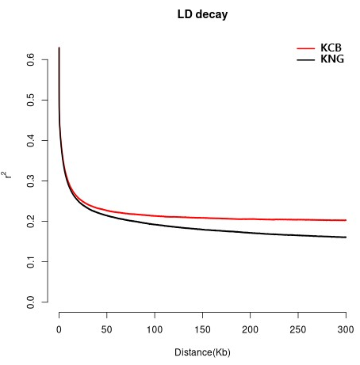
Supplementary Fig. 1. Results of LD decay analysis.
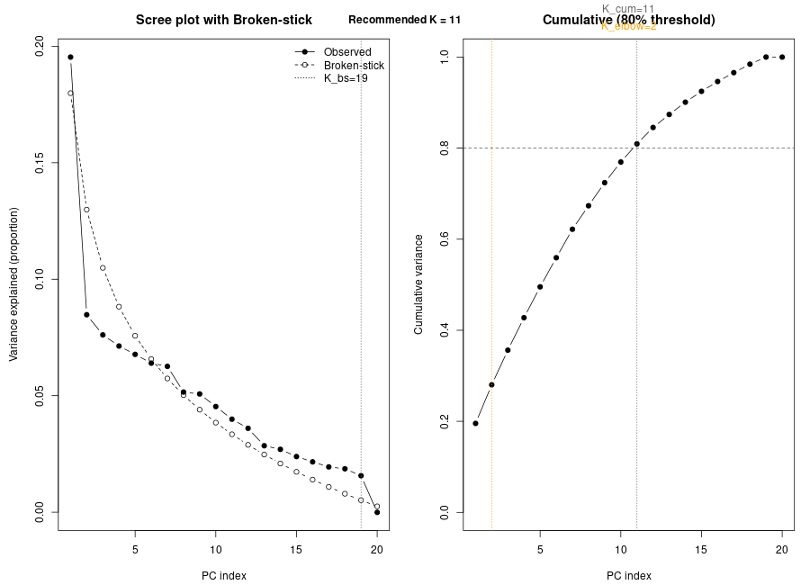
Supplementary Fig. 2. Optimization of principal component selection for PCA.

Supplementary Table 1. Summary of annotations number and region counts
Type (alphabetical order) | Count | Percent (%)
3_prime_UTR_variant | 126,585 | 0.34
5_prime_UTR_premature_start_codon_gain_variant | 3,794 | 0.01
5_prime_UTR_variant | 28,974 | 0.08
bidirectional_gene_fusion | 20 | 0.00
conservative_inframe_deletion | 573 | 0.00
conservative_inframe_insertion | 630 | 0.00
disruptive_inframe_deletion | 1,218 | 0.00
disruptive_inframe_insertion | 605 | 0.00
downstream_gene_variant | 1,708,117 | 4.55
exon_loss_variant | 8 | 0.00
frameshift_variant | 4,113 | 0.01
gene_fusion | 9 | 0.00
initiator_codon_variant | 11 | 0.00
intergenic_region | 16,929,108 | 45.12
intragenic_variant | 1 | 0.00
intron_variant | 16,650,086 | 44.38
missense_variant | 103,173 | 0.28
non_coding_transcript_exon_variant | 50,902 | 0.14
non_coding_transcript_variant | 65 | 0.00
splice_acceptor_variant | 683 | 0.00
splice_donor_variant | 907 | 0.00
splice_region_variant | 32,797 | 0.09
start_lost | 193 | 0.00
start_retained_variant | 4 | 0.00
stop_gained | 1,353 | 0.00
stop_lost | 166 | 0.00
stop_retained_variant | 106 | 0.00
synonymous_variant | 146,319 | 0.39
upstream_gene_variant | 1,731,193 | 4.61
DOWNSTREAM | 1,708,114 | 4.56
EXON | 305,228 | 0.81
GENE | 29 | 0.00
INTERGENIC | 16,929,108 | 45.16
INTRON | 16,622,870 | 44.34
SPLICE_SITE_ACCEPTOR | 625 | 0.00
SPLICE_SITE_DONOR | 814 | 0.00
SPLICE_SITE_REGION | 29,983 | 0.08
TRANSCRIPT | 66 | 0.00
UPSTREAM | 1,731,193 | 4.62
UTR_3_PRIME | 126,585 | 0.34
UTR_5_PRIME | 32,767 | 0.09

