Supplementary data

Catalyst | Condition | Catalyst dosage | pH | Time | Absorbance | yield
ZnO | UV light | 250 mg/L | 9 | 0 min | 0.772 | -
ZnO | UV light | 250 mg/L | 9 | 20 min | 0.708 | 8.29%
ZnO | UV light | 250 mg/L | 9 | 40 min | 0.576 | 25.38%
ZnO | UV light | 250 mg/L | 9 | 60 min | 0.471 | 38.99%
ZnO | UV light | 250 mg/L | 9 | 80 min | 0.365 | 52.77%
ZnO | UV light | 250 mg/L | 9 | 100 min | 0.308 | 60.10%
ZnO | UV light | 250 mg/L | 9 | 120 min | 0.217 | 71.89%
ZnO | UV light | 250 mg/L | 9 | 140 min | 0.131 | 83.03%
ZnO | UV light | 250 mg/L | 9 | 160 min | 0.081 | 89.50%
ZnO | UV light | 250 mg/L | 9 | 180 min | 0.069 | 91.06%
ZnO/Chitosan | UV light | 250 mg/L | 9 | 0 min | 0.774 | -
ZnO/Chitosan | UV light | 250 mg/L | 9 | 20 min | 0.458 | 40.82%
ZnO/Chitosan | UV light | 250 mg/L | 9 | 40 min | 0.289 | 62.66%
ZnO/Chitosan | UV light | 250 mg/L | 9 | 60 min | 0.131 | 83.07%
ZnO/Chitosan | UV light | 250 mg/L | 9 | 80 min | 0.062 | 91.98%
ZnO/Chitosan | UV light | 250 mg/L | 9 | 100 min | 0.055 | 92.89%
ZnO/Chitosan | UV light | 250 mg/L | 9 | 120 min | 0.037 | 95.21%
ZnO/Chitosan | UV light | 250 mg/L | 9 | 140 min | 0.021 | 97.28%
ZnO/Chitosan | UV light | 250 mg/L | 9 | 160 min | 0.020 | 97.41%
ZnO/Chitosan | UV light | 250 mg/L | 9 | 180 min | 0.018 | 97.67%
MWCNTs/ZnO/Chitosan | UV light | 250 mg/L | 9 | 0min | 0.874 | -
MWCNTs/ZnO/Chitosan | UV light | 250 mg/L | 9 | 2min | 0.634 | 27.45%
MWCNTs/ZnO/Chitosan | UV light | 250 mg/L | 9 | 4min | 0.475 | 34.75%
MWCNTs/ZnO/Chitosan | UV light | 250 mg/L | 9 | 6min | 0.386 | 46.98%
MWCNTs/ZnO/Chitosan | UV light | 250 mg/L | 9 | 8min | 0.214 | 70.60%
MWCNTs/ZnO/Chitosan | UV light | 250 mg/L | 9 | 10min | 0.135 | 81.46%
MWCNTs/ZnO/Chitosan | UV light | 250 mg/L | 9 | 12min | 0.065 | 91.07%
MWCNTs/ZnO/Chitosan | UV light | 250 mg/L | 9 | 14min | 0.044 | 93.95%
MWCNTs/ZnO/Chitosan | UV light | 250 mg/L | 9 | 16min | 0.029 | 96.01%
MWCNTs/ZnO/Chitosan | UV light | 250 mg/L | 9 | 18min | 0.011 | 98.49%
MWCNTs/ZnO/Chitosan | UV light | 250 mg/L | 9 | 20min | 0.01 | 98.76%

Table S1. The photocatalytic activity of applied samples under UV irradiation.

Catalyst | Condition | Catalyst dosage | pH | Time | Absorbance | yield
ZnO | dark | 250 mg/L | 9 | 0 min | 0.772 | -
ZnO | dark | 250 mg/L | 9 | 30min | 0.730 | 5.44%
ZnO | dark | 250 mg/L | 9 | 60 min | 0.699 | 9.45%
ZnO | dark | 250 mg/L | 9 | 90 min | 0.668 | 13.47%
ZnO | dark | 250 mg/L | 9 | 120 min | 0.615 | 20.34%
ZnO | dark | 250 mg/L | 9 | 150 min | 0.569 | 26.29%
ZnO | dark | 250 mg/L | 9 | 180min | 0.525 | 32.10%
ZnO/Chitosan | dark | 250 mg/L | 9 | 0 min | 0.823 | -
ZnO/Chitosan | dark | 250 mg/L | 9 | 30 min | 0.712 | 13.36%
ZnO/Chitosan | dark | 250 mg/L | 9 | 60 min | 0.633 | 17.79%
ZnO/Chitosan | dark | 250 mg/L | 9 | 90 min | 0.589 | 23.50%
ZnO/Chitosan | dark | 250 mg/L | 9 | 120 min | 0.492 | 36.10%
ZnO/Chitosan | dark | 250 mg/L | 9 | 150 min | 0.470 | 38.96%
ZnO/Chitosan | dark | 250 mg/L | 9 | 180 min | 0.405 | 47.40%
MWCNTs/ZnO/Chitosan | dark | 250 mg/L | 9 | 0min | 0.874 | -
MWCNTs/ZnO/Chitosan | dark | 250 mg/L | 9 | 2min | 0.713 | 18.42%
MWCNTs/ZnO/Chitosan | dark | 250 mg/L | 9 | 4min | 0.576 | 20.87%
MWCNTs/ZnO/Chitosan | dark | 250 mg/L | 9 | 6min | 0.465 | 36.12%
MWCNTs/ZnO/Chitosan | dark | 250 mg/L | 9 | 8min | 0.377 | 48.21%
MWCNTs/ZnO/Chitosan | dark | 250 mg/L | 9 | 10min | 0.310 | 57.41%
MWCNTs/ZnO/Chitosan | dark | 250 mg/L | 9 | 12min | 0.213 | 70.74%
MWCNTs/ZnO/Chitosan | dark | 250 mg/L | 9 | 14min | 0.140 | 80.76%
MWCNTs/ZnO/Chitosan | dark | 250 mg/L | 9 | 16min | 0.135 | 81.46%
MWCNTs/ZnO/Chitosan | dark | 250 mg/L | 9 | 18min | 0.104 | 85.71%
MWCNTs/ZnO/Chitosan | dark | 250 mg/L | 9 | 20min | 0.100 | 86.26%

Table S2. The photocatalytic activity of applied samples under dark condition.

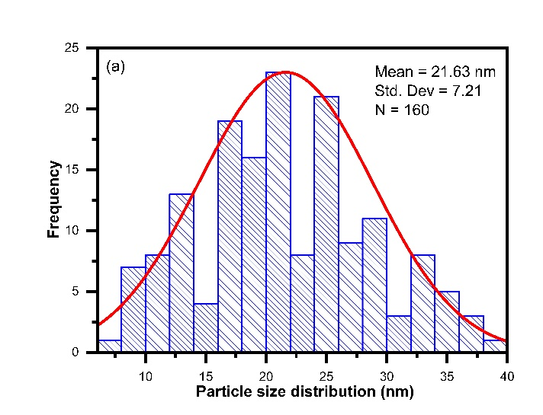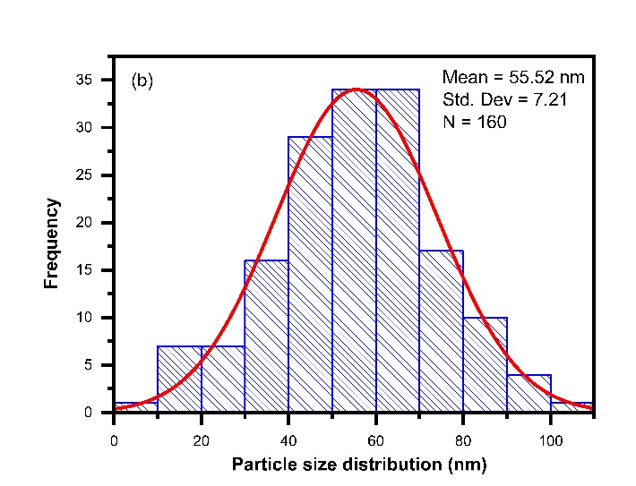
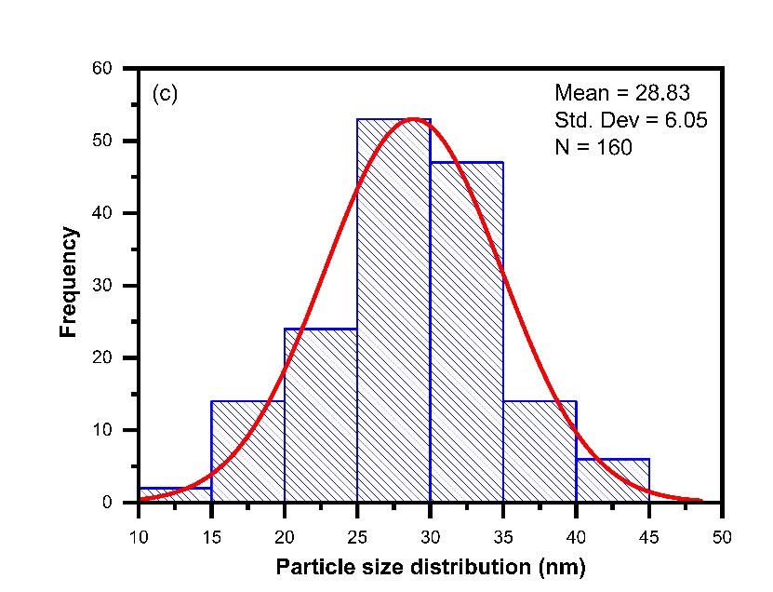
Fig S1. Particle size distribution of (a) pure ZnO, (b) ZnO/Chitosan nanocomposite and (c) MWCNTs/ZnO/Chitosan nanocomposite.

