Supplementary information for
Precision functional mapping of individual long-term learning brain

Jiali Mu^{1#}, Tianyong Xu^{1#}, Xiao Han¹, Yukai Ma¹, Fan Liu¹, Jingcheng Wang¹, Hongjian He¹, Changsong Zhou^{2,3}, Xi-Nian Zuo^{4,5,6*†}, Feiyan Chen^{1*†}

Supplementary methods

Task design

Mental calculation

The mental calculation task used a block design, comprising a total of 16 blocks (11.4 minutes), evenly divided into 8 Calculation blocks and 8 Control (Magnitude Comparison) blocks. Each block contained 2 trials and was preceded by a 1-s instructional cue.
Each trial began with a central fixation cross (0.5 s), followed by a sequential presentation phase. This phase consisted of six stimuli: the first was a visual abacus (“bead”) image, and the subsequent five were Arabic numerals. Each stimulus was displayed for 1 s, separated by a 1-s blank-screen interval.

The two block types differed in their task demands. In Calculation blocks, participants were required to perform successive mental calculations, updating a running total with each sequentially presented stimulus. In Control blocks, participants attended to the identical stimulus sequence without performing arithmetic; instead, following the sequence, they performed a magnitude comparison judgment between two presented digits.

N-back

The verbal and visuospatial working memory tasks both used an N-back block design. Each comprised three load conditions: 0-back, 2-back, and 4-back. For each task type, with 3 blocks per load condition, a total of 9 blocks(total 8.75 minutes). Each block consisted of 14 consecutive trials, among which 4 were designated match trials. The visual stimulus was identical across both task types: a capital letter presented pseudorandomly at one of the four corners of a central square. The tasks differed in their matching rule. In the verbal N-back task, participants judged whether the current letter matched the letter presented N trials earlier, irrespective of its location. In the spatial N-back task, participants judged whether the current spatial location matched the location presented N trials earlier, irrespective of the letter identity.

Stroop

The Stroop task used a block design, comprising a total of 9 blocks (5.6 minutes) across three trial types: incongruent, congruent, and neutral. On each trial, two stimuli were presented vertically. The upper target stimulus was a colored patch (red, green, blue, or yellow). The lower matching stimulus was the Chinese character for one of these four color words (“red”, “green”, “blue”, or “yellow”), printed in black. Participants were required to judge whether the color of the upper patch matched the meaning of the lower character, while ignoring any semantic conflict or congruence between the two dimensions.

Shifting

The task-switching paradigm used a block design, comprising a total of 12 blocks (11.6 minutes). The blocks consisted of two major types: Repeat blocks and Mix blocks.
Repeat blocks included three single-task conditions: Letter (judging consonant/vowel), Number (judging odd/even), and Color (judging warm/cool). Each block contained trials from only one condition. Mix blocks contained both repeat trials (25%) and switch trials (75%), and were further subdivided into two types based on the switch-trial configuration. In Mix1 blocks, all switch trials were switch-to trials, meaning the cue indicated a switch to one specific alternate task (e.g., from Letter to Number). In Mix2 blocks, all switch trials were switch-away trials, meaning the cue indicated a switch to either of the two alternate tasks (e.g., from Letter to either Number or Color). On each trial, a visual cue and a stimulus were presented within one of six equally sized segments of a circle. The stimulus could be a letter, a digit, or a colored patch. The response mapping was consistent across tasks: left-hand keypress for vowel/odd/warm-color stimuli, and right-hand keypress for consonant/even/cool-color stimuli.

Mental rotation

The mental rotation task used a block design with a 2 × 3 factorial structure: two stimulus types (same vs. mirror-image) across three angular disparities (0°, 80°, 160°). The task comprised 12 blocks. Each block consisted of 7 trials, resulting in a total task duration of 11.6 minutes. On each trial, a pair of three-dimensional geometric figures was presented side-by-side at the center of the screen. Participants were required to judge whether the two figures were identical (left keypress) or mirror images (right keypress) of each other, regardless of their rotational orientation.

Natural stimuli

Participants underwent naturalistic viewing fMRI using ‘Inscapes’, a 7-minute computer-generated animation specifically designed to enhance participant compliance while minimizing specific cognitive demands. This stimulus was selected for its low-demand naturalistic properties: it is non-verbal, non-social, and lacks a narrative arc, thereby reducing higher-order social or linguistic processing. To ensure a stable physiological and affective state, the animation features a fixed camera angle with no scene cuts and an MRI-compatible soundtrack engineered to harmonize with scanner acoustic noise.

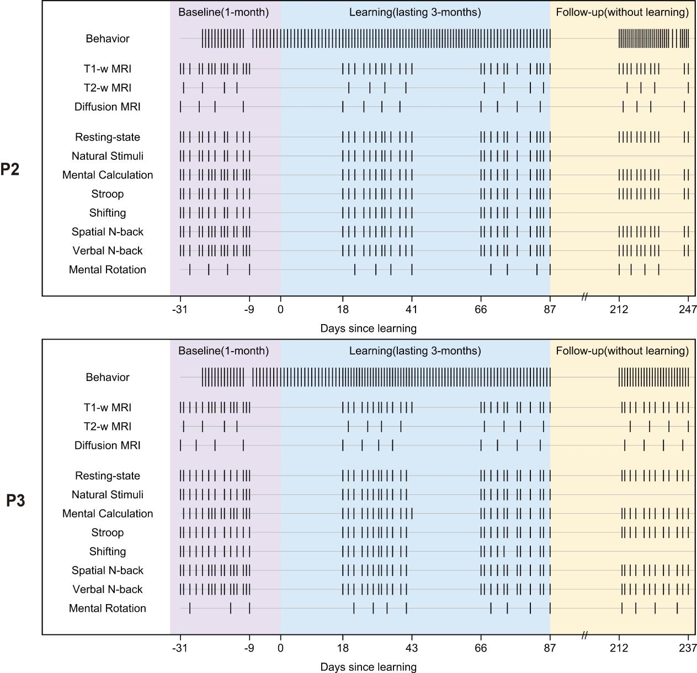
Supplementary Figure 1. Experimental timeline for P2 and P3. T1w, T1-weighted; T2w, T2-weighted; DTI, diffusion tensor imaging.
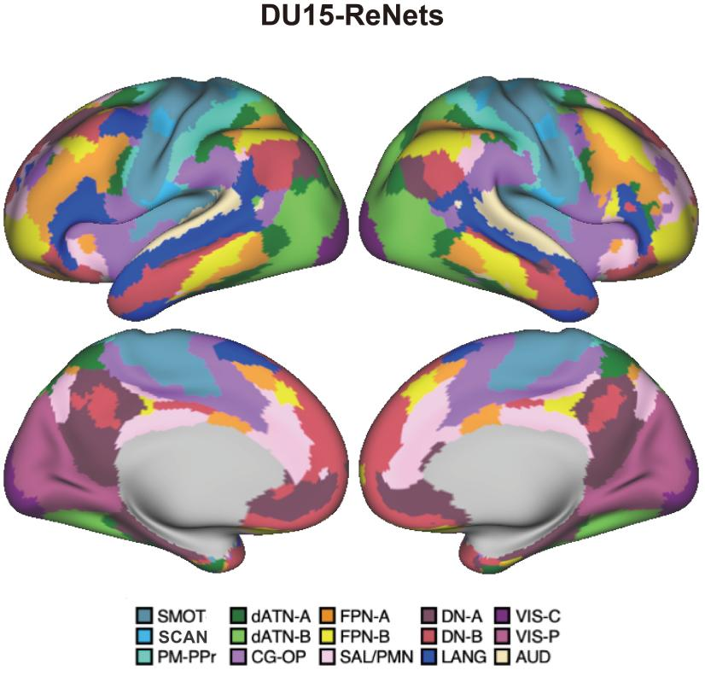
Supplementary Figure 2. The brain was parcellated into 15 networks based on the DU15 template. The original SMOT-A and SMOT-B components of this template were manually separated into distinct SMOT and SCAN networks for the present analysis. Colors indicate final network membership. SMOT, SomatomotorA; SCAN, somato-cognitive action network; PM-PPr, Premotor-Posterior Parietal Rostral; CGOP, Cingulo-Opercular; SAL/PMN, Salience/Parietal Memory Network; dATN-A, Dorsal Attention-A; dATN-B, Dorsal Attention-B; FPN-A, Frontoparietal Network-A; FPN-B, Frontoparietal Network-B; DN-A, Default Network-A; DN-B, Default Network-B; LANG, Language; VIS-C, Visual Central; VIS-P, Visual Peripheral; AUD, Auditory.

Supplementary Table 1. Summary of MRI scan time across experimental phases.

P1 / P2 / P3
Task | Baseline | Learning |  | Follow-up | Total Scans | Total Duration (min)
Structural MRI Tasks
T1-w MRI | 16/16/16 | 14/12/13 | 13/12/12 | 12/12/12 | 55/52/53 | 286.55/270.92/276.13
T2-w MRI | 4/4/4 | 4/4/4 | 4/4/4 | 4/4/4 | 16/16/16 | 81.44/81.44/81.44
Diffusion MRI | 4/4/4 | 4/4/4 | 4/4/4 | 4/4/4 | 16/16/16 | 87.84/87.84/87.84
Functional MRI Tasks
Resting-state fMRI | 13/12/13 | 12/12/12 | 12/12/12 | 12/12/12 | 49/48/49 | 686.00/672.00/686.00
Mental Calculation | 16/16/15 | 14/12/13 | 13/12/12 | 12/12/12 | 55/52/52 | 627.00/592.80/592.80
Stroop | 12/12/12 | 12/12/12 | 12/12/12 | 12/12/12 | 48/48/48 | 268.80/268.80/268.80
Spatial N-back | 16/16/16 | 12/12/12 | 12/12/12 | 12/12/12 | 52/52/52 | 455.00/455.00/455.00
Shifting | 14/12/12 | 14/12/12 | 12/12/11 | 0/0/0 | 40/36/35 | 464.00/417.60/406.00
Verbal N-back | 16/16/16 | 14/12/12 | 12/12/12 | 12/12/12 | 54/52/52 | 472.50/455.00/455.00
Mental Rotation | 4/4/3 | 5/4/4 | 4/4/4 | 4/4/4 | 17/16/15 | 197.20/185.60/174.00
Natural Stimuli | 12/12/13 | 12/12/12 | 12/12/12 | 0/0/0 | 36/36/37 | 504.00/504.00/518.00
All tasks total scan time
4130.33/3991.00/4001.01

Supplementary Table 2. Generalized additive model (GAM) fitting statistics for behavioral metrics across baseline and learning follow-up phases.

Participant | Metric | Phase | R²adj | F | P |  | Deviance Explained
P1 | Accuracy Score | Baseline | 0.12 | 3.97 | 0.060 | 16.6%
P1 | Accuracy Score | Learning Follow-up | 0.75 | 35.81 | < 0.001*** | 76.6%
P1 | Addition Span | Baseline | 0.60 | 4.39 | 0.011* | 75.3%
P1 | Addition Span | Learning Follow-up | 0.54 | 26.49 | < 0.001*** | 56.2%
P2 | Accuracy Score | Baseline | 0.31 | 1.98 | 0.125 | 48.5%
P2 | Accuracy Score | Learning Follow-up | 0.84 | 79.56 | < 0.001*** | 85.0%
P2 | Addition Span | Baseline | 0.30 | 1.63 | 0.206 | 51.4%
P2 | Addition Span | Learning Follow-up | 0.52 | 24.47 | < 0.001*** | 53.5%
P3 | Accuracy Score | Baseline | 0.77 | 8.75 | < 0.001*** | 85.0%
P3 | Accuracy Score | Learning Follow-up | 0.96 | 275.16 | < 0.001*** | 96.1%
P3 | Addition Span | Baseline | 0.62 | 5.67 | 0.002** | 71.8%
P3 | Addition Span | Learning Follow-up | 0.83 | 81.03 | < 0.001*** | 83.8%
Note: ***P < 0.001; **P < 0.01; *P < 0.05.

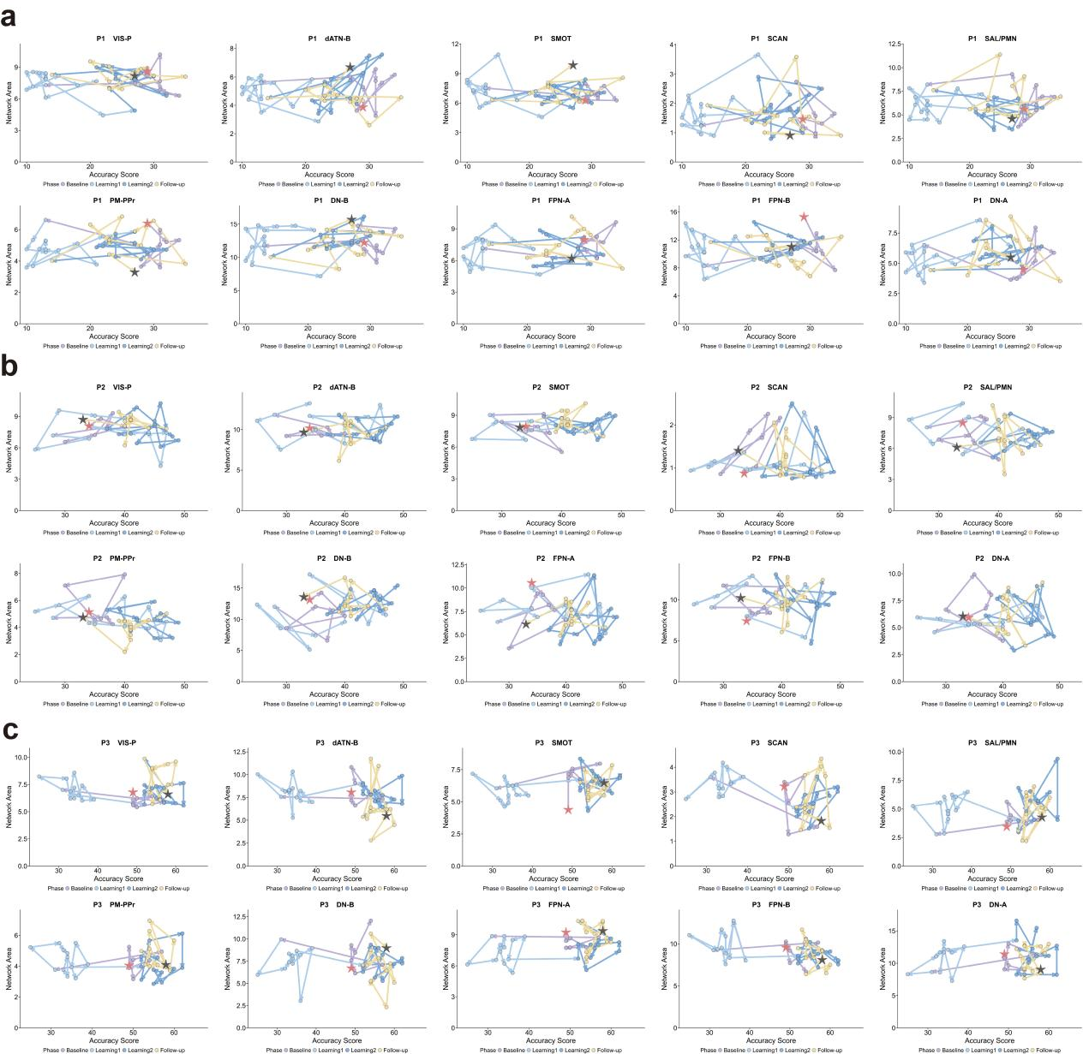

Supplementary Figure 3. Dynamic relationship between functional network architecture and behavioral accuracy. Asterisks denote the first (red color) and last (black color) scanning visits. P1-P3 indicate individual participants. SMOT, SomatomotorA; SCAN, somato-cognitive action network; PM-PPr, Premotor-Posterior Parietal Rostral; SAL/PMN, Salience/Parietal Memory Network; dATN-B, Dorsal Attention-B; FPN-A, Frontoparietal Network-A; FPN-B, Frontoparietal Network-B; DN-A, Default Network-A; DN-B, Default Network-B; VIS-P, Visual Peripheral.

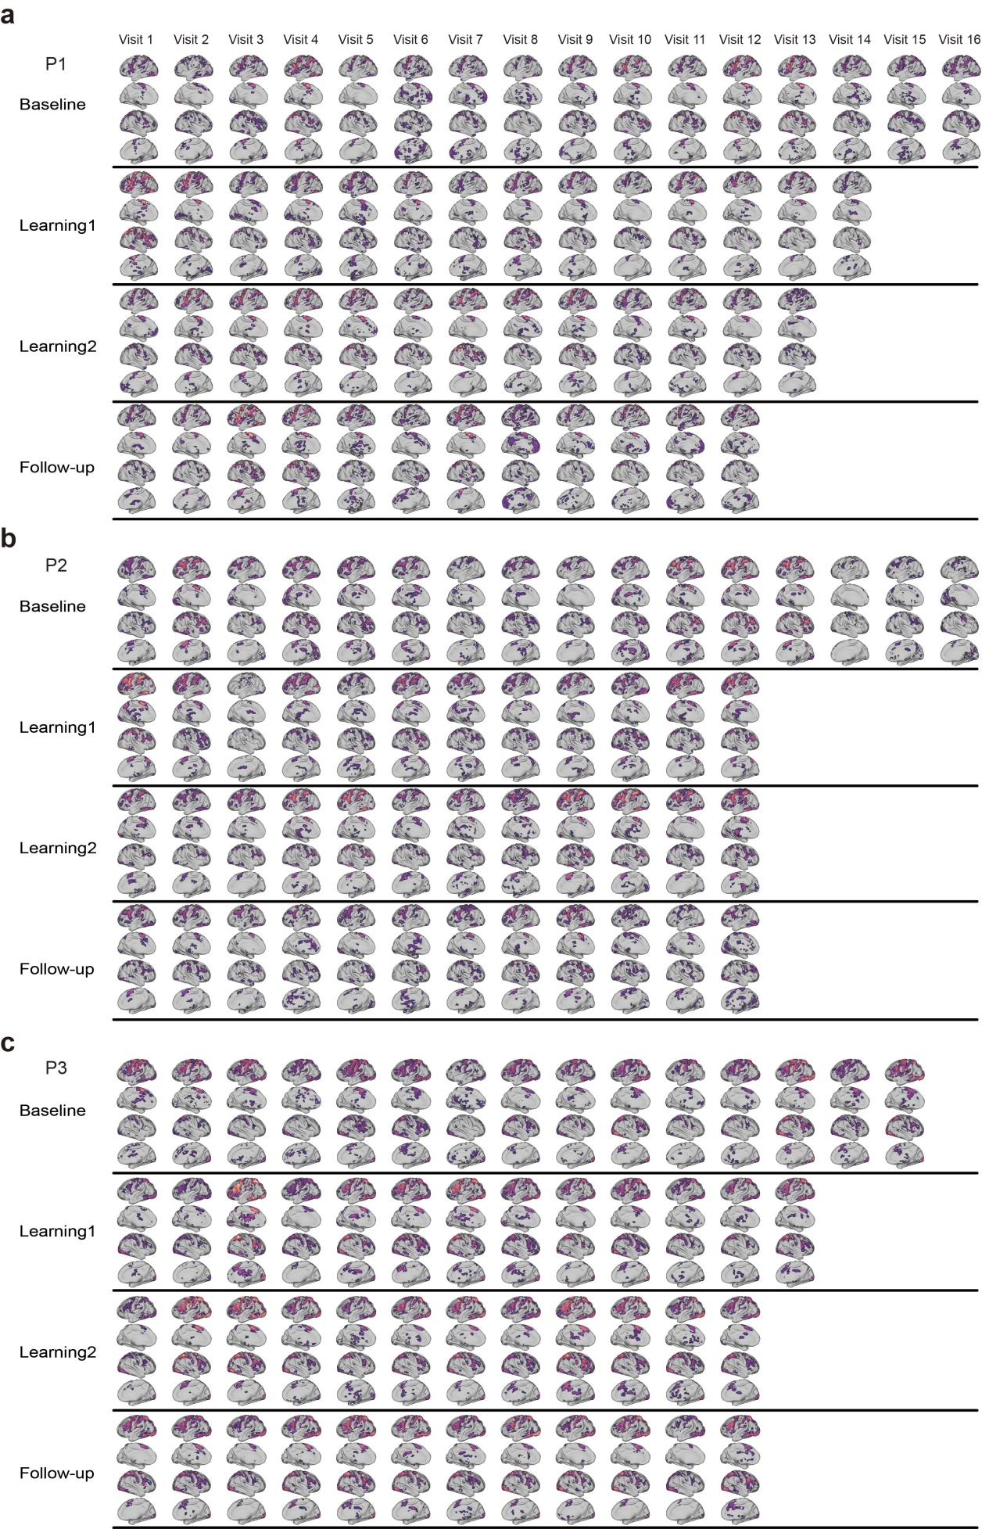
Supplementary Figure 4. Mental calculation activation maps for each scanning session across three subjects. Within each phase, visits are arranged chronologically from left to right.

