Methods

Experimental overview
A light pulse atom interferometer is conceptually similar to an optical interferometer, with the roles of light and matter interchanged. Atoms, acting as matter waves, are subjected to a sequence of light pulses which impart momentum to them, acting analogously to mirrors and beam splitters. Applying a light pulse for an appropriate length of time will cause a transition between the ground and excited states of an atom, accompanied by the absorption and stimulated emission of a photon. Such a pulse, commonly referred to as a π-pulse, acts as an atom-optic mirror due to the momentum that is transferred. Similarly, tuning the light pulse such that it only has a 50% transition probability, commonly referred to as a π/2-pulse, acts as a beam splitter through providing a momentum kick to only half of the atomic probability distribution. A matter wave equivalent of the optical Mach-Zehnder interferometer can then be created through applying a π/2 – π – π/2 pulse sequence with an evolution time, T, between the pulses. The resulting space-time area enclosed by the atomic trajectories (Extended data Fig. 1 right) is proportional to the local gravitational acceleration, which can then be measured from the relative population of the two atomic states after the final pulse.
A gravity gradiometer utilises two such interferometers offset vertically and probed simultaneously with the same pulse sequence. This suppresses common–mode effects, such as noise from vibration or phase changes due to variations in tilt with respect to the gravity of the Earth, which are indistinguishable from the gravity anomalies of interest due to Einstein’s equivalence principle. Our device consists of two sub-units (Extended data Fig. 1 left), a sensor head and a control system, with light and electrical signals transferred via a 5 m umbilical.
The sensor head features a vacuum system with dual magneto-optical trap (MOT) preparation and interrogation regions in an hourglass configuration, with all light delivered to the atoms via on-axis counter-orientated telescopes. The light is delivered in each direction, with portions of the beam being redirected towards the atom trapping region using in-vacuum mirrors, to form the radial cooling beams in each MOT. The central portion passes through, such that each input provides the vertical laser cooling beam in a given direction for both MOTs. This makes all fluctuations in intensity common for the radial cooling beams (preventing lateral offsets), and, through use of a Gaussian beam shape, provides a higher intensity for the vertical beams to better saturate the radiation pressure force in this direction. This results in a greatly improved stability and robustness of the laser cooling process, reducing fluctuations in temperature or atom-cloud position (Fig. 1b) without the need for excessive laser powers that would inhibit field operation. In a comparable test system, this provided a reduction in average cloud centre-of-mass motion to (0.14 ± 0.09) mm as compared to (1.19 ± 0.86) mm over an hour in similar conditions with a 6 beam MOT. A bias coil is positioned around the system to define a quantization axis and remove degeneracy between magnetic sub-levels. This has a variable pitch shape to account for edge effects and improve field uniformity over the atom interferometry region. The system is enclosed in a magnetic shield that provides 25dB attenuation of the external field. The in-situ magnetic field profile is measured (via spectroscopy of the Raman transition) as being homogeneous to below 5% across the atom interferometry region, limited by internal magnetic field sources from vacuum pumps.
The laser system consists of telecom lasers which are frequency doubled to 780 nm, to be near to the D2 line of rubidium-87,. Atom interferometry is realised via two-photon stimulated Raman transitions. The Raman laser used to drive these has a linewidth of 73 kHz and is locked with an offset of 1.9 GHz to the $|F=2>→|F^{'}=3>$ transition. The second Raman frequency is generated using an electro-optic modulation-based approach. Performing the differential measurement suppresses phase noise that may arise due to optical path-length changes between the two Raman beams (such as those due to vibration and thermally induced changes in the refractive index of fibres). This allows the two beams to be delivered independently without the need for a phase lock between them, facilitating an implementation in which the modulated spectrum is applied to only one of the input beams. This avoids parasitic Raman transitions that give rise to systematic offsets and dephasing when using conventional modulation-based schemes, such as those including a retro-reflected beam. To realise a practical implementation of space-time area reversal, also known as wave-vector reversal, the system has an electro-optic modulator in each input direction of the Raman beams, and the modulation signal is applied to one arm in each measurement before being inverted using a radio-frequency switch (see Extended data Fig. 1). The contributions to the interferometer phases due to the gravitational acceleration are sensitive to the direction of the recoil imparted by the light, while those arising from many other effects, such as those due to magnetic fields, are not. This allows these effects to be removed when interleaved measurements are performed in the two recoil directions. The Raman beams are delivered along the same beam axis as the cooling light, passing through the system without being redirected by the prisms. The polarisation of the light is set to the appropriate configuration for cooling or driving Raman transitions through use of voltage controlled variable retarder plates in the upper and lower telescopes used to deliver the light.
The experimental sequence starts by collecting approximately 10⁸ rubidium-87 atoms in each MOT from a background vapour over 1-1.5 s. Molasses cooling is then used to reduce the upper- and lower-cloud temperatures to (2.86 ± 0.09) μK and (3.70 ± 0.20) μK, respectively (see Fig. 1b). Optical state selection and velocity selection is performed to select only atoms in the $|F=1, m_{F}=0>$ magnetic sub-level and desired velocity class. This is achieved through application of π-pulses and a series of blow-away pulses to remove atoms in undesired states and velocity classes. Atom interferometry is then performed with a pulse separation of T = 85 ms and π-pulse length of 4 µs. The interferometers are read out using bi-state fluorescence detection to determine the atomic state population ratios of the |F=2> and |F=1> ground states, where (2.7 ± 0.1)∙10⁵ and (1.7 ± 0.1)∙10⁵ atoms participate in the upper and lower interferometers respectively, with a typical measurement rate of 0.7 Hz. The differential phase, from which the gravity gradient is derived, is extracted by plotting the upper interferometer outputs against the lower interferometer outputs, to form a Lissajous plot as shown in the inset of Fig. 2. The quantum projection noise of the system based upon the participating atom number is approximately 44 E/√Hz. The total noise budget includes contributions from additional terms, and is shown in Extended data Table 1, alongside relevant systematics observed during the survey. The noise budget was investigated via computer simulation of noise processes, compared to experimental data, and ellipse fitting.

Survey practice and processing of the measurement data
For each measurement on the survey, 600 runs of the atom interferometer were typically taken with the sensor head in one location, giving twelve 25-point ellipses in each of the interferometer directions and therefore 12 separate estimates of the gravity gradient. Repeat measurements were taken on each measurement position, with typically three points on each position. A measurement was taken at a base-station between each measurement point, with the final base-station measurement for one location used as the first for the next. The quality of fitting to each ellipse was identified using the error metric, $ε$, defined as
$ε=\frac{\left(\frac{1}{a}+\frac{1}{c}\right)}{2}{\left(\frac{1}{N}\sum_{i=1}^{N}{L_{i}^{2}}\right)}^{\frac{1}{2}}$,
where N is the number of data points, L is the minimum distance between each data point and a point on the ellipse and a and c correspond to an ellipse defined parametrically by equations $x=a\sin{θ}+b$ and $y=c\sin\left(θ+ϕ\right)+d$ respectively. Ellipse fits found to have $ε> 0.05$ were automatically discarded. This resulted in 98.4% of all data being usable in normal operation, representing a favourable data-up-time compared to similar conventional geophysical devices.
To process the data, a straight line was fitted to the base-station points, with this line then being subtracted from all data points. This is standard practice to remove drift in geophysical surveys. The gravity gradient value is then taken as the average of the measurement points, resulting in an estimate of the difference in gradient between the measurement location and the base-station. Additionally, the variations in the data points are used to make an estimate of the error in the difference value. When multiple measurements from the same location were combined, a weighted average was used, giving less weight to measurements with greater errors. The weighting factor is proportional to the reciprocal of the variance of each measurement.
The average of the gravity gradient error found across the measurement positions of the survey is 17.9 E. Comparing this to an approximate signal size of 150 E gives an approximate signal to noise ratio of 8.

Inference from gravity gradiometer data
Bayesian inference is a framework within which prior beliefs can be updated with information contained in data. For a model parameter vector, $θ$, and a data vector, $d$,
$p\left(θ | d\right)=\frac{p\left(d | θ\right)p\left(θ\right)}{p\left(d\right)}$,
where $p\left(d | θ\right)$ is the likelihood, $p\left(θ\right)$ the prior, $p\left(d\right)$ is a normalization constant and $p\left(θ | d\right)$ is the posterior distribution.
The likelihood function provides the misfit between the measured data, $d$, and the modelled data values calculated from the model parameter vector, $θ$. The model used here is that of a three-dimensional cuboid, the free model parameters are shown in Extended data Fig. 2, along with the functional form of the respective prior distributions. The rationale behind the chosen prior distributions is detailed in Extended data Table 2. The total uncertainty for each measurement point is calculated using the Pythagorean sum of the standard error and the model uncertainty random variable multiplied by the average standard error. The signals arising from local features in the forward model other than the anomaly of interest are subtracted from the data before the inference. These features include the basements, walls and drain shown in the scale drawing of Fig. 3b.
The probabilistic Python package pymc3 is used to implement the cuboid model, define the model parameter prior distributions and sample the posterior distribution, using a no U-turn sampler. Extended data Fig. 3 shows the Bayesian posterior distribution for select model parameters.
The parameter posterior distributions represent the updated beliefs about the model parameters, given the measurement data. To aid interpretation of the posterior distribution, the probability of excavation (POE) is calculated, which represents the spatial probability of the anomaly underground, given the model and prior distributions (as shown in Fig. 3c). The horizontal position of the tunnel centre is determined as (0.19 ± 0.19) m along the survey line, with the distribution being approximately Gaussian. The depth from the origin, defined in the vertical using the lowest point on the survey line, to the centre is (1.7 -0.59/+2.3) m. At the horizontal position of the tunnel, the distance to the surface from the origin is approximately 0.19 m meaning that the total distance from the surface to the tunnel centre is (1.89 -0.59/+2.3) m. From the tunnel geometry, this places the top of the tunnel at approximately 0.89 m depth from the surface.

Extended data Fig. 1
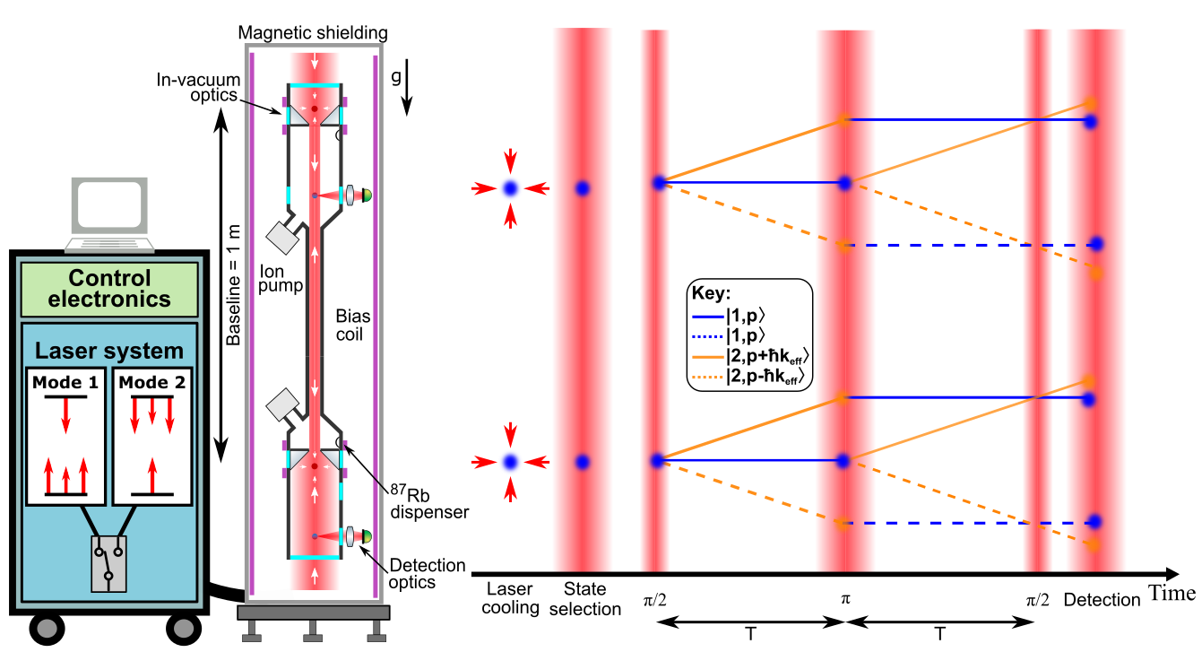

Extended data Fig. 1. Overview of the experimental system and the sequence used in the atom interferometer. The system is formed of the main sensor head and an enclosure for the laser and control systems, with the laser system showing the two modes of beam delivery that are used, with arrows representing the beams input to the chamber. The sensor head is formed using the hourglass configuration. This keeps all beam delivery along the central axis, improving stability and allowing the use of a radially compact magnetic shield. The laser system is formed of telecom lasers which are frequency doubled to 780 nm, to be near to the D2 transition line of rubidium-87. The laser light and electronic signals pass through an umbilical to reach the sensor head, with the laser light being delivered from the top and bottom of the sensor. The experimental sequence begins with atoms being loaded into two 3D MOTs, and then being dropped by turning off the laser light. While in free-fall, a sequence of velocity selective Raman pulses and blow away pulses are used to select only the desired magnetic sub-level state and velocity class, with other atoms being removed from the sequence. This is followed by a π/2- π- π/2 interferometry sequence. The Raman transitions are realised using an electro-optic modulator to create sidebands at a frequency difference equal to the hyperfine ground state splitting. In contrast to previous approaches^{4,,}, this is applied to only one input direction (laser system operating in Mode 1). This removes the effect of parasitic Raman transitions that create offsets and contrast loss in conventional modulation based approaches. This is enabled through the hourglass configuration allowing independent delivery of the Raman beams, while suppressing phase noise through differential operation. The laser system allows a practical implementation of space-time area reversal5, through switching which input direction contains the modulated beam spectrum (laser system operating in Mode 2). This reverses the direction of the first momentum kick in the interferometer causing it to open in the opposite direction (dashed lines in the interferometer sequence). The contributions to the phase due to the gravitational acceleration are sensitive to the direction of the recoil imparted by the light, while many other effects such as those due to magnetic fields are not. Interleaving measurements with interferometers running in each of these modes removes these sources of error while doubling the contribution due to gravity. Finally, the interferometer outputs are read out by measuring the atomic state populations of the two hyperfine ground states, using a fluorescence pulse delivered along the central axis, with the light that is scattered by the atoms being captured on a photodiode.

Extended data Fig. 2

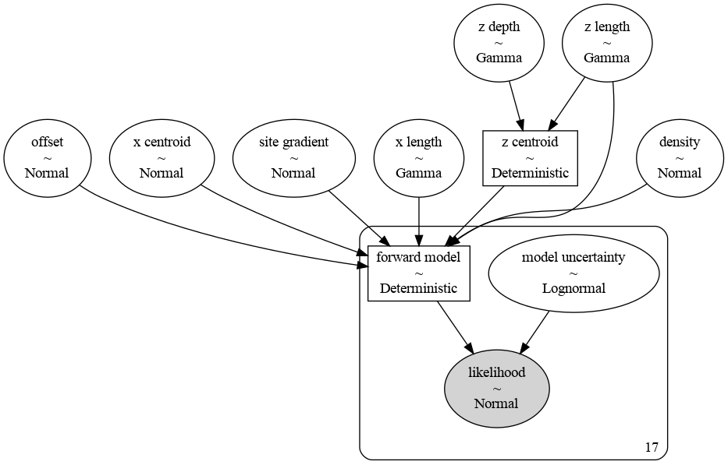
Extended data Fig. 2. Relationship between model parameters (white ovals), with their respective prior distribution form, to the normal likelihood distribution (grey oval). Deterministic parameters are shown in rectangular boxes. Parameters contained inside the rounded edge rectangle are all one dimensional arrays of length 17, the length of the gradiometer data set.

Extended data Fig. 3
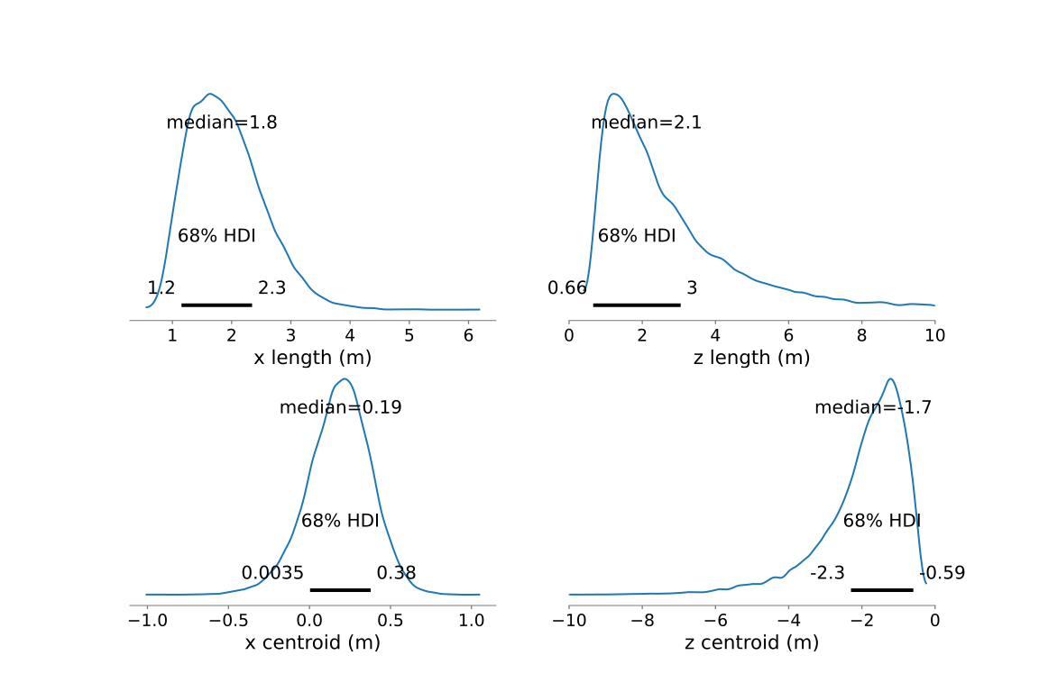
Extended data Fig. 3. Bayesian posterior distributions for selected model parameters, with x being the horizontal and z the vertical directions. The median and 68% highest density interval (HDI, represented by the black lines and numerical extents) are shown for each distribution. The shape of the z length and z centroid distributions is non-Gaussian due to the known depth ambiguity for gravity sensing and asymmetries in the boundary condition, i.e. the parameters being limited by the ground surface above the tunnel.

Extended data Table 1
Extended data Table 1, showing contributions to the uncertainty budget of the sensor during the measurement of the data set for Fig. 2, and systematic shifts during the survey of Fig. 3.
Sensor noise budget
Uncertainty source | Limiting noise level | Comments
Photodiode thermal noise (Johnson noise) | 144 E/√Hz | Measured from detection photodiodes and read out chain with no light present
Background light noise | 344 E/√Hz | Measured using reference pulses with no atoms present.
Atom shot noise | 184 E/√Hz | Number of atoms measured from photodiode signals using known detection geometry and detector sensitivity. This exceeds simple estimates of quantum projection noise due to noise arising from those atoms that do not participate in the interferometer. This is due to fringe contrast being less than 100% and because the gradiometer extracts differential phase through an ellipse-fitting process in the presence of common-mode noise, rather than phase differencing the outputs of two ideally-balanced interferometers.
Survey systematics
Source | Systematic shift | Comments
Coriolis shifts due to orientation angle (yaw) error | < 26 E, point to point | Calibrated during survey, finding 5.9 E/degree at orientation angle used in survey. Angle controlled to within 4.5 degrees, and measured using a theodolite (Leica TS15 Total Station).
Baseline stability | < 0.1 E | Estimated via time of flight, Fig. 1b.
Projection error due to instrument tilt (pitch, roll) error | < 1 E, point to point | Calibrated, measuring 1 E/millidegree shifts, representing 350x improvement over the projection shifts that would be observed for an ideal gravity sensor. Angle controlled to 0.001 degrees during survey using an inclinometer (Jewell Instruments DMP-2-10-232-AMP) and a machined pitch on the instrument feet.
Magnetic fields on site | <43 E, across site | No shift observed across a calibration range of 221 mGauss (measured at the lower cloud height) vertical field, applied using a coil of diameter 0.85 m, placed at the base of the sensor. Shifts are below measurement resolution. It is possible alternative geometries create different shifts, with the shape of the calibration field approximating that over the survey site. The magnitude of the applied field matches the peak-to-peak variation across the site for a measurement at the sensor height. The standard deviation of the calibration measurement was 43 E. The magnetic field measurements for the site and calibration field were performed with a Bartington Grad-13.

Extended data Table 2
Extended data Table 2, showing rationale behind the respective prior distributions, which have been informed through inspection using conventional geophysical equipment such as ground penetrating radar.
Model parameter (unit) | Explanation | Distribution | Rationale
X centroid (m) | Cuboid centroid in the x direction. | $$Normal\left(μ=0,σ=4\right)$$ | Cuboid unlikely to be located outside of the measurement line.
Z depth (m) | Depth to the top of the cuboid. | $$γ\left(α=2,β=0.5\right)$$ | Cuboid unlikely to be deeper than the measurement line width.
X length (m) | Length of the cuboid in the x direction. | $$γ\left(α=2,β=0.5\right)$$ | Positive value, unlikely to be larger than the measurement line width.
Z length (m) | Length of the cuboid in the z direction. | $$γ\left(α=2,β=0.5\right)$$ | Positive value, unlikely to be deeper than the measurement line width.
Density ($g/{{cm}^{2}}$) | Density difference between the void and surrounding soil. | $$Normal\left(-1.8,0.1\right)$$ | Informative prior, encoding feasible region of average soil density.
Site gradient ($E/m$) | Gravity gradient slope across the site. | $$Normal\left(0,10\right)$$ | Uninformative prior.
Offset (E) | Offset between the measured data and the modelled data. | $$Normal\left(0,10\right)$$ | Uninformative prior.
Model uncertainty (dimensionless) | The simple cuboid model has limited explanatory power to deal sufficiently with measurement outliers. | $$LogNormal\left(μ=0,σ=0.25,shape=\left(17,1\right)\right)$$ | Multiplied by the average uncertainty of the measurement points. Encoding that we expect an uncertainty of comparable magnitude to the average measurement uncertainty, due to the limited explanatory power of the simple cuboid forward model.

Stray, B. A cold atom gravity gradiometer with field application performance. Thesis, Univ. Birmingham (2021).
Lévèque, T., Antoni-Micollier, L., Faure, B. & Berthon, J. A laser setup for rubidium cooling dedicated to space applications. Appl. Phys. B, 116, 997–1004, https://doi.org/10.1007/s00340-014-5788-z (2014).
Theron, F., Carraz, O., Renon, G., Zahzam, N., Bidel, Y., Cadoret, M. & Bresson, A. Narrow linewidth single laser source system for onboard atom interferometry. Appl. Phys. B: Lasers Opt., 118, 1–5, https://doi.org/10.1007/s00340-014-5975-y (2015).
Carraz, O. et al. Phase shift in an atom interferometer induced by the additional laser lines of a Raman laser generated by modulation. Phys. Rev. A, 86, 033605, https://doi.org/10.1103/PhysRevA.86.033605 (2012).
Louchet-Chauvet, A. et al. The influence of transverse motion within an atomic gravimeter. New J. Phys. 13, 065025, https://doi.org/10.1088/1367-2630/13/6/065025 (2011).
Brennan, D. G. Linear Diversity Combining Techniques. Proceeding of the IRE, 47, 1075 – 1102, https://doi.org/10.1109/JPROC.2002.808163 (1959).
Okabe, M. Analytical expressions for gravity anomalies due to homogeneous polyhedral bodies and translations into magnetic anomalies. Geophysics, 44, 730–741, https://doi.org/10.1190/1.1440973 (1979).
Salvatier J., Wiecki T. V. & Fonnesbeck C. Probabilistic programming in Python using PyMC3. PeerJ Comput. Sci., 2:e55, https://doi.org/10.7717/peerj-cs.55 (2016).
Hoffman, M.D., Gelman, A. The No-U-Turn Sampler: Adaptively Setting Path Lengths in Hamiltonian Monte Carlo. J. Mach. Learn. Res., 15, 1351-1381, https://doi.org/10.5555/2627435.2638586 (2014).
Brown, G., Ridley, K., Rodgers, A., de Villiers, G. Bayesian signal processing techniques for the detection of highly localised gravity anomalies using quantum interferometry technology. SPIE, 99920, https://doi.org/10.1117/12.2240933 (2016).
Rammeloo, C., Zhu, L., Lien, Y., Bongs, K. & Holynski, M. Performance of an optical single-sideband laser system for atom interferometry. J. Opt. Soc. Am. B, 37, 1485-1493, https://doi.org/10.1364/JOSAB.385919 (2020).
Zhu, L., Lien, Y., Hinton, A., Niggebaum, A., Rammeloo, C., Bongs, K. & Holynski, M. Application of optical single-sideband laser in Raman atom interferometry. Opt. Express, 26, 6542-6553, https://doi.org/10.1364/OE.26.006542 (2018).

