Table 8
Phytochemical components identified in gu-ben-hua-shi (AESS) containing serum of rats.
NO | Components | 2D Structure | PubChem CID | Formula | CAS
1 | Neochlorogenic acid | 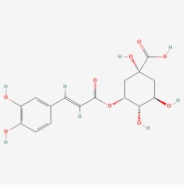 | 5280633 | C16H18O9 | 996-33-2
2 | Chlorogenic acid | 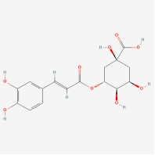 | 1794427 | C16H18O9 | 327-97-9
3 | Cryptochlorogenic acid | 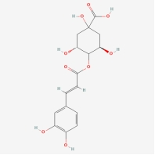 | 9798666 | C16H18O9 | 905-99-7
4 | Prim-O-glucosylcimifugin | 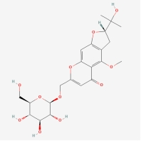 | 14034912 | C22H28O11 | 80681-45-4
5 | Rutin | 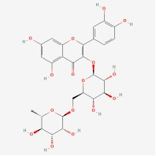 | 5280805 | C27H30O16 | 153-18-4
6 | Kaempferol-3-O-rutinoside | 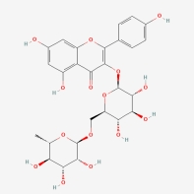 | 5318767 | C27H30O15 | 17650-84-9
7 | Narcissoside | 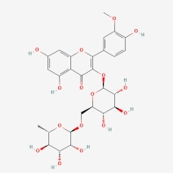 | 5481663 | C28H32O16 | 604-80-8
8 | Isochlorogenic acid A | 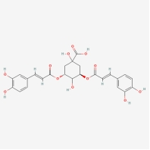 | 6474310 | C25H24O12 | 2450-53-5
9 | 5-O-Methylvisammioside | 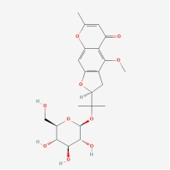 | 21670038 | C22H28O10 | 84272-85-5
10 | Isochlorogenic acid C | 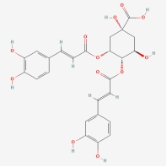 | 6474309 | C25H24O12 | 57378-72-0/32451-88-0

