Supplementary Tables
Table S1
The sequences of siRNAs/shRNAs used in this study.
Name | Sequences
si-YAP/shYAP | F：5’-CUGCCACCAAGCUAGAUAATT-3’  R：5’-UUAUCUAGCUUGGUGGCAGTT-3’
Negative control | F：5’-GCGACGAUCUGCCUAAGAUTT-3’  R：5’-AUCUUAGGCAGAUCGUCGCTT-3’
siRNA: short interfering RNAs; shRNAs: short hairpin RNAs.

Table S2
The dermatitis score and ear thickness of the mice.
Group | dermatitis score |  |  | ear thickness（mm）
Group | male |  | female | male | female
Ctrl | 0 | 0 |  | 0.150±0.012 |  | 0153±0.012
AD | 4.000±1.000 | 3.667±1.528 |  | 0.207±0.021 |  | 0.210±0.010
AD+0.5 AESS | 3.667±0.577 | 4.333±1.155 |  | 0.200±0.010 |  | 0.203±0.006
AD+AESS | 2.000±1.000 | 1.667±0.577 |  | 0.183±0.006 |  | 0.177±0.006
AD+2 AESS | 1.667±0.577 | 1.000±0.000 |  | 0.173±0.006 |  | 0.163±0.006
AD+sh-YAP+AESS | 4.333±1.155 | 4.000±1.000 |  | 0.237±0.015 |  | 0.237±0.116
AD+DEX | 1.333±0.577 | 1.000±0.000 |  | 0.153±0.006 |  | 0.170±0.010
Ctrl: control mice; AD, atopic dermatitis model mice; AD+0.5 AESS: mice intragastrically administered of 1/2 of the standard dose of AESS formula; AD + AESS: mice intragastrically administered the standard dose of AESS formula; AD +2 AESS: mice intragastrically administered of 2 times of the standard dose of AESS formula; AD + sh-YAP + AESS: mice of the AD + AESS group injected with shRNA-YAP lentivirus; AD + DEX: mice intragastrically administered 3 mg/kg dexamethasone.

Table S3
Trans Epidermal Water Loss (TEWL) of the mice (g/m²hr).
Group | Week 1 |  | Week 2 |  | Week 3
Group | male | female | male | female | male | female
Ctrl | 6.222±0.509 | 6.556±0.193 | 6.889±0.385 | 6.889±0.385 | 6.889±0.385 | 6.666±0.577
AD | 6.889±1.071 | 6.556±0.839 | 10.778±0.962 | 11.556±1.836 | 17.444±1.644 | 16.778±1.503
AD+0.5 AESS | 7.222±1.018 | 6.667±1.334 | 9.778±1.262 | 9.111±0.770 | 15.111±0.509 | 14.555±0.694
AD+AESS | 6.556±0.839 | 6.889±0.694 | 8.667±0.577 | 7.222±0.509 | 10.556±0.839 | 11.000±2.309
AD+2 AESS | 6.111±0.694 | 6.556±0.770 | 6.333±0.882 | 6.111±0.509 | 8.000±0.333 | 8.222±1.262
AD+sh-YAP  +AESS | 7.111±0.385 | 7.111±0.694 | 12.556±0.839 | 12.000±2.082 | 18.778±0.509 | 18.778±0.509
AD+DEX | 7.667±0.334 | 7.778±0.962 | 11.778±1.018 | 11.778±1.575 | 18.111±0.509 | 17.667±1.667
Ctrl: control mice; AD, atopic dermatitis model mice; AD+0.5 AESS: mice intragastrically administered of 1/2 of the standard dose of AESS formula; AD + AESS: mice intragastrically administered the standard dose of AESS formula; AD +2 AESS: mice intragastrically administered of 2 times of the standard dose of AESS formula; AD + sh-YAP + AESS: mice of the AD + AESS group injected with shRNA-YAP lentivirus; AD + DEX: mice intragastrically administered 3 mg/kg dexamethasone.
Table S4
Stratum corneum hydration (SCH) of the mice (a.u.).
Group | Week 1 |  |  | Week 2 |  |  | Week 3
Group | male | female |  | male | female |  | male | female
Ctrl | 20.444±1.836 |  | 20.334±0.577 | 20.444±0.193 |  | 21.889±1.347 | 20.222±0.509 |  | 19.778±0.770
AD | 18.111±1.071 |  | 19.222±1.388 | 15.222±0.509 |  | 14.889±1.071 | 12.111±0.385 |  | 10.111±0.694
AD+0.5 AESS | 19.333±0.882 |  | 19.333±1.000 | 15.889±1.678 |  | 16.666±1.155 | 12.000±1.528 |  | 11.222±0.839
AD+AESS | 19.667±1.000 |  | 20.556±0.839 | 19.333±1.000 |  | 18.556±0.193 | 16.556±0.839 |  | 16.111±0.694
AD+2 AESS | 20.444±1.018 |  | 19.667±0.667 | 19.778±0.694 |  | 19.889±0.839 | 18.333±0.667 |  | 18.666±1.155
AD+sh-YAP  +AESS | 19.334±1.155 |  | 19.444±0.839 | 12.000±1.528 |  | 12.778±1.895 | 8.889±0.694 |  | 8.111±1.071
AD+DEX | 18.556±0.509 |  | 18.778±0.509 | 14.222±0.509 |  | 14.222±0.694 | 10.444±0.509 |  | 10.333±0.882
Ctrl: control mice; AD, atopic dermatitis model mice; AD+0.5 AESS: mice intragastrically administered of 1/2 of the standard dose of AESS formula; AD + AESS: mice intragastrically administered the standard dose of AESS formula; AD +2 AESS: mice intragastrically administered of 2 times of the standard dose of AESS formula; AD + sh-YAP + AESS: mice of the AD + AESS group injected with shRNA-YAP lentivirus; AD + DEX: mice intragastrically administered 3 mg/kg dexamethasone.

Supplementary Figures
Fig. S1. UPLC-MS/MS chromatograms of main prototypes and metabolites in drug-containing serum.
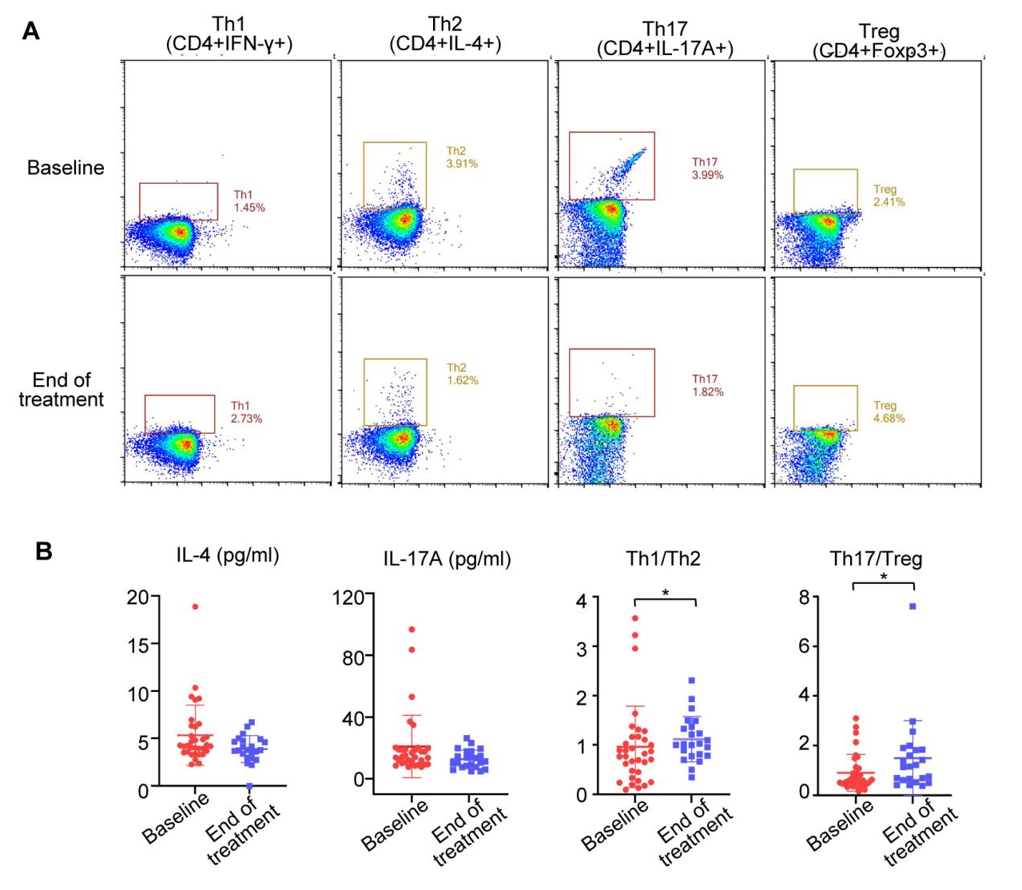Fig. S2. The effect of gu-ben-hua-shi (AESS) on inflammatory disorder in atopic dermatitis (AD) patients. (A) Flow cytometry results from the clinical patients before/after AESS treatment. (B) Scatter plot of IL-4, IL-17A, Th1/Th2 and Th17/Treg of the clinical patients before/after AESS treatment. *P<0.05 v.s. Baseline

Fig. S3. The effect of gu-ben-hua-shi (AESS) on autophagy in atopic dermatitis (AD) mice models. (A) LC3 positive cells in mice skin lesions from immunofluorescence (left: 400×; middle: 600×; right:1000×, red arrows indicate LC3 fluorescent points). Ctrl: control mice; AD, atopic dermatitis model mice; AD+0.5 AESS: mice intragastrically administered of 1/2 of the standard dose of AESS formula; AD + AESS: mice intragastrically administered the standard dose of AESS formula; AD +2 AESS: mice intragastrically administered of 2 times of the standard dose of AESS formula; AD +sh-YAP + AESS: mice of the AD + AESS group injected with shRNA-YAP lentivirus; AD + DEX: mice intragastrically administered 3 mg/kg dexamethasone.
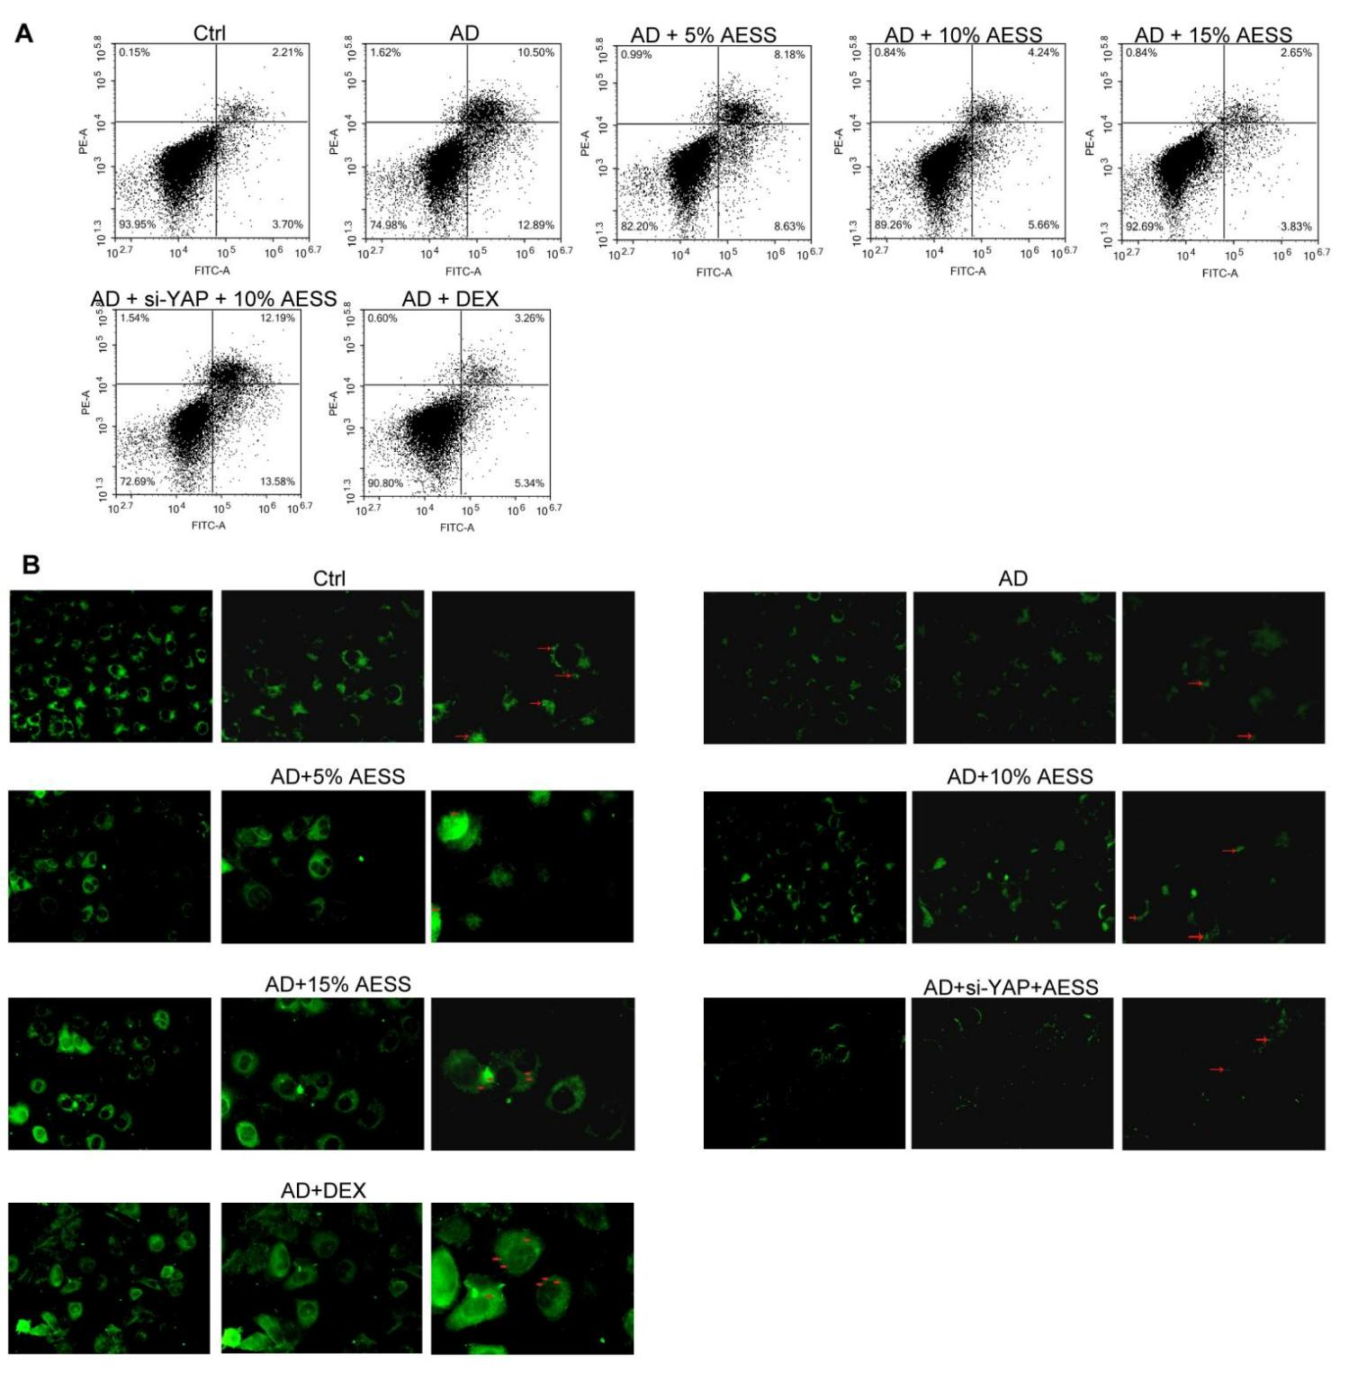
Fig. S4. The effect of gu-ben-hua-shi (AESS) on atopic dermatitis (AD) like inflammatory cell model. (A) Flow cytometry analysis of cell apoptosis rate results. (B) LC3 positive cells in cells from immunofluorescence (left: 400×; middle: 600×; right:1000×, red arrows indicate LC3 fluorescent points). Ctrl: control cells; AD: atopic dermatitis like inflammatory cells; AD+5% AESS: AD-like cells cultured with 5% AESS contained serum; AD+10% AESS: AD-like cells cultured with 10% AESS contained serum; AD+15% AESS: AD-like cells cultured with 15% AESS contained serum; AD+si-YAP+10% AESS: cells of the AD+10% AESS group transfected with YAP si-RNA; AD+DEX: AD-like cells cultured with 20 μg/mL dexamethasone.

Supplementary Methods
Chemical analysis of gu-ben-hua-shi formula (AESS)
The characteristic fingerprint of gu-ben-hua-shi formula (AESS) was developed by using high performance liquid chromatography/tandem mass spectrometry (UPLC-MS/MS). UPLC-MS/MS technology was carried out by Dionex Ultimate HPLC 3000 coupled with QE-Orbitrap mass spectrometer was used in the analytical method development (Thermo-Fisher, USA), and the separation was performed on Hypersil GOLD column (2.1×100 mm, 1.9 μm). Mobile phase: 0.1% formic acid water (A)–acetonitrile (B). Gradient elution: 0–2 min, 5% B; 2–42 min, 5–95%B; 42–47 min, 95%B; 47–47.1 min, 95–5%B; 47.1–50 min, 5%B. Flow rate: 0.3 mL/min. The sample injection volume was 5 μL., and the column temperature was maintained at 40°C throughout the analysis period. The mass spectrometer was equipped with an electrospray ionization (ESI) interface operated in both positive and negative ion mode. Scanning range: 100.0–1500.0 m/z. Ion source temperature: 320℃; The resolution was set at 70,000; The capillary voltage was 3.5 kV in positive ion mode and 3.2 kV in negative ion mode.
Sample size calculation
Based on previous studies (Ping, 2021), the threshold was set at 70% and the expected value was set at 90%. Under these conditions, α= 0.05, β= 0.2, significance level of 0.05 and 80% power (PASS statistic software, version 15.0, NCSS), the total sample size was 26 patients, and assuming a dropout rate of 20% by considering ineligible subjects, a total of 34 individuals were included in the study.
Reference
Jia J, Feng L, Ye S, Ping R, Mo X, Zhang Y, Li X, Chen D. 2022. Therapeutic effect of chinese herbal medicine gu-ben-hua-shi (AESS) formula on atopic dermatitis through regulation of yes-associated protein. Front. Pharmacol. 13, 929580.
Ping RY. 2021. An exploratory study on the metabolomics of patients with eczema and the effect of Gubenhuashi Decoction on eczema and metabolomics [phd’s thesis], Guangzhou University of Chinese Medicine.

