Supplementary information

Time-Resolved Detection of Multilevel Switching of the Magnetization and Exchange Bias Driven by Spin-Orbit Torques

Yuyan Wang^{1,2}*, Takuya Taniguchi², Po-Hung Lin³, Daniel Zicchino², Andreas Nickl², Jan Sahliger², Chih-Huang Lai³, Cheng Song⁴, Huaqiang Wu^{1,5}, Qionghai Dai¹, Christian Back²*
¹Beijing National Research Center for Information Science and Technology, Tsinghua University, Beijing, China. ²Department of Physics, Technical University of Munich, Garching b. Munich, Germany. ³Department of Materials Science and Engineering, National Tsing Hua University, Hsinchu, Taiwan. ⁴School of Materials Science and Engineering, Tsinghua University, Beijing, China. ⁵School of Integrated Circuits, Tsinghua University, Beijing, China.
Email: wangyuyan@tsinghua.edu.cn; christian.back@tum.de

Supplementary Note 1: Magnetic properties of the thin film samples

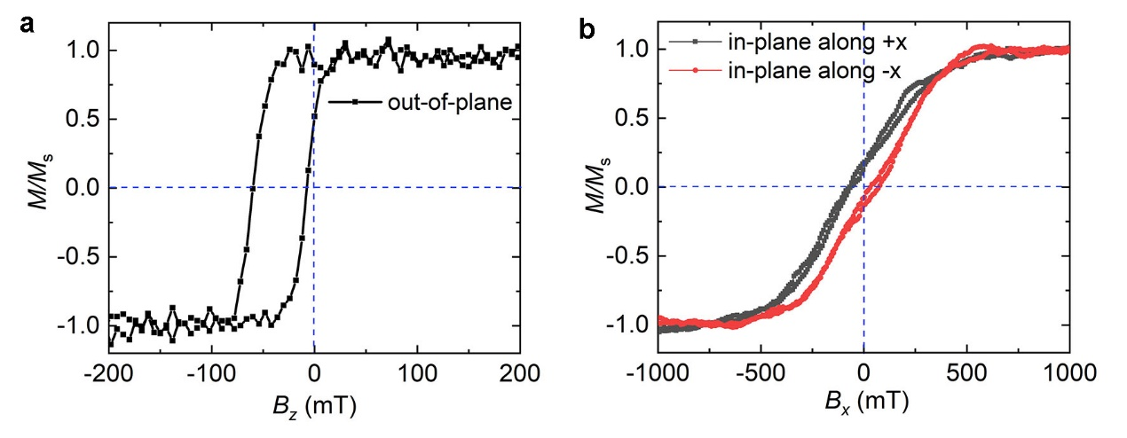
Fig. S1. Normalized M-H loops along the (a) out-of-plane direction, (b) in-plane direction obtained using vibrating sample magnetometer (VSM). The in-plane M-H loops are measured with the externally applied magnetic field along the in-plane direction of the annealing field (black squares), and opposite to the annealing field (red circles), respectively.

Supplementary Note 2: Time-resolved SOT switching

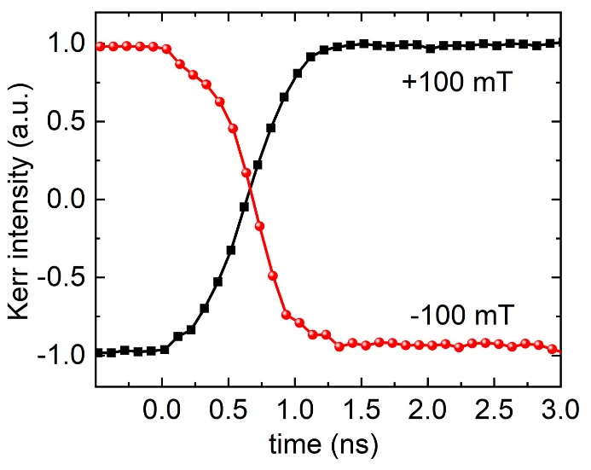
Fig. S2 Reversal of the magnetization m_{z} for opposite directions of the in-plane magnetic field B_{x} = +100 mT and –100 mT as a function of delay time. The magnetization of Co switches between upward and downward orientation when the direction of the external magnetic field B_{x} is reversed.

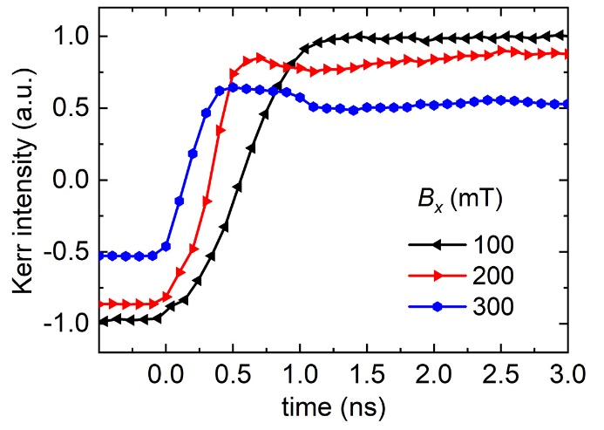
Fig. S3 Time-resolved magnetization switching for negative current pulses and different in-plane magnetic fields B_{x} larger than 100 mT. Full switching of the magnetization is achieved at B_{x} = 100 mT, as discussed in Fig. 2a in the main text. When B_{x} exceeds the critical field of 100 mT, the polar Kerr signal decreases dramatically due to the tilt of the magnetization towards the in-plane magnetic field B_{x}, together with a notable increase of the switching speed.

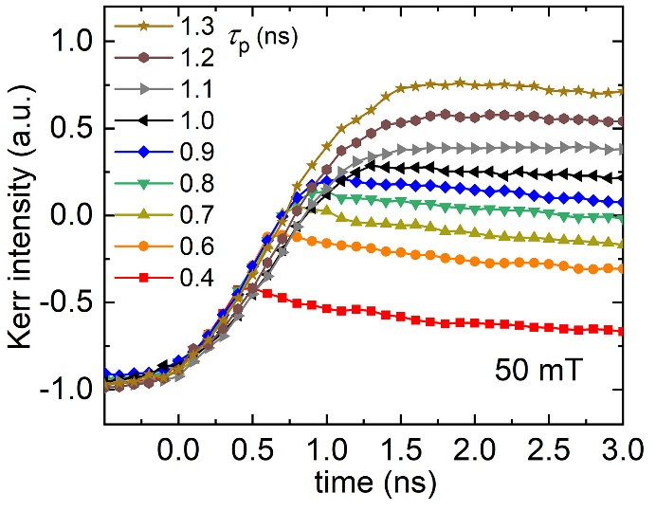
Fig. S4 Time-resolved magnetization switching at B_{x} = 50 mT and current pulse length 𝛕_{P} ranging from 0.4 ns to 1.3 ns.

Supplementary Note 3: Quasistatic SOT switching

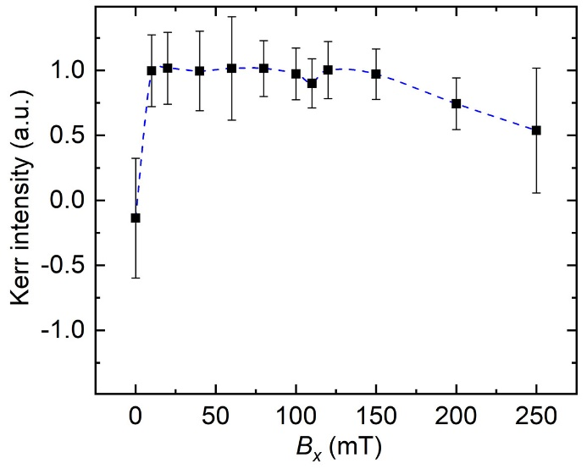
Fig. S5 Summarized Kerr intensity (normalized) for quasistatic current induced magnetization reversal for different external magnetic fields B_{x}.

Supplementary Note 4: Micromagnetic simulations

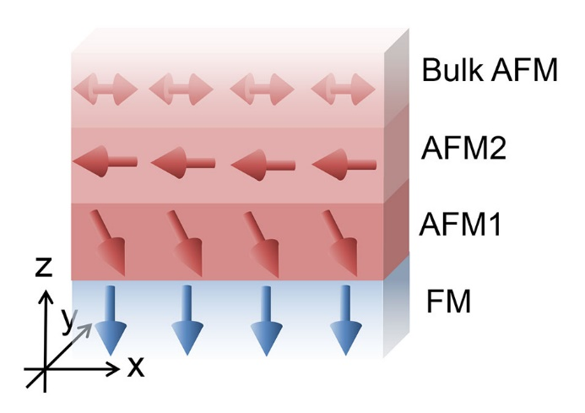
Fig. S6 Schematic illustration of the system used in the simulation. The blue and red arrows indicate the magnetization of each layer. The detailed parameters are described in the part of Methods of the main text.

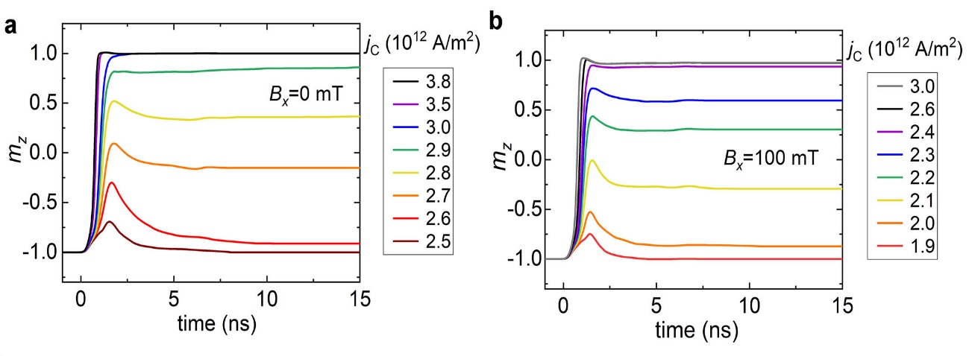
Fig. S7 Micromagnetic simulations of the time-resolved SOT switching process on a timescale of 15 ns. Magnetization switching for different current densities (a) when the external field is absent, and (b) with in-plane field B_{x} of 100 mT. The switching of the magnetization stabilizes after 6 ns and is non-volatile, being is faster for larger B_{x}.

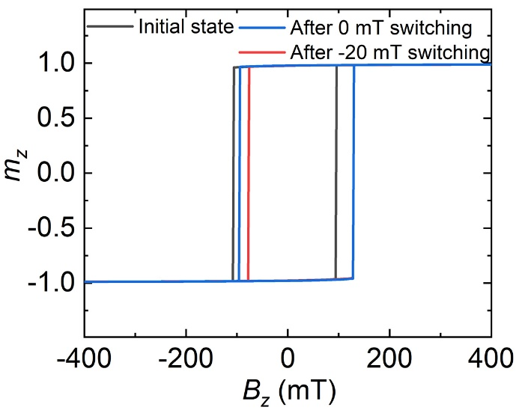
Fig. S8 Micromagnetic simulations of the out-of-plane M-H loops before and after SOT switching at B_{x} = 0 mT and B_{x} = –20 mT, which indicates the reversal of exchange bias. Larger in-plane field of –20 mT results in a more shift of exchange bias field (26 mT) than that of zero in-plane field (17 mT).

