Table 1:Roof Form Memetic Extraction
Cultural Genes | Chart | Roof Form | Styling Features | Meme Distillation | $${\text{w}}_{\text{i}}$$ | $${\text{C}}_{\text{I}}$$ | $${\text{C}}_{\text{R}}$$
$${\text{C}}_{\text{11}}$$ | 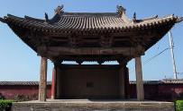 | Single-eave hip roof | 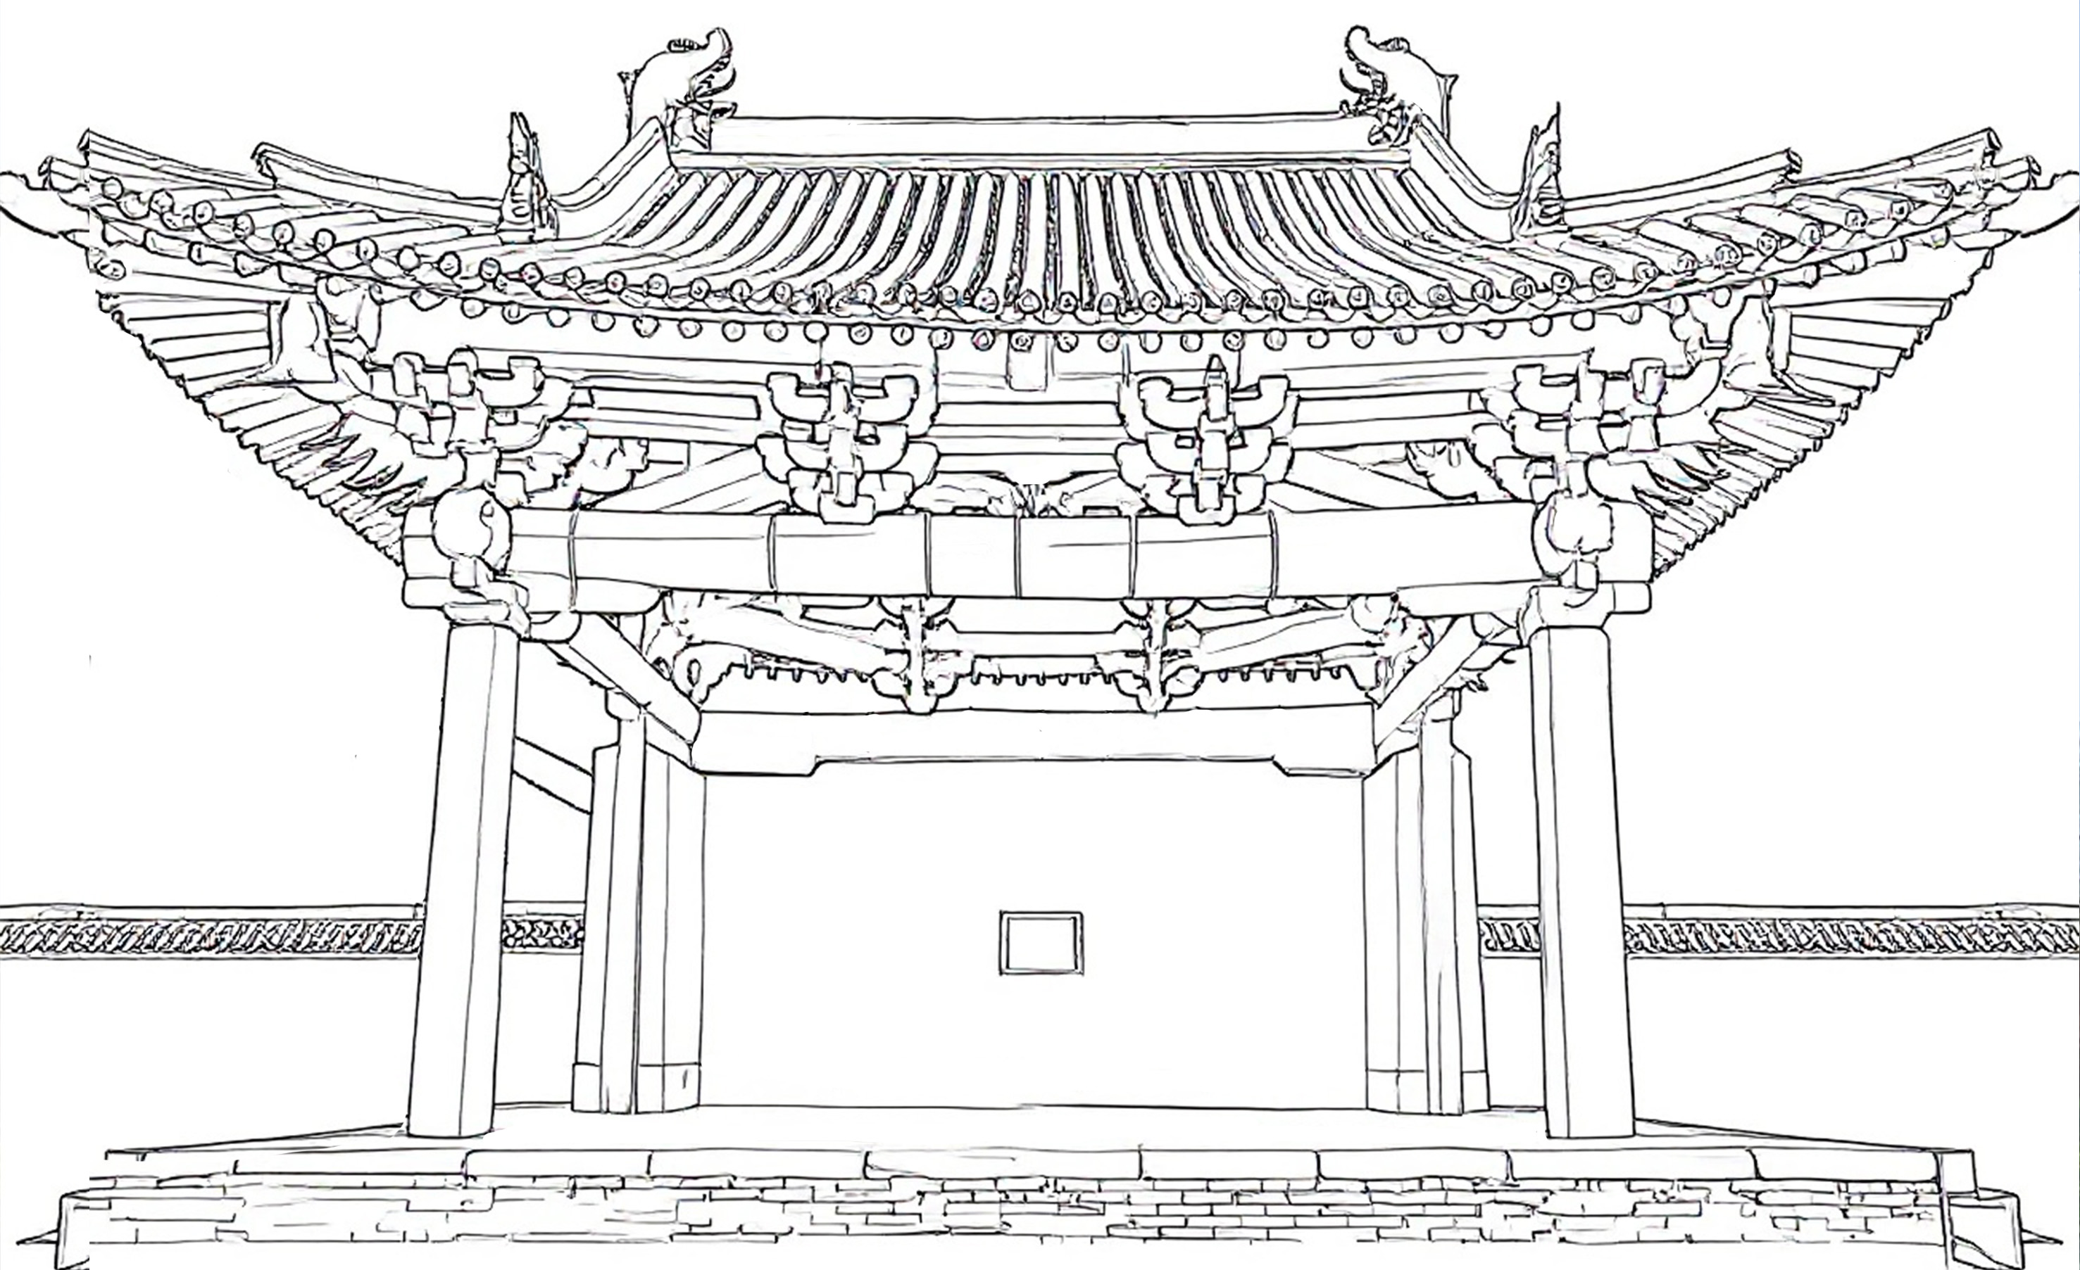 | 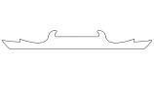 | 0.191 | 0.02 | 0.016
${\text{C}}_{\text{1}\text{2}}$ | 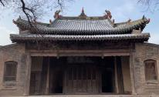 | Double-eaved hipped roof |  | 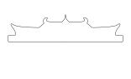 | 0.109 | 0.02 | 0.016
$${\text{C}}_{\text{1}\text{3}}$$ | 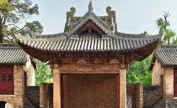 | Single-eave cross gable roof | 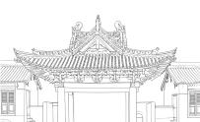 | 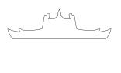 | 0.476 | 0.02 | 0.016
$${\text{C}}_{\text{1}\text{4}}$$ | 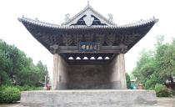 | Single-eave cross gable roof | 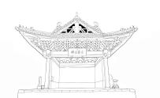 | 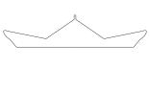 | 0.060 | 0.02 | 0.016
$${\text{C}}_{\text{1}\text{5}}$$ | 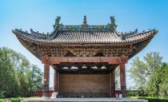 | Single-eave hip roof | 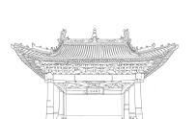 | 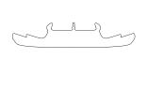 | 0.126 | 0.02 | 0.016
$${\text{C}}_{\text{1}\text{6}}$$ | 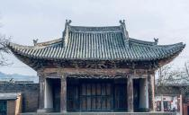 | Single-eave hip roof | 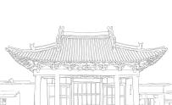 | 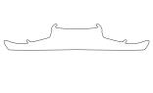 | 0.037 | 0.02 | 0.016

Table 2: Extraction of Structural Form Memes
Cultural Genes | Chart | Structural Features | Structure Extraction | Meme Distillation | $${\text{w}}_{\text{i}}$$ | $${\text{C}}_{\text{1}}$$ | $${\text{C}}_{\text{R}}$$
$${\text{C}}_{\text{2}\text{1}}$$ | 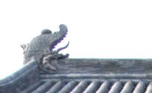 | Chimera | 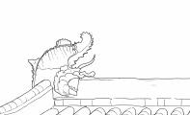 | 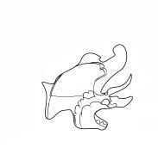 | 0.210 | 0.011 | 0.009
$${\text{C}}_{\text{2}\text{2}}$$ | 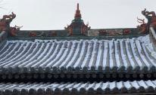 | Finial | 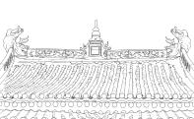 | 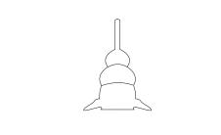 | 0.341 | 0.011 | 0.009
$${\text{C}}_{\text{2}\text{3}}$$ |  | Pediment | 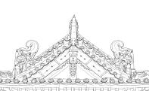 | 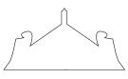 | 0.075 | 0.011 | 0.009
$${\text{C}}_{\text{2}\text{4}}$$ | 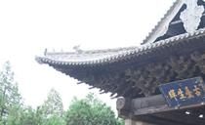 | Eaves | 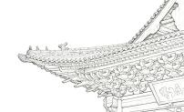 | 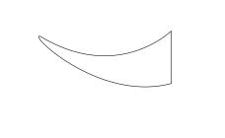 | 0.259 | 0.011 | 0.009
$${\text{C}}_{\text{2}\text{5}}$$ | 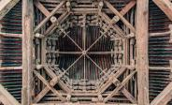 | Coffered ceiling | 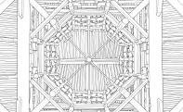 | 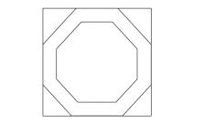 | 0.067 | 0.011 | 0.009
$${\text{C}}_{\text{2}\text{6}}$$ | 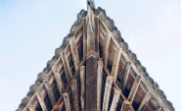 | Dougong | 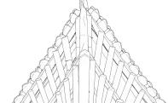 | 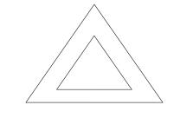 | 0.048 | 0.011 | 0.009

Table 3 Pattern Memes Extraction
Cultural Genes | Chart |  | Decorative Extraction | Location | Styling Features | Meme Distillation | $${\text{w}}_{\text{i}}$$ | $${\text{C}}_{\text{1}}$$ | $${\text{C}}_{\text{R}}$$
$${\text{C}}_{\text{3}\text{1}}$$ | 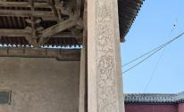 |  | Pillar Pattern | Pillar | 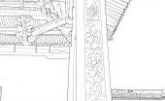 | 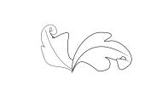 | 0.071 | 0.032 | 0.025
$${\text{C}}_{\text{3}\text{2}}$$ | 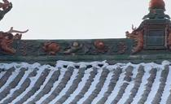 |  | Peony | Spinal Adjustment | 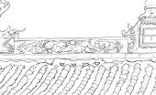 |  | 0.114 | 0.032 | 0.025
$${\text{C}}_{\text{3}\text{3}}$$ | 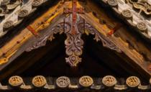 |  | Interlaced scrollwork | Pediment | 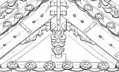 |  | 0.210 | 0.032 | 0.025
$${\text{C}}_{\text{3}\text{4}}$$ | 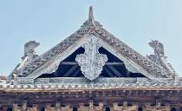 |  | Ruyi Cloud Pattern | Pediment | 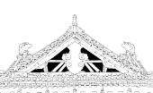 | 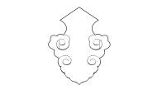 | 0.053 | 0.032 | 0.025
$${\text{C}}_{\text{3}\text{5}}$$ | 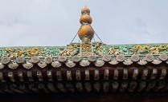 |  | Scrollwork Lotus Pattern | Finial | 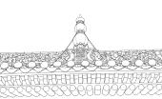 | 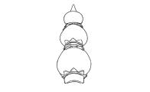 | 0.456 | 0.032 | 0.025
$${\text{C}}_{\text{3}\text{6}}$$ | 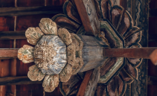 |  | Lotus Petal Pattern | Coffered ceiling | 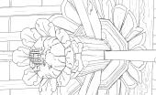 | 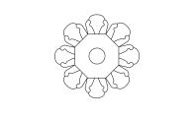 | 0.097 | 0.032 | 0.025

Table 4: Extraction of Material Memes
Cultural Genes |  | Chart | Building Materials | Styling Features | Meme Distillation | （${\text{w}}_{\text{i}}$） | $${\text{C}}_{\text{1}}$$ | $${\text{C}}_{\text{R}}$$
$${\text{C}}_{\text{4}\text{1}}$$ | 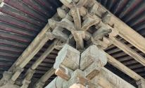 |  | Wood | 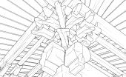 | 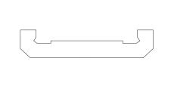 | 0.212 | 0.02 | 0.016
$${\text{C}}_{\text{4}\text{2}}$$ | 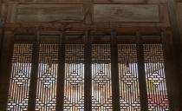 |  | Wood | 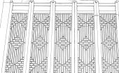 | 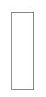 | 0.302 | 0.02 | 0.016
$${\text{C}}_{\text{4}\text{3}}$$ | 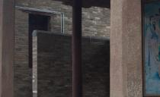 |  | Stone | 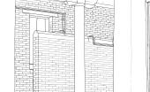 | 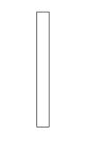 | 0.052 | 0.02 | 0.016
$${\text{C}}_{\text{4}\text{4}}$$ | 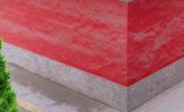 |  | Brick | 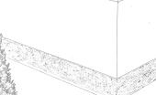 | 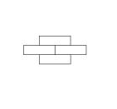 | 0.059 | 0.02 | 0.016
$${\text{C}}_{\text{4}\text{5}}$$ | 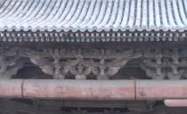 |  | Pottery | 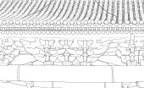 | 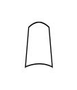 | 0.054 | 0.02 | 0.016
$${\text{C}}_{\text{4}\text{6}}$$ | 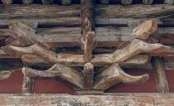 |  | Wood | 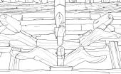 | 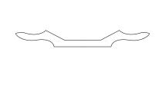 | 0.322 | 0.02 | 0.016

Table 5: Color Meme Extraction
Cultural Genes | Chart | Color extraction | CMYK values | Semantics | $${\text{w}}_{\text{i}}$$ | CI | CR
$${\text{C}}_{\text{5}\text{1}}$$ | 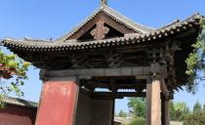 | 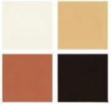 | 4,15,11,0  16,31,51,0  35,69,73,0  79,81,86,68 | Warding off evil spirits, praying for blessings | 0.116 | 0.021 | 0.017
$${\text{C}}_{\text{5}\text{2}}$$ | 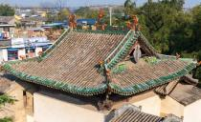 |  | 56,31,36,0  31,20,43,0  7,8,19,0  23,43,54,0 | auspicious, festive | 0.318 | 0.021 | 0.017
$${\text{C}}_{\text{5}\text{3}}$$ | 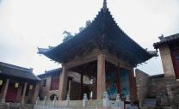 | 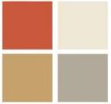 | 8, 12, 20, 62  8，10，18，0  0, 70, 65, 25  5, 8, 18, 35 | Sacred,solemn, prayerful, hierarchical | 0.188 | 0.021 | 0.017
$${\text{C}}_{\text{5}\text{5}}$$ | 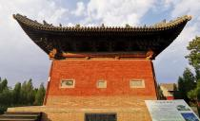 | 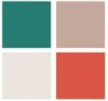 | 82,43,59,1  28,36,36,0  10,11,14,0  18,79,71,0 | Prayer, Vitality | 0.171 | 0.021 | 0.017
$${\text{C}}_{\text{5}\text{6}}$$ | 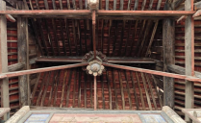 | 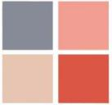 | 54,44,34,0  5,50,35,0  11,28,29,0  18,79,71,0 | Simple, festive, and folk | 0.041 | 0.021 | 0.017

Table 6 Semantic Meme Extraction
Cultural Genes | Chart | Keyword | Semantic Extraction | Symbol extraction | Meme Distillation | $${\text{w}}_{\text{i}}$$ | $${\text{C}}_{\text{1}}$$ | $${\text{C}}_{\text{R}}$$
$${\text{C}}_{\text{6}\text{1}}$$ | 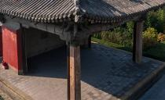 | Gedestal | Moral Edification | 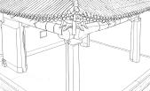 | 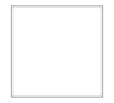 | 0.087 | 0.018 | 0.015
$${\text{C}}_{\text{6}\text{2}}$$ | 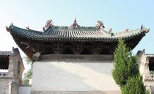 | Orientation and Layout | Theocratic Entertainment | 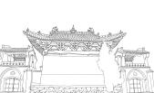 | 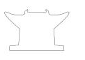 | 0.135 | 0.018 | 0.015
$${\text{C}}_{\text{6}\text{3}}$$ | 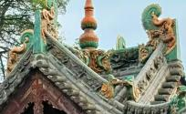 | Glazed tiles | Aesthetic Vitality | 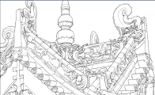 | 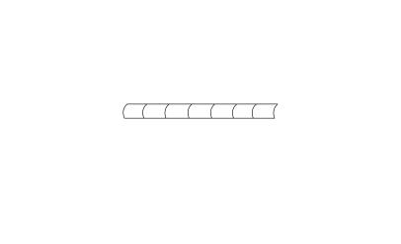 | 0.316 | 0.018 | 0.015
$${\text{C}}_{\text{6}\text{4}}$$ | 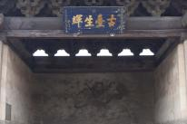 | lintel | Cultural Inclusivity | 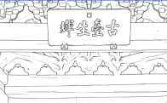 |  | 0.246 | 0.018 | 0.015
$${\text{C}}_{\text{6}\text{5}}$$ | 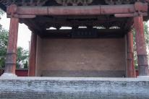 | Column Base Design | Focus on practicality | 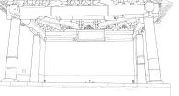 | 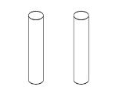 | 0.141 | 0.018 | 0.015
$${\text{C}}_{\text{6}\text{6}}$$ | 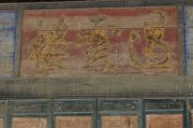 | Plaque | Etiquette and music education function | 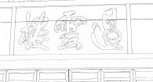 |  | 0.075 | 0.018 | 0.015

Table 7: Extraction of Spatial Layout Memes
Cultural Genes | Chart | Building Layout | Keyword | Symbol extraction | Meme Distillation | $${\text{W}}_{\text{i}}$$ | $${\text{C}}_{\text{I}}$$ | $${\text{C}}_{\text{R}}$$
$${\text{C}}_{\text{7}\text{1}}$$ | 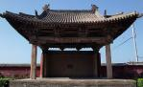 | The order of rites | Central axis symmetry |  | 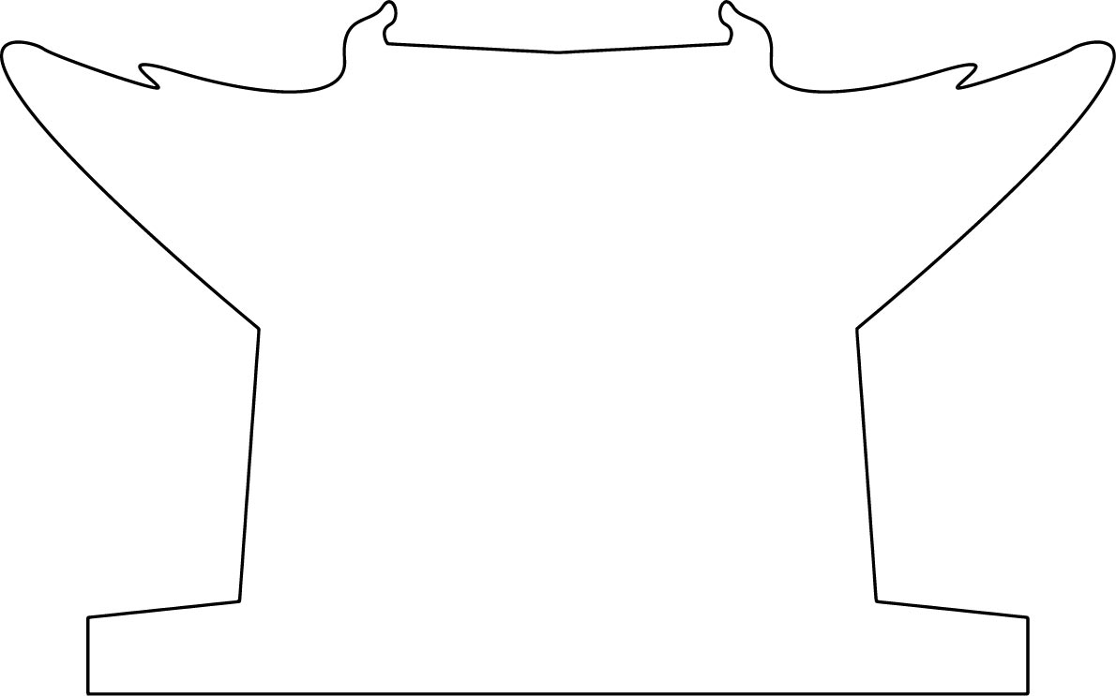 | 0.310 | 0.014 | 0.011
$${\text{C}}_{\text{7}\text{2}}$$ | 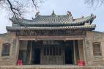 | The order of rites | Central axis symmetry |  | 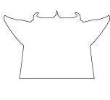 | 0.227 | 0.014 | 0.011
$${\text{C}}_{\text{7}\text{3}}$$ |  | Establishing spatial hierarchy via orientation, elevation, and proximity | Spatial hierarchy | 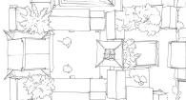 | 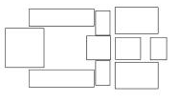 | 0.183 | 0.014 | 0.011
$${\text{C}}_{\text{7}\text{4}}$$ | 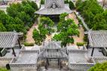 |  | Spatial hierarchy | 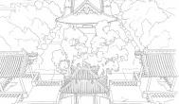 | 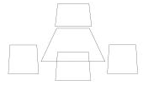 | 0.066 | 0.014 | 0.011
$${\text{C}}_{\text{7}\text{5}}$$ | 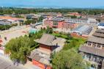 | Connecting different functional units | Community composition | 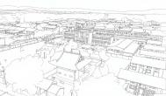 | 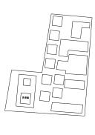 | 0.146 | 0.014 | 0.011
$${\text{C}}_{\text{7}\text{6}}$$ | 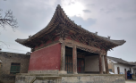 | Rectangular platform base | Transitional space | 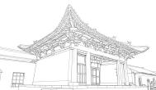 | 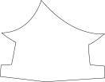 | 0.069 | 0.014 | 0.011

Table 9: Primary Indicator Judgment Matrix
 | B1 | B2 | B3 | B4 | B5 | B6 | B7
B1 | 1.000 | 0.500 | 2.000 | 6.481 | 3.000 | 5.000 | 7.483
B2 | 2.000 | 1.000 | 3.000 | 7.483 | 5.000 | 6.481 | 9.000
B3 | 0.500 | 0.333 | 1.000 | 5.000 | 2.000 | 3.000 | 6.481
B4 | 0.154 | 0.134 | 0.200 | 1.000 | 0.333 | 0.500 | 2.000
B5 | 0.333 | 0.200 | 0.500 | 3.000 | 1.000 | 2.000 | 3.873
B6 | 0.200 | 0.154 | 0.333 | 2.000 | 0.500 | 1.000 | 3.000
B7 | 0.134 | 0.111 | 0.154 | 0.500 | 0.200 | 0.333 | 1.000

Table 10 Secondary Indicator Judgment Matrix
 | C11 | C12 | C13 | C14 | C15 | C16
$${\text{C}}_{\text{11}}$$ | 1.000 | 2.000 | 0.316 | 3.000 | 2.000 | 4.899
$${\text{C}}_{\text{12}}$$ | 0.500 | 1.000 | 0.218 | 2.000 | 0.816 | 3.464
$${\text{C}}_{\text{13}}$$ | 3.162 | 4.583 | 1.000 | 7.348 | 4.899 | 8.485
$${\text{C}}_{\text{14}}$$ | 0.333 | 0.500 | 0.136 | 1.000 | 0.354 | 2.000
$${\text{C}}_{\text{15}}$$ | 0.500 | 1.225 | 0.204 | 2.828 | 1.000 | 3.873
$${\text{C}}_{\text{16}}$$ | 0.204 | 0.289 | 0.118 | 0.500 | 0.258 | 1.000

Table 11Secondary Indicator Judgment Matrix
 | C21 | C22 | C23 | C24 | C25 | C26
$${\text{C}}_{\text{2}\text{1}}$$ | 1.000 | 0.500 | 3.000 | 0.816 | 4.000 | 4.000
$${\text{C}}_{\text{22}}$$ | 2.000 | 1.000 | 4.472 | 1.225 | 5.196 | 6.481
$${\text{C}}_{\text{23}}$$ | 0.333 | 0.224 | 1.000 | 0.289 | 0.866 | 2.000
$${\text{C}}_{\text{24}}$$ | 1.225 | 0.816 | 3.464 | 1.000 | 4.472 | 4.583
$${\text{C}}_{\text{25}}$$ | 0.250 | 0.192 | 1.155 | 0.224 | 1.000 | 1.581
$${\text{C}}_{\text{26}}$$ | 0.250 | 0.154 | 0.500 | 0.218 | 0.632 | 1.000

Table 12:Secondary Indicator Judgment Matrix
 | C31 | C32 | C33 | C34 | C35 | C36
$${\text{C}}_{\text{3}\text{1}}$$ | 1.000 | 0.667 | 0.289 | 1.581 | 0.136 | 0.866
$${\text{C}}_{\text{32}}$$ | 1.500 | 1.000 | 0.577 | 2.828 | 0.236 | 1.000
C33 | 3.464 | 1.732 | 1.000 | 3.742 | 0.354 | 3.162
C34 | 0.632 | 0.354 | 0.267 | 1.000 | 0.200 | 0.354
C35 | 7.348 | 4.243 | 2.828 | 5.000 | 1.000 | 5.657
C36 | 1.155 | 1.000 | 0.316 | 2.828 | 0.177 | 1.000

Table 13:Secondary Indicator Judgment Matrix
 | C41 | C42 | C43 | C44 | C45 | C46
$${\text{C}}_{\text{4}\text{1}}$$ | 1.000 | 0.500 | 4.583 | 5.477 | 3.464 | 0.577
$${\text{C}}_{\text{42}}$$ | 2.000 | 1.000 | 6.000 | 5.477 | 5.477 | 0.655
$${\text{C}}_{\text{43}}$$ | 0.218 | 0.167 | 1.000 | 0.816 | 1.000 | 0.200
$${\text{C}}_{\text{44}}$$ | 0.183 | 0.183 | 1.225 | 1.000 | 1.155 | 0.236
$${\text{C}}_{\text{45}}$$ | 0.289 | 0.183 | 1.000 | 0.866 | 1.000 | 0.169
$${\text{C}}_{\text{46}}$$ | 1.732 | 1.528 | 5.000 | 4.243 | 5.916 | 1.000

 | C51 | C52 | C53 | C54 | C55 | C56
$${\text{C}}_{\text{3}\text{1}}$$ | 1.000 | 0.354 | 0.707 | 0.816 | 0.500 | 3.000
C52 | 2.828 | 1.000 | 1.291 | 2.449 | 2.449 | 6.000
C53 | 1.414 | 0.775 | 1.000 | 1.225 | 1.000 | 4.243
C54 | 1.225 | 0.408 | 0.816 | 1.000 | 1.414 | 4.583
C55 | 2.000 | 0.408 | 1.000 | 0.707 | 1.000 | 5.000
C56 | 0.333 | 0.167 | 0.236 | 0.218 | 0.200 | 1.000
Table 14:Secondary Indicator Judgment Matrix

Table 15:Secondary Indicator Judgment Matrix
 | $${\text{C}}_{\text{61}}$$ | $${\text{C}}_{\text{62}}$$ | $${\text{C}}_{\text{63}}$$ | $${\text{C}}_{\text{64}}$$ | $${\text{C}}_{\text{65}}$$ | $${\text{C}}_{\text{66}}$$
$${\text{C}}_{\text{61}}$$ | 1.000 | 0.500 | 0.250 | 0.471 | 0.612 | 1.291
$${\text{C}}_{\text{62}}$$ | 2.000 | 1.000 | 0.333 | 0.655 | 0.816 | 1.732
$${\text{C}}_{\text{63}}$$ | 4.000 | 3.000 | 1.000 | 1.291 | 1.732 | 4.000
$${\text{C}}_{\text{64}}$$ | 2.121 | 1.528 | 0.775 | 1.000 | 2.000 | 4.472
$${\text{C}}_{\text{65}}$$ | 1.633 | 1.225 | 0.577 | 0.500 | 1.000 | 1.414
$${\text{C}}_{\text{66}}$$ | 0.775 | 0.577 | 0.250 | 0.224 | 0.707 | 1.000

Table 16:Secondary Indicator Judgment Matrix
 | $${\text{C}}_{\text{7}\text{1}}$$ | $${\text{C}}_{\text{72}}$$ | $${\text{C}}_{\text{73}}$$ | $${\text{C}}_{\text{74}}$$ | $${\text{C}}_{\text{75}}$$ | $${\text{C}}_{\text{76}}$$
$${\text{C}}_{\text{7}\text{1}}$$ | 1.000 | 1.414 | 2.000 | 4.583 | 1.500 | 5.477
$${\text{C}}_{\text{72}}$$ | 0.707 | 1.000 | 1.225 | 4.000 | 1.414 | 3.464
$${\text{C}}_{\text{73}}$$ | 0.500 | 0.816 | 1.000 | 3.162 | 1.183 | 3.000
$${\text{C}}_{\text{74}}$$ | 0.218 | 0.250 | 0.316 | 1.000 | 0.577 | 1.000
$${\text{C}}_{\text{75}}$$ | 0.667 | 0.707 | 0.845 | 1.732 | 1.000 | 1.528
$${\text{C}}_{\text{76}}$$ | 0.183 | 0.289 | 0.333 | 1.000 | 0.655 | 1.000

Table 17 Consistency Test Results
Indicator | B1 | C1 | C2 | C3 | C4 | C5 | C6 | C7 | Consistency Check
$${\text{λ}}_{\text{max}}$$ | 7.124 | 6.100 | 6.054 | 6.159 | 6.100 | 6.105 | 6.092 | 6.072
CI | 0.021 | 0.020 | 0.011 | 0.032 | 0.020 | 0.021 | 0.018 | 0.014 | pass through
RI | 1.360 | 1.260 | 1.260 | 1.260 | 1.260 | 1.260 | 1.260 | 1.260
CR | 0.015 | 0.016 | 0.009 | 0.025 | 0.016 | 0.017 | 0.015 | 0.011

Table 18: AHP Weighting Results
Factor | $${\text{C}}_{\text{22}}$$ | $${\text{C}}_{\text{24}}$$ | $${\text{C}}_{\text{13}}$$ | $${\text{C}}_{\text{11}}$$ | $${\text{C}}_{\text{35}}$$ | $${\text{C}}_{\text{33}}$$ | $${\text{C}}_{\text{52}}$$ | $${\text{C}}_{\text{64}}$$ | $${\text{C}}_{\text{63}}$$ | $${\text{C}}_{\text{46}}$$ | $${\text{C}}_{\text{42}}$$ | $${\text{C}}_{\text{71}}$$
Architectural Memes |  |  |  |  |  |  |  | 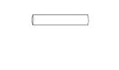
Weight | 0.341 | 0.259 | 0.476 | 0.191 | 0.456 | 0.210 | 0.318 | 0.246 | 0.316 | 0.322 | 0.302 | 0.310
Composite Weighting | 0.047 | 0.117 | 0.128 | 0.097 | 0.034 | 0.073 | 0.012 | 0.013 | 0.030 | 0.019 | 0.015 | 0.008

Table 19 Weight Value Sorting
Product Performance | Absolute Weight | Relative Weight | Sorting
Form Symbolism Innovation (D1) | 1.168 | 15.1 | 1
Stage Structure Recognition (D2) | 0.586 | 7.9 | 8
Structural Adaptability (D3) | 0.8 | 10.8 | 3
Cultural Product Function Clarity (D4) | 0.683 | 9.2 | 4
Decorative Pattern Innovation (D5) | 0.389 | 5.3 | 11
Cultural Element Integration (D6) | 0.82 | 11.1 | 2
Wood Material Properties (D7) | 0.401 | 5.41 | 10
Architectural Color Aesthetics (D8) | 0.656 | 8.9 | 5
Semantic Expression Accuracy (D9) | 0.489 | 6.6 | 9
Cultural Connotation Transmission Clarity (D10) | 0.636 | 8.6 | 6
Spatial Imagery Transformation (D11) | 0.181 | 2.4 | 12
Emotional Resonance and Interactivity (D12) | 0.598 | 8.1 | 7

Table 20 Initial Evaluation Matrix
Product Performance | Option One | Option Two | Option Three
Form Symbolism Innovation (D1) | 8.2 | 7.83 | 7.63
Stage Structure Recognition (D2) | 5.11 | 3.74 | 4.17
Structural Adaptability (D3) | 6.97 | 6.17 | 6.23
Cultural Product Function Clarity (D4) | 6.26 | 5.4 | 5.49
Decorative Pattern Innovation (D5) | 5 | 3.74 | 3.69
Cultural Element Integration (D6) | 7.23 | 7 | 6.34
Wood Material Properties (D7) | 4.69 | 4.2 | 3.6
Architectural Color Aesthetics (D8) | 4.86 | 3.66 | 3.86
Semantic Expression Accuracy (D9) | 4.86 | 3.57 | 3.86
Cultural Connotation Transmission Clarity (D10) | 4.66 | 3.6 | 3.69
Spatial Imagery Transformation (D11) | 4.66 | 3.74 | 3.51
Emotional Resonance and Interactivity (D12) | 4.49 | 3.77 | 3.51

Table 21 Standardized Evaluation Matrix
 | $${\text{D}}_{\text{1}}$$ | $${\text{D}}_{\text{2}}$$ | $${\text{D}}_{\text{3}}$$ | $${\text{D}}_{\text{4}}$$ | $${\text{D}}_{\text{5}}$$ | $${\text{D}}_{\text{6}}$$ | $${\text{D}}_{\text{7}}$$ | $${\text{D}}_{\text{8}}$$ | $${\text{D}}_{\text{9}}$$ | $${\text{D}}_{\text{10}}$$ | $${\text{D}}_{\text{11}}$$ | $${\text{D}}_{\text{12}}$$
Option 1 | 0.600 | 0.674 | 0.622 | 0.631 | 0.689 | 0.608 | 0.647 | 0.675 | 0.679 | 0.671 | 0.672 | 0.657
Option 2 | 0.573 | 0.493 | 0.551 | 0.544 | 0.516 | 0.589 | 0.579 | 0.508 | 0.499 | 0.518 | 0.540 | 0.552
Option 3 | 0.558 | 0.550 | 0.556 | 0.553 | 0.509 | 0.533 | 0.496 | 0.536 | 0.539 | 0.531 | 0.507 | 0.514

