Supplementary data

- Supplementary Table S1: Exhaustive Performance Metrics for All Predictors and Analysis Groups

- Supplementary Figure S1: Complete set of plots (ROC, PR, all 5 distributions) for each VEP for the 5 harmonized regions (5’UTR, 3' UTR, Intronic, Non-coding Exons and Upstream)

- Supplementary Figure S2. MobiDeep MLP architecture and example prediction

- Supplementary Figure S3. Optuna Hyperparameter Optimization

- Supplementary Table S2. Detailed Performance Metrics of MobiDeep in Training and Test sets across stratified cross-validation runs

- Supplementary Table S3: RNU 4-2 variants scoring by MobiDeep vs Clinvar classifications

Supplementary Table S1: Exhaustive Performance Metrics for All Predictors and Analysis Groups.
Complete set of performance statistics, including mean and standard deviation (SD), for all calculated metrics across 10000 bootstrap iterations. Area Under the ROC Curve (AUROC), Area Under the PR Curve (AUPRC), True Positives (TP), False Positives (FP), True Negatives (TN), False Negatives (FN), sensitivity (recall), specificity, positive predictive value (PPV, precision), negative predictive value (NPV), F1-score, F2-score, accuracy, Matthews Correlation Coefficient (MCC), Youden's J Index, and the mean optimal classification threshold. This dataset forms the basis for all summary tables and figures presented in the main text.
Supplementary Figure S1: Complete set of plots (ROC, PR, all 5 distributions) for each VEP for the 5 harmonized regions (5’UTR, 3' UTR, Intronic, Non-coding Exons and Upstream) 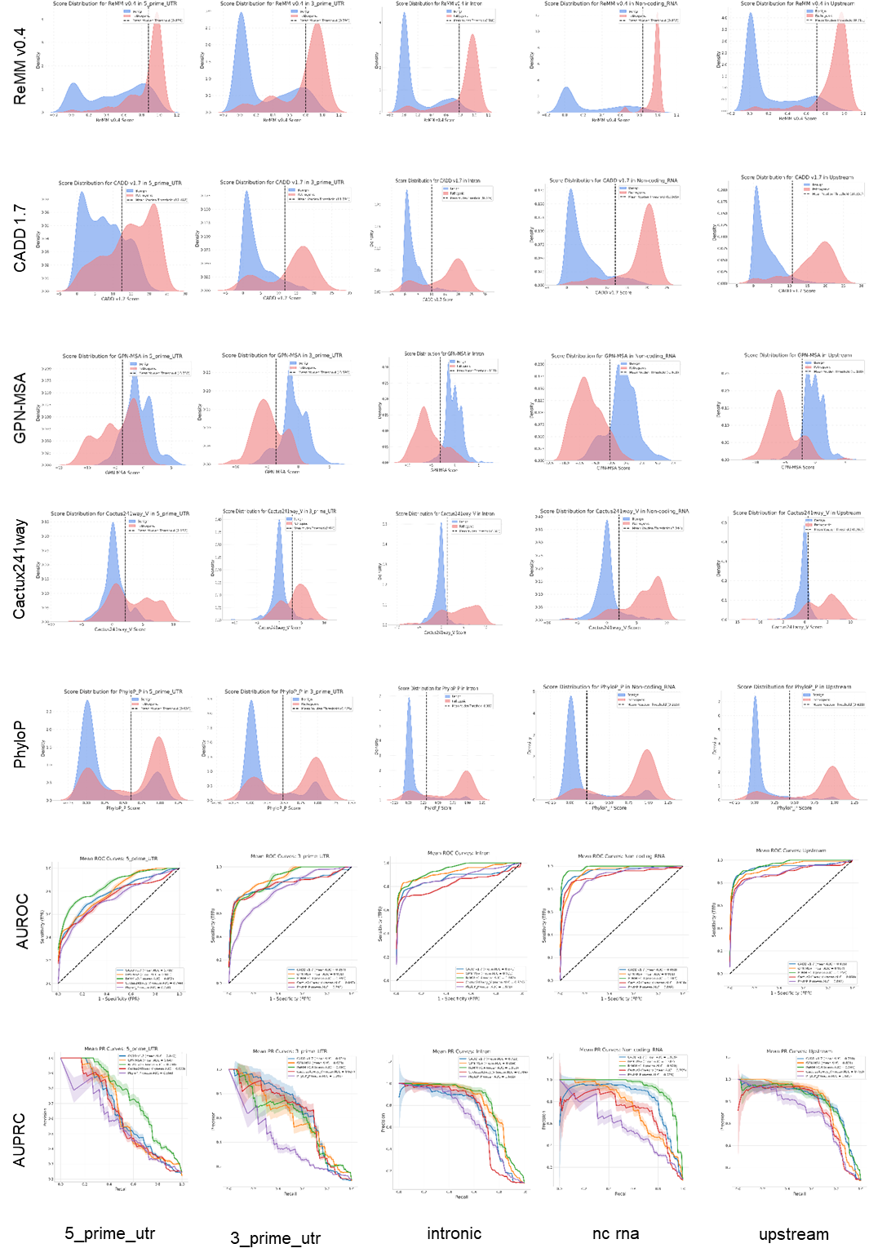

Supplementary Figure S2. MobiDeep MLP architecture and example prediction

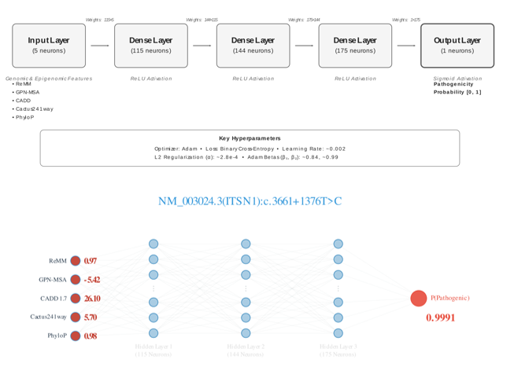

Upper panel: MobiDeep's Multi-Layer Perceptron (MLP) Architecture: consists of an input layer taking 5 genomic, epigenomic and conservation features (ReMM v0.4, GPN-MSA, CADD 1.7, Cactus241way, and PhyloP), followed by three dense hidden layers with ReLU activation, and a final output layer with a sigmoid activation function to predict the probability of pathogenicity. Key hyperparameters used for training (Optimizer, Loss, Learning Rate, L2 Regularization, Adam Betas).

Lower panel: Example Prediction for NM_003024.3(ITSN1):c.3661+1376T>C: visual representation of how a specific variant (NM_003024.3(ITSN1):c.3661+1376T>C) is processed by the MLP. The input layer shows the raw scores for each of the 5 features. These inputs propagate through the three hidden layers, and the final output layer provides the predicted probability of pathogenicity (P(Pathogenic)) [0-1].

Supplementary Figure S3. Optuna Hyperparameter Optimization
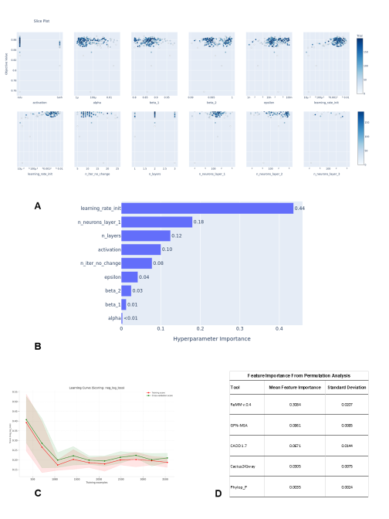
(A) Optuna slice plot showing the relationship between individual hyperparameters and the objective value (AUPRC). (B) Bar chart quantifying the importance of each hyperparameter, with learning_rate_init identified as the most influential. (C) Learning curve illustrating the model's training and cross-validation negative log-loss, confirming good generalization without overfitting. (D) Permutation-based feature importance, highlighting ReMM as the most predictive feature for the final optimized model.
Supplementary Table S2. Detailed Performance Metrics of MobiDeep in Training and Test set across stratified cross-validation runs.

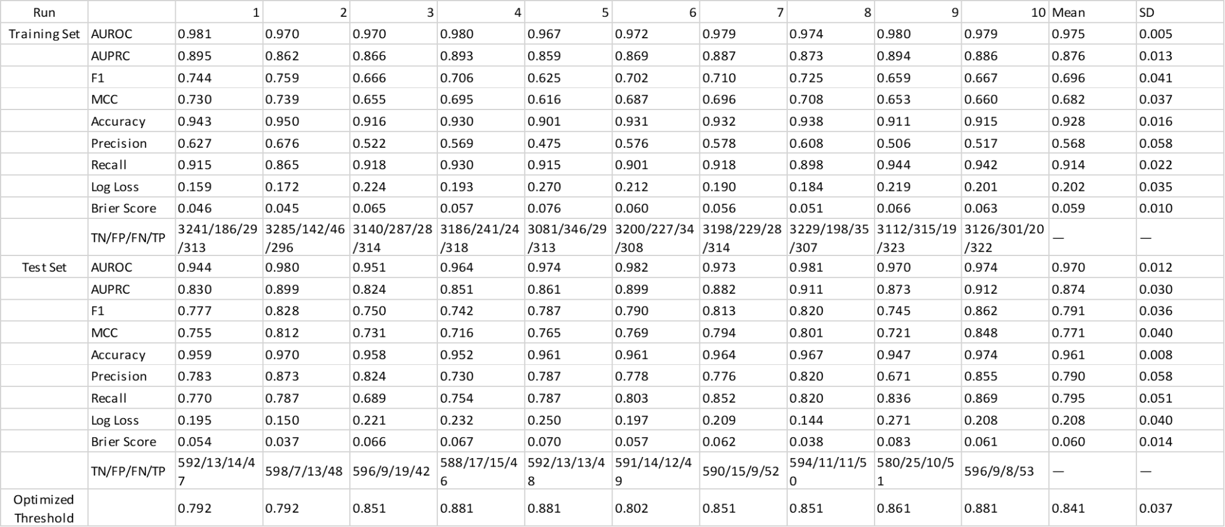

Metrics: AUROC, area under the receiver operating characteristic curve; AUPRC, area under the precision-recall curve; F1, F1-score; MCC, Matthews correlation coefficient. Confusion matrix: True negatives/false positives/false negatives/true positives. Threshold: Optimized decision threshold for each fold. Values represent mean and SD standard deviation across folds

Supplementary Table S3: RNU 4-2 variants scoring by MobiDeep vs Clinvar classifications
MobiDeep performance results for a set of 30 variants in the RNU4-2 non-coding RNA, retrieved from the ClinVar (dated 2025/05/30). These variants were not included in the initial training data. All 18 variants classified as Pathogenic/Likely Pathogenic (P/LP) in ClinVar were correctly assigned scores exceeding the high confidence pathogenicity threshold (0.968) by MobiDeep. All "Likely benign" variants were correctly assigned scores below these thresholds. Variants listed as "Uncertain significance" in ClinVar were largely predicted as pathogenic.

