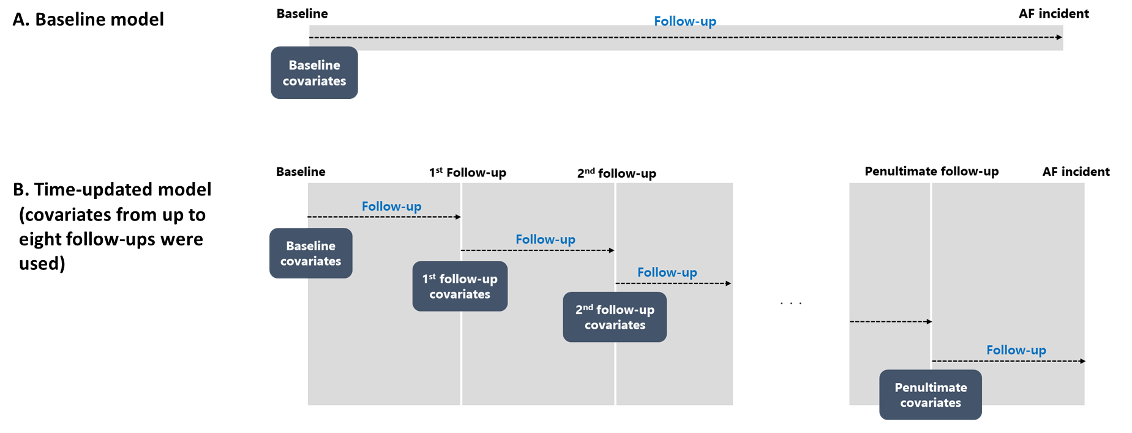
Figure S2. Baseline and time-updated Cox regression models incorporating the changes in MRF over time and the estimated MRF burden. A. Baseline model and B. Time-updated model

