Appendix
Figure 1 Scree Plot for Sentiment Proxies PCA

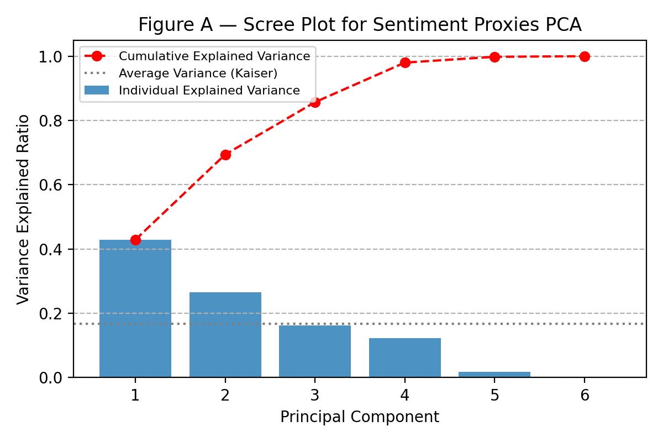

Table 1A GARCH(1.1) Diagnostics
AIC | BIC | LogLik | N
15583.2290 | 15617.1830 | -7786.6140 | 6574.0000

Table 2A EGARCH(1,1) Diagnostics
AIC | BIC | LogLik | N
15417.349 | 15458.094 | -7702.674 | 6574.000

Table 3A GJR-GARCH(1,1) Diagnostics
AIC | BIC | LogLik | N
15485.513 | 15526.259 | -7736.757 | 6574.000

