Supplementary Figures
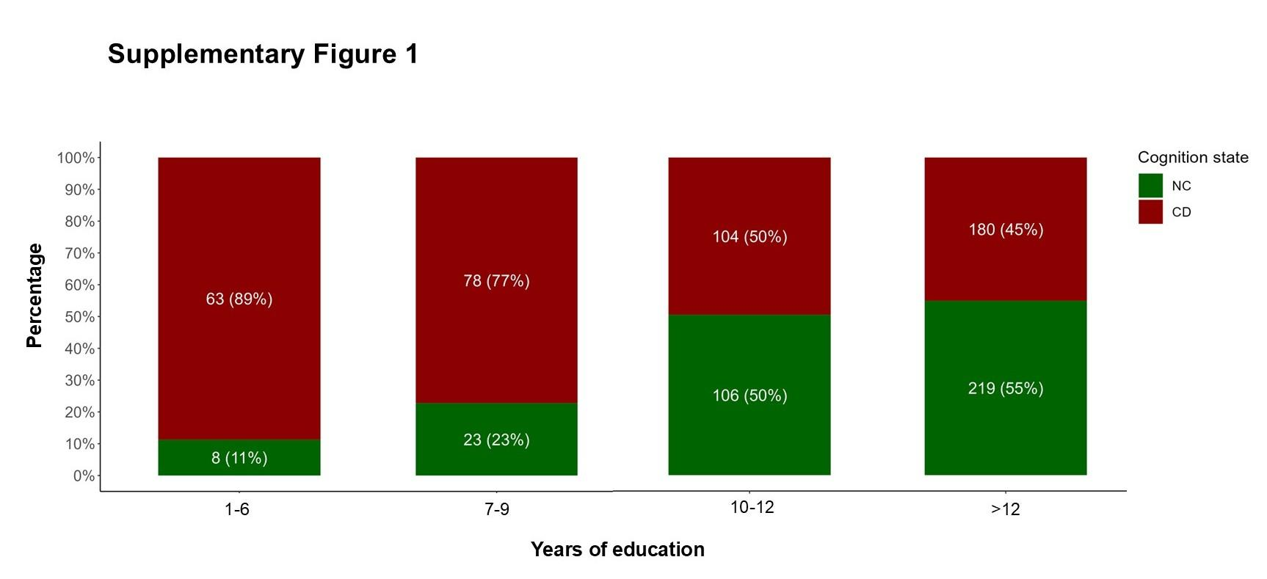Supplementary Figure 1. Prevalence of NC (green) and CD (red), using a MoCA cutoff score of <26, in cognitively healthy Latin American adults as a function of years of education.

