Supplemental material: Malaria Vaccine Implementation Program Reduced Clinical Malaria, Kenya
  - Impact evaluation with predictive time-series models of routine surveillance data
June 5, 2025
Table of contents
Supplement A: R Environment 3
Supplement B: Expected impact 5
Supplement C: Data Sources 10
Data Dictionary 10
API Data Download 11
Organisational units (orgUnits) 12
Supplement D: Enrolled Health Care Facilities 13
MVIP Areas 13
MVIP Health Facilities 17
Supplement E: Vaccine Doses 30
Supplement F: Confirmed Cases 34
Confirmed Malaria Cases (Kenya Health Information System) 34
MVIP Clinical Cases: Filter to cases reported by health facilities and CHW in MVIP sub-counties (mcc0) 35
Identify potential outliers 39
Create mcc3 with new variables for case type (OPD, CHW) 40
Associate CHW cases with their corresponding OPD, creating a new variable, opdUnit 41
Aggregate across opdUnits (mcc4) 42
Supplement G: Consistently Reporting Facilities 44
Facilities reporting confirmed malara cases 44
Facilities Consistently Reporting Confirmed Cases Each Month 48
Consistent reporting pre-intervention through the evaluation period 48
Map of included facilities (preliminary) 51
With the choice of number of facilities, we save the analytic Dataset (mcc5) 53
Consistently_reporting_evaluation_facilities (12/12 months during evaluation period) (mcc6) 56
Map of included facilities (final) 58
Supplement H: Time-series models of uncomplicated cases to estimate vaccine impact 60
Analyses 60
Time-Periods 63
Time-Series Models (Mables) 65
Validation 65
Validation Algorithm: Optimizing versus Synchronizing 70
Model Selection - Pre-intervention 71
Impact 72
Grand Summary 82
Supplement I: Impact of distance from comparison to implementing facilities 83
Distance-dose response 83
Supplement J: Alternative Modeling Scenarios 95
Alternative Data and Modelling Scenarios 95
Data 95
Raw data 95
Cleaned data: All facilities with outliers removed and CHEW associated with OPD (mcc4) and Over4 covariate 109
Adjusted data (mcc5) 121
Always reporting from 2020 (mcc6), consistentently reporting since 2015 126
Always reporting from since 2015 (mcc7) 126
Adjusted, Primary models only 131
Adjusted, ‘Optimized’ models 135
Adjusted, ‘Optimized’ Primary models 139
Ratio of under5 to over4 cases 144
Health Facility based models 145
Summary 145
References 150

Supplement A: R Environment
Data were prepared and analysed in RStudio 2024.4.0.735[1] running R version 4.4.1 with the following packages installed:
Package | Version
coin | 1.4-3
conflicted | 1.2.0
cowplot | 1.2.0
data.table | 1.17.8
data.tree | 1.2.0
distributional | 0.5.0
DT | 0.34.0
fable | 0.4.1
fable.prophet | 0.1.0
fabletools | 0.5.1
feasts | 0.4.2
fitdistrplus | 1.2-4
flextable | 0.9.10
forecast | 8.24.0
fuzzyjoin | 0.1.6.1
ggpattern | 1.2.1
ggrepel | 0.9.6
ggspatial | 1.1.10
ggthemes | 5.2.0
glue | 1.8.0
gridExtra | 2.3
gt | 1.1.0
gtsummary | 2.4.0
HDInterval | 0.2.4
htmltools | 0.5.8.1
igraph | 2.2.1
kableExtra | 1.4.0
knitr | 1.50
leaflegend | 1.2.1
leaflet | 2.2.3
leaflet.extras | 2.0.1
lubridate | 1.9.4
lwgeom | 0.2-14
magick | 2.9.0
maps | 3.4.3
MLmetrics | 1.1.3
nngeo | 0.4.8
overlapping | 2.2
pacman | 0.5.1
progress | 1.2.3
readxl | 1.4.5
scales | 1.4.0
sf | 1.0-23
stringr | 1.6.0
table.express | 0.4.2
tictoc | 1.2.1
tidyfst | 1.8.2
tidyverse | 2.0.0
tsibble | 1.1.6
webshot | 0.5.5
webshot2 | 0.1.2

Supplement B: Expected impact
The following assumptions were used to calculate the expected impact of RTS,S on uncomplicated malaria.

Immunization Schedule
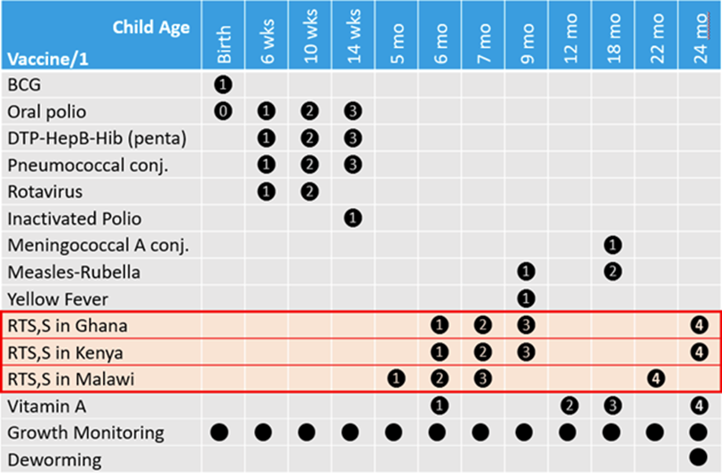
Figure 1.S Immunization schedule, including RTS,S/AS01_{E} In the three MVIP countries (Source: WHO MVIP SAP available at https://cdn.clinicaltrials.gov/large-docs/65/NCT03806465/SAP_002.pdf).

Vaccine Eligibility
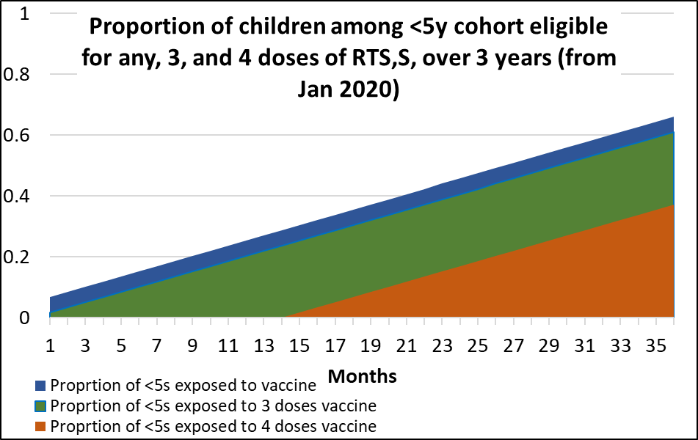
Figure 2.S The proportion of all <5y children that were eligible for malaria vaccine started small and increased to 65% after 36 months post-introduction of RTS,S.

Vaccine Coverage
From the the western Kenya MVIP feasibility surveys, RTS,S coverage estimates among eligible children were 82.7% for dose 1, 78.1% for dose 2, 68.9% for dose 3, and 34.0% for dose 4. However, the eligible children were approximately 1/5 of all the children <5. Table 1 shows the estimate proportion of children <5 that received 3 or 4 doses following the introduction of RTS,S.
Table 1.S Percent of under 5 population vaccinated by months since last dose
Months since last dose | Year 1 | Year 2 | Year 3
6m post vx with 3 doses | 13.1% | 15.4% | 13.1%
18m post vx with 3 doses | - | 7.2% | 7.2%
30m post vx with 3 doses | - | - | 7.2%
6m post vx with 4 doses | - | 5.9% | 7.2%
18m post vx with 4 doses | - | - | 5.9%

Vaccine Efficacy
Vaccine efficacy decreases over time. Table 2 shows the vaccine efficacy for children receiving 3 and 4 does of RTS,S/AS01_{E.} The values were either reported from phase III trials in malaria endemic regions,[2,3]. We assumed there was no efficacy unless children received at least 3 doses of RTS,S/AS01_{E.}
Table 2.S Vaccine efficacy reported from phase III trials or imputed(*)
Months since last dose | 3 doses | 4 doses
6m post vx | 68.3% | 68.3%
18m post vx | 45.1% | 45.1%
30m post vx | 35.2% | 43.9%
48m post vx | 28.3% | 36.0%

Potential Impact
a = vxcov %>%
mutate( x = str_split( `Months since last dose`, " with ") ,
months = map_chr( x, 1 ) ,
doses = map_chr( x, 2 )) %>%
pivot_longer( c(`Year 1`, `Year 2`,`Year 3`) ) %>%
select( -x ) %>%
rename( year = name , coverage = value )
# a %>% flextable() %>% FitFlextableToPage()
b = eff %>%
pivot_longer( c( `3 doses`, `4 doses` ) ) %>%
rename( months = `Months since last dose` ,
eff = value ,
doses = name )
# b %>% flextable() %>% FitFlextableToPage()
c = a %>% inner_join( b , by = join_by(months, doses) ) %>%
mutate( impact = coverage * eff ) %>%
select( - `Months since last dose` )
# c %>% flextable() %>% FitFlextableToPage()
d = c %>%
select( - eff, - coverage ) %>%
pivot_wider( id_cols = c( months, doses ) , values_from = impact, names_from = year) %>%
bind_rows(summarise(.,
across( where(is.numeric) , ~ sum( .x, na.rm = T )),
across( where(is.character) , ~ "Total"))) %>%
mutate( across( where( is.numeric ), ~ ifelse( is.na(.), "-", paste0(round(100 * ., 1), "%"))) )
saveRDS( d, paste0( params$output , "expected_impact.rds"))
months | doses | Year 1 | Year 2 | Year 3
6m post vx | 3 doses | 8.9% | 10.5% | 8.9%
18m post vx | 3 doses | - | 3.2% | 3.2%
30m post vx | 3 doses | - | - | 2.5%
6m post vx | 4 doses | - | 4% | 4.9%
18m post vx | 4 doses | - | - | 2.7%
Total | Total | 8.9% | 17.8% | 22.3%
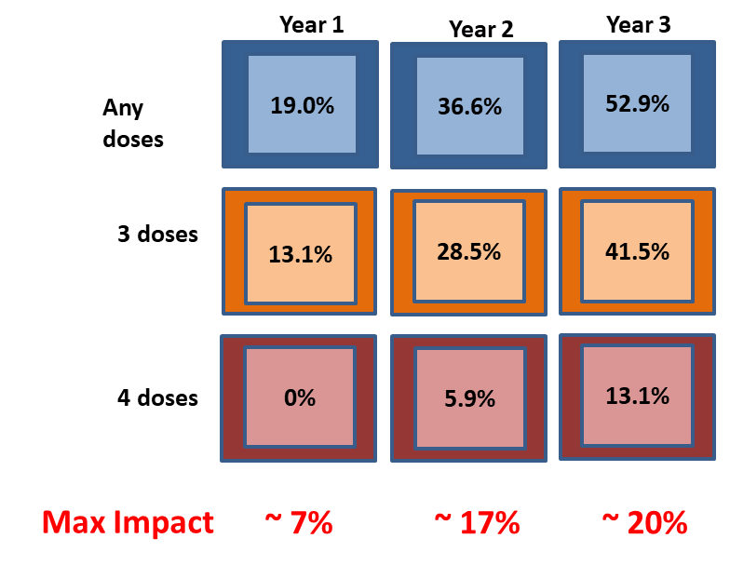
Figure 3.S Percent of children under 5 vaccinated (assuming coverage of 80% for RTSS1, 70% for RTSS3, and 35% for RTSS4) and percent impact of disease reduction among children under 5 (assuming vaccine efficacy as shown in Table 2)

Supplement C: Data Sources

Data Dictionary
We reviewed available data in the Kenya DHIS2 that represented monthly reporting of uncomplicated cases. Table 3 lists 5 monthly data elements with disaggregations that were included in the study dataset. Two of the three elements represent clinical cases reported by health facilities for persons <5 yrs and >=5 yrs. Three of the five represent clinical cases reported by community health education workers (CHEW). Prior to 2020 [NB: check date], CHEW reported confirmed malaria without an age disaggregation. For this study, we categorized those cases as <5 so that they could be used to establish trends in <5 confirmed cases. In 2020, after expanding their role to testing and treating all ages KHIS enabled reporting clinical cases for <5 yrs and >=5 yrs.
KHIS also receives reports of uncomplicated malaria cases among pregnant women, which represents approximately 1% of uncomplicated malaria among persons >5 yrs. These data, however, were not available for the same period as the other uncomplicated cases, so we did not include them in our analyses.
Table 3.S Dictionary of DHIS2 data elements accessed for confirmed cases
dataElement | Categories | periodType | dataSet | zeroIsSignificant | data.id
CHEW No. positive | default | Monthly | MOH 748 - COMMUNITY HEALTH UNIT MONTHLY SUMMARY REPORT FOR MALARIA COMMODITIES | FALSE | CVHsV294PjK.NhSoXUMPK2K
CHEW No. positive < 5 | default | Monthly | MOH 748 - COMMUNITY HEALTH UNIT MONTHLY SUMMARY REPORT FOR MALARIA COMMODITIES | FALSE | NeUMw0K561Q.NhSoXUMPK2K
CHEW No. positive >= 5 | default | Monthly | MOH 748 - COMMUNITY HEALTH UNIT MONTHLY SUMMARY REPORT FOR MALARIA COMMODITIES | FALSE | TZHFXJrxbUU.NhSoXUMPK2K
Confirmed Malaria (only Positive cases) | >5 yrs | Monthly | AWP Monthly Service Delivery;Family Health, PVLS, malaria & Consolidated Dashboards - USAID 2022;HIS-PMS DATA EXCHANGE;MOH 705 A Outpatient summary < 5 years Revised 2020;MOH 705 B Outpatient summary > 5 years Revised 2020 | TRUE | OoakJhWiyZp.SeDaCnHi3m5
Confirmed Malaria (only Positive cases) | <5 yrs | Monthly | AWP Monthly Service Delivery;Family Health, PVLS, malaria & Consolidated Dashboards - USAID 2022;HIS-PMS DATA EXCHANGE;MOH 705 A Outpatient summary < 5 years Revised 2020;MOH 705 B Outpatient summary > 5 years Revised 2020 | TRUE | OoakJhWiyZp.lHl2rmXpHse

The column “data.id” column was created by concatenating the dataElement id and the categoryOptionCombo id with “.” separator.

 Tip
Common terms used with DHIS2 reporting
Data Element: A data element represents the smallest unit of data that can be collected and analyzed in DHIS2. It could be a single piece of information such as the number of patients, the prevalence of a disease, or any other relevant health-related indicator. Each data element typically has a name, code, description, and data type associated with it.
Categories: Categories are used to define dissagregations like age group, and gender.
(WARNING: In some cases the categories are not just parts of a whole. For example, commodities frequently have disaggregations for ‘No. at start of month’, ‘No. at end of month’, ‘No. of days stocked out’. Note that in this case, the categories refer to different things (commodity units and days), and it does not make sense to add them together. Unfortunately, the default behavior when selecting a data element in the DHIS2 web-platform is to provide the total without the disaggregation. In this commodity example, the total makes no sense.)
Dataset: A dataset in DHIS2 is a collection of related data elements that are grouped together for data collection, analysis, and reporting purposes. Datasets are typically used to organize data collection forms or data entry screens.
Indicator is not necessarily a program indicator; it is any value derived from multiple data elements; examples include test-positivity rate, cases per 100,000 population, or total of inpatient and outpatient cases.

API Data Download
The data.id in Table 3 were downloaded from KHIS (https://hiskenya.org, DHIS2 version 2.35.5) using the DHIS2 API[4] to request data for all orgUnits each month from January 2015 through December 2022 (data accessed on 2023-08-06). Data were first downloaded with the option “SUM”; then with the option “COUNT”; and combined into one R dataset. For illustration, a small sample of the data (5 of 1,444,124 rows) is shown in Table 4.
 Note
Aggregated DHIS2 data are available through KHIS with access provided by Kenya Ministry of Health. Requests to access these datasets should be directed to Ministry of Health KHIS https://hiskenya.org/dhis-web-commons/security/login.action and KMHFL, kmhfl@health.go.ke.

Confirmed Cases
Table 4.S Sample of data downloaded for confirmed cases
dataElement | categoryOptionCombo | period | orgUnit | COUNT | SUM
OoakJhWiyZp | SeDaCnHi3m5 | 201301 | A2FJEDRHsgv | 1 | 1
OoakJhWiyZp | SeDaCnHi3m5 | 201303 | A2FJEDRHsgv | 1 | 30
OoakJhWiyZp | SeDaCnHi3m5 | 201306 | A2FJEDRHsgv | 1 | 3
OoakJhWiyZp | SeDaCnHi3m5 | 201307 | A2FJEDRHsgv | 1 | 1
OoakJhWiyZp | SeDaCnHi3m5 | 201309 | A2FJEDRHsgv | 1 | 11

The raw data file was download from KHIS on 2024-09-20 22:17:46.
The value of SUM is the total value (number of confirmed cases) from the orgUnit on that row, including the total value from any subordinate facilities. An orgUnit may represent a health provider (e.g. community health worker or health facility) as well as an administrative unit (e.g. sub-district, district, region, etc.). The value of COUNT represents the number of facilities reporting the variable (data.id). When COUNT >1, then the value includes totals from subordinate orgUnits, for example a sub-district with multiple health facilities reporting to it. The number of subordinate orgUnits that report the specified variable (data.id) each month frequently varies (see supplement on reporting bias). For orgUnits that do not have any subordinates, e.g. community health workers, the COUNT will always be 1.
Details of how to prepare the data for analyses are available in the supplement {ref}

Vaccinations
The monthly number of persons vaccinated with RTS,S was reported by enrolled facilities and downloaded from KHIS.
We downloaded monthly malaria vaccine data by facility reported through DHIS2 from 2018 to 2022 on 2023-08-26.

Organisational units (orgUnits)
level orgUnit == opd.id n
1 5 TRUE 1714
2 6 FALSE 1757

Supplement D: Enrolled Health Care Facilities

MVIP Areas
intervention.file = "Kenya_MVIP_clusters.xlsx"
interventions = readxl::read_excel( paste0( params$data.dir , intervention.file ) ) %>%
mutate( Intervention = factor( `Vaccination status` , 0:2,
labels = c('Comparison', 'Implementing', "non-MVIP" )) )
interventionCounties =
interventions %>%
distinct( Intervention , County, SubCounty ) %>%
group_by( Intervention, County ) %>%
summarise( `Sub Counties` = str_c( SubCounty, collapse = ", " ) ,
.groups = "keep" )
interventionCounties %>% flextable() %>% FitFlextableToPage
Table 5.S Health units associatied with each organization unit level
Intervention | County | Sub Counties
Comparison | Bungoma | Kanduyi, Sirisia
Comparison | Busia | Bunyala, Matayos, Teso North, Teso South
Comparison | Homa Bay | Karachuonyo, Rachuonyo South, Mbita, Rangwe, Suba South
Comparison | Kakamega | Lurambi, Matungu, Mumias East, Shinyalu
Comparison | Kisumu | Nyakach
Comparison | Migori | Rongo, Suna East, Suna West, Uriri
Comparison | Siaya | Ugunja
Comparison | Vihiga | Hamisi, Sabatia
Implementing | Bungoma | Bumula
Implementing | Busia | Butula, Samia, Nambale
Implementing | Homa Bay | Homa Bay Town, Kabondo Kasipul, Ndhiwa
Implementing | Kakamega | Butere, Ikolomani, Khwisero, Malava, Mumias West, Navakholo
Implementing | Kisumu | Kisumu Central, Kisumu East, Muhoroni
Implementing | Migori | Awendo, Nyatike
Implementing | Siaya | Rarieda, Ugenya
Implementing | Vihiga | Emuhaya, Luanda, Vihiga

mvip.counties = mvip.boundaries %>% group_by( ADM1_EN ) %>% st_make_valid() %>% summarize(.groups = 'keep')
mvip.subcounties = mvip.boundaries %>% group_by( ADM1_EN, ADM2_EN ) %>% st_make_valid() %>% summarize(.groups = 'keep')
Kenya_base_map_data = map_data( "world", region = 'Kenya')
Uganda_base_map_data = map_data( "world", region = 'Uganda')
Tanzania_base_map_data = map_data( "world", region = 'Tanzania')
Sudan_base_map_data = map_data( "world", region = 'South Sudan')
Ethiopia_base_map_data = map_data( "world", region = 'Ethiopia')
Somalia_base_map_data = map_data( "world", region = 'Somalia')
df <- data.frame(x1 = 36.5, x2 = 35.5, y1 = 1.3, y2 = 0.1)
ggplot( ) +
geom_polygon( data = Kenya_base_map_data ,
aes(x = long, y = lat, group = group ) ,
fill = 'white', color = 'black') +
geom_polygon( data = Uganda_base_map_data ,
aes(x = long, y = lat, group = group) ,
fill = 'white', color = 'black') +
geom_polygon( data = Tanzania_base_map_data ,
aes(x = long, y = lat, group = group ) ,
fill = 'white', color = 'black') +
geom_polygon( data = Sudan_base_map_data ,
aes(x = long, y = lat, group = group ) ,
fill = 'white', color = 'black') +
geom_polygon( data = Ethiopia_base_map_data ,
aes(x = long, y = lat, group = group) ,
fill = 'white', color = 'black') +
geom_polygon( data = Somalia_base_map_data ,
aes(x = long, y = lat, group = group) ,
fill = 'white', color = 'black') +
annotate( "text", label = "Kenya", x = 38, y = 0, size = 6, colour = "black" ) +
annotate( "text", label = "Uganda", x = 33.5, y = 2, size = 3, colour = "black" ) +
annotate( "text", label = "Tanzania", x = 36, y = -4,
size = 3, colour = "black" ) +
annotate( "text", label = "South\nSudan", x = 33.5, y = 5,
size = 3, colour = "black" ) +
annotate( "text", label = "Ethiopia", x = 38, y = 5,
size = 3, colour = "black" ) +
annotate( "text", label = "Somalia", x = 42, y = 2,
size = 3, colour = "black" ) +
annotate( "text", label = "MVIP\nCounties", x = 37, y = 2,
size = 5, colour = "blue" ) +
geom_curve(aes(x = x1, y = y1, xend = x2, yend = y2), data = df,
arrow = arrow( length = unit(0.08, "inch") ) ,
color = "gray20" , curvature = -0.3 ) +
geom_sf( data = mvip.counties , inherit.aes = FALSE , aes( fill = ADM1_EN ) ) +
geom_sf( data = lake_victoria_boundaries ,
inherit.aes = FALSE, fill = 'lightblue' ) +
annotate( "text" , label = "Lake\nVictoria", x = 33, y = -1 ,
size = 2, colour = "black" ) +
annotate( "text" , label = "Indian\nOcean", x = 42, y = -3 ,
size = 2, colour = "black" ) +
coord_sf( xlim = c(33, 43) , ylim = c(-5, 6) ) +
theme_map() +
theme( panel.background = element_rect(fill = 'lightgreen',
color = 'lightgreen' ) ,
legend.position= "right", legend.title = element_text( face = 'bold') ) +
# guides( fill = 'none' ) +
labs( fill = "County") +
ggspatial::annotation_scale(location = "bl", width_hint = 0.4) +
ggspatial::annotation_north_arrow(location = "tr", which_north = "true",
pad_x = unit(0.0, "in"), pad_y = unit(0.2, "in"),
style = north_arrow_fancy_orienteering)
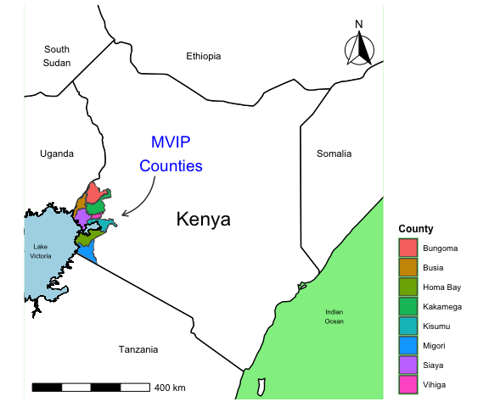
Map of MVIP sub-counties colored by intervention
ggsave( './output/intervention_counties_map.png' , dpi=300, width = 6, height = 8, units = 'in')
jw <- comparison::JaroWinkler()
mvip.boundaries.interventions = interventions %>%
full_join( mvip.boundaries ,
by = c( "County" = "ADM1_EN" , "SubCounty" = "ADM2_EN" )) %>%
st_as_sf()
saveRDS( mvip.boundaries.interventions , paste0( params$output, 'mvip.boundaries.interventions.rds' ))
mvip.boundaries.interventions$Intervention[is.na(mvip.boundaries.interventions$Intervention)] = "non-MVIP"
# count( mvip.boundaries.interventions %>% as_tibble(), County, SubCounty, st_is_empty( geometry ) )
msc = mvip.boundaries.interventions %>%
filter( !is.na( Intervention ) )
base_map =
ggplot() +
geom_sf( data = mvip.boundaries.interventions ,
aes( fill = Intervention ) ) +
geom_sf( data = lake_victoria_boundaries ,
inherit.aes = FALSE, fill = 'grey' ) +
coord_sf( xlim = c(33.8, 35.5) , ylim = c(-1.5, 1.1) ) +
theme_map( ) +
theme( legend.position= "right",
legend.title = element_text( face = 'bold') ) +
scale_fill_manual(
labels = c("Comparison", "Implementing", "Non-MVIP"),
values = c( "lightgreen", "lightblue", "gray95") )
base_map
ggsave( './output/base_map.png' , dpi=300, width = 6, height = 8, units = 'in')
saveRDS( base_map , paste0( params$output, 'base_map.rds' ))
base_map_subCounty = base_map +
geom_spatial_text(
data = bind_cols( msc,
msc %>%
st_make_valid() %>% st_centroid() %>%
st_coordinates() ) ,
aes( label = gsub(" ", "\n", SubCounty ) , x = X, y = Y ) ,
crs = 4326 ,
size = 1.5, color = 'black', face = 'bold' ,
max.overlaps= 10 )
base_map_subCounty
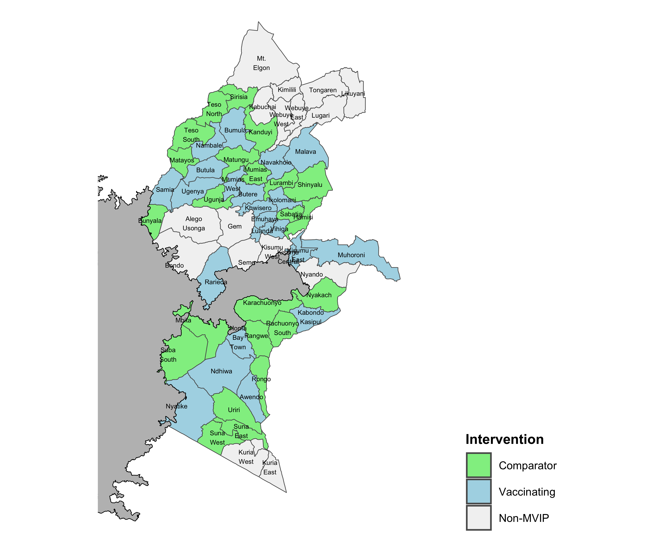
Map of MVIP sub-counties colored by intervention
ggsave( './output/base_map_labeled.png' , dpi=300, width = 6, height = 8, units = 'in')
saveRDS( base_map_subCounty , paste0( params$output, 'base_map_subCounty.rds' ))

MVIP Health Facilities
We obtain information on orgUnits in KHIS and then filter them to the sub-counties enrolled in MVIP. In this file, the variable DHISID is the unique id, orgUnit, used to identify each facility in KHIS. After ensuring

KHIS Facilities (not limited to MVIP area)
A list of organizational units, which includes health facilities was downloaded (Sep 9, 2023) from KHIS using the DHIS2 API[4], for each organisational unit (orgUnit) level (1-6), e.g. for level 2 (see Table 7 ):
API for all orgUnits in a level: https://hiskenya.org/api/organisationUnits.geojson?level=2&fields=:all&paging=false
ous = read_excel( paste0( params$data.dir ,"MetaData_2023-01-23.xlsx" ) , "OrgUnits" )
orgUnits.example.level2 = ous %>%
filter( level == 2 ) %>%
rename( orgUnit = id , parentOrgUnit = parent ) %>%
select( name, orgUnit, level, levelName, parentOrgUnit , leaf ) %>%
head(n=3)
orgUnits.example.level3 = ous %>%
filter( level == 3 ) %>%
rename( orgUnit = id , parentOrgUnit = parent ) %>%
select( name, orgUnit, level, levelName, parentOrgUnit , leaf ) %>%
head(n=3)
orgUnits.example.level4 = ous %>%
filter( level == 4 ) %>%
rename( orgUnit = id , parentOrgUnit = parent ) %>%
select( name, orgUnit, level, levelName, parentOrgUnit , leaf ) %>%
head(n=3)
orgUnits.example.level5 = ous %>%
filter( level == 5 ) %>%
rename( orgUnit = id , parentOrgUnit = parent ) %>%
select( name, orgUnit, level, levelName, parentOrgUnit , leaf ) %>%
head(n=3)
orgUnits.example.level6 = ous %>%
filter( level == 6 ) %>%
rename( orgUnit = id , parentOrgUnit = parent ) %>%
select( name, orgUnit, level, levelName, parentOrgUnit , leaf ) %>%
head(n=3)
bind_rows( orgUnits.example.level2,orgUnits.example.level3,
orgUnits.example.level4,orgUnits.example.level5,
orgUnits.example.level6 ) %>%
flextable() %>% FitFlextableToPage
Table 6.S Example of orgUnits available from a DHIS2 instance (showing 5 of 28,359 rows)
name | orgUnit | level | levelName | parentOrgUnit | leaf
Baringo County | vvOK1BxTbet | 2 | County | Kenya | FALSE
Bomet County | HMNARUV2CW4 | 2 | County | Kenya | FALSE
Bungoma County | KGHhQ5GLd4k | 2 | County | Kenya | FALSE
Baringo Central Sub County | k7Rj54u6dMx | 3 | Sub-County | Baringo County | FALSE
Baringo North Sub County | bqtTmWcikTN | 3 | Sub-County | Baringo County | FALSE
East Pokot Sub County | Mk4bMOSMRTB | 3 | Sub-County | Baringo County | FALSE
Ainabkoi/Olare Ward | keTxMrb6Oag | 4 | County Assembly Ward | Ainabkoi Sub County | FALSE
Kapsoya Ward | H9e1tEercdW | 4 | County Assembly Ward | Ainabkoi Sub County | FALSE
Kaptagat Ward | cYwuj1W0Wux | 4 | County Assembly Ward | Ainabkoi Sub County | FALSE
Abakaile Dispensary | QITW06phVzk | 5 | Health Facility | Abakaile Ward | FALSE
Alikune Dispensary | edjfwbsoTLn | 5 | Health Facility | Abakaile Ward | FALSE
Kumahumato Dispensary | J2nSU1CrG7s | 5 | Health Facility | Abakaile Ward | FALSE
Ayucha Community Health Unit | lsAviUAjWGL | 6 | CommunityUnit | Ayucha Heallth Centre | TRUE
Checkpoint Community Unit | TlYwJC9qpNb | 6 | CommunityUnit | Nakuru West( A.I.P.C.A) Medical Centre | TRUE
Honeycup Community Health Unit | JsZeP9JbXsS | 6 | CommunityUnit | Nakuru West( A.I.P.C.A) Medical Centre | TRUE

The orgUnit list in DHIS2 is organized as a parent-child listing: There is one line for each orgUnit that provides details of the orgUnit level, whether it is a ‘leaf’, and the orgUnit to which it belongs. For example, a community health unit (level 6) will show the parent orgUnit (level 5). All of the orgUnit are identified by their alphanumeric id. We then use code to turn that parent-child list of orgUnits into a table with the full names of each level. For example, each level 6 CommunityUnit will be a row in the table that includes the name of the County, SubCounty, County Assembly Ward, Health Facility, and CommunityUnit.
Organisational Hierarchy (DHIS2 Documentation[5])
“The [orgUnit] hierarchy is built up of parent-child relations, e.g. a Country or MoH unit (the root) might have e.g. 8 parent units (provinces), and each province again ( at level 2) might have 10-15 districts as their children. Normally the health facilities will be located at the lowest level, but they can also be located at higher levels, e.g. national or provincial hospitals, so skewed organisational trees are supported (e.g. a leaf node can be positioned at level 2 while most other leaf nodes are at level 5).”
Note: ‘leaf’ is a logical variable in DHIS2 that refers to the lowest level of a tree-like structure. When TRUE, there is no orgUnit below. When FALSE, there is at least one orgUnit below whose data will be aggregated into the totals for this orgUnit (see DHIS2 Documentation in the box below).
# dhis2 ous.tree ####
ous = read_excel( paste0( params$data.dir ,"MetaData_2023-01-23.xlsx" ) , "OrgUnits" )
ouLevels = read_excel( paste0( params$data.dir ,"MetaData_2023-01-23.xlsx" ) , "OrgUnitLevels" )
The KHIS organization units are organized by orgUnit levels:
ouLevels = ous %>%
distinct( level, levelName ) %>%
filter( !is.na( level )) %>%
mutate( level = as.integer( level ))
ouLevels %>% flextable() %>% FitFlextableToPage
Table 7.S Organisational Unit Levels in KHIS
level | levelName
1 | Kenya
2 | County
3 | Sub-County
4 | County Assembly Ward
5 | Health Facility
6 | CommunityUnit

The orgUnit levels in DHIS2 are different from the Kenya Publilc Health service levels, which are organized by level of care[6]:
kph = tribble(
~`KEPH Service Level`, ~Description ,
"6" , "Tertiary referral hospital" ,
"5", "Secondary referral hospital" ,
"4", "Primary facilities" ,
"3" , "Health centers",
"2", "Dispensaries and clinics" ,
"1" , "Commnity health units"
)
kph %>% flextable() %>% FitFlextableToPage
KEPH Service Level | Description
6 | Tertiary referral hospital
5 | Secondary referral hospital
4 | Primary facilities
3 | Health centers
2 | Dispensaries and clinics
1 | Commnity health units
# fix rows with missing level (levelName is present)
ous = ous %>% select( - level ) %>%
inner_join( ouLevels , by = 'levelName' )
facilityLevels = ous %>%
mutate( `Facility Key Word` = str_extract( name,
regex( "\\bhospital|health|clinic|community\\b" , ignore_case = TRUE ) ) %>% str_to_title()
) %>%
filter( ! is.na( `Facility Key Word` )) %>%
count( level, levelName, `Facility Key Word` ) %>%
rename( `No. of Units` = n )
facilityLevels %>% flextable() %>% FitFlextableToPage
Table 8.S Number of health providers associatied with each KHIS organization unit level
level | levelName | Facility Key Word | No. of Units
4 | County Assembly Ward | Hospital | 3
5 | Health Facility | Clinic | 3,392
5 | Health Facility | Community | 254
5 | Health Facility | Health | 2,078
5 | Health Facility | Hospital | 1,038
6 | CommunityUnit | Clinic | 7
6 | CommunityUnit | Community | 9,447
6 | CommunityUnit | Health | 247
6 | CommunityUnit | Hospital | 11

MVIP-KHIS Health Facilities
Select all facilities within the MVIP intervention sub-counties.
# open file created in previous chunk
if (!exists( 'ous.tree') ) ous.tree = readRDS( paste0( params$data.dir , "ous.tree.rds" ) )
# match names with dhis2 ous.tree ####
# match by district and fuzzy facility name
jw <- comparison::JaroWinkler()
MVIP.KHIS = interventions %>%
filter( !is.na( SubCounty ) , !is.na( Intervention)) %>%
fuzzy_left_join(
ous.tree ,
match_fun = function(x, y){ jw(x, y) > 0.95 } ,
by = c( 'County' , 'SubCounty' ) ) %>%
rename( County = County.x , SubCounty = SubCounty.x ,
Ward = `County Assembly Ward` ) %>%
select( County, SubCounty, Ward, `Health Facility`, CommunityUnit ,
Intervention, Vector_2021, IRS, orgUnit, orgUnitName , level, leaf, parent.orgUnit
)
unmatched = MVIP.KHIS %>%
filter( is.na( orgUnit ))
- Verify that all of the MVIP sub-county interventions were linked with DHIS2 orgUnits: TRUE

Western Kenya Health Facility List
An additional facility list for the MVIP area was obtained with contained additional information about the facilities, including the ownership (public vs. private), KEPH service level, and updated coordinates.[7]
# Assign intervention to master list.
WKHF = read_excel( paste0( params$data.dir ,"HF Western Kenya - master list.xlsx" ) ,
guess_max = min(2000) ) %>%
select( County_DHIS2, Sub_County_DHIS2, Facility_Name, KEPH_Level ,
DHISID, Owner,
Long_Final, Lat_Final, Source_LL_FINAL ) %>%
left_join( interventions ,
by = c( "County_DHIS2" = "County",
"Sub_County_DHIS2" = "SubCounty" )
) %>%
mutate( Intervention = ifelse( is.na( Intervention) ,
'Non-MVIP (implementing)' ,
as.character( Intervention ) ) )

Update DHISID
- Check for duplicate facility names: ther one duplicate facility, “Obwogre Dispensary”, one of which one has a DHISID and the other does not; we keep the one with the DHISID.
count( WKHF, Sub_County_DHIS2 , Facility_Name ) %>% arrange(-n) %>% filter(n>1)
# A tibble: 1 × 3
Sub_County_DHIS2 Facility_Name n
<chr> <chr> <int>
1 Ugenya Obwogre Dispensary 2
WKHF = WKHF %>% filter( ! ( Facility_Name %in% "Obwogre Dispensary" & DHISID == "None" ) )
- Check for spatial coordinates:
WKHF %>%
count( hasLongitude = ! is.na( Long_Final), hasLatitude = ! is.na(Lat_Final ))
# A tibble: 2 × 3
hasLongitude hasLatitude n
<lgl> <lgl> <int>
1 FALSE FALSE 9
2 TRUE TRUE 1692
- Check for unique DHISID, which should match the KHIS orgUnit, and will be used to link these facilities with KHIS:
duplicateDHISid = count( WKHF, DHISID ) %>% filter( n>1 ) %>% arrange(-n)
duplicateDHISid
# A tibble: 1 × 2
DHISID n
<chr> <int>
1 None 109
noDHISID = WKHF$DHISID %in% 'None'
There are no duplicates, but some DHISID are missing; DHISID is ‘None’ for 109.
- For those with no DHISID, try to match the Facility_Name with the orgUnit name in KHIS.
The DHISID was added for 6 of 109 rows.

Hybrid MVIP-KHIS-Western Kenya Health Facility List
- Update KHIS orgUnits with the Western Kenya facilities list us. Note that the master list does that include any of the community health units that are associated with health facilities. Because this analysis will include the cases reported by community health units,
#|echo: true
MVIP.KHIS.WKHF = MVIP.KHIS %>%
# join with masterlist
left_join( updatedWKHF %>%
select( DHISID, Facility_Name, Long_Final ,Lat_Final,
Owner, KEPH_Level ),
by = c( "orgUnit"= "DHISID") )
saveRDS( MVIP.KHIS.WKHF, paste0( params$data.dir , "MVIP.KHIS.WKHF.rds" ) )
- 1,493 rows in MVIP.KHIS were linked with the WKHF table.

Facility types in MVIP areas
#|echo: true
mvipFacilityLevels = MVIP.KHIS.WKHF %>%
mutate( `Facility Key Word` = str_extract( orgUnitName,
regex( "\\bhospital|health|community|dispens\\b" ,
ignore_case = TRUE ) ) %>%
str_to_title()
) %>%
left_join( ouLevels , by = 'level' ) %>%
# mutate( levelName = ifelse( paste0( levelName, "-", Owner ) ) %>%
count( level, levelName, Intervention ) %>%
pivot_wider( names_from = "Intervention", values_from = n ) %>%
mutate( across(everything(), ~ ifelse(is.na(.), "-", . )) ,
) %>%
rename( `KHIS Level` = levelName )
# Save
saveRDS(mvipFacilityLevels, "output/mvipFacilityLevels.rds")
total_facilities <- mvipFacilityLevels %>%
filter( `KHIS Level` == 'Health Facility' ) %>%
summarise( across( where(is.numeric) , \(x) sum( x, na.rm = TRUE) ) ) %>%
mutate( levelName = 'Health Facility' )
tbl.mvipFacilitiesByLevel = mvipFacilityLevels %>%
select( - level ) %>%
flextable() %>% FitFlextableToPage
# kable( align = c("l", "r", "r") )
# add_header_above( c( rep("", 1) , "No. of Units" = 2) )
tbl.mvipFacilitiesByLevel
Table 9.S Type of health units in MVIP districts associatied with each organization unit level
KHIS Level | Comparison | Implementing
Sub-County | 23 | 23
County Assembly Ward | 115 | 113
Health Facility | 874 | 840
CommunityUnit | 838 | 931

#|echo: true
mvipFacilityOwners = MVIP.KHIS.WKHF %>%
filter( level == 5 ) %>%
left_join( ouLevels , by = 'level' ) %>%
# mutate( levelName = ifelse( paste0( levelName, "-", Owner ) ) %>%
count( level, levelName, Owner , Intervention ) %>%
# mutate( percent = paste0( "(" , (n / sum(n) ) %>% percent , ")" ) ) %>%
pivot_wider( names_from = "Intervention", values_from = n) %>%
mutate( across(everything(), ~ ifelse(is.na(.), "Unidentified", . )) ,
) %>%
rename( `KHIS Level` = levelName )
# Save
saveRDS(mvipFacilityOwners, "output/mvipFacilityOwners.rds")
tbl.mvipFacilityOwners = mvipFacilityOwners %>%
select( - level ) %>%
flextable() %>% FitFlextableToPage
# kable( align = c("l", "l", "r", "r") )
# add_header_above( c( rep("", 2) , "No. of Units" = 2) )
tbl.mvipFacilityOwners
Table 10.S Type of health units in MVIP districts associatied with each organization unit level
KHIS Level | Owner | Comparison | Implementing
Health Facility | Ministry of Health | 392 | 399
Health Facility | Mission/Faith-Based Organization | 80 | 65
Health Facility | Non-Governmental Organization | 16 | 29
Health Facility | Other Min | 14 | 9
Health Facility | Private | 255 | 234
Health Facility | Unidentified | 117 | 104

Percentage of facility ownership by intervention
For facilities in KHIS that were linked with the master list, we compared the facility ownership across interventions Table 11 . (The column with owner, the row with missing value for owner indicates facilities in the master list that were not linked with those in KHIS)
comp = MVIP.KHIS.WKHF %>%
filter(is.na(CommunityUnit), Intervention == "Comparison" ) %>%
count( Intervention, Owner ) %>%
mutate( Owner = ifelse( is.na(Owner), 'Unknonwn' , Owner ) ) %>%
group_by( Intervention ) %>%
tidyfst:: add_prop()
vacc = MVIP.KHIS.WKHF %>%
filter(is.na(CommunityUnit), Intervention == "Implementing") %>%
count( Intervention, Owner ) %>%
mutate( Owner = ifelse( is.na(Owner), 'Unknonwn' , Owner ) ) %>%
group_by( Intervention ) %>%
tidyfst:: add_prop()
mvipFacilitiesByOwner =
bind_rows( comp, vacc ) %>%
mutate( Owner = str_replace_all( Owner, "Other Min" , "Other MOH" ) ) %>%
select( Intervention, Owner, prop_label ) %>%
pivot_wider( names_from = "Intervention", values_from = prop_label )
mvipFacilitiesByOwner %>%
flextable() %>% FitFlextableToPage
saveRDS( mvipFacilitiesByOwner, paste0( params$output , 'mvipFacilitiesByOwner.rds' ))
Table 11.S Ownership of health units for the MVIP intervention areas
Owner | Comparison | Implementing
Ministry of Health | 38.7% | 40.9%
Mission/Faith-Based Organization | 7.9% | 6.7%
Non-Governmental Organization | 1.6% | 3.0%
Other MOH | 1.4% | 0.9%
Private | 25.2% | 24.0%
Unknonwn | 25.2% | 24.6%

Vector Control Strategy Among Intervention Areas
***TODO: add dates of interventions
Sub-counties in Western Kenya participated in several vector control strategies. IRS was applied annually in 14 sub-counties. Meanwhile, mass bednet campaigns were carried out in 32 sub-counties during 2021. Of these, 12 sub-counties received long-lasting insecticide nets treated with pyrethroids (Standard net) and 20 received long-lasting insecticide nets treated with combined pyrethroid and piperonyl-butoxide (PBO).[8] A greater proportion of sub-district assigned to the comparison groups received the more effective vector control interventions, IRS and PBO nets Table 12.
#|echo: true
#|
total.facilities =
MVIP.KHIS.WKHF %>%
# inner_join( interventions %>% count( County, SubCounty, Vector_2021 ) ,
# by = c( 'County' , 'SubCounty' ) ) %>%
rename( `Vector Control (2021)` = Vector_2021 ) %>%
# filter( level %in% 3:6 ) %>%
group_by( Intervention , `Vector Control (2021)` ) %>%
summarise( N.Counties = n_distinct( County ),
N.SubCounties = n_distinct( SubCounty ) ,
N.Facilities = n_distinct( `Health Facility` )
# , N.CHU= n_distinct( CommunityUnit )
) %>%
ungroup %>%
group_by( Intervention ) %>%
mutate(prop = N.Facilities / sum(N.Facilities) * 100) %>%
# tidyfst:: add_prop( 'N.Facilities' ) %>%
# select( - prop_label ) %>%
# rename( Percent = prop_label ) %>%
ungroup %>%
bind_rows(
summarise(., across(where(is.numeric), sum) ,
across(where(is.character), ~ 'Total' ) )
) %>%
mutate(
Percent = percent( prop / 100 )
) %>%
select( - prop )
subtotals <- total.facilities %>%
group_by( Intervention ) %>%
summarise(., across(where(is.numeric), sum) ,
across(where(is.character), ~ 'Total' ) ) %>%
mutate( Intervention = paste( Intervention, "Subtotal")) %>%
ungroup()
total.facilities %>%
flextable() %>% FitFlextableToPage
# kable( align = c("l","l", "r", "r" , "r", "r" ) )
Table 12.S Vector control interventions assigned to sub-counties in each MVIP intervention area
Intervention | Vector Control (2021) | N.Counties | N.SubCounties | N.Facilities | Percent
Comparison | IRS | 2 | 9 | 383 | 44.0%
Comparison | PBO | 3 | 10 | 344 | 39.5%
Comparison | Pyrethroid | 3 | 4 | 144 | 16.5%
Implementing | IRS | 2 | 5 | 244 | 29.2%
Implementing | PBO | 3 | 10 | 270 | 32.3%
Implementing | Pyrethroid | 3 | 8 | 322 | 38.5%
 | Total | 16 | 46 | 1,707 | 200.0%

Map of Health Providers in MVIP Areas
When available, we used the coordinates provided in the Western Kenya file. When not available, we used the coordinates provided by KHIS.
**TODO: verify KHIS coordinates belong to corresponding admin unit.
#|echo: true
khis.sf = readRDS( paste0( params$data.dir , params$geo.file ) ) %>%
rename( orgUnit = id )
# use coordinates to make simple features spatial dataset (https://r-spatial.github.io/sf/)
geo_coord_system = st_crs( khis.sf )
# Some polygons have invalid geometry. see https://github.com/r-spatial/sf/issues/1902 for similar issue
# In the SF package, the solution is to turn off spherical geometry and rebuild the geometry with st_make_valid() as planar geometry. See: https://r-spatial.org/r/2020/06/17/s2.html and #1771.
sf_use_s2(FALSE)
Spherical geometry (s2) switched off
# convert WKHF make simple features spatial dataset
# WKHF.sf = WKHF %>%
# filter( ! is.na( Long_Final ) ) %>%
# st_as_sf( coords = c( "Long_Final" , "Lat_Final") ) %>%
# mutate( masterList.geometry.type = st_geometry_type( geometry ) )
# Make spatial dataset of MVIP.KHIS
MVIP.KHIS.WKHF.sf = MVIP.KHIS.WKHF %>%
left_join( khis.sf %>% select( orgUnit, geometry, parentName ) ,
by = 'orgUnit' ) %>%
st_as_sf() %>%
st_make_valid()
# Update coordinates:
# if present, use WKHF coordinates to update facilities
# - 9 facilities in WKHF missing coordinates
WKHFCoordinates = !is.na( MVIP.KHIS.WKHF$Lat_Final )
orgUnitsWithWKHFcoordinates = MVIP.KHIS.WKHF[ WKHFCoordinates ,]$orgUnit
# Rebuild spatial dataset using coordinates from WKHF first, then adding KHIS sf geometry
MVIP.KHIS.WKHF.sf2 =
bind_rows(
MVIP.KHIS.WKHF.sf[ WKHFCoordinates, ] %>%
st_as_sf( coords = c("Long_Final", "Lat_Final") ) %>%
st_make_valid() ,
MVIP.KHIS.WKHF.sf[ ! WKHFCoordinates, !names(MVIP.KHIS.WKHF.sf) %in% c("Long_Final", "Lat_Final") ]
)
# After update, some facilities (mostly level 6 CHW) do not have coordinates
MVIP.KHIS.WKHF.sf2$noGeo = st_is_empty( MVIP.KHIS.WKHF.sf )
saveRDS( MVIP.KHIS.WKHF.sf2, paste0( params$data.dir , "MVIP.KHIS.WKHF.sf2.rds" ) )
# Fill in level for facilities from masterList -- all are presumed level= 5
levelNA = is.na( MVIP.KHIS.WKHF.sf2$level )
# Set facilities as those orgUnits in level 5 and 6
mvip.facilities = MVIP.KHIS.WKHF.sf2 %>%
# filter( level > 4 ) %>%
mutate( level = as.factor( level ) )
saveRDS( mvip.facilities , paste0( params$data.dir, 'mvip.facilities.rds' ) )
# Count facilities by orgUnit level
mvip.facilities %>% st_drop_geometry() %>%
count( level, KEPH_Level , noGeo ) %>%
flextable() %>% FitFlextableToPage
level | KEPH_Level | noGeo | n
3 |  | FALSE | 20
3 |  | TRUE | 26
4 |  | FALSE | 95
4 |  | TRUE | 133
5 | Level 2 | FALSE | 535
5 | Level 2 | TRUE | 605
5 | Level 3 | FALSE | 140
5 | Level 3 | TRUE | 142
5 | Level 4 | FALSE | 36
5 | Level 4 | TRUE | 33
5 | Level 5 | TRUE | 2
5 |  | FALSE | 91
5 |  | TRUE | 130
6 |  | FALSE | 732
6 |  | TRUE | 1,037
#|echo: true
#|
# note that some coordinates are outside MVIP, probably because of data entry error
boundaryBox = mvip.boundaries.interventions %>% st_bbox()
ggplot() +
geom_sf( data = mvip.boundaries.interventions, aes( fill = Intervention) ) +
geom_sf( data = mvip.facilities ,
aes( color = level ), size = 1 ) +
coord_sf(
xlim = c( boundaryBox[1], boundaryBox[3]),
ylim = c(boundaryBox[2], boundaryBox[4] ),
expand = FALSE
) +
theme_map( ) +
theme( legend.position= "right",
legend.title = element_text( face = 'bold') ) +
scale_fill_manual(
labels = c("Comparison", "Implementing", "Non-MVIP"),
values = c( "lightgreen", "lightblue", "gray95") )
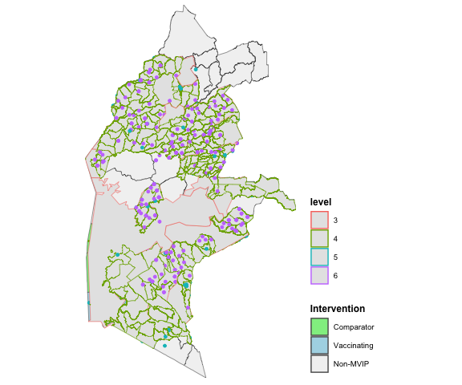
# scale_color_manual(
# labels = c("4" , "5", "6" ),
# values = c( "black", "dark grey" , "gray95") )

Online map
An interactive map, prepared using the R leaflet package,[9] is available online (url to be named later). A measurement tool (kms) is provided in the lower left corner to estimate the distance between facilities.

Supplement E: Vaccine Doses

Vaccinations reported by enrolled facilities
We downloaded monthly malaria vaccine data by facility reported through DHIS2 from 2018 to 2022 on 2023-08-26.
Table 13.S Number of monthly malaria vaccine reports by dose
data.id | data | vx_reports
Rhkz9D6hdZV_NhSoXUMPK2K | NVIP Malaria Vaccine Dose 2_default | 27020
U46JIUFqgvj_NhSoXUMPK2K | NVIP Malaria Vaccine Dose 1_default | 27906
pznTlBTeIb7_NhSoXUMPK2K | NVIP Malaria Vaccine Dose 4_default | 17266
znLJPgpYjpF_NhSoXUMPK2K | NVIP Malaria Vaccine Dose 3_default | 25656

Number of subcounties providing RTS,S reports
Intervention | vx_reports
Comparison | 23
Implementing | 23
non-MVIP | 16
Several additional sub-counties provided vaccination during the MVIP
non-MVIP vaccination sub-counties
County | Sub-County
Kakamega County | Mumias West Sub County
Kisumu County | Kisumu Central Sub County
Kisumu County | Kisumu East Sub County
Kisumu County | Kisumu West Sub County
Kisumu County | Seme Sub County
Siaya County | Gem Sub County

Complete list of MVIP and non-MVIP subcounties
Intervention | County | Sub-County | vx_reports
Comparison | Bungoma County | Kanduyi Sub County | 399
Comparison | Bungoma County | Sirisia Sub County | 224
Comparison | Busia County | Bunyala Sub County | 134
Comparison | Busia County | Matayos Sub County | 256
Comparison | Busia County | Teso North Sub County | 130
Comparison | Busia County | Teso South Sub County | 260
Comparison | Homa Bay County | Karachuonyo Sub County | 657
Comparison | Homa Bay County | Mbita Sub County | 369
Comparison | Homa Bay County | Rachuonyo South Sub County | 335
Comparison | Homa Bay County | Rangwe Sub County | 335
Comparison | Homa Bay County | Suba South Sub County | 331
Comparison | Kakamega County | Lurambi Sub County | 319
Comparison | Kakamega County | Matungu Sub County | 249
Comparison | Kakamega County | Mumias East Sub County | 210
Comparison | Kakamega County | Shinyalu Sub County | 317
Comparison | Kisumu County | Nyakach Sub County | 373
Comparison | Migori County | Rongo Sub County | 220
Comparison | Migori County | Suna East Sub County | 191
Comparison | Migori County | Suna West Sub County | 283
Comparison | Migori County | Uriri Sub County | 315
Comparison | Siaya County | Ugunja Sub County | 212
Comparison | Vihiga County | Hamisi Sub County | 459
Comparison | Vihiga County | Sabatia Sub County | 181
Implementing | Bungoma County | Bumula Sub County | 2790
Implementing | Busia County | Butula Sub County | 2842
Implementing | Busia County | Nambale Sub County | 2130
Implementing | Busia County | Samia Sub County | 2362
Implementing | Homa Bay County | Homa Bay Town Sub County | 3091
Implementing | Homa Bay County | Kabondo Kasipul Sub County | 3748
Implementing | Homa Bay County | Ndhiwa Sub County | 5909
Implementing | Kakamega County | Butere Sub County | 2770
Implementing | Kakamega County | Ikolomani Sub County | 2740
Implementing | Kakamega County | Khwisero Sub County | 2902
Implementing | Kakamega County | Malava Sub County | 4395
Implementing | Kakamega County | Mumias West Sub County | 2127
Implementing | Kakamega County | Navakholo Sub County | 2408
Implementing | Kisumu County | Kisumu Central Sub County | 4438
Implementing | Kisumu County | Kisumu East Sub County | 3700
Implementing | Kisumu County | Muhoroni Sub County | 4363
Implementing | Migori County | Awendo Sub County | 3252
Implementing | Migori County | Nyatike Sub County | 6773
Implementing | Siaya County | Rarieda Sub County | 4306
Implementing | Siaya County | Ugenya Sub County | 2917
Implementing | Vihiga County | Emuhaya Sub County | 1760
Implementing | Vihiga County | Luanda Sub County | 2810
Implementing | Vihiga County | Vihiga Sub County | 2368
non-MVIP | Busia County | Bunyala Sub County | 23
non-MVIP | Busia County | Matayos Sub County | 16
non-MVIP | Busia County | Teso North Sub County | 11
non-MVIP | Busia County | Teso South Sub County | 2
non-MVIP | Homa Bay County | Mbita Sub County | 2
non-MVIP | Kakamega County | Lurambi Sub County | 20
non-MVIP | Kakamega County | Mumias West Sub County | 126
non-MVIP | Kisumu County | Kisumu Central Sub County | 167
non-MVIP | Kisumu County | Kisumu East Sub County | 316
non-MVIP | Kisumu County | Kisumu West Sub County | 3847
non-MVIP | Kisumu County | Nyando Sub County | 340
non-MVIP | Kisumu County | Seme Sub County | 3587
non-MVIP | Migori County | Suna East Sub County | 3
non-MVIP | Siaya County | Bondo Sub County | 375
non-MVIP | Siaya County | Gem Sub County | 5321
non-MVIP | Vihiga County | Sabatia Sub County | 32
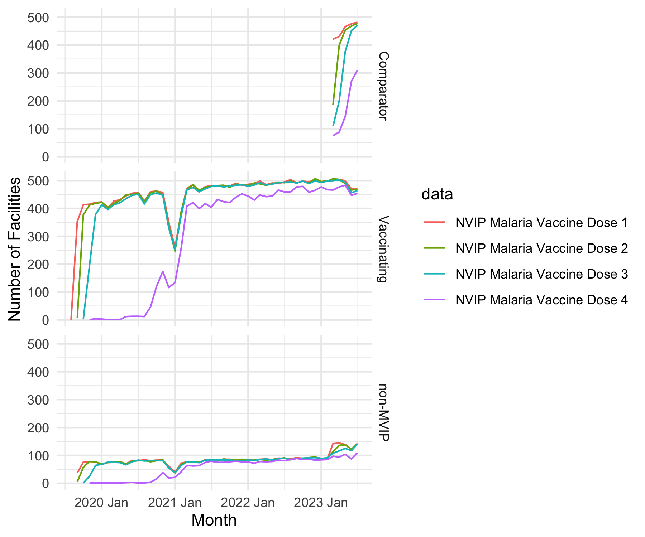
Number of facilities reporting RTS,S administration by intervention area
- Before 2023, only facilities in the Implementing areas reported administering RTS,S vx 1-4. Facilities in the Comparison areas began implementing in 2023.
- Approximately 75 facilities in sub-districts adjacent to the MVIP reporting administering RTS,S vx 1-4 during 2020-2022.
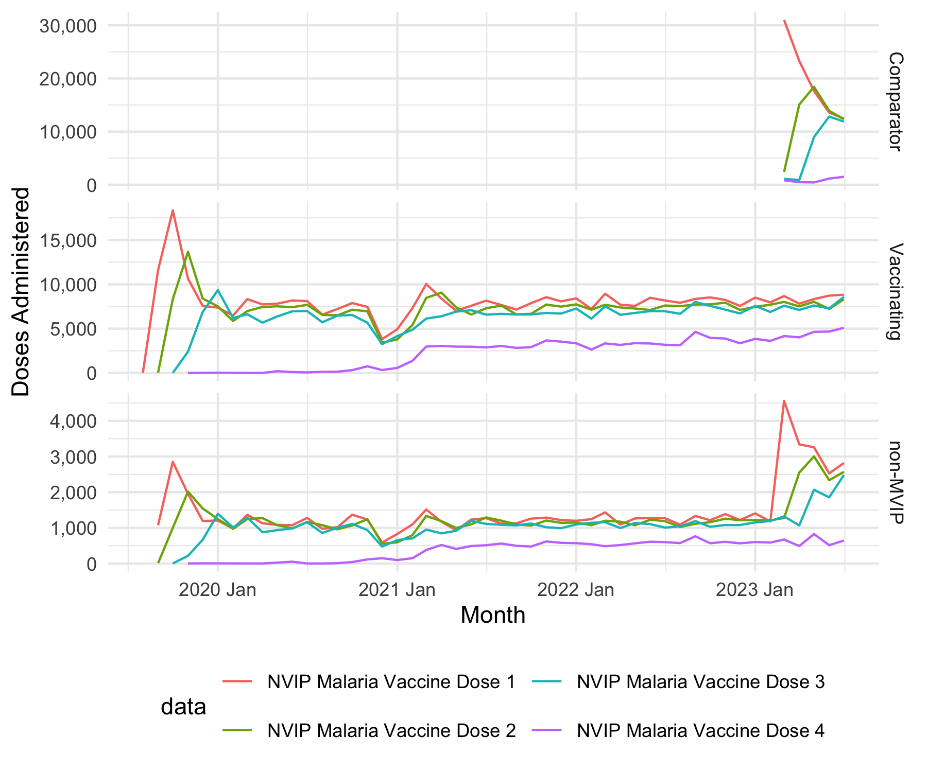
Figure 6.S Number of RTS,S doses administered by intervention area
- Substantial number of children in the Implementing areas received at least 3 doses by Jan 2020. Administering a 4th doses to substantial number of children began in spring 2021.
Intervention | level | doses | no_doses
Comparison | 5 | 6759 | 114
Implementing | 5 | 76901 | 1082
non-MVIP | 4 | 723 | 163
non-MVIP | 5 | 13465 | 150
Level 4 indicates a county hospital; level 5 are health facilities. No doses were provided by level 6, the community unit.

Number of doses by Implementing facility
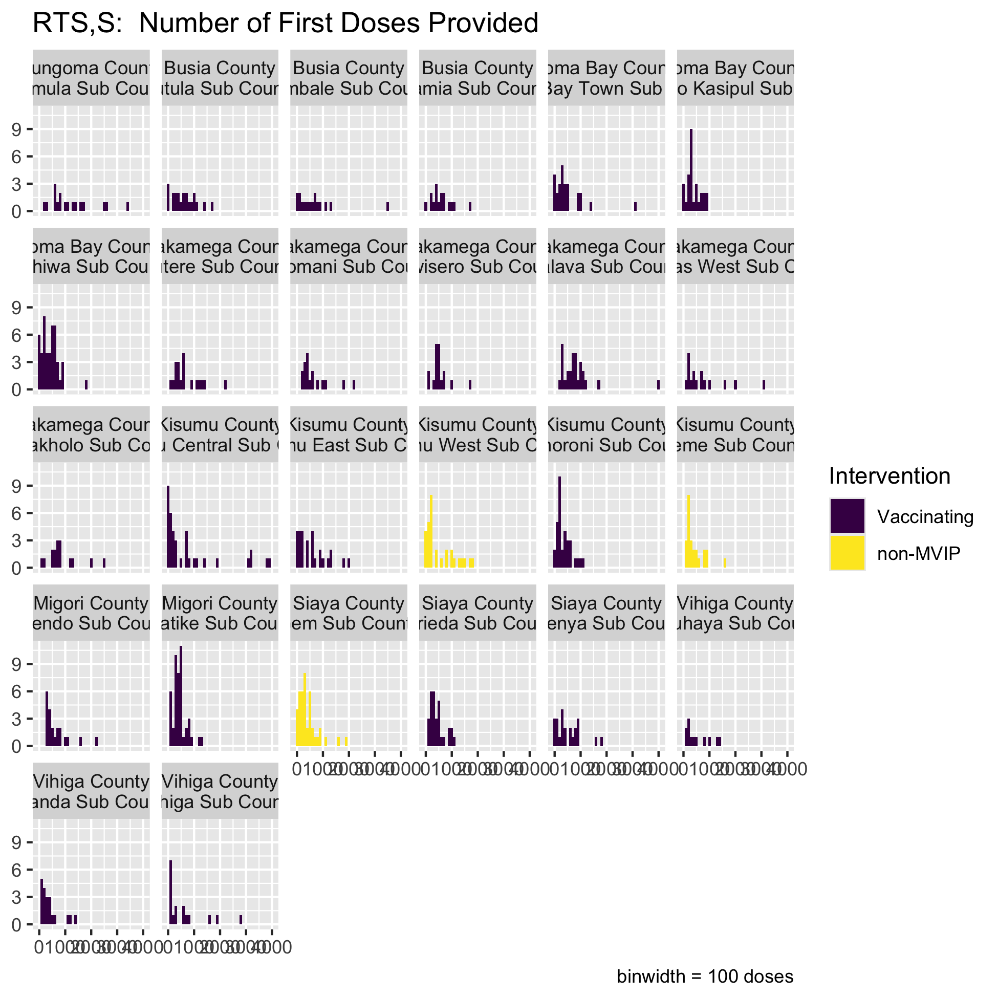
Number of first doses of RTS,S administered in MVIP implementing sub-counties

Clean vx data
Sample of vx data (first 5 rows)
orgUnit | data.id | error | n
A1BCmizFgwx | Rhkz9D6hdZV_NhSoXUMPK2K | none | 42
A1BCmizFgwx | U46JIUFqgvj_NhSoXUMPK2K | none | 43
A1BCmizFgwx | pznTlBTeIb7_NhSoXUMPK2K | none | 29
A1BCmizFgwx | znLJPgpYjpF_NhSoXUMPK2K | none | 41
A2vpkzQnTO0 | Rhkz9D6hdZV_NhSoXUMPK2K | none | 45
A2vpkzQnTO0 | U46JIUFqgvj_NhSoXUMPK2K | none | 46

Vaccination over time
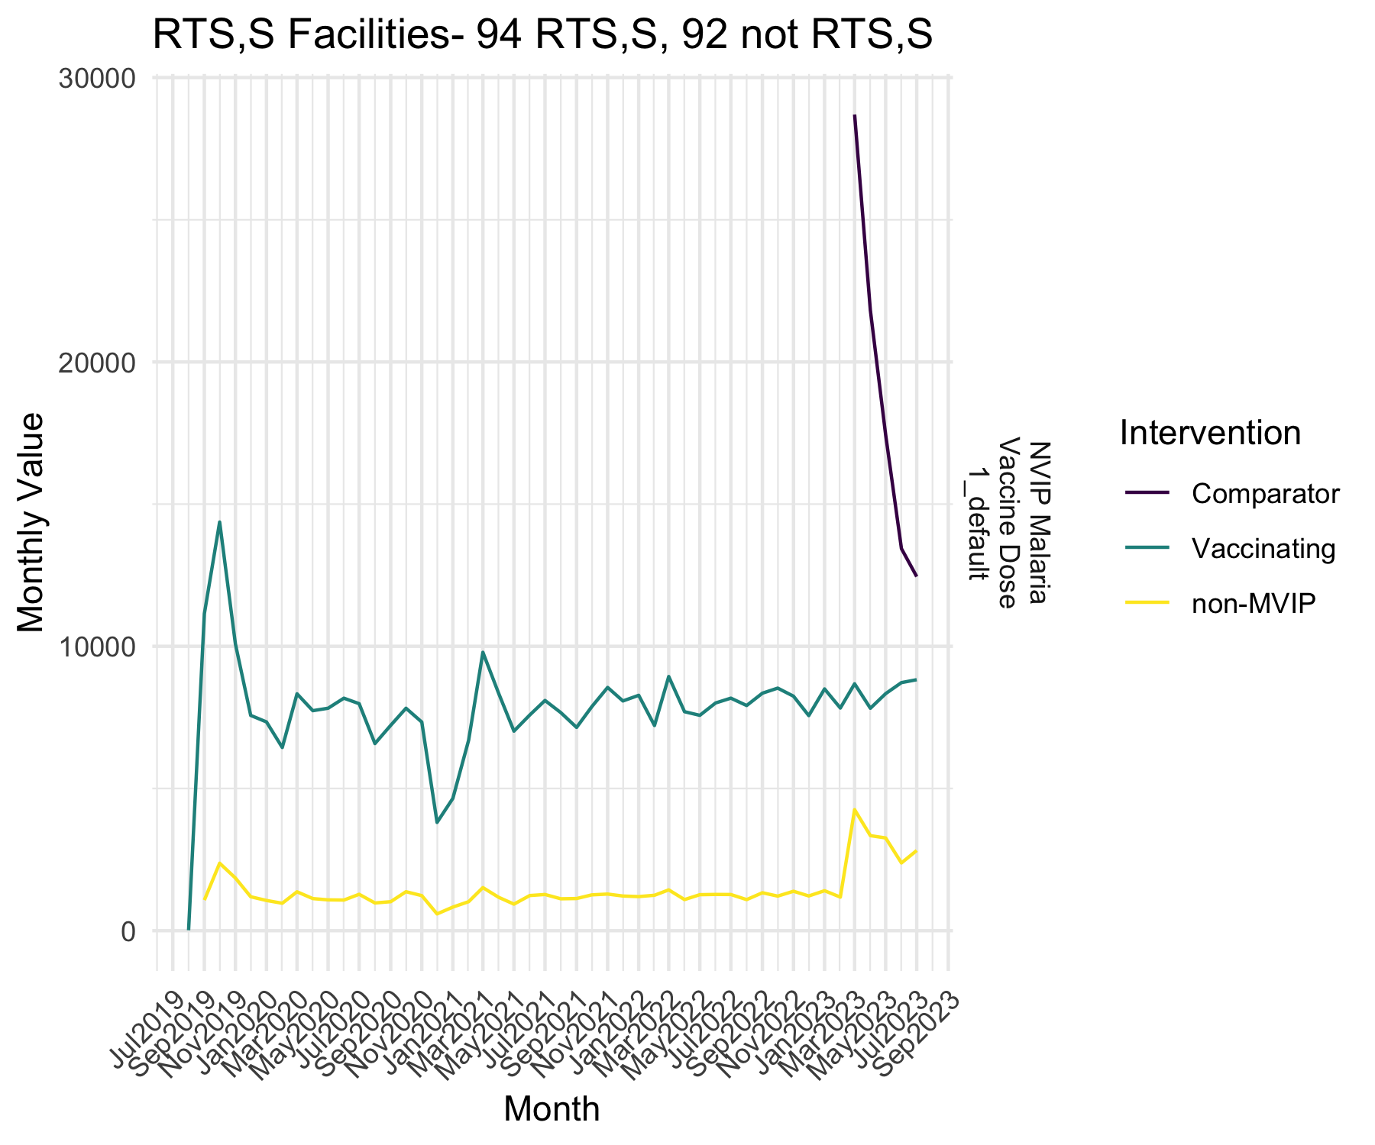
Number of first doses of RTS,S administered in MVIP implementing sub-counties

Supplement F: Confirmed Cases

Confirmed Malaria Cases (Kenya Health Information System)

Clinical cases reported to KHIS
Data were downloaded from KHIS through the DHIS2 API. Successive API calls were made for each data element for all months from Jan 2013 through Dec 2022. An example of the format of the downloaded data was shown in Section 4.
Table 14.S Sample of data downloaded for confirmed cases
dataElement | categoryOptionCombo | period | orgUnit | COUNT | SUM
OoakJhWiyZp | SeDaCnHi3m5 | 201301 | A2FJEDRHsgv | 1 | 1
OoakJhWiyZp | SeDaCnHi3m5 | 201303 | A2FJEDRHsgv | 1 | 30
OoakJhWiyZp | SeDaCnHi3m5 | 201306 | A2FJEDRHsgv | 1 | 3
OoakJhWiyZp | SeDaCnHi3m5 | 201307 | A2FJEDRHsgv | 1 | 1
OoakJhWiyZp | SeDaCnHi3m5 | 201309 | A2FJEDRHsgv | 1 | 11

The raw data file was download from KHIS on 2024-09-20 22:17:46.

Preparing Dataset for Analyses
The raw data was prepared by mapping the data element codes to their corresponding names and converting the R data frame to a tsibble[10] time-series dataset.
[Large table omitted from Word document]

MVIP Clinical Cases: Filter to cases reported by health facilities and CHW in MVIP sub-counties (mcc0)
The reported clinical cases is linked with the file for health facilities (TDODO: link to MVIP_Facilities) and restricted to data submitted prior to January 2023.
- Filter to facilities in MVIP that are below KHIS level 4, i.e. only primary care facilities
- Create agegrp variable for cases <5 and ge5.
- Confirm that all the confirmed cases were MVIP providers and calculate the percentage of MVIP providers that provided malaria clinical.case data.
level | n_facilities
5 | 1,526
6 | 909
Table 16 indicates the number of reports submitted by MVIP providers (health facilities and community health workers) for each data element, and ?@fig-mvipConfirmedCasesReportsByYear shows the raw (unadjusted) number of confirmed malaria cases reported by MVIP providers.
Table 15.S Number of health providers in MVIP areas reporing data for each data elements, 2013-2022, by KHIS orgUnit level.
Data Element | 5 | 6 | Total
Confirmed Malaria (only Positive cases)_>5 yrs | 1,523 | 3 | 1,526
Confirmed Malaria (only Positive cases)_<5 yrs | 1,503 | 2 | 1,505
CHEW No. positive_default | 307 | 751 | 1,058
CHEW No. positive >= 5_default | 203 | 849 | 1,052
CHEW No. positive < 5_default | 206 | 850 | 1,056

Table 16.S Annual number of health providers in MVIP areas reporing data for each data elements, 2013-2022
Data Element | 2013 | 2014 | 2015 | 2016 | 2017 | 2018 | 2019 | 2020 | 2021 | 2022
Confirmed Malaria (only Positive cases)_>5 yrs | 797 | 861 | 916 | 978 | 1,051 | 1,117 | 1,188 | 1,286 | 1,328 | 1,387
Confirmed Malaria (only Positive cases)_<5 yrs | 783 | 845 | 904 | 970 | 1,042 | 1,112 | 1,176 | 1,267 | 1,320 | 1,368
CHEW No. positive_default |  |  |  | 2 |  | 876 | 872 | 544 | 720 | 56
CHEW No. positive >= 5_default |  |  |  |  |  |  |  |  | 826 | 1,045
CHEW No. positive < 5_default |  |  |  |  |  |  |  |  | 798 | 1,042

- CHEW positive results were reported for all ages until 2021, when a new form allowed age disaggregation
- In 2021-2022, it may have been possible for some facilities to report on both forms, which would lead to double-counting of cases.
- Were some facilities reporting both CHEW No. positive default and age-group-specific CHEW No. positive?
Table 17.S Monthly number of health providers in MVIP areas reporting data for each data elements, 2021
Data Element | 2021 Jan | 2021 Feb | 2021 Mar | 2021 Apr | 2021 May | 2021 Jun | 2021 Jul | 2021 Aug | 2021 Sep | 2021 Oct | 2021 Nov | 2021 Dec | 2022 Jan | 2022 Feb | 2022 Mar | 2022 Apr | 2022 May | 2022 Jun | 2022 Jul | 2022 Aug | 2022 Sep | 2022 Oct | 2022 Nov | 2022 Dec
Confirmed Malaria (only Positive cases)_>5 yrs | 862 | 1,086 | 1,166 | 1,150 | 1,148 | 1,188 | 1,187 | 1,210 | 1,194 | 1,201 | 1,181 | 1,185 | 1,226 | 1,266 | 1,280 | 1,271 | 1,263 | 1,262 | 1,299 | 1,290 | 1,289 | 1,288 | 1,286 | 1,281
Confirmed Malaria (only Positive cases)_<5 yrs | 768 | 996 | 1,060 | 1,073 | 1,081 | 1,108 | 1,108 | 1,141 | 1,110 | 1,140 | 1,101 | 1,132 | 1,152 | 1,192 | 1,220 | 1,197 | 1,190 | 1,230 | 1,230 | 1,219 | 1,226 | 1,235 | 1,223 | 1,202
CHEW No. positive_default | 313 | 373 | 397 | 453 | 445 | 376 | 360 | 367 | 464 | 70 | 41 | 28 |  |  |  | 12 |  | 2 | 13 | 1 | 30 | 20 |  | 18
CHEW No. positive >= 5_default |  |  |  |  |  |  |  |  | 7 | 472 | 643 | 772 | 765 | 754 | 816 | 813 | 841 | 872 | 886 | 852 | 885 | 881 | 923 | 938
CHEW No. positive < 5_default |  |  |  |  |  |  |  |  | 4 | 409 | 583 | 726 | 733 | 720 | 786 | 762 | 805 | 861 | 869 | 830 | 837 | 855 | 887 | 889

Table 18.S Annual number of health providers in MVIP areas reporing data for each data elements, 2013-2022
Data Element | 2013 | 2014 | 2015 | 2016 | 2017 | 2018 | 2019 | 2020 | 2021 | 2022
Confirmed Malaria (only Positive cases)_>5 yrs | 797 | 861 | 916 | 978 | 1,051 | 1,117 | 1,188 | 1,286 | 1,328 | 1,387
Confirmed Malaria (only Positive cases)_<5 yrs | 783 | 845 | 904 | 970 | 1,042 | 1,112 | 1,176 | 1,267 | 1,320 | 1,368
CHEW No. positive_default |  |  |  | 2 |  | 876 | 872 | 544 | 720 | 56
CHEW No. positive >= 5_default |  |  |  |  |  |  |  |  | 826 | 1,045
CHEW No. positive < 5_default |  |  |  |  |  |  |  |  | 798 | 1,042

Table 19.S CHEW values entered for both total and age-categories (omitted for space from Word doc)

Table 20.S The age-disagregations and totals for CHEW values reported by MVIP facilities in 2021-2022
under5 | over4 | total_under5_over4
268,516 | 486,281 | 754,797

There were 168 values entered by the same orgUnit for total and age-category CHEW, which totals 1.3238^{4} cases, 1.8% of the total CHEW under5 and over4 cases.
- Censor the total value and retain the age-specific values.
- Explicitly fill-in missing values. For example, if a value was not submitted by a facility in a given month, we explicitly add an entry for that month and assign the value NA. This is done to ensure time-series models see the full time-period without any breaks.
- Save result as mcc (MVIP confirmed cases), a time-series dataset of the raw data with duplicated CHEW values removed.
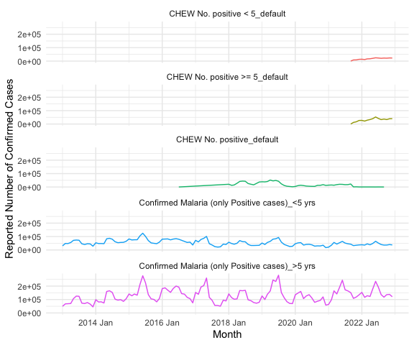
Figure 7.S Number of reported confirmed cases in MVIP areas, 2013-2022
`mutate_if()` ignored the following grouping variables:
• Column `data`
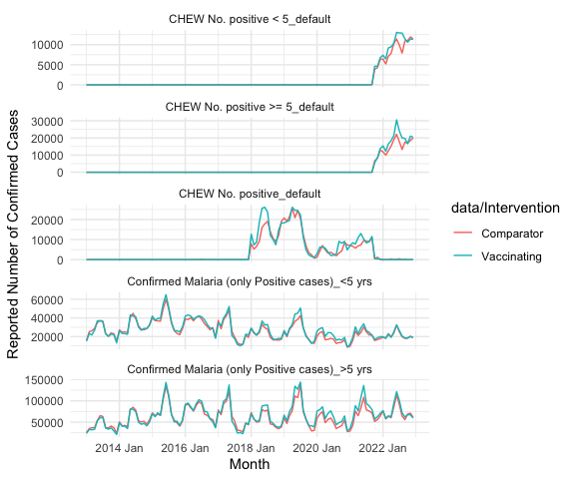
Figure 8.S Number of reported confirmed cases in MVIP areas, 2013-2022
The number of cases in implementing areas were similar to the number in comparison areas both before and after introduction of RTSS.

Identify potential outliers
and create dataset (mcc1) with new column, clean, that has removed outliers.

Table 22.S Number of errors flagged with the seasonal algorithms
* Cleaning.R outlier.summary.tibble
# A tibble: 7 × 6 `Error Flag` N `%N` `Total Value` `%Total Value` `Largest Value`
<chr> <chr> <chr> <chr> <chr> <chr>
1 key_entry_error 0 - 0 - -
2 over_max 0 - 0 - -
3 mad15 219 0.1% 111,509 0.5% 8,383
4 mad10 371 0.1% 116,890 0.5% 2,911
5 seasonal5 691 0.3% 289,267 1.2% 8,383
6 seasonal3 1,548 0.6% 509,776 2.2% 2,911
7 No Error Flags 257,517 99.1% 22,818,895 96.5% 2,388

Create mcc3 with new variables for case type (OPD, CHW)
Community cases are associated with health facilities and should be combined before scanning for consistently reporting facilities. We assume that community cases occurred in catchment area of their parent facility and that in order to assess the trends in cases in each catchment area, the community cases should be combined with their respective health facility cases. We assume that cases diagnosed at community would otherwise have been diagnosed at the health facility. However, it is possible that the increased access to care provided by CHW (starting Jan 2018) could have increased the total number of reported cases.
Unfortunately, the community cases in 2018-late 2021 were not age disaggregated and therefore cannot be included in age-specific models of vaccine impact. We are able to include the cases reported with age disaggregation on the revised reporting form in late 2021.
We combine the CHEW cases with their respective health facility with new variables to indicate age group and source of confirmation (CHEW vs OPD) data from CHEW and facilities
Note that CHW replaced the default category with “<5” and “>5” in 2021. We assume that all of the CHW reported prior to 2021 were in “<5” and recode “default” as “<5”
Table 23.S Number of health providers reporting outpatient (OPD) and community (CHW) confirmed malaria cases
case_type | level | Over4 | Under5 | unknown
CHW | 5 | 203 | 206 | 307
CHW | 6 | 849 | 850 | 740
OPD | 5 | 1,523 | 1,503
OPD | 6 | 3 | 2

Table 24.S Number of cases confirmed by (OPD) and community (CHW) health-care providers (potential outliers removed)
case_type | Over4 | Under5 | unknown
CHW | 477,632 | 261,290 | 942,065.8
OPD | 14,902,967 | 6,234,940

When age-groups reporting was available for CHEW (2021-2022), under5 accounted for 35.4% of cases. Applying that percentage to the unknown age CHEW cases suggests 333,124 under5 cases from 2018-2020 may not be included. This is approximately 20.3%of OPD cases during same years.
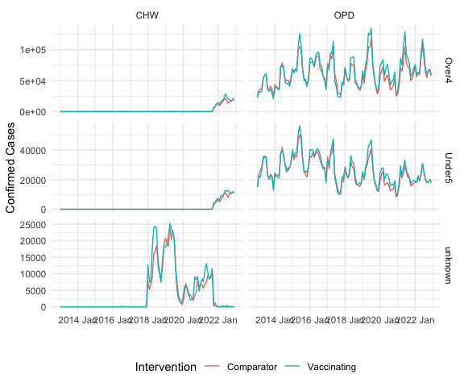

Associate CHW cases with their corresponding OPD, creating a new variable, opdUnit
Some CHEW report using the same orgUnit id as the health facilities that report OPD cases; some report using the health facility as their parent; and some CHEW report to the health facility two levels above (e.g. grandparent). Cases reported by CHW are possibly cases that would otherwise have been reported by the OPD. Therefore, we associate all of these CHEW reports to their respective OPD orgUnit (‘effectiveOrgUnit’) before aggregating the data. The data for each age group will then be aggregated to each health facility. We will use that data to determine facilities that consistently report. Those facilities that consistently report will be included in the final aggregation by intervention (comparison and implementing).
# A tibble: 20 × 7
# Groups: Intervention, case_type, agegrp [10]
Intervention case_type agegrp level ou eou same
<fct> <chr> <chr> <int> <int> <int> <int>
1 Comparison CHW Over4 5 90 90 90
2 Comparison CHW Over4 6 389 226 1
3 Comparison CHW Under5 5 93 93 93
4 Comparison CHW Under5 6 391 230 1
5 Comparison CHW unknown 5 139 139 139
6 Comparison CHW unknown 6 358 221 0
7 Comparison OPD Over4 5 778 778 778
8 Comparison OPD Over4 6 2 2 2
9 Comparison OPD Under5 5 766 766 766
10 Comparison OPD Under5 6 1 1 1
11 Implementing CHW Over4 5 113 113 113
12 Implementing CHW Over4 6 460 275 1
13 Implementing CHW Under5 5 113 113 113
14 Implementing CHW Under5 6 459 275 1
15 Implementing CHW unknown 5 168 168 168
16 Implementing CHW unknown 6 382 250 1
17 Implementing OPD Over4 5 745 745 745
18 Implementing OPD Over4 6 1 1 1
19 Implementing OPD Under5 5 737 737 737
20 Implementing OPD Under5 6 1 1 1
[1] 519
We associated 519 of 521 CHEW orgUnits with their parent OPD.
Table 25.S Number of OPD facilities and CHEW health providers are associated with an OPD
Intervention | case_type | OPD
Comparison | CHW | 579
Comparison | OPD | 782
Implementing | CHW | 666
Implementing | OPD | 746

(NB: the missing values are due to the fill_gaps procedure)

Aggregate across opdUnits (mcc4)
Data is summarised by across each effectiveOrgUnit by Intervention and age group. After summarising, the effectiveOrgUnit is set as the orgUnit (for comparability with required input in modeling and other functions). Cleaned and consolidated dataset created (mcc4) with all facilities that reported 2013-2022.
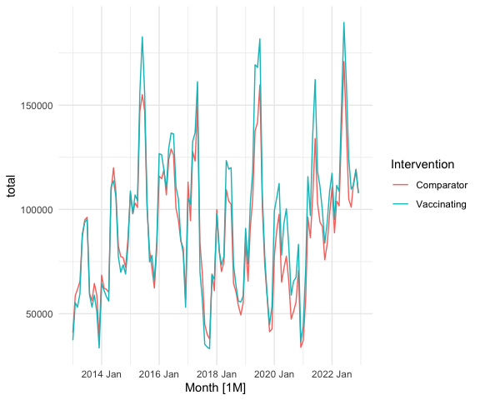
Table 26.S Characteristics of included data
agegrp | Intervention | Facilities | Reports | Cases | Cases_clean | Percent_Clean
Over4 | Comparison | 781 | 93,720 | 7,724,861 | 7,428,298 | 96.2%
Over4 | Implementing | 747 | 89,640 | 8,207,446 | 7,952,301 | 96.9%
Under5 | Comparison | 768 | 92,160 | 3,282,088 | 3,154,371 | 96.1%
Under5 | Implementing | 739 | 88,680 | 3,462,657 | 3,341,859 | 96.5%

NB: Percent_Clean refers to the percentage of the number of reported cases that are left after cleaning. It does not mean that x% of values were clean, just that filter to values not flagged as potential outliers resulted in x% of the total value.
By combining CHW data with its associated OPD facility, the dataset was reduced to 364200 from 742320.
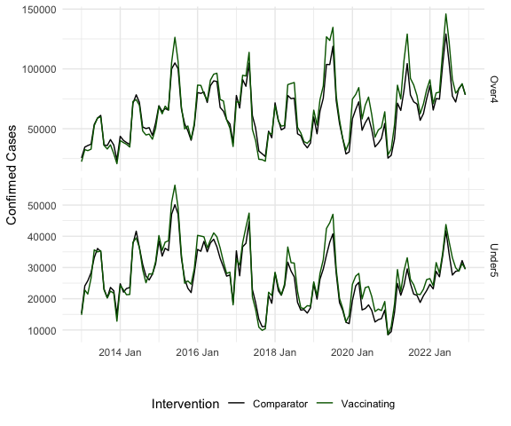
Figure 9.S Number of confirmed malaria cases reported by age group in the MVIP implementing and comparison areas.
Prior to introduction of RTSS, the number of reported under5 confirmed cases in the implementing areas was greater than the number reported in comparison areas (2018-2019), but the difference appears to decrease in 2020-2020. Conversely, in the over4 cases, the difference is less and does not appear to change as much.

Supplement G: Consistently Reporting Facilities

Facilities reporting confirmed malara cases
if (!exists( "mcc0" ) ) mcc0 = readRDS( paste0( params$output.dir , 'mcc0.rds' ) )
if (!exists( "mcc3" ) ) mcc3 = readRDS( paste0( params$output.dir , 'mcc3.rds' ) )
if (!exists( "mcc4" ) ) mcc4 = readRDS( paste0( params$output.dir , 'mcc4.rds' ) )
# reported vaccinations
if (!exists( "vx" ) ) vx = readRDS( paste0( params$data.dir, 'vx.rds' ))
if (!exists( "mvip.boundaries.interventions" ) ) mvip.boundaries.interventions = readRDS( paste0( params$data.dir, 'mvip.boundaries.interventions.rds' ) )
if (!exists( "mvip.facilities" ) ) mvip.facilities = readRDS( paste0( params$data.dir, 'mvip.facilities.rds' ) )
if (!exists( 'base_map') ) base_map = read_rds( paste0( params$output.dir , 'base_map.rds' ))

TODO: Stratify reporting by dataset (case type)

TODO: faclities reported should be length( unique(mcc1$orgUnit)) = 2435
mcc4 %>%
dqaPercentReporting() %>%
dqa_reporting_plot( text_size = 12 ) +
theme_minimal( )
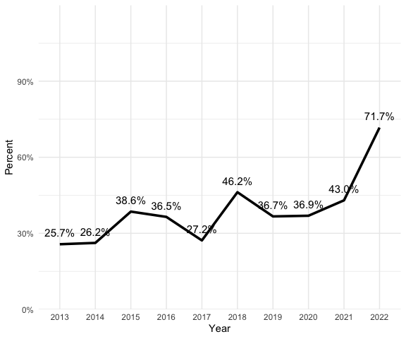
Figure 10.S Percentage of OPD facilities reporting confirmed cases all 12 months of the year
facilities.reporting( mcc4 )
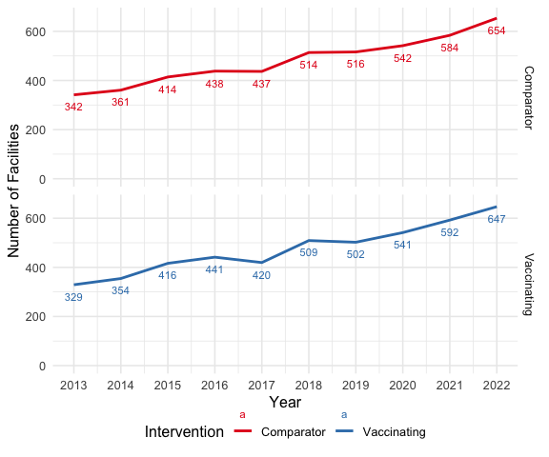
Figure 11.S Mean number of opd facilities reporting confirmed cases each month by intervention area
dataset.consisency( mcc4 )
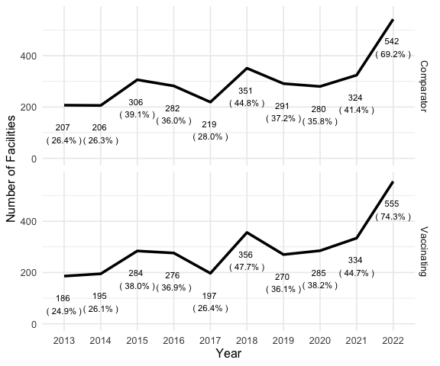
Figure 12.S Number of facilities consistently reporting (12 of 12 months) confirmed cases each year by intervention area
Characteristics facilities reporting confirmed malaria cases (selected = TRUE) compared with those facilities not reporting confirmed cases (selected = FALSE)
d = facility_characteristics( mcc4, vx,
# select all facilities
selected_facilities = unique(mcc4$orgUnit) ) %>%
ungroup
ft_characteristics( d )
Intervention | selected | Facilities | MOHª | <5y Malaria(%) | RTS,S Doses(%) | PBO-nets^{b} | IRS^{c}
Comparison | TRUE | 781 | 56.1% | 2,494,963 (46.2%) | 0 (0.0%) | 39.1% | 44.6%
Implementing | TRUE | 747 | 57.3% | 2,680,241 (49.7%) | 928,646 (100.0%) | 32.7% | 29.7%
Comparison |  | 1 | NaN% | 104,613 (1.9%) | 0 (0.0%) | 52.1% | 26.4%
Implementing |  | 1 | NaN% | 115,899 (2.1%) | 0 (0.0%) | 35.6% | 15.0%
a: Percent of facilities owned by Ministry of Health. Other facilities owned by 'Private', 'Mission/Faith-Based Organization', or 'Non-Governmental Organization'. Owner was not incidated for 24.8% of facilities
b: Percent of facilities where PBO nets distributed during mass campaign in 2021
c: Percent of facilities where IRS applied annually
saveRDS( d, paste0( params$output.dir , 'mvip-facility-characteristics.rds' ) )
The facilities reporting confirmed cases were also the ones that reported 99.7% of RTSS doses. Among these, the percentage of facilities receiving PBO nets during the 2021 mass bednet campaign was greater in the comparison area (39.1% vs 32.7%).

Facilities Consistently Reporting Confirmed Cases Each Month
To assess the potential reporting bias, we will look at the consistency of monthly reporting. Ideally, all facilities report each and every month.
To remove reporting bias from the evaluation period, we want to include only those facilities that reported each and every month during the study period (Jan 2020 - Dec 2022) and as many months as possible prior to Jan 2020. At least 24 months of data required to develop prediction models with seasonal data. An additional 12 months of data is required to validate the prediction models. Therefore, we want to assess the number of consistently reporting facilities from no later than Jan 2017 through Dec 2022.
As facilities were being added to to KHIS-DHIS2, more facilities reported each year up to and including 2017. Therefore, there will likely be a tradeoff between an having more months available for modeling and the number of facilities consistently reporting.
A facility was counted as having reported consistently if either the facility or associated CHW reported for that month. It some months the CHW did not report, so this assumes that when CHW did not report cases, the cases were reported by the facility. This could be the case when CHW are stocked-out of test kits and patients could only be tested at the nearest facility.

evaluation_consistency %>% select( -Facilities ) %>%
pivot_wider( names_from = "MissingPerYr" , values_from = N ) %>%
flextable() %>% FitFlextableToPage()
Intervention | 0 | 1 | 2 | 3 | 4 | 5 | 6 | 7 | 8 | 9 | 10 | 11
Comparison | 198 | 330 | 405 | 466 | 508 | 532 | 557 | 571 | 586 | 594 | 604 | 614
Implementing | 206 | 348 | 419 | 477 | 511 | 538 | 559 | 574 | 582 | 593 | 602 | 612
# saveRDS( evaluation_consistency, paste0( params$data.dir , 'evaluation_consistency.rds') )
While as many as 1226 facilities reported during this period, only 410 reported all months.

Consistent reporting pre-intervention through the evaluation period
# reporting_consistency %>%
# select( -Facilities ) %>%
# pivot_wider( names_from = "MissingPerYr" , values_from = N ) %>%
# kable
reporting_consistency %>%
filter( ! is.na( Intervention )) %>%
select( -Facilities ) %>%
pivot_wider( names_from = "MissingPerYr" , values_from = N ) %>%
arrange( Starting, Intervention ) %>%
gt( rowname_col = "Intervention"
, groupname_col = "MissingPerYr"
) %>%
tab_header( title = "Number of Facilities Reporting Confirmed Cases Each Month" ,
subtitle = "allow 0-2 missing reports per year")
Table 1: Number of Facilities Reporting Confirmed Cases Each Month
allow 0-2 missing reports per year
 | Starting | 0 | 1 | 2
Comparison | 2013 Jan | 43 | 108 | 148
Implementing | 2013 Jan | 28 | 97 | 144
Comparison | 2013 Jul | 46 | 118 | 156
Implementing | 2013 Jul | 31 | 106 | 152
Comparison | 2014 Jan | 48 | 120 | 162
Implementing | 2014 Jan | 35 | 108 | 155
Comparison | 2014 Jul | 52 | 134 | 180
Implementing | 2014 Jul | 42 | 124 | 177
Comparison | 2015 Jan | 55 | 139 | 182
Implementing | 2015 Jan | 47 | 132 | 182
Comparison | 2015 Jul | 61 | 147 | 190
Implementing | 2015 Jul | 51 | 140 | 191
Comparison | 2016 Jan | 66 | 151 | 194
Implementing | 2016 Jan | 59 | 146 | 197
Comparison | 2016 Jul | 72 | 160 | 204
Implementing | 2016 Jul | 68 | 158 | 212
Comparison | 2017 Jan | 81 | 165 | 210
Implementing | 2017 Jan | 72 | 165 | 216
Comparison | 2017 Jul | 85 | 173 | 227
Implementing | 2017 Jul | 83 | 180 | 241
Comparison | 2018 Jan | 118 | 206 | 268
Implementing | 2018 Jan | 112 | 235 | 314
Comparison | 2018 Jul | 126 | 219 | 281
Implementing | 2018 Jul | 127 | 249 | 327
Comparison | 2019 Jan | 147 | 243 | 307
Implementing | 2019 Jan | 137 | 261 | 339
Comparison | 2019 Jul | 163 | 263 | 336
Implementing | 2019 Jul | 156 | 277 | 357
Comparison | 2020 Jan | 198 | 330 | 405
Implementing | 2020 Jan | 206 | 348 | 419
Comparison | 2020 Jul | 237 | 385 | 468
Implementing | 2020 Jul | 240 | 396 | 476
Figure 13
Our criteria for selecting the consistently reporting facilities are:
- Have the fewest number of missing months-ideally zero-as any missed month introduces unknown bias.
- To have at least 3 years of data prior to the intervention to have the most data for validating the models used to predict the number of cases during the intervention period (the counterfactual).
- To include as many facilities as possible, assuming that at least 100 facilities in each intervention required to make representative sample.

Map of included facilities (preliminary)
if (!exists( "mvip.boundaries.interventions" ) ) mvip.boundaries.interventions = readRDS( paste0( params$data.dir, 'mvip.boundaries.interventions.rds' ) )
if (!exists( "mvip.facilities" ) ) mvip.facilities = readRDS( paste0( params$output.dir, 'mvip.facilities.rds' ) )
# note that some coordinates are outside MVIP, probably because of data entry error
boundaryBox = mvip.boundaries.interventions %>% st_bbox()
included.facilities = mvip.facilities %>%
mutate( included = ifelse( orgUnit %in% consistently_reporting_facilities, 'Included', 'Excluded' ))
if (!exists( 'base_map') ) read_rds( paste0( params$data.dir , 'base_map.rds' ))
base_map +
geom_sf( data = included.facilities %>%
filter( included == "Excluded" , level == 5) ,
# color = 'red' ,
alpha = .5 , size = .5 , shape = 21 ,
aes( fill = Intervention, color = included, level == 5 ) ) +
geom_sf( data = included.facilities %>%
filter( included == "Included" ),
# color = 'blue' ,
size = 1 , shape = 21 ,
aes( fill = Intervention , color = included ) ) +
scale_color_manual(
labels = c("Excluded", "Included" ),
values = c( "red", "blue") ) +
coord_sf(
xlim = c( boundaryBox[1], boundaryBox[3]),
ylim = c(boundaryBox[2], boundaryBox[4] ),
expand = FALSE
)
Coordinate system already present. Adding new coordinate system, which will
replace the existing one.
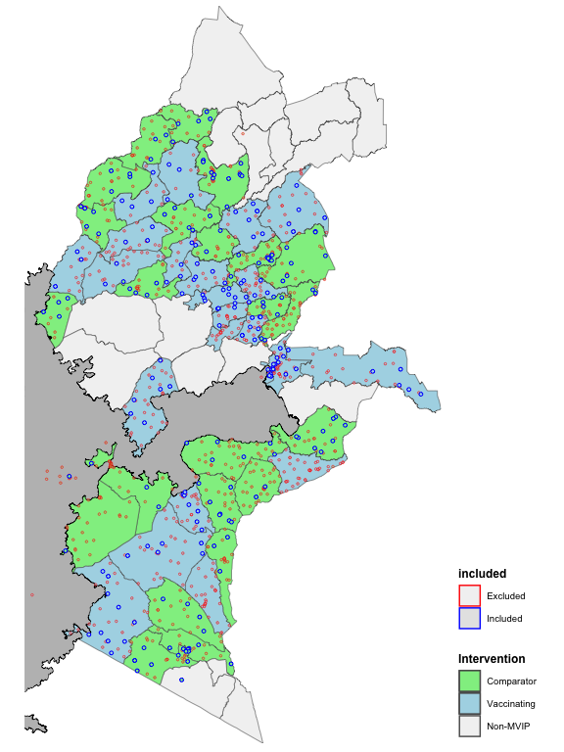
ggsave( paste0( params$output.dir , 'selected.facilities.map.png' ), width = 6, dpi = 300 )
Saving 6 x 8 in image

With the choice of number of facilities, we save the analytic Dataset (mcc5)
mcc5 = mcc4 %>%
filter( orgUnit %in% consistently_reporting_facilities,
Month >= start_month )
mcc5 %>% as_tibble %>% ungroup %>% group_by( Intervention ) %>%
summarise( Facilities = n_distinct( orgUnit )) %>% flextable()
Intervention | Facilities
Comparison | 139
Implementing | 132
saveRDS( mcc5 , paste0( params$output.dir , 'mcc5.rds') )
mcc5 %>%
dqaPercentReporting() %>%
dqa_reporting_plot( text_size = 12 ) +
theme_minimal( )
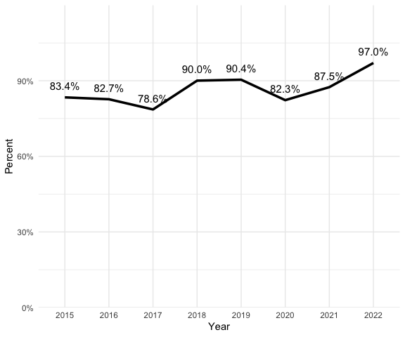
Figure 14.S Percentage of facilities reporting confirmed cases all 12 months
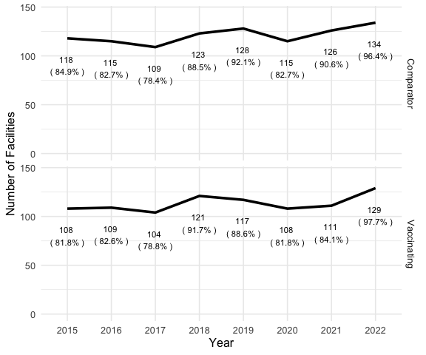
Figure 15.S Number of facilities consistently reporting confirmed cases each year
Characteristics facilities reporting confirmed malaria cases (selected = TRUE) compared with those facilities not reporting confirmed cases (selected = FALSE)
d = facility_characteristics( mcc5, vx,
# select all facilities
selected_facilities = unique(mcc5$orgUnit) ,
errs = F )
saveRDS( d, paste0( params$output.dir , 'mcc5-characteristics.rds' ) )
ft_characteristics( d , errs = F )
Intervention | selected | Facilities | MOHª | <5y Malaria(%) | RTS,S Doses(%) | PBO-nets^{b} | IRS^{c}
Comparison | TRUE | 139 | 60.4% | 1,004,891 (18.6%) | 0 (0.0%) | 46.8% | 33.8%
Implementing | TRUE | 132 | 59.1% | 944,082 (17.5%) | 374,001 (40.3%) | 45.5% | 18.9%
Comparison |  | 642 | 55.0% | 1,594,685 (29.6%) | 0 (0.0%) | 43.3% | 38.8%
Implementing |  | 615 | 56.9% | 1,852,058 (34.3%) | 554,645 (59.7%) | 32.4% | 24.5%
a: Percent of facilities owned by Ministry of Health. Other facilities owned by 'Private', 'Mission/Faith-Based Organization', or 'Non-Governmental Organization'. Owner was not incidated for 24.8% of facilities
b: Percent of facilities where PBO nets distributed during mass campaign in 2021
c: Percent of facilities where IRS applied annually
By selecting for consistently reporting facilities, the percentage of facilities in areas receiving PBO nets is now essentially the same in both intervention areas. We did not anticipate that the selection of consistently reporting facilities would have this effect, which makes the two groups potentially more comparable. While the number of facilities in areas receiving PBO nets is essentially the same, it is possible that the size of facility are different.
Reporting bias during the pre-MVIP period (pre-2020) may be mitigated by models that link under-5 with over-5 cases. In principle, the modeled number of under-5 will reflect changes in over-5 regardless if the change is due to under-reporting or actual changes in malaria incidence. During the evaluation period, there is a risk that under-reporting will confound the impact assessment.

TODO: code numbers in next paragraph, as they have changed…..
Among the comparison group, the number of consistently reporting facilities ranges from 140-150. The range is greater in the implementing group, particularly during the evaluation period (2020-2023): 116-137 versus 131-150. As the reporting increases, the apparent impact will be reduced.

Consistently_reporting_evaluation_facilities (12/12 months during evaluation period) (mcc6)
To eliminate this potential confounder during the evaluation period, we will limit the facilities to those that reported every month during the evaluation period.
start_month = yearmonth("Jan 2020")
allowable_missing = 0
consistently_reporting_evaluation_facilities = reporting_consistency %>%
filter( Starting == start_month &
MissingPerYr == allowable_missing ) %>%
pull( Facilities ) %>% unlist
mcc6 = mcc5 %>%
filter( orgUnit %in% consistently_reporting_evaluation_facilities )
mcc6 %>% as_tibble %>% ungroup %>% group_by( Intervention ) %>%
summarise( Facilities = n_distinct( orgUnit )) %>% flextable()
Intervention | Facilities
Comparison | 104
Implementing | 93
saveRDS( mcc6 , paste0( params$output.dir , 'mcc6.rds') )
dataset.consisency( mcc6 )
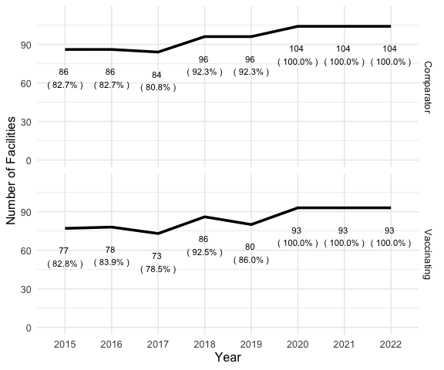
Figure 16.S Number of facilities always reporting confirmed cases (12 of 12 months each year) during evaluation period (Jan 2020-Dec 2022) and at least 11 of 12 months each year prior.
Intervention | selected | Facilities | MOHª | <5y Malaria(%) | RTS,S Doses(%) | PBO-nets^{b} | IRS^{c}
Comparison | TRUE | 104 | 63.5% | 842,767 (15.6%) | 0 (0.0%) | 50.0% | 26.9%
Implementing | TRUE | 93 | 55.9% | 655,748 (12.2%) | 267,038 (28.8%) | 47.3% | 10.8%
Comparison |  | 677 | 54.8% | 1,756,809 (32.6%) | 0 (0.0%) | 43.1% | 39.3%
Implementing |  | 654 | 57.5% | 2,140,392 (39.7%) | 661,608 (71.2%) | 32.7% | 25.0%
a: Percent of facilities owned by Ministry of Health. Other facilities owned by 'Private', 'Mission/Faith-Based Organization', or 'Non-Governmental Organization'. Owner was not indicated for 24.8% of facilities
b: Percent of facilities where PBO nets distributed during mass campaign in 2021
c: Percent of facilities where IRS applied annually

Map of included facilities (final)
if (!exists( "mvip.boundaries.interventions" ) ) mvip.boundaries.interventions = readRDS( paste0( params$data.dir, 'mvip.boundaries.interventions.rds' ) )
if (!exists( "mvip.facilities" ) ) mvip.facilities = readRDS( paste0( params$data.dir, 'mvip.facilities.rds' ) )
# note that some coordinates are outside MVIP, probably because of data entry error
boundaryBox = mvip.boundaries.interventions %>% st_bbox()
included.facilities = mvip.facilities %>%
mutate( included = ifelse( orgUnit %in% consistently_reporting_evaluation_facilities, 'Included', 'Excluded' ))
ggplot() +
geom_sf( data = mvip.boundaries.interventions, aes( fill = Intervention) ) +
geom_sf( data = included.facilities %>% filter( included == "Excluded" ) ,
color = 'black' , size = 1 , shape = 21 , aes( fill = Intervention ) ) +
geom_sf( data = included.facilities %>% filter( included == "Included" ),
color = 'red' , size = 1 , shape = 21 , aes( fill = Intervention ) ) +
coord_sf(
xlim = c( boundaryBox[1], boundaryBox[3]),
ylim = c(boundaryBox[2], boundaryBox[4] ),
expand = FALSE
) +
theme_map( ) +
theme( legend.position= "right",
legend.title = element_text( face = 'bold') ) +
scale_fill_manual(
labels = c("Comparison", "Implementing", "Non-MVIP"),
values = c( "lightgreen", "lightblue", "gray95") )
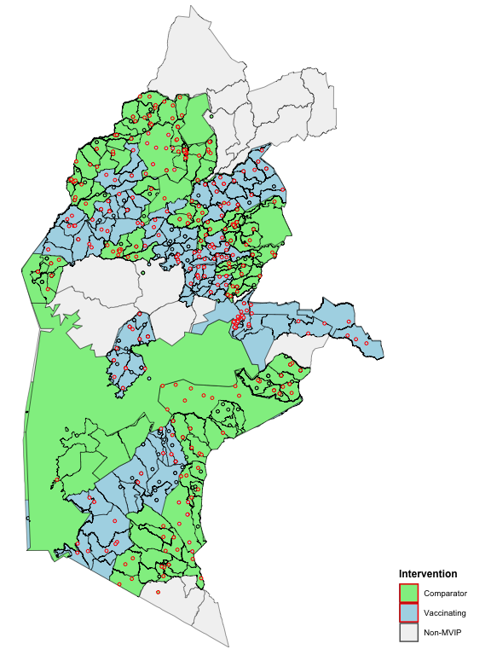

Supplement H: Time-series models of uncomplicated cases to estimate vaccine impact

Analyses
Load dataset (details available in online appendix Section 7.1.2

mcc5.total
dataset is mcc5.total. Values that were flagged as outliers by the mad10 algorithm (very large values) were converted to missing.
Intervention | Facilities
Comparison | 139
Implementing | 132

Plots of raw data analysis: Naive analysis
`mutate_if()` ignored the following grouping variables:
• Column `Intervention`
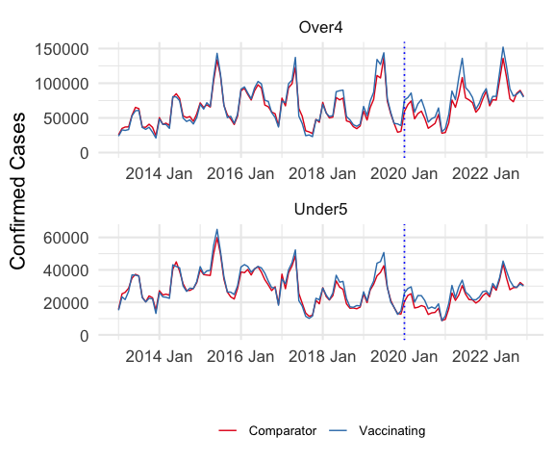
Figure 17.S Confirmed malaria cases reported among children Under5 by combined outpatient and community health worker (raw data)
Saving 6 x 5 in image
`mutate_if()` ignored the following grouping variables:
• Column `Intervention`
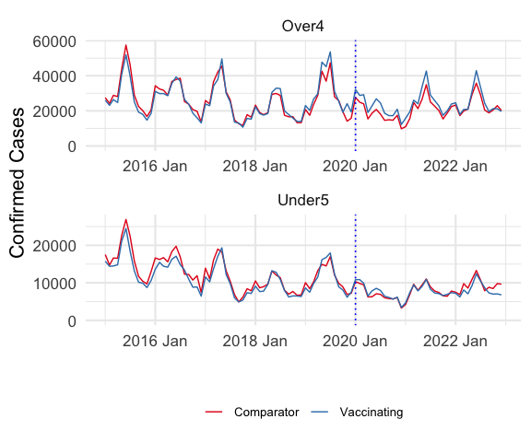
Confirmed malaria cases reported among children Under5 by combined outpatient and community health worker (consistently reporting facilities; potential outliers removed)
Saving 6 x 5 in image

Exploratory non-time-series analyses
`mutate_if()` ignored the following grouping variables:
• Column `Intervention`
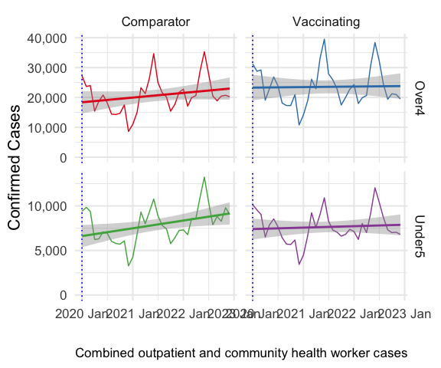
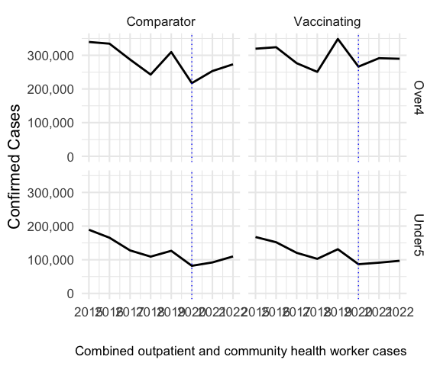

Time-series analysis
RTSS - Fable with agegrp controls ( by MVIP, controlling for agegrp )
- IRS districts NOT removed…
Create fable from mcc5.aci.mad10 dataset, then divide dataset into pre and post vaccine periods. For pre-vaccine period, perform time-series cross validation.[11,12]
TODO: Explain having separate col for age group to use as covariate

Time-Periods
TODO: Chart showing the periods.. - lock in start data based on consistently reporting
#|fig-cap: "Number of facilities consistently reporting (minimum 11 of 12 months) confirmed cases each year"
dataset.consisency( mcc5 )
# ggsave( paste0( params$image.dir ,'adjusted(mcc5).consistency.png' ), dpi = 300 , width = 6)
fc = facility_characteristics( mcc5, vx )
saveRDS( fc , paste0( params$output , 'adjustedCharacteristics.rds' ) )
#|tbl-cap: Characteristics of adjusted dataset
ft_characteristics( fc )
Intervention | selected | Facilities | MOHª | <5y Malaria(%) | RTS,S Doses(%) | PBO-nets^{b} | IRS^{c}
Comparison |  | 781 | 56.1% | 2,599,576 (48.2%) | 0 (0.0%) | 43.7% | 38.2%
Implementing |  | 747 | 57.3% | 2,796,140 (51.8%) | 928,646 (100.0%) | 33.8% | 23.9%
a: Percent of facilities owned by Ministry of Health. Other facilities owned by 'Private', 'Mission/Faith-Based Organization', or 'Non-Governmental Organization'. Owner was not incidated for 24.8% of facilities
b: Percent of facilities where PBO nets distributed during mass campaign in 2021
c: Percent of facilities where IRS applied annually

Time-Series Models (Mables)
- TODO describe primary models
(Note: The term “mable” comes from the authors of the Forecasting: Principles and Practice.[13])
Pre-intervention time-series models (mables) and cross-validation selection
- Time-series model[14] (mable), including ensemble prediction[15] for all permutations of the ARIMA, ETS, and NNETAR models.
- TODO log transformation.
For prophet model (cite fable.prophet), the seasonal component has a parameters:
order: The number of terms in the partial Fourier sum. The higher the order, the more flexible the seasonality can be. (1 is least - more prone to under fitting, and 8 is most - more likely to overfit )
type: The nature of the seasonality. If “additive”, the variability in the seasonal pattern is fixed. If “multiplicative”, the seasonal pattern varies proportionally to the level of the series.

Validation
To test the validity of each model we compare the predicted values with the actual values during the calendar year 2019. The predicted values are generated as a ‘fable’[16] from each model. The fables are created from the mables using the known values for confirmed cases in persons 5 and older during the calendar year 2019.
To assess the models accuracy for forecasting, it is important to use a metric that evaluates the accuracy of a forecast. A general process for validating models, commonly used in machine learning, involves fitting a number of models with different characteristics to a training dataset and then testing them on a validation set.[17] If the accuracy were to have been determined based on the goodness of fit with the training data, it is very likely the data will be overfit and not do well when forecasting values not in the training set. Therefore, it is good practice to reserve data from the training set that can be used to see how well the model predicts the missing values.
To assess the models forecast accuracy, it is important to use a metric that evalueates the accuracy of a forecast. Metrics like the mean absolute percent error (MAPE) [18] penalizes the forecast for error above and below the actual value. The MAPE has limitations[19,20] however, and many other metrics have been proposed.[17]
In this application, the RMSE is chosen to validate the models because the model fitting functions themselves (e.g. ARIMA) use the RMSE to optimize their paramaters, and therefore we also use RMSE to select the best fit.[21]
The percentage error is usually defined as in $\hat{y}$: $ = _{i=1}^{n} y_i $., where et is the scale-dependent error, yt is the actual value, and $\hat{y}$ at the tth time step.
$$\begin{matrix} & pt=y_{t}-haty\end{matrix}$$
pt = 100et (15) yt Examples of percentage errors are as follows.
WAPE:
$$\begin{matrix} & WAPE=\frac{\sum_{t=1}^{h}{\left|y_{t}-{\hat{y}}_{t}\right|}*100}{ϵ+\sum_{t=1}^{h}{y_{t}}}\end{matrix}$$
$$ϵ=1e^{-10}$$
### Model classes
Parameters for each primary model were selected with each package’s auto-fitting method. The reported number over-5 malaria cases were included as a covariate in each model except ETS, which does not allow covariates. Values for the dependent variable, under-5 cases, were log-transformed to stablilize variance and ensure that predicted values were non-negative. For ARIMA models, the exogenous regressor was also log-transformed to prevent undefined predicted values. No undefined values were generated by other models and the model fit was improved with an untransformed regressor.
Note: The exogenous variable, older, was log-transformed for the ARIMA model because models with the untransformed variable yielded an error message, “Warning in sqrt(diag(best$var.coef)) : NaNs produced”, which indicates model instability. None of the other models produced a warning and the results showed improved model fit (slightly smaller SWAPE) when untransformed.
- TODO: describe 3 potential validation methods: 1. In-sample 2. OOS 12-month 3. OOS CV (3-months ahead)

1. In-sample performance
Intervention | .model | .type | ME | RMSE | MAE | MPE | MAPE | MASE | RMSSE | ACF1 | rank
Comparison | p8 | Training | 2.3200 | 719 | 554 | -0.2060 | 4.90 | 0.2170 | 0.2190 | 0.2450 | 1
Comparison | a | Training | -35.6000 | 800 | 643 | -0.2280 | 5.90 | 0.2520 | 0.2430 | -0.0205 | 2
Comparison | n | Training | 40.8000 | 826 | 673 | -0.3020 | 6.23 | 0.2640 | 0.2510 | 0.3510 | 3
Comparison | p4 | Training | 5.3400 | 867 | 686 | -0.3000 | 6.11 | 0.2690 | 0.2640 | -0.0549 | 4
Comparison | p1 | Training | 6.2000 | 877 | 697 | -0.3270 | 6.25 | 0.2730 | 0.2670 | 0.0166 | 5
Comparison | t | Training | 11.7000 | 941 | 733 | -0.3740 | 6.52 | 0.2870 | 0.2870 | 0.2570 | 6
Comparison | e | Training | -48.4000 | 1,500 | 1,130 | -1.5100 | 10.00 | 0.4450 | 0.4550 | 0.1070 | 7
Implementing | n | Training | 19.6000 | 320 | 216 | -0.0047 | 1.87 | 0.0818 | 0.0953 | -0.0452 | 1
Implementing | p8 | Training | -3.7500 | 968 | 648 | -0.2800 | 5.64 | 0.2450 | 0.2880 | 0.4280 | 2
Implementing | a | Training | -70.9000 | 914 | 651 | -0.5690 | 5.64 | 0.2460 | 0.2720 | 0.1340 | 3
Implementing | t | Training | 0.0973 | 1,060 | 739 | -0.3930 | 6.71 | 0.2800 | 0.3140 | 0.3000 | 4
Implementing | p4 | Training | -0.3940 | 1,030 | 759 | -0.3440 | 6.67 | 0.2870 | 0.3080 | 0.2250 | 5
Implementing | p1 | Training | 3.6500 | 1,140 | 806 | -0.4040 | 7.13 | 0.3050 | 0.3390 | 0.2520 | 6
Implementing | e | Training | -85.2000 | 1,610 | 1,220 | -1.9100 | 11.00 | 0.4620 | 0.4800 | 0.1380 | 7
The best-fitting models using in-sample validation are:
Intervention | .model | .type | ME | RMSE | MAE | MPE | MAPE | MASE | RMSSE | ACF1 | Intervention Rank | percent_diff | mean
Comparison | p8 | Training | 2.324 | 718.601 | 554.396 | -0.206 | 4.904 | 0.217 | 0.219 | 0.245 | 1 | 0 | 0.2312967
Implementing | n | Training | 19.648 | 320.085 | 216.015 | -0.005 | 1.867 | 0.082 | 0.095 | -0.045 | 1 | 0 | 0.1727968
However, in-sample validation is prone to selecting models that over-fit the data and that do not do well when predicting new data. Therefore, we prefer out-of sample (OOS) validation, where values are removed from the training set and the model is evaluated on the ability to predict those missing values.

2. OOS Training and Testing
- compute out-of-sample accuracy (fabletools:accuracy. See https://stackoverflow.com/questions/58902600/only-nans-in-accuracy-table-in-forecasts-using-fable-package for example usage)
Note: The exogenous variable, older, was log-transformed for the ARIMA model because models with the untransformed variable yielded an error message, “Warning in sqrt(diag(best$var.coef)) : NaNs produced”, which indicates model instability. None of the other models produced a warning and the results showed improved model fit (slightly smaller SWAPE) when untransformed.
- In-sample accuracy of training set
- TODO: compare with accuracy of complete set [above] and test set [below] – in-sample MASE worse with models trained on less data
- Top 10 models for each Intervention. Models ranked by MAPE (smallest is best)
- Accuracy of 12-month forecast from training set compared with 12-month test data, using SWAPE.
Intervention | .model | swape | Intervention  Rank | percent_diff | mean
Comparison | an | 7.383 | 1 | 0.0 | 7.520055
Comparison | ant | 7.476 | 2 | 1.3 | 7.063058
Comparison | at | 8.395 | 3 | 13.7 | 8.396559
Comparison | p8 | 8.951 | 4 | 21.2 | 9.230729
Comparison | nt | 9.524 | 5 | 29.0 | 8.067032
Comparison | n | 9.667 | 6 | 30.9 | 9.686032
Comparison | p4 | 11.142 | 7 | 50.9 | 10.646817
Comparison | p1 | 11.425 | 8 | 54.7 | 10.646514
Comparison | a | 11.672 | 9 | 58.1 | 11.181656
Comparison | aent | 13.057 | 10 | 76.9 | 14.704455
Implementing | nt | 6.610 | 1 | 0.0 | 8.067032
Implementing | ant | 6.650 | 2 | 0.6 | 7.063058
Implementing | an | 7.657 | 3 | 15.8 | 7.520055
Implementing | at | 8.398 | 4 | 27.0 | 8.396559
Implementing | p8 | 9.511 | 5 | 43.9 | 9.230729
Implementing | n | 9.706 | 6 | 46.8 | 9.686032
Implementing | p1 | 9.868 | 7 | 49.3 | 10.646514
Implementing | p4 | 10.151 | 8 | 53.6 | 10.646817
Implementing | a | 10.691 | 9 | 61.7 | 11.181656
Implementing | t | 13.706 | 10 | 107.4 | 13.693355
For the comparison group, the ant model has least SWAPE with next closest model 19% greater. For Implementing group, the aent model has the least SWAPE, but several other models are closing, includeing ant (+3.6%). Not only does the ant model have a small mean SWAPE, the variance is also one of the smallest.
`stat_bin()` using `bins = 30`. Pick better value with `binwidth`.
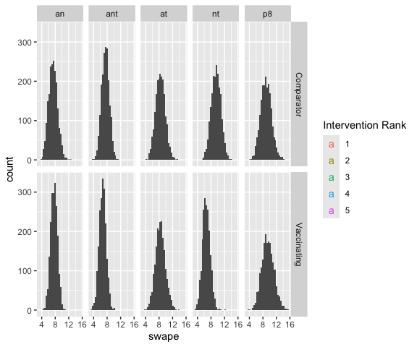
- check differences in accuracy distributions between models
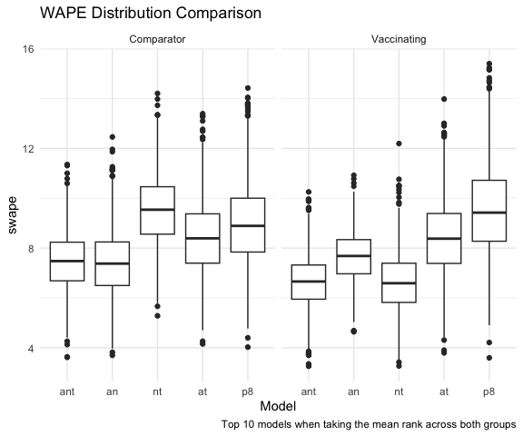

Cross-Validation[12]
- Not run (code included for demonstration)
- Forecasts with cv-test (1-3-months ahead)
- In-sample accuracy, for comparison with OOS test accuracy (not run)
- OOS CV-Test accuracy

Validation Algorithm: Optimizing versus Synchronizing
As shown in proceeding steps, the method used for model-selection may significantly affect the counterfactual prediction used that are the basis for estimating the intervention’s (RTSS) impact. In this setting, we have two groups (Comparison and Implementing) with distinct time-series. When predicting a time series containing multiple groups, the decision on whether to use the same model type for all groups (synchronize) or to select the best model for each group independently (optimize) is an important consideration. This topic is discussed in various academic publications, although (to our knowledge) does not directly address the situation with two study groups having been chosen for similar characteristics. The literature we reviewed suggests that model selection should generally be based on the best model validation for each group (optimize), especially when the groups have different characteristics. However, practical considerations like consistency and coherence may justify selecting the same model (synchronize).
The predictive models used here have different methods for discovering and projecting underlying trend and seasonal components. Thus it is possible that, given similar data, one model class (e.g. arima, neural network, etc.) may systematically bias the projection relative to another model type. Thus, there is the potential that the difference seen between the two groups could be do to the model type, rather than then intervention. Therefore, we propose the following heuristic(?) for model selection:
- When possible, use the same model class for each group in a given time period.

  - When the time-period changes (say going from pre-intervention to post-intervention), the model selection may also change and the preference is to use the same model for each group, even if it is different from the model class used with a different time period.
- Model selection should be based on out of sample (OOS) validation, which is less likely to be overfit. A model that overfits the training data captures noise and random fluctuations in the training set. Consequently, it fails to generalize well to new, unseen data, leading to poor predictive performance in real-world scenarios. Therefore we suggest using training and test sets where the test set is the most recent data in the time-series.

  - Because malaria data has strong yearly seasonality so the test set should include an entire year.
- Model fitting should include both primary model classes (arima, etc.) and all combinations of those models to create ensemble models.

  - The default should be to create equally weighted ensemble models. In other words, an ensemble model created from arima and ETS models would be a simple average of the two.
- The most-reliable point-estimate of goodness of fit is the symmetric weighted absolute percent error (SWAPE).

  - The point estimate is the mean SWAPE across all iterations of predicted months in the test period.

  - The models should be ranked from lowest SWAPE (rank 1) to highest SWAPE for each group and should include the standard error of the mean
- In the event that validation suggest different model classes for each group:
  - Compare the model mean and standard error to see which models are likely not significantly different (e.g. confidence intervals do not overlap)
  - If there are more than one model shared by each group, choose the model with the lowest combined mean SWAPE.
  - If there is no common model class with the initial test-period (e.g. 12-month forecast), try using a cross-validation method to see if that yields a consistent model.
  - If the top ranked models are significantly different between the two groups, this suggests there is some fundamental difference between them and that model selection should be different for each group (optimize).

Model Selection - Pre-intervention
We selected the ensemble model ant (an equally weighted average of predictions from the ARIMA, NEURALNET, and TSLM models) as the best model because it the lowest mean SWAPE.
Intervention | .model | rank
Comparison | ant | 1
Implementing | ant | 1
Comparison | an | 2
Implementing | an | 2
Comparison | a | 5
Implementing | a | 6
Comparison | p8 | 81
Implementing | p8 | 105

Impact

cumulative
Impact relative to 3-year forecast. After validating the model, we re-run the model including all the data prior to the intervention period (Jan 2020-Dec 2022). Note that there is no easy way to write the model specifications for only the ones selected in the validation step. So we run all the models, forecast the data, and then select only the forecast that match the validation models. The functions forecast_impact, impact_summary, and impact_difference are carry out these steps.
The impact was calculated as the weighted percent difference (WPE), which we defined as the percent difference relative to the foretasted value:
$$percentDifference=100*\left(actualValue-foretastedValue\right)/foretastedValue$$
$$WPE=\sum_{firstmonth}^{lastmonth}{p}ercentDifference/\sum_{firstmonth}^{lastmonth}{f}orecastedValue$$

YEAR 1 Post-Intervention

12-month forecast
Model all preintervention data then select forecast from the validation set.
Note: we are removing the prophet models (p1,p4,p8), which are not in the selected model, to speed up calculations. When re-modeling the data we will reintroduce the models. (see sections on evaluation of year1 and year2 with 12-month forecasts)
26.643 sec elapsed
`mutate_if()` ignored the following grouping variables:
• Columns `Intervention`, `.model`, `Month`
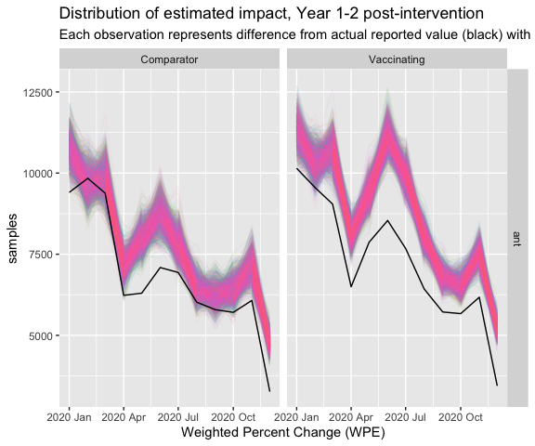
- Summarise across all replicates
.model | Intervention |  |  | WPE.mean |  |  | WPE.sd
ant | Comparison |  |  | -11.57865 |  |  | 1.2405809
ant | Implementing |  |  | -17.20387 |  |  | 0.9486557
Intervention |  | .model | mean |  | sd | median |  | n | rank
Comparison |  | ant | -11.6 |  | 1.240 | -11.6 |  | 2,000 | 1
Implementing |  | ant | -17.2 |  | 0.949 | -17.2 |  | 2,000 | 1
# A tibble: 7 × 2
Threshold `Probability less than`
<dbl> <dbl>
1 0 1
2 -5 0.644
3 -10 0.0035
4 -15 0
5 -20 0
6 -25 0
7 -30 0
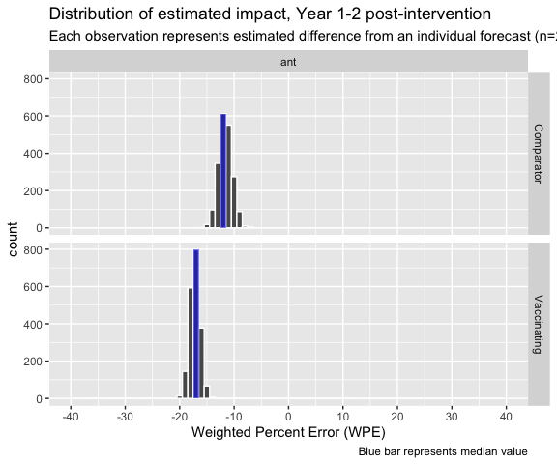
Figure 18.S Estimated difference between predicted and actual number of cases during first 12-months post vaccination, by intervention.
- probabilities associated with distribution
Evaluation Period | n | mean | sd | median | hdi_lower | hdi_upper
1-12 months | 2,000 | -5.63 | 1.6 | -5.57 | -8.93 | -2.7
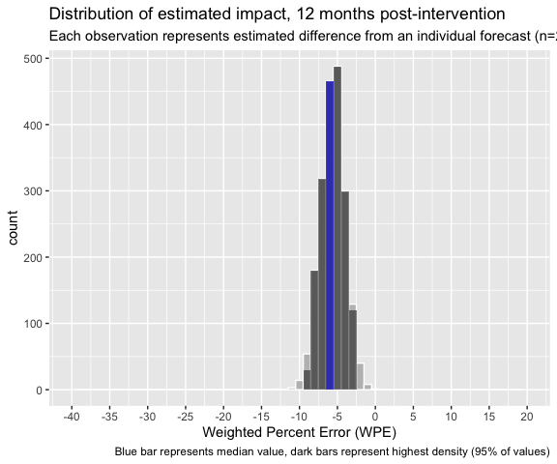
Figure 19.S Estimated impact during first 12-months post vaccination.

minimum_detectable_difference
Assume distribution of 2 groups are same as those observed.
[1] -3 3

YEAR 2 Post-Intervention

24-month forecast
- Use the same primary models as in year 1 (combo.forecasts.yr1) but create new forecasts for 24 months (year1 and year2)
45.017 sec elapsed
`mutate_if()` ignored the following grouping variables:
• Columns `Intervention`, `.model`, `Month`
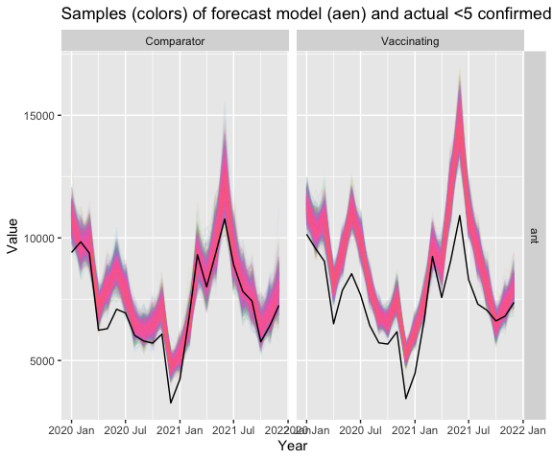
- Summarise across all replicates
Intervention | WPE.mean | WPE.sd
Comparison | -8.323414 | 1.1080380
Implementing | -16.561397 | 0.7208192
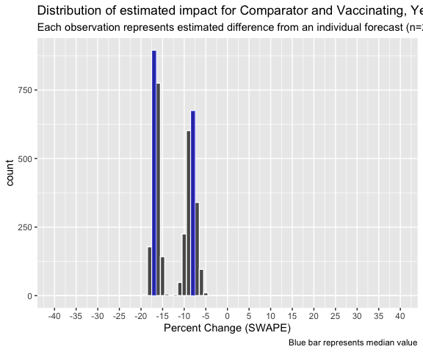
Figure 20.S Estimated difference between predicted and actual number of cases during 24-months post vaccination, by intervention.
Evaluation Period | n | mean | sd | median | hdi_lower | hdi_upper
1-24 months | 2,000 | -8.24 | 1.31 | -8.23 | -10.73 | -5.78
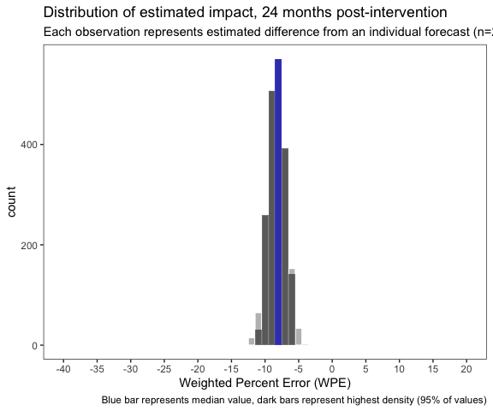
# A tibble: 5 × 2
Threshold `Probability less than`
<dbl> <dbl>
1 0 1
2 -5 0.994
3 -10 0.0905
4 -15 0
5 -20 0

minimum_detectable_difference
Assume distribution of 2 groups are same as those observed.
[1] -2.5 2.5

YEAR 3 Post-Intervention

36-month forecast
- Use the same primary models as in year 1 (combo.forecasts.yr1) but create new forecasts for 36 months (year1, year2, and year3)
64.27 sec elapsed
`mutate_if()` ignored the following grouping variables:
• Columns `Intervention`, `.model`, `Month`
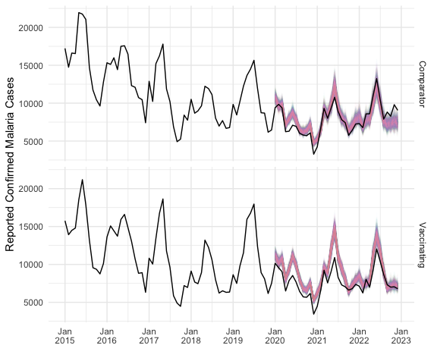
Saving 6.5 x 5 in image
- Calculate WPE for each replicate
- Summarise across all replicates
Intervention | WPE.mean | WPE.sd
Comparison | -2.214097 | 1.0852044
Implementing | -13.783103 | 0.6581507
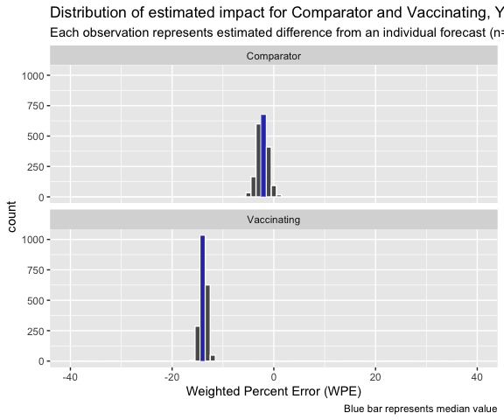
Evaluation Period | n | mean | sd | median | hdi_lower | hdi_upper
1-36 months | 2,000 | -11.57 | 1.27 | -11.57 | -14.2 | -9.19
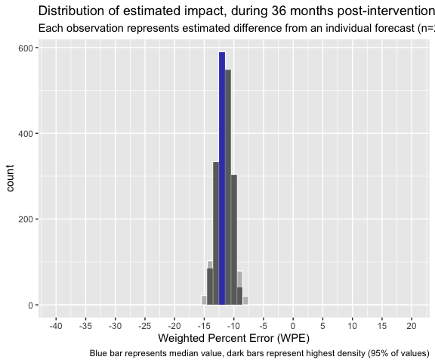
Threshold | Probability less than
0 | 1.0000
-5 | 1.0000
-10 | 0.8915
-15 | 0.0035
-20 | 0.0000

minimum_detectable_difference
Assume distribution of 2 groups are same as those observed.
[1] -40.0 -2.1

Grand Summary
Evaluation Period | n | mean | sd | median | hdi_lower | hdi_upper
1-12 months | 2,000 | -5.63 | 1.60 | -5.57 | -8.93 | -2.70
1-24 months | 2,000 | -8.24 | 1.31 | -8.23 | -10.73 | -5.78
1-36 months | 2,000 | -11.57 | 1.27 | -11.57 | -14.20 | -9.19

Supplement I: Impact of distance from comparison to implementing facilities

Distance-dose response

Shortest distance from comparison facility to a implementing facility included in analytic dataset (mcc5)
- The implementing and comparison areas are practically and adjacent and there are many comparison facilities that are very close (3-10km) to the Implementing facilities. We may consider censoring those facilities because of the risk that children attending those facilities were vaccinated.
We start by including only those facilities in the analytic dataset (mcc5).
# MVIP cases associated with consistently reporting
if (!exists( "mcc4" ) ) mcc4 = readRDS( paste0( params$output , 'mcc4.rds' ) )
if (!exists( "mcc5" ) ) mcc5 = readRDS( paste0( params$output , 'mcc5.rds' ) )
# reported vaccinations
if (!exists( "vx" ) ) vx = readRDS( paste0( params$data.dir, 'vx.rds' ))
if (!exists( "mvip.boundaries.interventions" ) ) mvip.boundaries.interventions = readRDS( paste0( params$data.dir, 'mvip.boundaries.interventions.rds' ) )
# note that some coordinates are outside MVIP, probably because of data entry error
boundaryBox = mvip.boundaries.interventions %>% st_bbox()
if (!exists( "mvip.facilities" ) ) mvip.facilities = readRDS( paste0( params$data.dir, 'mvip.facilities.rds' ) )
if (!exists( 'base_map') ) base_map = read_rds( paste0( params$data.dir , 'base_map.rds' ))
# mvip.facilities is created in supplement MVIP_Facilities
# consistently_reporting_facilities is created in supplement MVIP_Reporting_Consistency
included.facilities = mvip.facilities %>%
filter( orgUnit %in% unique( mcc5$orgUnit ) )
Create separate list of implementing and comparison facilities.
Calculate distances between each comparison and all implementing facilities and then select the shortest distance for each comparison facility.
# define threshold for close buffer area (in KM)
close = 5 # in kilometers
nearest_vx_distance.mcc5 = compFacilities_to_nearest_vxFacilities.mcc5 %>%
st_sf %>% mutate(
orgUnit = compFacilities.mcc5 %>%
filter( !st_is_empty(compFacilities.mcc5) ) %>%
pull( orgUnit ) ,
distance = st_length(compFacilities_to_nearest_vxFacilities.mcc5) ,
nearest_vx_km = round( distance / 1000 , 0 ) %>% as.numeric() ,
proximity = ifelse( nearest_vx_km <= close , 'near' , 'far' ) )
save(vxFacilities.all, compFacilities.mcc5 , compFacilities_to_nearest_vxFacilities.mcc5,
nearest_vx_distance.mcc5 ,
file = paste0(params$output, "compFacilities_to_nearest_vxFacilities.rda"))
nearest_vx_distance.mcc5 %>%
st_drop_geometry() %>%
count( proximity , nearest_vx_km ) %>%
ggplot() +
geom_col( aes( nearest_vx_km, n, fill = proximity )) +
scale_fill_manual( values = c( near = 'purple' , far = 'red4' ) ) +
scale_x_continuous( limits = c(0, 50 )) +
labs( caption = "Kenya MVIP: analytic dataset" , x = "Kilometers", y = 'Facilities' ) +
theme_bw()
ggsave( paste0(params$image.dir, "nearest_vx_distance.mcc5.png") , dpi = 300 )
Saving 6 x 5 in image
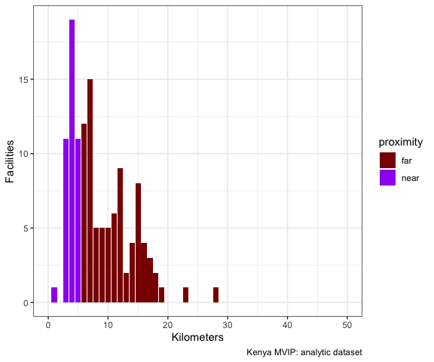
Figure 21.S Distance (Km) from comparison facility to nearest implementing facility
We set 5km as the cutoff between facilities that are near to a implementing facility and those that are far from a implementing facility.
nearest_vx_distance.mcc5 %>%
as_tibble %>%
count( proximity ) %>%
add_prop() %>% select( proximity ,n , prop_label ) %>%
rename( Percentage = prop_label ) %>%
flextable()
proximity | n | Percentage
far | 83 | 65.9%
near | 43 | 34.1%
base_map +
geom_sf( data = vxFacilities.all ,
# color = 'red' ,
alpha = .5 , size = .5 , shape = 21 ,
aes( fill = Intervention, level == 5 ) ) +
geom_sf( data = nearest_vx_distance.mcc5 ,
aes( color = proximity , size = proximity ) ) +
geom_sf( data = compFacilities.mcc5 ,
# color = 'blue' ,
size = 1 , shape = 21 ,
aes( fill = Intervention ) ) +
scale_size_identity() +
scale_color_manual( "Distance from comparison facility\nto nearest implementing facility" ,
labels = c("near", "far" ),
values = c( 'near' = "purple", 'far' = "red4") ) +
# scale_size_manual(
# labels = c("near", "far" ),
# values = c( 'near' = 10, 'far' = 1) ) +
#
# geom_sf( data = mcc6.facilities %>% filter( included == "Included" ) ,
# color = 'red' , size = 1 , shape = 21 , aes( fill = Intervention ) ) +
coord_sf(
xlim = c( boundaryBox[1], boundaryBox[3]),
ylim = c(boundaryBox[2], boundaryBox[4] ),
expand = FALSE
)
Coordinate system already present. Adding new coordinate system, which will
replace the existing one.
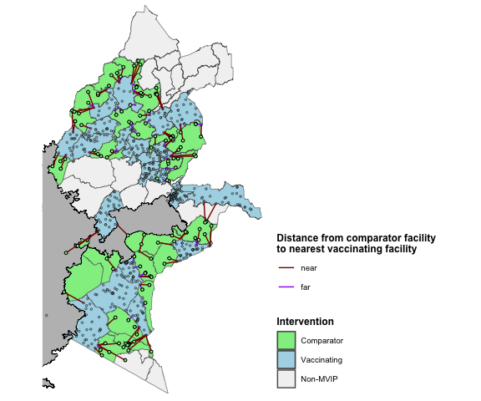
Geolocation was unavailable for 291 of the 840 implementing facilities and 13 of the 139 comparison facilities included in analysis based on having consistently reported confirmed cases.

Compare impact in comparison areas (mcc5)

Compare impact in comparison areas (mcc4)
Same as above but including all facilities (mcc4 dataset) to increase the number of facilities and see if association of proximity with impact still holds.
nearest_vx_distance.mcc4 %>%
as_tibble %>%
count( proximity ) %>%
add_prop() %>% select( proximity ,n , prop_label ) %>%
rename( Percentage = prop_label ) %>%
flextable()
base_map +
geom_sf( data = vxFacilities.all ,
# color = 'red' ,
alpha = .5 , size = .5 , shape = 21 ,
aes( fill = Intervention, level == 5 ) ) +
geom_sf( data = nearest_vx_distance.mcc4 ,
aes( color = proximity , size = proximity ) ) +
geom_sf( data = compFacilities.mcc4 ,
# color = 'blue' ,
size = 1 , shape = 21 ,
aes( fill = Intervention ) ) +
scale_size_identity() +
scale_color_manual( "Distance from comparison facility\nto nearest implementing facility" ,
labels = c("near", "far" ),
values = c( 'near' = "purple", 'far' = "red4") ) +
# scale_size_manual(
# labels = c("near", "far" ),
# values = c( 'near' = 10, 'far' = 1) ) +
#
# geom_sf( data = mcc6.facilities %>% filter( included == "Included" ) ,
# color = 'red' , size = 1 , shape = 21 , aes( fill = Intervention ) ) +
coord_sf(
xlim = c( boundaryBox[1], boundaryBox[3]),
ylim = c(boundaryBox[2], boundaryBox[4] ),
expand = FALSE
)

Impact: Implementing (mcc5) compared with near facilities
- Define data for impact evaluation: All implementing facilities and those comparison facilities within 5 km of a implementing facility.
near.facilities.mcc5 = nearest_vx_distance.mcc5 %>%
filter( proximity %in% 'near' ) %>%
pull( orgUnit )
fable.data.age.near.mcc5 = mcc5 %>%
filter( Intervention %in% 'Implementing' | orgUnit %in% near.facilities.mcc5 )
`mutate_if()` ignored the following grouping variables:
• Columns `Intervention`, `.model`, `Month`
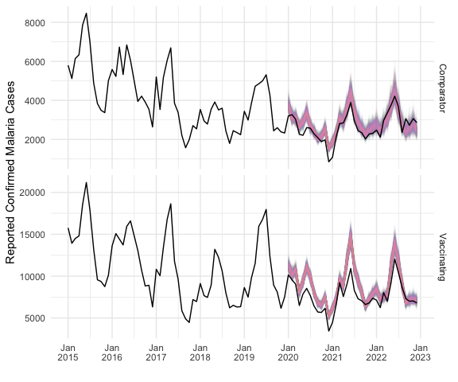
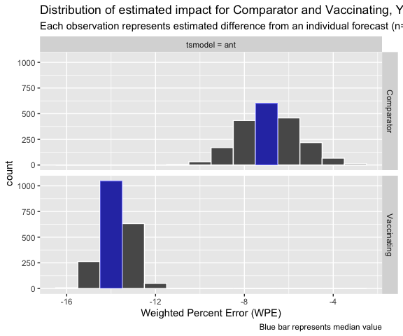
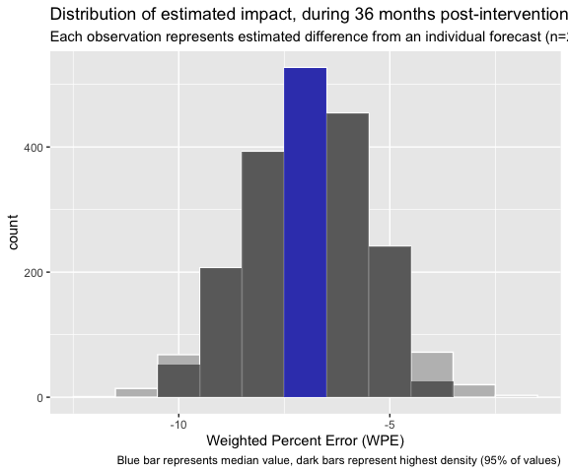
Intervention | .model | n | mean | sd | median | hdi_lower | hdi_upper
Comparison | ant | 2,000 | -6.9 | 1.3 | -6.9 | -9.5 | -4.3
Implementing | ant | 2,000 | -13.8 | 0.7 | -13.8 | -15.1 | -12.5
Impact (1-36 months) | Implementing - Comparison | 2,000 | -6.9 | 1.5 | -6.9 | -10.0 | -4.3

Impact: Implementing (mcc5) compared with far facilities
far.facilities.mcc5 = nearest_vx_distance.mcc5 %>%
filter( proximity %in% 'far' ) %>%
pull( orgUnit )
fable.data.age.far.mcc5 = mcc5 %>%
filter( Intervention %in% 'Implementing' | orgUnit %in% far.facilities.mcc5 )
`mutate_if()` ignored the following grouping variables:
• Columns `Intervention`, `.model`, `Month`
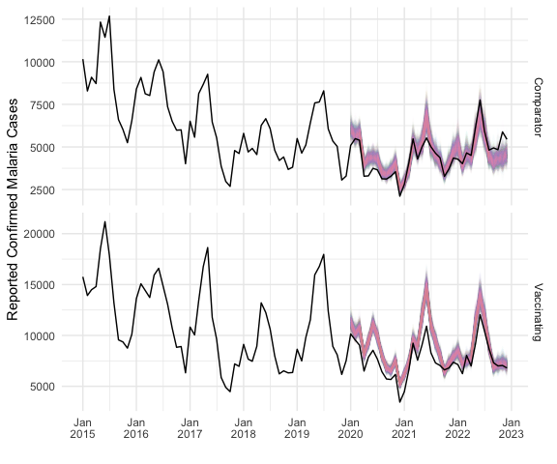
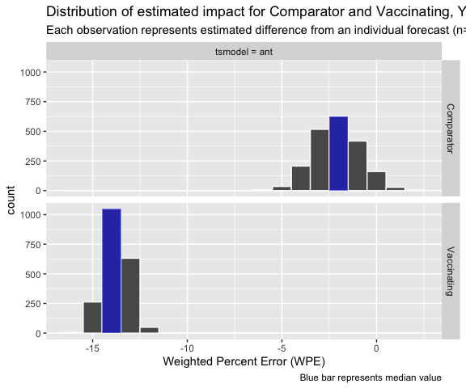
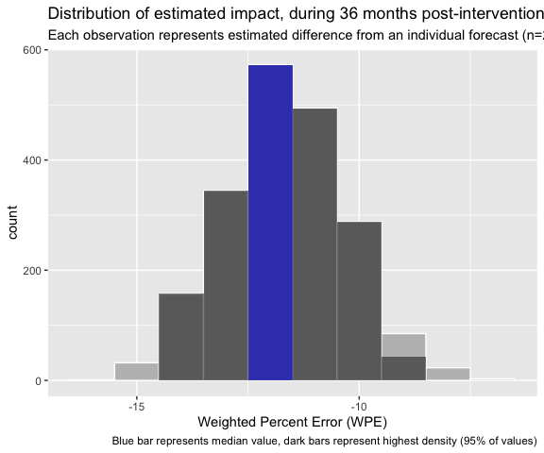
Intervention | .model | n | mean | sd | median | hdi_lower | hdi_upper
Comparison | ant | 2,000 | -2.1 | 1.2 | -2.1 | -4.5 | 0.1
Implementing | ant | 2,000 | -13.8 | 0.7 | -13.8 | -15.1 | -12.5
Impact (1-36 months) | Implementing - Comparison | 2,000 | -11.7 | 1.4 | -11.6 | -14.5 | -9.2

Contrast near vs far
- Histogram between impact using far comparison facilities and near comparison facilities.
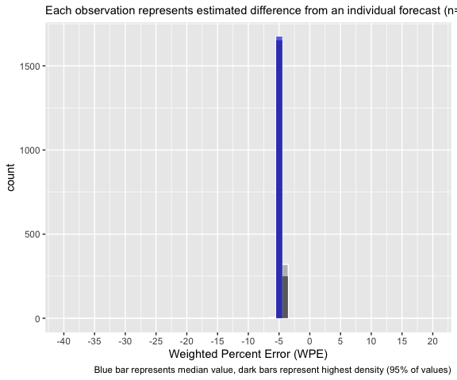

Supplement J: Alternative Modeling Scenarios

Alternative Data and Modelling Scenarios

Data
if (!exists( "reporting_consistency" ) ) reporting_consistency = readRDS( paste0( params$output ,
'reporting_consistency.rds' ))
start_month = yearmonth("Jan 2015")
allowable_missing = 1
consistently_reporting_facilities = reporting_consistency %>%
filter( Starting == start_month &
MissingPerYr == allowable_missing ) %>%
pull( Facilities ) %>% unlist
# mcc0 - all MVIP (mvip clinical cases ) OPD and CHEW (raw data)
if (!exists( "mcc0" ) ) mcc0 = readRDS( paste0( params$output , 'mcc0.rds' ) )
# mcc1 - mcc0 data minus duplicate entries AND potential outliers
if (!exists( "mcc1" ) ) mcc1 = readRDS( paste0( params$output , 'mcc1.rds' ) )
# mcc2 - mcc1 with grouping variables for age and clinic type, minus CHEW-age unspecified, pre 2021
if (!exists( "mcc2" ) ) mcc2 = readRDS( paste0( params$output , 'mcc2.rds' ) )
# mcc3 - mcc2 with chew cases linked with opd
if (!exists( "mcc3" ) ) mcc3 = readRDS( paste0( params$output , 'mcc3.rds' ) )
# mcc4 -
if (!exists( "mcc4" ) ) mcc4 = readRDS( paste0( params$output , 'mcc4.rds' ) )
# mcc5
if (!exists( "mcc5" ) ) mcc5 = readRDS( paste0( params$output , 'mcc5.rds' ) )
# mcc3 restricted to consistently reporting facilities (adjusted data )
if (!exists( "mcc6" ) ) mcc6 = readRDS( paste0( params$output , 'mcc6.rds' ) )
# reported vaccinations
if (!exists( "vx" ) ) vx = readRDS( paste0( params$data, 'vx.rds' ))
if (!exists( "mvip.boundaries.interventions" ) ) mvip.boundaries.interventions = readRDS( paste0( params$data, 'mvip.boundaries.interventions.rds' ) )
if (!exists( "mvip.facilities" ) ) mvip.facilities = readRDS( paste0( params$data, 'mvip.facilities.rds' ) )
if (!exists( 'base_map') ) base_map = read_rds( paste0( params$output , 'base_map.rds' ))

Raw data
dataset.consisency( mcc0 %>% mutate( total = original ) )
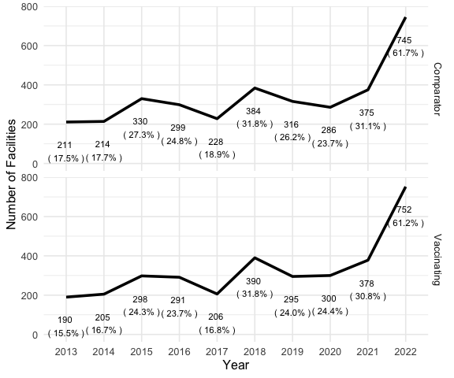
ggsave( paste0( params$image.dir , 'raw(mcc0).consistency.png' ), dpi = 300 , width = 6)
Saving 6 x 5 in image
# note that some coordinates are outside MVIP, probably because of data entry error
boundaryBox = mvip.boundaries.interventions %>% st_bbox()
base_map +
geom_sf( data = mvip.facilities %>% filter( level == 5 ) ,
color = 'grey' , size = 1 , shape = 21
# , aes( fill = Intervention )
) +
coord_sf(
xlim = c( boundaryBox[1], boundaryBox[3]),
ylim = c(boundaryBox[2], boundaryBox[4] ),
expand = FALSE
)
Coordinate system already present. Adding new coordinate system, which will
replace the existing one.
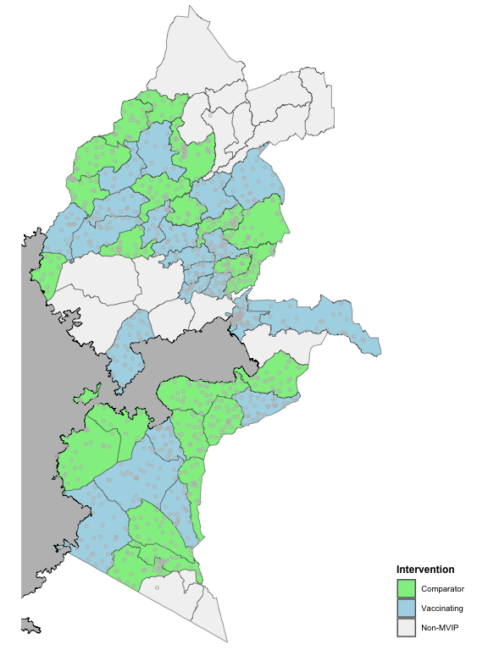
d = facility_characteristics( mcc0, vx )
# d %>% flextable() %>% FitFlextableToPage()
saveRDS( d , paste0( params$output , 'rawCharacteristics.rds' ) )
#|tbl-cap: Characteristics of unadjusted (raw) dataset
ft_characteristics( d )
Intervention | selected | Facilities | MOHª | <5y Malaria(%) | RTS,S Doses(%) | PBO-nets^{b} | IRS^{c}
Comparison |  | 781 | 56.1% | 2,599,576 (48.2%) | 0 (0.0%) | 43.7% | 38.2%
Implementing |  | 747 | 57.3% | 2,796,140 (51.8%) | 928,646 (100.0%) | 33.8% | 23.9%
a: Percent of facilities owned by Ministry of Health. Other facilities owned by 'Private', 'Mission/Faith-Based Organization', or 'Non-Governmental Organization'. Owner was not incidated for 24.8% of facilities
b: Percent of facilities where PBO nets distributed during mass campaign in 2021
c: Percent of facilities where IRS applied annually

- Under5 (unadjusted-all facilities, no outliers removed) [mcc0], no covariate
d = dataset( mcc0 , , unadjusted = TRUE , startMonth = yearmonth( "Jan 2013" ))
test.forecasts = tsmodels( d$pre.intervention.train , d$pre.intervention.test ,
type = "transform" )
Preparing primary models
Primary models finished. 2.616 sec elapsed
Preparing primary forecasts...
Primary forecasts finished 28.793 sec elapsed
Preparing ensemble forecasts...
Ensemble forecasts finished 4.975 sec elapsed
Total time 36.384 sec elapsed
validations = model_metrics( test.forecasts , d$pre.intervention.test )
Calculating monthly SWAPE
1.934 sec elapsed
Calculating mean SWAPE
Total time 1.941 sec elapsed
model_selection = modelSelection( validations , type = 'synchronize' )
model_selection
# A tibble: 2 × 2
# Groups: Intervention [2]
Intervention .model
<fct> <chr>
1 Comparison aent
2 Implementing aent
evaluation.forecasts = tsmodels( d$pre.intervention , d$post.intervention ,
type = "transform" ) %>%
semi_join( model_selection , by = c( 'Intervention', '.model' ))
Preparing primary models
Primary models finished. 3.627 sec elapsed
Preparing primary forecasts...
Primary forecasts finished 62.204 sec elapsed
Preparing ensemble forecasts...
Ensemble forecasts finished 5.046 sec elapsed
Total time 70.877 sec elapsed
impact.tableaux( d$fable.data.age , evaluation.forecasts )
`mutate_if()` ignored the following grouping variables:
• Columns `Intervention`, `.model`, `Month`
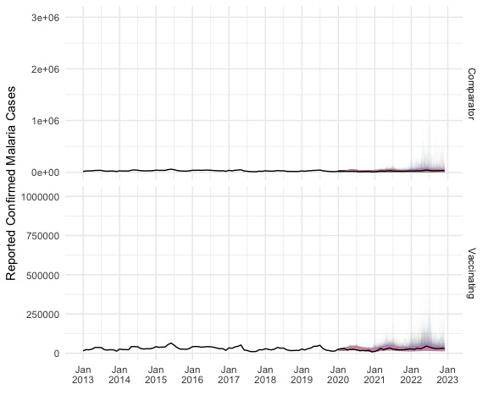
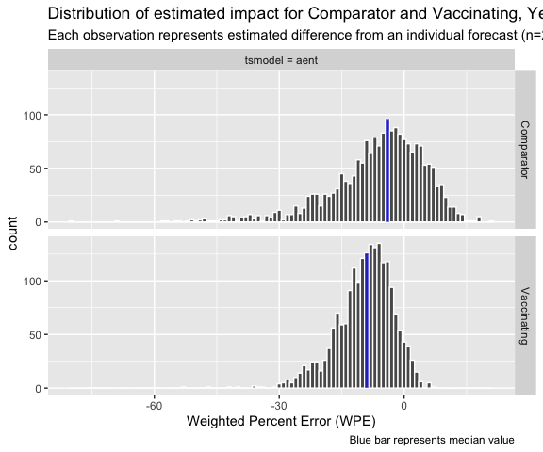
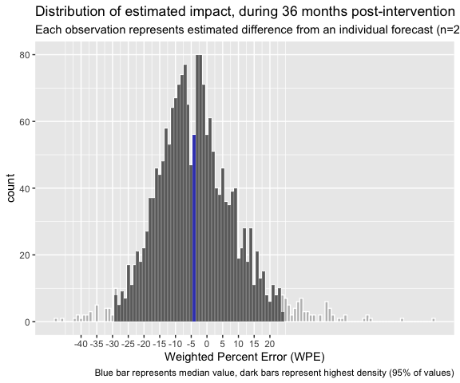
Intervention | .model | n | mean | sd | median | hdi_lower | hdi_upper
Comparison | aent | 2,000 | -6.2 | 11.5 | -4.4 | -28.8 | 14.2
Implementing | aent | 2,000 | -9.4 | 6.8 | -8.6 | -23.6 | 2.5
Impact (1-36 months) | Implementing - Comparison | 2,000 | -3.2 | 13.4 | -4.1 | -29.1 | 23.9
rawUnder5 = list( actual = d$fable.data.age,
predicted = evaluation.forecasts )
saveRDS( rawUnder5, paste0( params$output , 'rawUnder5.rds' ) ,
compress = FALSE )

- Raw Over4 (unadjusted-all facilities, no outliers removed) [mcc0], no covariate
d = dataset( mcc0 , , unadjusted = TRUE , startMonth = yearmonth( "Jan 2013" ) )
test.forecasts = tsmodels( d$pre.intervention.train , d$pre.intervention.test ,
type = "transform" , .var = 'older' )
Preparing primary models
Primary models finished. 2.563 sec elapsed
Preparing primary forecasts...
Primary forecasts finished 25.698 sec elapsed
Preparing ensemble forecasts...
Ensemble forecasts finished 4.344 sec elapsed
Total time 32.606 sec elapsed
validations = model_metrics( test.forecasts , d$pre.intervention.test,
.var = 'older' )
Calculating monthly SWAPE
1.693 sec elapsed
Calculating mean SWAPE
Total time 1.7 sec elapsed
model_selection = modelSelection( validations , type = 'synchronize' )
model_selection
# A tibble: 2 × 2
# Groups: Intervention [2]
Intervention .model
<fct> <chr>
1 Comparison en
2 Implementing en
evaluation.forecasts = tsmodels( d$pre.intervention , d$post.intervention ,
type = "transform", .var = 'older' ) %>%
semi_join( model_selection , by = c( 'Intervention', '.model' ))
Preparing primary models
Primary models finished. 3.76 sec elapsed
Preparing primary forecasts...
Primary forecasts finished 59.42 sec elapsed
Preparing ensemble forecasts...
Ensemble forecasts finished 4.888 sec elapsed
Total time 68.068 sec elapsed
impact.tableaux( d$fable.data.age , evaluation.forecasts )
`mutate_if()` ignored the following grouping variables:
• Columns `Intervention`, `.model`, `Month`
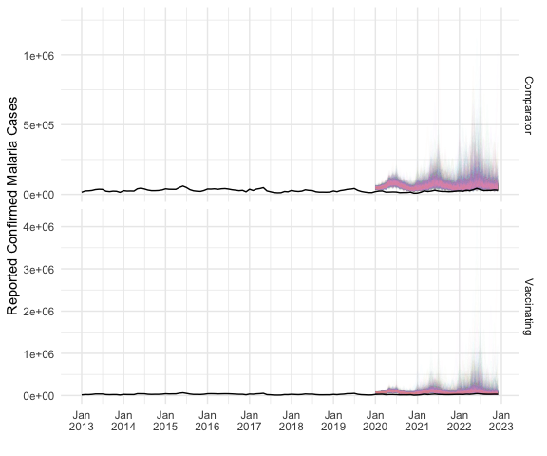
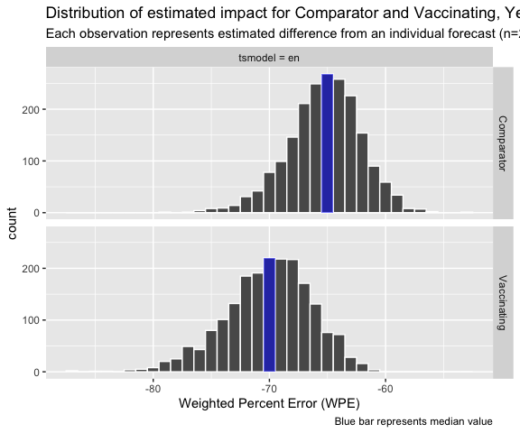
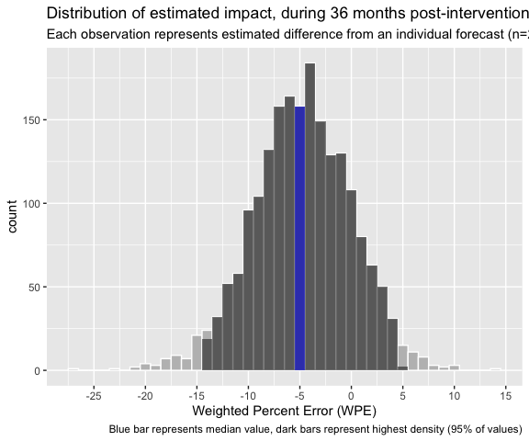
Intervention | .model | n | mean | sd | median | hdi_lower | hdi_upper
Comparison | en | 2,000 | -65.3 | 3.1 | -65.1 | -71.2 | -59.0
Implementing | en | 2,000 | -70.1 | 3.7 | -69.8 | -77.2 | -62.9
Impact (1-36 months) | Implementing - Comparison | 2,000 | -4.8 | 4.8 | -4.7 | -14.2 | 4.6
rawOver4 = list( actual = d$fable.data.age,
predicted = evaluation.forecasts ,
.var = 'older' )
saveRDS( rawOver4 ,
paste0( params$output , 'rawOver4.rds' ) ,
compress = FALSE )

- Raw Under5 with Over4 as covariate (unadjusted-all facilities, no outliers removed) [mcc0]
d = dataset( mcc0 , unadjusted = TRUE , startMonth = yearmonth( "Jan 2013" ) )
test.forecasts = tsmodels( d$pre.intervention.train , d$pre.intervention.test ,
type = "transform and covariate" ,
covariate = 'older' )
Preparing primary models
Primary models finished. 4.204 sec elapsed
Preparing primary forecasts...
Primary forecasts finished 26.268 sec elapsed
Preparing ensemble forecasts...
Ensemble forecasts finished 4.325 sec elapsed
Total time 34.797 sec elapsed
validations = model_metrics( test.forecasts , d$pre.intervention.test )
Calculating monthly SWAPE
1.653 sec elapsed
Calculating mean SWAPE
Total time 1.66 sec elapsed
model_selection = modelSelection( validations , type = 'synchronize' )
model_selection
# A tibble: 2 × 2
# Groups: Intervention [2]
Intervention .model
<fct> <chr>
1 Comparison a
2 Implementing a
evaluation.forecasts = tsmodels( d$pre.intervention , d$post.intervention,
type = "transform and covariate" ,
covariate = 'older' ) %>%
semi_join( model_selection , by = c( 'Intervention', '.model' ))
Preparing primary models
Primary models finished. 5.592 sec elapsed
Preparing primary forecasts...
Primary forecasts finished 60.931 sec elapsed
Preparing ensemble forecasts...
Ensemble forecasts finished 5.056 sec elapsed
Total time 71.579 sec elapsed
# interventionDifference = diff( evaluation.forecasts , d$post.intervention )
impact.tableaux( d$fable.data.age , evaluation.forecasts )
`mutate_if()` ignored the following grouping variables:
• Columns `Intervention`, `.model`, `Month`
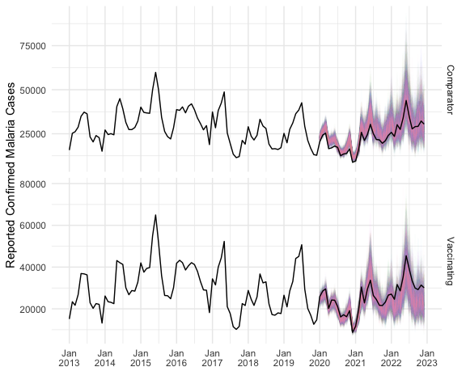
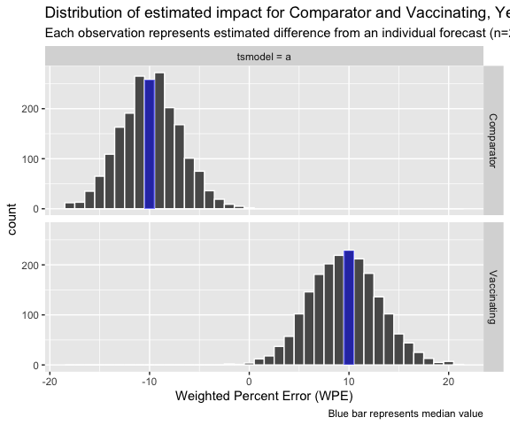
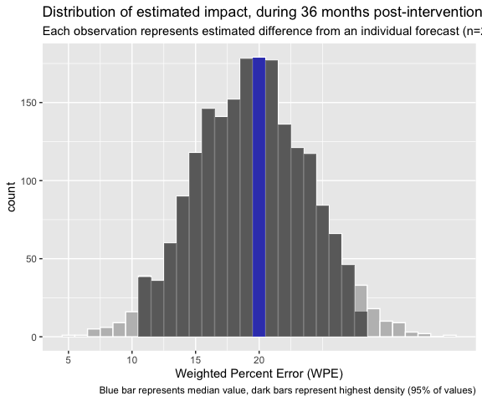
Intervention | .model | n | mean | sd | median | hdi_lower | hdi_upper
Comparison | a | 2,000 | -9.9 | 3.0 | -10.0 | -15.9 | -4.2
Implementing | a | 2,000 | 9.6 | 3.5 | 9.6 | 2.6 | 16.2
Impact (1-36 months) | Implementing - Comparison | 2,000 | 19.5 | 4.5 | 19.5 | 10.6 | 27.9
rawCovariate = list( actual = d$fable.data.age,
predicted = evaluation.forecasts ,
.var = 'older' )
saveRDS( rawCovariate, paste0( params$output , 'rawCovariate.rds' ) ,
compress = FALSE )

Cleaned data: All facilities with outliers removed and CHEW associated with OPD (mcc4) and Over4 covariate
d = facility_characteristics( mcc4, vx )
saveRDS( d , paste0( params$output , 'raw(mcc4)Characteristics.rds' ) )
#|tbl-cap: Characteristics of unadjusted (raw) dataset
ft_characteristics( d )
Intervention | selected | Facilities | MOHª | <5y Malaria(%) | RTS,S Doses(%) | PBO-nets^{b} | IRS^{c}
Comparison |  | 781 | 56.1% | 2,599,576 (48.2%) | 0 (0.0%) | 43.7% | 38.2%
Implementing |  | 747 | 57.3% | 2,796,140 (51.8%) | 928,646 (100.0%) | 33.8% | 23.9%
a: Percent of facilities owned by Ministry of Health. Other facilities owned by 'Private', 'Mission/Faith-Based Organization', or 'Non-Governmental Organization'. Owner was not incidated for 24.8% of facilities
b: Percent of facilities where PBO nets distributed during mass campaign in 2021
c: Percent of facilities where IRS applied annually

- Under 5 only
d = dataset( mcc4 , unadjusted = FALSE, startMonth = yearmonth( "Jan 2013" ) )
test.forecasts = tsmodels( d$pre.intervention.train , d$pre.intervention.test ,
type = "transform" )
Preparing primary models
Primary models finished. 2.988 sec elapsed
Preparing primary forecasts...
Primary forecasts finished 26.332 sec elapsed
Preparing ensemble forecasts...
Ensemble forecasts finished 4.604 sec elapsed
Total time 33.925 sec elapsed
validations = model_metrics( test.forecasts , d$pre.intervention.test )
Calculating monthly SWAPE
1.863 sec elapsed
Calculating mean SWAPE
Total time 1.869 sec elapsed
model_selection = modelSelection( validations , type = 'synchronize' )
model_selection
# A tibble: 2 × 2
# Groups: Intervention [2]
Intervention .model
<fct> <chr>
1 Comparison aent
2 Implementing aent
evaluation.forecasts = tsmodels( d$pre.intervention , d$post.intervention ,
type = "transform" ) %>%
semi_join( model_selection , by = c( 'Intervention', '.model' ))
Preparing primary models
Primary models finished. 4.242 sec elapsed
Preparing primary forecasts...
Primary forecasts finished 60.773 sec elapsed
Preparing ensemble forecasts...
Ensemble forecasts finished 5.309 sec elapsed
Total time 70.325 sec elapsed
impact.tableaux( d$fable.data.age , evaluation.forecasts )
`mutate_if()` ignored the following grouping variables:
• Columns `Intervention`, `.model`, `Month`
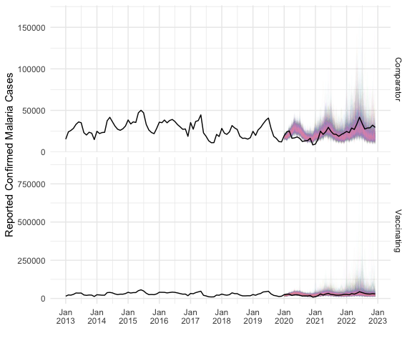
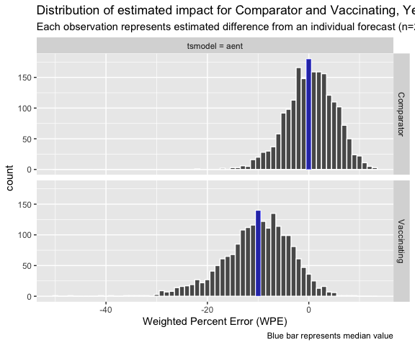
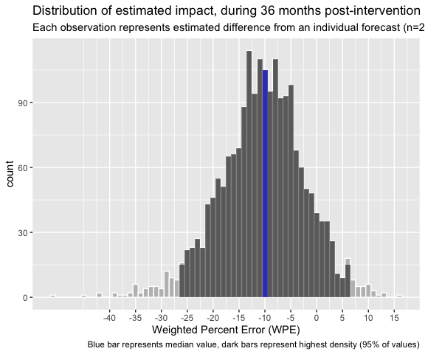
Intervention | .model | n | mean | sd | median | hdi_lower | hdi_upper
Comparison | aent | 2,000 | 0.4 | 4.8 | 0.5 | -9.1 | 9.6
Implementing | aent | 2,000 | -10.2 | 6.8 | -9.7 | -24.8 | 1.9
Impact (1-36 months) | Implementing - Comparison | 2,000 | -10.6 | 8.3 | -10.3 | -26.4 | 6.3
cleanedUnder5 = list( actual = d$fable.data.age,
predicted = evaluation.forecasts ,
.var = 'older' )
saveRDS( cleanedUnder5, paste0( params$output , 'cleanedUnder5.rds' ) ,
compress = FALSE )

- Over 4 only
d = dataset( mcc4 , unadjusted = FALSE, startMonth = yearmonth( "Jan 2013" ) )
test.forecasts = tsmodels( d$pre.intervention.train , d$pre.intervention.test ,
type = "transform" ,
.var = 'older' )
Preparing primary models
Primary models finished. 2.829 sec elapsed
Preparing primary forecasts...
Primary forecasts finished 27.009 sec elapsed
Preparing ensemble forecasts...
Ensemble forecasts finished 4.849 sec elapsed
Total time 34.688 sec elapsed
validations = model_metrics( test.forecasts , d$pre.intervention.test ,
.var = 'older' )
Calculating monthly SWAPE
1.823 sec elapsed
Calculating mean SWAPE
Total time 1.829 sec elapsed
model_selection = modelSelection( validations , type = 'synchronize' )
model_selection
# A tibble: 2 × 2
# Groups: Intervention [2]
Intervention .model
<fct> <chr>
1 Comparison aen
2 Implementing aen
evaluation.forecasts = tsmodels( d$pre.intervention , d$post.intervention ,
type = "transform" ,
.var = 'older' ) %>%
semi_join( model_selection , by = c( 'Intervention', '.model' ))
Preparing primary models
Primary models finished. 6.09 sec elapsed
Preparing primary forecasts...
Primary forecasts finished 61.617 sec elapsed
Preparing ensemble forecasts...
Ensemble forecasts finished 5.439 sec elapsed
Total time 73.146 sec elapsed
impact.tableaux( d$fable.data.age , evaluation.forecasts )
`mutate_if()` ignored the following grouping variables:
• Columns `Intervention`, `.model`, `Month`
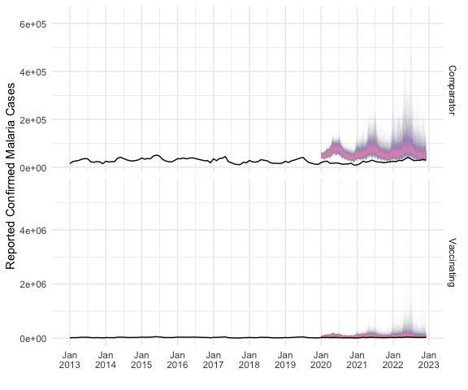
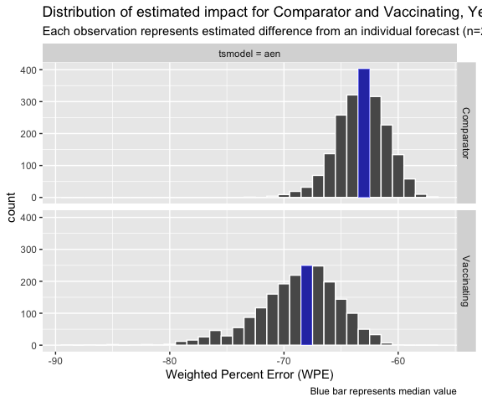
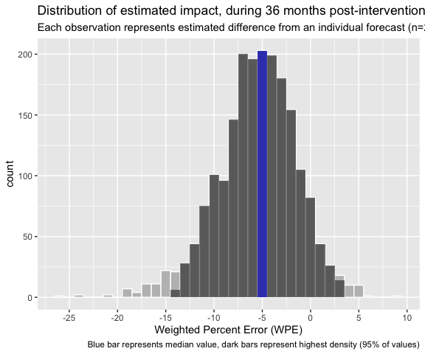
Intervention | .model | n | mean | sd | median | hdi_lower | hdi_upper
Comparison | aen | 2,000 | -63.2 | 2.2 | -63.1 | -67.3 | -59.0
Implementing | aen | 2,000 | -68.8 | 3.6 | -68.4 | -76.4 | -62.3
Impact (1-36 months) | Implementing - Comparison | 2,000 | -5.6 | 4.2 | -5.3 | -13.7 | 3.1
cleanedOver4 = list( actual = d$fable.data.age,
predicted = evaluation.forecasts ,
.var = 'older' )
saveRDS( cleanedOver4, paste0( params$output , 'cleanedOver4.rds' ) ,
compress = FALSE )

- Under 5 with Over 4 Covariate
d = dataset( mcc4 , unadjusted = FALSE, startMonth = yearmonth( "Jan 2013" ) )
test.forecasts = tsmodels( d$pre.intervention.train , d$pre.intervention.test ,
type = "transform and covariate" ,
covariate = 'older' )
Preparing primary models
Primary models finished. 4.519 sec elapsed
Preparing primary forecasts...
Primary forecasts finished 25.286 sec elapsed
Preparing ensemble forecasts...
Ensemble forecasts finished 4.364 sec elapsed
Total time 34.169 sec elapsed
validations = model_metrics( test.forecasts , d$pre.intervention.test )
Calculating monthly SWAPE
1.615 sec elapsed
Calculating mean SWAPE
Total time 1.621 sec elapsed
model_selection = modelSelection( validations , type = 'synchronize' )
model_selection
# A tibble: 2 × 2
# Groups: Intervention [2]
Intervention .model
<fct> <chr>
1 Comparison antp4
2 Implementing antp4
evaluation.forecasts = tsmodels( d$pre.intervention , d$post.intervention ,
type = "transform and covariate" ,
covariate = 'older' ) %>%
semi_join( model_selection , by = c( 'Intervention', '.model' ))
Preparing primary models
Primary models finished. 6.378 sec elapsed
Preparing primary forecasts...
Primary forecasts finished 58.572 sec elapsed
Preparing ensemble forecasts...
Ensemble forecasts finished 5.157 sec elapsed
Total time 70.108 sec elapsed
impact.tableaux( d$fable.data.age , evaluation.forecasts )
`mutate_if()` ignored the following grouping variables:
• Columns `Intervention`, `.model`, `Month`
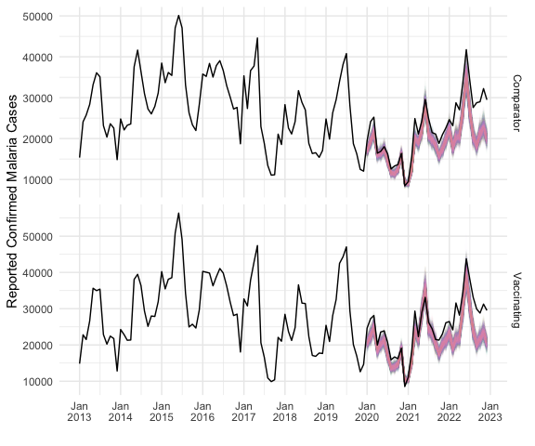
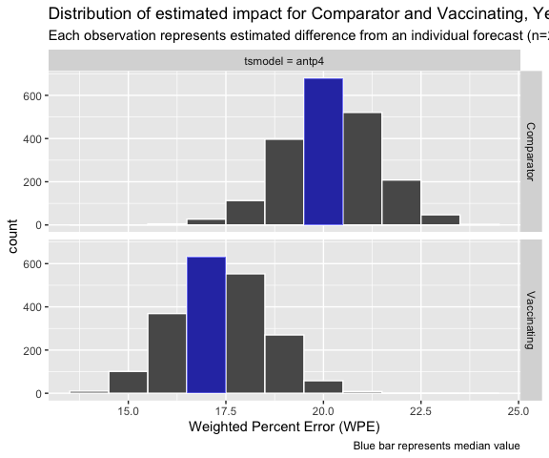
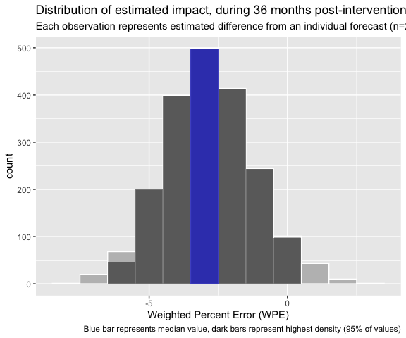
Intervention | .model | n | mean | sd | median | hdi_lower | hdi_upper
Comparison | antp4 | 2,000 | 20.2 | 1.2 | 20.2 | 17.8 | 22.5
Implementing | antp4 | 2,000 | 17.4 | 1.2 | 17.3 | 15.1 | 19.6
Impact (1-36 months) | Implementing - Comparison | 2,000 | -2.8 | 1.6 | -2.9 | -6.1 | 0.4
cleanedCovariate = list( actual = d$fable.data.age,
predicted = evaluation.forecasts ,
.var = 'older' )
saveRDS( cleanedCovariate, paste0( params$output , 'cleanedCovariate.rds' ) ,
compress = FALSE )

Adjusted data (mcc5)
#|label: mcc5.consistency
#|fig-cap: "Number of facilities consistently reporting (minimum 11 of 12 months) confirmed cases each year"
dataset.consisency( mcc5 )
ggsave( paste0( params$output ,'adjusted(mcc5).consistency.png' ), dpi = 300 , width = 6)
Saving 6 x 5 in image
mcc5.facilities = mvip.facilities %>%
filter( st_geometry_type(.) == "POINT" ) %>%
mutate( included = ifelse( orgUnit %in% consistently_reporting_facilities, 'Included', 'Excluded' ))
base_map +
geom_sf( data = mvip.facilities %>% filter( st_geometry_type(.) == "POINT" ) ,
color = 'grey' , size = 1 , shape = 21 , aes( color = included ) ) +
geom_sf( data = mcc5.facilities %>% filter( included == "Included" ),
color = 'blue' , size = 1 , shape = 21 , aes( color = included , fill = Intervention ) ) +
coord_sf(
xlim = c( boundaryBox[1], boundaryBox[3]),
ylim = c(boundaryBox[2], boundaryBox[4] ),
expand = FALSE
)
Coordinate system already present. Adding new coordinate system, which will
replace the existing one.
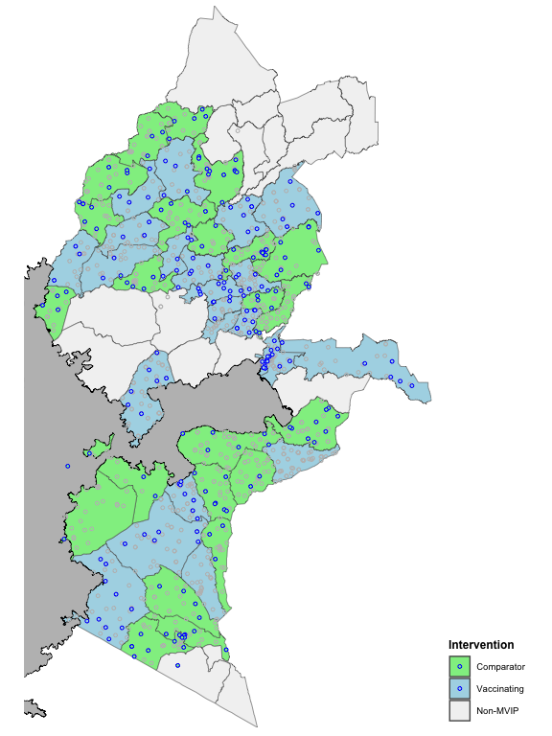
d = facility_characteristics( mcc5, vx,
selected_facilities = consistently_reporting_facilities,
errs = FALSE )
saveRDS( d , paste0( params$output , 'adjustedCharacteristics.rds' ) )
#|tbl-cap: Characteristics of adjusted dataset
ft_characteristics( d , errs = FALSE )
Intervention | selected | Facilities | MOHª | <5y Malaria(%) | RTS,S Doses(%) | PBO-nets^{b} | IRS^{c}
Comparison | TRUE | 139 | 60.4% | 1,004,891 (18.6%) | 0 (0.0%) | 46.8% | 33.8%
Implementing | TRUE | 132 | 59.1% | 944,082 (17.5%) | 374,001 (40.3%) | 45.5% | 18.9%
Comparison |  | 642 | 55.0% | 1,594,685 (29.6%) | 0 (0.0%) | 43.3% | 38.8%
Implementing |  | 615 | 56.9% | 1,852,058 (34.3%) | 554,645 (59.7%) | 32.4% | 24.5%
a: Percent of facilities owned by Ministry of Health. Other facilities owned by 'Private', 'Mission/Faith-Based Organization', or 'Non-Governmental Organization'. Owner was not incidated for 24.8% of facilities
b: Percent of facilities where PBO nets distributed during mass campaign in 2021
c: Percent of facilities where IRS applied annually
mcc5.facilities = mvip.facilities %>%
mutate( included = ifelse( orgUnit %in% consistently_reporting_facilities, 'Included', 'Excluded' ))
base_map +
geom_sf( data = mvip.facilities ,
color = 'grey' , size = 1 ) +
geom_sf( data = mcc5.facilities %>% filter( included == "Included" ),
color = 'blue' , size = 1 , shape = 21 , aes( fill = Intervention ) ) +
# geom_sf( data = mcc6.facilities %>% filter( included == "Included" ) ,
# color = 'red' , size = 1 , shape = 21 , aes( fill = Intervention ) ) +
coord_sf(
xlim = c( boundaryBox[1], boundaryBox[3]),
ylim = c(boundaryBox[2], boundaryBox[4] ),
expand = FALSE
)
Coordinate system already present. Adding new coordinate system, which will
replace the existing one.
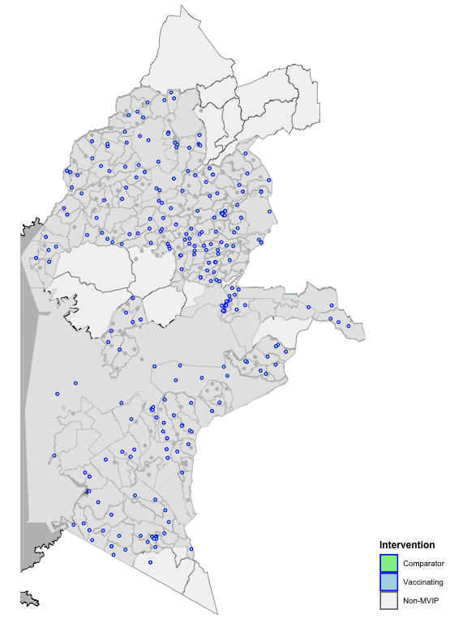
ggsave( paste0( params$image.dir , 'adjustedMap.png' ) , dpi = 300, width = 6 )
Saving 6 x 8 in image

- Under5 only

- Over 4 only

- Under5 with Over4 Covariate

Always reporting from 2020 (mcc6), consistentently reporting since 2015

Always reporting from since 2015 (mcc7)
start_month = yearmonth("Jan 2015")
allowable_missing = 0
always_reporting_facilities_2015_0 = reporting_consistency %>%
filter( Starting == start_month &
MissingPerYr == allowable_missing ) %>%
pull( Facilities ) %>% unlist
mcc7 = mcc5 %>%
filter( orgUnit %in% always_reporting_facilities_2015_0 )
mcc7 %>% as_tibble %>% ungroup %>% group_by( Intervention ) %>%
summarise( Facilities = n_distinct( orgUnit )) %>% flextable()
Intervention | Facilities
Comparison | 55
Implementing | 47
#|label: mcc6.consistency
#|fig-cap: "Number of facilities consistently reporting (minimum 11 of 12 months) confirmed cases each year"
dataset.consisency( mcc7 )
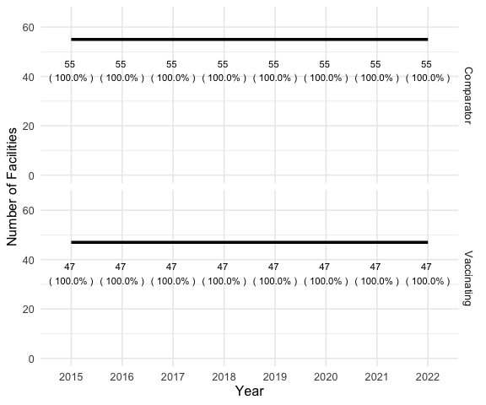
ggsave( paste0( params$image.dir ,'adjusted(mcc6).consistency.png' ), dpi = 300 , width = 6)
Saving 6 x 5 in image
d = facility_characteristics( mcc7, vx )
saveRDS( d , paste0( params$output , 'always2015Characteristics.rds' ) )
#|tbl-cap: Characteristics of adjusted dataset
ft_characteristics( d )
Intervention | selected | Facilities | MOHª | <5y Malaria(%) | RTS,S Doses(%) | PBO-nets^{b} | IRS^{c}
Comparison |  | 781 | 56.1% | 2,599,576 (48.2%) | 0 (0.0%) | 43.7% | 38.2%
Implementing |  | 747 | 57.3% | 2,796,140 (51.8%) | 928,646 (100.0%) | 33.8% | 23.9%
a: Percent of facilities owned by Ministry of Health. Other facilities owned by 'Private', 'Mission/Faith-Based Organization', or 'Non-Governmental Organization'. Owner was not incidated for 24.8% of facilities
b: Percent of facilities where PBO nets distributed during mass campaign in 2021
c: Percent of facilities where IRS applied annually
if (!exists( "mvip.boundaries.interventions" ) ) mvip.boundaries.interventions = readRDS( paste0( params$output, 'mvip.boundaries.interventions.rds' ) )
if (!exists( "mvip.facilities" ) ) mvip.facilities = readRDS( paste0( params$output, 'mvip.facilities.rds' ) )
# note that some coordinates are outside MVIP, probably because of data entry error
boundaryBox = mvip.boundaries.interventions %>% st_bbox()
mcc7.facilities = mvip.facilities %>%
mutate( included = ifelse( orgUnit %in% always_reporting_facilities_2015_0, 'Included', 'Excluded' ))
mcc5.facilities = mvip.facilities %>%
mutate( included = ifelse( orgUnit %in% consistently_reporting_facilities, 'Included', 'Excluded' ))
if (!exists( 'base_map') ) base_map = read_rds( paste0( params$output , 'base_map.rds' ))
base_map +
geom_sf( data = mvip.facilities ,
color = 'grey' , size = 1 , shape = 21 , aes( fill = Intervention ) ) +
geom_sf( data = mcc5.facilities %>% filter( included == "Included" ),
color = 'blue' , size = 1 , shape = 21 , aes( fill = Intervention ) ) +
geom_sf( data = mcc6.facilities %>% filter( included == "Included" ) ,
color = 'red' , size = 1 , shape = 21 , aes( fill = Intervention ) ) +
coord_sf(
xlim = c( boundaryBox[1], boundaryBox[3]),
ylim = c(boundaryBox[2], boundaryBox[4] ),
expand = FALSE
)
d = dataset( mcc7 )
test.forecasts = tsmodels( d$pre.intervention.train , d$pre.intervention.test,
type = "transform and covariate" ,
covariate = 'older' )
Preparing primary models
Primary models finished. 1.715 sec elapsed
Preparing primary forecasts...
Primary forecasts finished 26.459 sec elapsed
Preparing ensemble forecasts...
Ensemble forecasts finished 4.582 sec elapsed
Total time 32.757 sec elapsed
validations = model_metrics( test.forecasts , d$pre.intervention.test )
Calculating monthly SWAPE
1.857 sec elapsed
Calculating mean SWAPE
Total time 1.864 sec elapsed
model_selection = modelSelection( validations , type = 'synchronize' )
evaluation.forecasts = tsmodels( d$pre.intervention , d$post.intervention ,
type = "transform and covariate" ,
covariate = 'older' ) %>%
semi_join( model_selection , by = c( 'Intervention', '.model' ))
Preparing primary models
Primary models finished. 2.295 sec elapsed
Preparing primary forecasts...
Primary forecasts finished 61.282 sec elapsed
Preparing ensemble forecasts...
Ensemble forecasts finished 5.121 sec elapsed
Total time 68.698 sec elapsed
impact.tableaux( d$fable.data.age , evaluation.forecasts )
`mutate_if()` ignored the following grouping variables:
• Columns `Intervention`, `.model`, `Month`
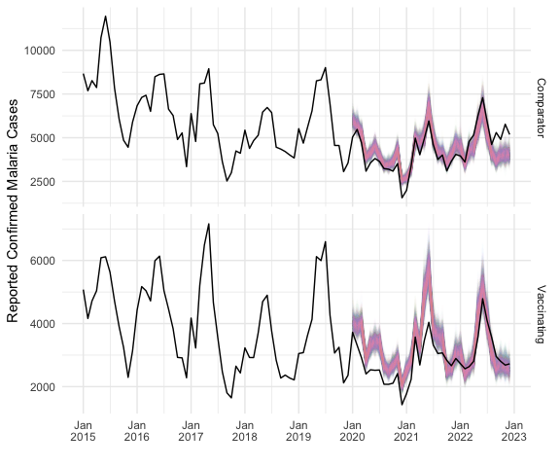
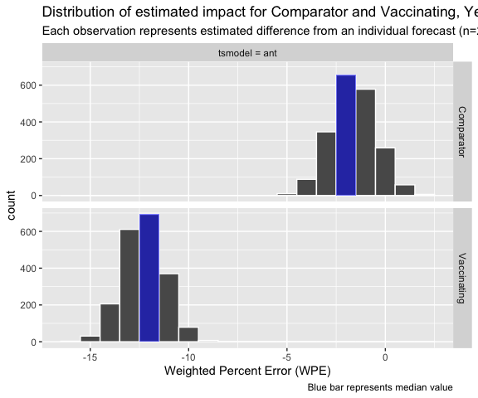
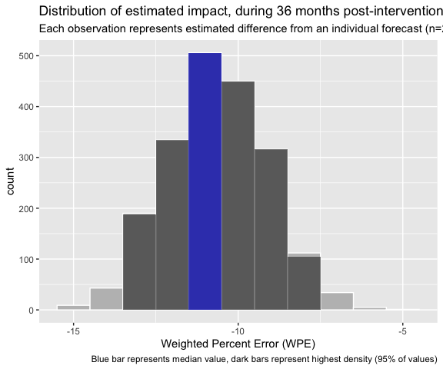
Intervention | .model | n | mean | sd | median | hdi_lower | hdi_upper
Comparison | ant | 2,000 | -1.6 | 1.1 | -1.6 | -3.8 | 0.7
Implementing | ant | 2,000 | -12.3 | 1.0 | -12.3 | -14.3 | -10.3
Impact (1-36 months) | Implementing - Comparison | 2,000 | -10.6 | 1.5 | -10.6 | -13.5 | -7.7
alwaysReporting2015 = list( actual = d$fable.data.age,
predicted = evaluation.forecasts ,
.var = 'older' )
saveRDS( alwaysReporting2015, paste0( params$output , 'alwaysReporting2015.rds' ) ,
compress = FALSE )

Adjusted, Primary models only
d = dataset( mcc5 )
test.forecasts = tsmodels( d$pre.intervention.train , d$pre.intervention.test,
type = "transform and covariate" ,
covariate = 'older' ,
ensemble = FALSE )
Preparing primary models
Primary models finished. 2.112 sec elapsed
Preparing primary forecasts...
Primary forecasts finished 26.105 sec elapsed
Preparing ensemble forecasts...
Total time 28.217 sec elapsed
validations = model_metrics( test.forecasts , d$pre.intervention.test )
Calculating monthly SWAPE
0.093 sec elapsed
Calculating mean SWAPE
Total time 0.095 sec elapsed
model_selection = modelSelection( validations , type = 'synchronize' )
model_selection
# A tibble: 2 × 2
# Groups: Intervention [2]
Intervention .model
<fct> <chr>
1 Comparison p8
2 Implementing p8
evaluation.forecasts = tsmodels( d$pre.intervention , d$post.intervention ,
type = "transform and covariate" ,
covariate = 'older' ,
ensemble = FALSE ) %>%
semi_join( model_selection , by = c( 'Intervention', '.model' ))
Preparing primary models
Primary models finished. 2.395 sec elapsed
Preparing primary forecasts...
Primary forecasts finished 59.656 sec elapsed
Preparing ensemble forecasts...
Total time 62.052 sec elapsed
impact.tableaux( d$fable.data.age , evaluation.forecasts )
`mutate_if()` ignored the following grouping variables:
• Columns `Intervention`, `.model`, `Month`
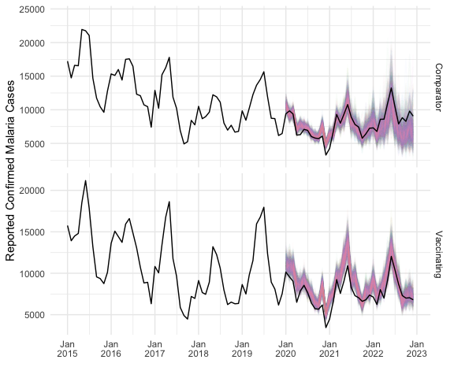
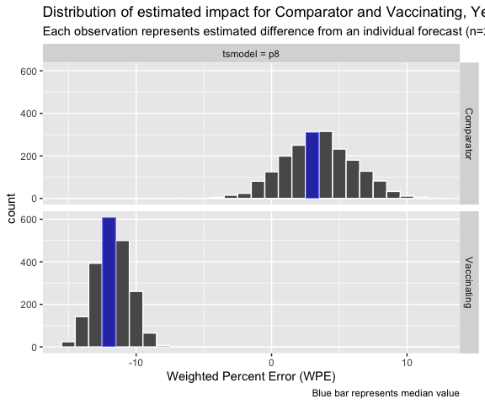
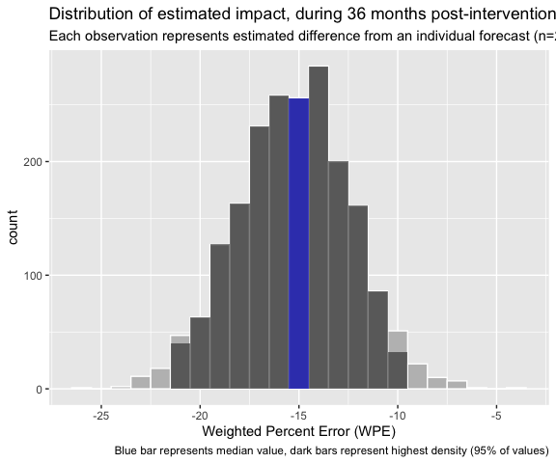
Intervention | .model | n | mean | sd | median | hdi_lower | hdi_upper
Comparison | p8 | 2,000 | 3.5 | 2.6 | 3.5 | -1.5 | 8.5
Implementing | p8 | 2,000 | -11.8 | 1.2 | -11.8 | -14.1 | -9.3
Impact (1-36 months) | Implementing - Comparison | 2,000 | -15.2 | 2.9 | -15.2 | -21.2 | -10.0
adjustedPrimaryOnly = list( actual = d$fable.data.age,
predicted = evaluation.forecasts ,
.var = 'older' )
saveRDS( adjustedPrimaryOnly, paste0( params$output , 'adjustedPrimaryOnly.rds' ) ,
compress = FALSE )

Adjusted, ‘Optimized’ models
d = dataset( mcc5 )
test.forecasts = tsmodels( d$pre.intervention.train , d$pre.intervention.test,
type = "transform and covariate" ,
covariate = 'older' ,
ensemble = TRUE )
Preparing primary models
Primary models finished. 2.13 sec elapsed
Preparing primary forecasts...
Primary forecasts finished 27.038 sec elapsed
Preparing ensemble forecasts...
Ensemble forecasts finished 4.458 sec elapsed
Total time 33.626 sec elapsed
validations = model_metrics( test.forecasts , d$pre.intervention.test )
Calculating monthly SWAPE
1.804 sec elapsed
Calculating mean SWAPE
Total time 1.81 sec elapsed
model_selection = modelSelection( validations , type = 'optimize' )
model_selection
# A tibble: 2 × 2
# Groups: Intervention [2]
Intervention .model
<fct> <chr>
1 Comparison an
2 Implementing nt
evaluation.forecasts = tsmodels( d$pre.intervention , d$post.intervention ,
type = "transform and covariate" ,
covariate = 'older' ,
ensemble = TRUE ) %>%
semi_join( model_selection , by = c( 'Intervention', '.model' ))
Preparing primary models
Primary models finished. 2.383 sec elapsed
Preparing primary forecasts...
Primary forecasts finished 60.58 sec elapsed
Preparing ensemble forecasts...
Ensemble forecasts finished 4.972 sec elapsed
Total time 67.936 sec elapsed
impact.tableaux( d$fable.data.age , evaluation.forecasts )
`mutate_if()` ignored the following grouping variables:
• Columns `Intervention`, `.model`, `Month`
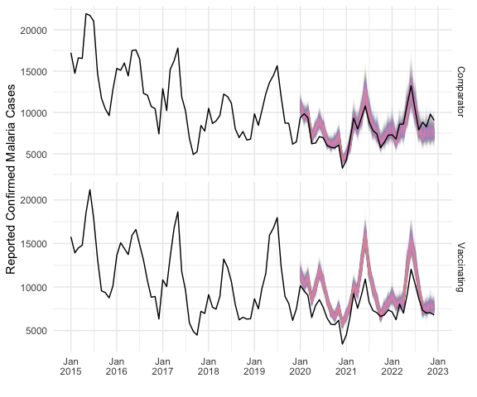
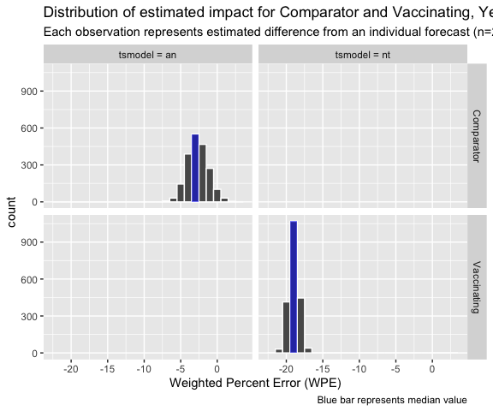
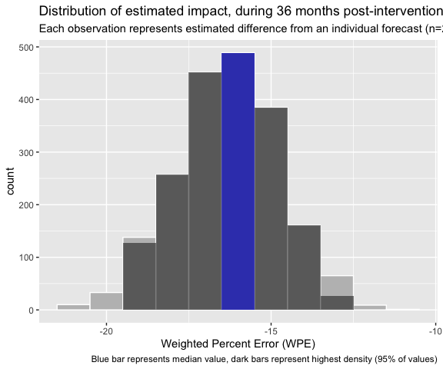
Intervention | .model | n | mean | sd | median | hdi_lower | hdi_upper
Comparison | an | 2,000 | -2.7 | 1.4 | -2.7 | -5.3 | 0.1
Implementing | nt | 2,000 | -19.0 | 0.7 | -19.0 | -20.3 | -17.5
Impact (1-36 months) | Implementing - Comparison | 2,000 | -16.3 | 1.6 | -16.3 | -19.4 | -13.2
adjustedOptimized = list( actual = d$fable.data.age,
predicted = evaluation.forecasts ,
.var = 'older' )
saveRDS( adjustedOptimized, paste0( params$output , 'adjustedOptimized.rds' ),
compress = FALSE )

Adjusted, ‘Optimized’ Primary models
d = dataset( mcc5 )
test.forecasts = tsmodels( d$pre.intervention.train , d$pre.intervention.test,
type = "transform and covariate" ,
covariate = 'older' ,
ensemble = FALSE,
)
Preparing primary models
Primary models finished. 2.161 sec elapsed
Preparing primary forecasts...
Primary forecasts finished 26.031 sec elapsed
Preparing ensemble forecasts...
Total time 28.192 sec elapsed
validations = model_metrics( test.forecasts , d$pre.intervention.test )
Calculating monthly SWAPE
0.094 sec elapsed
Calculating mean SWAPE
Total time 0.096 sec elapsed
model_selection = modelSelection( validations , type = 'optimize' )
model_selection
# A tibble: 2 × 2
# Groups: Intervention [2]
Intervention .model
<fct> <chr>
1 Comparison p8
2 Implementing p8
evaluation.forecasts = tsmodels( d$pre.intervention , d$post.intervention ,
type = "transform and covariate" ,
covariate = 'older' ,
ensemble = FALSE ) %>%
semi_join( model_selection , by = c( 'Intervention', '.model' ))
Preparing primary models
Primary models finished. 2.398 sec elapsed
Preparing primary forecasts...
Primary forecasts finished 60.3 sec elapsed
Preparing ensemble forecasts...
Total time 62.698 sec elapsed
impact.tableaux( d$fable.data.age , evaluation.forecasts )
`mutate_if()` ignored the following grouping variables:
• Columns `Intervention`, `.model`, `Month`
Intervention | .model | n | mean | sd | median | hdi_lower | hdi_upper
Comparison | p8 | 2,000 | 3.5 | 2.6 | 3.5 | -1.5 | 8.5
Implementing | p8 | 2,000 | -11.8 | 1.2 | -11.8 | -14.1 | -9.3
Impact (1-36 months) | Implementing - Comparison | 2,000 | -15.2 | 2.9 | -15.2 | -21.2 | -10.0
adjustedOptimizedPrimary = list( actual = d$fable.data.age,
predicted = evaluation.forecasts ,
.var = 'older' )
saveRDS( adjustedOptimizedPrimary, paste0( params$output ,
'adjustedOptimizedPrimary.rds' ) ,
compress = FALSE )

Ratio of under5 to over4 cases
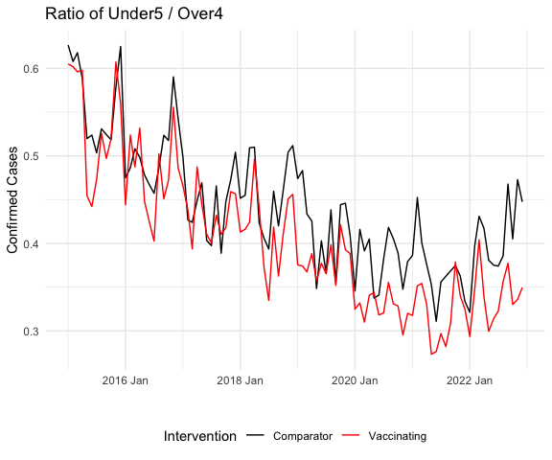
d = dataset( mcc8 , group_by_age = FALSE )
test.forecasts = tsmodels( d$pre.intervention.train , d$pre.intervention.test,
type = "transform" ,
.var = 'total'
)
validations = model_metrics( test.forecasts , d$pre.intervention.test ,
.var = 'total')
model_selection = modelSelection( validations , type = 'synchronize' )
model_selection
evaluation.forecasts = tsmodels( d$pre.intervention , d$post.intervention ,
type = "transform" ,
.var = 'total' ) %>%
semi_join( model_selection , by = c( 'Intervention', '.model' ))
impact.tableaux( d$fable.data.age , evaluation.forecasts , .var = 'total')
adjustedRatioU5O4 = list( actual = d$fable.data.age,
predicted = evaluation.forecasts ,
.var = 'older' )
saveRDS( adjustedRatioU5O4, paste0( params$output ,
'adjustedRatioU5O4.rds' ) ,
compress = FALSE )

Health Facility based models

Summary
#|tbl-cap: Estimated impact (WPE) with alternative data and/or time-series model parameters
rawUnder5 = readRDS( paste0( params$output , 'rawUnder5.rds' ) )
rawOver4 = readRDS( paste0( params$output , 'rawOver4.rds' ) )
rawCovariate = readRDS( paste0( params$output , 'rawCovariate.rds' ) )
cleanedUnder5 = readRDS( paste0( params$output , 'cleanedUnder5.rds' ) )
cleanedOver4 = readRDS( paste0( params$output , 'cleanedOver4.rds' ) )
cleanedCovariate = readRDS( paste0( params$output , 'cleanedCovariate.rds' ) )
adjustedUnder5 = readRDS( paste0( params$output , 'adjustedUnder5.rds' ) )
adjustedOver4 = readRDS( paste0( params$output , 'adjustedOver4.rds' ) )
adjustedCovariate = readRDS( paste0( params$output , 'adjustedCovariate.rds' ) )
alwaysReporting2015 = readRDS( paste0( params$output ,
'alwaysReporting2015.rds' ) )
alwaysReporting2020 = readRDS( paste0( params$output ,
'alwaysReporting2020.rds' ) )
adjustedPrimaryOnly = readRDS( paste0( params$output , 'adjustedPrimaryOnly.rds' ) )
adjustedOptimized = readRDS( paste0( params$output , 'adjustedOptimized.rds' ) )
adjustedOptimizedPrimary = readRDS( paste0( params$output , 'adjustedOptimizedPrimary.rds' ) )
adjustedRatioU5O4 = readRDS( paste0( params$output , 'adjustedRatioU5O4.rds' ) )
impact.near = readRDS( paste0( params$output , 'impact.near.rds' ) )
impact.far = readRDS( paste0( params$output , 'impact.far.rds' ) )
models = list( rawUnder5 = rawUnder5,
rawOver4 = rawOver4 ,
rawCovariate = rawCovariate ,
cleanedUnder5 = cleanedUnder5,
cleanedOver4 = cleanedOver4,
cleanedCovariate = cleanedCovariate,
adjustedUnder5 = adjustedUnder5,
adjustedOver4 = adjustedOver4,
adjustedCovariate = adjustedCovariate,
# alwaysReporting2020 = alwaysReporting2020 ,
alwaysReporting2015 = alwaysReporting2015 ,
adjustedPrimaryOnly = adjustedPrimaryOnly ,
adjustedOptimized = adjustedOptimized ,
# adjustedOptimizedPrimary = adjustedOptimizedPrimary ,
impact.near = impact.near ,
impact.far = impact.far
# , adjustedRatioU5O4 = adjustedRatioU5O4
)
m = map_df( 1:length(models) ,
~ impactTable( models[.x][[1]]$actual ,
models[.x][[1]]$predicted ) %>%
mutate( Scenario = names(models)[.x] )
) %>%
select( Scenario, everything() ) %>%
mutate( across( where( is.numeric ), \(x) signif(x, 3 )) ,
CI = paste0( "(", hdi_lower , "," , hdi_upper , ")" ) ,
Data = case_when(
grepl( 'raw' , Scenario ) ~ 'Raw' ,
grepl( 'cleaned', Scenario ) ~ 'Cleaned' ,
TRUE ~ 'Cleaned and \nconsistently \nreporting'
) ,
Scenario = case_when(
Scenario == 'impact.near' ~ 'Near Comparison' ,
Scenario == 'impact.far' ~ 'Far Comparison' ,
grepl('Covariate', Scenario ) ~ 'Under5 with\nOver4 covariate' ,
grepl( 'raw' , Scenario ) ~ str_remove( Scenario, 'raw') ,
grepl( 'cleaned', Scenario ) ~ str_remove( Scenario, 'cleaned') ,
TRUE ~ str_remove( Scenario, 'adjusted') ,
) ,
)
saveRDS( m, './output/alternative_scenarios_summary.rds' )
# Create the flextable
summary.data = m %>% select( Data, Scenario, Intervention, .model, mean, CI )
ft <- flextable( summary.data )
ft = bg( ft , i = ~ grepl( 'Impact', `Intervention` ), bg = "lightgrey")
# Merge the 'Group' column vertically to visually separate the groups
ft <- merge_v( ft, j = ~ Data)
ft <- merge_v( ft, j = ~ Scenario)
# Add borders between the groups for clear demarcation
ft <- border(ft, border.top = officer::fp_border(width = 2),
part = "body")
# Add a border to the header
ft <- border(ft, border.top = officer::fp_border(width = 2), part = "header")
# Apply conditional formatting to color negative numbers red and positive numbers blue
numeric_columns <- names( summary.data )[ map_lgl( summary.data , is.numeric ) ]
for (col in numeric_columns) {
# Apply numeric formatting (e.g., 2 decimal places)
ft <- colformat_double(
x = ft,
j = col,
digits = 1
)
# Apply color formatting for each cell based on whether the number is positive or negative
for (i in seq_len(nrow(m)) ) {
ft <- flextable::compose( ft,
i = i,
j = col,
value = as_paragraph(
if ( m[[col]][i] < 0 ) {
as_chunk( m[[col]][i], props = officer::fp_text(color = "red"))
} else {
as_chunk( m[[col]][i], props = officer::fp_text(color = "black"))
}
)
)
}
}
# Display the flextable
ft = ft %>% FitFlextableToPage()
# Adjust font size to 10 for the entire flextable
ft <- fontsize(ft, size = 10, part = "all") # Apply font size to header, body, and footer
ft <- line_spacing(ft, space = 0.8, part = "all") # Decrease line spacing (0.8 is tighter spacing)
ft
Data | Scenario | Intervention | .model | mean | CI
Raw | Under5 | Comparison | aent | -6.2 | (-28.8,14.2)
Raw | Under5 | Implementing | aent | -9.4 | (-23.6,2.49)
Raw | Under5 | Impact (1-36 months) | Implementing - Comparison | -3.2 | (-29.1,23.9)
Raw | Over4 | Comparison | en | -65.3 | (-71.2,-59)
Raw | Over4 | Implementing | en | -70.1 | (-77.2,-62.9)
Raw | Over4 | Impact (1-36 months) | Implementing - Comparison | -4.8 | (-14.2,4.58)
Raw | Under5 with  Over4 covariate | Comparison | a | -9.9 | (-15.9,-4.2)
Raw | Under5 with  Over4 covariate | Implementing | a | 9.6 | (2.62,16.2)
Raw | Under5 with  Over4 covariate | Impact (1-36 months) | Implementing - Comparison | 19.5 | (10.6,27.9)
Cleaned | Under5 | Comparison | aent | 0.4 | (-9.07,9.62)
Cleaned | Under5 | Implementing | aent | -10.2 | (-24.8,1.85)
Cleaned | Under5 | Impact (1-36 months) | Implementing - Comparison | -10.6 | (-26.4,6.28)
Cleaned | Over4 | Comparison | aen | -63.2 | (-67.3,-59)
Cleaned | Over4 | Implementing | aen | -68.8 | (-76.4,-62.3)
Cleaned | Over4 | Impact (1-36 months) | Implementing - Comparison | -5.6 | (-13.7,3.11)
Cleaned | Under5 with  Over4 covariate | Comparison | antp4 | 20.2 | (17.8,22.5)
Cleaned | Under5 with  Over4 covariate | Implementing | antp4 | 17.4 | (15.1,19.6)
Cleaned | Under5 with  Over4 covariate | Impact (1-36 months) | Implementing - Comparison | -2.8 | (-6.06,0.42)
Cleaned and  consistently  reporting | Under5 | Comparison | p8 | -37.1 | (-41.2,-32.5)
Cleaned and  consistently  reporting | Under5 | Implementing | p8 | -54.3 | (-57.9,-51)
Cleaned and  consistently  reporting | Under5 | Impact (1-36 months) | Implementing - Comparison | -17.1 | (-22.6,-11.7)
Cleaned and  consistently  reporting | Over4 | Comparison | p8 | -80.2 | (-81.6,-78.7)
Cleaned and  consistently  reporting | Over4 | Implementing | p8 | -85.7 | (-87,-84.6)
Cleaned and  consistently  reporting | Over4 | Impact (1-36 months) | Implementing - Comparison | -5.5 | (-7.51,-3.72)
Cleaned and  consistently  reporting | Under5 with  Over4 covariate | Comparison | ant | -2.3 | (-4.36,-0.107)
Cleaned and  consistently  reporting | Under5 with  Over4 covariate | Implementing | ant | -13.8 | (-15.1,-12.5)
Cleaned and  consistently  reporting | Under5 with  Over4 covariate | Impact (1-36 months) | Implementing - Comparison | -11.5 | (-14.1,-9.14)
Cleaned and  consistently  reporting | alwaysReporting2015 | Comparison | ant | -1.6 | (-3.79,0.668)
Cleaned and  consistently  reporting | alwaysReporting2015 | Implementing | ant | -12.3 | (-14.3,-10.3)
Cleaned and  consistently  reporting | alwaysReporting2015 | Impact (1-36 months) | Implementing - Comparison | -10.6 | (-13.5,-7.66)
Cleaned and  consistently  reporting | PrimaryOnly | Comparison | p8 | 3.5 | (-1.46,8.48)
Cleaned and  consistently  reporting | PrimaryOnly | Implementing | p8 | -11.8 | (-14.1,-9.33)
Cleaned and  consistently  reporting | PrimaryOnly | Impact (1-36 months) | Implementing - Comparison | -15.2 | (-21.2,-10)
Cleaned and  consistently  reporting | Optimized | Comparison | an | -2.7 | (-5.35,0.0599)
Cleaned and  consistently  reporting | Optimized | Implementing | nt | -19.0 | (-20.3,-17.5)
Cleaned and  consistently  reporting | Optimized | Impact (1-36 months) | Implementing - Comparison | -16.3 | (-19.4,-13.2)
Cleaned and  consistently  reporting | Near Comparison | Comparison | ant | -6.9 | (-9.48,-4.32)
Cleaned and  consistently  reporting | Near Comparison | Implementing | ant | -13.8 | (-15.1,-12.5)
Cleaned and  consistently  reporting | Near Comparison | Impact (1-36 months) | Implementing - Comparison | -6.9 | (-9.99,-4.27)
Cleaned and  consistently  reporting | Far Comparison | Comparison | ant | -2.1 | (-4.52,0.149)
Cleaned and  consistently  reporting | Far Comparison | Implementing | ant | -13.8 | (-15.1,-12.5)
Cleaned and  consistently  reporting | Far Comparison | Impact (1-36 months) | Implementing - Comparison | -11.7 | (-14.5,-9.22)

- focus on model subtracting change in comparison areas from change in implementing areas.
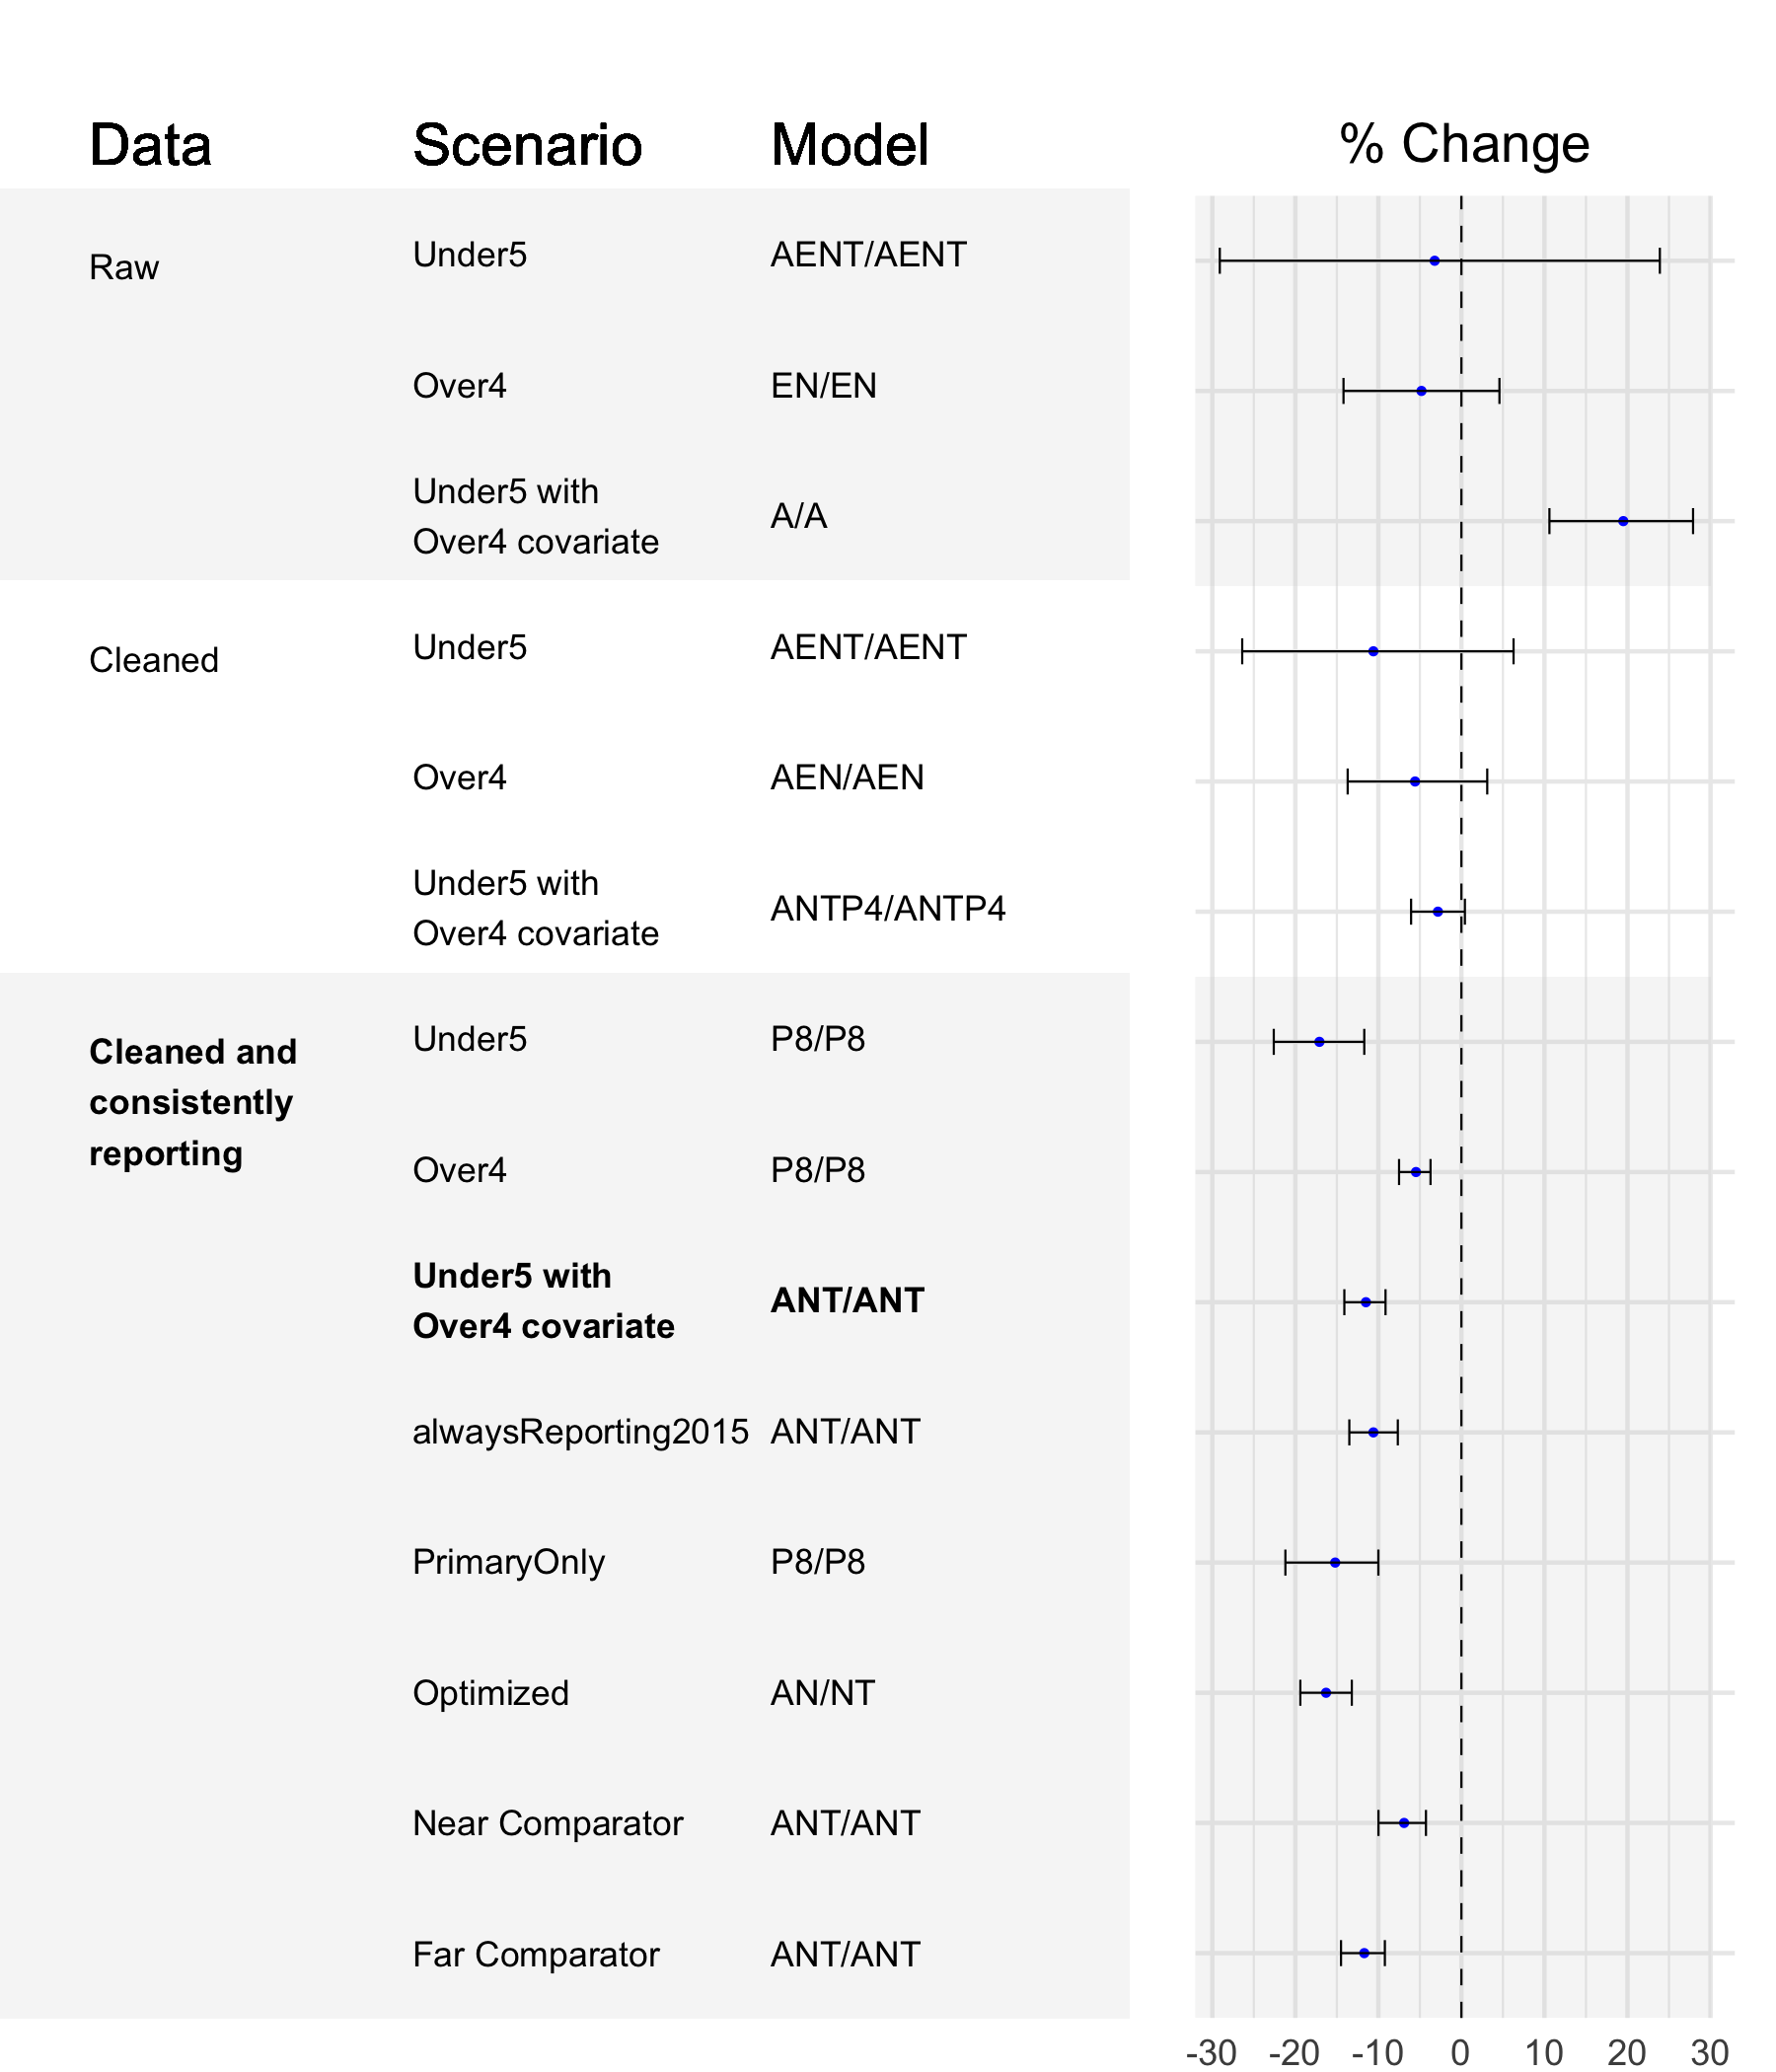

References
1. RStudio Team. RStudio: Integrated Development Environment for R. Boston, MA: RStudio, PBC.; 2020.
2. Rts T, Partnership (2014) SCT. Efficacy and Safety of the RTS,S/AS01 Malaria Vaccine during 18 Months after Vaccination: A Phase 3 Randomized, Controlled Trial in Children and Young Infants at 11 African Sites. PLOS Medicine. 2014;11:e1001685.
3. RTS SCTP. Efficacy and safety of RTS,S/AS01 malaria vaccine with or without a booster dose in infants and children in Africa: Final results of a phase 3, individually randomised, controlled trial. The Lancet. 2015;386:31–45.
4. Introduction - DHIS2 Documentation. https://docs.dhis2.org/en/develop/using-the-api/dhis-core-version-240/introduction.html;
5. Organisation Units - DHIS2 Documentation. https://docs.dhis2.org/en/implement/database-design/organisation-units.html;
6. List of hospitals in Kenya. Wikipedia. 2024;
7. Moturi AK, Suiyanka L, Mumo E, Snow RW, Okiro EA, Macharia PM. Geographic accessibility to public and private health facilities in Kenya in 2021: An updated geocoded inventory and spatial analysis. Frontiers in Public Health. 2022;10.
8. Martin JL, Mosha FW, Lukole E, Rowland M, Todd J, Charlwood JD, et al. Personal protection with PBO-pyrethroid synergist-treated nets after 2 years of household use against pyrethroid-resistant Anopheles in Tanzania. Parasites & Vectors. 2021;14:150.
9. Cheng J, Schloerke B, Karambelkar B, Xie Y. Leaflet: Create interactive web maps with the JavaScript ’leaflet’ library. 2024; Available from: https://CRAN.R-project.org/package=leaflet
10. Wang E, Cook D, Hyndman RJ. A new tidy data structure to support exploration and modeling of temporal data. 2020;29:466–78. Available from: https://doi.org/10.1080/10618600.2019.1695624
11. 5.8 evaluating point forecast accuracy | forecasting: Principles and practice (3rd ed) [Internet]. Available from: https://otexts.com/fpp3/accuracy.html
12. 5.10 time series cross-validation | forecasting: Principles and practice (3rd ed) [Internet]. Available from: https://otexts.com/fpp3/tscv.html
13. Hyndman RJ, Athanasopoulos G. Forecasting: Principles and practice, 3rd edition. This online version of the book was last updated on 22 March 2024. OTexts;
14. 5.1 a tidy forecasting workflow | forecasting: Principles and practice (3rd ed) [Internet]. Available from: https://otexts.com/fpp3/a-tidy-forecasting-workflow.html
15. Hyndman RJ. Forecasting ensembles and combinations. https://pkg.robjhyndman.com/combinations_talk/ensembles_uscdc_2022.html#/title-slide; 2022.
16. 5.1 a tidy forecasting workflow | forecasting: Principles and practice (3rd ed) [Internet]. Available from: https://otexts.com/fpp3/a-tidy-forecasting-workflow.html
17. Hewamalage H, Ackermann K, Bergmeir C. Forecast Evaluation for Data Scientists: Common Pitfalls and Best Practices.
18. Linden A, Adams JL, Roberts N. Evaluating Disease Management Program Effectiveness: An Introduction to Time-Series Analysis. Disease Management. 2003;6:243–55.
19. Kolassa S. Answer to "what are the shortcomings of the mean absolute percentage error (MAPE)?" [Internet]. 2017. Available from: https://stats.stackexchange.com/a/299713
20. Kolassa S. Why the “best” point forecast depends on the error or accuracy measure. International Journal of Forecasting. 2020;36:208–11.
21. Kolassa S. Answer to "RMSE or MAPE? Which one to choose for accuracy?" [Internet]. 2021. Available from: https://stats.stackexchange.com/a/554440

