Cereal grain 3D point cloud analysis method technical documentation

Cereal grain 3D scanning system design
In this study, in order to efficiently obtain dense point clouds of cereal grains, a 3D scanning system was designed. The whole system consisted of 6 parts: structured light scanner, robot, scanner fixture, object platform, industrial computer and control unit.
The 3D structured light scanner in the system was Reeyee Pro (Wiiboox). Combing the advantages of structured light and binocular stereo vision, the scanner used white light LED raster scanning technology, which can achieve a single-sided accuracy of 0.05mm within 2s. The main equipment is composed of a projector, two cameras and an internal modulated light source (shown in Figure 1). Based on the principle of triangulation and raster image, it could obtain the dense point cloud data of objects. More information about the scanner can be found at https://www.wiiboox.net/3d-scanner-reeyee-pro.php
Figure 1 The composition of Reeyee Pro

The system uses the AUBO i5 robot, which was a lightweight 6 degrees of freedom (DOF) collaborative robot with a positioning accuracy of ±0.02mm and a maximum load of 5kg. The working range of the robot was a sphere with a radius of 886.5 mm, which ensured sufficient scanning space. The main parameters of the robot are shown in Table 1.
Table 1 AUBO i5 robot main parameters.
Parameter | Value
Degrees of freedom | 6
Work limitation | 886.5mm
Work load | 5Kg
Weight | 28Kg
Accuracy | ±0.02mm
Extremity speed | ≤2.8m/s

In order to match the scanner with the robot, the fixture is designed and 3D printed with ABS material by ourselves and weighs 1.5kg, while the weight of the entire scanner including the texture camera is less than 1kg. Therefore, the load and positioning accuracy of the robot have reached the requirements of the system for automatic and batch data collection. The objective table was constructed by aluminum alloy and was used to fix the robot and place samples. The small industrial computer was respectively connected with the control box and the scanner, and controls the operation of the robot and the scanner at the same time. The schematic diagram of the system is shown in Figure 2.
Figure 2 Cereal grain 3D scanning system

Cereal grain point cloud acquisition
The cereal grain point cloud acquisition is shown as Figure 3, which could be divided into 4 steps: the scanner calibration, the selection of the placement schemes, the scanning path determination, and the batch scanning.
(1) Calibration of the scanner. The structured light scanner needed to be calibrated and corrected before working. When calibrating the camera, the calibration board need to be set in four positions including the directions of 0°, 90°, 180°, and 270°. Then the distance between the scanner and the calibration board should be adjusted from 350mm to 450mm, while collecting images.
(2) Selection of the placement schemes. At present, there are mainly two kinds of three-dimensional scanning schemes for grains. One way is to spread the grains flatly on a platform, and another is to fix the grains through the seed holder. The former has high efficiency, but the accuracy is low because the scanning grain is not complete. The latter obtains the complete point cloud of grain with high accuracy, but the disadvantage is that it can only scan a single grain, which is too time-consuming. To improve it, the grains were directly fixed vertically on the stage, and multiple grains could be scanned completely in the study. And it is worth noting that a low center of gravity can be more stable in scanning.
(3) Determination of the scanning path point. As shown in Table 1, the minimum space point distance of Reeyee Pro is 0.16mm. To achieve as high spatial resolution as possible, the robot was studied to obtain proper scanning path point. The most important factors affecting the scanning result were the object distance, angle and exposure. Based on the working distance of the scanner and the light intensity of the environment, it was easy to find the right distance and exposure. Therefore, the most difficult thing was to find the best angle actually. After several comparisons of point cloud densities, the final scanning angle was about 45°. Finally, in this study, the average minimum point distance of the grain point cloud was capable of reaching 0.1731.
(4) Batch scanning. Due to the limitation of scanning area and rotation effect, the grain placement range was set to 100×100mm in the center. In addition, the distance between adjacent grains was set as 20mm to avoid grain shading. Meanwhile, the grain placement strategy was 6×4+1 (4 rows for every 6 grains in a row, and the last one is placed separately), which is helpful for matching the manual and automatic values. What is more, the scanning strategy of rotating 8 times and scanning 45 degree a time was adopted.
Figure 3 Flow chart of cereal grain point cloud acquisition.

Solution Selection and technology roadmap
After acquiring original point cloud, our goal was actually to separate single grain and then extract the phenotypic parameters from them in turn. The main steps included point cloud preprocessing, point cloud segmentation and phenotypic parameter calculation. The whole processing pipeline is shown as Figure 4.

Figure 4 Cereal grain point cloud processing pipeline.

Detailed methodological information
- Coordinate transformation
By using the rotation and translation matrix to correct the coordinate system, the centroid of the original point cloud was converted to the origin of the coordinate system. The main steps of the conversion were as follows: First calculate the centroid coordinates of the point cloud model, and move the origin of the initial coordinate system to the point to form a new point cloud collection. Then, principal component analysis (PCA) was used to transform the point cloud into a new coordinate system. The covariance matrix was constructed for the point cloud model, and the eigenvalues and eigenvectors of the covariance matrix were solved. The three eigenvectors were the main directions of the point cloud. According to the centroid coordinates and the principal direction, rotation translation matrix relative to the origin of the initial coordinate system could be established. It transformed the point cloud into the new normalized coordinate system. The corresponding code is expressed in C + + language as:
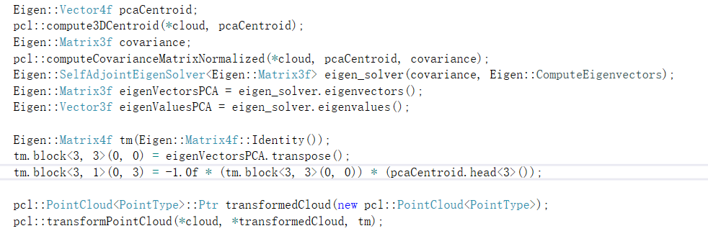
Where cloud was original point cloud and transformedCloud was point cloud after coordinate transformation.

- Point cloud filtering and down sampling
Affected by the scanning environment, the accuracy of the equipment, and the operating habits of experimenters, noise points sometimes appeared in the original point cloud. In view of the characteristics of noise points, statistical filtering was used to denoise point clouds. The corresponding code is expressed in C + + language as:
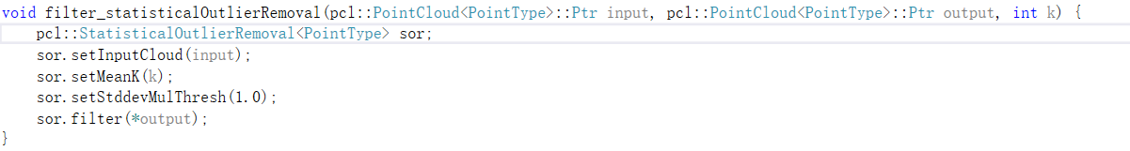
Where statistical coefficient k was set to 10 in the code.

Due to the point cloud obtained by the structured light scanner is dense point cloud, the direct processing efficiency was very low. The voxel down sampling of the point cloud could effectively reduce the workload. The corresponding code is expressed in C + + language as:
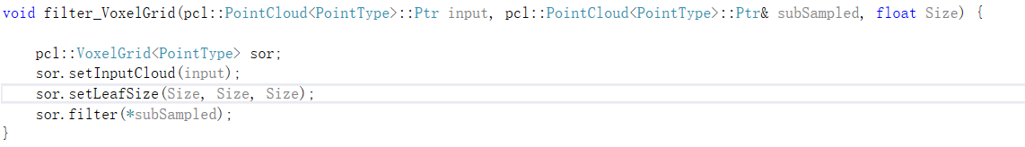
Where voxel side length Size was set to 0.25 in the code.

- Segmentation of stage and grains
It was evident that the point cloud of the stage could be regarded as a plane. Therefore, the linear plane model fitting based on the random sample consensus algorithm (RANSAC) was used to estimate the stage plane model. The original point cloud and the plane model were segmented to obtain the stage point cloud and the multiple grains point cloud. The corresponding code is expressed in C + + language as:
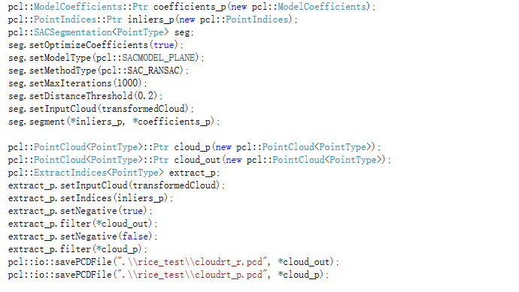

- Segmentation of single grains
After segmenting the stage and grains, the multi-grain point clouds were divided into single grains by region growing algorithm. The point with the smallest curvature value was used as the seed point to create the region growth segmentation object. Then clustering was carried out by the angle and curvature between the normal of seed points and adjacent points. The corresponding code is expressed in C + + language as:
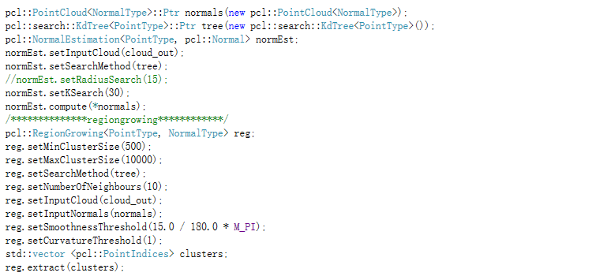
For adapting to rice, wheat and corn grains, minimum cluster point cloud size was set to 500 and maximum cluster point cloud size was set to 10000.

- Grain length, width and thickness extraction
The extraction of grain length, width and thickness was mainly achieved by constructing a bounding box. Firstly, the coordinate system of the segmented single grain point clouds were transformed to convert axis-aligned bounding box (AABB) into orientation bounding box (OBB). Secondly, the maximum and minimum values of the transformed single grain point cloud in the new coordinate system were calculated as $x_{max}、x_{min}、y_{max}、y_{min}、z_{max}、z_{min}$ respectively. Finally, the grain length, width and thickness were computed as following equations.

$$l=x_{max}-x_{min}$$ | (1)
$$w=y_{max}-y_{min}$$ | (2)
$$h=z_{max}-z_{min}$$ | (3)
Where l, w and h are the length, width and thickness of a grain, respectively.
The corresponding code is expressed in C + + language as:
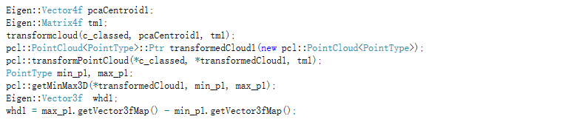
Where whd1[0] is thickness, whd1[1] is width, whd1[2] is length.

- Grain surface area extraction
The triangular mesh model of the point clouds was established by greedy projection triangulation algorithm. It was assumed that the surface of the point cloud was smooth and the density changes were uniform. Point clouds were projected onto a plane based on normal. The projected point cloud was triangulated in the plane. According to the topological connection relation of three points in the plane, a triangular mesh surface model was obtained. Secondly, the holes were filled by reconstructing the mesh boundary edges, which were generated by the grain segmentation. The corresponding code is expressed in C + + language as:
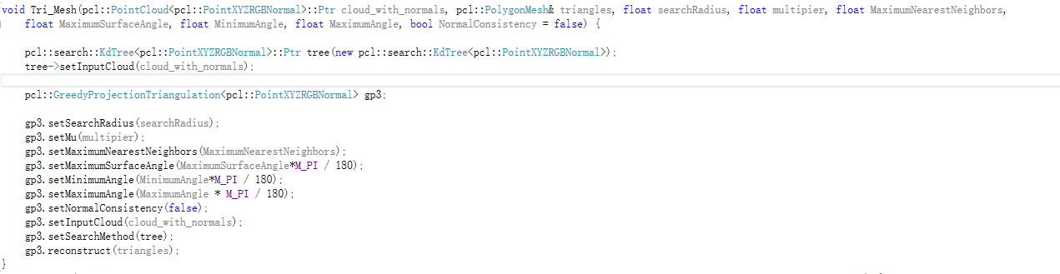
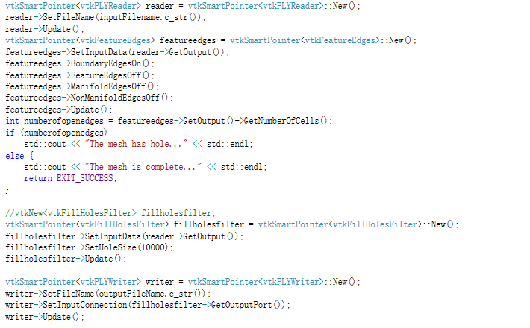

- Grain volume extraction
The grain volume was extracted as Figure 8. Firstly, the convex pentahedrons were constructed by the triangular mesh and central plane projection, and then grain volume V was the sum of their volumes. As shown in the Figure 5, $A_{1}, B_{1} and C_{1}$ are the three vertices of a triangular mesh. It is assumed that the volume of the straight triangular prism $A_{0}B_{0}C_{0}ABC$ is equal to the volume of this convex pentahedron, then the height of the straight triangular prism could be approximated as the height of the gravity center of ${△A}_{1}B_{1}C_{1}$.
$$V_{A_{1}B_{1}C_{1}ABC}=V_{A_{0}B_{0}C_{0}ABC}=S_{△ABC}×h≈S_{△ABC}×h_{0}$$ | (4)
Where $h$ is height of the straight prism, $h_{0}$ is height of the center of gravity of ${△A}_{1}B_{1}C_{1}$
Figure 4 Grain volume calculation method

The corresponding code is expressed in C + + language as:
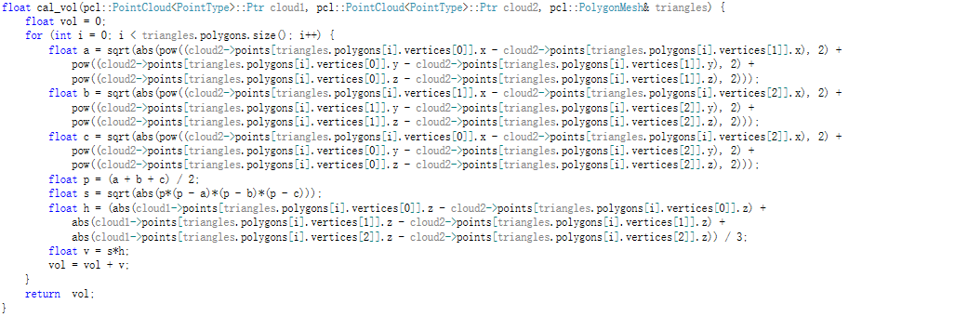
Where cloud1 was grain point cloud, cloud2 was projected point cloud

- Projected area and perimeter of grain in the main direction extraction
In this study, three main directions of grain point cloud were projected, and the projected area and perimeter of cross section, longitudinal section, and horizontal section were obtained as the shape description of grain. Firstly, the point cloud of a single grain after coordinate transformation was projected on the plane of x=0, y=0, z=0 respectively. Then, based on the greedy projection algorithm, the areas of the projected triangular mesh and the perimeter of the mesh edges were calculated. Taking x=0 plane as an example, the corresponding code is expressed in C + + language as:
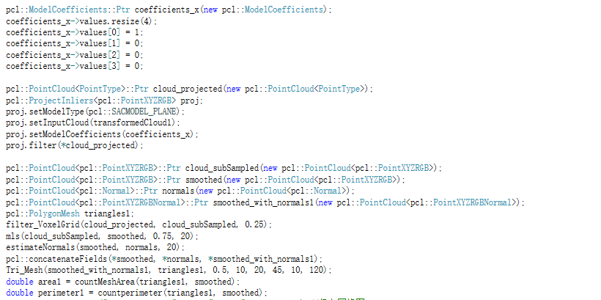
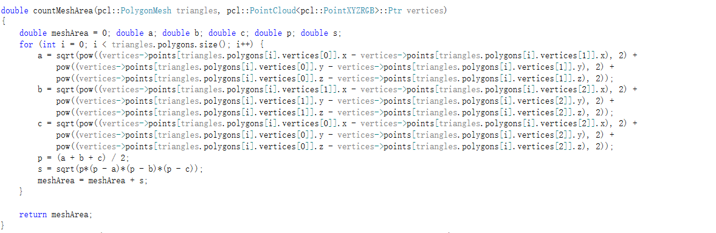
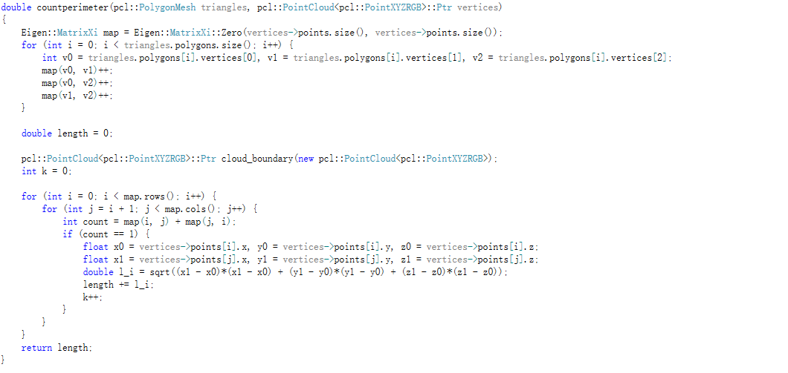

Algorithm dependency library
The algorithm is based on cross-platform open source Point Cloud library (PCL) and Visualization Toolkit (VTK). The following are the dependency libraries:
OpenNI2.dll
pcl_common_release.dll
pcl_features_release.dll
pcl_filters_release.dll
pcl_io_ply_release.dll
pcl_io_release.dll
pcl_ml_releasse.dll
pcl_kdtree_release.dll
pcl_octree_ release.dll
pcl_sample_consensus_release.dll
pcl_search_release.dll
pcl_segmentation_release.dll
pcl_surface_release.dll

Models establishment of recognition
With the rice grain phenotypic dataset, the models of recognition between filled and unfilled grains, distinction between indica and japonica, and classification of rice grain sub-varieties were established by six different machine learning algorithms including decision tree, random forest, support vector machine, naive bayes, XGBoost, and BP neural network. All the classification models were based on the Sklearn library (Python), and their main parameters were turned by learning curve and grid search. And, the 10-fold cross-validation method was used to test each model.

- Classification and regression trees (CART)

The corresponding code was expressed in Python language as follows. First of all, divide the data set.
Based on grid search, we could preliminarily determine some parameters.
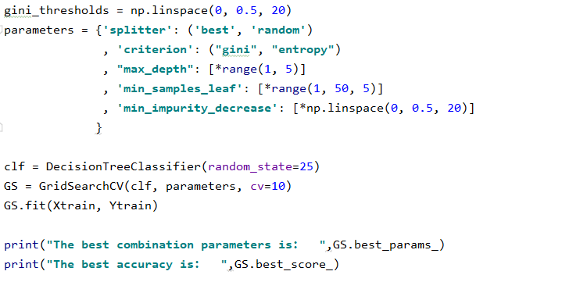
Then single parameter was decided by learning curve.
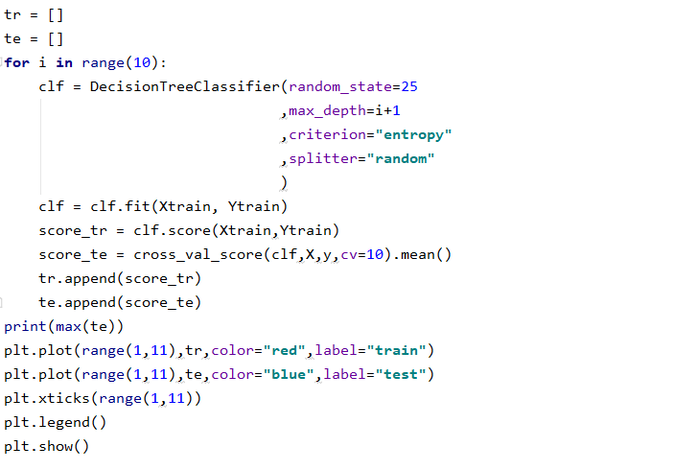
As is shown in Figure 5, max_depth was supposed to be 5 for best result.
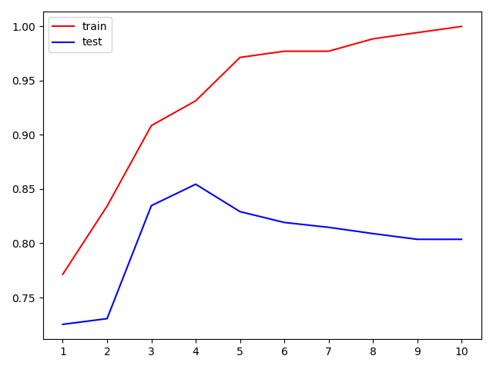
Figure 5 Learning curve of the maximum tree depth

Finally, based on the determined parameters, the 10-fold cross-validation method was used to test the model for obtaining accuracy, F1 score and AUC value.
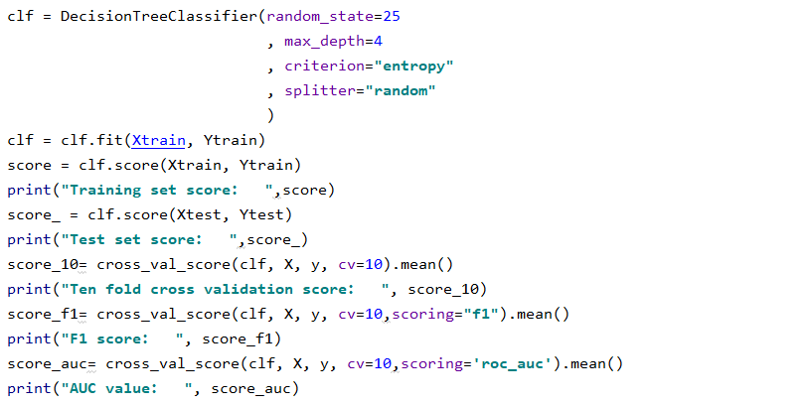

- Random forest (RF)
The validation code was expressed in Python language as follows
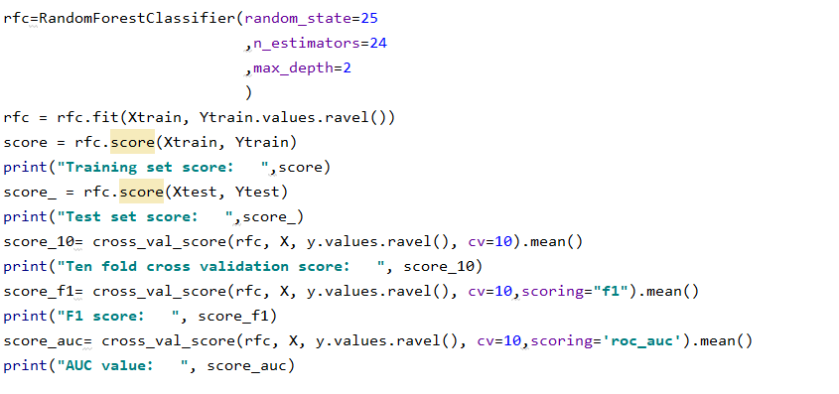

- Support vector machines (SVM)
The validation code was expressed in Python language as follows
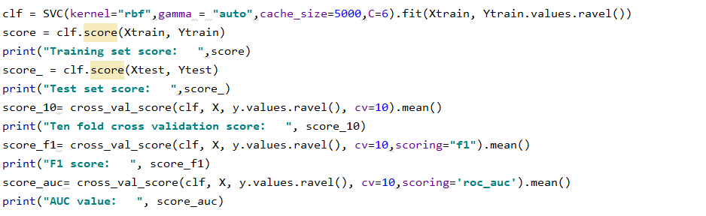

- Naive bayes (NB)
The validation code was expressed in Python language as follows
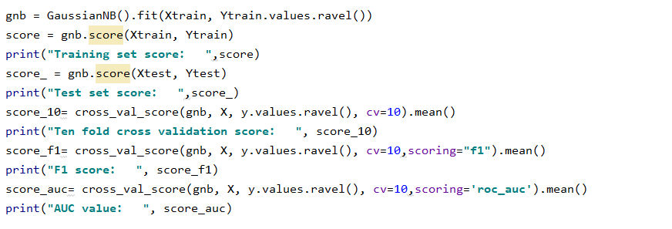

- Back propagation (BP)
The validation code was expressed in Python language as follows
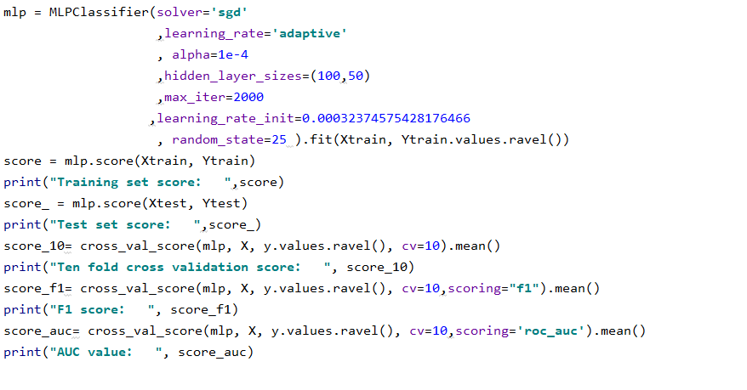

- Extreme gradient boosting (XGBoost)
The validation code was expressed in Python language as follows
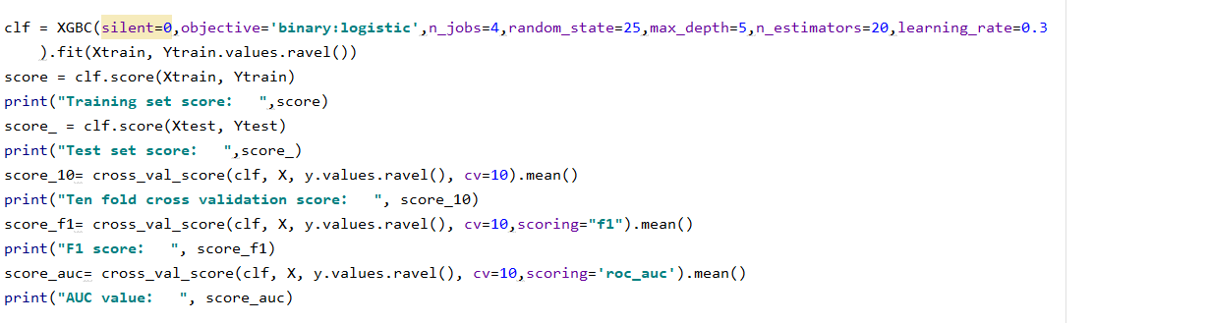

Contribution of phenotypic parameters
Comparing the above 6 machine learning methods, XGBoost achieved the best results In order to explore the contribution of phenotypic parameters, the XGBoost classifier was analyzed in detail. The corresponding code was expressed in Python language as follows.
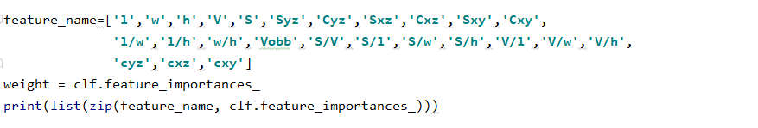
The weight rank of characteristic parameters in XGBoost can refer to the Additional File 6: Appendix S2. And the entire experimental workflow can refer to the Additional File 1 Video S1.

