Supplemental Figure. 1
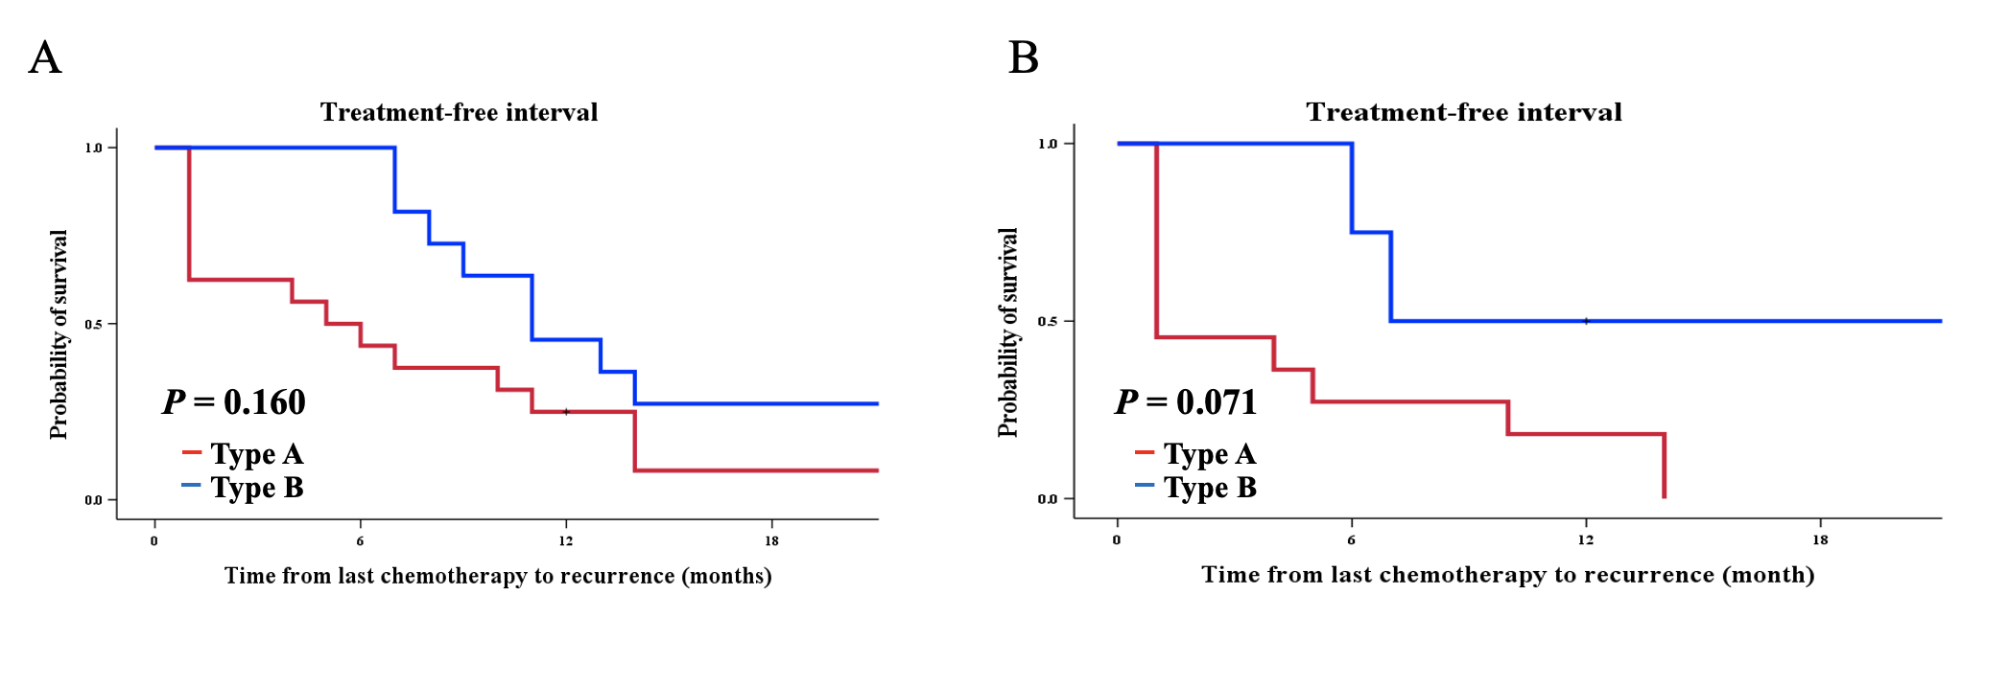
Supplemental Figure. 2
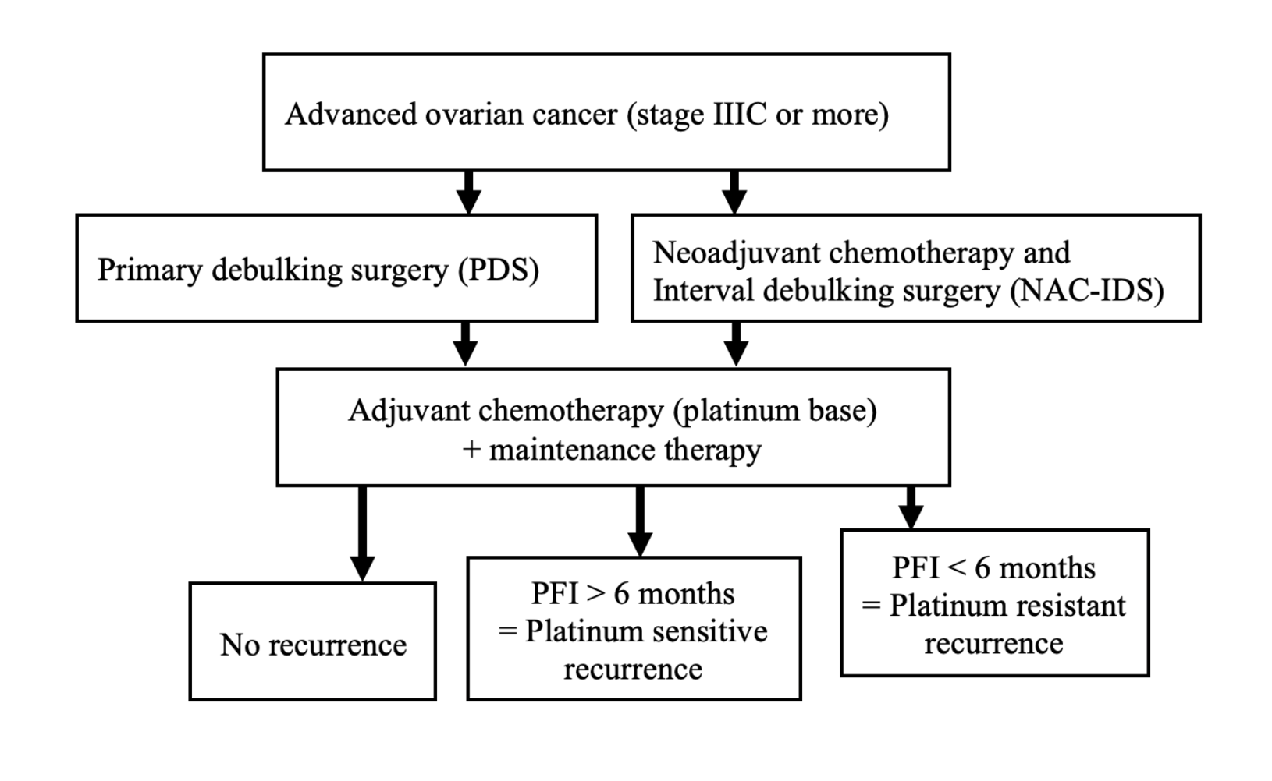

Supplemental Table 1. Patients characteristics of both groups
 | Type A  (n = 12) | Type B  (n = 11) | P-value
Age at diagnosis | 62.5  (41-75) | 60.0  (41-71) | 0.288
NAC course  (times) | 5.5  (3-9) | 6.0  (3-10) | 0.104
Duration from NAC  to IDS (days) | 34.0  (23-50) | 36.0  (24-53) | 0.525
CA125 at daignosis  (U/mL) | 1,367  (161-15,109) | 1,640  (142-6,220) | 0.976
CA125 before operation (U/mL) | 26.5  (8.2-177) | 15.0  (11-34) | 0.151
Complete surgery | 8/12  (66.7%) | 8/11  (72.7%) | 1.00
Abbreviations: NAC, neo-adjuvant chemotherapy; IDS, interval-debulking surgery

