- Overview

This document details the technical workflow of ground-penetrating radar (GPR) data acquisition, processing, visualization, and reliability verification for the rammed-earth remains of ancient city wall in Shugang, encompassing standardized operational specifications, software parameter configurations, data format specifications, and validation methodologies.
- Basic Process of Data Acquisition
The ground-penetrating radar (GPR) employed in this study was the TRU™ (Tree Radar Unit) tree radar system manufactured by Tree Radar, Inc. (Silver Spring, MD, USA). During the detection process, disturbances to the heritage site itself were avoided. The profile slice layout adopted a non-invasive marking method using a steel tape measure. Before detection, the fallen leaves and humus on the profile slice were cleared, and the profile slice was laid out. During the detection process, obstacles were avoided. The pull rod was uniformly pulled to move the radar antenna along the pre-drawn boundary profile slice to ensure that the profile slices within each sampling plot could be fully covered (Fig. S1). At the same time, the antenna was kept in contact with the ground and followed the speed requirements on the operation screen to reduce signal attenuation and noise interference.
The settings of dielectric constant required by GPR before scanning were configured. After scanning, the data was exported in DZT format, and the original detection data was processed uniformly later. The original radar data underwent preprocessing steps such as zero-offset correction, background removal, band-pass filtering and gain adjustment to improve the signal-to-noise ratio and highlight the root reflection characteristics. Finally, a semi-automatic recognition algorithm (such as Hough transform and template matching) was used to extract the hyperbola features, and the recognition accuracy was improved by combining manual visual verification.
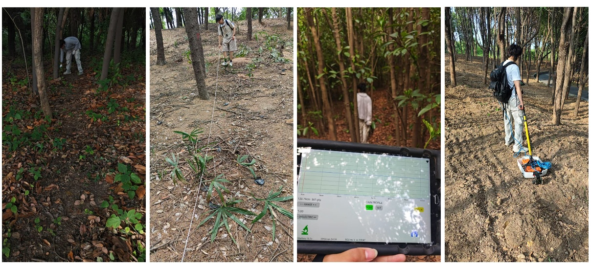
Fig. S1 Field sampling photos

- Dielectric constant calibration
To determine the dielectric constant suitable for ground penetrating radar (GPR) depth inversion in this site area, three known points with natural profiles were selected in the site area for dielectric constant calibration. One of the points is located on the north side of the rammed earth boundary of the ancient city wall (Fig. S2). Relying on the visual characteristics of the natural profile, it provided a real and reliable depth reference. Without excavation, a quantitative correspondence between the two-way travel time of the radar and the actual depth was established, achieving non-destructive dielectric constant calibration.
At the site, 900 MHz antennas were used, and the parameter settings and detection processes were the same as those of the subsequent detection sampling plot. Profile slices were arranged along the natural profile. Radar data was obtained through GPR scanning and compared with the measured profile depth to establish the corresponding relationship between the travel time of the reflection interface and the measured depth. The results showed that: eight clear reflection interfaces appeared at the depth of 0.30 m in the radar profile. The image features, recognizability, and the relationships with the position, depth, and size of the tree roots exposed in the field had clear correspondences, providing reliable depth reference data for the calibration of the dielectric constant.
Given that the humidity content of the rammed-earth remains of ancient wall in Shugang is generally between 8% and 12%, an empirical dielectric constant of 14 was initially adopted, but there were deviations during inversion. By calibrating through comparison with the measured depth, the specific dielectric constant model for this site area was determined to be 16, and the inversion depth accuracy of the same reflection interface was significantly improved after correction. The single-point calibration result established the "radar travel time-depth" conversion parameters applicable to the rammed-earth remains in Shugang, and clarified the reliability of taking the dielectric constant value of 16 in this site area; even though the initial parameters were conservative, the accurate interpretation of the spatial position of the target body was achieved through this calibration model. This result provided a reliable parameter model for the data interpretation and depth inversion of the subsequent unprobed areas, ensuring the accuracy of obtaining the depth information of relic elements such as root distributions.
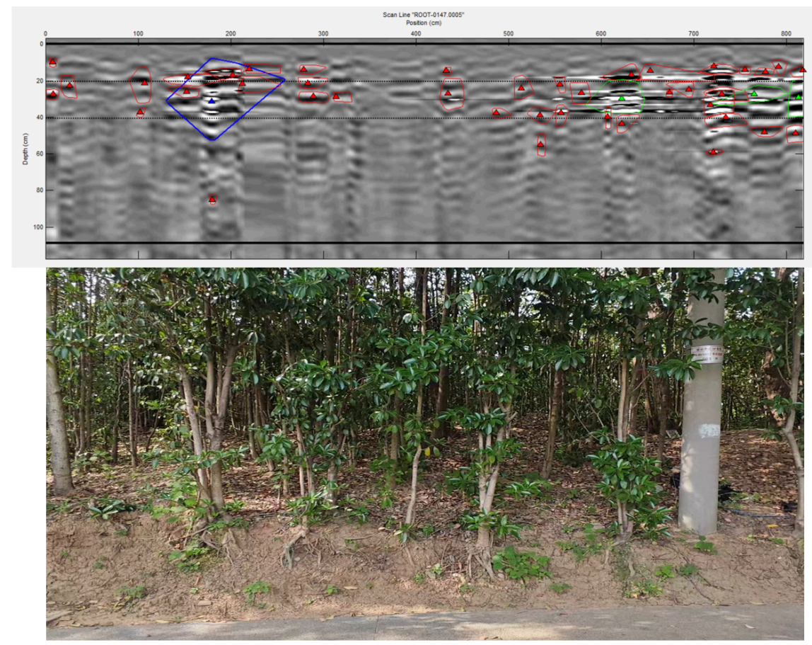
Fig. S2 Soil site profile for calibrating soil dielectric constant

- Data processing flow
The DZT data scanned by the radar was preprocessed: preliminary filtering was performed with the Root113b-k software, the gain set waveform was modified, a ground reference line was set for measuring the buried depth, and the detection threshold was set. The detection range was preset with the analyze gate (analyzeicon), and finally soil "clutter" was removed through signal filtering to improve the signal-to-noise ratio, enhance the intuitiveness of root detection, and two filters, Hor Dewow and HorMoving average, were enabled for auxiliary determination in the echo dynamic mode. Subsequently, object detection and determination were conducted: after grouping the sampling plots by Root-PRM, they were imported into the B-scan software for automatic recognition, and hyperbola features were extracted in combination with manual correction; key parameters such as recognition rate, depth error, length error, and signal-to-noise ratio were statistically analyzed.
After extracting the root points, the visualization of the root point distribution was completed using the TBA v 3.8.2 program: B-Scan analysis was performed on the GPR profile slice slice at the sampling plot and the calibrated result of the root reflection was saved as an INI file; Subsequently, a survey area layout file (PRM) was generated in Site Layout and spatial coordinates were assigned to each profile slice. Finally, a continuous underground profile was generated through the Virtual Trench module, the distribution and density of the detection points along the profile were visually displayed, the depth axis was calibrated according to the dielectric constant, color was applied by depth zone, and the image was exported at 300 dpi for result display (Fig. S3).
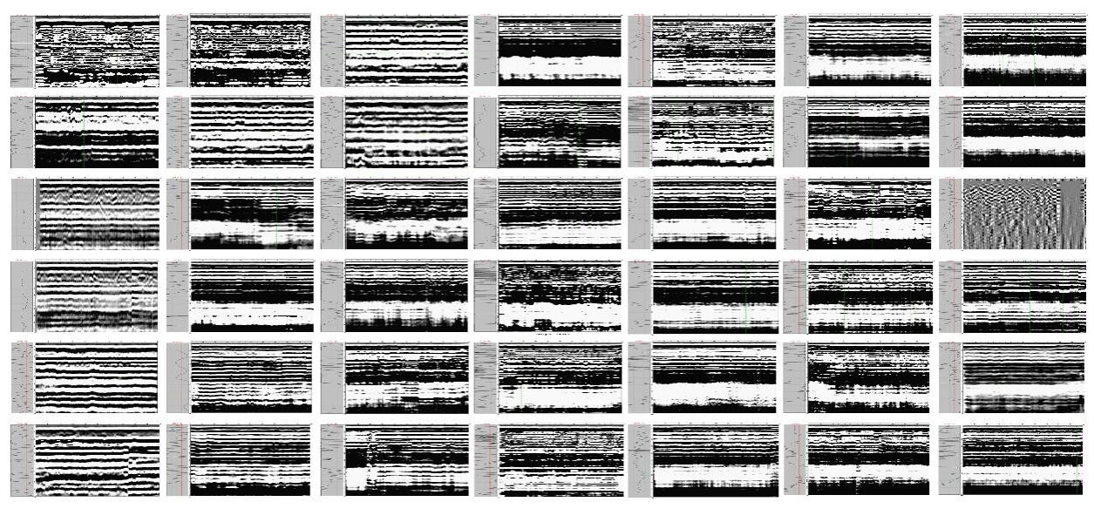
Fig. S3 GPR detection visualization

