Table 3 3D VR Artifacts

Artifact | Description | Role
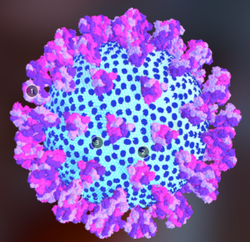  Structure of Sars-COV-2 | 1.Spike protein  2.Membrane protein  3.Envelop protein | Responsible for attachment and entry of the virus into the host cell  promotes completion of viral assembly by stabilizing the N protein-RNA complex, inside the internal virion  plays major role in pathogenesis, virus assembly, and release
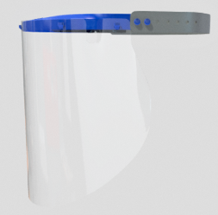  2  1  Face shield | 1.Visor  2. Strap | Protects wearer’s face from contamination  Adjusts the face shield to fit the wearer.
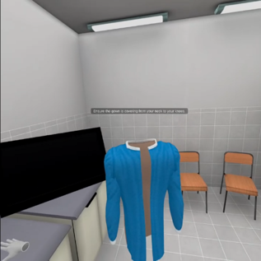  Medical gown | Long sleeved disposable surgical gown with elastic cuffs. | Barrier to fluids and microbial transmission from patient to medical personnel.
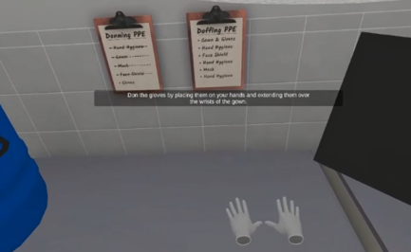  Surgical gloves | Pair of white surgical gloves | protective barrier to prevent the possible transmission of diseases between healthcare professionals and patients during surgical procedures

Table 4 Vocational distribution of participants among types of institutions
Characteristics of participants | n | %
Occupation (n=52)
Medical Officer  Clinical Officer  Nursing Officer  Public Health Officer  Lab technologist  Pharmacist  Epidemiologist | 8  14  15  2  9  1  3 | 15.38  26.92  28.85  3.85  17.31  1.92  5.77
^{government organization} ^{Non-government organization} ^{private organization}

