Analysis of Amino Acid Mutation Sites Controlling the Stability of Carbonyl Reductase CpCR
Simulation revealed that the amino acid residues in the enzyme's NADPH-binding region include Leu283 and His53 (forming hydrogen bonds with nicotinamide and ribitol); Val281, Ser307, and L309 (forming hydrogen bonds with the amino group of NAD+); Arg217, Lys221, Asp261, Ile194, and Ser216 (forming hydrogen bonds with phosphate group 1); Gly196, Ser258, Arg356, and Tyr49 (forming hydrogen bonds with phosphate group 2). Based on the passivation mechanism and stability calculations of CPCR2 in biphasic catalytic systems, the key amino acid mutation sites controlling the stability of wild-type carbonyl reductase (wt-CpCR) in the reaction medium are predicted to be Ala98, Ser307, Gly262, Ser216, Ser307, and Ser258. Except for Ser307, all are located in the flexible regions of wt-CpCR. According to comparative mutation free energy calculations (ΔΔGmut = ΔΔGfold(mutant) - ΔΔGfold(wild type)), the proposed mutations are Ala98Asn (-3.24 kcal/mol), Ser307Asn (-3.01 kcal/mol), Gly262Asn (-1.32 kcal/mol), Ser216Asn (-1.23 kcal/mol), Ser307Asn (-1.23 kcal/mol), and Ser258Asn (-1.29 kcal/mol). These mutation sites are highlighted in yellow on the right side of Figure 27 and are precisely located in non-α-helix and non-β-sheet regions, corresponding to flexible linker domains.

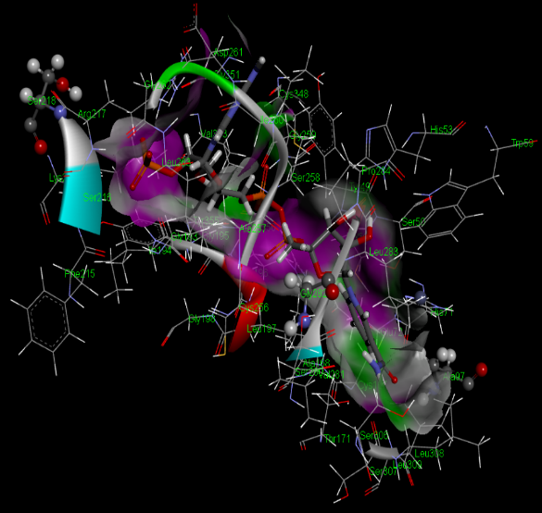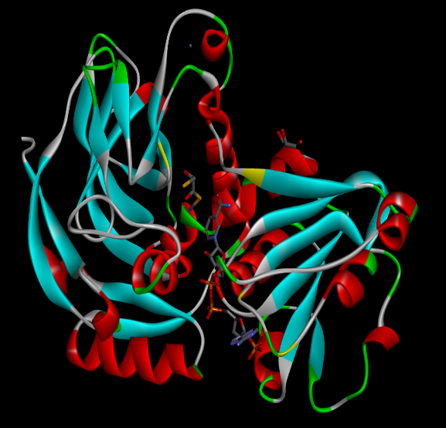
Figure. Docking diagram of carbonyl reductase CpCR with NADPH (the yellow flexible regions indicate mutation sites).
酶与氟取代脂肪族β酮基丁酸酯类特征底物对接示意图

