Docking of protein 4OAQ with acetophenone
according to the instructions for the Discovery Studio 2017 packages

1. Pre-docking Preparation of Protein and Acetophenone
1.1 Obtaining the 3D Structure File of Acetophenone
Search databases including ZINC and PubChem using the chemical name of acetophenone to obtain the 3D structure file in .SDF format.
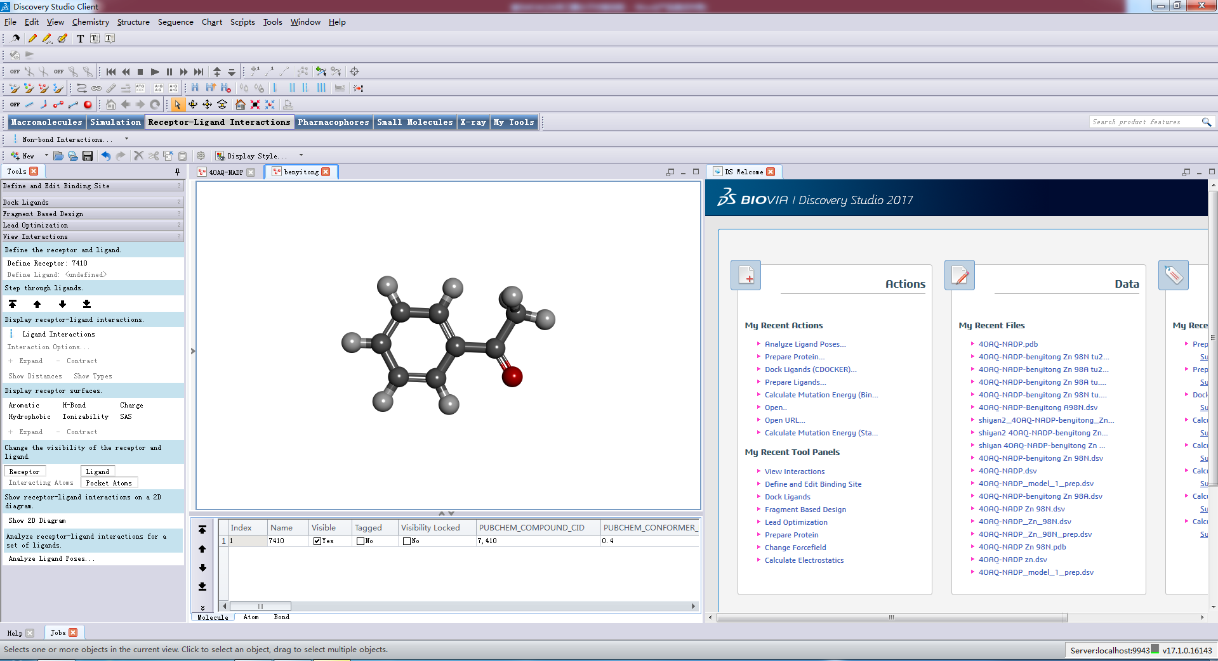
1.2 Acquisition of the Protein Structure File
The protein structure file can be acquired either by directly searching and downloading it from the PDB database using the protein name, or within the DS software by clicking on the "File" menu, selecting "OPEN URL", and entering the protein name, which will allow the software to open the file directly.
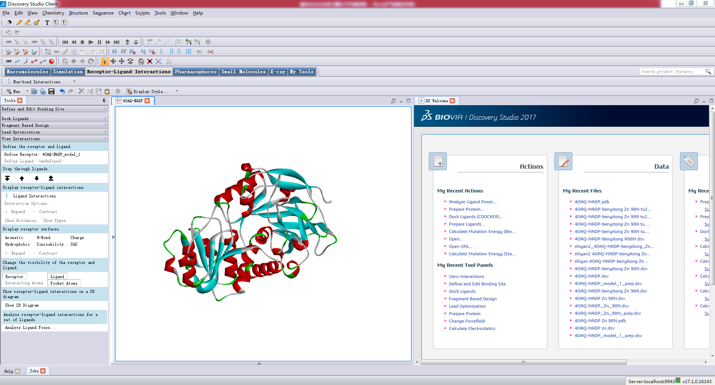

2 Ligand Preparation:
The ligand molecule in .SDF format is opened in DS software and processed by sequentially clicking through the steps. The preparation parameters are kept at their default values without any changes, and the procedure is run directly.
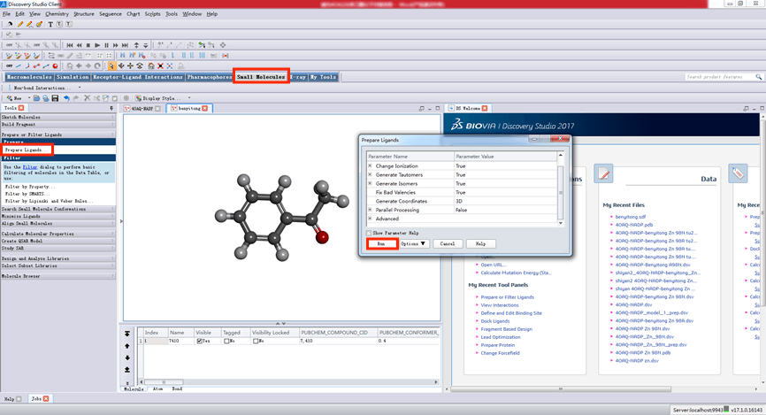
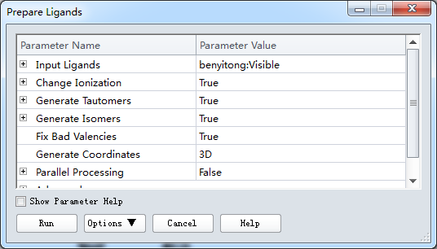
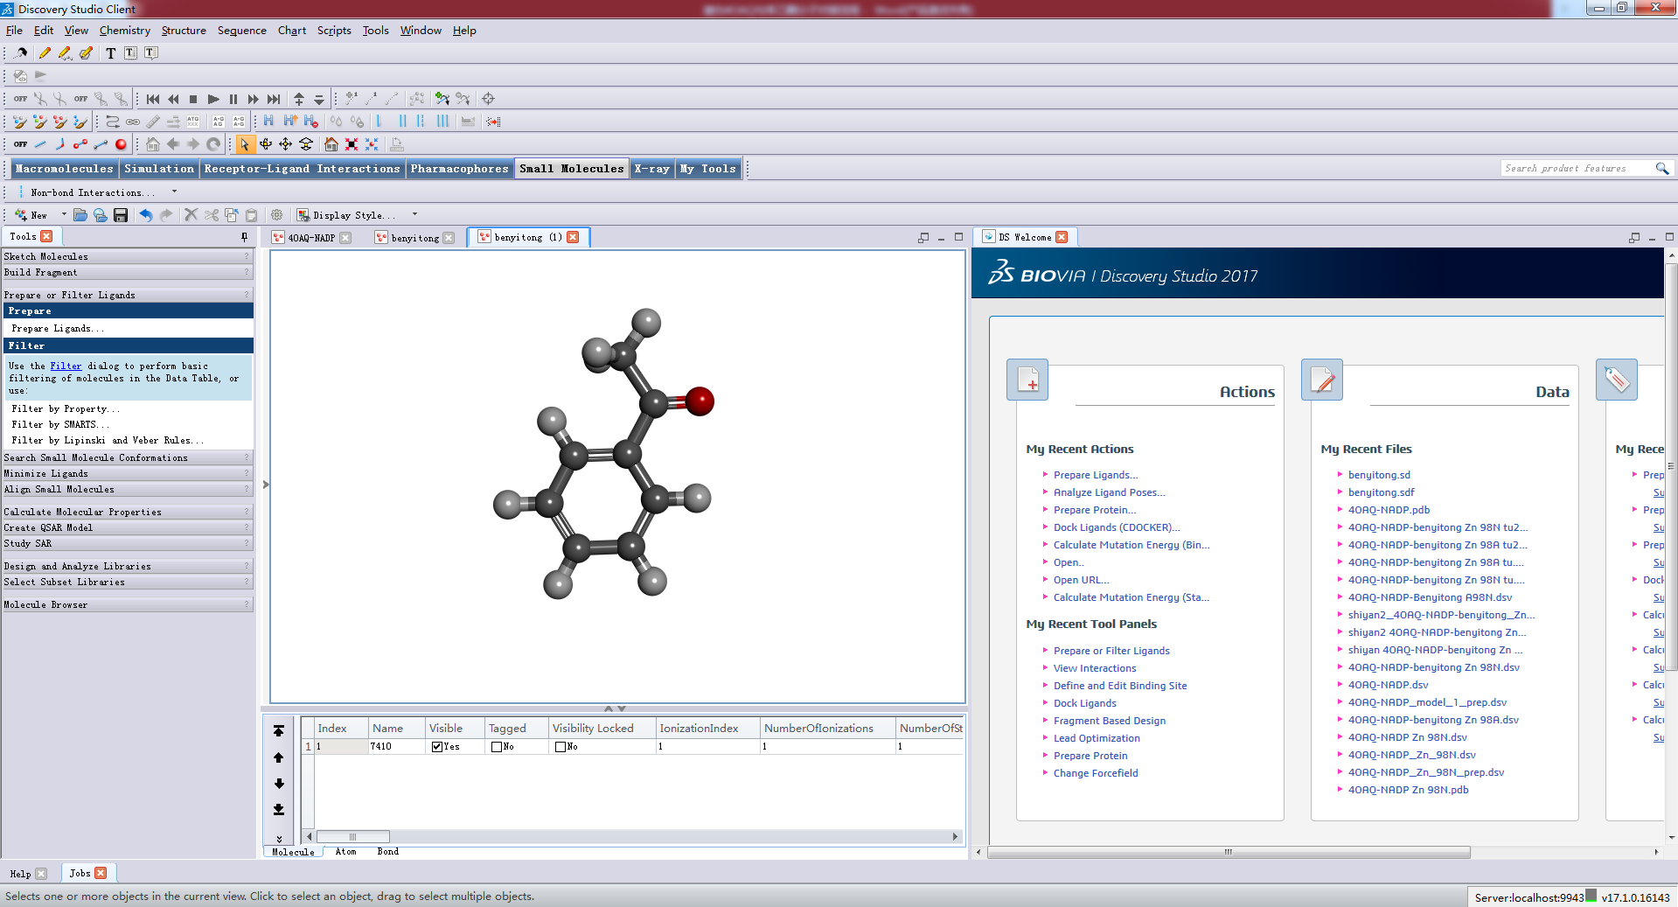

3 Protein Preparation
Click the following buttons in sequence, keep the system parameters at their default values, and run the program directly.

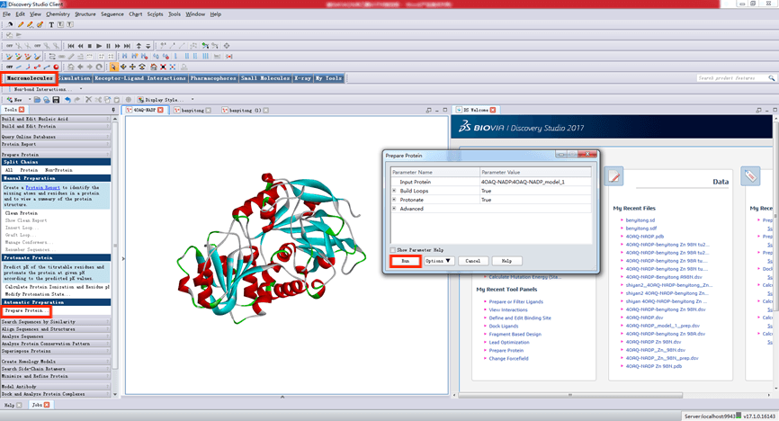
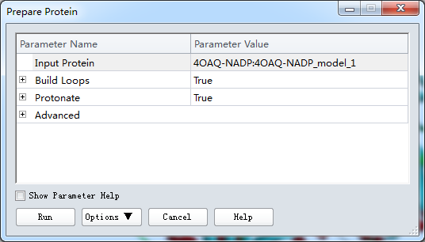
4、run
The prepared protein is obtained, and the protein file contains the "_prep" suffix.
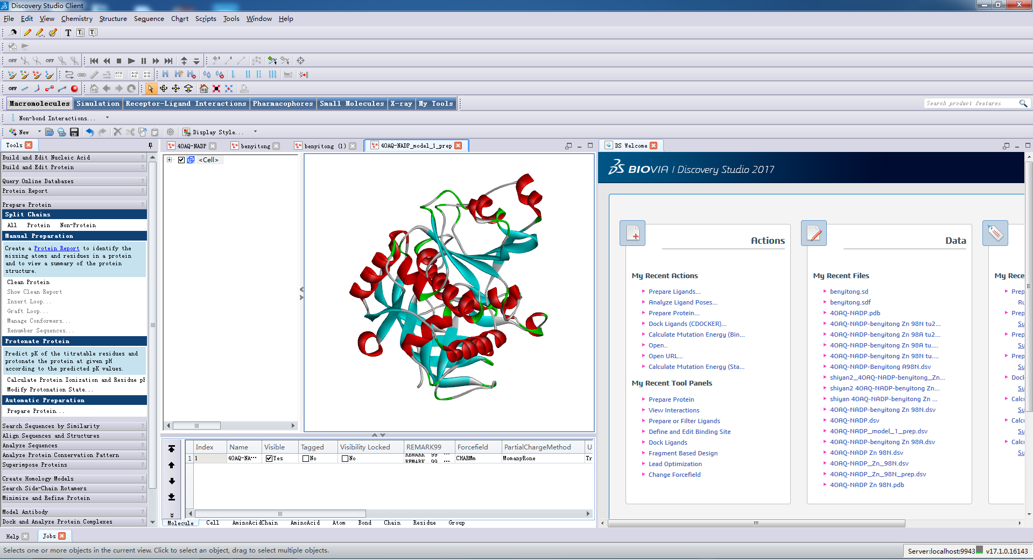
5、Docking Preparation
First, define the protein.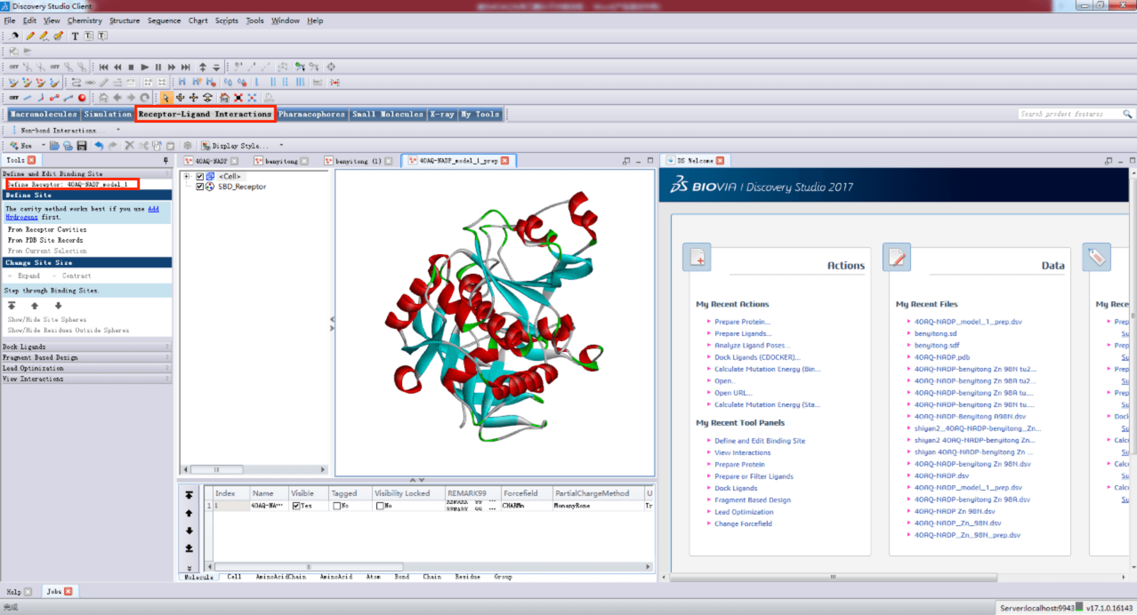
Visualize the active center.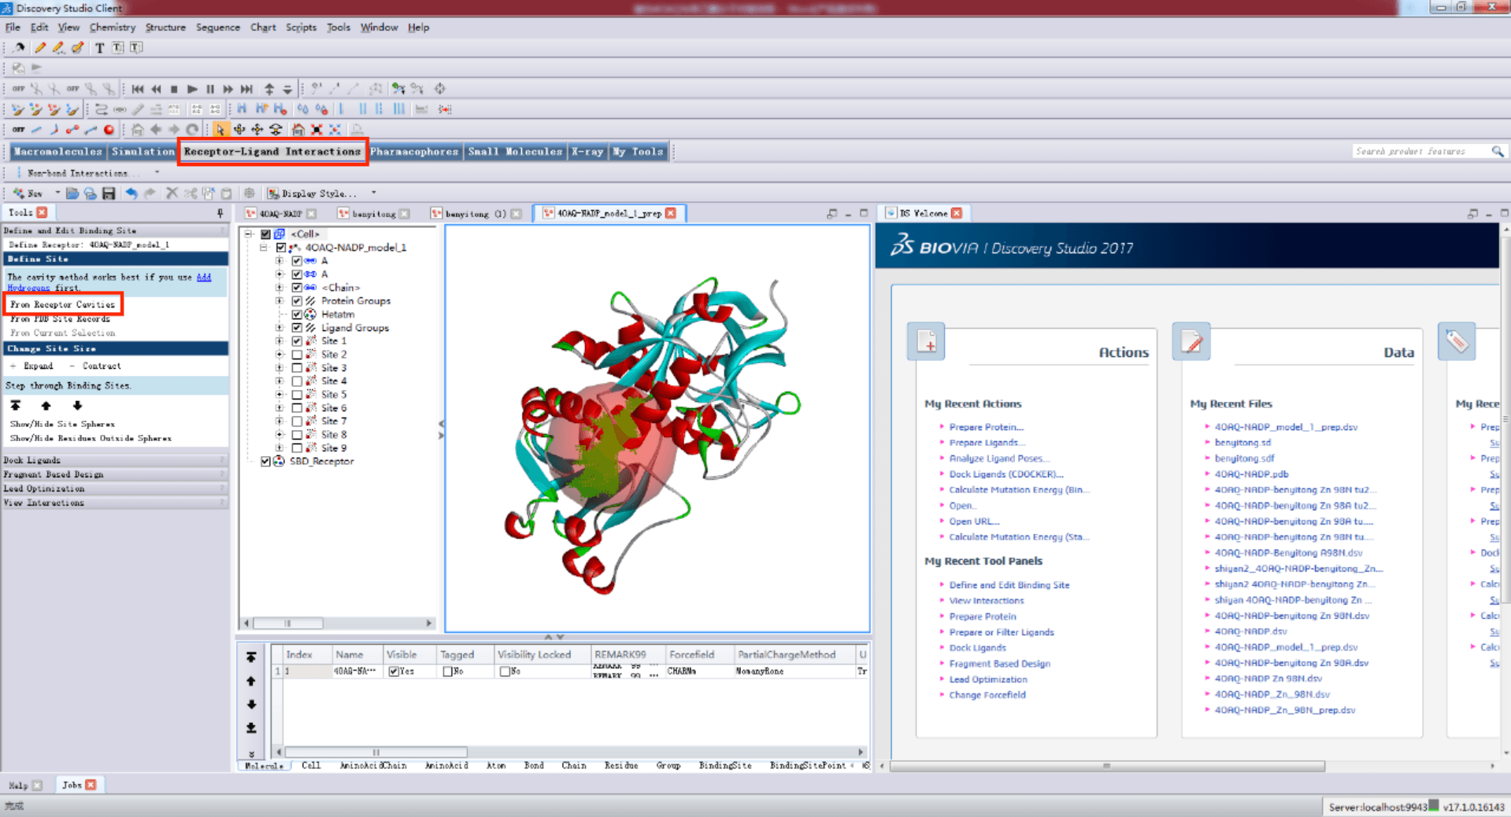
Select the appropriate active site and right-click to modify its properties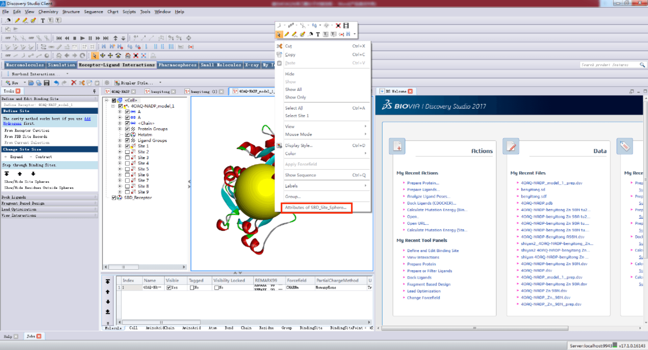
Change the radius to a suitable value. In cases where the initial radius is large, a value of around 10 Å is recommended.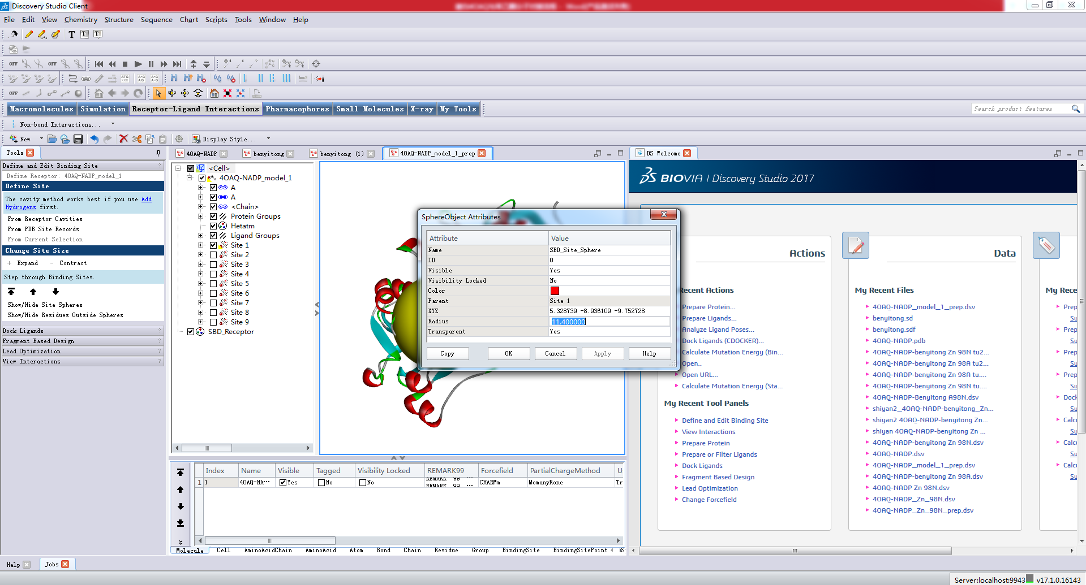 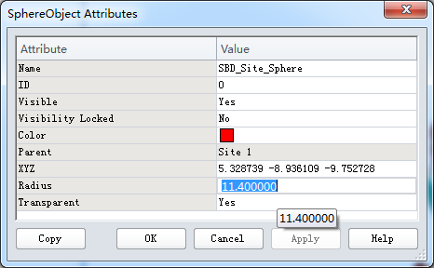

6. Initiate Docking
Select the prepared acetophenone ligand from the Input Ligands options, then change the value under Top His to 0.5. All other parameters remain at their system default values and require no modification.

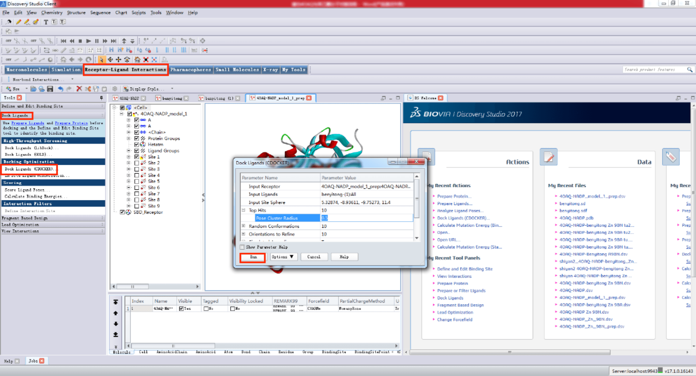
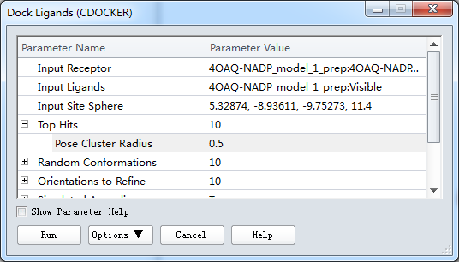
Run
The docking results are displayed upon completion of the run.
