Supporting information

Fig. S1 Schematic view of the genome editing construct used
ttLbCas12a, temperature-tolerant Lachnospiraceae bacterium Cas12a (LbCas12a). Pcubi, Parsley ubiquitin promoter; Tpea3A, terminator of ribulose-1,5-bisphosphate carboxylase small subunit; AtU6-26, Arabidopsis thaliana U6-26 promoter; crRNA, sequence of CRISPR RNA; PNOS, NOS promoter; NTPII, Neomycin phosphotransferase II gene; TNOS, NOS terminator; LB, left border; RB. right border.

Fig. S2 Alignment of protein sequences of functional WT allele, non-functional u allele, and four CRISPR-generated alleles
Listed sequences were predicted from the sequenced cDNA nucleotide sequences. The red color represents mismatched residues compared to the WT sequence.

Fig. S3 Alignment of the amino acid sequences around the mutated region of SlGLK2 and homologs from other plant species
These sequences have diversified lengths and sequences in this region. Amino acid sequences of SlGLK2 homologs were aligned and displayed by NCBI Multiple Sequence Alignment Viewer (Version 1.22.0). Disordered region (Right blue), target region (pink), MYB domain (yellow), GCT box (green). Solanum lycopersicum (NP_001266252.1), Solanum pennellii (XP_015089237.1), Solanum tuberosum (KAH0722065.1), Capsicum annuum (AFF60406.1), Smallanthus sonchifolius (KA3774048.1), Gossypium mustelinum (TYI95756.1), Morella rubra (KAB1227988.1), Trifolium pratense (XP_045804791.1), Nicotiana tomentosiformis (XP_009589600.1), Medicago truncatula (XP_013465151.1), Citrus sinensis (XP_006470159.1), Glycine max (NP_001241943.1), Glycine soja (KAG4967779.1), Pisum sativum (XP_050883705.1)

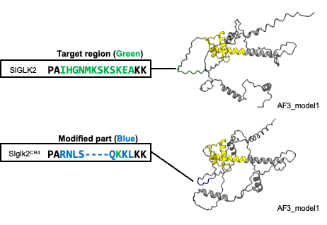

Fig. S4 The mutated region of CR-Sglk2-4 allele is located in the linker region of SlGLK2
Predicted SlGLK2 structures of Wild-type and CR-Sglk2-4 allele (CR4) using AlphaFold3. The target region and modified sequences are highlighted in green and blue, respectively. Predicted MYB domain is shown in yellow.

a)
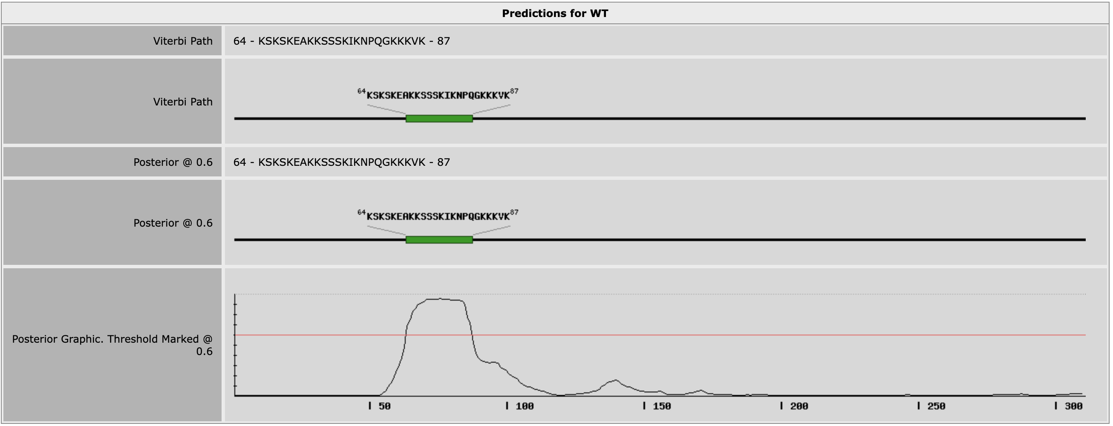

b)
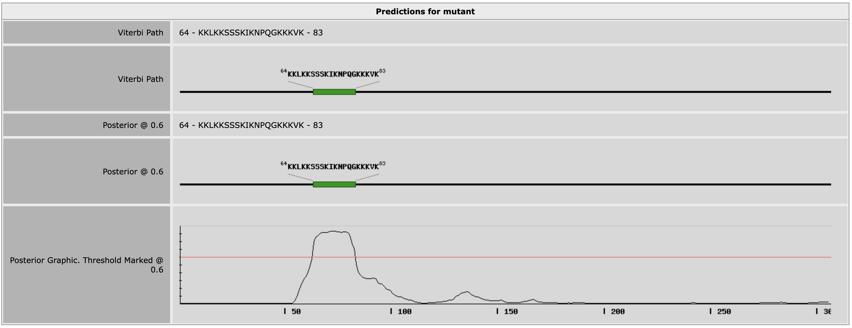

Fig. S5 CR-Sglk2-4 allele does not affect nuclear localization signal
Subcellular localization prediction of SlGLK2 variants using LOCALIZER v.1.0.4 (https://localizer.csiro.au/) indicates that both variants, WT (a) and 13-bp-deletion variant (b) of the CR-Slglk2-4 line, have a nuclear localization signal with no transit peptides.

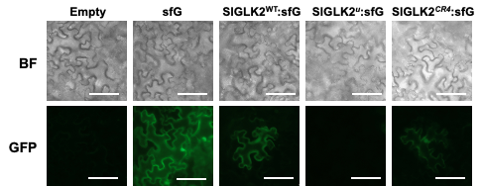

Fig. S6 Subcellular localization of SlGLK2 variants in Nicotiana benthamiana leaf
Subcellular localization of WT, u allele, and 13-bp deletion variant of SlGLK2 protein. Each variant was fused with super folder green fluorescent protein (sfGFP) and transiently expressed in N. benthamiana leaves.

