SUPPLEMENTARY MATERIALS
Table S1 Strains and plasmids used in this study.
Table S2 Primers used for SSM.
Table S3 Primers used for SM.
Table S4 Primers used for plasmid construction in G. oxydans.
Fig. S1. The flowchart of the experimental scheme.
Fig. S2. Construction of expression vectors of pBBR-gHp0169 (a), pBBR-gHp0169-xdh_{M3} (b), pBBR-gHp0169-xdh_{M3}-gHp0169-gdh (c), and pBBR-gHp0169-xdh_{M3}-gHp0169-gdh-gHp0169-vhb (f).
Fig. S3. The crystal structures of the tetramer and monomer of GoXDH.
Fig. S4. SDS-PAGE analysis of GoXDH and GoXDH_{M3} expressed in E. coli BL21(DE3); 1, supernatant of GoXDH; 2, purified GoXDH; 3, supernatant of GoXDH_{M3}; 2, purified GoXDH_{M3}.
Fig. S5. Effects of temperature and pH on the reducing activity of GoXDH and GoXDH_{M3}.
Fig. S6. Time-course of substrate consumption and biomass during the cell cultivation of G. oxydans/XDH_{M3}-GDH-VHb at different string speeds in a 10-L stirred bioreactor (a) 400 rpm; (b) 500 rpm; (c) 600 rpm; (d) 700 rpm.

Table S1 Strains and plasmids used in this study.
Strains or plasmids | Characteristics | Reference
Strains
G. oxydans 621H | Xylitol production strain | Prust et al., 2005
E. coli DH5α | F⁻, endA1, hsdR17 (rk-mk-), supE44, thi1, recA1, gyrA, (Nalr), relA1, D (lacZYAargF), U169, and F80lacZDM15 | Invitrogen
E. coli HB101 | F⁻, hsdS20 (r-B, m-B), supE44, ara-14, galK-2, lacY1, proA2, rpsL20, xyl-5, mtl-1, recA13, Kan^{R}, oriColE1, RK2-Mob⁺, RK2-Tra⁺, and mH-1 with plasmid pRK2013 | Invitrogen
Plasmids
pET-28b-xdh | Kana^{r}, expression cassette containing the gene of xdh from G. oxydans | This study
pET-28b-gdh | Kana^{r}, expression cassette containing the gene of gdh with RBS from Exiguobacterium sibiricum | [1]
pET-28b-vhb | Kana^{r}, expression cassette containing the gene of vhb with RBS from Vitreoscilla | [2]
pBBR1MCS-5 | Gm^{r}, broad-host-range cloning vector | [3]
pBBR-gHp0169 | Gm^{r}, expression cassette containing the gHp0169 promoter and gHp0169 terminator | [4]
pBBR-gHp0169-xdh | Gm^{r}, expression cassette containing the gHp0169 promoter, xdh, and gHp0169 terminator | This study
pBBR-gHp0169-xdh- gHp0169-gdh | Gm^{r}, expression cassette containing the genes of xdh and gdh have their own gHp0169 promoter, RBS and gHp0169 erminator | This study

Table S1 Strains and plasmids used in this study (Continued).
Strains or plasmids | Characteristics | Reference
pBBR- gHp0169-xdh- gHp0169-gdh-gHp0169-vhb | Gm^{r}, expression cassette containing the genes of xdh, gdh, and vhb have its own gHp0169 promoter, RBS, and gHp0169 terminator | This study

Table S2 Primers used for SSM.
Primer | Sequence (5’-3’)
S77-F | GCACCGTTGATNNKGTTGTTCGTG
S77-R | CACGAACAACMNNATCAACGGTGC
F87-F | CGGTAAAATCGATNNKCTGTTCAAC
F87-R | GTTGAACAGMNNATCGATTTTACCG
D103-F | CTCCGGTTCAGNNKTACCCGAGC
D103-R | GCTCGGGTAMNNCTGAACCGGAG
S106-F | GGATTACCCGNNKGATGATTTCGC
S106-R | GCGAAATCATCMNNCGGGTAATCC
A110-F | GCGATGATTTCNNKCGTGTTCTG
A110-R | CAGAACACGMNNGAAATCATCGC
V117-F | GACCATCAACNNKACCGGCGCGTTCC
V117-R | GGAACGCGCCGGTMNNGTTGATGGTC
T118-F | GACCATCAACGTGNNKGGCGCGTTCC
T118-R | GGAACGCGCCMNNCACGTTGATGGTC
K149-F | CATGGCGGGTGTTNNKGGCCCGCCGAAC
K149-R | GTTCGGCGGGCCMNNAACACCCGCCATG
P152-F | GGCCCGCNNKACATGGCGGCATAC
P152-R | GTATGCCGCCATGTMNNGCGGGCC
A156-F | CGAACATGGCGNNKTACGGTGCG
A156-R | CGCACCGTAMNNCGCCATGTTCG
G158-F | CATGGCGGCATACNNKGCGAGCAAAGGC
G158-R | GCCTTTGCTCGCMNNGTATGCCGCCATG
G162-F | GTGCGAGCAAANNKGCGATCATCG
G162-R | CGATGATCGCMNNTTTGCTCGCAC
D107-F | GGATTACCCGAGCNNKGATTTCGCGCG
D107-R | CGCGCGAAATCMNNGCTCGGGTAATCC

Table S2 Primers used for SSM (Continued).
Primer | Sequence (5’-3’)
R111-F | CGATGATTTCGCGNNKGTTCTGACCATC
R111-R | GATGGTCAGAACMNNCGCGAAATCATCG
L113-F | GATTTCGCGCGTGTTNNKACCATCAACGTGAC
L113-R | GTCACGTTGATGGTMNNAACACGCGCGAAATC
T114-F | CGCGCGTGTTCTGNNKATCAACGTGACC
T114-R | GGTCACGTTGATMNNCAGAACACGCGCG
I115-F | GTGTTCTGACCNNKAACGTGAC
I115-R | GTCACGTTMNNGGTCAGAACAC
T118-F | CTGACCATCAACGTGNNKGGCGCGTTCCAC
T118-R | GTGGAACGCGCCMNNCACGTTGATGGTCAG
H122-F | GACCGGCGCGTTCNNKGTTCTGAAAGCG
H122-R | CGCTTTCAGAACMNNGAACGCGCCGGTC
S128-F | CGTTCTGAAAGCGGTTNNKCGTCAGATGATCACC
S128-R | GGTGATCATCTGACGMNNAACCGCTTTCAGAACG
R129-F | CTGAAAGCGGTTAGCNNKCAGATGATCACCC
R129-R | GGGTGATCATCTGMNNGCTAACCGCTTTCAG
G130-F | GCGGTTAGCCGTNNKATGATCACCCAGAAC
G130-R | GTTCTGGGTGATCATMNNACGGCTAACCGC
T133-F | CCGTCAGATGATCNNKCAGAACTACGGCCG
T133-R | CGGCCGTAGTTCTGMNNGATCATCTGACGG
Q134-F | GTCAGATGATCACCNNKAACTACGGCCGT
Q134-R | ACGGCCGTAGTTMNNGGTGATCATCTGAC

Table S3 Primers used for SM.
Primer | Sequence (5’-3’)
S77-F | GCACCGTTGATTGTGTTGTTCGTG
S77-R | CACGAACAACACAATCAACGGTGC
S106-F | GGATTACCCGAACGATGATTTCGC
S106-R | GCGAAATCATCGTTCGGGTAATCC
A110-F | GCGATGATTTCAACCGTGTTCTG
A110-R | CAGAACACGGTTGAAATCATCGC
T114-F | CGCGCGTGTTCTGCATATCAACGTGACC
T114-R | GGTCACGTTGATATGCAGAACACGCGCG
I115-F | GTGTTCTGACCAGGAACGTGAC
I115-R | GTCACGTTCCTGGTCAGAACAC

Table S4 Primers used for plasmid construction in G. oxydans.
Primer | Sequence (5’-3’)
pBBR-gHp-F | GATGAAGCCCTTTCCGCAAGG
pBBR-gHp-R | GCGGAAGGCGTTATACCCTG
xdh-F | CAGGGTATAACGCCTTCCGCcagagtttgaggcattcggaat
xdh-R | GTCCTTGCGGAAAGGGCTTCAtcaaccgccagcaatcggcag
zwf-F | TTCAGGGTATAACGCCTTCCGCcgagaggtcagagagtcttccat
zwf-R | GTCCTTGCGGAAAGGGCTTCAttactccgacgcttcatgccag
pnt123-F | CAGGGTATAACGCCTTCCGCcagacacaggatcgcagccaatg
pnt123-R | GTCCTTGCGGAAAGGGCTTCAttacgaggcggagaggccct
gnd-F | cagacacaggatcgcagccaATGTACAACAGCCTGAAAGG
gnd-R | CCTTGCGGAAAGGGCTTCATTTATTAACCACGGCCCGCCTGG
vhb-F | CAGGGTATAACGCCTTCCGCGAACTTAAGGAAGACCCTC
vhb-R | CCTTGCGGAAAGGGCTTCATCTTATTCGACGGCCTGGGCG
pBBR-xdh-F | GAGCTCCAATTCGCCCTATAGTG
pBBR-xdh-R | GCTGCAGGAATTCGATATCAAGC
gHp-gdh-F | GCTTGATATCGAATTCCTGCAGCGAAAGCGGCTGGCGCGTG
gHp-gdh-R | CACTATAGGGCGAATTGGAGCTCGAGGCGGCGATACTACCGGC
pBBR-xdh-gdh-F | GTCGTATTACGCGCGCTCAC
pBBR-xdh-gdh-R | CACTATAGGGCGAATTGGAGCTC
gHp-vhb-F | GTCGTATTACGCGCGCTCAC
gHp-vhb-R | CACTATAGGGCGAATTGGAGCTC

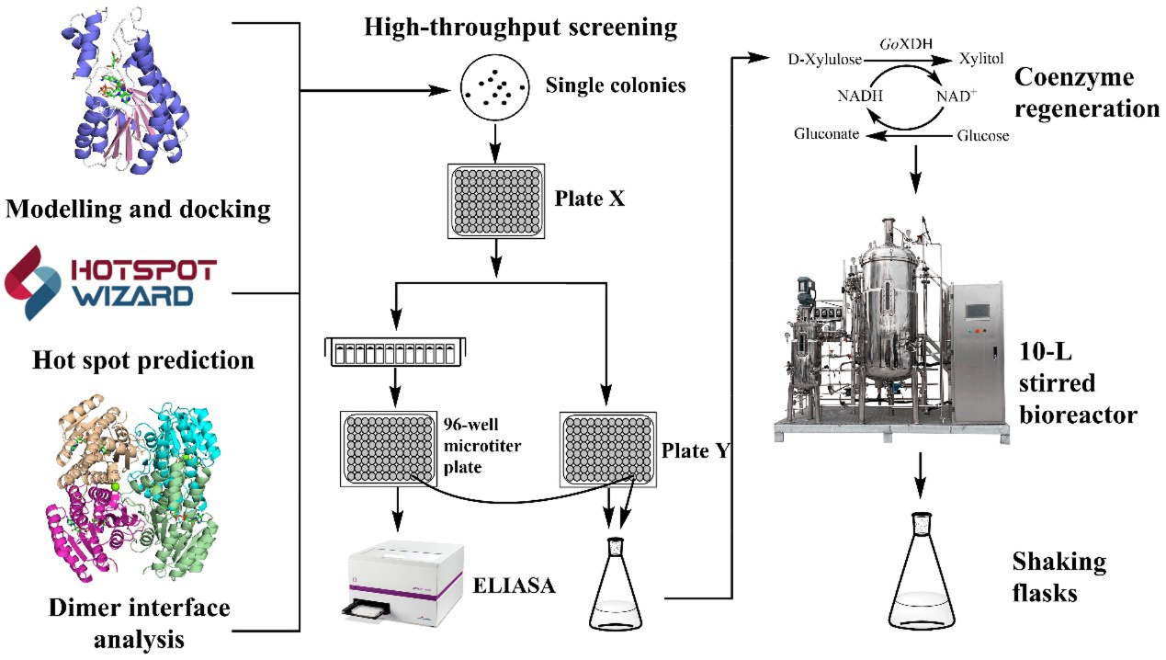
Fig. S1. The flowchart of the experimental scheme.

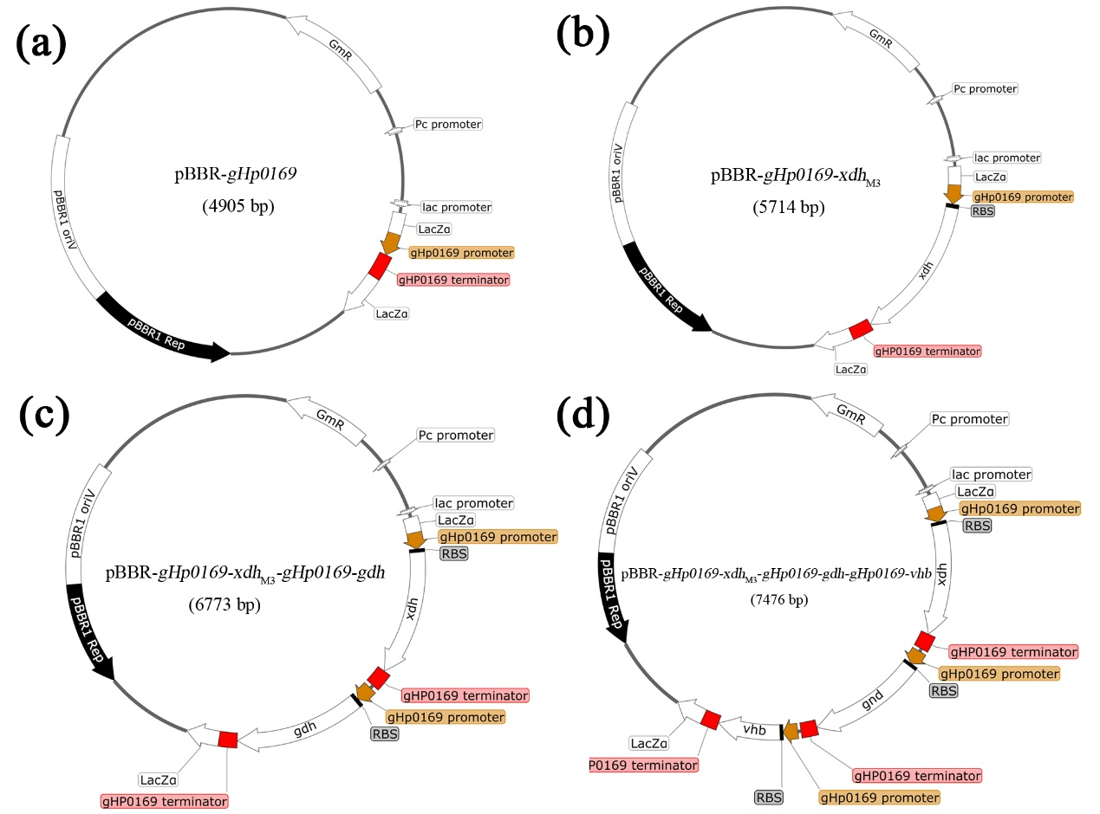
Fig. S2. Construction of expression vectors of pBBR-gHp0169 (a), pBBR-gHp0169-xdh_{M3} (b), pBBR-gHp0169-xdh_{M3}-gHp0169-gdh (c), and pBBR-gHp0169-xdh_{M3}-gHp0169-gdh-gHp0169-vhb (d).

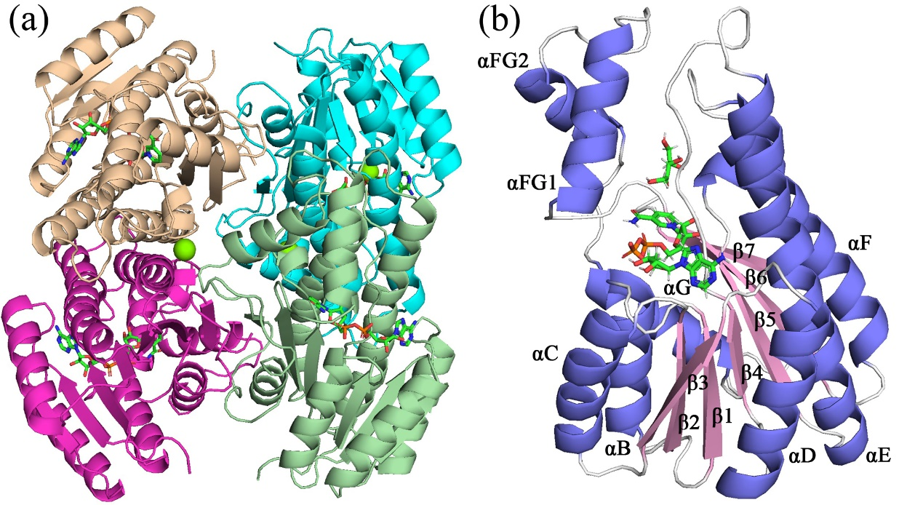
Fig. S3. The crystal structures of the tetramer and monomer of GoXDH.

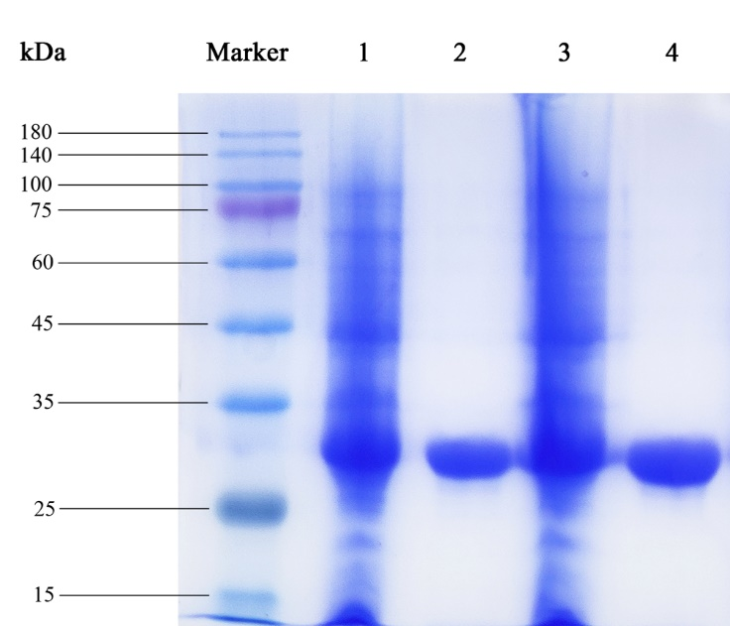
Fig. S4. SDS-PAGE analysis of GoXDH and GoXDH_{M3} expressed in E. coli BL21(DE3); 1, supernatant of GoXDH; 2, purified GoXDH; 3, supernatant of GoXDH_{M3}; 2, purified GoXDH_{M3}.

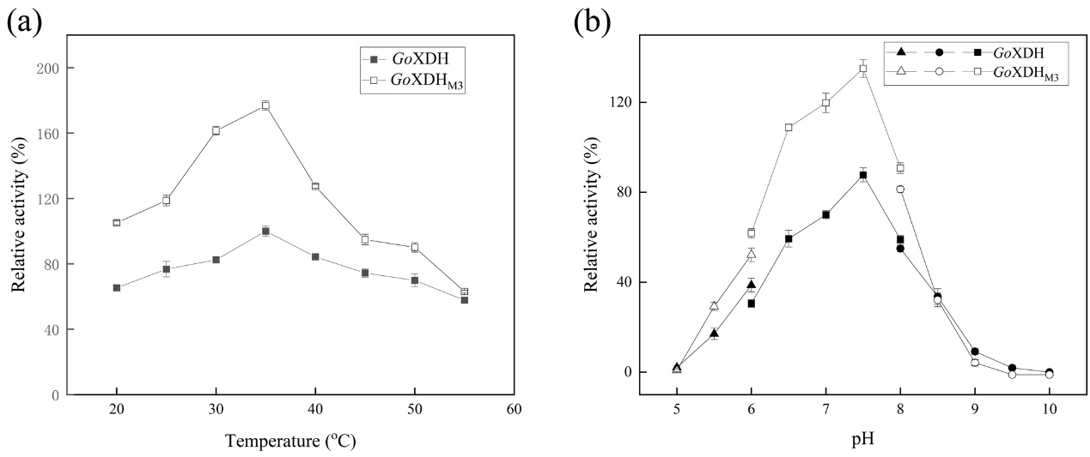
Fig. S5. Effects of temperature and pH on the reducing activity of GoXDH and GoXDH_{M3}.

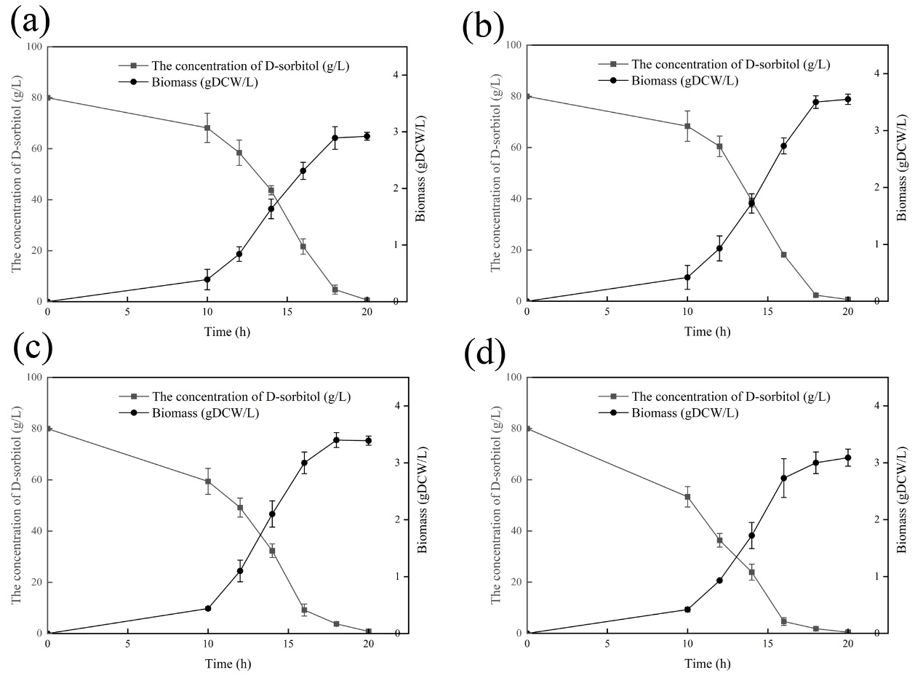
Fig. S6. Time-course of substrate consumption and biomass during the cell cultivation of G. oxydans/XDH_{M3}-GDH-VHb at different string speeds in a 10-L stirred bioreactor (a) 400 rpm; (b) 500 rpm; (c) 600 rpm; (d) 700 rpm.

References
1. Qiu S, Xu SY, Li SF, Meng KM, Cheng F, Wang YJ, Zheng YG: Fluorescence‐based screening for engineered aldo‐keto reductase KmAKR with improved catalytic performance and extended substrate scope. Biotechnology Journal 2021, 16(9):2100130.
2. Ouyang P, Wang H, Hajnal I, Wu Q, Guo Y, Chen GQ: Increasing oxygen availability for improving poly (3-hydroxybutyrate) production by Halomonas. Metabolic engineering 2018, 45:20-31.
3. Liu D, Ke X, Hu Z-C, Zheng Y-G: Combinational expression of D-sorbitol dehydrogenase and pyrroloquinoline quinone increases 6-(N-hydroxyethyl)-amino-6-deoxy-α-L-sorbofuranose production by Gluconobacter oxydans through cofactor manipulation. Enzyme and Microbial Technology 2020, 141:109670.
4. Jia DX, Liu D, Zheng YG: Heterologous expression，purification and enzymatic characterization of succinate-semialdehyde dehydrogenase GabD4. Food and Fermentation Industries 2016, 42(5):97-101.

