Characterisation of Single-step Charcoal-purified Cosmetic-grade C-Phycocyanin Produced from Native Spirulina platensis in Bangladesh

Supplementary Information

Supplementary Tables
Table S1a Composition of Bd1 medium (pH 8.6) for Spirulina cultivation
Components | Quantity (g L⁻¹)
NaHCO₃ | 3.2
NaNO₃ | 0.5
KCl | 0.2
MgSO₄.2H₂O | 0.1
FeSO₄.7H₂O | 0.002
CaCl₂ | 0.008
EDTA | 0.008
H₂SO₄ (96%) | 0.1 (mL)
H₃PO₄ (85%) | 0.4 (mL)
A₈ trace element solution | 1.0 (mL)
B₃ trace element solution | 1.0 (mL)

Table S1b Composition of A₈ trace element solution for Bd1 medium
Components | Quantity (g L⁻¹)
MnCl₂.4H₂O | 1.63
ZnSO₄.7H₂O | 2.32
CuSO₄.5H₂O | 0.32
NiSO₄.7H₂O | 0.35
Co(NO₃)₂.6H₂O | 0.37
H₃BO₃ | 2.98
H₂SO₄ (96%) | 2.75 (mL)

Table S1c Composition of B₃ trace element solution for Bd1 medium
Components | Quantity (g L⁻¹)
NaOH | 4.12
MoO₃ | 0.5
NH₄VO₃ | 0.35
Na₂WO₄ | 0.14

Table S2 Toxic heavy metal content in harvested Spirulina paste
Heavy metals | Content (µg g⁻¹ FW) in Spirulina paste | *Permissible content (µg g⁻¹)
⁵⁹Co | 0.47 ± 0.01
⁵²Cr | 0.93 ± 0.00
¹¹¹Cd | 0.07 ± 0.01 | 0.5
⁷⁵As | 0.12 ± 0.00 | 0.1
²⁰⁸Pb | 1.46 ± 0.00 | 0.1
²⁰²Hg | 0.00 ± 0.00 | 0.1
*According to the General Standards for Contaminants and Toxins in Food and Feed, FAO, 1995 (Codex Alimentarius Commission, 1995)

Table S3 C-PC, APC, and Chl concentrations in crude extracts of FD and AD powders obtained by employed extraction techniques, S/L ratio, and extraction durations
Dry preparation | Extraction technique | S/L ratio (g DW mL⁻¹) | Duration (h) | C-PC conc. (mg mL⁻¹) | APC conc. (mg mL⁻¹) | Chl conc. (mg mL⁻¹)
FD | DAE | 1:20 | 8 | 4.96 ± 0.07^{b} | 0.86 ± 0.02^{c} | 0.31 ± 0.01^{c}
FD | SAE | 1:20 | 8 | 6.09 ± 0.13ª | 1.05 ± 0.03ª | 0.37 ± 0.01ª
FD | UAE | 1:20 | 8 | 5.14 ± 0.04^{b} | 0.40 ± 0.01^{f} | 0.29 ± 0.01^{d}
AD | DAE | 1:20 | 8 | 4.98 ± 0.09^{b} | 0.75 ± 0.02^{d} | 0.29 ± 0.01^{d}
AD | SAE | 1:20 | 8 | 5.88 ± 0.02ª | 0.99 ± 0.01^{b} | 0.35 ± 0.00^{b}
AD | UAE | 1:20 | 8 | 4.48 ± 0.08^{c} | 0.48 ± 0.01e | 0.29 ± 0.01^{d}
FD | SAE | 1:10 | 8 | 10.25 ± 0.53ª | 2.18 ± 0.15ª | 0.65 ± 0.04ª
FD | SAE | 1:20 | 8 | 6.09 ± 0.13^{b} | 1.05 ± 0.03^{b} | 0.37 ± 0.01^{c}
FD | SAE | 1:30 | 8 | 4.49 ± 0.07^{c} | 0.85 ± 0.02^{cd} | 0.27 ± 0.01^{d}
FD | SAE | 1:40 | 8 | 2.81 ± 0.03^{d} | 0.50 ± 0.01e | 0.17 ± 0.00e
FD | SAE | 1:50 | 8 | 1.87 ± 0.02e | 0.34 ± 0.01^{f} | 0.11 ± 0.00^{f}
AD | SAE | 1:10 | 8 | 10.07 ± 0.11ª | 2.04 ± 0.04ª | 0.61 ± 0.01^{b}
AD | SAE | 1:20 | 8 | 5.88 ± 0.02^{b} | 0.99 ± 0.01^{bc} | 0.35 ± 0.00^{c}
AD | SAE | 1:30 | 8 | 4.24 ± 0.06^{c} | 0.72 ± 0.03^{d} | 0.24 ± 0.01^{d}
AD | SAE | 1:40 | 8 | 2.77 ± 0.02^{d} | 0.46 ± 0.01^{ef} | 0.16 ± 0.00e
AD | SAE | 1:50 | 8 | 1.83 ± 0.01e | 0.32 ± 0.01^{f} | 0.11 ± 0.00^{f}
FD | SAE | 1:30 | 8 | 4.49 ± 0.07^{b} | 0.85 ± 0.02^{c} | 0.27 ± 0.01^{b}
FD | SAE | 1:30 | 16 | 4.88 ± 0.06ª | 0.77 ± 0.00^{d} | 0.28 ± 0.00^{ab}
FD | SAE | 1:30 | 24 | 4.23 ± 0.03^{c} | 0.85 ± 0.01^{c} | 0.26 ± 0.00^{c}
AD | SAE | 1:30 | 8 | 4.24 ± 0.06^{c} | 0.72 ± 0.03^{d} | 0.24 ± 0.01^{d}
AD | SAE | 1:30 | 16 | 4.62 ± 0.06^{b} | 0.92 ± 0.01^{b} | 0.29 ± 0.00ª
AD | SAE | 1:30 | 24 | 4.10 ± 0.09^{c} | 1.10 ± 0.01ª | 0.28 ± 0.00^{b}
Different superscripts in the same column differ significantly (p<0.05) by the Tukey’s pairwise comparison test

Table S4 C-PC, APC, and Chl concentrations in ACA purified extracts after C_{A} treatment at varied charcoal quantity for varied adsorption period
Crude extract | C_{A} conc. (g L⁻¹) | Period (h) | C-PC conc. (mg mL⁻¹) | APC conc. (mg mL⁻¹) | Chl conc. (mg mL⁻¹)
C-FD | 10 | 8 | 4.31 ± 0.14ª | 0.99 ± 0.04ª | 0.27 ± 0.01ª
C-FD | 30 | 8 | 4.11 ± 0.03^{ab} | 0.79 ± 0.04^{b} | 0.24 ± 0.01^{b}
C-FD | 60 | 8 | 3.71 ± 0.07^{cd} | 0.61 ± 0.05^{c} | 0.21 ± 0.01^{c}
C-FD | 90 | 8 | 2.79 ± 0.08e | 0.23 ± 0.02e | 0.13 ± 0.01e
C-AD | 10 | 8 | 4.08 ± 0.03^{ab} | 1.02 ± 0.01ª | 0.27 ± 0.00 ª
C-AD | 30 | 8 | 3.91 ± 0.07^{bc} | 0.68 ± 0.02^{bc} | 0.22 ± 0.01^{bc}
C-AD | 60 | 8 | 3.47 ± 0.24^{d} | 0.47 ± 0.06^{d} | 0.18 ± 0.02^{d}
C-AD | 90 | 8 | 3.03 ± 0.12e | 0.23 ± 0.04e | 0.14 ± 0.01e
C-FD | 60 | 8 | 3.71 ± 0.07ª | 0.61 ± 0.05ª | 0.21 ± 0.01ª
C-FD | 60 | 16 | 3.46 ± 0.00^{ab} | 0.72 ± 0.00ª | 0.21 ± 0.00^{ab}
C-FD | 60 | 24 | 3.30 ± 0.04^{b} | 0.34 ± 0.02^{c} | 0.16 ± 0.00^{c}
C-AD | 60 | 8 | 3.47 ± 0.24^{ab} | 0.47 ± 0.06^{b} | 0.18 ± 0.02^{bc}
C-AD | 60 | 16 | 3.37 ± 0.20^{ab} | 0.71 ± 0.04ª | 0.20 ± 0.01^{ab}
C-AD | 60 | 24 | 3.30 ± 0.07^{b} | 0.33 ± 0.04^{c} | 0.16 ± 0.01^{c}
Different superscripts in the same column differ significantly (p<0.05) by the Tukey’s pairwise comparison test

Table S5a Protein-specific peaks in infrared spectra of C-PC powders compared to the reference standard
C-PC powders | Characteristic vibration peaks (cm⁻¹)
C-PC powders | O-H/  N-H | -CH₂/=C-H |  | Amide I  (C=O) | Amide II  (N-H) | Amide III  (N-H/C-N) | C=C  (pyrrole) | O-H  (acid)
Ref. std. | 3272 | 2927 | 2876 | 1651 | 1542 | 1452 | 1402 | 1267
C-FD | 3272 | 2928 | 2875 | 1651 | 1544 | 1451 | 1402 | 1257
C-AD | 3272 | 2930 | 2874 | 1651 | 1546 | 1451 | 1402 | 1246
P-FD | 3272 | 2928 | 2875 | 1651 | 1544 | 1451 | 1402 | 1258
P-AD | 3271 | 2930 | 2875 | 1651 | 1545 | 1450 | 1402 | 1246

Table S5b Peaks at fingerprint region in the infrared spectra of C-PC powders compared to the reference standard
C-PC powders | Characteristic vibration peaks (cm⁻¹)
C-PC powders | Fingerprint Region
Ref. std. | 1045 | 987 | 923 | 833 | - | 531
C-FD | 1049 | 989 | 926 | 854 | 668 | 527
C-AD | 1052 | 992 | 944 | 855 | 668 | 527
P-FD | 1048 | 989 | 925 | 854 | 668 | 526
P-AD | 1052 | 992 | 944 | 855 | 668 | 526

Table S6 DPPH radical scavenging activity and ascorbic acid equivalent antioxidant capacity (AAEAC) of C-PC powders
Test samples | Regression line | R² | IC₅₀ (µg mL⁻¹) | AAEAC (µg mg ⁻¹ C-PC)
AA | y = 10.150x - 3.226 | 0.995 | 5.24 ± 0.17 | -
C-FD | y = 0.051x + 13.249 | 0.989 | 720.61 ± 13.82 | 7.28 ± 0.29
C-AD | y = 0.050x + 11.206 | 0.988 | 775.88 ± 9.90 | 6.76 ± 0.17
P-FD | y = 0.054x + 18.981 | 0.952 | 574.43 ± 17.58 | 9.13 ± 0.42
P-AD | y = 0.053x + 17.136 | 0.974 | 620.08 ± 17.92 | 8.46 ± 0.43

Table S7 Cytotoxicity of C-PC powders and VCS on A. salina nauplii
Test samples | Regression line | R² | LC₅₀ (µg mL⁻¹)
VCS | y = 30.800x + 60.645 | 0.973 | 0.45 ± 0.03
C-FD | y = 25.368x - 5.644 | 0.955 | 156.13 ± 14.07
C-AD | y = 24.764x - 5.891 | 0.945 | 180.70 ± 19.22
P-FD | y = 27.783x - 2.658 | 0.968 | 78.58 ± 11.53
P-AD | y = 26.173x - 4.649 | 0.955 | 122.46 ± 12.48

Supplementary Figures
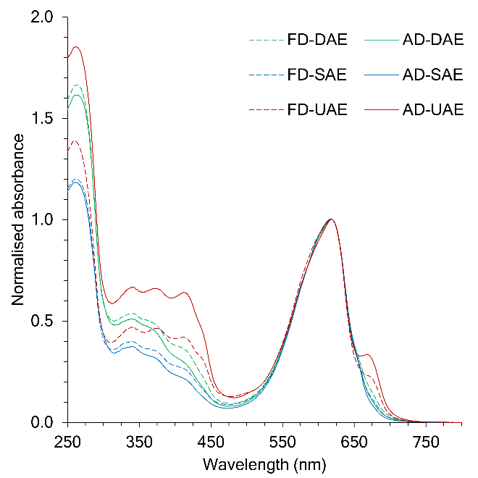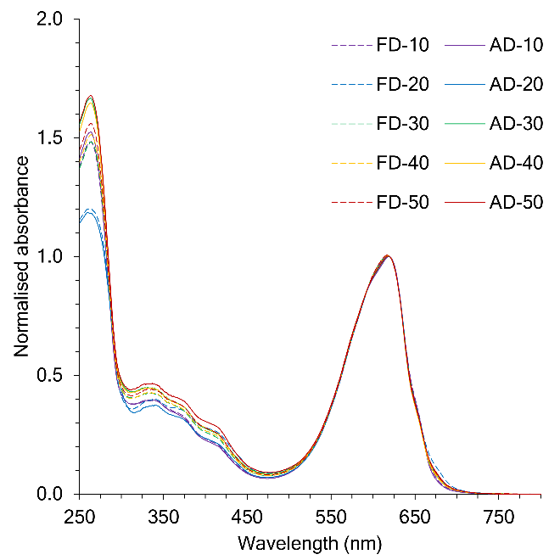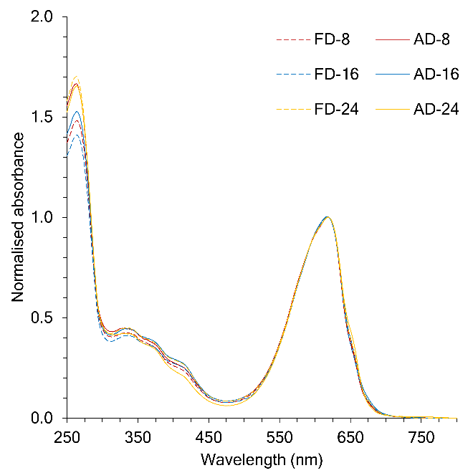
a
b
c
Figure S1 Normalised UV-Vis spectra of crude C-PC extracts of FD and AD powders, obtained from a. DAE, SAE, and UAE techniques; b. 1:10-1:50 (w/v) S/L ratio using SAE; and c. 8, 16, and 24 h of extraction durations using SAE at 1:30 S/L ratio.
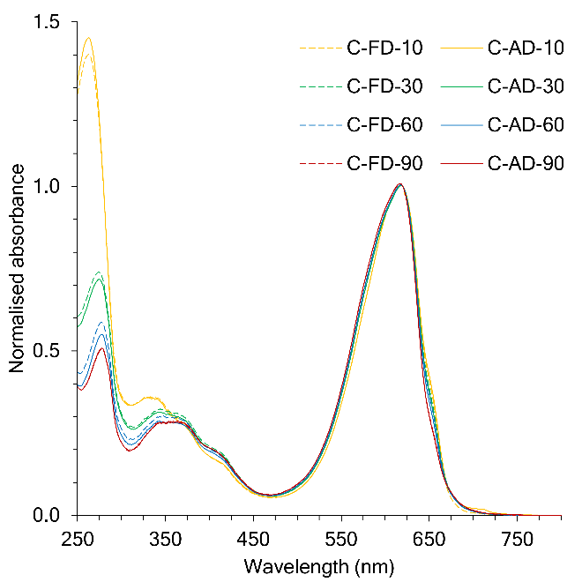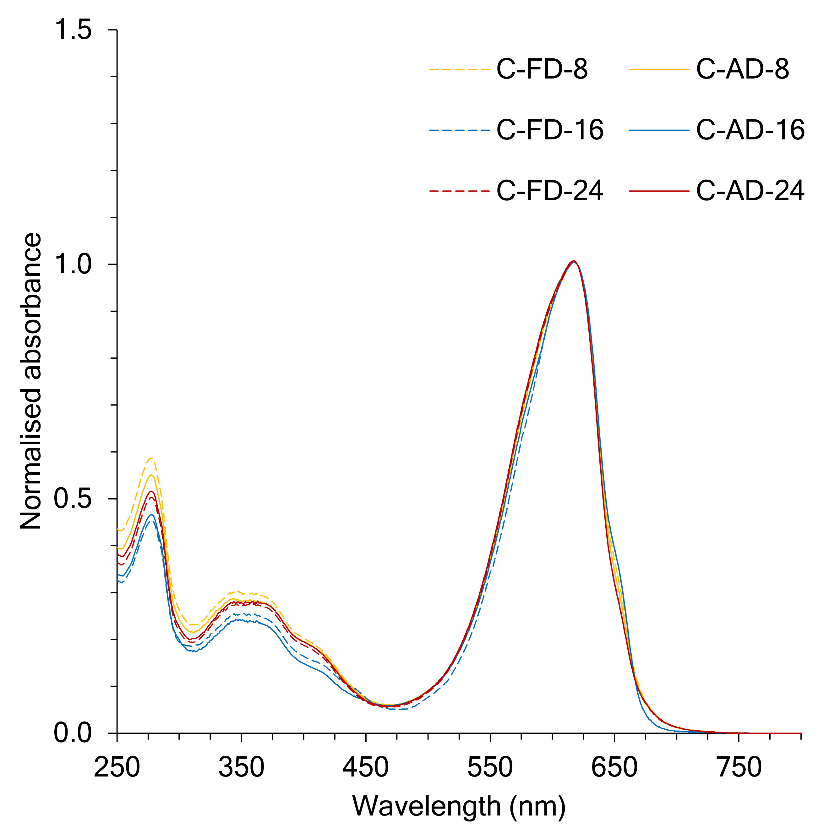
a
b
Figure S2 Normalised UV-Vis spectra of ACA purified C-PC extracts using a. charcoal concentrations of 10, 30, 60, and 90 g L⁻¹ and b. 8, 16, and 24 h of purification period at 60 g L⁻¹ charcoal concentration
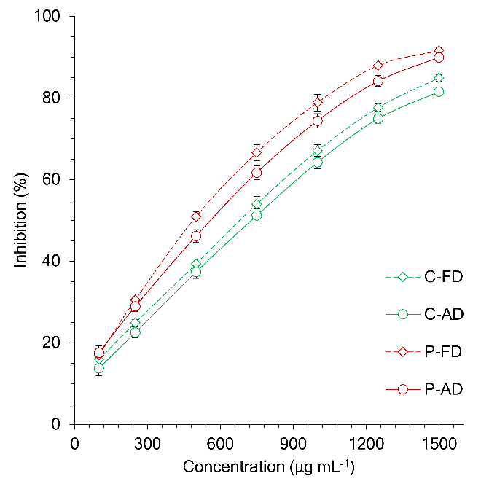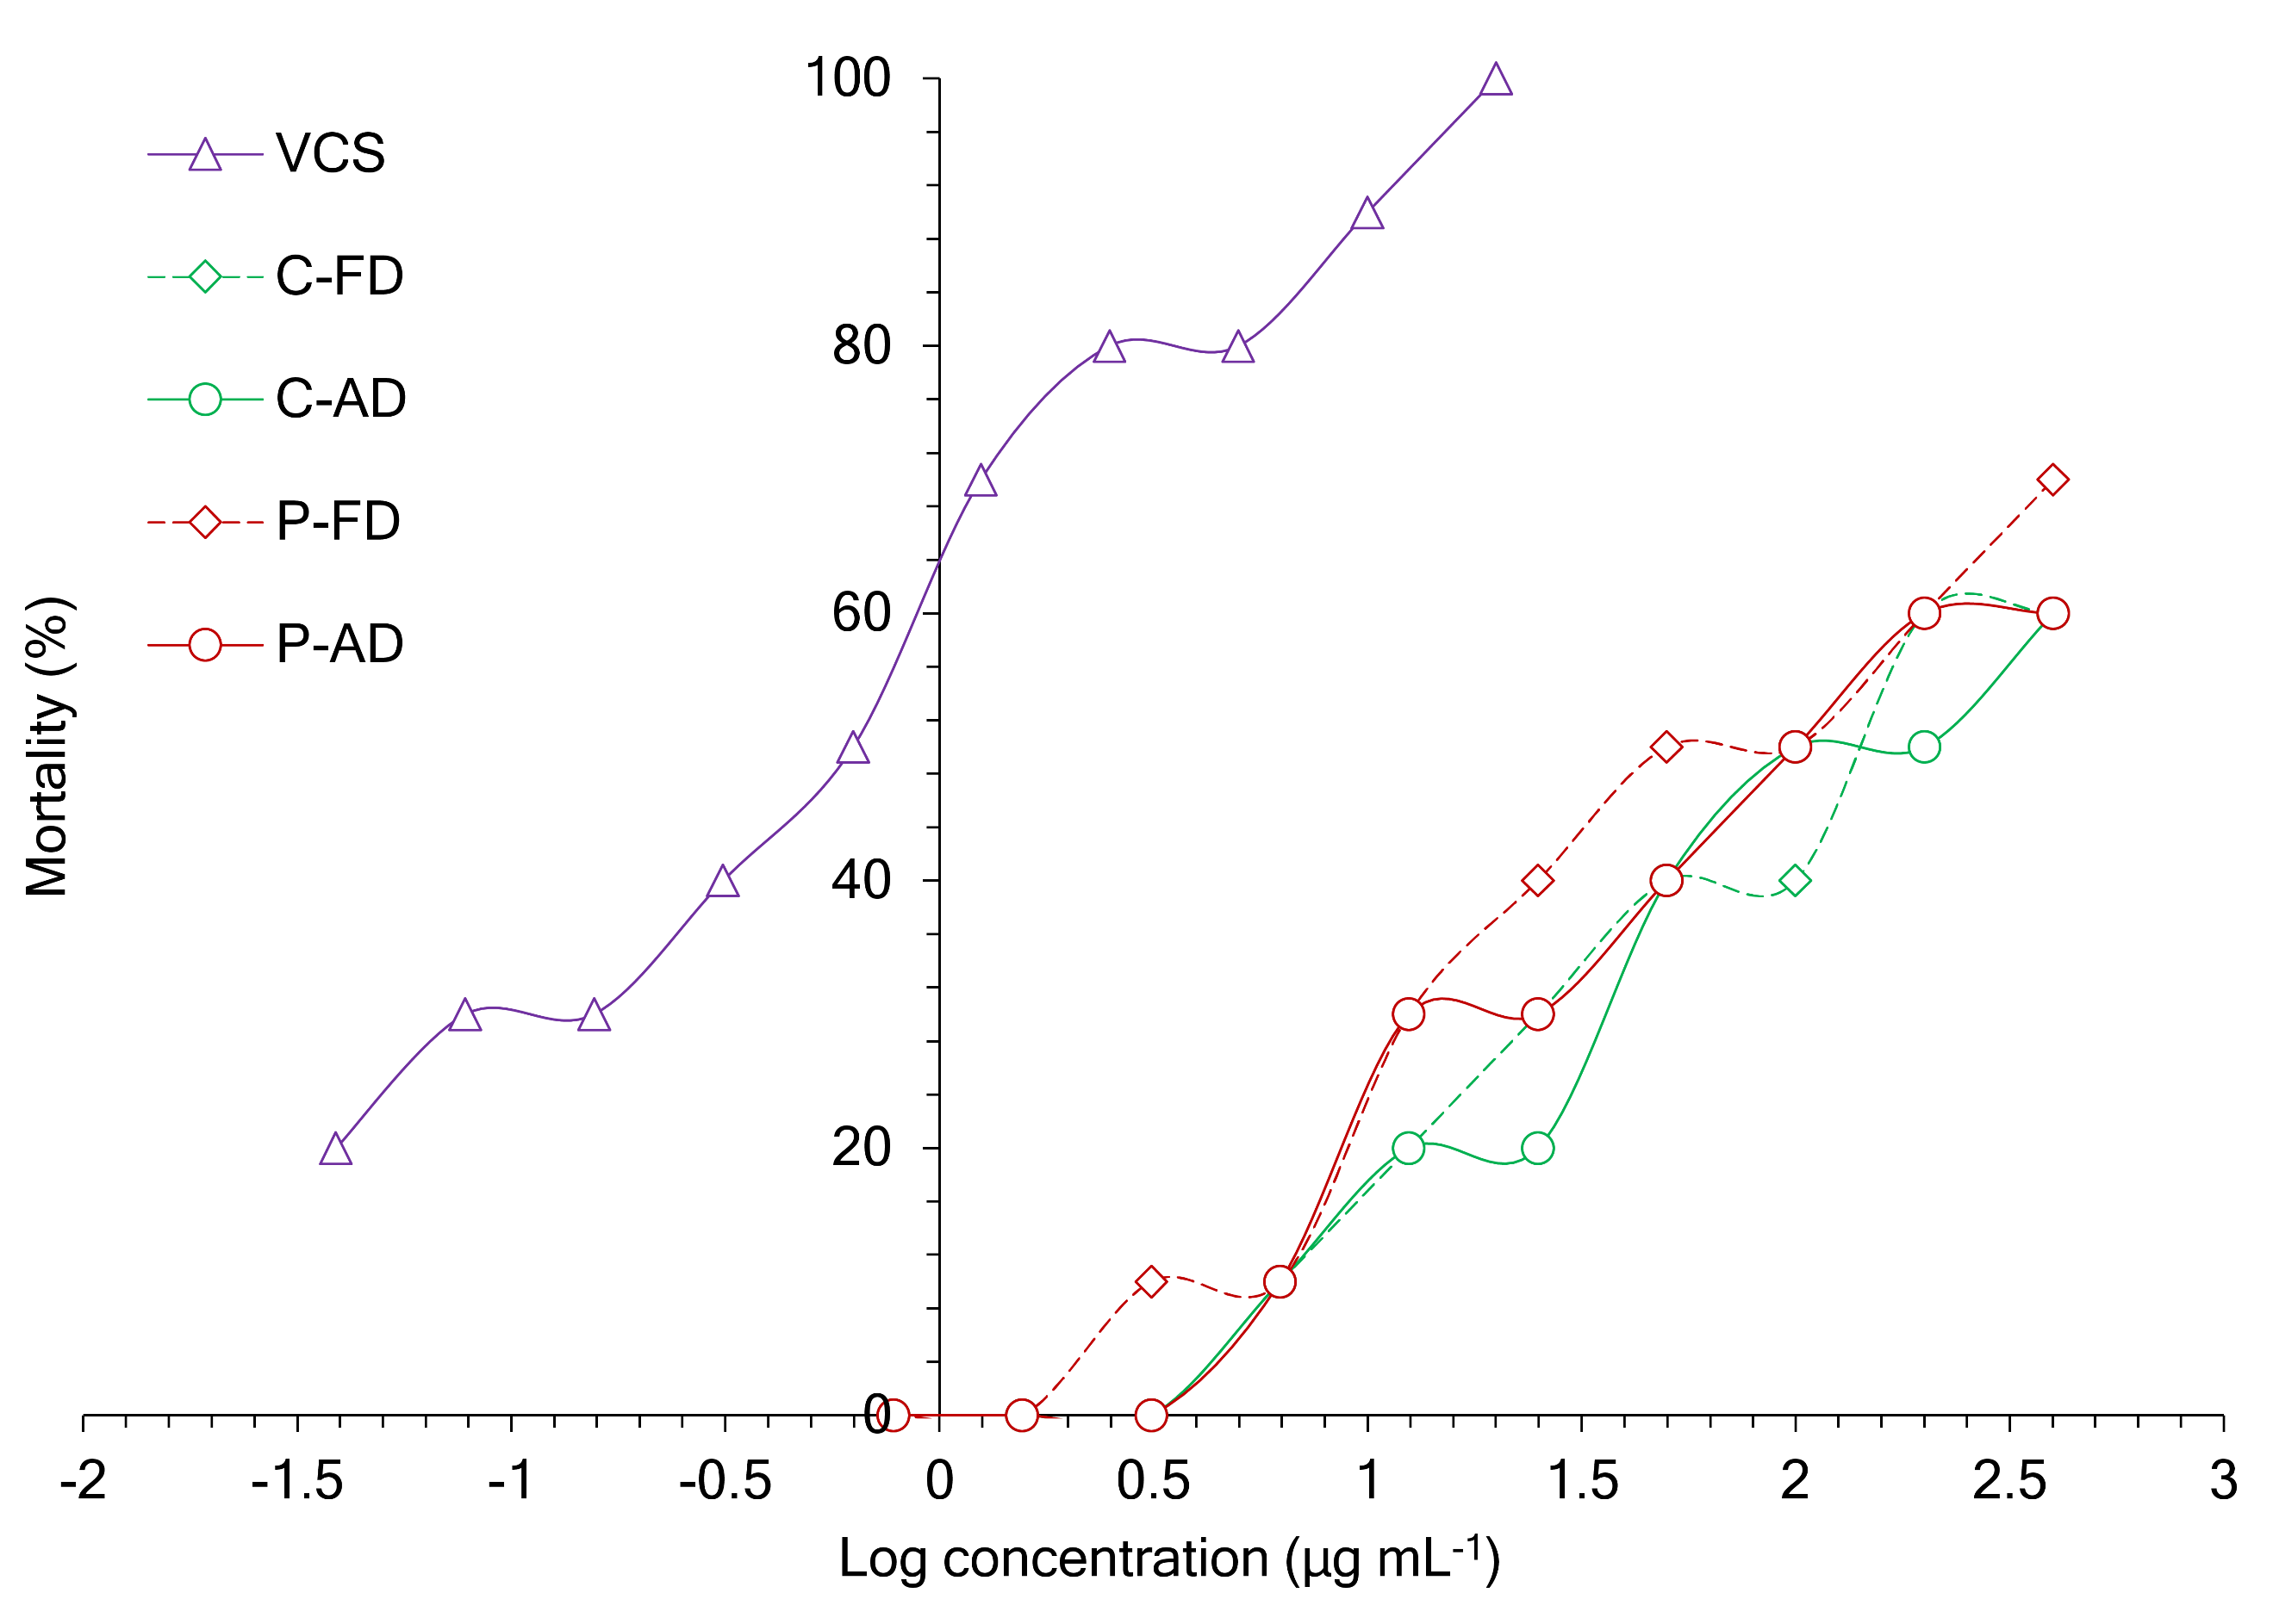
a
b
Figure S3 Linear regressions of a. C-PC concentration vs. DPPH scavenging percentage; and b. C-PC and VCS concentration vs. percentage mortality of A. salina

