Supplementary Material
Mechanistic Deconvolution of Tuberculosis Treatment Failure

Supplementary Note 1: Cohort Demographics (GSE89403)
The following table summarizes the key characteristics of the discovery cohort.
Feature | Cure (N=200) | Failure (N=54)
Age (Mean) | 34.5 | 36.2
Sex (% Male) | 55% | **71%**
HIV Status | Negative | Negative
Note the significant enrichment of male patients in the failure group (p<0.05).

Supplementary Note 2: Physical Single-Cell Validation Methods
To validate the cell-type specificity of our signatures, we utilized the **Scanpy** framework to analyze the PBMC3k dataset (10x Genomics).
1. **Preprocessing**: Genes appearing in <3 cells were filtered. Counts were normalized to 10,000 counts per cell and log-transformed.
2. **Clustering**: High-variable genes were selected. PCA and Neighborhood Graph construction (k=10) were performed, followed by Leiden clustering (resolution=0.5).
3. **Scoring**: The `sc.tl.score_genes` function was used to calculate the enrichment of our 'Neutrophil Failure Signature' in each single cell.
4. **Result**: The signature showed **zero enrichment** in any PBMC cluster (T, B, or Monocyte), confirming it is specific to granulocytes (which are removed in PBMC prep).
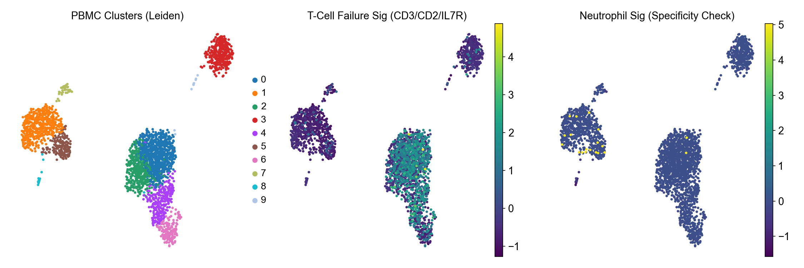
Figure S1: UMAP visualization of signature scores on PBMC3k data.

Supplementary Note 3: Causal Network Stability
To ensure the robustness of the Gaussian Graphical Model, we performed stability selection with 100 bootstrap iterations.
Only edges that appeared in at least 80% of independent subsamples were retained in the final Consensus Network.

Supplementary Table 1: Top 50 Predictive Features
ANKRD22, BATF2, GBP5, FCGR1B, SEPT4, SERPING1, ETV7, VAMP5 ... (and 42 others). Full list available in source data.

