Table 4 Images of fibers under OM
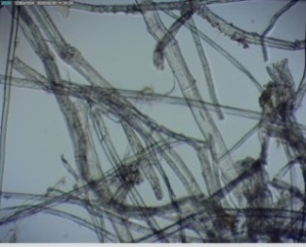 | 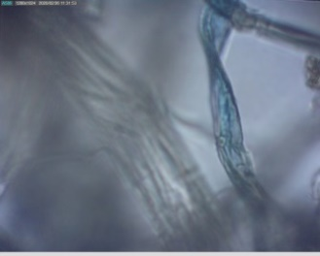 | 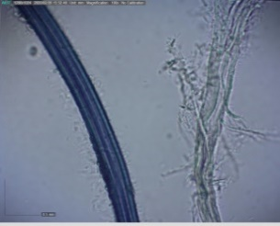 | 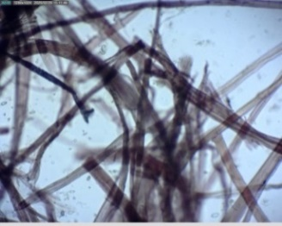
Flax and hemp fibers, 100x, sample 3D | Blue cotton fiber, 100x, sample 3D | Blue silk fiber, 100x, sample 10D | Herzberg Stain Test, flax and hemp fiber, 100x, sample 3D

Table 5 SEM-EDS images and spectra of historical papers
Sample mark | SEM | EDS | Found items (trace elements)
1D | 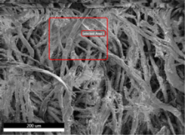 | 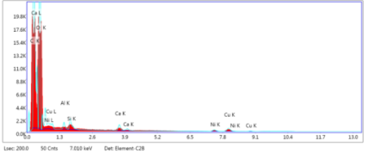 | C, O, Ca, (Si, Al, Ni)
2D | 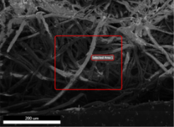 | 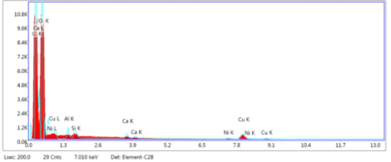 | O, C, Ca, (Cu, Al, Si, Ni)
3D | 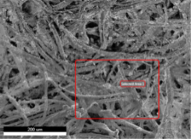 | 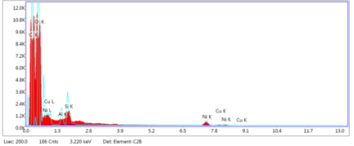 | O, C, (Cu, Si, Al, Ni)
4D | 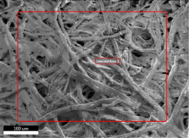 | 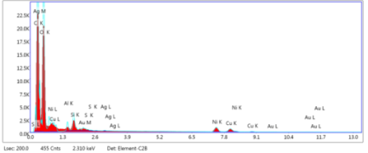 | O, C, (Si, Cu, Al, Ni, Au, S, Ag)
5D | 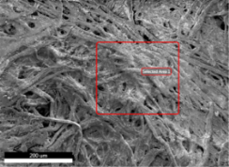 | 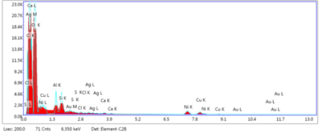 | O, C, Ca, (Al, Si, Cu, Ni)
6D | 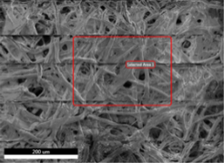 | 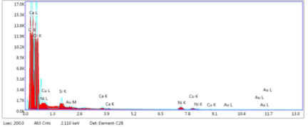 | O, C, Ca, (Cu, Si, Ni)
7D | 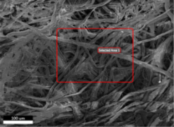 | 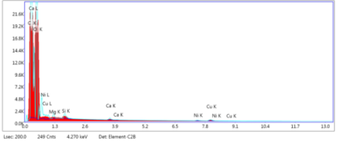 | O, C, Ca, (Ni, Cu Mg, Si, K)
8D | 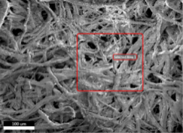 | 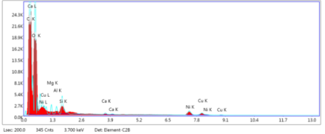 | O, C, Ca, (Cu, Si, Ni, Mg, Al, Si)
9D | 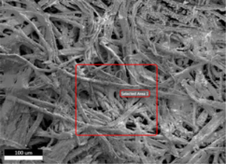 | 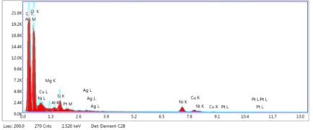 | O, C, (Si, Mg, Al, Cu, Ni) Ag?
10D | 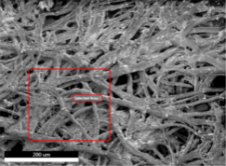 | 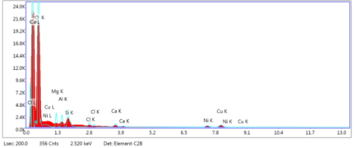 | O, C, Ca, (Si, Mg, Al, Cu, Ni)

Table 6 XRF spectra of historical papers
Sample mark | XRF | Found items (trace elements)
1D | 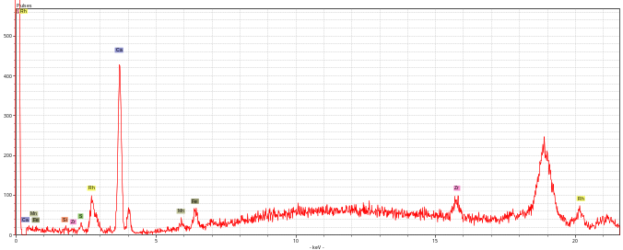 | Ca (Si, Mn, Fe, S)
2D | 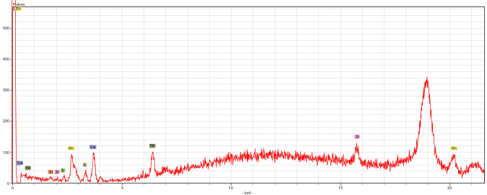 | Ca, Fe (K, Si, S)
3D | 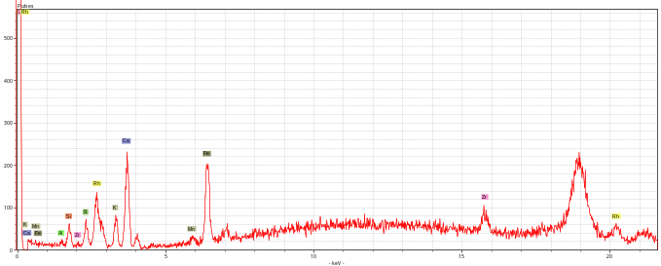 | Ca, Fe, (K, Al, Si, S, Mn)
4D | 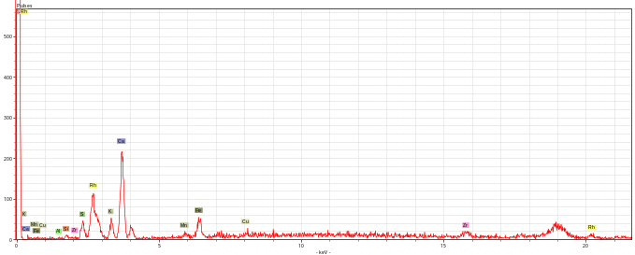 | Ca, (Fe, K, S, Al, Si, Mn, Cu?)
5D | 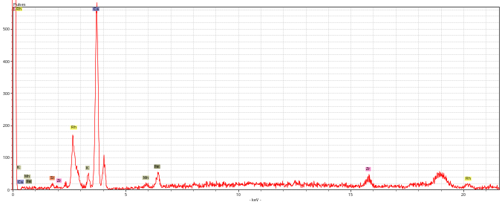 | Ca (K, Si, Mn, Fe)
6D | 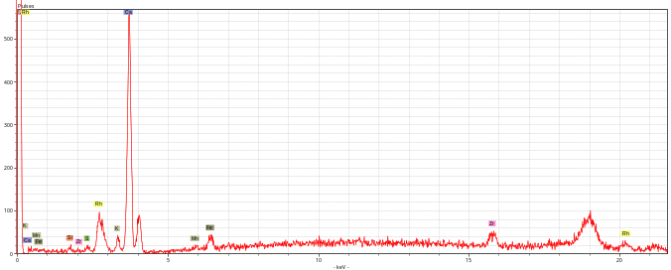 | Ca (K, Si, Mn, Fe, S)
7D | 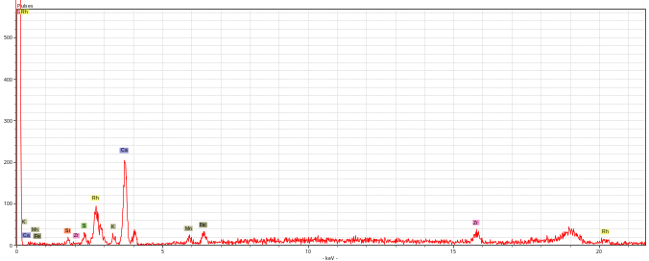 | Ca (K, Si, Mn, Fe, S)
8D | 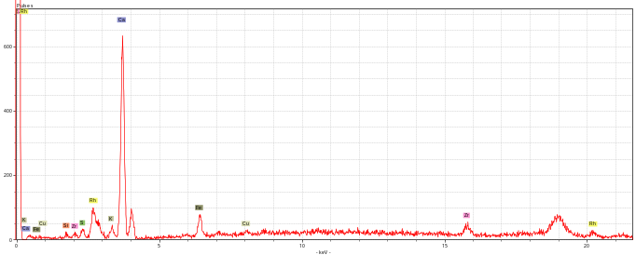 | Ca (Fe, Cu, Si, S, K)
9D | 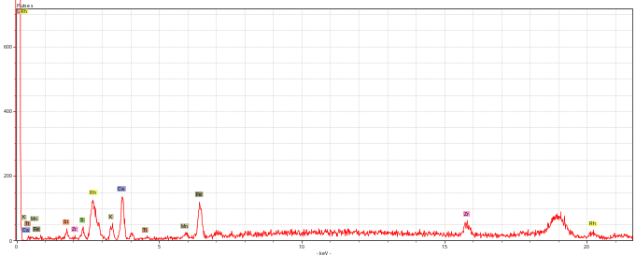 | Ca, Fe (Si, S, K, Mn, Ti)
10D | 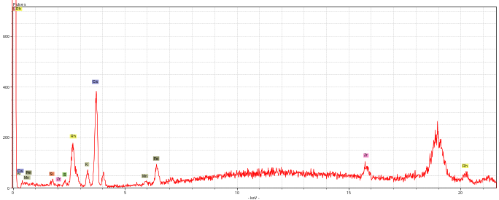 | Ca, Fe (K, S, Mn, Si)

