Title:
Function-Driven Molecular Design Enabled by Instruction-Tuned Large Language Models

Xurui Wang^{1†}, Yanxi Wang^{1†}, Ruizhao Zhu^{1†}, Hailiang Li^{1†}, Xinghong Wu¹, Xinyi Zhang¹, Mingyuan Zhou¹, Huaiwen Pu¹, Kaicong Cai^{2,3}, Yanan Tang⁴*, Qianfan Yang¹*, Feng Li¹*

¹ Key Laboratory of Green Chemistry and Technology of Ministry of Education, College of Chemistry, Sichuan University, Chengdu, 610064, Sichuan, P. R. China.
² College of Chemistry and Materials Science, Fujian Provincial Key Laboratory of Advanced Materials Oriented Chemical Engineering, Fujian Normal University, Fuzhou, 350117, P. R. China.
³ Fujian Provincial Key Laboratory of Featured Biochemical and Chemical Materials, Ningde Normal University Ningde, 352100, P. R. China.
⁴ Analytical and Testing Center, Sichuan University, Chengdu, 610064, Sichuan, P. R. China.

† These authors contribute equally.

Outline
Supplementary Note 0. Data Curation and Dataset Diagnostics
Supplementary Note 1. Comparative Analysis of Existing Generative Frameworks
Supplementary Note 2. Model Setup and Prompt Design
Supplementary Note 3. Model-Level Evaluation Procedures
Supplementary Note 4. Functional Evaluation of G4-Targeted Generative Models
Supplementary Note 5. GLAM Model Training and Evaluation
Supplementary Note 6. Comparative Benchmarking Against Current Generative Models
Supplementary Note 7. Baseline Model Adaptation Attempts
Supplementary Note 8. Generalizability of SemantiChem to rRNA and Mpro

Supplementary Note 0. Data Curation and Dataset Diagnostics
Supplementary Data linkage
All data files referenced in this Note are provided in the accompanying Supplementary Data package. Each dataset is placed within the folder corresponding to its Supplementary Note (e.g., Supplementary Note 0/), ensuring a one-to-one mapping between the ESI descriptions and the underlying raw files. File names appear in blue throughout the text to indicate direct correspondence to the downloadable data.

S0.1 Source Ligand Datasets
The datasets described below constitute the experimentally validated chemical foundations used to construct instruction–response pairs, derive target-aware prompts, and fine-tune large language models (LLMs). Each dataset corresponds to a specific nucleic acid (NA) or protein target class and defines the domain-relevant chemical space used during model conditioning.
G-quadruplex (G4) ligands
- g4ldb_training.csv
A curated collection of active G-quadruplex ligands obtained from the G4LDB database.
This dataset was used to construct G4-relevant instruction templates and to guide tuning of G4-specialized LLM variants.
Structured rRNA ligands
- rRNA_AID_720706_datatable_active.csv
Active ligands targeting structured ribosomal RNA, extracted from PubChem BioAssay AID: 720706.
These ligands provided the chemical basis for rRNA-specific instruction sets and target-conditioned generation.
SARS-CoV-2 main protease (Mpro) inhibitors
- SARS-CoV-2 Mpro ligands.csv
Small-molecule inhibitors of the SARS-CoV-2 main protease, retrieved from ChEMBL by querying “SARS-CoV-2 main protease” and filtering for annotated small-molecule activity records.
This collection served as the training source for Mpro-related semantic instructions.

S0.2 Complete Generation Outputs
This section lists all raw SMILES outputs produced by the generative models evaluated in the study. All molecules are included without filtering to ensure complete reproducibility of the computational experiments. Models are grouped by their training lineage and specialization stage.
1. SELFIES-pretrained base models
Models pretrained via SMILES→SELFIES translation tasks and used as the foundation for subsequent fine-tuning.
- ChemE_SELFIES.csv
- Instruct_SELFIES.csv
Generation volume: each model generated 600 molecules.

2. G4-specialized models
Models fine-tuned using G4-specific instruction data derived from the G4LDB ligand set.
- ChemE_G4_type1.csv
- ChemE_G4.csv
- Instruct_G4.csv
Generation volume:
- ChemE-G4-type1: 600 molecules
- ChemE-G4 and Instruct-G4: 2,600 molecules each

3. Target-specific variants (rRNA and Mpro)
SELFIES-based ChemE models adapted to structured rRNA and SARS-CoV-2 Mpro domains.
- ChemE_rRNA.csv
- ChemE_Mpro.csv
Generation volume: each model generated 2,600 molecules.

4. Baseline models
External baseline generators including variational autoencoders, adversarial autoencoders, recurrent sequence models, and pocket-based structure generators.
- SPMM_PDS.csv
- Pocket2mol_G4.csv
- char_rnn_generated.csv
- aae_generated.csv
- vae_generated.csv
Generation volume: each model generated 2,600 molecules.

S0.3 Notes on dataset diagnostics
To support downstream analysis, all source datasets were inspected for structural integrity, duplication, valence consistency, and charge normalization. Additional diagnostics, such as scaffold enumeration, chemical space diversity metrics, and target-specific bias analyses, are provided in Supplementary Figures and Tables, where applicable.

Supplementary Note 1. Comparative Analysis of Existing Generative Frameworks
This Note provides two comparative tables summarizing (i) previously reported generative molecular design frameworks and (ii) representative chemical LLMs. These tables serve to contextualize the methodological space in which SemantiChem operates and highlight the absence of NA-specific ligand generation capabilities in existing approaches.

Table S1. Reported generative molecular design frameworks, summarized with respect to their claimed target scope, coverage of nucleic acid (NA) systems, and availability of NA ligand generation examples.
Models | Target scope (claimed) | Mention NA? | Actual NA ligand generation examples? | Code-level feasibility for NA extension ª | Input modality | Ref.
Graph-based generative models
MARS | Multi-target | No | No | Blocking issue: Lacks NA-specific predictors and large-scale high-quality training data (only ~4K ligands).  Conclusion: Cannot be effectively fine-tuned for NA targets. | Molecular graph | ¹
GraphDF | Unconditional  (general molecules) | No | No | Blocking issue: Lacks NA-specific predictors and large-scale high-quality training data (only ~4K ligands).  Conclusion: Cannot be effectively fine-tuned for NA targets. | Molecular graph  (empty graph initialization) | ²
GraphINVEN | Unconditional  (general molecules) | No | No | Blocking issue: Lacks NA-specific predictors and large-scale high-quality training data (only ~4K ligands).  Conclusion: Cannot be effectively fine-tuned for NA targets. | Molecular graph  (empty graph initialization) | ³
SMILES / SELFIES sequence-based models
MolGPT | Unconditional  (general molecules) | No | No | Blocking issue: Large-scale NA–ligand datasets are extremely limited (only ~900 complexes).  Conclusion: Cannot be effectively fine-tuned for NA targets. | SMILES  + optional property/scaffold tokens | ⁴
TRIOMPHE | Multi-target | No | No | Blocking issue: No nucleotide-compatible input representation or training pipeline.  Conclusion: Not extendable. | Transcriptome profile  + SMILES | ⁵
MegaMolBART | Unconditional  (general molecules) | No | No | Blocking issue: Large-scale NA–ligand datasets are extremely limited (only ~900 complexes).  Conclusion: Cannot be effectively fine-tuned for NA targets. | SMILES | ⁶
3D structure-based generative models
Pocket2Mol ^{b} | Multi-target | No | No | Blocking issue: Input representation restricted to protein pocket geometry.  Conclusion: Runs with minor code edits, but not functionally transferable. | 3D protein pocket atoms | ⁷
TargetDiff | Multi-target | No | No | Blocking issue: No nucleotide-compatible input representation or training pipeline.  Conclusion: Not extendable. | 3D protein pocket atoms | ⁸
Lingo3DMol | Multi-target | No | No | Blocking issue: No nucleotide-compatible input representation or training pipeline.  Conclusion: Not extendable. | 3D protein pocket atoms  + NCI/anchor features | ⁹
Diffusion models for molecules
MolDiff | Unconditional  (general molecules) | No | No | Blocking issue: Lacks large-scale high-quality training data (only ~4K ligands).  Conclusion: Cannot be effectively fine-tuned for NA targets. | Molecular graph  (Gaussian noise 3D initialization) | ¹⁰
DrugDiff | Unconditional  (general molecules) | No | No | Blocking issue: Lacks large-scale high-quality training data (only ~4K ligands).  Conclusion: Cannot be effectively fine-tuned for NA targets. | SELFIES  (Gaussian noise latent initialization) | ¹¹
PMDM | Multi-target | No | No | Blocking issue: No nucleotide-compatible input representation or training pipeline.  Conclusion: Not extendable. | 3D protein pocket atoms  + coordinates | ¹²
Pretrained chemical language models
MolT5 | Unconditional  (general molecules) | No | No | Blocking issue: Lacks large-scale high-quality training data (only ~4K ligands).  Conclusion: Cannot be effectively fine-tuned for NA targets. | Natural language | ¹³
ChemGPT ^{b} | Unconditional  (general molecules) | No | No | Blocking issue: Lacks large-scale high-quality training data (only ~4K ligands).  Conclusion: Cannot be effectively fine-tuned for NA targets. | SELFIES/SMILES | ¹⁴
InstructBioMol | Multi-target | Yes, mentioned  but not supported now | No | Blocking issue: Lacks instruction-aligned large-scale high-quality training data (only ~4K ligands).  Conclusion: Cannot be effectively fine-tuned for NA targets. | Natural language  + FASTA sequence/3D structure | ¹⁵
SPMM ^{b} | Unconditional  (general molecules) | No | No | Blocking issue: Seed-based generation is structure-oriented and lacks NA-specific target conditioning.  Conclusion: Can generate seed-based ligands, but not systematically extendable or fine-tunable for NA targets. | SMILES  + property vector | ¹⁶
ether0 ^{b} | Unconditional  (general molecules) | No | No | Blocking issue: Lacks large-scale high-quality training data (only ~4K ligands).  Conclusion: Cannot be effectively fine-tuned for NA targets. | Natural language  + SMILES/IUPAC  /formula/reaction strings | ¹⁷
RL-enhanced generative models
REINVENT 4 | Unconditional  (general molecules) | No | No | Blocking issue: Lacks NA-specific predictors and large-scale high-quality training data (only ~4K ligands).  Conclusion: Cannot be effectively fine-tuned for NA targets. | SMILES | ¹⁸
MolDQN | Unconditional  (general molecules) | No | No | Blocking issue: Lacks NA-specific predictors and large-scale high-quality training data (only ~4K ligands).  Conclusion: Cannot be effectively fine-tuned for NA targets. | SMILES/molecular graph | ¹⁹
GraphTRL | Unconditional  (general molecules) | No | No | Blocking issue: Lacks NA-specific predictors and large-scale high-quality training data (only ~4K ligands).  Conclusion: Cannot be effectively fine-tuned for NA targets. | SMILES/graph | ²⁰
POLYGON | Multi-target | No | No | Blocking issue: Lacks NA-specific predictors and large-scale high-quality training data (only ~4K ligands).  Conclusion: Cannot be effectively fine-tuned for NA targets. | SMILES  (VAE latent initialization) | ²¹
ª Data availability is reported using G-quadruplex (G4) ligands as a representative NA target. For ligand-only models, the number of known G4 ligands (~4–5k) is shown; for pocket-conditioned models, the number of available G4-ligand complexes in PDB (~900) is shown.
^{b} Models tested as baselines in the main text.

Table S2. Representative chemical large language models (LLMs), compared in terms of input modality, task domain, training paradigm, outputs, instruction controllability, and target specificity.
Model | Input representation | Task domain | Training paradigm | Output | Instruction controllability | Target specificity | Ref.
SemantiChem  (this work) | Natural language instruction | Molecular generation for nucleic acid (NA) targets | Self-supervised pretraining  + multi-task instruction tuning | Molecule (SELFIES) | Yes | NA-specific (G4, rRNA); moderate generalization to proteins
LLMs for molecular generation (no instruction controllability)
MegaMolBART | SMILES | Molecular generation, property prediction | Self-supervised pretraining (seq2seq autoencoder) | Molecule (SMILES) | No | Target-agnostic | ⁶
Chemformer | SMILES | Reaction prediction, molecular optimization /generation, property prediction | Self-supervised pretraining  + fine-tuning | Molecule (SMILES), property/activity | No | Target-agnostic | ²²
ChemGPT | SELFIES / SMILES | Molecular generation | Self-supervised pretraining (causal LM) | Molecule (SELFIES/SMILES) | No | Target-agnostic | ²³
DrugGPT | SMILES | Molecular generation, bioactivity prediction | Self-supervised pretraining  + fine-tuning | Molecule (SMILES), predicted bioactivity | No | Protein-centric | ²⁴
ether0 | SMILES / SELFIES | Molecular generation, reasoning, property prediction | Self-supervised pretraining (causal LM with reasoning tasks) | Molecule (SMILES/SELFIES), property values | No | Protein-centric | ¹⁷
MolT5 | SMILES  + natural language | Molecule-text translation (captioning, text-guided molecule generation) | Self-supervised pretraining  + fine-tuning | Molecule (SMILES), text | No | Target-agnostic | ¹³
LLMs for property prediction, QA, or multimodal alignment (not generative)
3D-MolT5 | SMILES  + natural language + 3D structural tokens | Molecule-text translation, property prediction, cross-modal alignment | Multi-modal pretraining  + instruction tuning | Molecule (SMILES), text, property values | No | Target-agnostic | ²⁵
ChemLLM | SMILES  + natural language + reaction strings | Chemical knowledge Q&A, property/reaction prediction, molecule–text conversion | Instruction tuning | Natural language answers, molecular info, reasoning | Partial (QA/reasoning) | Target-agnostic | ²³
MoleculeSTM | SMILES  + natural language + molecular graphs | Structure-text retrieval, text-guided molecule editing, property prediction | Multi-modal contrastive pretraining + instruction tuning | Joint structure-text embeddings, edited molecules, predicted properties | Partial (retrieval/editing) | Target-agnostic | ²⁶

Reference
1. Xie, Y. et al. MARS: Markov Molecular Sampling for Multi-objective Drug Discovery. Preprint at https://arxiv.org/abs/2103.10432 (2021).
2. Luo, Y., Yan, K. & Ji, S. GraphDF: A Discrete Flow Model for Molecular Graph Generation. In Proc. 38th International Conference on Machine Learning 7192–7203 (PMLR, 2021).
3. Mercado, R. et al. Graph networks for molecular design. Mach. Learn.: Sci. Technol. 2, 025023 (2021).
4. Bagal, V., Aggarwal, R., Vinod, P. K. & Priyakumar, U. D. MolGPT: Molecular Generation Using a Transformer-Decoder Model. J. Chem. Inf. Model. 62, 2064–2076 (2022).
5. Kaitoh, K. & Yamanishi, Y. TRIOMPHE: Transcriptome-Based Inference and Generation of Molecules with Desired Phenotypes by Machine Learning. J. Chem. Inf. Model. 61, 4303–4320 (2021).
6. NVIDIA. MegaMolBART: a deep-learning model for small-molecule generation and cheminformatics. GitHub repository, https://github.com/NVIDIA/MegaMolBART (2022).
7. Peng, X. et al. Pocket2Mol: Efficient Molecular Sampling Based on 3D Protein Pockets. In Proc. 39th International Conference on Machine Learning 17644–17655 (PMLR, 2022).
8. Guan, J. et al. 3D Equivariant Diffusion for Target-Aware Molecule Generation and Affinity Prediction. Preprint at https://arxiv.org/abs/2303.03543 (2023).
9. Feng, W. et al. Generation of 3D molecules in pockets via a language model. Nat. Mach. Intell. 6, 62–73 (2024).
10. Peng, X., Guan, J., Liu, Q. & Ma, J. J. A. MolDiff: Addressing the Atom-Bond Inconsistency Problem in 3D Molecule Diffusion Generation. Preprint at https://arxiv.org/abs/2305.07508 (2023).
11. Oestreich, M. et al. DrugDiff: small molecule diffusion model with flexible guidance towards molecular properties. J. Cheminform. 17, 23 (2025).
12. Huang, L. et al. A dual diffusion model enables 3D molecule generation and lead optimization based on target pockets. Nat. Commun. 15, 2657 (2024).
13. Edwards, C. et al. Translation between Molecules and Natural Language. Preprint at https://arxiv.org/abs/2204.11817 (2022).
14. Frey, N. C. et al. Neural scaling of deep chemical models. Nat. Mach. Intell. 5, 1297–1305 (2023).
15. Zhuang, X. et al. Advancing biomolecular understanding and design following human instructions. Nat. Mach. Intell. 7, 1154–1167 (2025).
16. Chang, J. & Ye, J. C. Bidirectional generation of structure and properties through a single molecular foundation model. Nat. Commun. 15, 2323 (2024).
17. Narayanan, S. M. et al. Training a Scientific Reasoning Model for Chemistry. Preprint at https://arxiv.org/abs/2506.17238 (2025).
18. Loeffler, H. H. et al. Reinvent 4: Modern AI-driven generative molecule design. J. Cheminform. 16, 20 (2024).
19. Zhou, Z., Kearnes, S., Li, L., Zare, R. N. & Riley, P. Optimization of Molecules via Deep Reinforcement Learning. Sci. Rep. 9, 10752 (2019).
20. Zhang, X. J. A. Enhancing Molecular Design through Graph-based Topological Reinforcement Learning. Preprint at https://arxiv.org/abs/2411.14726 (2024).
21. Munson, B. P. et al. De novo generation of multi-target compounds using deep generative chemistry. Nat. Commun. 15, 3636 (2024).
22. Irwin, R., Dimitriadis, S., He, J. & Bjerrum, E. J. Chemformer: a pre-trained transformer for computational chemistry. Mach. Learn.: Sci. Technol. 3, 015022 (2022).
23. Zhang, D. et al. ChemLLM: A Chemical Large Language Model. Preprint at https://arxiv.org/abs/2402.06852 (2024).
24. Li, Y. et al. DrugGPT: A GPT-based Strategy for Designing Potential Ligands Targeting Specific Proteins. Preprint at https://doi.org/10.1101/2023.06.29.543848 (2023).
25. Pei, Q., Wu, L., Gao, K., Zhu, J. & Yan, R. 3D-MolT5: Leveraging Discrete Structural Information for Molecule-Text Modeling. In Proc. International Conference on Learning Representations (ICLR, 2025).
26. Liu, S. et al. Multi-modal molecule structure–text model for text-based retrieval and editing. Nat. Mach. Intell. 5, 1447–1457 (2023).

Supplementary Note 2. Model Setup and Prompt Design
This Note summarizes the model configurations, training procedures, prompt construction strategies, and decoding settings used to develop the ChemE-G4, Instruct-G4, ChemE-rRNA, and ChemE-Mpro models. All models were built from publicly available checkpoints and refined through a three-stage development pipeline:
- Base model: unmodified pretrained checkpoint
- SELFIES pretraining: domain-specific SMILES→SELFIES translation
- Target-specific instruction tuning: G4-, rRNA-, or Mpro-tailored prompts
All training was conducted using the LLaMA Factory framework (version 0.9.0). Model configurations, LoRA settings, prompt types, and decoding benchmarks are summarized in Tables S2.1-S2.4. All associated configuration files and generation outputs are provided in the Supplementary Note 2/ folder of the Supplementary Data package.

S2.1 External resources
The following resources and pretrained checkpoints were used:
- Meta-LLaMA-3-8B-Instruct:
https://huggingface.co/meta-llama/Meta-Llama-3-8B-Instruct
- Llama3.1-BestMix-Chem-Einstein-8B:
https://huggingface.co/ZeroXClem/Llama3.1-BestMix-Chem-Einstein-8B
- LLaMA Factory (v0.9.0):
https://github.com/hiyouga/LLaMA-Factory
- PubChem10M_SELFIES dataset:
https://huggingface.co/datasets/alxfgh/PubChem10M_SELFIES

Model checkpoints trained in this study (private during peer review)
The following fine-tuned checkpoints generated in this study are hosted on Hugging Face as private repositories:
• Instruct-G4
• ChemE-G4
• ChemE-Mpro
• ChemE-rRNA

Access for editors and reviewers is provided through a read-only token supplied in the submission system. A Code Ocean capsule will also be prepared during peer review upon request.
All model checkpoints will be made publicly available upon publication.

S2.2 Training configurations
Table S2.1 Training Configurations for Each Stage (Selected Parameters).
Stage | Batch size | Learning rate | Epochs | Optimizer | Tokenizer | Notes
Base | N/A | N/A | N/A | N/A | SMILES | No training applied
SELFIES pretrain | 64 | 1e-4 | 2 | Adam | SELFIES | Incremental pretraining on SELFIES
NA targets fine-tune | 16 | 1e-4 | 10 | AdamW | SELFIES | Task-specific SFT using G4 ligand prompts

Table S2.2 LoRA hyperparameters used in both pretraining and fine-tuning stages. Default values were inherited from the LLaMA Factory framework (v0.9.0).
Parameter | Value | Applied to
LoRA rank (r) | 8 | SELFIES pretraining, G4 fine-tuning
LoRA alpha | 32 | SELFIES pretraining, G4 fine-tuning
LoRA dropout | 0.1 | SELFIES pretraining, G4 fine-tuning

Supplementary data
- S2_selfies_pretrain_config.yaml
Training configuration for SELFIES pretraining using the LLaMA Factory framework.
- S2_instruction_tuning_config.yaml
LoRA-based configuration for G4-specific instruction tuning.

S2.3 Training dynamics
Model training curves are shown in Figure S2.1.

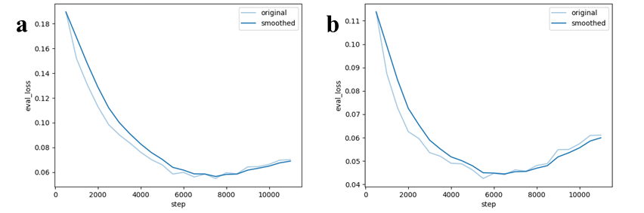
Figure S2.1 Validation loss curves over training steps for the two models. (a) Instruct-G4: checkpoint selected at step 7500, corresponding to the lowest validation loss before divergence. (b) ChemE-G4: checkpoint selected at step 6500, prior to overfitting.

Supplementary data
- S2_validation_loss.csv
Validation loss values over training steps.

S2.4 Prompt templates and generation scripts

Table S2.3 Summary of prompt types and generation scripts used in instruction tuning and inference.
Task Type | Prompt Template Example | Usage Stage | Script / Resource Path
Type 1: Known Ligand Generation | “Can you provide an example of an existing ligand?” | instruction tuning | /1.1 generate_QA_Pairs/type1.py
Type 2: Fragment Completion | “Predict the missing fragments in this ligand using [MASK].” | Instruction tuning | /1.1 generate_QA_Pairs/type2.py
Type 3: Atom Completion | “Predict fragments behind [SINGLEMASK] in the ligand.” | Instruction tuning | /1.1 generate_QA_Pairs/type3.py
Type 4: Identity QA | “What can you do?” | Instruction tuning | Modified from LLaMA Factory identity template, see Supplementary data
Inference: Novel Generation | “Please show me a ligand which hasn’t been reported.” | Inference | /1.3 generate_molecules/request.py

Supplementary data
- S2_prompt_templates.csv
Complete set of prompt templates used in instruction tuning and molecular generation.
- S2_identity_dataset.json
Identity-style prompts adapted for ligand generation.

S2.5 Decoding strategies and hyperparameter optimization
Generation performance was systematically evaluated under different combinations of temperature (T) and top-p (P) sampling settings.

Table S2.4 Generation quality under different decoding hyperparameter settings for Instruct-G4 and ChemE-G4 models. Temperature (T) and top-p sampling (P) were systematically varied to evaluate their effects on validity, uniqueness, novelty, Frechet ChemNet Distance (FCD), and fragment similarity. Each configuration was used to generate 600 molecules.
Model | Metric | 0.7T, 0.5P | 0.7T, 0.7P | 0.7T, 1.0P | 0.2T, 0.9P | 0.5T, 0.9P | 1.0T, 0.9P
Instruct-G4 | Validity | 1.000 | 1.000 | 0.997 | 1.000 | 1.000 | 0.998
Instruct-G4 | Uniqueness | 0.012 | 0.195 | 0.872 | 0.093 | 0.448 | 0.917
Instruct-G4 | Novelty | 0.429 | 0.564 | 0.670 | 0.607 | 0.605 | 0.708
Instruct-G4 | FCD/TEST | 78.326 | 46.112 | 27.700 | 57.257 | 39.284 | 27.562
Instruct-G4 | FCD/TESTSF | 78.165 | 46.201 | 27.869 | 57.438 | 40.000 | 27.780
Instruct-G4 | FRAG/TEST | 0.336 | 0.684 | 0.817 | 0.490 | 0.712 | 0.812
Instruct-G4 | FRAG/TESTSF | 0.332 | 0.675 | 0.808 | 0.487 | 0.703 | 0.803
ChemE-G4 | Validity | 1.000 | 1.000 | 1.000 | 1.000 | 1.000 | 0.999
ChemE-G4 | Uniqueness | 0.017 | 0.273 | 0.898 | 0.103 | 0.508 | 0.940
ChemE-G4 | Novelty | 0 | 0.677 | 0.640 | 0.661 | 0.600 | 0.673
ChemE-G4 | FCD/TEST | 85.096 | 41.512 | 26.870 | 59.920 | 37.088 | 25.479
ChemE-G4 | FCD/TESTSF | 84.900 | 41.513 | 27.000 | 59.800 | 37.137 | 25.604
ChemE-G4 | FRAG/TEST | 0.340 | 0.665 | 0.822 | 0.508 | 0.657 | 0.833
ChemE-G4 | FRAG/TESTSF | 0.334 | 0.661 | 0.812 | 0.502 | 0.651 | 0.827

Supplementary data
- S2_cheme_optimization/
SMILES outputs from ChemE-G4 under six decoding settings:
  - 02t_09p.csv
  - …
  - 10t_09p.csv
- S2_instruct_optimization/
SMILES outputs from Instruct-G4 under six decoding settings.

Supplementary Note 3. Model-Level Evaluation Procedures
This Note provides the detailed procedures used to evaluate model behavior according to the three components illustrated in Fig. 1b: (i) domain-related chemical language understanding, (ii) responsiveness to controlled prompt modifications, and (iii) semantic-structural correspondence in model outputs. Since natural-language–driven molecular generation remains largely unexplored in prior work, specialized evaluation routines were developed to quantify these aspects. All molecule-level outputs and calculation results associated with these evaluation experiments are provided in the Supplementary Note 3/ folder of the Supplementary Data package. Custom descriptor calculation scripts (for Max_fused and LCCS) are available to the editors and reviewers through the submission-version GitHub repository (https://github.com/ADNLab-SCU/SemantiChem). A Code Ocean capsule will also be prepared.

S3.1 Evaluation of chemical-language understanding
To assess whether models correctly interpret domain-specific G4-related chemical language, eight natural-language prompts (Q1–Q8) were designed to probe key semantic concepts such as π–π stacking, end-stacking, groove-binding features, and toxicity-aware constraints (Table S3.1). Each prompt was issued 10 times to ChemE-G4 and Instruct-G4 under fixed decoding settings.
Model outputs were manually classified into four categories:
- Semantic match
Chemically relevant, on-topic responses aligned with the intended G4-related concept.
- Valid SELFIES (off-target)
Syntactically valid SELFIES strings that failed to reflect the requested semantic concept.
- Invalid SELFIES
Outputs containing SELFIES decoding errors or malformed tokens.
- Unrelated or hallucinated text
Non-chemical fragments, incomplete strings, or generic language responses.
Semantic Precision was defined as the fraction of outputs classified as semantic matches for each query.
As summarized in Figure S3.1, ChemE-G4 demonstrated strong alignment for Q1 (π–π stacking) and Q2 (end-stacking), whereas both ChemE-G4 and Instruct-G4 failed to produce grounded responses for Q8, which involved cross-domain toxicity reasoning. Subsequent perturbation and semantic-delta experiments (Sections S3.2–S3.3) were constructed based on these representative success and failure modes.

Table 3.1 Overview of the eight prompts used for semantic evaluation of domain knowledge in fine-tuned LLMs. Prompts Q1–Q5 yielded partially successful or expected semantic alignments, while Q6-Q8 triggered off-target or uninformative responses, reflecting limitations in pharmacological or cross-domain reasoning.
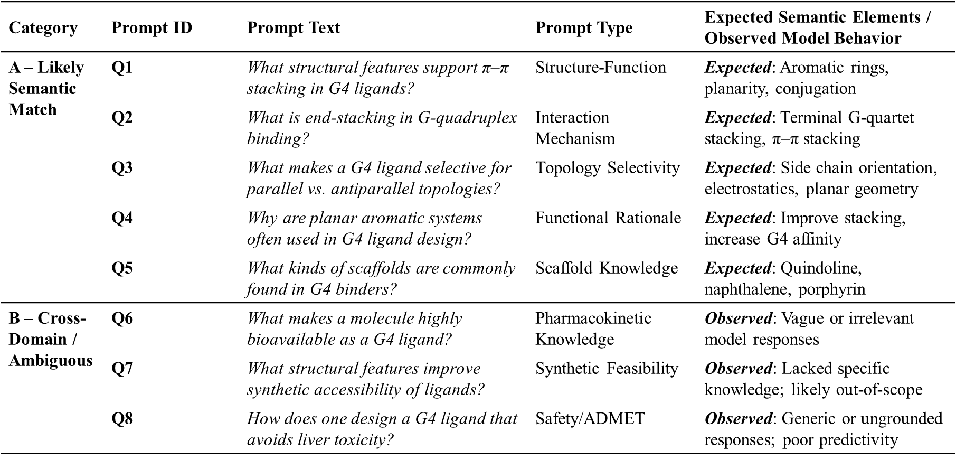

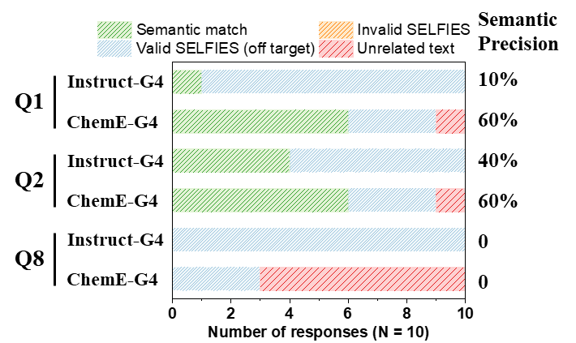
Figure S3.1 Response type distributions for three representative prompts. Bars show the percentage of outputs classified as semantic match, valid off-target SELFIES, invalid SELFIES, or unrelated text. ChemE-G4 outperformed Instruct-G4 on Q1-Q2. Both models failed to produce grounded responses on Q8, a cross-domain toxicity prompt.

Supplementary data
- ChemE_G4_output\
CSV files containing raw model outputs for Q1-Q8 prompts issued to ChemE-G4.
  - q1_pipiStacking.csv
  - ...
  - q8_avoidToxicity.csv
- Instruct-G4_output/
CSV files containing raw model outputs for Q1-Q8 prompts issued to Instruct-G4.
- Analysis.xlsx
Manual classification of model outputs into semantic match, valid SELFIES, invalid SELFIES, and hallucinated text.
S3.2 Evaluation of Prompt-Driven Controllability
Based on the representative success and failure modes identified in Section S3.1 (Q1 π–π stacking, Q2 end-stacking, and Q8 toxicity-related reasoning), we evaluated the degree to which ChemE-G4 and Instruct-G4 respond to controlled prompt variations. Three structured prompt sets (Q2S, Q1L, Q8F) were constructed to probe semantic specificity, stylistic sensitivity, and robustness to out-of-domain instructions.
For each prompt variant, 500 molecules were generated per model. Prompt-induced differences in molecular distributions were quantified using binary classifiers trained on RDKit descriptors. Performance was evaluated by five-fold cross-validation, and classifier AUCs and top-weighted descriptors were analyzed to determine whether prompt semantics produced statistically distinguishable structural outcomes.
Full generation outputs and property analyses are contained in the Supplementary Note 3/ folder of the Supplementary Data.

S3.2.1 Prompt shift response (Q2S: stacking-related prompts)
To assess whether models respond consistently to semantically distinct stacking cues, we evaluated the following prompt set:
- Q2S-P1: “Design a G4 ligand.”
- Q2S-P2: “Design a G-quadruplex ligand that binds via end-stacking with terminal G-quartets.”
- Q2S-P3: “Design a G-quadruplex ligand that stacks selectively on parallel G4 topologies.”

As summarized in Table S3.2, ChemE-G4 produced consistent and interpretable shifts under P2 and P3, with classifier AUCs above random and descriptor weights reflecting expected semantic cues, for example:
- P2: increased aromaticity, fused-ring count, reduced flexibility
- P3: increased polarity, higher amine content

In contrast, Instruct-G4 yielded separable but less semantically aligned shifts—for example, decreased aromatic ring count under P2 and increased flexibility under P3—indicating weaker consistency between prompt semantics and structural outcomes.
Representative classifier curves, descriptor weights, and distribution plots for Instruct-G4 are shown in Figure S3.2, with ChemE-G4 results included in the main text (Figure 3).

Table S3.2 Classifier performance and top-weighted molecular descriptors for prompt shift comparisons (Q2S). Signs (+/–) indicate the direction of descriptor association with the shifted prompt.
Model | Prompt set | Comparison | Mean AUC  (5-fold CV) | Descriptors  (ranked by weight)
ChemE-G4 | Q2S | P2 vs P1 | 0.542 ± 0.021 | MaxFused (+),  AromaticRings (+),  RotatableBonds (–)
ChemE-G4 | Q2S | P3 vs P1 | 0.579 ± 0.023 | Amine_Primary (+),  HBD (–), TPSA (+),  HBA (+), RotatableBonds (–)
Instruct-G4 | Q2S | P2 vs P1 | 0.570 ± 0.040 | AromaticRings (–),  RotatableBonds (+),  MaxFused (+)
Instruct-G4 | Q2S | P3 vs P1 | 0.590 ± 0.050 | HBD (+), Amine_Primary (+),  RotatableBonds (+), HBA (+),  TPSA (–)

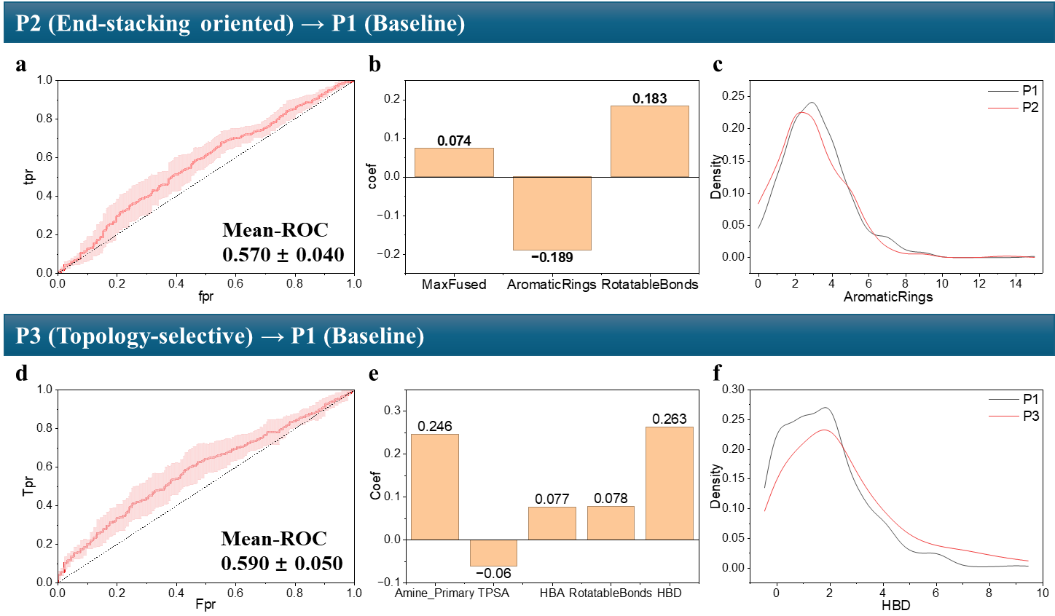
Figures S3.2 Classifier analyses of Instruct-G4 responses to stacking-related prompts in the Q2S set. (a) ROC curve, (b) descriptor weights, and (c) KDE plot of the top-weighted descriptor (AromaticRings) for P2 vs P1. (d) ROC curve, (e) descriptor weights, and (f) KDE plot of the top-weighted descriptor (HBD) for P3 vs P1.

S3.2.2 Sensitivity to language style (Q1L prompts)
To determine whether stylistic variations alter model outputs, we evaluated the Q1L set:
- Q1L-P₀: “Design a G4 ligand with π–π stacking ability.”
- Q1L-P₋₁: “What kind of ligand could stack on a G-quadruplex surface?”
- Q1L-P₊₁: “Generate a molecule capable of engaging in π–π interactions with G4 DNA, mimicking planar aromatic systems.”

As shown in Table S3.3, ChemE-G4 produced moderate separability between P0 and P−1, driven primarily by TPSA and Largest Conjugated Carbon System (LCCS), whereas P+1 produced minimal separation. Instruct-G4 showed a similar trend with weaker effect sizes.
Representative ROC curves, descriptor weights, and KDE plots for Instruct-G4 are presented in Figure S3.3.

Table S3.3 Classifier performance and molecular descriptors for language style comparisons (Q1L). Signs (+/–) indicate the direction of descriptor association with the shifted prompt.
Model | Prompt set | Comparison | Mean AUC  (5-fold CV) | Descriptors  (ranked by weight)
ChemE-G4 | Q1L | P₋₁ vs P₀ | 0.574 ± 0.048 | TPSA (+), LCCS (–)
ChemE-G4 | Q1L | P₊₁ vs P₀ | 0.527 ± 0.047 | LCCS (+), TPSA (+)
Instruct-G4 | Q1L | P₋₁ vs P₀ | 0.611 ± 0.026 | TPSA (+), LCCS (+)
Instruct-G4 | Q1L | P₊₁ vs P₀ | 0.504 ± 0.024 | TPSA (+), LCCS (–)

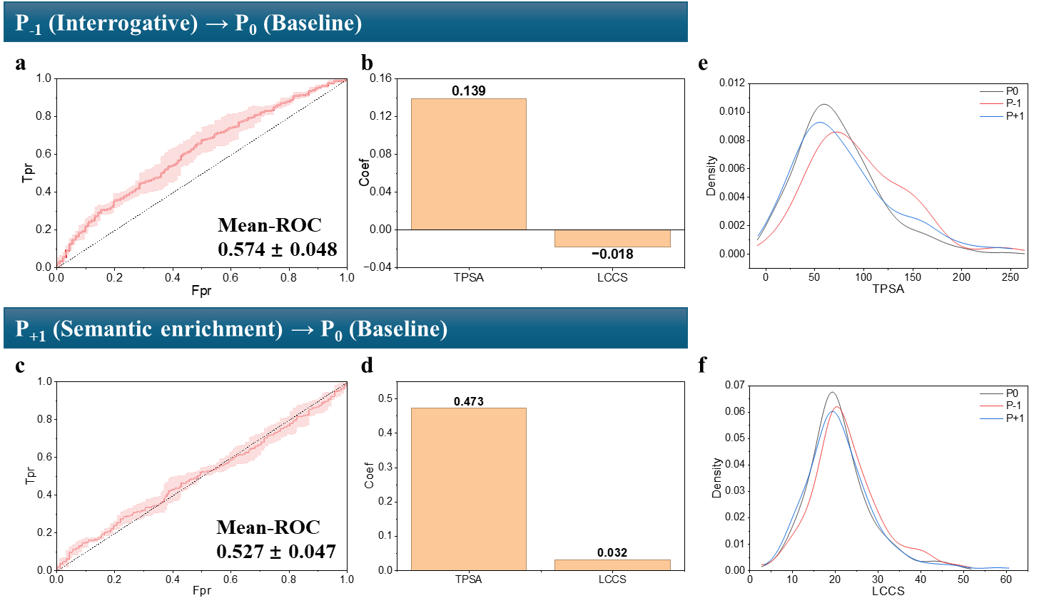
Figures S3.3 Classifier analyses of Instruct-G4 responses to stylistic variations in the Q1L set. (a) ROC curve and (b) descriptor weights for P_{–1} vs P₀. (c) ROC curve and (d) descriptor weights for P₊₁ vs P₀. KDE plots of TPSA (e) and LCCS (f) are shown across all comparisons.

S3.2.3 Robustness to out-of-domain instructions (Q8F prompts)
To test whether models can incorporate prompts outside their training scope, we evaluated toxicity-related variants:
- Q8F-P1: “Design a G4 ligand.”
- Q8F-P2: “Design a G4 ligand that avoids toxicity.”

As shown in Table S3.4, classifiers trained on toxicity-associated descriptors (TPSA, LogP, PAINS filters) performed at near-random levels for both ChemE-G4 and Instruct-G4. Descriptor coefficients were small and inconsistent, with no reliable alignment to toxicity-avoidance semantics, indicating both models’ limited ability to incorporate out-of-domain constraints.
Representative plots for both models are shown in Figure S3.4.

Table S3.4 Classifier performance and molecular descriptors for out-of-domain prompts.
Model | Prompt set | Comparison | Mean AUC  (5-fold CV) | Descriptor(s)  (ranked by weight)
ChemE-G4 | Q8F | P2 vs P1 | 0.515 ± 0.026 | PAINS, LogP, TPSA
Instruct-G4 | Q8F | P2 vs P1 | 0.524 ± 0.026 | TPSA, PAINS, LogP

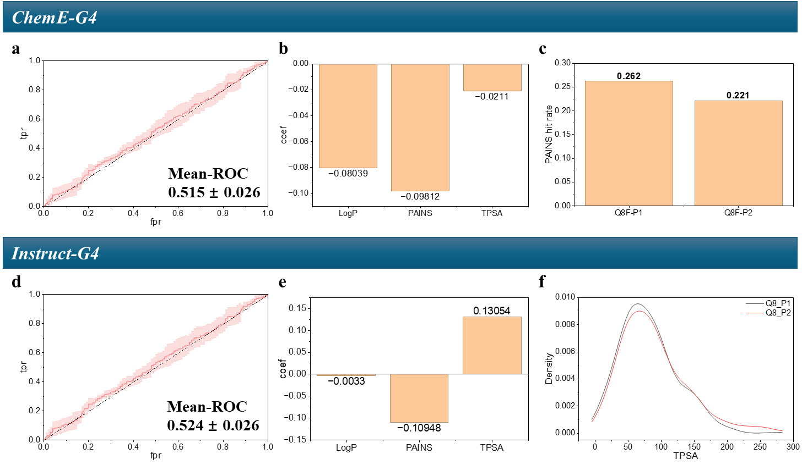
Figures S3.4 Classifier analyses of ChemE-G4 and Instruct-G4 responses to out-of-domain prompts in the Q8F set. (a) ROC curve, (b) descriptor weights, and (c) PAINS hit rates for P2 vs P1 with ChemE-G4. (d) ROC curve, (e) descriptor weights, and (f) KDE plot of the top-weighted descriptor (TPSA) for P2 vs P1 with Instruct-G4.

Supplementary Data
All prompt-controlled generation outputs and RDKit-based property analyses used in Sections S3.2.1-S3.2.3 are provided in:
- 1_Prompt_Shift_Response/
- 2_Style_Sensitivity/
- 3_Contradiction_Robustness/
Each folder contains:
- ChemE_G4/ — SMILES outputs and analysis results for ChemE-G4
- Instruct_G4/ — corresponding outputs for Instruct-G4
Each .csv file corresponds to a specific prompt variant (e.g., q2s_p1.csv, q1l_p0.csv), with invalid and duplicate molecules removed.

S3.3 Analysis of Semantic–Structural Correspondence
To evaluate whether prompt semantics influence not only molecular properties but also scaffold-level convergence, structural similarity networks were constructed for the Q2S dataset generated by ChemE-G4. Pairwise Tanimoto similarities (MACCS fingerprints) were computed and used to generate networks at two thresholds.
At the lower threshold (similarity ≥ 0.7), the resulting network formed a giant connected component encompassing the majority of molecules (Figure S3.5a), indicating broad scaffold overlap across prompts. In contrast, the higher threshold (similarity ≥ 0.9) produced a fragmented network containing 125 discrete clusters (Figure S3.5b), which was used for subsequent cluster-level analyses.
As shown in Table S3.5, every cluster contained molecules originating from multiple prompts. The largest cluster category comprised mixed P1+P2+P3 clusters (24 clusters, 215 molecules), consistent with the presence of broadly accessible “universal stacking scaffolds” generated regardless of semantic specificity. The most frequent pairwise overlap was observed for P2+P3 (38 clusters, 120 molecules), indicating strong semantic synergy between end-stacking and topology-selective stacking cues. Overlaps involving the generic prompt (P1+P2 or P1+P3) were smaller and more diffuse, suggesting that weakly constrained prompts only occasionally converge toward more specific semantic regions.
Representative clusters are shown in Figure S3.6.
- The largest P1+P2+P3 cluster (40 molecules) corresponded to naphthalene diimide derivatives, a known G4 ligand class with universal stacking potential.
- The largest P2+P3 cluster (11 molecules) contained porphyrin derivatives, whose extended aromatic cores favor end-stacking while substituents confer topology selectivity.
- The largest P1+P2 cluster (8 molecules) consisted of multi-aryl scaffolds with cationic side chains, reflecting common mixed-mode G4 ligand design principles.

These results demonstrate that semantic prompt differences produce quantifiable effects on scaffold-level organization, with meaningful structural convergence emerging only under semantically aligned stacking instructions.

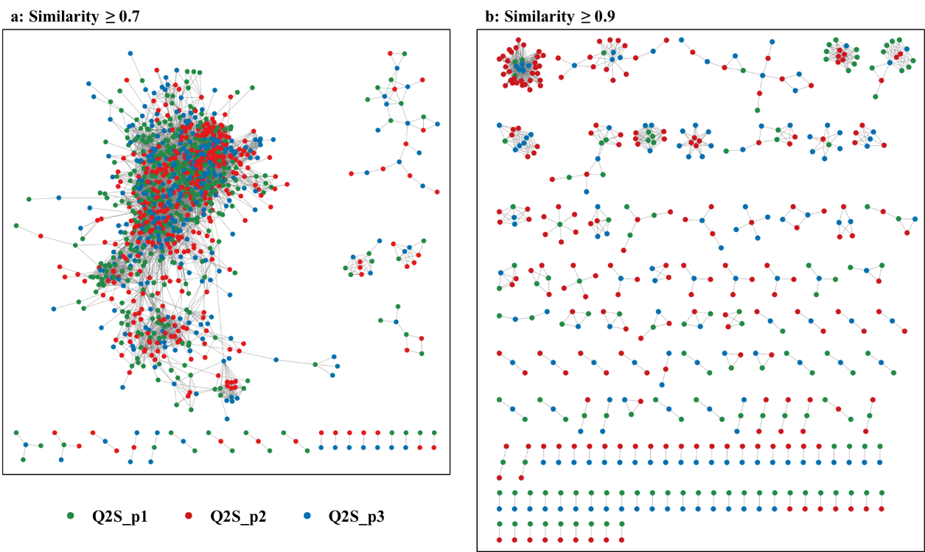
Figure S3.5 Similarity networks of ChemE-G4 Q2S molecules constructed using pairwise Tanimoto scores (MACCS fingerprints) at two thresholds: (a) similarity ≥ 0.7; (b) similarity ≥ 0.9. Node colors indicate prompt origin (green = P1, red = P2, blue = P3).

Table S3.5 Summary of cluster statistics at similarity cutoff ≥ 0.9 in the ChemE-G4 Q2S dataset.
Cluster Type | Cluster Count | Total Molecules | Average Cluster Size
P1+P2+P3 | 24 | 215 | 8.96
P2+P3 | 38 | 120 | 3.16
P1+P3 | 35 | 84 | 2.40
P1+P2 | 28 | 80 | 2.86

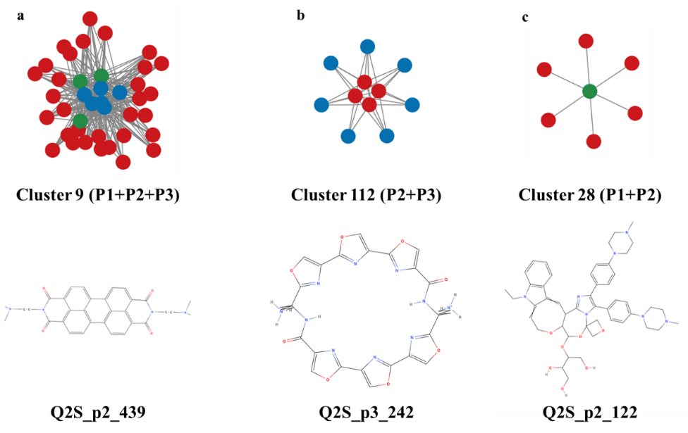
Figure S3.6 Largest clusters of each type identified at similarity cutoff ≥ 0.9 in the ChemE-G4 Q2S dataset: (a) cluster 9 (P1+P2+P3), (b) cluster 112 (P2+P3), and (c) cluster 28 (P1+P2). One representative molecule is shown for each cluster.
Supplementary Data
Raw ChemE-G4 outputs for the prompts
- q2s_p1.csv
- q2s_p2.csv
- q2s_p3.csv
Pairwise similarity matrices:
- q2s_p1–q2s_p2_sim_matrix.csv
- q2s_p1–q2s_p3_sim_matrix.csv
- q2s_p2–q2s_p3_sim_matrix.csv
Cytoscape network files:
- Similarity_network_0.7.cys
- Similarity_network_0.9.cys
Cluster statistics:
- cluster_analysis_0.9.csv
Cluster ID, prompt composition, cluster size, and per-prompt counts/ratios for similarity ≥ 0.9.

Supplementary Note 4. Functional Evaluation of G4-Targeted Generative Models
This Note provides the functional evaluation data supporting the G4-targeted molecular generation results. Analyses include chemical-space visualization of generated ligands, docking-score distributions across multiple G4 structures, GLAM-based activity prediction, and experimental validation by FRET melting assays. All associated data files are provided in the Supplementary Note 4/ folder of the Supplementary Data package.

S4.1 Chemical-space visualization of generated ligands
TMAP projections were used to compare the structural distribution of generated molecules with their corresponding training sets. Red nodes represent generated ligands; blue nodes represent ligands from the training set.

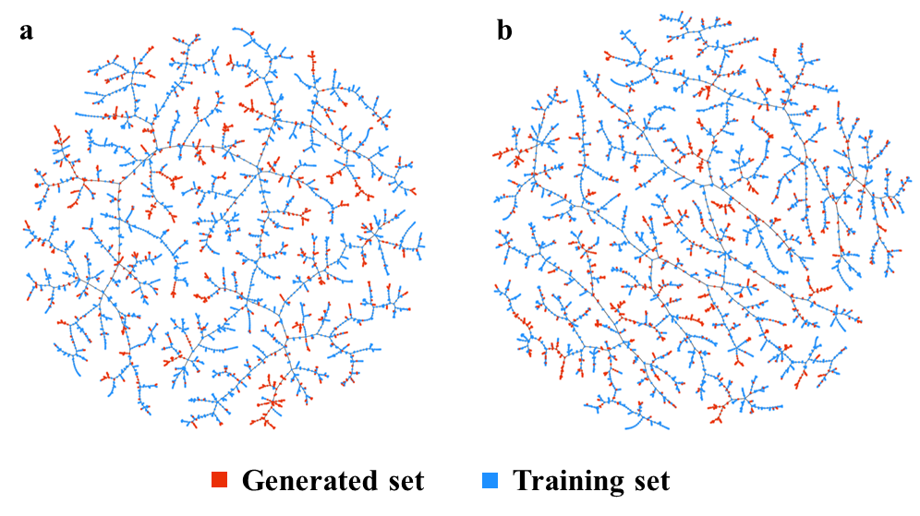
Figure S4.1 TMAP-based structural distribution of generated ligands and their corresponding training sets. Red nodes represent molecules generated by the fine-tuned models; blue nodes represent molecules from the training set. (a) Instruct-G4 (G-quadruplex ligands); (b) ChemE-G4 (G-quadruplex ligands).

Supplementary data
- S4.1_TMAP_embeddings/
Interactive visualization outputs (HTML + JS) for each model:
  - Instruct-G4.html / Instruct-G4.js
  - ChemE-G4.html / ChemE-G4.js

S4.2 Docking-score distributions across models and targets
Generated ligands were docked against multiple G-quadruplex targets to assess binding compatibility. Docking was performed using AutoDock Vina with standardized parameter settings.

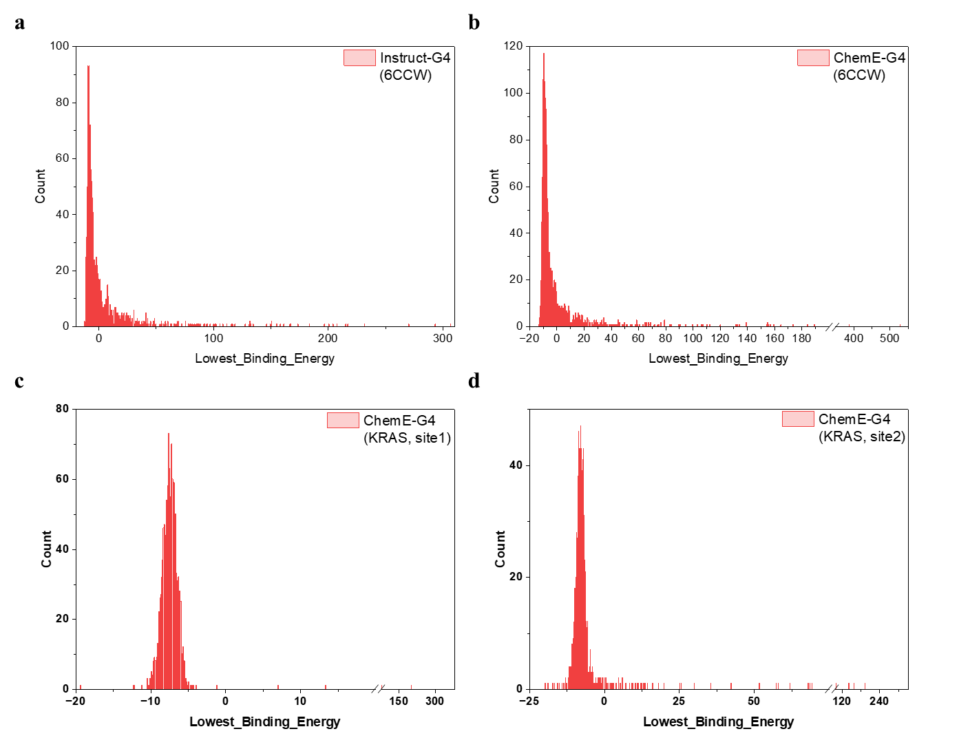
Figure S4.2 Full distribution of docking scores for all generated G4 ligands across multiple models and targets.
(a) Instruct-G4 docked against the human telomeric G4 (PDB: 6CCW).
(b–d) ChemE-G4 docked against three G4 targets: (b) human telomeric G4 (PDB: 6CCW), (c) KRAS promoter G4 (PDB: 7X8M, site 1), and (d) KRAS promoter G4 (PDB: 7X8M, site 2).

Supplementary data
- S4.2_Docking_Scores/
Docking scores of generated ligands across all models.
  - Instruct_G4_docking_results.csv
  - ChemE_G4_6CCW_docking_results.csv
  - ChemE_G4_7X8M_1_docking_results.csv
  - ChemE_G4_7X8M_2_docking_results.csv

S4.3 GLAM activity prediction results
GLAM-based activity predictions were used to provide an orthogonal estimate of G4-binding likelihood. All GLAM prediction outputs are provided in Supplementary Note 5.

S4.4 Experimental validation by FRET melting assays
Representative compounds were experimentally tested using FRET melting assays against human telomeric G4 DNA and dsDNA control.

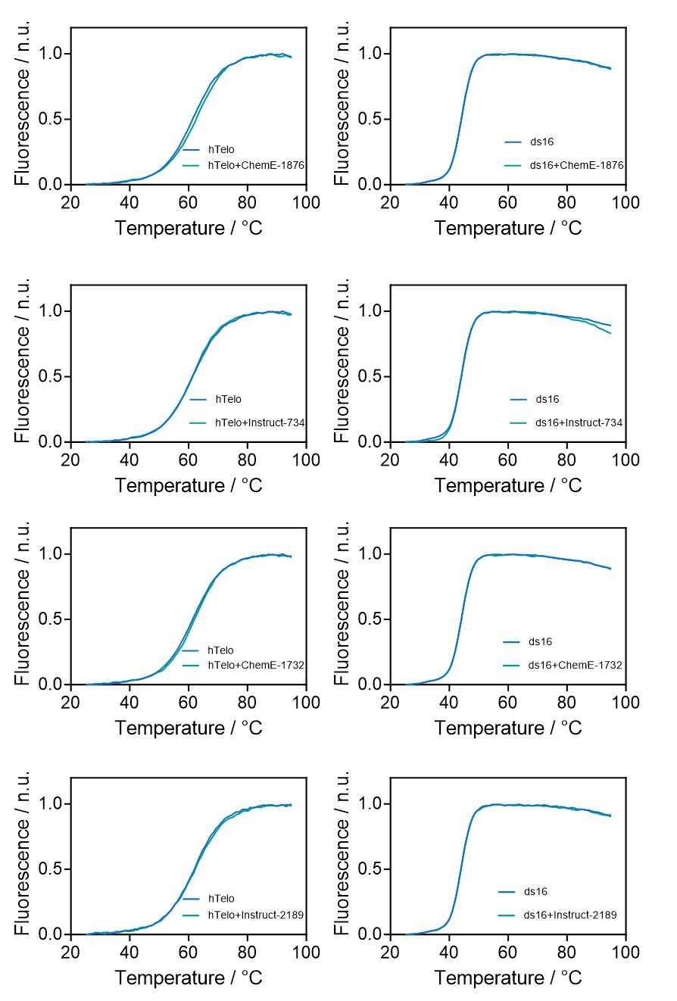

Figure S4.3 FRET melting curves of human telomeric G4 and dsDNA in the presence of representative ligands.

Supplementary Note 5. GLAM Model Training and Evaluation
This Note provides the data and procedures used to train, tune, and evaluate the GLAM model for predicting G4-binding activity. Details include dataset construction, model architectures, multi-stage hyperparameter optimization, cross-validation performance, independent-set evaluation, and scoring of large drug-like chemical libraries. All associated files are provided in the Supplementary Note 5/ folder of the Supplementary Data package.

S5.1 Training dataset and independent test set
We constructed a binary classification dataset to train and evaluate the GLAM model, consisting of chemically diverse positive and negative examples that reflect real-world challenges in ligand design.
Positive class: We compiled a curated set of positive examples from G4LDB entries published prior to January 1, 2023. These compounds are structurally diverse and experimentally validated for G-quadruplex (G4) binding activity, as reported in peer-reviewed studies. Ligands targeting different G4 topologies (parallel, antiparallel, hybrid) and nucleic acid contexts (e.g., promoter regions, telomeric sequences) were included to ensure coverage across G4 structural heterogeneity.
Negative class: To construct a pharmacologically realistic negative set, we selected FDA-approved small-molecule drugs with no known G4-binding activity. To ensure structural dissimilarity and avoid inductive bias, only compounds with a maximum Tanimoto similarity score below 0.4 to any G4LDB ligand were retained. This filtering step eliminates close analogs of known G4 binders, minimizing trivial decoys and ensuring the negative class remains chemically diverse and relevant.
Independent test set: To assess the model's generalization capability, we constructed an external test set comprising both positive and negative examples. The positive class consists of all G4LDB entries added after January 1, 2023, which were excluded from model development to prevent temporal data leakage. The negative class includes small molecules randomly selected from an internal high-throughput screening campaign in which no G4-binding activity was observed. The full list of test compounds is provided in the Supplementary Data.
The final training dataset comprised 3,569 positive and 2,695 negative compounds, with approximate class balance sufficient to mitigate model bias. The independent test set included 608 compounds, of which 304 were positive, derived from 58 distinct publications.

Supplementary data
- dataset_training_positives.csv
G4LDB ligands published before 2023, used as the positive training set for GLAM.
- dataset_training_negatives.csv
FDA-approved small molecules with no known G4 affinity, selected as the negative training set.
- test_set_predictions.csv
Independent test set combining post-2023 G4LDB ligands (positives) and HTS-screened inactive compounds (negatives).

S5.2 Model architecture and hyperparameter tuning
GLAM framework
The GLAM model employs a GNN-based architecture. SMILES inputs were converted into molecular graphs and processed following the standard GLAM pipeline. Data were split into:
- 80% training
- 10% validation
- 10% internal test

Multi-stage hyperparameter tuning
A structured, multi-stage strategy was used:
- Initial phase:
A fixed architecture was trained using a set of randomly sampled configurations (init_config), each with a unique seed.
- Model selection and blending:
Top-performing models based on validation ROC-AUC were selected for ensemble-style blending (top_blend).
- Robustness evaluation:
Selected configurations were retrained with multiple seeds (high_seed) to obtain averaged performance.
Tables S5.1 and S5.2 summarize configuration groups and cross-validation results. The configuration from group V15 was selected as the final GLAM model.

Table S5.1 Configuration groups used in the multi-stage hyperparameter tuning process. Each group is defined by the number of randomly sampled base models (init_config), the number of top-performing models selected for blending (top_blend), and the number of high-seed retrainings (high_seed) used for performance averaging.
Group | init_config | top_blend | high_seed
V1 | 10 | 1 | 3
V2 | 10 | 3 | 5
V3 | 10 | 5 | 7
V4 | 10 | 7 | 10
V5 | 15 | 1 | 3
V6 | 15 | 3 | 5
V7 | 15 | 5 | 7
V8 | 15 | 7 | 10
V9 | 30 | 1 | 3
V10 | 30 | 3 | 5
V11 | 30 | 5 | 7
V12 | 30 | 7 | 10
V13 | 50 | 1 | 3
V14 | 50 | 3 | 5
V15 | 50 | 5 | 7
V16 | 50 | 7 | 10
Table S5.2 Cross-validation performance metrics for selected hyperparameter configurations.
Group | AUC | Accuracy | Precision | Recall
V1 | 0.972901 | 0.926518 | 0.950549 | 0.925134
V2 | 0.980392 | 0.9377 | 0.963989 | 0.930481
V3 | 0.977941 | 0.923323 | 0.935829 | 0.935829
V4 | 0.97949 | 0.934505 | 0.958678 | 0.930481
V5 | 0.975236 | 0.928115 | 0.982405 | 0.895722
V6 | 0.978238 | 0.923323 | 0.947802 | 0.92246
V7 | 0.981209 | 0.93131 | 0.950954 | 0.933155
V8 | 0.974079 | 0.912141 | 0.932249 | 0.919786
V9 | 0.980827 | 0.934505 | 0.963788 | 0.925134
V10 | 0.983161 | 0.9377 | 0.951482 | 0.94385
V11 | 0.972933 | 0.926518 | 0.94086 | 0.935829
V12 | 0.981347 | 0.926518 | 0.955556 | 0.919786
V13 | 0.967628 | 0.913738 | 0.918848 | 0.938503
V14 | 0.979087 | 0.936102 | 0.96648 | 0.925134
V15 | 0.983596 | 0.945687 | 0.964481 | 0.94385
V16 | 0.983405 | 0.944089 | 0.954424 | 0.951872

Threshold selection
GLAM produces a continuous score in [0, 1]. A stringent threshold of 0.9 was used to classify compounds as active.

Supplementary data
- glam_final_config.json
Final configuration of the GLAM model, including architecture, training hyperparameters, and optimizer settings used in cross-validation and independent test evaluation.

S5.3 Ten-fold cross-validation performance
Ten-fold cross-validation was performed on the training dataset. Evaluation metrics included ROC-AUC, accuracy, precision, and recall. Performance distributions across folds are shown in Figure S5.1. The fold with the highest ROC-AUC was selected for downstream evaluation.

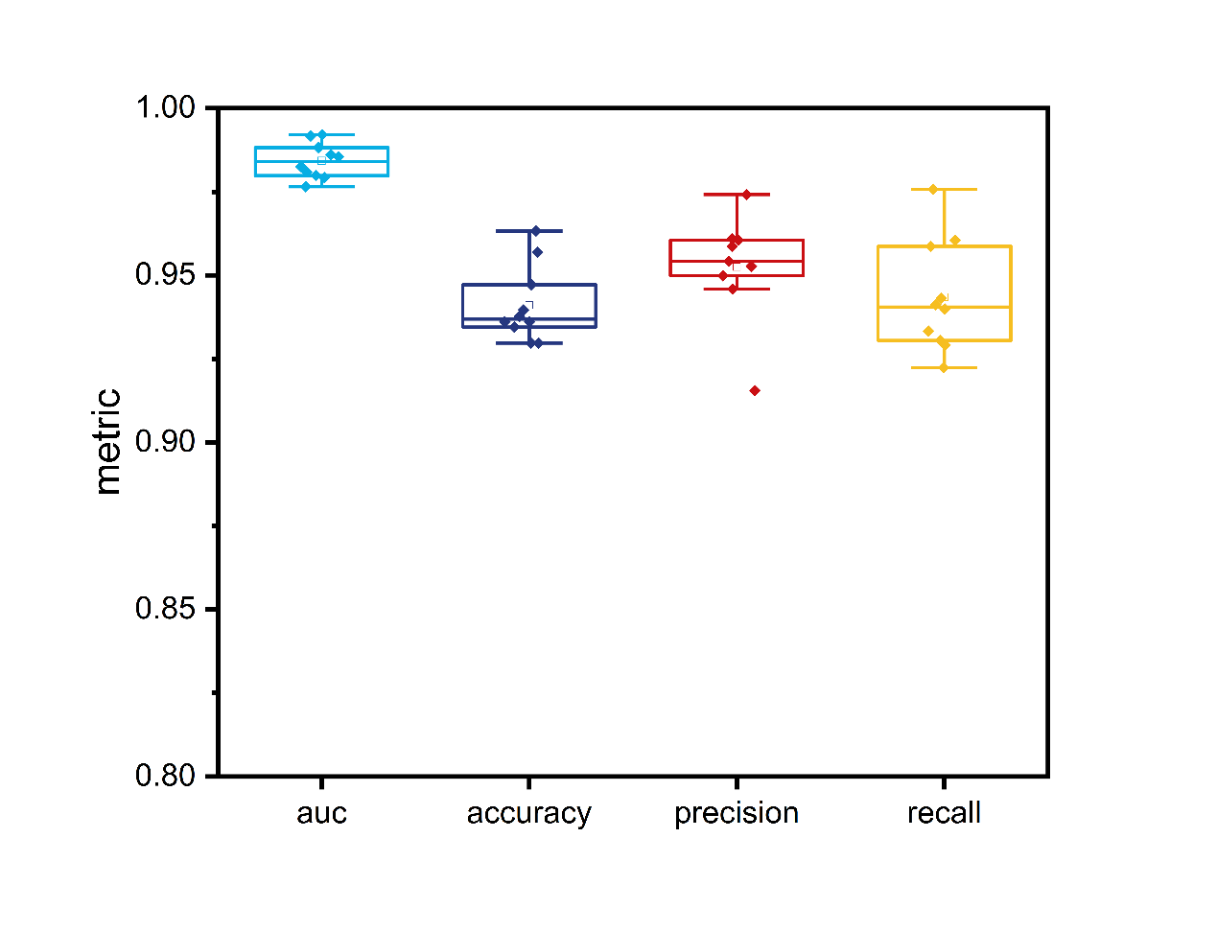
Figure S5.1 Boxplots showing the distribution of cross-validation performance metrics across 10 folds.

Supplementary data
- crossval_fold_metrics.csv
Performance metrics (AUC, accuracy, precision, recall) for each of the 10 cross-validation folds used to evaluate the GLAM model.

S5.4 Independent-set evaluation
The final GLAM configuration was evaluated on the independent test set. As shown in Figure S5.2, the model achieved:
- Accuracy: 0.90
- Precision: 0.86
- Recall: 0.96
- F1-score: 0.91

These results demonstrate strong sensitivity for detecting G4-active ligands, with a moderate false-positive rate.

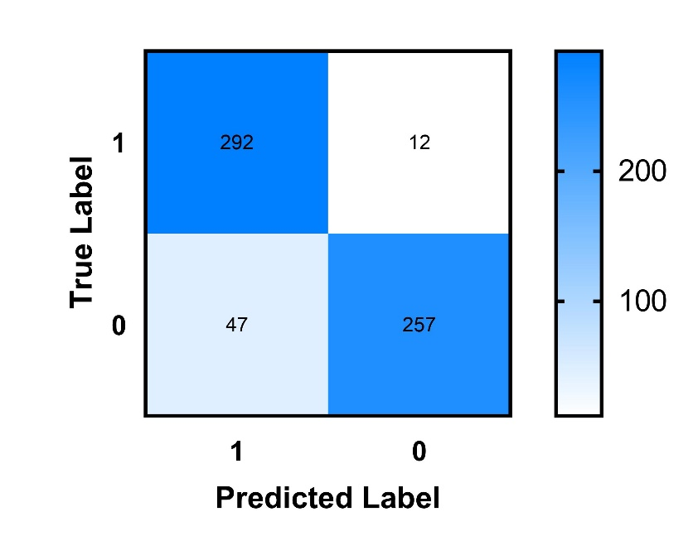
Figure S5.2 Confusion matrix of GLAM predictions on the independent test set (threshold = 0.9). The matrix summarizes performance across 608 test compounds, highlighting strong recall in identifying active G4 ligands.

Supplementary data
- test_set_predictions.csv
Prediction outputs of the final GLAM model on the independent test set. Includes SMILES, true labels, predicted labels, and confidence scores.

S5.5 Scoring of random drug-like molecules
To estimate the background activation rate, the final GLAM model was applied to 1,012,341 randomly sampled drug-like molecules from PubChem. All molecules satisfied Lipinski’s Rule of Five.
Using the same threshold of 0.9:
- 16.5% of drug-like compounds were predicted as G4-active.

This rate provides a baseline expectation for evaluating enrichment in LLM-generated libraries.

Supplementary data
- Random_druglike_set_predictions.csv
GLAM prediction results on 1,012,341 randomly sampled drug-like molecules from PubChem. Includes SMILES strings, predicted scores, and classification outcomes used to compute background activation rate.

S5.6 GLAM Predictions on Model-Generated Molecules
The finalized GLAM model was applied to ligand libraries generated by the G4-targeted models and baseline generators. Prediction scores and binary activity labels (threshold = 0.9) are provided for each molecule.

Supplementary data
- S5.6_GLAM_prediction_results/
  - ChemE_G4_ prediction_results.csv
  - CharRNN_prediction_results.csv
  - SPMM_PDS_ prediction_results.csv
  - Pocket2Mol_ prediction_results.csv
  - ChemGPT_ prediction_results.csv

Supplementary Note 6. Comparative Benchmarking Against Current Generative Models
This Note provides the benchmarking analyses used to compare SemantiChem with established generative frameworks. Evaluations include standard generation-quality metrics, G4 docking enrichment, and physicochemical property comparisons. All associated data files are provided in the Supplementary Note 6/ folder of the Supplementary Data package.

S6.1 Generation-quality benchmarks
Generation performance was compared using standard metrics from the MOSES benchmark suite. Baseline models included AAE, VAE, and CharRNN.

Table S6.1 Summary of generation performance metrics on the MOSES benchmark for three models (AAE, VAE, and CharRNN).
Models | AAE | VAE | CharRNN
Validity | 0.005 | 0.014 | 0.656
Unique@1k | 1 | 1 | 0.923
Novelty | 1 | 0.944 | 0.347

S6.2 Docking performance across generative models
To evaluate G4-binding compatibility, docking scores were computed for ligands generated by baseline models. Corresponding SemantiChem docking results are provided separately in Supplementary Note 4.

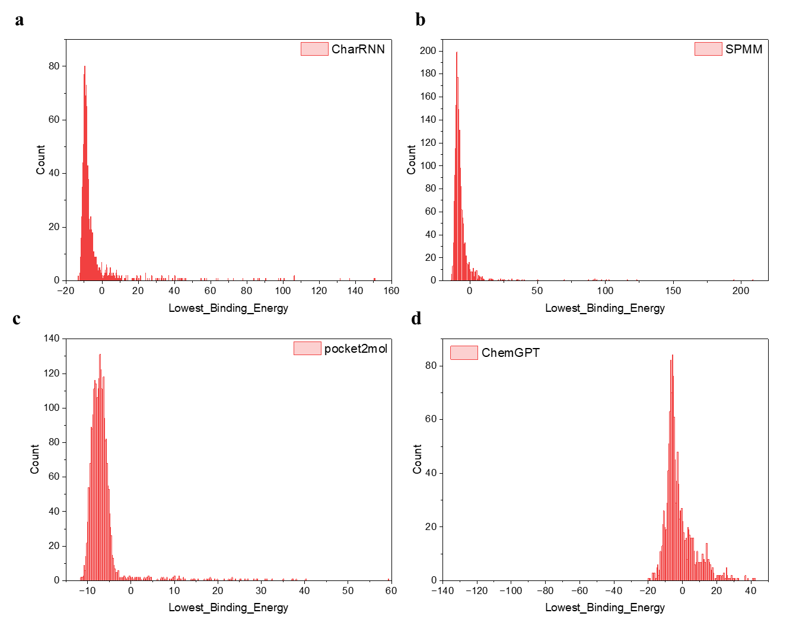
Figure S6.1 Full distribution of docking scores on 6CCW for baseline models. (a) CharRNN, (b) SPMM, (c) Pocket2Mol and (d) ChemGPT.

Supplementary data
- S6.2_Docking_Scores/
  - CharRNN_docking_results.csv
  - AAE_docking_results.csv
  - VAE_docking_results.csv
  - SPMM_PDS_docking_results.csv
  - Pocket2Mol_docking_results.csv
  - ChemGPT_docking_results.csv

S6.3 Comparative physicochemical analysis
To compare generative behavior across model architectures, five RDKit descriptors were analyzed: LogP, TPSA, molecular weight (MW), hydrogen bond donors (HBD), and hydrogen bond acceptors (HBA). Descriptor statistics were computed directly from the SMILES outputs. Descriptor calculation scripts are available to the editors and reviewers through the submission-version GitHub repository (https://github.com/ADNLab-SCU/SemantiChem). A Code Ocean capsule will also be prepared.

Table S6.2 Physicochemical property comparison across generative models. Values are reported as mean ± standard deviation for each model (CharRNN, SPMM, Pocket2Mol and ChemE-G4). Absolute differences (|Δ|) are computed relative to the G4LDB reference set.
Property | G4DLB | CharRNN |  | SPMM |  | Pocket2mol |  | ChemGPT |  | ChemE-G4 (this work)
Property | Value | Value | $$\left|∆\right|$$ | Value | $$\left|∆\right|$$ | Value | $$\left|∆\right|$$ | Value | $$\left|∆\right|$$ | Value | $$\left|∆\right|$$
LogP | 4.557±3.924 | 4.114±2.158 | 0.443 | 2.985±0.947 | 1.572 | 2.677±1.735 | 1.880 | 7.229±4.800 | 2.672 | 4.242±2.390 | 0.315
TPSA | 102.071±89.864 | 85.818±50.057 | 16.253 | 181.233±16.297 | 79.162 | 98.151±40.945 | 3.920 | 112.908±71.775 | 10.837 | 85.386±56.410 | 16.685
Mw | 590.860±331.000 | 500.890±136.110 | 89.960 | 571.570±24.651 | 19.294 | 318.640±126.610 | 272.220 | 678.116±247.995 | 87.256 | 513.240±179.090 | 77.610
HBD | 2.217±2.900 | 1.928±1.808 | 0.289 | 5.106±1.019 | 2.889 | 2.735±1.390 | 0.518 | 2.606±2.514 | 0.389 | 1.948±1.929 | 0.269
HBA | 7.228±5.498 | 6.049±2.930 | 1.179 | 10.038±0.926 | 2.810 | 3.898±1.684 | 3.330 | 6.999±4.126 | 0.229 | 6.150±3.646 | 1.078

Table S6.3 Comparison of SPMM-generated derivatives to the PDS scaffold. All molecules were generated by SPMM conditioned on the structure of PDS. Mean ± standard deviation is shown for each descriptor. Absolute differences (|Δ|) are computed relative to PDS and to the G4LDB reference set.
Property | G4LDB | PDS | SPMM | $\left|∆\right|$ to PDS | $\left|∆\right|$ to G4LDB
LogP | 4.557±3.924 | 2.695 | 2.985 ± 0.947 | 0.290 | 1.572
TPSA | 102.071±89.864 | 202.620 | 181.233 ± 16.297 | 21.387 | 79.162
Mw | 590.860±331.000 | 596.640 | 571.566 ± 24.651 | 25.074 | 19.294
HBD | 2.217±2.900 | 5.000 | 5.106 ± 1.019 | 0.106 | 2.889
HBA | 7.228±5.498 | 11.000 | 10.038 ± 0.926 | 0.962 | 2.810

Supplementary Note 7. Baseline Model Adaptation Attempts
This Note documents adaptation attempts made to extend existing protein- or general-purpose generative frameworks to nucleic acid systems. These models are widely used in molecular design but lack native support for nucleic acid pockets or nucleic acid–specific chemical semantics. All related scripts and logs are provided in the Supplementary Note 7/ folder of the Supplementary Data package.

S7.1 Pocket2Mol adaptation attempts
Minimal modifications for zero-shot generation
Pocket2Mol is designed for protein–ligand systems and does not natively support nucleic acid pockets. To enable zero-shot generation on the human telomeric G4 DNA (PDB: 6CCW), two minimal code adjustments were applied to the official implementation:
- Preprocessing bypass
The function pdb_to_pocket_data() was modified to skip protein-specific residue checks during pocket construction.
- Robust data loading
The dataset class __getitem__() in pl.py was patched with a try–except block to ignore malformed samples, increasing tolerance for nucleic acid topologies.
After these modifications, Pocket2Mol successfully generated samples in “Sampling for PDB pockets” mode. Out of 5,000 attempted generations, the first 2,600 valid molecules were retained for downstream benchmarking analyses.

Fine-tuning attempts and failure
To evaluate whether Pocket2Mol can be adapted beyond zero-shot usage, we assembled a finetuning dataset consisting of 859 pocket–ligand pairs from 79 curated G4–ligand complexes in G4LDB. Pockets were defined as all heavy atoms within 6 Å of each ligand. Ligands were standardized, converted to 3D using RDKit, and minimized with UFF.
Despite formatting the dataset for Pocket2Mol’s training pipeline and applying minimal compatibility patches, including disabling residue-level parsing in pdb_to_pocket_data() and modifying PocketLigandPairDataset to accept atom-level pockets, training consistently failed with AttributeError exceptions. These errors stemmed from deep architectural dependencies on protein residues (e.g., amino acid-based parsing, backbone Cα atoms, protein-centric atom naming conventions).
This failure indicates a deeper architectural mismatch: Pocket2Mol’s inductive biases toward protein residues and amino acid–based pocket embeddings cannot be reconciled with nucleic acid structures without substantial redesign.

S7.2 Adaptation attempts with the generalist language model ether0
To examine whether general-purpose instruction-tuned LLMs can perform NA-related molecular design, we tested the open-source ether0 model (arXiv:2506.17238) on two categories of prompts:
- G4 ligand generation, e.g. “Please show me a G-quadruplex ligand which hasn't been reported. Be sure the structure is novel and unique.”
- DNA binding retrieval, e.g. “Generate the SMILES of a well-known, experimentally validated small molecule that binds to DNA through intercalation or groove binding.”

As summarized in Table S7.1, ether0 was able to produce formatted outputs and SMILES strings, but responses showed limited biological grounding. Safety filters frequently blocked NA-targeting queries, and successful generations often yielded chemically irrelevant structures.
These observations indicate that while generalist models can technically respond to molecular design prompts, they are not aligned with NA-specific requirements. In contrast, task-adapted frameworks such as SemantiChem are explicitly trained to interpret NA design logic and produce biologically meaningful outputs.

Table S7.1 Summary of ether0 responses to nucleic acid-related design prompts.
Prompt Category | ether0 Response Summary | Failure Type
G-quadruplex ligand | Misinterpreted “G” as gallium/gadolinium; failed to generate relevant structure | Chemical misunderstanding
 | Returned “unsafe question” in 4 out of 6 rounds | Safety misclassification
 | One output SMILES was unrelated, lacking planarity/aromaticity | Functionally irrelevant
DNA binder | Initially flagged as unsafe (benzylamine = “chemical weapon”) | Incorrect safety rejection
 | Eventually returned benzimidazole, but without context or rationale | Weak biological grounding
 | Repeated generic descriptions of adenine/purines instead of generating output | Prompt misunderstanding

Supplementary data
- ether0_prompt_responses.docx
Raw prompt–response logs from five rounds of testing the ether0 model on nucleic acid-related generation tasks. Includes full outputs, model reasoning traces, and failure behaviors for G-quadruplex and DNA-binding prompts discussed in Section S6.

Supplementary Note 8. Generalizability of SemantiChem to rRNA and Mpro
This Note provides the supporting analyses for evaluating the generalizability of SemantiChem to non-G4 nucleic acid and protein targets. Two target families were examined: structured ribosomal RNA (rRNA) and the SARS-CoV-2 main protease (Mpro). Evaluations include chemical-space visualization, target-specific docking distributions, and cross-target physicochemical comparisons. All data files referenced here are provided in the Supplementary Note 8/ folder of the Supplementary Data package.

S8.1 TMAP-based structural distribution
To assess the structural diversity and target-specific clustering behavior of the SemantiChem variants adapted to rRNA and Mpro, TMAP embeddings were generated using molecular fingerprints computed from all model outputs.

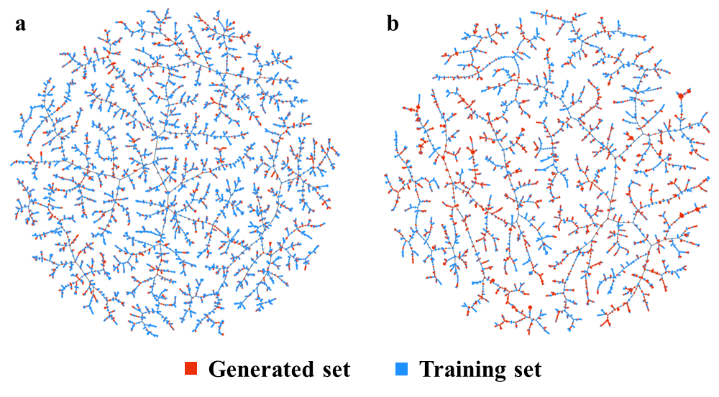
Figure S8.1 TMAP-based structural distribution of generated ligands and their corresponding training sets. Red nodes represent molecules generated by the fine-tuned models; blue nodes represent molecules from the training set. (a) ChemE-rRNA (ribosomal RNA ligands); (b) ChemE-Mpro (SARS-CoV-2 main protease ligands).

Supplementary data
- S8.1_TMAP_embeddings/
Interactive visualization outputs (HTML + JS) for each model:
  - rRNA.html / rRNA.js
  - Mpro.html / Mpro.js

S8.2 Docking-score distributions across rRNA and Mpro
Generated ligands from ChemE-rRNA and ChemE-Mpro were docked to their respective targets. Docking scores were computed using standard Vina settings and are reported for all valid molecules.

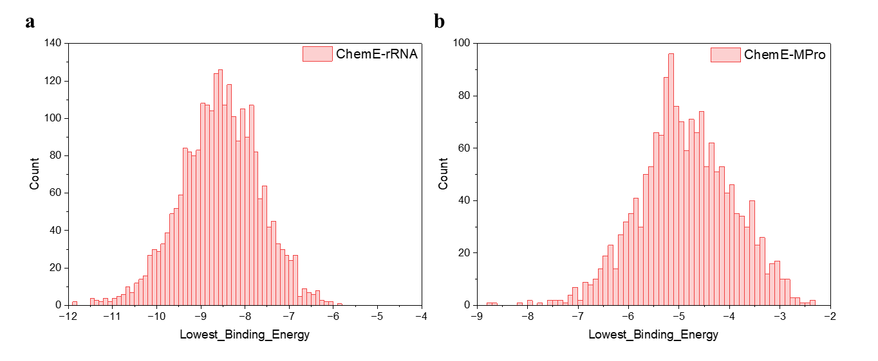
Figure S8.2 Full distribution of docking scores for generated compounds from (a) ChemE-rRNA and (b) ChemE-Mpro models.

Supplementary data
- S8.2_Docking_Scores/
Docking scores of generated ligands across all models.
  - rRNA_docking_results.csv
  - Mpro_docking_results.cs

S8.3 Physicochemical consistency across targets
Standard RDKit descriptors were computed for ligands generated by ChemE-G4, ChemE-rRNA, and ChemE-Mpro. Reported descriptors include LogP, TPSA, molecular weight (MW), hydrogen bond donors (HBD), and hydrogen bond acceptors (HBA). Summary statistics are provided for each model-target combination. Descriptor calculation scripts are available to the editors and reviewers through the submission-version GitHub repository (https://github.com/ADNLab-SCU/SemantiChem). A Code Ocean capsule will also be prepared.

Table S8.1 Physicochemical consistency across targets. For each target (G4, rRNA and Mpro), properties are shown for both the training set and model-generated molecules. Values are reported as mean ± standard deviation. Absolute differences (|Δ|) indicate deviation between generated outputs and their corresponding training distributions.
Property | G4 |  |  | rRNA |  |  | Mpro
Property | Training set | Generated set | $$\left|∆\right|$$ | Training set | Generated set | $$\left|∆\right|$$ | Training set | Generated set | $$\left|∆\right|$$
LogP | 4.557±3.924 | 4.242±2.390 | 0.315 | 3.524±1.068 | 3.412±1.139 | 0.112 | 2.333±2.668 | 3.186±3.034 | 0.853
TPSA | 102.071±89.864 | 85.386±56.410 | 16.685 | 71.414±29.294 | 71.300±27.808 | 0.114 | 72.818±60.410 | 66.163±48.260 | 6.655
Mw | 590.86±331.00 | 513.24±179.09 | 77.61 | 372.51±78.18 | 365.14±68.91 | 7.37 | 300.14±170.55 | 305.23±156.60 | 5.09
HBD | 2.217±2.900 | 1.948±1.929 | 0.269 | 1.219±0.954 | 1.186±0.941 | 0.033 | 1.643±1.994 | 1.513±1.609 | 0.130
HBA | 7.228±5.498 | 6.150±3.646 | 1.078 | 4.660±1.762 | 4.579±1.717 | 0.081 | 4.062±3.407 | 3.594±2.792 | 0.468

