UV mutagenesis and tolerance adaptive laboratory evolution of Pichia fermentans modulate the membrane-bound xylose uptake transporters (XUT) genes for enhanced xylitol production
Ramalingam Kayalvizhi¹ and Samuel Jacob^{1*}
¹Department of Biotechnology, School of Bioengineering, College of Engineering and Technology, Faculty of Engineering and Technology, SRM Institute of Science and Technology, SRM Nagar, Chengalpattu Dist., Kattankulathur - 603203, Tamil Nadu, India
*Corresponding author: samueljb@srmist.edu.in

Table S1 Composition of the fermentation medium
Media components | Quantity (g/L)
Xylose | 100
Peptone | 20
Yeast extract | 10
Potassium dihydrogen phosphate | 0.5
Ammonium sulphate | 0.5
Magnesium sulphate | 0.5

Table S2 Fermentation kinetics parameters from experimental data of xylitol production using UV-irradiated strains of P. fermentans
Fermentation kinetic parameters | Unit | Xylitol produced by UV-irradiated strains of P. fermentans
Fermentation kinetic parameters | Unit | UV1C | UV2C | UV3C | UV4C | UV5C
Cell biomass
Maximum cell biomass concentration | g/L | 27.42 ± 0.18 | 28.28 ± 0.50 | 30.82 ± 0.43 | 28.07 ± 0.31 | 24.92 ± 0.33
Yield coefficient of cell biomass (Y_{x/s}) | g cell biomass/g substrate | 0.39 ± N.D. | 0.39 ± N.D. | 0.42 ± 0.01 | 0.42 ± 0.01 | 0.41 ± 0.01
Xylose (substrate)
Xylose uptake efficiency | % | 63.44 ± 0.91 | 71.77 ± 0.73 | 73.56 ± 0.29 | 65.78 ± 1.36 | 59.64 ± 0.97
Maximum xylose consumption rate | g/L.h | 0.77 ± N.D. | 0.85 ± 0.01 | 0.94 ± N.D. | 0.84 ± 0.02 | 0.76 ± 0.01
Xylitol (product)
Maximum xylitol concentration | g/L | 32.33 ± 0.42 | 37.60 ± 0.28 | 41.3 ± 0.67 | 32.67 ± 0.56 | 26.13 ± 0.45
Xylitol productivity | g/L.h | 0.36 ± N.D. | 0.45 ± N.D. | 0.53 ± 0.01 | 0.42 ± 0.01 | 0.34 ± 0.01
Xylitol yield | g xylitol/g xylose | 0.47 ± N.D. | 0.53 ± N.D. | 0.56 ± 0.01 | 0.49 ± 0.02 | 0.44 ± 0.01
Fermentation efficiency | % | 51.00 ± 0.47 | 57.58 ± 0.51 | 61.69 ± 1.22 | 54.67 ± 2.00 | 48.16 ± 0.78
The experiment was performed in triplicate and data were represented as mean ± SD (N.D. negligible deviation)

Table S3 Comparison of xylitol yields in yeast strains after physical and chemical mutagenesis
Yeast | Method of Mutagenesis | Xylitol yield (g/g of xylose) |  | Fold increase | Reference
Yeast | Method of Mutagenesis | Wild-type | Mutant strain | Fold increase | Reference
Pichia fermentans | Chemical mutagen -Ethyl methane sulfonate | 0.45 | 0.68 | 1.51 | Prabhu et al., (2020)
Candida tropicalis | UV irradiation | 0.77 | 0.81 | 1.05 | Rao Ravella sreenivas et al., (2006)
Candida tropicalis | UV irradiation followed by N-Methyl-N’-nitro-N-nitrosoguanidine exposure | 0.77 | 0.87 | 1.13 | Rao Ravella sreenivas et al., (2006)
Candida tropicalis | Chemical mutagen - Ethyl methane sulfonate | 0.48 | 0.83 | 1.73 | Singh et al., (2023)
Kluyveromyces marxianus | Chemical mutagen - Ethyl methane sulfonate | 0.48 | 0.67 | 1.40 | Kim et al., (2015)
Pichia fermentans | UV irradiation | 0.38 | 0.61 | 1.61 | This study

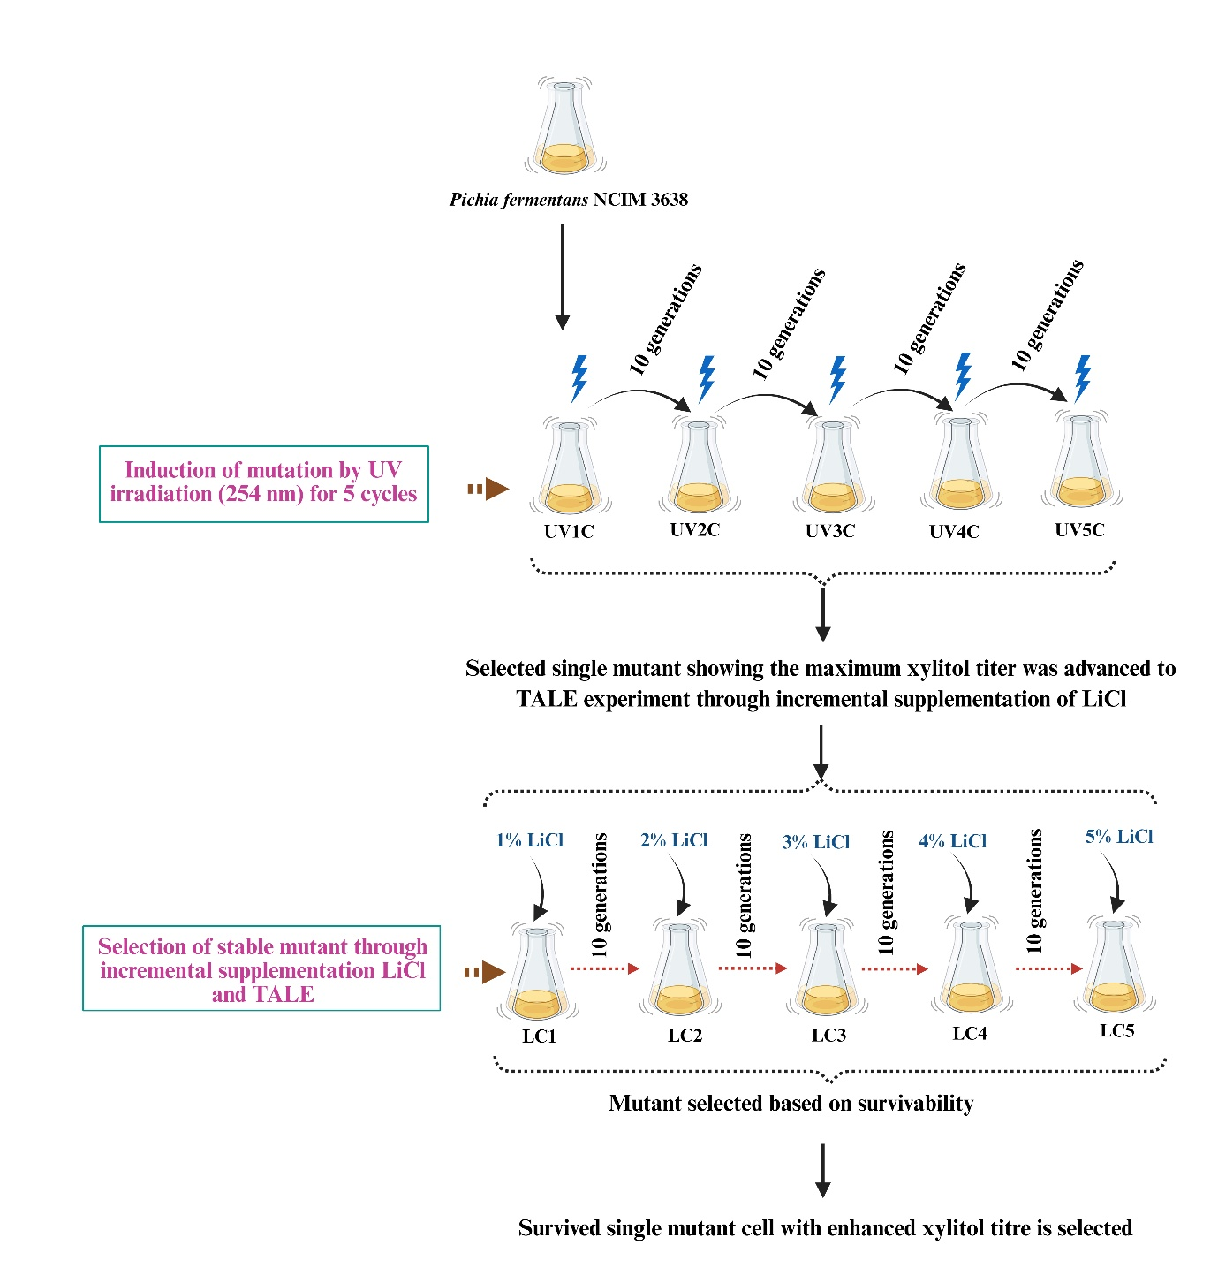
Fig. S1. Schematic representation of the methodology of UV mutagenesis and LiCl-based TALE in P. fermentans NCIM 3638

Fig. S2. Bright field microscopic images of Pichia fermentans (a) Wild-type (b) KS-MUT9

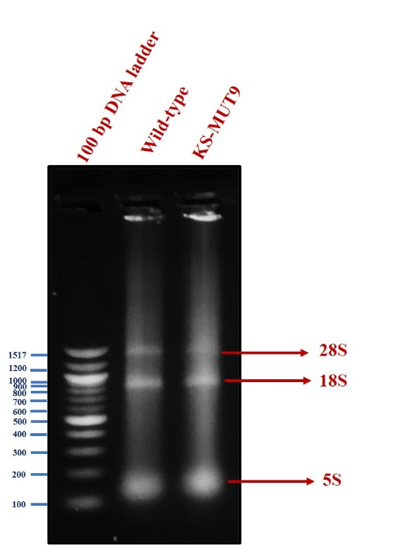
Fig. S3. Agarose gel electrophoresis of total RNA isolated from wild-type and mutant KS-MUT9 strains of Pichia fermentans

Fig. S4. Gradient PCR optimization of primers targeting XYL1, XYL2, XUT4, XUT6, XUT7, and 18S rRNA genes in Pichia fermentans NCIM 3638 at annealing temperatures of 50–60 °C. PCR products were analyzed by agarose gel electrophoresis. *M - DNA marker; red boxes indicate optimal annealing temperatures.

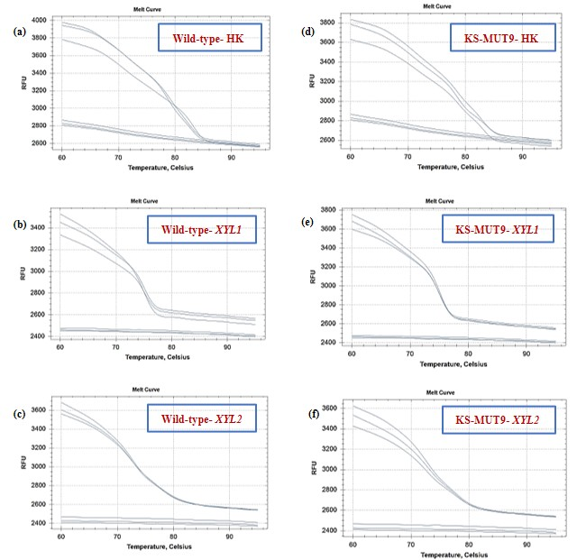
Fig. S5. Melt curve of real-time PCR SYBR assay of relative gene expression of xylose metabolizing gene XYL1 and xylitol metabolizing gene XYL2 in wild-type and mutant KS-MUT9 strains of Pichia fermentans. *HK- Reference gene (18S rRNA)
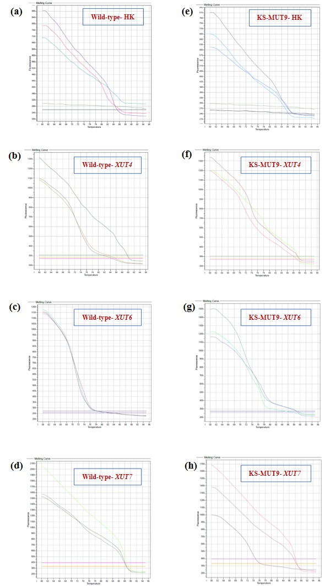
Fig. S6. Melt curve of real-time PCR SYBR assay of relative gene expression of xylose transporter genes (XUT4, XUT6 and XUT7) in wild-type and mutant KS-MUT9 strains of Pichia fermentans. *HK- Reference gene (18S rRNA)

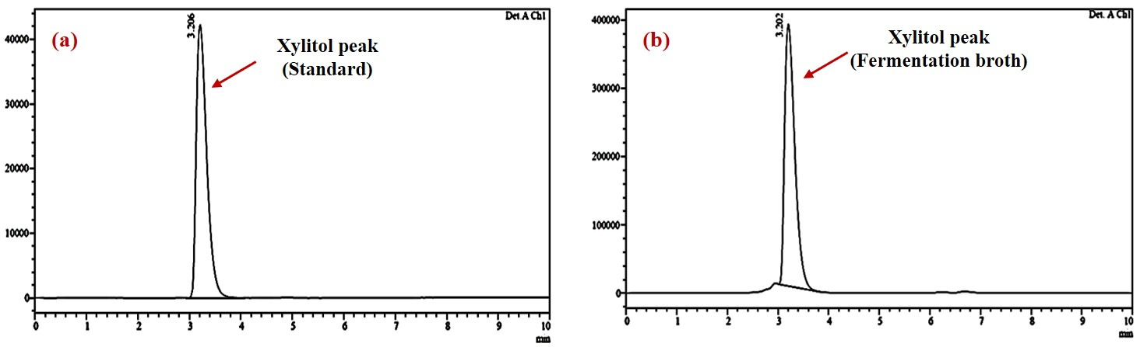
Fig. S7. HPLC chromatogram showing xylitol in the (a) standard and (b) fermentation broth of mutant KS-MUT9 strain. *Red arrow points the xylitol peak

Fermentation kinetics equations

$Yield coefficient of biomass\left(Y_{X/S}\right)=\frac{∆X}{∆S}=\frac{X_{f}-X_{0}}{S_{0}-S_{f}}$ (Eq. S1)
$Maximum xylose consumption rate (g/{L.h})= \frac{S_{0}-S_{f}}{t}$ (Eq. S2)
$Efficiency of xylose utilization \left(\%\right)=\frac{S_{0}-S_{f}}{S_{0}}×100$ (Eq. S3)
$Xylitol yield \left(g/g\right)=\frac{P_{f}}{S_{0}-S_{f}}$ (Eq. S4)
$Xylitol productivity \left(g/{L.h}\right)=\frac{Maximum xylitol concentration \left(g/L\right)}{Fermentation time (h)}$ (Eq. S5)
$Yield coefficient of xylitol \left(Y_{P/S}\right)=\frac{∆P}{∆S}=\frac{P_{f}-P_{0}}{S_{0}-S_{f}}$ (Eq. S6)
$Fermentation efficiency \left(\%\right)=\frac{Observed xylitol yield}{\begin{aligned}Theoretical xylitol yield \\ (0.91 g/{g } xylose) \end{aligned}}×100$ (Eq. S7)
where Y_{X/S} (g cell biomass produced/g xylose consumed) represents the yield coefficient for cell biomass; ΔX represents the change in cell biomass concentration (g/L); X₀ and X_{f} represent the initial and final cell biomass concentration (g/L); ΔS represents the change in xylose concentration (g/L); S₀ and S_{f} represent the initial and final xylose concentration (g/L); t represents fermentation time (h); Y_{P/S} (g xylitol produced/g xylose consumed) represents the yield coefficient for xylitol production; ΔP represents the change in concentration of xylitol (g/L); P₀ and P_{f} represent the initial and final xylitol concentration (g/L).

