Supplementary Table 1
List of Sybr green primers used for qPCR

Gene Name | Forward and Reverse PCR primer sequence
ICAM1 | GGTTGAACCCCACAGTCACCTATG  GCTGTAGATGGTCACTGTCTGCAG
IL1A | AGTGCTGCTGAAGGAGATGCCTGA  CCCCTGCCAAGCACACCCAGTA
IL1B | TGCACGCTCCGGGACTCACA  CATGGAGAACACCACTTGTTGCTCC
IL6 | AAATTCGGTACATCCTCGACG  TTTCACCAGGCAAGTCTCC
IL8 | GAGTGGACCACACTGCGCCA  TCCACAACCCTCTGCACCCAGT
MMP1 | ATCGGCCCACAAACCCCAAA  TGGCAGTTGTGGCCAGAAAACA
ACTB | AGAGCTACGAGCTGCCTGAC  AGCACTGTGTTGGCGTACAG
GAPDH | GAAGGTGAAGGTCGGAGTC  TTGAGGTCAATGAAGGGG
CDKN2A | CTGCCCAACGCACCGAATAG  CCACCAGCGTGTCCAGGAAG
CDKN1A | CTGCAGGGGACAGCAGAGG  CCGGCGTTTGGAGTGGTAG
HA-H2A.Z | ATGGCCTACCCCTACGACGTG  AACCGCCTTTGTCTTGGCCTTTC
H2AZ1 | GGTCCGATTAGCCTTTTCTCTG  AACCGCCTTTGTCTTGGCCTTTC

Supplementary Figure 1
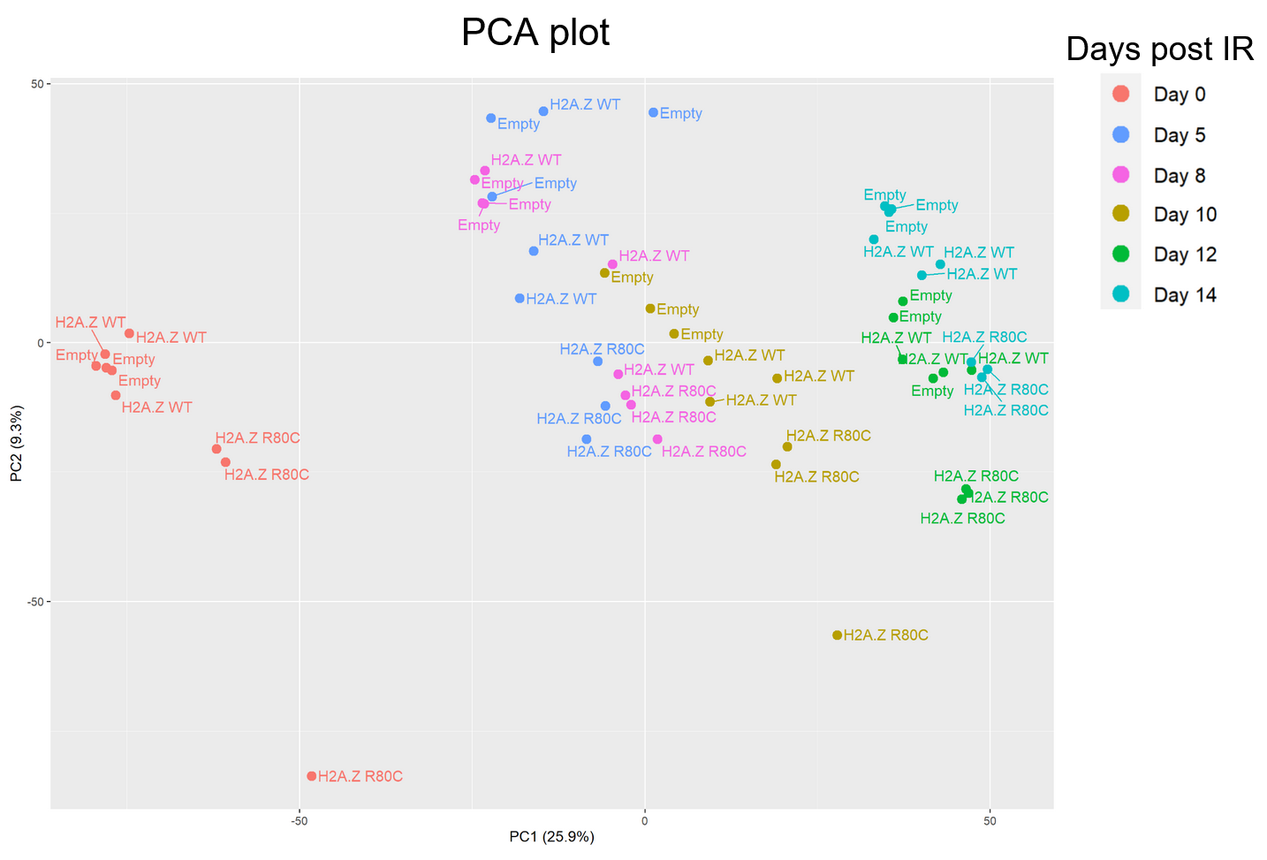
PCA plot showing PC1 and PC2 of bulk RNA-seq samples colored based on days elapsed post irradiation, including percentage of variances explained by the respective primary component

Supplementary Figure 2
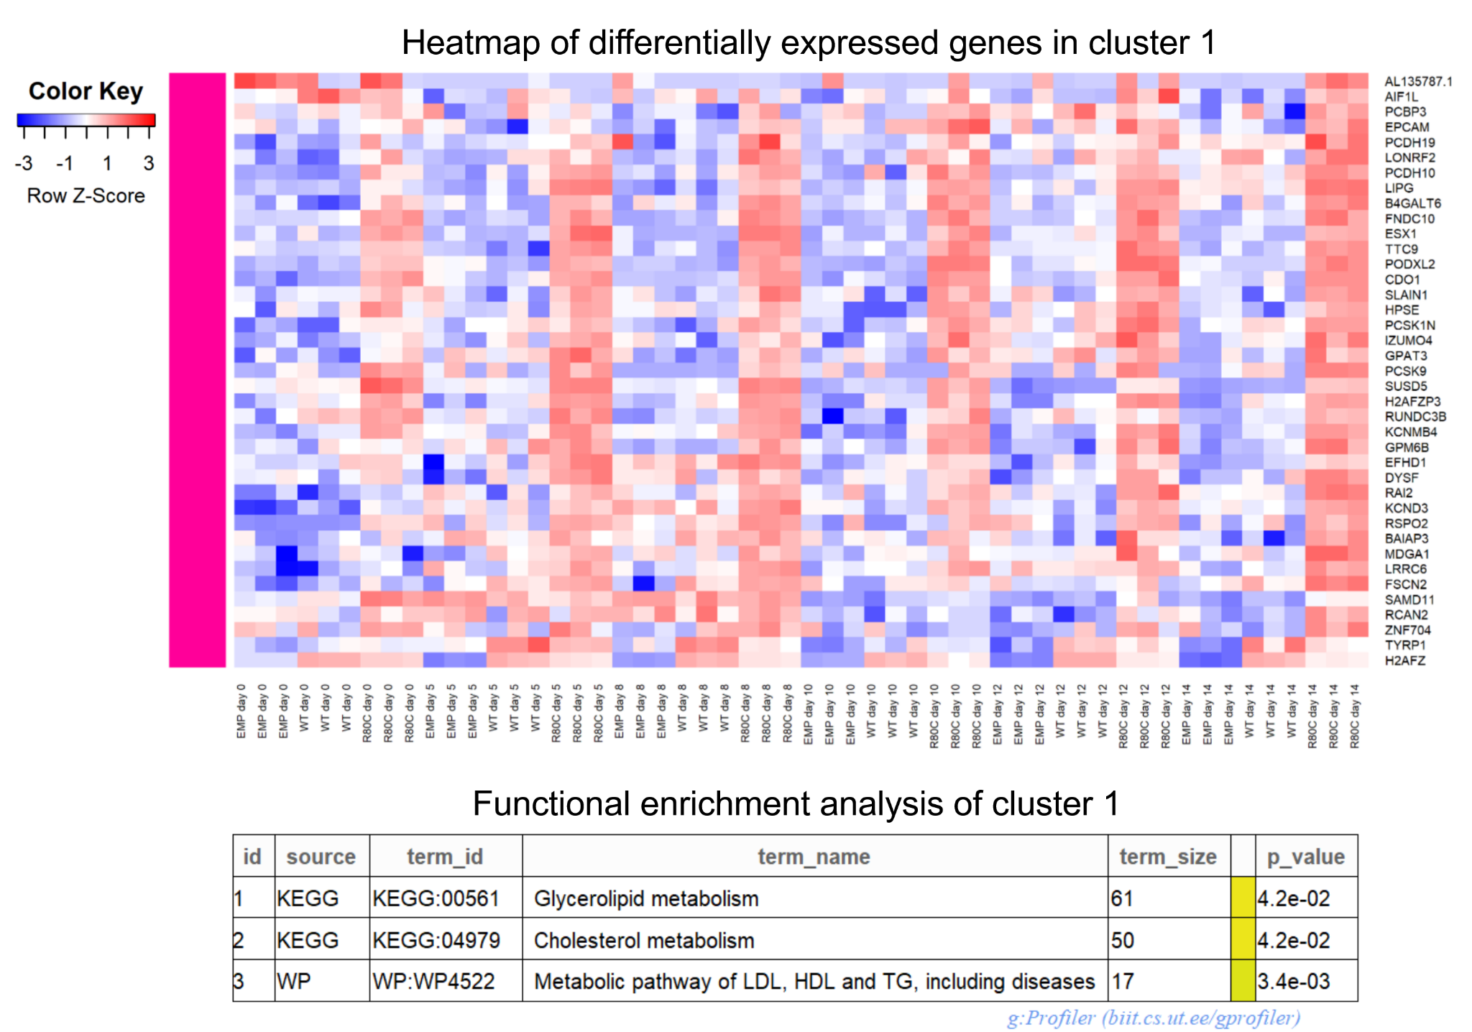
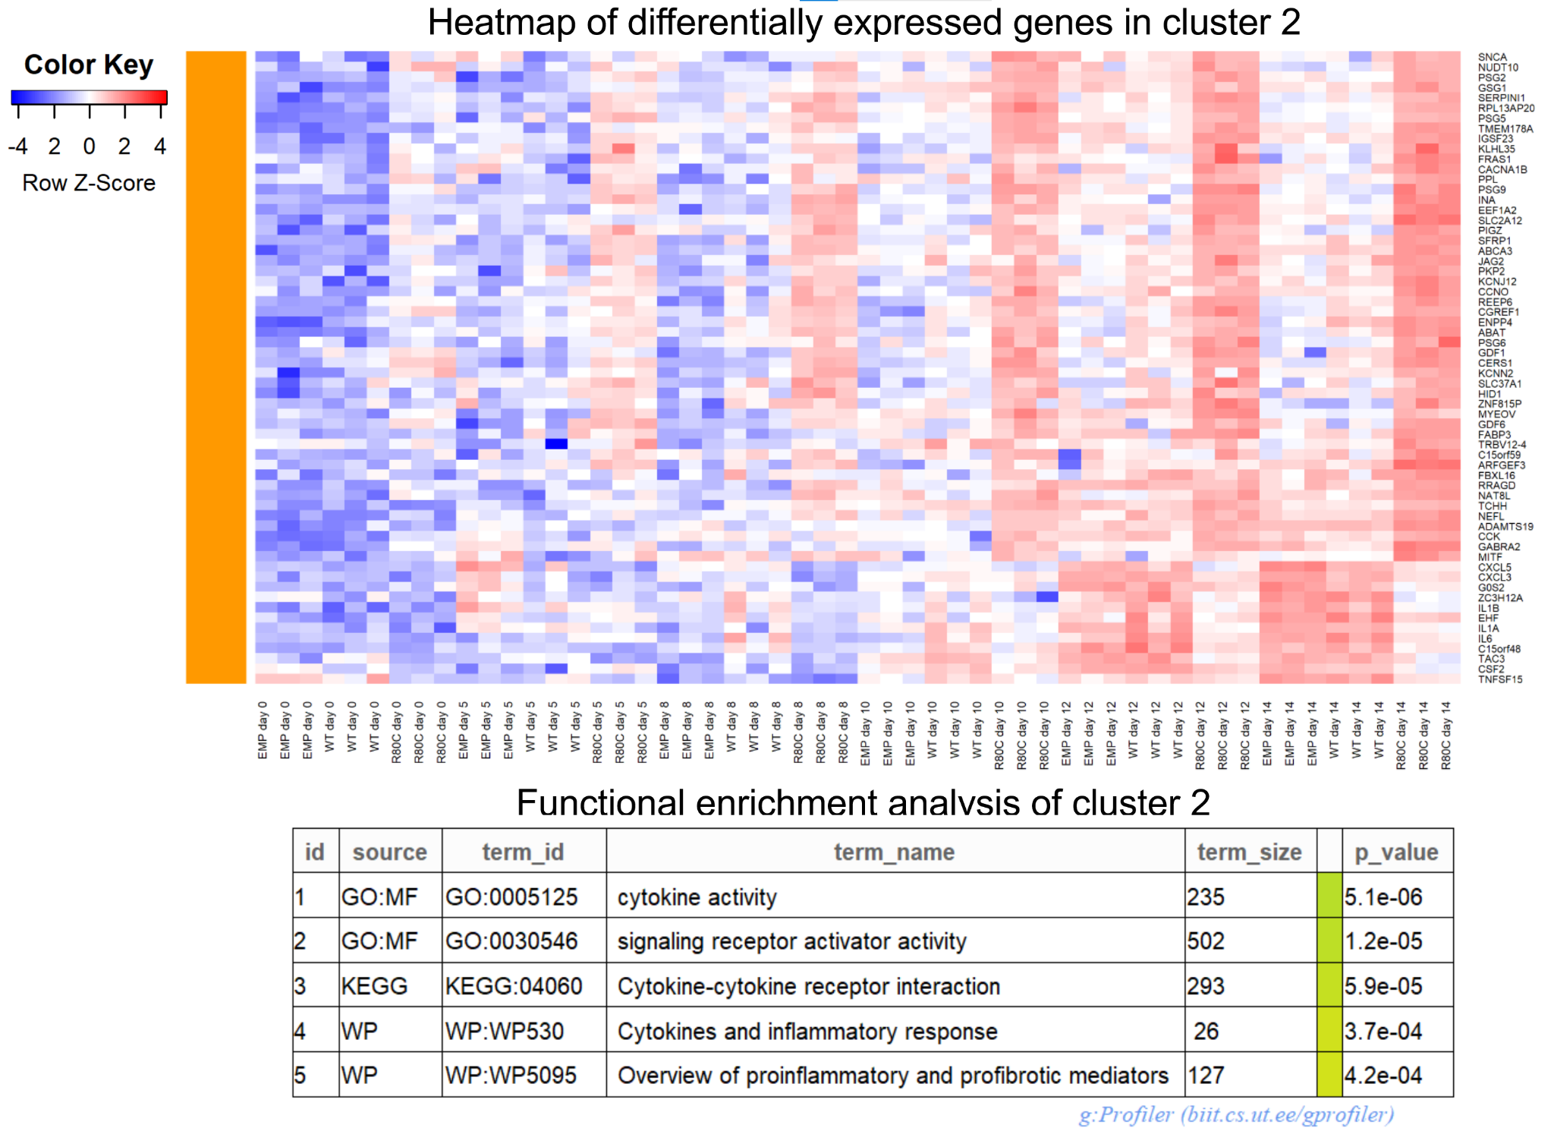
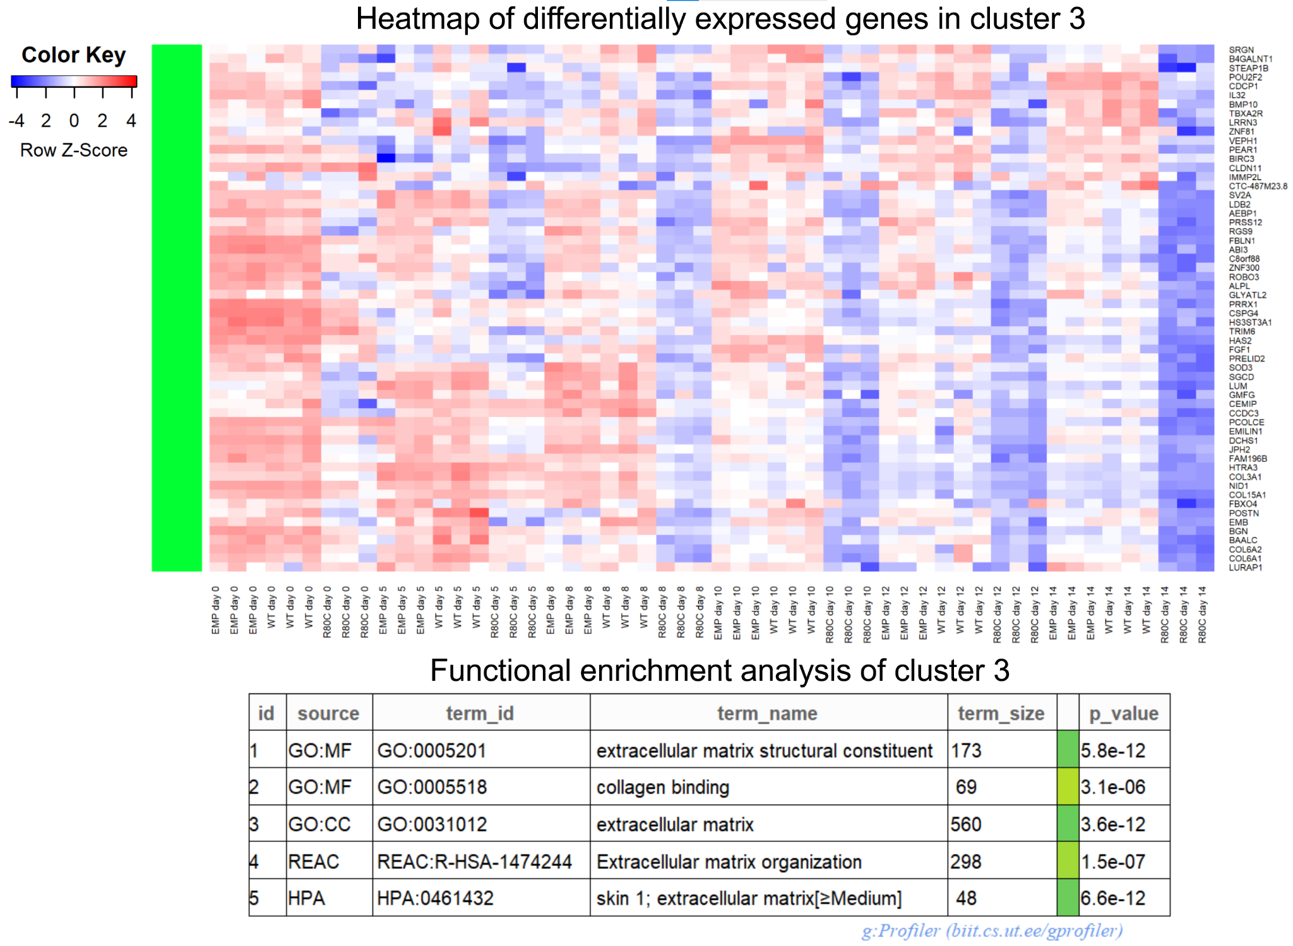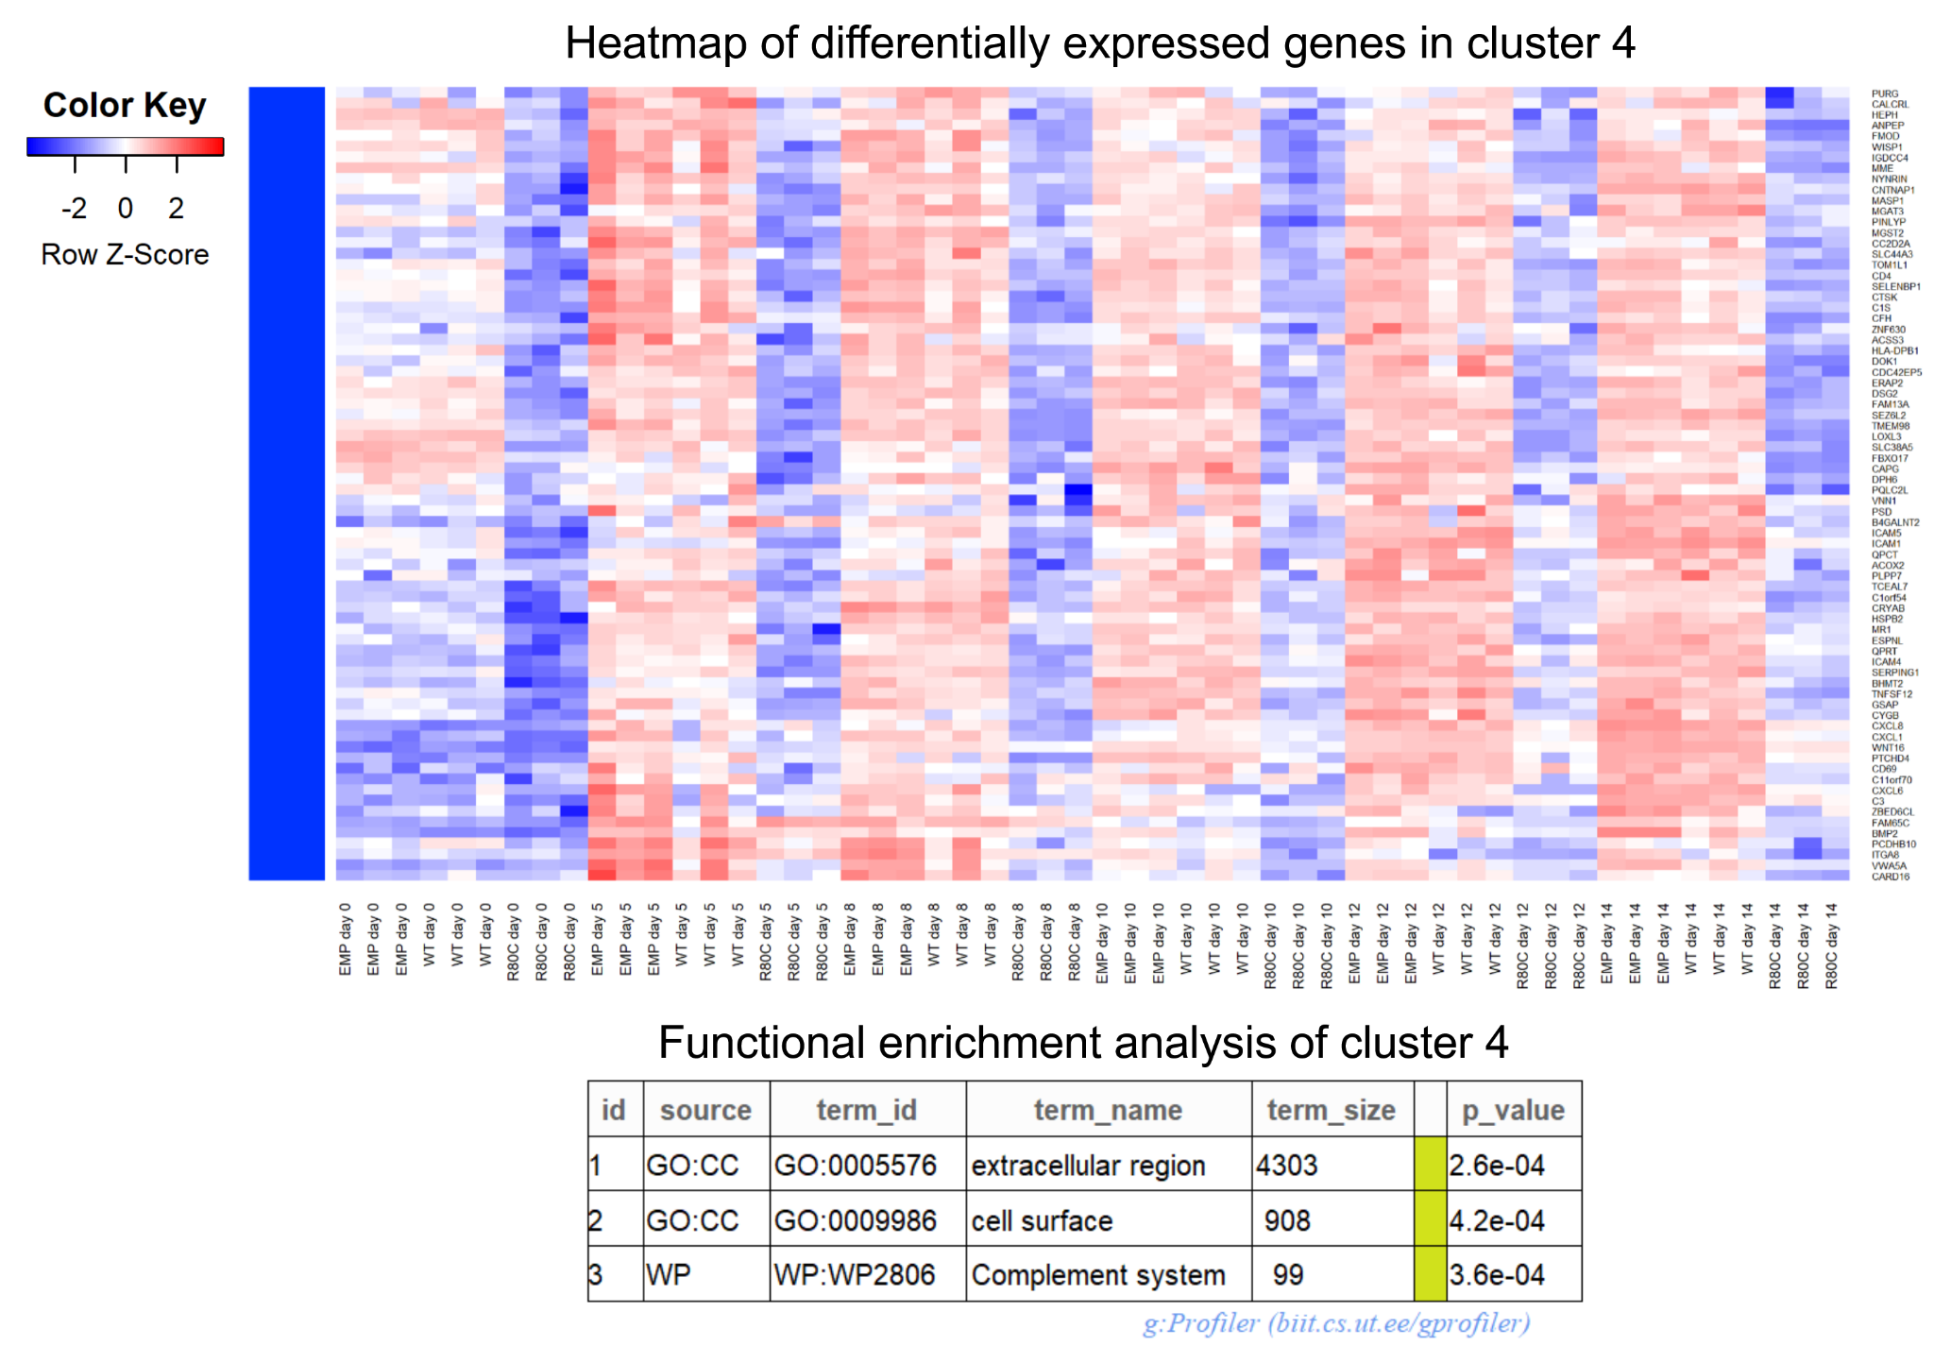

Supplementary Figure 3
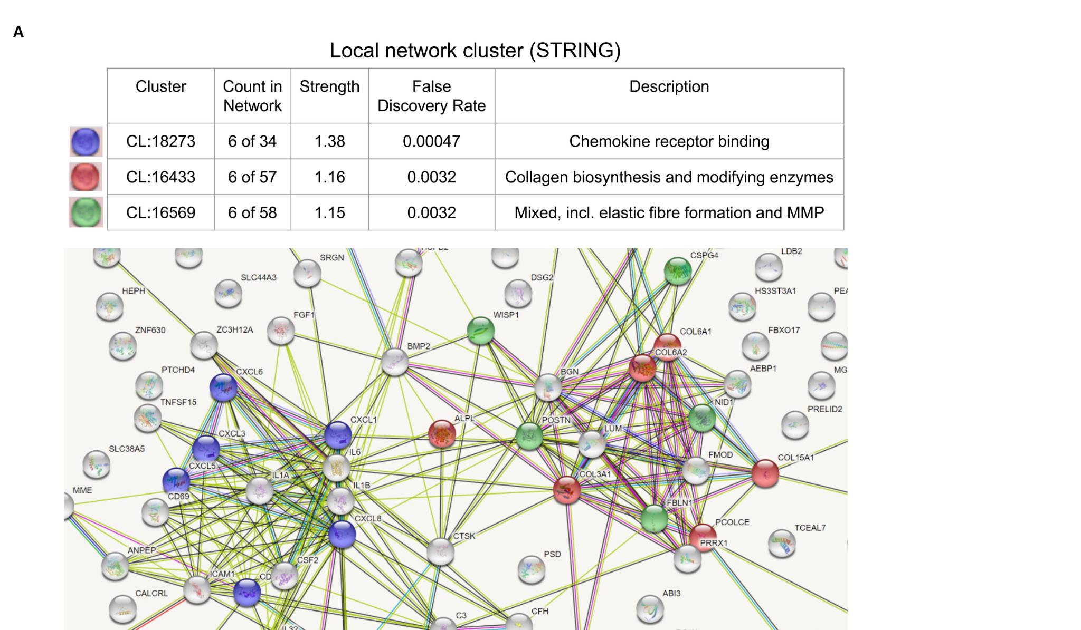

Supplementary Figure 4
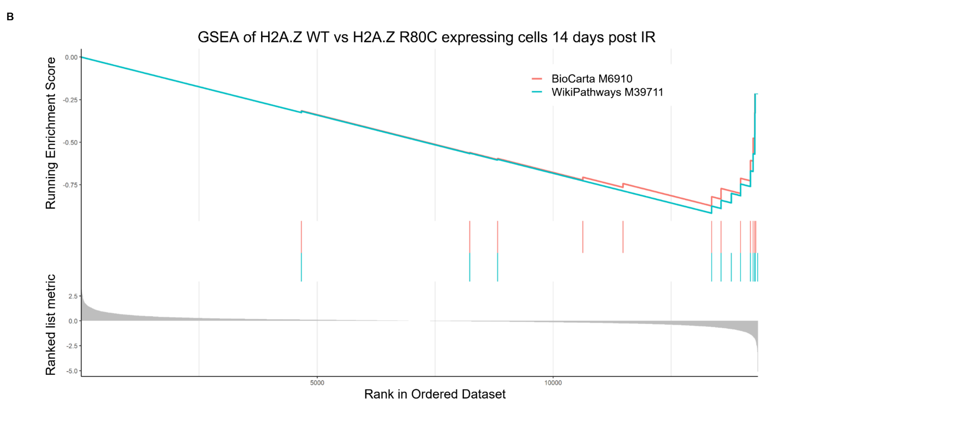
(A) STRING database analysis of genes enriched in H2A.Z WT expressing cells compared to H2A.Z R80C expressing cells at 14 days post irradiation (B) Gene Set Enrichment Analysis shows that genes associated with Cytokines and Inflammatory Response (BioCarta M6910 (BIOCARTA_INFLAM_PATHWAY) and WikiPathways M39711 (WP_CYTOKINES_AND_INFLAMMATORY_RESPONSE)) are strongly enriched in H2A.Z WT expressing cells compared to H2A.Z R80C expressing cells. BioCarta M6910 has an enrichment score of -0.87 and WikiPathways M39711 an enrichment score of -0.92.

Supplementary Figure 5

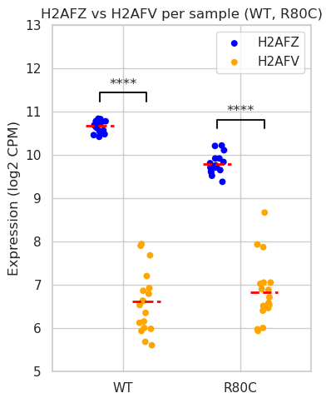
Expression (log2 CPM) of H2AFV and H2AFZ as observed in H2A.Z WT and H2A.Z R80C expressing cells from days 0 to 14 during senescence induction.

Supplementary Figure 6

