Uncropped gel image for Fig. 1C in “Histone variant H2A.Z mutant suppresses the senescence-associated secretory phenotype”

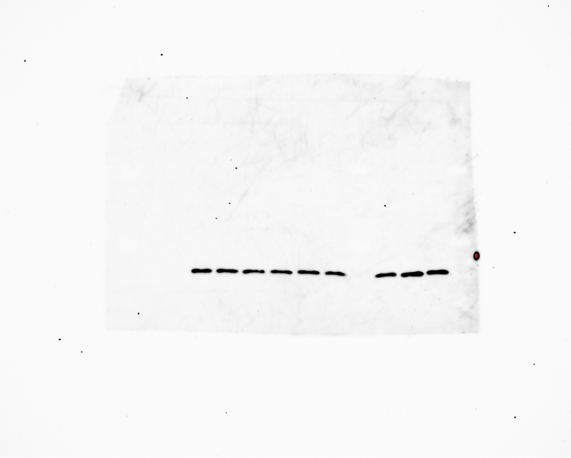
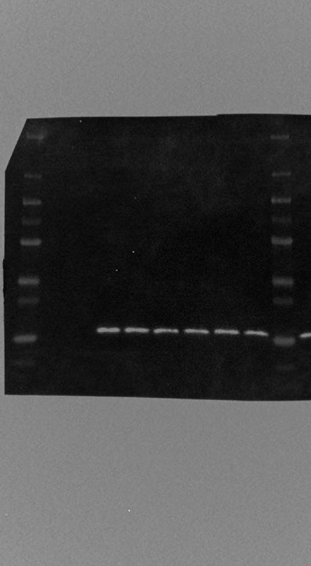
HA-tag

GAPDH
