Supplementary Materials for

Boson-peak-like anomaly caused by transverse phonon softening in strain glass
Shuai Ren,^{1, *} Hongxiang Zong,^{2, *} Xuefei Tao,² Yonghao Sun,¹ Baoan Sun,¹ Dezhen Xue,² Xiangdong Ding,^{2, +} and Weihua Wang^{1, +}
¹ Institute of Physics, Chinese Academy of Sciences, Beijing 100190, China
² State Key Laboratory for Mechanical Behavior of Materials, Xi’an Jiaotong University, Xi’an 710049, China
* These authors contributed equally to this work.
+ e-mail: dingxd@mail.xjtu.edu.cn, whw@iphy.ac.cn

- Difference of the microstructure in structural glass and strain glass
Strain glass is a glassy phenomenon in shape memory alloys, whose microstructure is crystalline, fundamentally different from the amorphous structure of structural glass. As shown in Supplementary Fig. 1, the structural glass inherits the disordering of the atomic configuration from the liquid and thereby exhibits an amorphous structure. In contrast, the strain glass inherits the crystalline structure of the parent phase^{1, 5}. Therefore, the average structure of strain glass is a simple crystalline structure, and the frozen martensitic nanodomains are the nanosized distorted regions with local strain order, which are coherent with the parent phase matrix.
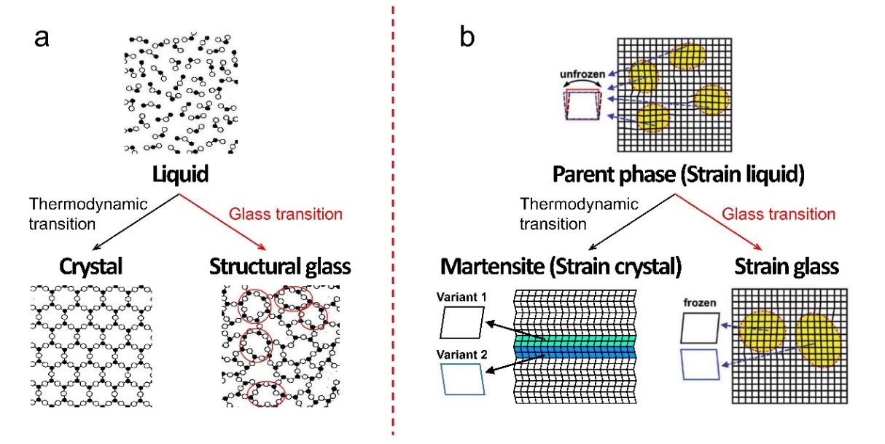
Supplementary Figure 1. Schematic pictures of microstructure in (a) structural glass and (b) strain glass. The microstructure of structural glass in (a) is amorphous, whereas the microstructure of strain glass in (b) is crystalline.
- Phase diagram of Ti_{50-x}Ni_{50+x} shape memory alloys
Supplementary Figure 2a exhibits the phase diagram of Ti_{50-x}Ni_{50+x} shape memory alloys, in which the strain glass appears when x exceeds a critical concentration around x = 1.5, consistent with the previous work²⁶. Supplementary Figure 2b exhibits the enthalpy change (ΔH) as a function of x, which is calculated by the heat flow curves in the inset of Supplementary Figure 2b. The ΔH gradually decreases to zero as x increases from 0 to 1.5, indicating that the martensitic transformation is gradually suppressed with the increase in x. Supplementary Figure 2c exhibits the frequency-dependent behavior of the storage modulus and tan δ: the dip temperatures (or peak temperatures) of the storage modulus (or tan δ) curves decrease when the frequency decreases. This is a typical evidence of strain glass, as reported by previous studies^{1, 4, 5}. The frequency-dependent behavior in strain glass indicates that the strain glass transition is a freezing transition from the parent phase which can be considered as a “strain liquid” phase¹, so it resembles the primary α-relaxation in metallic glass. By fitting the Vogel–Fulcher relation (ω=ω₀exp[-E_{a}/k_{B}(T_{g}-T₀)]), the ideal freezing temperature T₀ is determined to be ~172 K, consistent with the value in the previous studies²⁶.
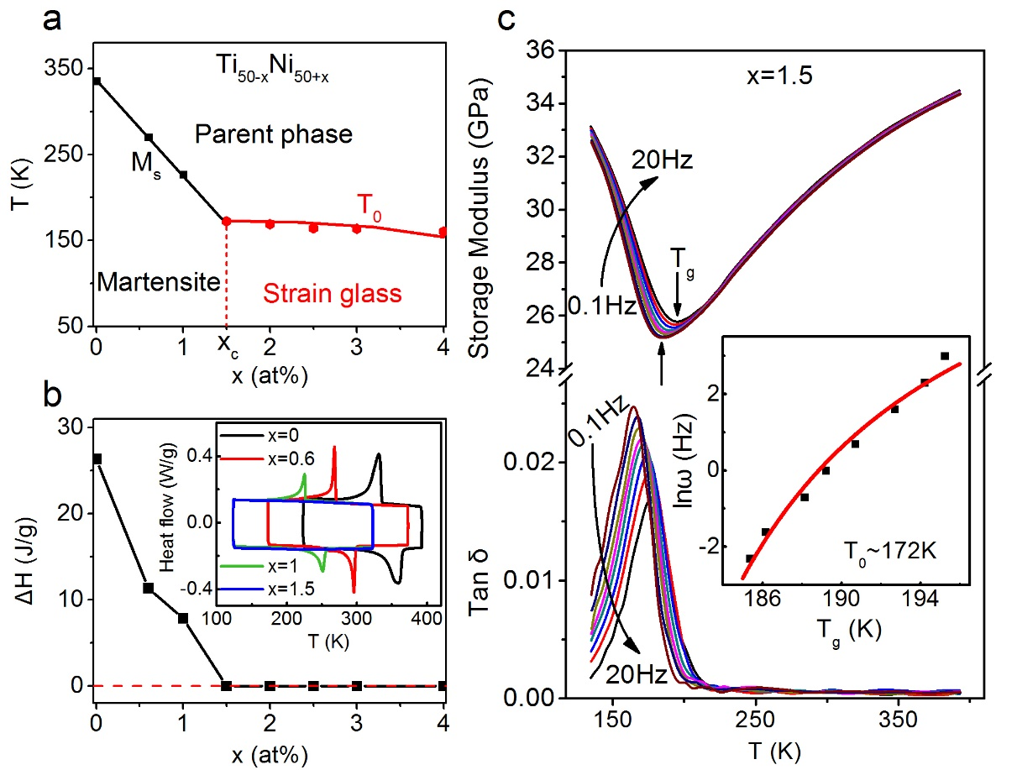
Supplementary Figure 2. The phase diagram of Ti_{50-x}Ni_{50+x} strain glass alloys and supporting data. a. The phase diagram of Ti_{50-x}Ni_{50+x} alloys. The crossover between the martensite and strain glass is around x=1.5. b. The enthalpy change (ΔH) as a function of x, which corresponds to the area under the heat flow peaks in the inset. c. The frequency dependence of the storage modulus and tan δ at x=1.5. The inset shows the fitting of Vogel–Fulcher relation of frequency as a function of T_{g}. The ideal freezing temperature T₀ is around 172 K.
- The boson peak in Zr₅₀Cu₄₀Al₁₀ bulk metallic glass (BMG)
The Zr₅₀Cu₄₀Al₁₀ BMG is determined by the DSC curve and XRD pattern in Supplementary Fig. 3a. Supplementary Figure 3b exhibits the linear fitting of C_{p}/T vs. T² for both the BMG and its corresponding crystal. The reduced specific heat (C_{p-}γT)/T³ as a function of T is shown in Supplementary Fig. 3c. The boson peak of the Zr₅₀Cu₄₀Al₁₀ BMG is also manifested as a broad hump, lending support to the BP-like anomaly in strain glass.
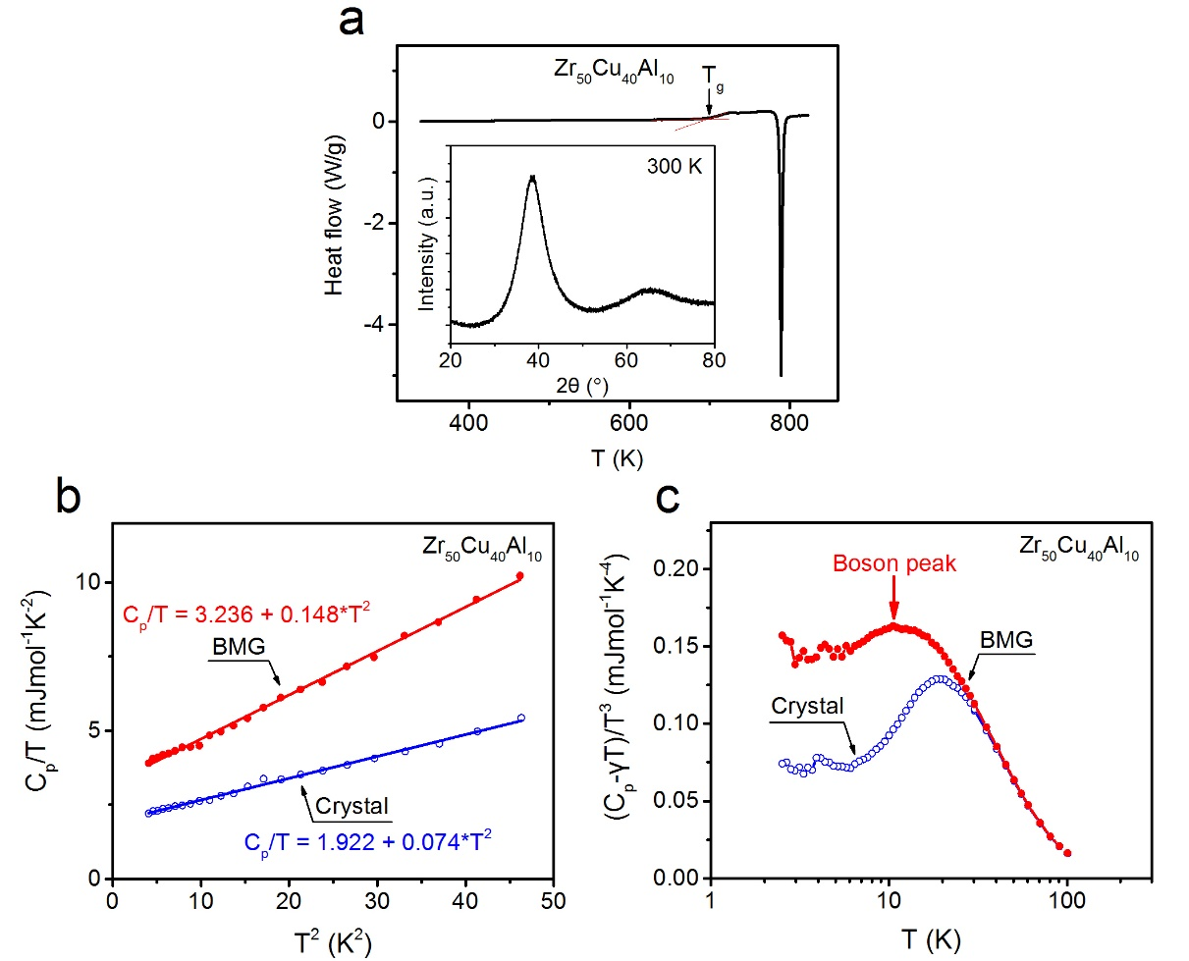
Supplementary Figure 3. Boson peak of the Zr₅₀Cu₄₀Al₁₀ BMG. a. DSC curve as well as the XRD pattern of the Zr₅₀Cu₄₀Al₁₀ BMG. b. C_{p}/T vs. T² relation with the C_{p} data below 7 K. The linear fitting follows the relation C_{p}/T=γ+βT². c. The plot of (C_{p-}γT)/T³ vs. T for the Zr₅₀Cu₄₀Al₁₀ BMG and its corresponding crystal. A broad hump, i.e., the boson peak, takes place around 10 K for the Zr₅₀Cu₄₀Al₁₀ BMG.
- BP-like anomaly in another Ti₅₀Pd_{50-x}Cr_{x} strain glass alloys
According to Ref. 40, the critical level of Cr separating the martensitic phase and strain glass in Ti₅₀Pd_{50-x}Cr_{x} alloys is around x=9. In this strain glass system, an obvious hump is also observed around 10 K in strain glass, which indicates that the BP-like anomaly is a universal behavior in strain glasses, and does not rely on any specific system.
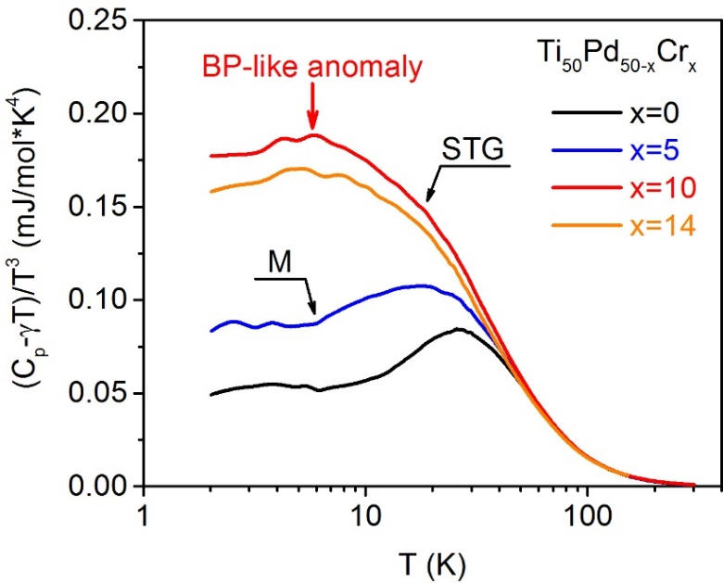
Supplementary Figure 4. Reduced specific heat (C_{p}-γT)/T³ as a function of T in Ti₅₀Pd_{50-x}Cr_{x} alloys. A BP-like anomaly is observed in the strain glass compositions (x=10, 14).
- Calculated Phase diagram of the Zr_{100-x}Ni_{x} model system
According to Ref. 31, upon the increase of Ni concentration, the low temperature phase changes from the martensitic phase to strain glass with a critical defect concentration of 4.0%.
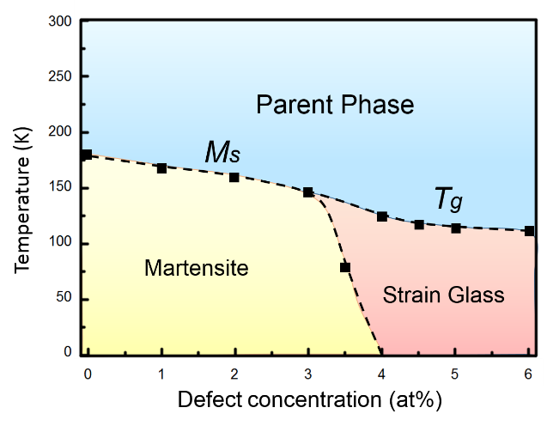
Supplementary Figure 5. Calculated phase diagram of Zr_{100-x}Ni_{x} model alloys.

