Appendix 1. taVNS Tolerability Form
taVNS Tolerability Form

Visits 1 and 2
1A. Did you experience any ear pain DURING taVNS? (Check one)

Yes ______ No ______ (if no, SKIP TO 2A)

1B. How would you rate the ear pain you experienced DURING taVNS on a scale of 0 (lowest) to 10 (highest)? (Circle one)
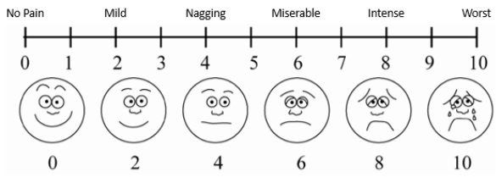

2A. Did you feel tingling/tickling/pricking DURING taVNS? (Check one)

Yes ______ No ______ (if no, SKIP TO 3A)

2B. How would you rate the irritation from tingling/tickling/pricking DURING taVNS on a scale of 0 (lowest) to 10 (highest)? (Circle one)
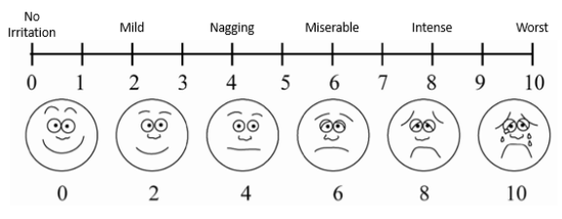

3A. Did you feel pain/discomfort AFTER taVNS? (Check one)

Yes ______ No ______ (If no, SKIP TO 4A)

3B. How would you rate the pain/discomfort you experienced AFTER taVNS scale of 0 (lowest) to 10 (highest)? (Circle one)
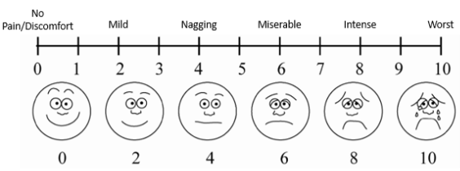

4A. Did you experience any other side effects from taVNS? (Check one)

Yes ______ No ______ (if no, SKIP TO 6A)

4B. How would you describe this side effect?
____________________________________________________________________________

4C. Did you experience this other side effect DURING OR AFTER taVNS? (Check one)

During ______ After ______

4D. How would you rate the intensity of this other side effect from taVNS on a scale of 0 (lowest) to 10 (highest)? (Circle one)
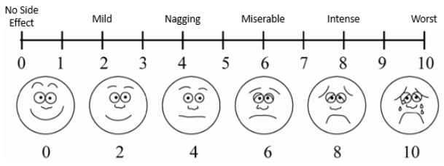

If more than one additional side effect:

5A. Did you experience any other side effects from taVNS? (Check one)

Yes ______ No ______ (if no, SKIP TO 6)

5B. How would you describe this side effect?
____________________________________________________________________________

5C. Did you experience this other side effect DURING OR AFTER taVNS? (Check one)

During ______ After ______

5D. How would you rate the intensity of this other side effect from taVNS on a scale of 0 (lowest) to 10 (highest)? (Circle one)
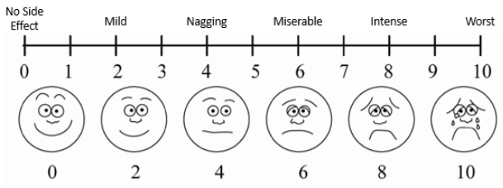

Visit 2 ONLY

6A. Did you experience any ear pain AFTER YOUR LAST VISIT? (Check one)

Yes ______ No ______ (if no, SKIP TO 8A)

6B. How would you rate the ear pain you experienced AFTER YOUR LAST VISIT on a scale of 0 (lowest) to 10 (highest)? (Circle one)
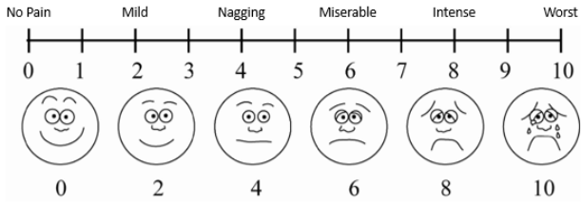

7A. Did you feel discomfort AFTER YOUR LAST VISIT? (Check one)

Yes ______ No ______ (If no, SKIP TO 9A)

7B. How would you rate the discomfort you experienced AFTER YOUR LAST VISIT scale of 0 (lowest) to 10 (highest)? (Circle one)
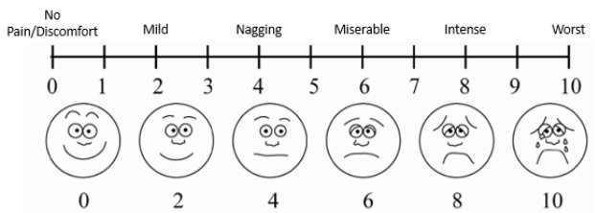

8A. Did you experience any other side effects AFTER YOUR LAST VISIT? (Check one)

Yes ______ No ______ (IF NO, Go to next page)

8B. How would you describe this side effect?
____________________________________________________________________________

8C. How would you rate the intensity of this other side effect from taVNS on a scale of 0 (lowest) to 10 (highest)? (Circle one)c
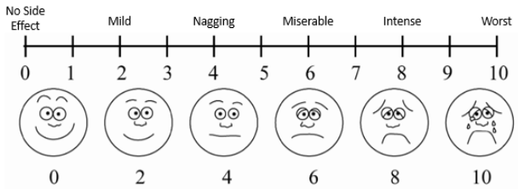

Appendix 2. Confounding Variables
Variable | Condition A (n=29) | Condition B (n=29) | p | Monophasic (n=30) | Biphasic (n=30) | p
Hours of sleep (median±SD) | 7±1.39 | 7±1.34 | 0.015 | 7.00±1.10 | 7.00±1.79 | 0.097
% reporting poor to very poor sleep quality | 17.2% | 10.3% | 0.337 | 13.3% | 23.3% | 0.773
% reporting ≥ 1 cup of coffee | 55.2% | 55.2% | 1.000* | 60% | 60% | 1.000*
% reporting ≥ 1 standard alcoholic drinks | 6.9% | 10.3% | 1.000* | 10% | 3.3% | 0.625*
% reporting ≥ 10 mins of exercise | 13.8% | 24.1% | 0.508* | 46.7% | 36.7% | 0.453*
% reporting a substance that may affect HRV or CNS processes | 44.8% | 41.4% | 1.000* | 46.7% | 56.7% | 0.250*
Baseline PTQ Composite Scores:
 | Median±SD | p
Condition A | 18.00±9.48 | 0.580
Condition B | 19.00±8.37 | 0.580
Baseline PANAS Positive and Negative Affect Scale Scores:
 | Median±SD | p
Monophasic Positive Affect Scale | 22.00±9.15 | 0.700
Biphasic Positive Affect Scale | 23.00±9.09 | 0.700
Monophasic Negative Affect Scale | 2.50±2.80 | 0.609
Biphasic Negative Affect Scale | 2.50±3.51 | 0.609
*McNemar Test (all others Wilcoxon signed-ranks test)

Appendix 3. taVNS Tolerability Form Nominal Frequencies
Question | Condition A (n=29) | Condition B (n=29) | Monophasic (n=30) | Biphasic  (n=30)
Did you experience any ear pain DURING taVNS? (# YES) | 7 | 8 | 5 | 5
Did you feel tingling/tickling/pricking DURING taVNS? (# YES) | 26 | 25 | 26 | 24
Did you feel pain/discomfort AFTER taVNS? (# YES) | 0 | 1 | 1 | 2
Did you experience any other side effects from taVNS? (#YES) | 4 | 4 | 0 | 0
Did you experience this other side effect DURING OR AFTER taVNS? (# During/ # After) | 3/1 | 3/1 | 0/0 | 0/0
If more than one additional side effect: Did you experience any other side effects from taVNS? (# YES) | 1 | 0 | 0 | 0
If experienced more than one additional side effect: Did you experience this other side effect DURING OR AFTER taVNS? (# During/ # After) | 1/0 | 0/0 | 0/0 | 0/0
Did you experience any ear pain after your last visit? (# YES) | 0 | 0 | 0 | 1
Did you feel any discomfort after your last visit? (# YES) | 0 | 0 | 0 | 0
Did you experience any other side effects after your last visit? (# YES) | 3 | 1 | 1 | 1

Appendix 4. taVNS Tolerability Form Scale Descriptives
Question | Condition A  (n)  Median±SD | Condition B  (n)  Median±SD | Monophasic  (n)  Median±SD | Biphasic  (n)  Median±SD
How would you rate the ear pain you experienced DURING taVNS on a scale of 0 (lowest) to 10 (highest)? | (7)  2.00±2.06 | (8)  3.00±1.69 | (5)  2.00±1.79 | (5)  2.00±2.07
How would you rate the irritation from tingling/tickling/pricking DURING taVNS on a scale of 0 (lowest) to 10 (highest)? | (26)  2.00±1.77 | (25)  2.00±1.77 | (26)  2.00±1.18 | (24)  2.50±1.47
How would you rate the pain/discomfort you experienced AFTER taVNS scale of 0 (lowest) to 10 (highest)? | (0)  --- | (1)  3.00 | (1)  6.00 | (2)  1.50±0.71
How would you rate the intensity of this other side effect from taVNS on a scale of 0 (lowest) to 10 (highest)? | (4)  1.50±1.71 | (4)  4.50±2.94 | (0)  --- | (0)  ---
How would you rate the intensity of this other side effect from taVNS on a scale of 0 (lowest) to 10 (highest)? | (1)  0.00 | (0)  --- | (0)  --- | (0)  ---
How would you rate the ear pain you experienced AFTER YOUR LAST VISIT on a scale of 0 (lowest) to 10 (highest)? | (0)  --- | (0)  --- | (0)  --- | (1)  1.00
How would you rate the discomfort you experienced AFTER YOUR LAST VISIT scale of 0 (lowest) to 10 (highest)? | (0)  --- | (0)  --- | (0)  --- | (0)  ---
How would you rate the intensity of this other side effect from taVNS on a scale of 0 (lowest) to 10 (highest) after your last visit? | (3)  6.00±3.06 | (1)  2.00 | (1)  4.00 | (1)  3.00

Appendix 5. Baseline HRV
 | Condition A (median±SD) | Condition B  (median±SD) | Monophasic  (median±SD) | Biphasic  (median±SD)
Heart rate (bpm) | 67.00±10.83 | 67.00±10.72 | 67.00±10.287 | 68.50±8.96
SDNN (ms) | 50.80±21.47 | 49.00±23.56 | 47.10±17.69 | 46.60±17.66
RMSSD (ms) | 41.60±30.34 | 43.10±32.39 | 41.20±28.77 | 44.20±25.99

