Appendix
Table S1. Key Variables and Equations of the Coupled Processes in the Water-Sediment-Ecology-Socioeconomic Model
No. | Parameter/Variable | Unit | Equation/Value
1 | Birth Rate | persons/year | Population Policy × kcl_Birth_Rate(Time)
2 | Death Rate | persons/year | lk_Death_Rate(Time)
3 | Rural Population | 10⁴ persons | Total Population - Urban Population
4 | Number of Births | 10⁴ persons | Total Population × Birth Rate
5 | Number of Deaths | 10⁴ persons | Total Population × Death Rate
6 | Total Population | 10⁴ persons | INTEG (Number of Births - Number of Deaths + Net In-migration)
7 | Watershed GDP | 10⁸ CNY | Primary Industry Added Value + Tertiary Industry Added Value + Secondary Industry Added Value
8 | Primary Industry Added Value | 10⁸ CNY | Forestry Value / Industrial Ratio
9 | Secondary Industry Added Value | 10⁸ CNY | lk_Secondary (Time)
10 | Tertiary Industry Added Value | 10⁸ CNY | lk_Tertiary (Time)
11 | Forestry Value | 10⁸ CNY | 0.0245 × Forest Area + 3.067
12 | Investment in FF&AF | 10⁸ CNY | Investment in Water & Environment × Grain for Green Policy
13 | Investment in Water & Environment | 10⁸ CNY | Public Utility Investment × Investment Ratio
14 | Investment in RG&AF | 10⁸ CNY | Investment in Water & Environment × Grain for Green Policy
15 | Increment in Forest Area | hectares | Forest Area × Forest Area Growth Rate
16 | Cultivated Land Area | hectares | lk_Cultivated_Land_Area(Time)
17 | Grassland Area | hectares | INTE(GIncrement in Grassland Area) + 225.679
18 | Forest Area | hectares | INTEG(Increment in Forest Area + Farmland-to-Forest Area) + 65.945
19 | Increment in Grassland Area | hectares | Grassland Area × Grassland Area Growth Rate
20 | Forest & Grassland Area | hectares | Forest Area + Grassland Area
21 | Vegetation Cover | hectares | Forest & Grassland Area + Cultivated Land Area
22 | Runoff | 10⁸ m³ | 0.030 × Precipitation-0.014 × Vegetation Cover-0.0211 × Domestic Water Demand + 0.000135 × (Precipitation^2) + 6.867
23 | Precipitation | 10⁸ m³ | lk_Precipitation(Time)
24 | Sediment Load | 10⁸ tons | 3.703 - 0.546 × Runoff+0.003 × Precipitation-0.004 × Vegetation Cover+0.038 × (Runoff^2)

Figure S1. Precipitation projections from different climate models under the SSP2-4.5 scenario. Under the medium-emission SSP2-4.5 scenario, models including MIROC6, ACCESS-CM2, CAMS-CSM1-0, and CMCC-CM2-SR5 all project positive trends (with slopes of 0.569, 1.194, 0.693, and 0.440, respectively), while BCC-CSM2-MR exhibits a slight negative trend (slope of -0.282). The intercepts vary substantially among models, ranging from 736.766 for BCC-CSM2-MR to -2252.875 for ACCESS-CM2, indicating considerable inconsistency in the estimated baseline precipitation state across different models. Furthermore, the CAMS-CSM1-0 model shows relatively smaller parameter estimation errors (slope error ±0.694, intercept error ±1406.066), suggesting slightly higher internal consistency for this model under this specific scenario. Overall, long-term precipitation projections under the SSP2-4.5 scenario are significantly influenced by inter-model variability and parameter uncertainty. Consequently, employing a multi-model ensemble mean for assessment helps to offset biases inherent in any single model, thereby providing a more robust scientific basis for climate change adaptation and water resources planning.

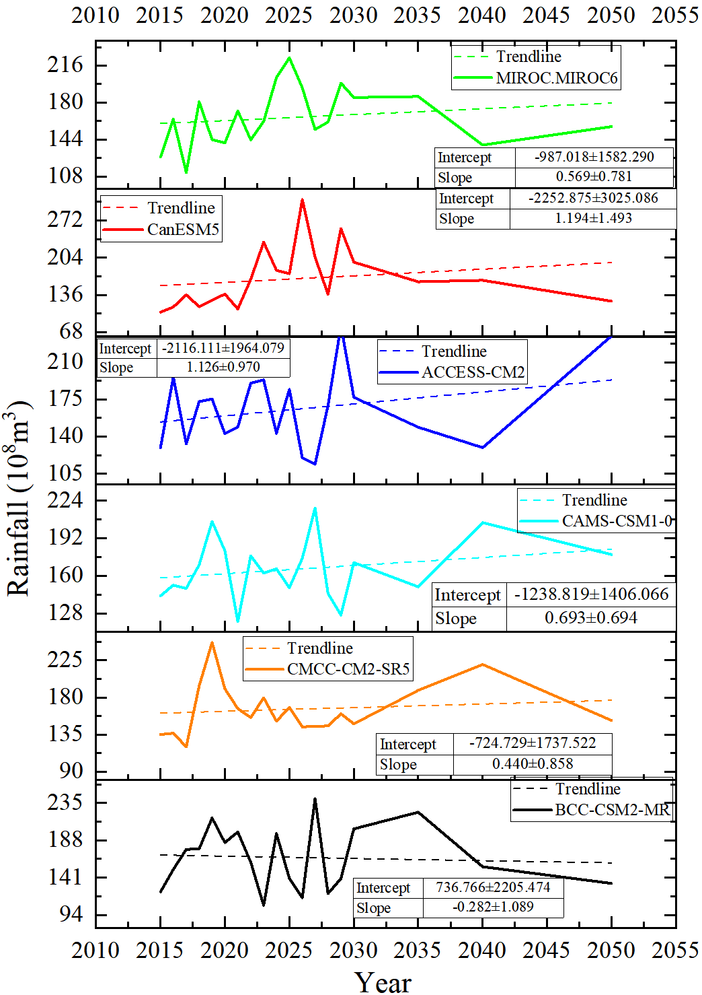
Figure S1. Precipitation Projections from Different Modeling Institutions under the SSP2-4.5 Scenario
Figure S2. Precipitation projections from different climate models under the SSP3-7.0 scenario. Under the high-emission SSP3-7.0 scenario, among the listed models, MIROC6, CanESM5, and ACCESS-CM2 all exhibit clear positive trends (with slopes of 0.368, 1.045, and 0.392, respectively). CAMS-CSM1-0 shows a weak negative trend, while the trends for CMCC-CM2-SR5 and BCC-CSM2-MR are close to zero (with slopes of 0.001 and 0.062, respectively), indicating that their projected long-term changes are extremely insignificant. The intercepts vary dramatically among the models, ranging from -1951.132 for CanESM5 to 162.780 for CMCC-CM2-SR5, highlighting fundamental disagreements in the estimated historical baseline precipitation across different models. Furthermore, the BCC-CSM2-MR model has the relatively narrowest parameter estimation error ranges (slope error ±0.575, intercept error ±1164.739), indicating a higher degree of internal consistency for this model under this specific scenario. In summary, although most models project increasing precipitation under the SSP3-7.0 scenario, the substantial inter-model variability and parameter uncertainty still dominate the long-term projections. Therefore, employing a multi-model ensemble mean for comprehensive assessment is particularly crucial to reduce reliance on any single model, obtain more robust estimates of future hydrological changes, and provide a reliable basis for climate risk adaptation under a high-emission pathway.

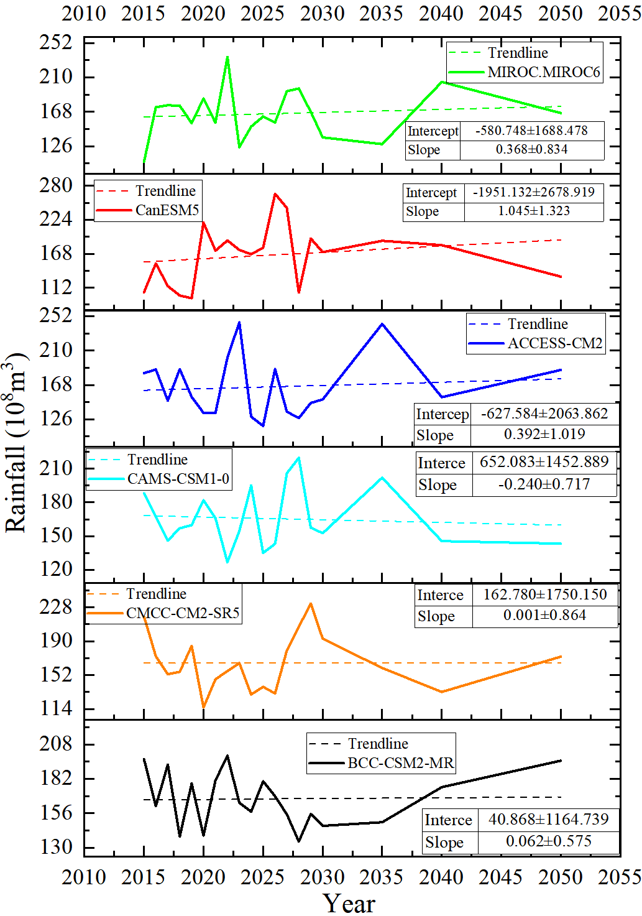
Figure S2. Precipitation Projections from Different Modeling Institutions under the SSP3-7.0 Scenario
Figure S3 presents precipitation projection data from different climate models under the SSP5-8.5 scenario. Among the listed models, most indicate an increasing precipitation trend, including MIROC6 (slope 0.613), CanESM5 (slope 0.880), ACCESS-CM2 (slope 0.214), CMCC-CM2-SR5 (slope 1.250), and BCC-CSM2-MR (slope 0.961). In contrast, CAMS-CSM1-0 exhibits a pronounced negative trend (slope -1.105). Furthermore, the CMCC-CM2-SR5 model shows relatively smaller parameter estimation error ranges (slope error ±0.737), indicating a certain degree of internal consistency under this high-forcing scenario. In summary, although precipitation projections under the SSP5-8.5 scenario generally lean toward an increase, issues of inconsistent directional trends among models and high parameter uncertainty remain prominent. Therefore, employing a multi-model ensemble approach for comprehensive analysis helps integrate signals from different models, reduce prediction bias under extreme scenarios, and provide a more robust basis for decision-making in response to high climate risks.
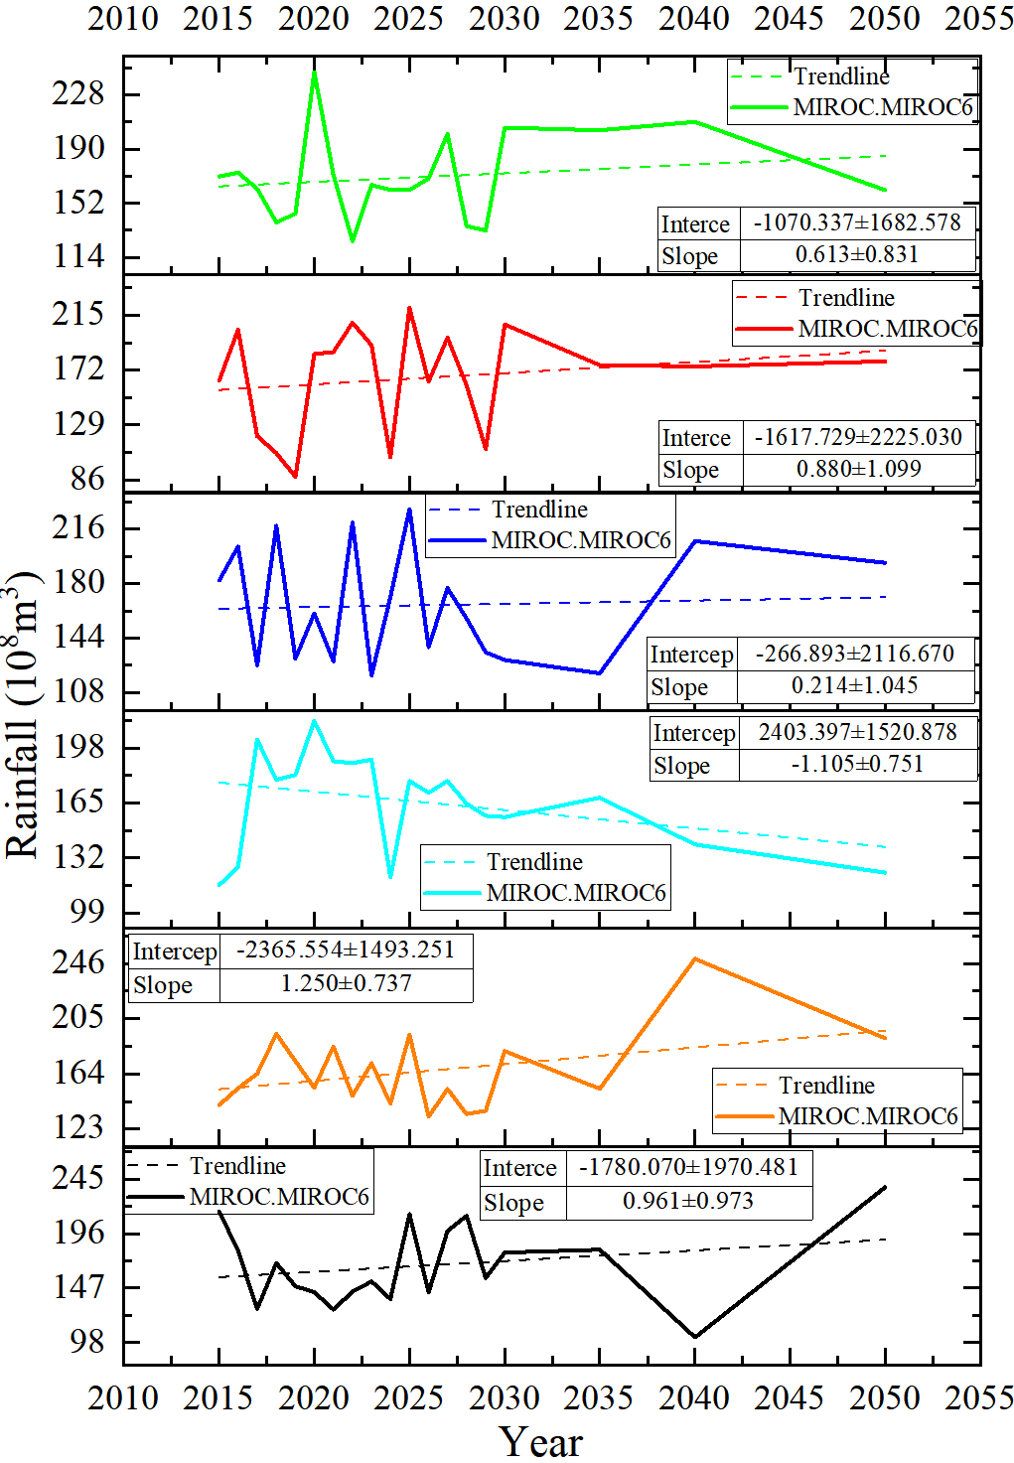
Figure S3. Precipitation Projections from Different Modeling Institutions under the SSP5-8.5 Scenario

