Recessive PPTC7 deficiency triggers excessive mitophagy to cause a severe inborn error of metabolism with hypomyelinating leukodystrophy

Table of Contents

1. Clinical synopsis

2. Supplementary figures

- Clinical synopsis

Family 2

A 9-year-old girl (IV:1) presented with progressive weakness, developmental regression, and recurrent chest infections. Her condition was first noticed at 4 months of age, when she showed delayed motor milestones, achieving head control at 7 months, crawling at 1 year, and assisted walking at 3 years. At 5 years old, she lost the ability to walk and reverted to crawling, followed by gradual deterioration of motor function leading to a bedridden state with progressive spasticity, particularly in the lower limbs. Despite her physical decline, hearing and vision remained normal, though speech was limited to a few words. Antenatal, natal, and postnatal histories were unremarkable.

At 7.5 years of age, MRI and MRS of the brain revealed diminished white matter volume with diffuse abnormal FLAIR signal, delayed myelination and decreased choline in the white matter. At 9 years, MRI of the pelvis showed left developmental dysplasia of the hip with superior dislocation of the femoral head, bilateral hip effusions, and a right multilocular synovial cyst; she also developed scoliosis and contractures in all limbs, consistent with progressive neuromuscular involvement. Nerve conduction studies (NCS) and electromyography (EMG) were performed and revealed severe axonal sensory motor length-dependent polyneuropathy with no demyelinating features were noted.

She experienced multiple chest infections and choking episodes, suggesting aspiration due to impaired airway clearance. Her past surgical history included repair of incomplete stomach volvulus five years earlier. Family history was significant for the deaths of three paternal aunts and one male cousin between 7 and 10 years of age, all with similar progressive neurological decline; there was no direct parental consanguinity, but both parents belonged to the same extended family. By 11 years of age, she presented with fever, cough, and respiratory distress, was diagnosed with pneumonia and type II respiratory failure, and required PICU admission with intubation and later re-intubation for central hypoventilation. Examination revealed severe dextroscoliosis, pectus carinatum, and spastic contractures of all four limbs. Laboratory investigations showed normal liver, renal, and electrolyte profiles with mild anemia, thrombocytopenia, and frequent metabolic acidosis corrected with bicarbonate infusion. The child remains bedridden with progressive neurological deterioration consistent with an inherited leukodystrophy and respiratory complications secondary to neuromuscular weakness and announced death by age of 11 years due to pneumonia and respiratory failure.

A reanalysis of the previously negative WES for this patient revealed this homozygous 3`UTR variant NM_139283.2:c.*57dup in PPTC7. Both parents were heterozygous and the rest of the family members and affected relatives were not available for genetic testing.

2. Supplementary figures

Supplemental Fig. 1 (associated with Fig. 3)

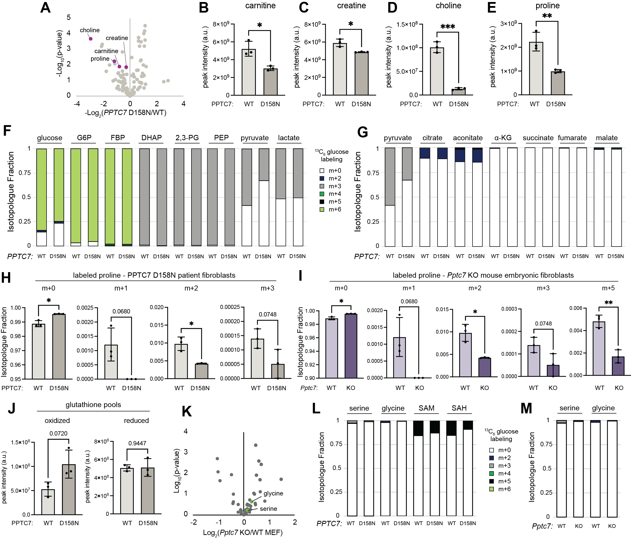

A. Metabolite measurements of PPTC7 D158N patient and control fibroblasts; mitochondria associated metabolites highlighted in purple. B.-E. Relative quantification of carnitine (B.), creatine (C.), choline (D.), and proline (E.) in control (i.e. PPTC7 wild type or WT) and D158N patient fibroblasts. * = p<0.05, ** = p<0.01, *** = p<0.001, Welch’s t-test. F., G. Flux analysis of glycolytic metabolites (F.) and TCA cycle metabolites (G.) in control and PPTC7 D158N fibroblasts shown as isotopologue fraction across identified species. H.,I. Isotopic labeling of proline from control and patient human fibroblasts (H.) or wild-type (WT) and Pptc7 knockout (KO) mouse embryonic fibroblasts (MEFs) (I.). All fibroblast lines were labeled with U-¹³C₆ glucose for 4 hours. * = p<0.05, ** = p<0.01, Welch’s t-test. Select p values listed above graphs. J. Relative distribution of oxidized and reduced glutathione in control and PPTC7 D158N human fibroblasts. Statistics performed with Welch's t-test; p values listed above select graphs. K. Metabolite measurements of wild-type and Pptc7 KO MEFs; 1C metabolites highlighted in purple. L., M. Flux analysis of 1C metabolites in control and PPTC7 D158N human fibroblasts (L.) or wild-type and Pptc7 KO MEFs (M.) labeled with U-¹³C₆ glucose for 4 hours. Relative isotopic distributions shown as isotopologue fraction across identified species.

Supplemental Fig. 2 (associated with Fig. 4)

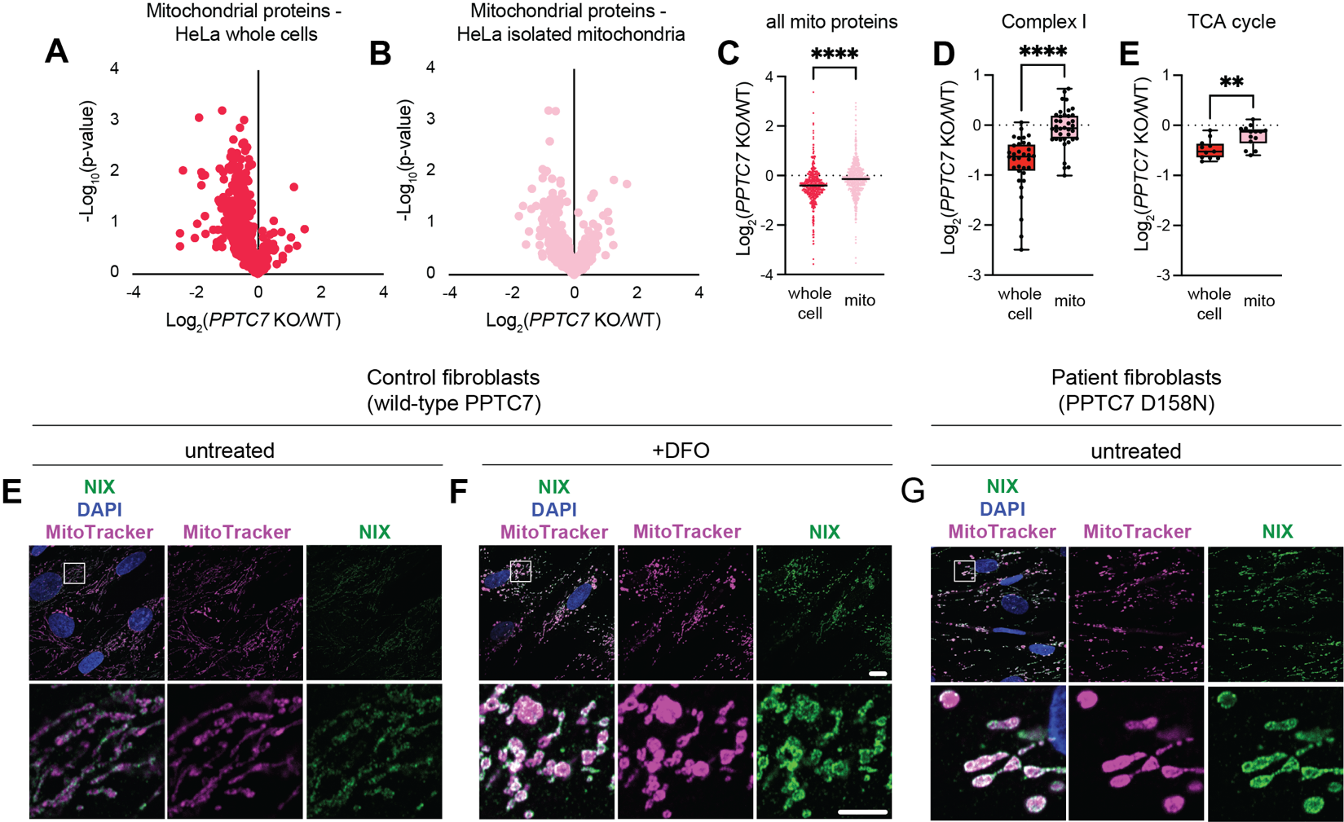

A., B. Volcano plot representing total protein measurements from of wild-type (WT) and PPTC7 knockout (KO) HeLa whole cells (A.) and isolated mitochondria (B.) (n=3 replicates). Each dot represents the log₂-fold change of a protein identified in Pptc7 KO/control HeLa cells or mitochondria. Only quantified mitochondrial proteins shown. C. Quantification of all mitochondrial proteins in whole cells (red) and isolated mitochondria (pink). Distribution of mitochondrial protein changes in PPTC7 KO versus wild-type (WT) samples shown, with a line at the median log2 fold change. ****=p<0.0001, Student’s t-test. D., E. Fold changes of proteins in Complex I (D.) and TCA cycle proteins (E.) in PPTC7 KO/WT whole cells (red) and isolated mitochondria (pink). **=p<0.01, ****=p<0.0001, Student’s t-test. E.-G. Mitochondrial morphology and NIX staining in control, untreated fibroblasts (E.), control fibroblasts treated with 100 μM deferoxamine (DFO) (F.), and patient PPTC7 D158N fibroblasts (G.).

Supplemental Fig. 3 (associated with Fig. 5)

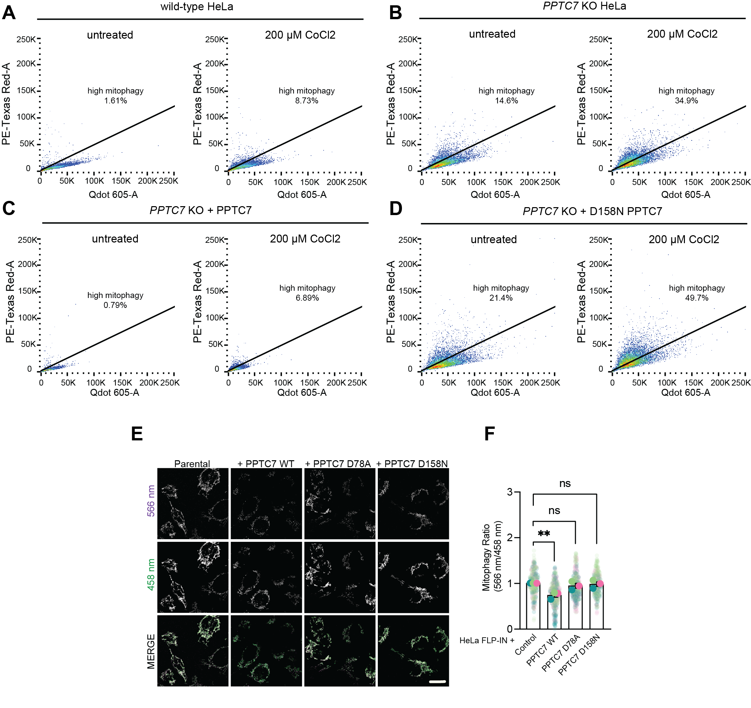

A.-D. Flow cytometry analysis of wild-type HeLa (A.) PPTC7 knockout (KO) HeLa (B.), PPTC7 KO + wild-type PPTC7 (C.), and PPTC7 KO + PPTC7 D158N (D.) in the presence or absence of 200 μM cobalt chloride (CoCl₂) treatment for 16 hours. Gated cells and percentages of representative high mitophagy images shown. E. mt-Keima analysis of wild-type HeLa FLP-IN TRE-x cells expressing exogenous wild-type, D78A, or D158N PPTC7. Acidic mitochondria shown in the 566 nm channel and mitochondria at physiological pH shown in the 458 nm channel; merge shown below. F. Quantification of the mitophagy ratio from data shown in E. ** = p<0.01, Student’s t-test. Mean datapoints from each experiment shown as solid circles; distribution of individual datapoints shown as opaque circles for each experiment. Error bars represent standard deviation of mean datapoints across n=3 independent experiments.

Supplemental Fig. 4 (associated with Fig. 6)

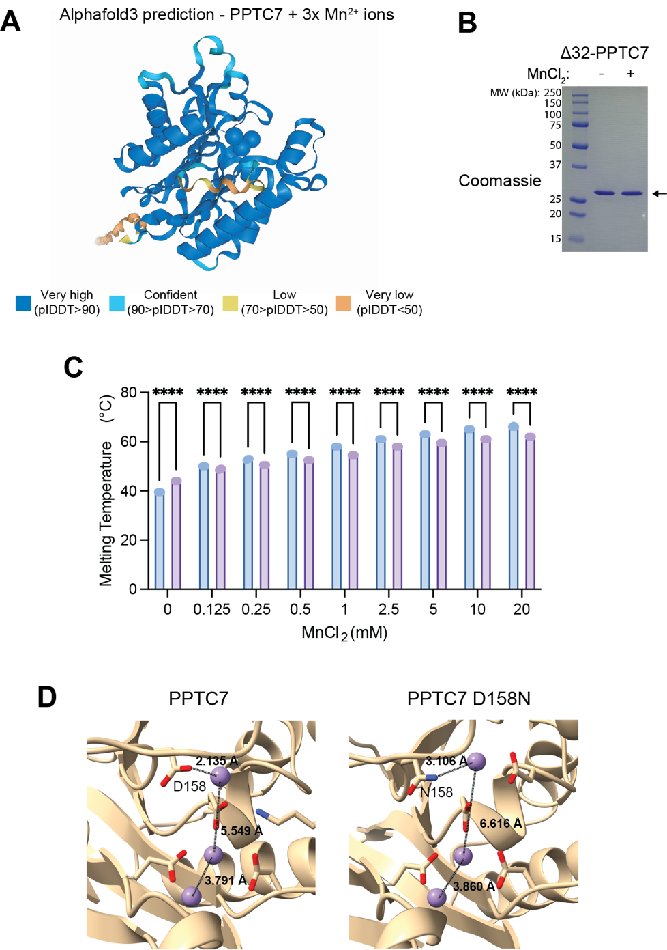

A. Alphafold3 prediction of Δ32-PPTC7 bound to 3 manganese ions. Confidence metrics reported below structure. B. Coomassie analysis of recombinant Δ32-PPTC7 in the absence (left) and presence (right) or 10 mM MnCl₂. C. Statistical analysis of Tm differences in wild-type PPTC7 (blue) and PPTC7 D158N (purple) across all tested MnCl2 concentrations. N=3 measurements, **** = p<0.0001, Student’s t-test. Bar graphs represent means of quantified datapoints. Error bars represent standard deviation. D. Zoom in of Alphafold3 prediction of wild-type PPTC7 (left) or PPTC7 D158N (right) with distances of key amino acids and manganese metals shown in angstroms.

Supplemental Fig. 5 (associated with Fig. 7)

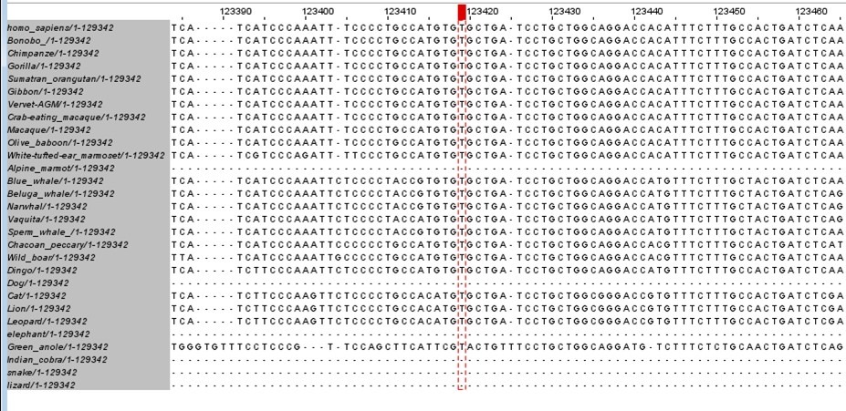

A multi-species sequence alignment of the region surrounding the 3`UTR variant showing high conservation of this region across higher primates and mammals. The red vertical dashed bar marks the position of the c.*57dup variant, highlighting that this nucleotide position is highly conserved across species. The multi-species sequences were obtained from Ensembl.

Supplemental Fig. 6

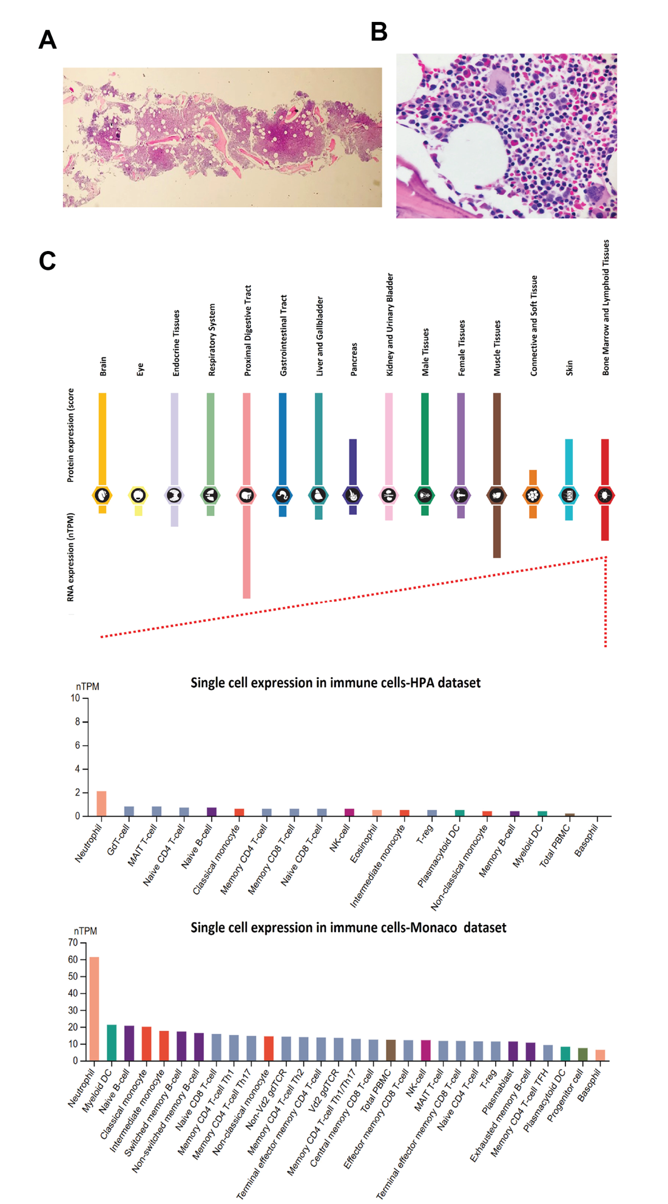

Bone marrow cytopathology in PPTC7 deficiency. A. Hematoxylin and Eosin (H&E) staining of the bone marrow core biopsy at 4X shows normocellular trabecular bone with estimated cellularity ~90%, which was appropriate for patient age. B. H&E staining of the bone marrow core biopsy at 40x shows active granulopoiesis. Increased erythropoiesis was essentially normoblastic. Megakaryocytes were adequate with unremarkable morphology. There was no abnormal cellular collection, increased apoptosis or stromal deposition. C. shows tissue-specific expression of PPTC7 at the RNA and protein levels from the Human Protein Atlas (HPA) project dataset. The tongue, skeletal muscle, and bone marrow tissues show the highest RNA expression. On the protein level, PPTC7 is highly expressed in multiple tissues, especially those with high energy demand. B). Shows the single cell expression of PPTC7 RNA in immune cells in two independent datasets, HPA and Monaco (PMID:30726743) datasets. In the HPA dataset, the data were obtained from the internal normalization pipeline for 18 immune cell types and total peripheral blood mononuclear cells (PBMC) and the transcript expression values were calculated as nTPM (normalized expression transcripts per million). In the Monaco dataset, the expression data were obtained from 29 blood cell types and total PBMC. Both datasets show differentially high expression of PPTC7 in neutrophils compared to the other immune cells.

