Circulating microRNAs as Biomarkers for Primary Open-Angle Glaucoma: A Case-Control Study
Eiman Meer¹, Yousaf Jamal Mahsood², Fazli Wahid^{1,3}, Muhammad Ilyas⁴, Sanna Khan⁵, Bakht Daniyal Khan², Hussain Hussain², Humaira Ayub¹*

^{1*}Department of Biological & Health Sciences, Pak-Austria Fachhochschule: Institute of Applied Sciences &Technology, Haripur, Khyber Pakhtunkhwa, Pakistan
²Department of Ophthalmology, Khyber Girls Medical College, Hayatabad Medical Complex, Peshawar, Khyber Pakhtunkhwa, Pakistan
³Terasaki Institute for Biomedical Innovation, Los Angeles, United States of America
⁴Center for Omic Sciences, Islamia College Peshawar, Khyber Pakhtunkhwa, Pakistan
⁵ School of Mechanical and Manufacturing Engineering, Dublin City University, Dublin, Ireland

*Correspondence
Humaira Ayub
Email: humaira.ayub@fbse.paf-iast.edu.pk
mir-210-3p Ct values in Plasma

Sample size | 90
Descriptive statistics
Factor | n | Minimum | 25th percentile | Median | 75th percentile | Maximum
CATRACT | 30 | 31.5070 | 31.755 | 32.022 | 32.294 | 33.883
NORMAL | 30 | 32.1060 | 34.205 | 34.989 | 35.961 | 39.258
POAG | 30 | 28.1470 | 28.946 | 29.482 | 30.120 | 31.810
Kruskal-Wallis test
Test statistic | 78.1042
Corrected for ties | 78.1042
Degrees of Freedom (DF) | 2
Significance level | P < 0.000001
Post-hoc analysis (Conover)
Factor | n | Average Rank | Different (P<0.05)  from factor nr
(1) CATRACT | 30 | 45.63 | (2)(3)
(2) NORMAL | 30 | 75.58 | (1)(3)
(3) POAG | 30 | 15.80 | (1)(2)

Mir-210-3p Fold Change in plasma
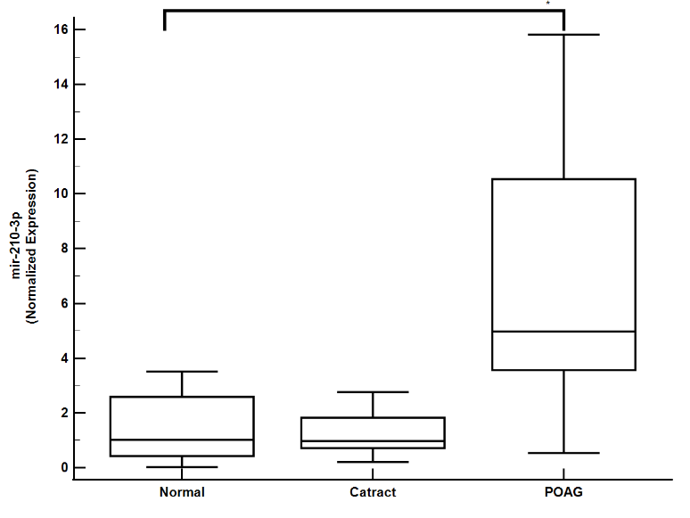
Data | mir_210_3p_Fold_Change  mir-210-3p Fold Change
Factor | GROUP

Descriptive statistics
Factor | n | Minimum | 25th percentile | Median | 75th percentile | Maximum
CATRACT | 30 | 0.2070 | 0.756 | 1.120 | 1.844 | 2.762
NORMAL | 30 | 0.02349 | 0.427 | 1.021 | 2.585 | 14.970
POAG | 30 | 1.0510 | 3.649 | 5.176 | 11.305 | 21.436
Kruskal-Wallis test
Test statistic | 43.0314
Corrected for ties | 43.0314
Degrees of Freedom (DF) | 2
Significance level | P < 0.000001
Post-hoc analysis (Conover)
Factor | n | Average Rank | Different (P<0.05)  from factor nr
(1) CATRACT | 30 | 33.30 | (3)
(2) NORMAL | 30 | 33.23 | (3)
(3) POAG | 30 | 71.90 | (1)(2)

mir-210-3p Ct values in Aqueous humor

 | Sample 1 | Sample 2
Sample size | 30 | 30
Lowest value | 33.2300 | 32.2470
Highest value | 34.9990 | 36.1900
Median | 34.3090 | 33.9855
95% CI for the median | 33.9305 to 34.7089 | 33.7133 to 34.4798
Interquartile range | 33.8540 to 34.8060 | 33.3610 to 34.7450

Hodges-Lehmann median difference | -0.2120
95% Confidence interval | -0.6530 to 0.1310

Mann-Whitney test (independent samples)
Average rank of the first group | 33.1000
Average rank of the second group | 27.9000
Mann-Whitney U | 372.00
Test statistic Z | -1.153
Two-tailed probability | P = 0.2488

mir-210-3p fold changes in AH
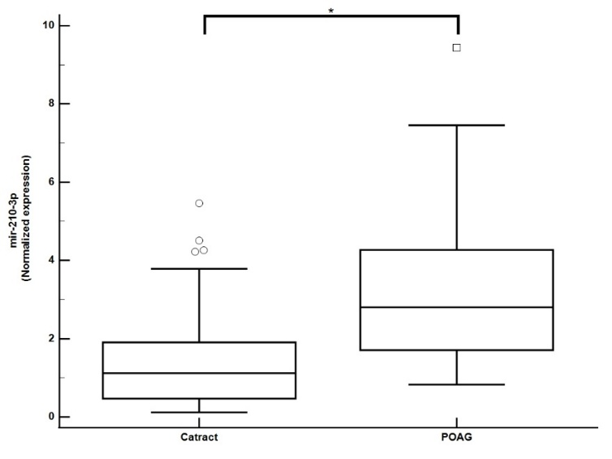
 | Sample 1 | Sample 2
Sample size | 30 | 30
Lowest value | 0.1190 | 0.8260
Highest value | 5.4680 | 9.4350
Median | 1.1200 | 2.8050
95% CI for the median | 0.5744 to 1.6659 | 1.7527 to 3.7717
Interquartile range | 0.4700 to 1.9070 | 1.7080 to 4.2710

Hodges-Lehmann median difference | 1.3440
95% Confidence interval | 0.6470 to 2.2500
Mann-Whitney test (independent samples)
Average rank of first group | 22.2667
Average rank of second group | 38.7333
Mann-Whitney U | 203.00
Test statistic Z | -3.652
Two-tailed probability | P = 0.0003
mir-143-3p CT Values in plasma
Descriptive statistics
Factor | n | Minimum | 25th percentile | Median | 75th percentile | Maximum
CATRACT | 30 | 29.3950 | 30.156 | 30.636 | 31.423 | 32.634
NORMAL | 30 | 29.1900 | 29.982 | 30.481 | 31.074 | 33.123
POAG | 30 | 29.3710 | 29.916 | 30.260 | 30.800 | 33.834
Kruskal-Wallis test
Test statistic | 2.3863
Corrected for ties | 2.3863
Degrees of Freedom (DF) | 2
Significance level | P = 0.303269

Factor | N | Average Rank
(1) CATRACT | 30 | 50.05
(2) NORMAL | 30 | 46.63
(3) POAG | 30 | 39.82
mir-143-3p Fold Change in plasma
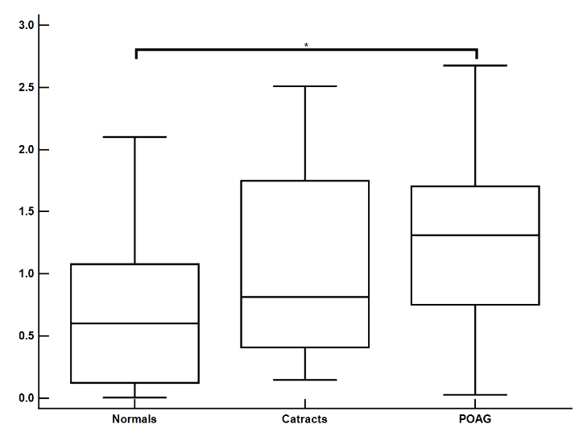
Sample size | 90
Descriptive statistics
Factor | n | Minimum | 25th percentile | Median | 75th percentile | Maximum
CATRACT | 30 | 0.1470 | 0.408 | 0.814 | 1.749 | 2.509
NORMAL | 30 | 0.005000 | 0.123 | 0.601 | 1.078 | 2.101
POAG | 30 | 0.02700 | 0.752 | 1.311 | 1.704 | 2.676
Kruskal-Wallis test
Test statistic | 11.5394
Corrected for ties | 11.5395
Degrees of Freedom (DF) | 2
Significance level | P = 0.003121
Post-hoc analysis (Conover)
Factor | N | Average Rank | Different (P<0.05)  from factor nr
(1) CATRACT | 30 | 49.63 | (2)
(2) NORMAL | 30 | 32.55 | (1)(3)
(3) POAG | 30 | 54.32 | (2)

mir-143-3p CT values in Aqueous Humor
 | Sample 1 | Sample 2
Sample size | 30 | 30
Lowest value | 26.4020 | 28.8910
Highest value | 30.6780 | 31.6030
Median | 27.4085 | 30.1785
95% CI for the median | 27.0670 to 27.7301 | 29.9927 to 30.4032
Interquartile range | 26.9820 to 27.7820 | 29.8350 to 30.4800

Hodges-Lehmann median difference | 2.8180
95% Confidence interval | 2.4770 to 3.1380
Mann-Whitney test (independent samples)
Average rank of first group | 16.2667
Average rank of second group | 44.7333
Mann-Whitney U | 23.00
Test statistic Z | -6.313
Two-tailed probability | P < 0.0001

Mir-143-3p AH Fold change
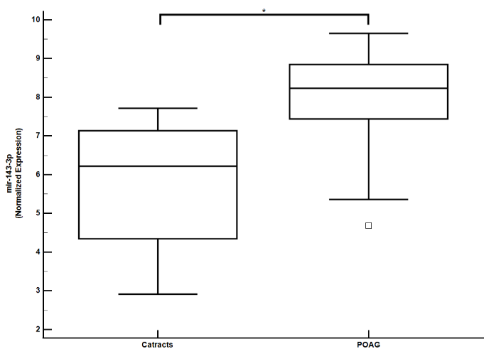
Sample 1
Variable | POAG
Sample 2
Variable | Cataracts

 | Sample 1 | Sample 2
Sample size | 30 | 30
Lowest value | 4.6870 | 2.9138
Highest value | 9.6500 | 7.7172
Median | 8.2350 | 6.2203
95% CI for the median | 7.7797 to 8.7548 | 5.0643 to 6.9733
Interquartile range | 7.4400 to 8.8480 | 4.3462 to 7.1369

Hodges-Lehmann median difference | -1.9751
95% Confidence interval | -2.8086 to -1.3100
Mann-Whitney test (independent samples)
Average rank of first group | 41.9000
Average rank of second group | 19.1000
Mann-Whitney U | 108.00
Test statistic Z | -5.056
Two-tailed probability | P < 0.0001

ROC analysis
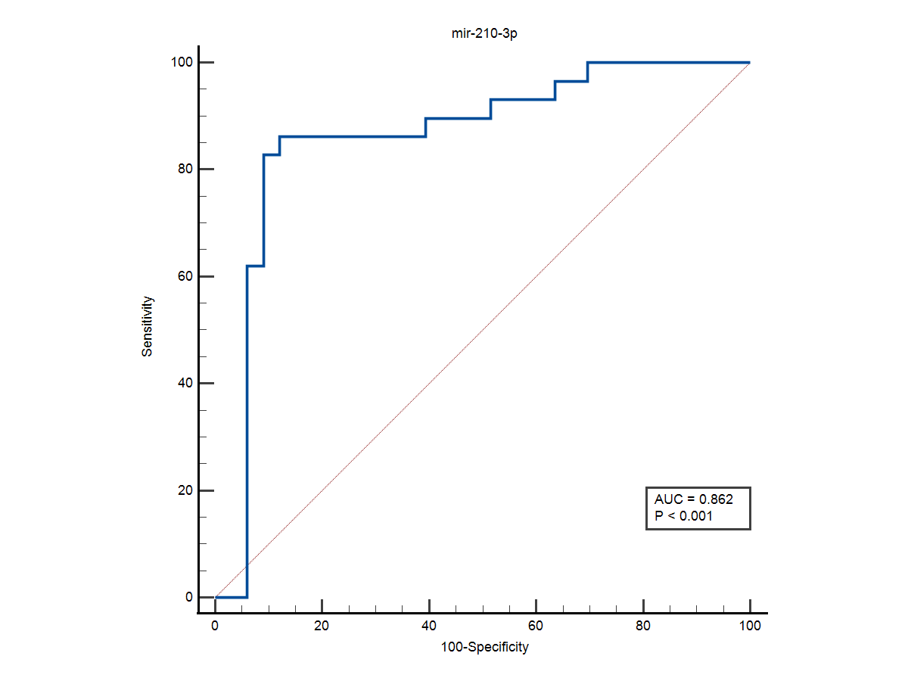
Variable | mir_210  mir-210
Classification variable | Groups

Sample size | 60
Positive group ª | 30
Negative group ^{b} | 30
ª Groups = 1
^{b} Groups = 0
Disease prevalence (%) | unknown
Area under the ROC curve (AUC)
Area under the ROC curve (AUC) | 0.862
Standard Error ª | 0.0528
95% Confidence interval ^{b} | 0.751 to 0.936
z statistic | 6.864
Significance level P (Area=0.5) | <0.0001
ª DeLong et al., 1988
^{b} Binomial exact
Youden index
Youden index J | 0.7409
Associated criterion | >3.470154749
Sensitivity | 86.21
Specificity | 87.88

Criterion values and coordinates of the ROC curve [Hide]
Criterion | Sensitivity | 95% CI | Specificity | 95% CI | +LR | -LR
≥0.25774208 | 100.00 | 88.1 - 100.0 | 0.00 | 0.0 - 10.6 | 1.00
>1.023486898 | 100.00 | 88.1 - 100.0 | 30.30 | 15.6 - 48.7 | 1.43 | 0.00
>1.051 | 96.55 | 82.2 - 99.9 | 30.30 | 15.6 - 48.7 | 1.39 | 0.11
>1.172834949 | 96.55 | 82.2 - 99.9 | 36.36 | 20.4 - 54.9 | 1.52 | 0.095
>1.173 | 93.10 | 77.2 - 99.2 | 36.36 | 20.4 - 54.9 | 1.46 | 0.19
>1.4054187 | 93.10 | 77.2 - 99.2 | 48.48 | 30.8 - 66.5 | 1.81 | 0.14
>1.411 | 89.66 | 72.6 - 97.8 | 48.48 | 30.8 - 66.5 | 1.74 | 0.21
>2.418413121 | 89.66 | 72.6 - 97.8 | 60.61 | 42.1 - 77.1 | 2.28 | 0.17
>2.436 | 86.21 | 68.3 - 96.1 | 60.61 | 42.1 - 77.1 | 2.19 | 0.23
>3.470154749 | 86.21 | 68.3 - 96.1 | 87.88 | 71.8 - 96.6 | 7.11 | 0.16
>3.512 | 82.76 | 64.2 - 94.2 | 87.88 | 71.8 - 96.6 | 6.83 | 0.20
>3.513721873 | 82.76 | 64.2 - 94.2 | 90.91 | 75.7 - 98.1 | 9.10 | 0.19
>4.103 | 62.07 | 42.3 - 79.3 | 90.91 | 75.7 - 98.1 | 6.83 | 0.42
>4.114070686 | 62.07 | 42.3 - 79.3 | 93.94 | 79.8 - 99.3 | 10.24 | 0.40
>14.156 | 0.00 | 0.0 - 11.9 | 93.94 | 79.8 - 99.3 | 0.00 | 1.06
>14.96997597 | 0.00 | 0.0 - 11.9 | 100.00 | 89.4 - 100.0 |  | 1.00
mir-143-3p ROC analysis
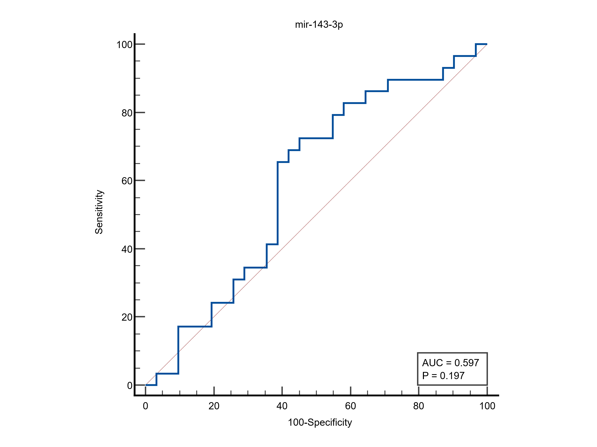
Sample size | 60
Positive group ª | 30
Negative group ^{b} | 30
ª Group = 1
^{b} Group = 0
Area under the ROC curve (AUC)
Area under the ROC curve (AUC) | 0.597
Standard Error ª | 0.0754
95% Confidence interval ^{b} | 0.463 to 0.722
z statistic | 1.291
Significance level P (Area=0.5) | 0.1968
ª DeLong et al., 1988
^{b} Binomial exact
Youden index
Youden index J | 0.2725
Associated criterion | >1.222
Sensitivity | 72.41
Specificity | 54.84
Criterion values and coordinates of the ROC curve
Criterion | Sensitivity | 95% CI | Specificity | 95% CI | +LR | -LR
≥0.083 | 100.00 | 88.1 - 100.0 | 0.00 | 0.0 - 11.2 | 1.00
>0.083 | 100.00 | 88.1 - 100.0 | 3.23 | 0.08 - 16.7 | 1.03 | 0.00
>0.195 | 96.55 | 82.2 - 99.9 | 3.23 | 0.08 - 16.7 | 1.00 | 1.07
>0.245 | 96.55 | 82.2 - 99.9 | 9.68 | 2.0 - 25.8 | 1.07 | 0.36
>0.274 | 93.10 | 77.2 - 99.2 | 9.68 | 2.0 - 25.8 | 1.03 | 0.71
>0.288 | 93.10 | 77.2 - 99.2 | 12.90 | 3.6 - 29.8 | 1.07 | 0.53
>0.397 | 89.66 | 72.6 - 97.8 | 12.90 | 3.6 - 29.8 | 1.03 | 0.80
>0.637 | 89.66 | 72.6 - 97.8 | 29.03 | 14.2 - 48.0 | 1.26 | 0.36
>0.664 | 86.21 | 68.3 - 96.1 | 29.03 | 14.2 - 48.0 | 1.21 | 0.48
>0.72 | 86.21 | 68.3 - 96.1 | 35.48 | 19.2 - 54.6 | 1.34 | 0.39
>0.752 | 82.76 | 64.2 - 94.2 | 35.48 | 19.2 - 54.6 | 1.28 | 0.49
>0.831 | 82.76 | 64.2 - 94.2 | 41.94 | 24.5 - 60.9 | 1.43 | 0.41
>0.959 | 79.31 | 60.3 - 92.0 | 41.94 | 24.5 - 60.9 | 1.37 | 0.49
>0.996 | 79.31 | 60.3 - 92.0 | 45.16 | 27.3 - 64.0 | 1.45 | 0.46
>1.192 | 72.41 | 52.8 - 87.3 | 45.16 | 27.3 - 64.0 | 1.32 | 0.61
>1.222 | 72.41 | 52.8 - 87.3 | 54.84 | 36.0 - 72.7 | 1.60 | 0.50
>1.259 | 68.97 | 49.2 - 84.7 | 54.84 | 36.0 - 72.7 | 1.53 | 0.57
>1.365 | 68.97 | 49.2 - 84.7 | 58.06 | 39.1 - 75.5 | 1.64 | 0.53
>1.41 | 65.52 | 45.7 - 82.1 | 58.06 | 39.1 - 75.5 | 1.56 | 0.59
>1.425 | 65.52 | 45.7 - 82.1 | 61.29 | 42.2 - 78.2 | 1.69 | 0.56
>1.787 | 41.38 | 23.5 - 61.1 | 61.29 | 42.2 - 78.2 | 1.07 | 0.96
>1.828 | 41.38 | 23.5 - 61.1 | 64.52 | 45.4 - 80.8 | 1.17 | 0.91
>1.9 | 34.48 | 17.9 - 54.3 | 64.52 | 45.4 - 80.8 | 0.97 | 1.02
>2.057 | 34.48 | 17.9 - 54.3 | 70.97 | 52.0 - 85.8 | 1.19 | 0.92
>2.093 | 31.03 | 15.3 - 50.8 | 70.97 | 52.0 - 85.8 | 1.07 | 0.97
>2.168 | 31.03 | 15.3 - 50.8 | 74.19 | 55.4 - 88.1 | 1.20 | 0.93
>2.308 | 24.14 | 10.3 - 43.5 | 74.19 | 55.4 - 88.1 | 0.94 | 1.02
>2.59 | 24.14 | 10.3 - 43.5 | 80.65 | 62.5 - 92.5 | 1.25 | 0.94
>2.676 | 17.24 | 5.8 - 35.8 | 80.65 | 62.5 - 92.5 | 0.89 | 1.03
>2.867 | 17.24 | 5.8 - 35.8 | 90.32 | 74.2 - 98.0 | 1.78 | 0.92
>3.68 | 3.45 | 0.09 - 17.8 | 90.32 | 74.2 - 98.0 | 0.36 | 1.07
>4.188 | 3.45 | 0.09 - 17.8 | 96.77 | 83.3 - 99.9 | 1.07 | 1.00
>4.314 | 0.00 | 0.0 - 11.9 | 96.77 | 83.3 - 99.9 | 0.00 | 1.03
>5.421 | 0.00 | 0.0 - 11.9 | 100.00 | 88.8 - 100.0 |  | 1.00

